Automatic clustering for of MRI images, application on perfusion
MRI of brain.

P. Chuzel, A. Mansour
Lab STICC
ENSTA Bretagne
Brest, France

J. Ognard, J. Gentric (1), L. Bressollette (1)
(1) Lab GETBO, equipe 3878
Brest university hospital, Cavale Blanche
Brest, France

D. Hamad
Université du Littoral-Côte-d’Opale
Calais, France

N. Betrouni
INSERM unité 1189
INSERM Lille
Lille, France

Abstract— Many studies have been made in order to propose automatic diagnostic in medical fields. This paper proposes a new approach to deal with the problem of spectral clustering for signal extracted from brain MRI images. The tool-chain developed during this study can be easily implemented for the extraction and the analysis of information from perfusion MRI. We propose a reliable program which can easily isolate healthy from any pathological tissues. Experimental results are shown and discussed.
Keywords- Spectral clustering, Signal and Image processing, Automatic segmentation, MR.

Introduction
Physicians use different sources of images in order to make a diagnostic. In the last two decades, many studies have been made in order to automatize the identification and the characterization of disease by extracting relevant information from those sources of images like the MRI, the Electrography or the Echography, in order to propose help to diagnostic [1], [2], [3], [4].
In [1], a new methodology was proposed in order to realize an automatic segmentation of tumor tissues for prostate cancer. Our objective is to generalize and modify the previously proposed method to improve the segmentation of MRI images to diagnose brain pathologies.
Our project focuses on the perfusion MRI by using a spectral clustering algorithm. Physicians use perfusion MRI in order to check the variation of pixel intensity of the MRI image and identify abnormal behavior. To apply similar methodology, we have to develop an unsupervised classification approach.
The main issue is that many classification algorithms like the k-means are not suitable for signal classification. The main purpose of spectral clustering is to firstly estimate the similarity among signals and, build a similarity matrix and work on the eigenvector and eigenvalue of this matrix in order to perform a classification. Spectral clustering algorithms are the most adapted for the data we are dealing with.
This study is the result of a collaboration among four institutes: ENSTA Bretagne, Brest Hospital University Research Center (CHRU), INSERM of Lille and ULCO.
We apply our approach on a perfusion MRI database of twelve patients showing different pathologies in the brain in order to apply our algorithm. Those MRI have been provided by the Brest CHRU. An example of MRI images obtained can be seen in the figure 1. For each pixel, a variation of the intensity on the different MRI images can be observe.
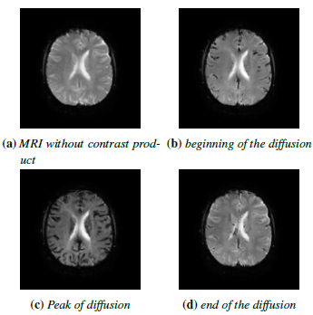
Figure 1 : Diffusion of the contrast product on the MRI

METHODOLOGY
Our database consists of perfusion MRI. During a perfusion MRI, the patient is injected by a contrast product, the gadolinium chelates. It’s well known and considered that normal and pathological tissues have different way and speed absorption of the contrast product. Pathological tissues have a very specific behavior which can be detected by our algorithm. Figure 8 presents at the end of the document shows our proposed bloc diagram.
In our database and for each patient, 26 sets of 40 images have been generated, each set is corresponding to a slice of the brain. The size of each image is 128*128 pixels. Each set is used in order to retrieve the variation of pixel intensity of the slice MRI during the diffusion of contrast product.
For each slice, we generate a 128*128*40 tensor. For each pixel, we extracted a signal of 40 samples which correspond to the variation of this pixel intensity in the 40 images of 128*128 pixels. Figure 2 shows the generated signals using this protocol.

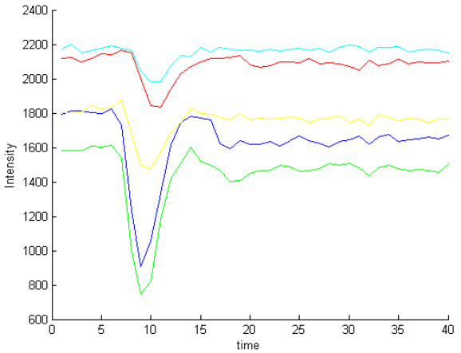
Figure 2 : Examples of signals extracted from the MRI.

Figure 2 shows that we obtain a hypo-signal during the diffusion of the contrast product until the intensity of the pixel come back to its original value. Our algorithm method afterwards selects a specific region of interest (ROI) on a slice and then apply a spectral clustering algorithm on those selected signals in order to cluster the different tissues of the area.

SPECTRAL CLUSTERING ALGORITHMS
In the literature, many references about the spectral clustering can be found [5], [6]. However, we will here focus on the Jordan and Weiss spectral clustering algorithm JWSC [5] because is very adapted to the unsupervised classification and it has provided the most satisfying results on the data we are dealing with. At the beginning, our algorithm builds a graph with its similarity matrix in order to evaluate the resemblance of the signal between them. In a second time, we will apply JWSC algorithm in order to cluster the signal thanks to the information extract from the similarity matrix.

Definition of the similarity matrix.
In order to have an algorithm independent from the processed data, we considered only full connected graph because it can estimate the resemblance of each sample with no a priori information. In a full connected graph, all the nodes are connected to each other.

In order to build the similarity matrix W, two different options have been studied:

- First option uses a sparse representation based on building a L1 graph. The main idea consists on rebuild each point Xi with all the other samples, according to a L1 minimization problem [7].
- Second option consists on defining W as:

is the coefficient of dispersion in the data around a point Xi , [1], [6]. During the study, we found that the optimum value of was the distance to the 7th closest neighbor of the point Xi.

During the realization of the tool-chain, the first option was implemented but didn’t give satisfaction. However, the second one on the contrary gave better results. The tool-chain use the second method for the construction of the graph and the matrix W.

Spectral clustering algorithm.
Many algorithms can be used for the spectral clustering, and some of them have been implemented during this project, [5], [8], [9]. We give here details on the Jordan and Weiss algorithm.
To implement the JWSC algorithm, we have firstly to define the Laplacian matrix L of the matrix W. The Laplacian is defined by:

Where D is the degree matrix defined by its coefficient:
D is a diagonal matrix ad I is the identity matrix.
The processing tool-chain estimates the eigenvector associated to the smallest eigenvalues of L, normalizes each of them and realizes a classification using the k-means algorithm.
The main steps of the JWSC algorithm are resumed in the algorithm 1.
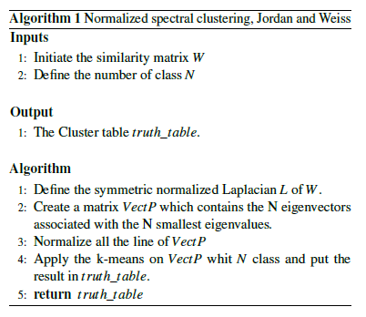

The main outcome of the algorithm is a truth table clustering all pixels in the ROI.

RESULTS
Figure 3 represents a MRI of a patient with brain tumor. Figure 4 shows the area of pathological tissue.
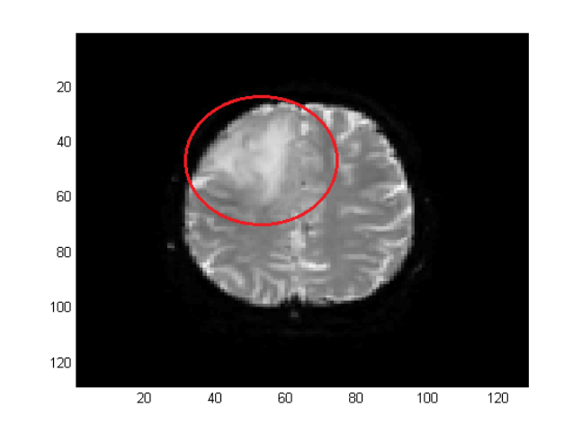
Figure 3 : First image of the MRI with false color.

By applying Algorithm 1 on the ROI with a number of class Nclass = 2 and Nclass = 3, we get some results which are shown in Figures 5,6,7.
Our experimental results show that the algorithm can easily isolate the pathology from the normal tissues. By adjusting Nclass = 3, we can generate a third class representing the uncertain zone.
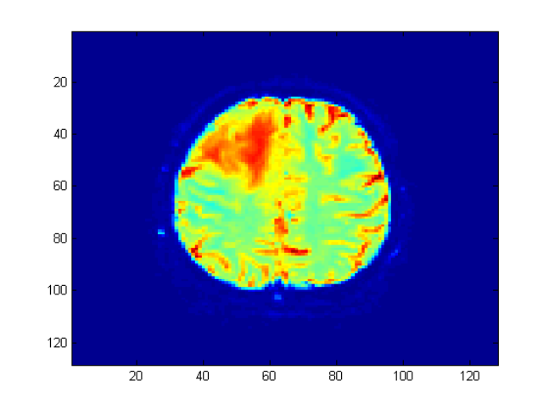
Figure 4 : Area presenting the pathology.

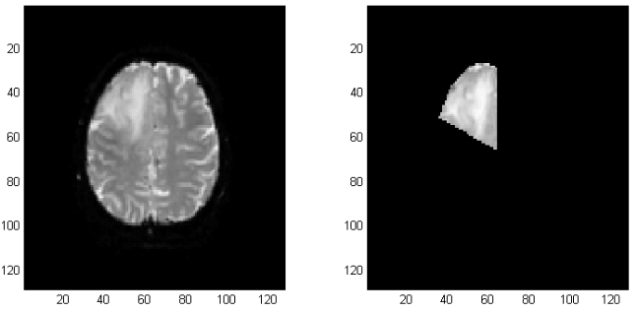
Figure 5 : Results of the algorithm. Left: MRI image. Right: Mask

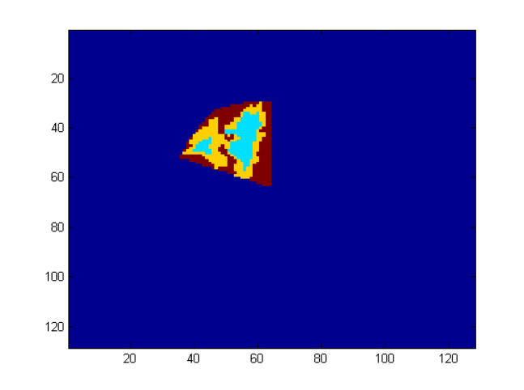
Figure 6 : The results of the algorithm for Nclass = 2.
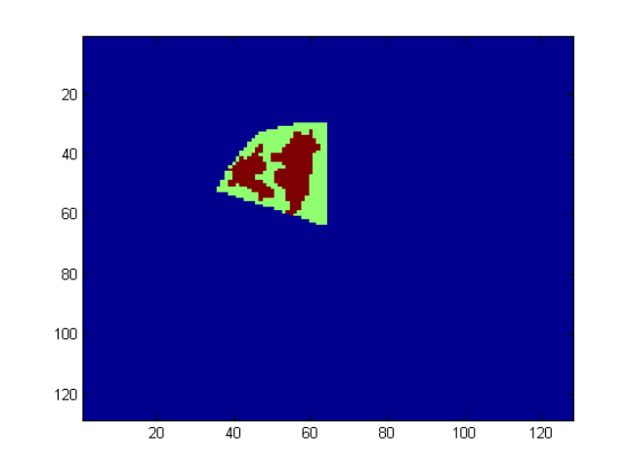
Figure 7 : The results of the algorithm for Nclass = 2.

The results are satisfying. Our similitude matrix depends only on the neighborhood of each point so our processing tool-chain is highly independent of the input data. Furthermore, the process is fully automated. The user must provide only the number of class and our program deal with the data in order to calculate the truth table.
Nevertheless, when we are trying to apply other algorithms in order to automatically find the optimal number of class [10], [6], the results aren’t satisfying in the case of real data. For now, our only choice is to provide a set of maps with different value of Nclass and interpret the results, as it has been done with Figure 6, 7, 8.
The processing tool-chain that have been implemented have been realized in order to have in the end the exact number of cluster N when we apply the k-means algorithm. That means that in some case the algorithm wouldn’t arrive to this number of class but we don’t allow this situation to happen. It may have a huge impact on the algorithm.

CONCLUSION
By generalizing and modifying the method developed in [1], this study proposes a new methodology using spectral clustering for the automatic segmentation of MRI images of brain.
The experimental results show that our algorithm is able to isolate the pathology from healthy tissues. Presently, we have only a reliable algorithm that seems to provide good results.
However, we are currently studying two options:
- Realization of parametric map of the area which can provide other information. For brain tissues, the two relevant parameters are the cerebral blood volume (CBV) and the cerebral blood flow (CBF) [11].

- Later on, we should realize a multi-modal analyze which imply to analyze other kind of MRI sequences in order to extract other sources of information.

We are targeting to provide a unsupervised clustering algorithm which would be able to fully identify and segmented pathological tissues of the brain.

References
- G. Tartare, “Contribution à l’analyse de l’IRM dynamique pour l’aide au diagnostic du cancer de la prostate,” Ph.D. dissertation, Université du Littoral-Côte-d’Opale, Lille, France, 2014.
- C. Schmitt, A. H. Henni, and G. Cloutier, “Characterization of blood clot viscoelasticity by dynamic ultrasound elastography and modeling of the rheological behavior,” Journal of biomechanics, vol. 44, no. 4, pp. 622–629, 2011.
- C. Schmitt, E. Montagnon, A. H. Henni, S. Qi, and G. Cloutier, “Shear wave induced resonance elastography of venous thrombi: A proof-of-concept,” IEEE Trans. On Medical Imaging, vol. 32, no. 3, pp. 565–577, 2013.
- J. Ophir, I. Cespedes, H. Ponnekanti, Y. Yazdi, and X. Li, “Elastography: a quantitative method for imaging the elasticity of biological tissues,” Ultrasonic imaging, vol. 13, no. 2, pp. 111–134, 1991.
- U. Von Luxburg, “A tutorial on spectral clustering,” Statistics and computing, vol. 17, no. 4, pp. 395–416, 2007.
- S. Mouysset, “Contributions à l’étude de la classification spectrale et applications,” Ph.D. dissertation, Institut National Polytechnique de Toulouse-INPT, France, 2010.
- S. Yan and H.Wang, “Semi-supervised learning by sparse representation.” in SDM. SIAM, 2009, pp. 792–801.
- A. Y. Ng, M. I. Jordan, and Y. Weiss, “On spectral clustering: Analysis and an algorithm,” Advances in neural information processing systems, vol. 2, pp. 849–856, 2002.
- J. Shi and J. Malik, “Normalized cuts and image segmentation,” IEEE Trans. on Pattern Analysis and Machine Intelligence, vol. 22, no. 8, pp. 888–905, 2000.
- L. Zelnik-Manor and P. Perona, “Self-tuning spectral clustering,” in Advances in neural information processing systems, 2004, pp. 1601–1608.
- E. R. Muir, L. T.Watts, Y. V. Tiwari, A. Bresnen, Q. Shen, and T. Q. Duong, “Quantitative cerebral blood flow measurements using MRI,” Cerebral Angiogenesis: Methods and Protocols, pp. 205–211, 2014. S. Temme, C. Grapentin, C. Quast, C. Jacoby,
- M. Grandoch, Z. Ding, C. Owenier, F. Mayenfels, J. W. Fischer, and R. Schubert, “Noninvasive imaging of early venous thrombosis by 19f magnetic resonance imaging with targeted perfluorocarbon nanoemulsions,” Circulation, vol. 131, no. 16, pp. 1405–1414, 2015.
- A. Idbaih, M. Boukobza, I. Crassard, R. Porcher, M.-G. Bousser, and H. Chabriat, “MRI of clot in cerebral venous thrombosis high diagnostic value of susceptibility weighted images,” Stroke, vol. 37, no. 4, pp. 991–995, 2006.
- D. S. Liebeskind, N. Sanossian,W. H. Yong, S. Starkman, M. P. Tsang, A. L. Moya, D. D. Zheng, A. M. Abolian, D. Kim, and L. K. Ali, “CT and MRI early vessel signs reflect clot composition in acute stroke,” Stroke, vol. 42, no. 5, pp. 1237–1243, 2011.
- M. Meil˘a, “Comparing clusterings, an information based distance,” Journal of multivariate analysis, vol. 98, no. 5, pp. 873–895, 2007.
- A. Y. Yang, Z. Zhou, A. G. Balasubramanian, S. S. Sastry, and Y. Ma, “Fast-minimization algorithms for robust face recognition,” IEEE Trans. on Image Processing, vol. 22, no. 8, pp. 3234–3246, 2013.
- S. Wu, X. Feng, and W. Zhou, “Spectral clustering of high-dimensional data exploiting sparse representation vectors,” Neurocomputing, vol. 135, pp. 229–239, 2014.
- J. Jiao, X. Mo, and C. Shen, “Image clustering via sparse representation,” in Advances in Multimedia Modeling. Germany: Springer, 2010, pp. 761–766.
- K. Doi, “Computer-aided diagnosis in medical imaging: historical review, current status and future potential,” Computerized medical imaging and graphics, vol. 31, no. 4, pp. 198–211, 2007.
- D. L. Longo, W. Dastrù, L. Consolino, M. Espak, M. Arigoni, F. Cavallo, and S. Aime, “Cluster analysis of quantitative parametric maps from DCE-MRI: application in evaluating heterogeneity of tumor response to antiangiogenic treatment,” Magnetic resonance imaging, vol. 33, no. 6, pp. 725–736, 2015.
- G. Tartare, D. Hamad, M. Azahaf, P. Puech, and N. Betrouni, “Spectral clustering applied for dynamic contrastenhanced mr analysis of time–intensity curves,” Computerized Medical Imaging and Graphics, vol. 38, no. 8, pp. 702–713, 2014.

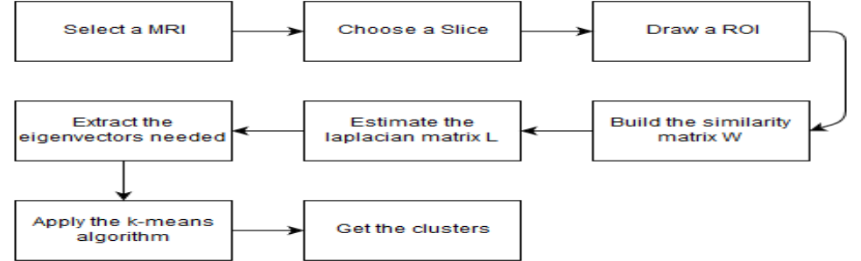
Figure 8 : The proposed processing tool-chain.

