**EEE101 C programming and SW engineering 1**

This is the report for Assignment 1 of EEE101.

1. **Assignment 1:**
2. **Analysis:**

Input:

User’s name, followed with the ID number and a height to transform.

Outputs:

“The name in reverse is:” and the user’s name in reverse; “The division of the first 4 digits and the last four digits of the ID number is :” and The division of the first 4 digits and the last four digits of the ID number is. Finally is " m is feet inches" with the values of miles feet inches in the space.

These three output are displayed in three different lines.

Some small constraints:

1. Because inside the name has a blank space, so the input character string also has a blank space. Due to the blank space cannot as a seperator between severial characters in the scanf_s function, there the gets function will be considerated to use in this program
2. The number of feet and inches must be a integer, so at last the data needs to be rounded.
3. In the program it must have some statement to make sure the IDnumber have 8 digits, so the function of strlen() must use.
4. The number store in array is char type, it could not be add directly, so a statement to transform the type of number in array is needed
5. **Design:**
6. Declare an array of maximum 50 characters named name[50] and an array of maximum 50 characters named IDnumber[50] *:*

IDnumber[50]: The input ID number, which is placed in an array.

name[50]: The input name, which is placed in an array.

1. Declare a variable of the type of float namely height, height represents the input user’s height in meters
2. Declare two variable of int namely feet and inches.
3. Ask the user to enter his or her name, then press “Enter” then enter the ID number.
4. Read the input name (surname and last name separated with space) and store it into the array “name[50]” when the Enter key is pressed. Then read the input ID number and store its value into the array “IDnumber[50]”
5. Ask user to input a real number representing the height in meters.
6. Read the input real number and store the values into height.
7. Using a for-loop to Display the input name in reverse on screen and return.
8. Using a for-loop to transform IDnumber from char type to int type then add the first four digits and the rest digits,finally division them and print them out.
9. Convert the height to feet and inches, make sure the data is rounded.
10. Display the height in feet and inches on the screen.
11. **For implementation please see the C code in file “1613453_Assignment 1.c” with comments.**
12. **Testing:**

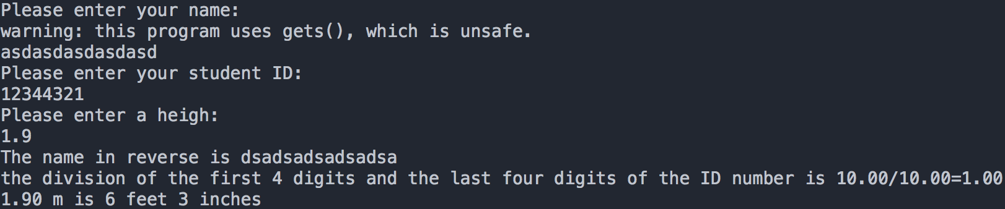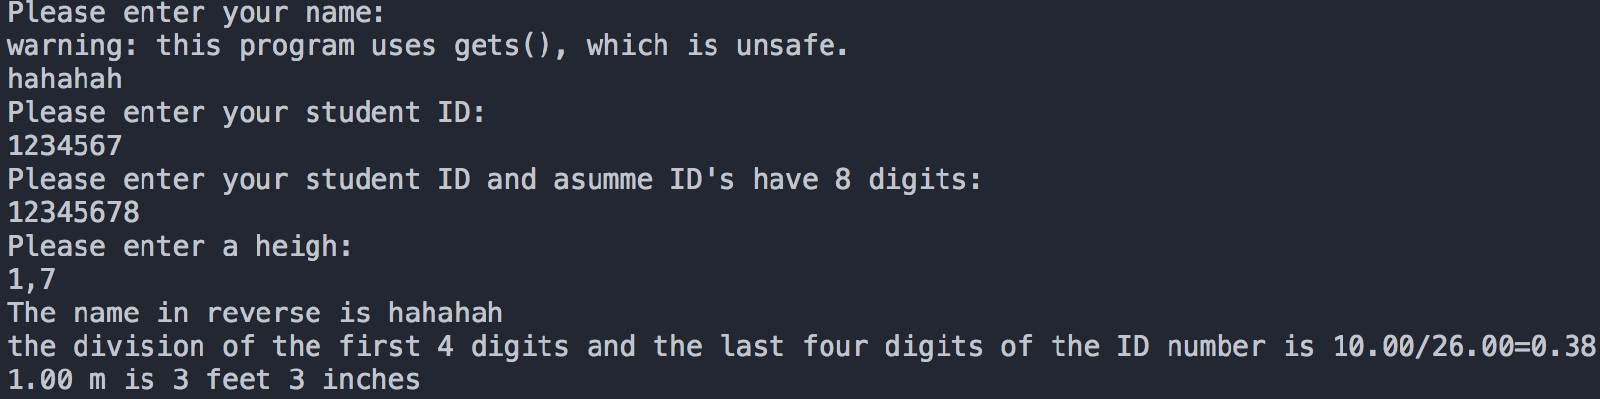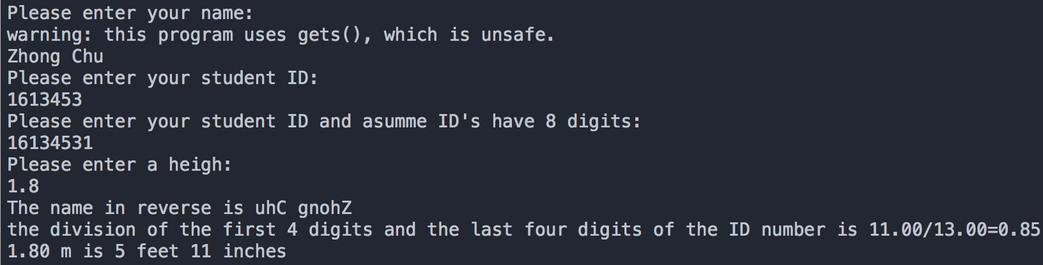

The C program has been test with several experiments and the outputs have been verified successfully. The third experiment I tested with my own name and ID number. For instance,

1. **C code:**

/*

Name: Simple Program for Name,Student ID number and Height

File name: 1613453_1.c

copyright: Free

Author: Zhong Chu ID number: 1613453.

Description: A Programm that can read full name,student ID number and height that user inputs, then store them in string,integer and float. Reverse the string. Divide and print the sum of first 4 digits and the sum of rest. convert the height which uses unit of 'meter' to units of 'feet' and 'inch'*/

#include <stdio.h> /* include information about standard library stdio.h*/

#include <string.h> /* include information about standard library string.h*/

#include <math.h> /* include information about standard library math.h*/

#include <stdlib.h> /* include information about standard library stdlib.h*/

#define chartonumber(x) (x-'0') /* To transform x from char to int*/

int main() /* Define a main function named main*/

{

char name[50],IDnumber[50]; /* Declare two arrays of 50 characters, whose name are name and IDnumber.*/

float height, sum_first,sum_last,result; /* Declare four variables of type of float namely heigh,sum_first,sum_last andresult*/

int feet,inches,i; /* Declare three variables of type of int namely feet,inches and i*/

sum_first=sum_last=result=0.0; /* let the initial value of sum_first,sum_last,result equal to 0.0*/

printf("Please enter your name:\n"); /* Ask user to input their name.*/

gets(name); /* store the name into the array of the name.*/

printf("Please enter your student ID:\n"); /* Ask user to input their student ID.*/

gets(IDnumber); /* store the student ID into the array of the name.*/

while(strlen(IDnumber)!= 8){

printf("Please enter your student ID and asumme ID's have 8 digits:\n");

gets(IDnumber); /* Using while to make sure the length of IDnumber is eight*/

}

printf("Please enter a heigh:\n"); /* Ask user to input a heigh*/

scanf("%f",&heigh); /* store the value of the input number into variable heigh using the scanf function */

printf("The name in reverse is "); /* display The name in reverse is on the screen */

i=strlen(name); /* compute the length of name and assign it to i*/

for( ; i >= 0;--i)

printf("%c",name[i]); /* Using a for-loop to print the name in reverse*/

printf("\n"); /* To exchange a newline */

for(int j = 0;j< 8;j++)

{

IDnumber[j]=chartonumber(IDnumber[j]); /* To transform IDnumber[j] from char to int*/

if(j<4) /* If j is smaller than four*/

sum_first=sum_first+IDnumber[j];

else /* If j is larger than four*/

sum_last=sum_last+IDnumber[j];

}

result=sum_first/sum_last; /* compute the result at the given number according to the formula provided */

printf("the division of the first 4 digits and the last four digits of the ID number is %.2f/%.2f=%.2f",sum_first,sum_last,result);

/* display the division of the first 4 digits and the last four digits of the ID number is */

printf("\n"); /* To exchange a newline */

feet=heigh/0.3048; /* Convert imperial height into feet form.*/

inches=(heigh-feet*0.3048)/0.0254; /* Convert the rest into inches form*/

if(fabs(heigh-feet*0.3048-inches*0.0254)>fabs(heigh-feet*0.3048-(inches+1)*0.0254))

++inches; /* make sure the results are rounded*/

printf("%.2f m is %d feet %d inches\n",heigh,feet,inches);

/* display Conversion results on the screen */

system("pause"); /* system ("pause") is from the program call "pause" command*/

return 0; /* Return value 0 to the system.*/

}