**Course: ENSF 614** - Fall 2023  
**Lab #:** Lab 2  
**Instructor:** Mahmood Moussavi  
**Student Names:** Redge Santillan, Christian Valdez  
**Submission Date:** September 27, 2023

**Exercise A**

Point 1

Point 2

Point 3

Point 4

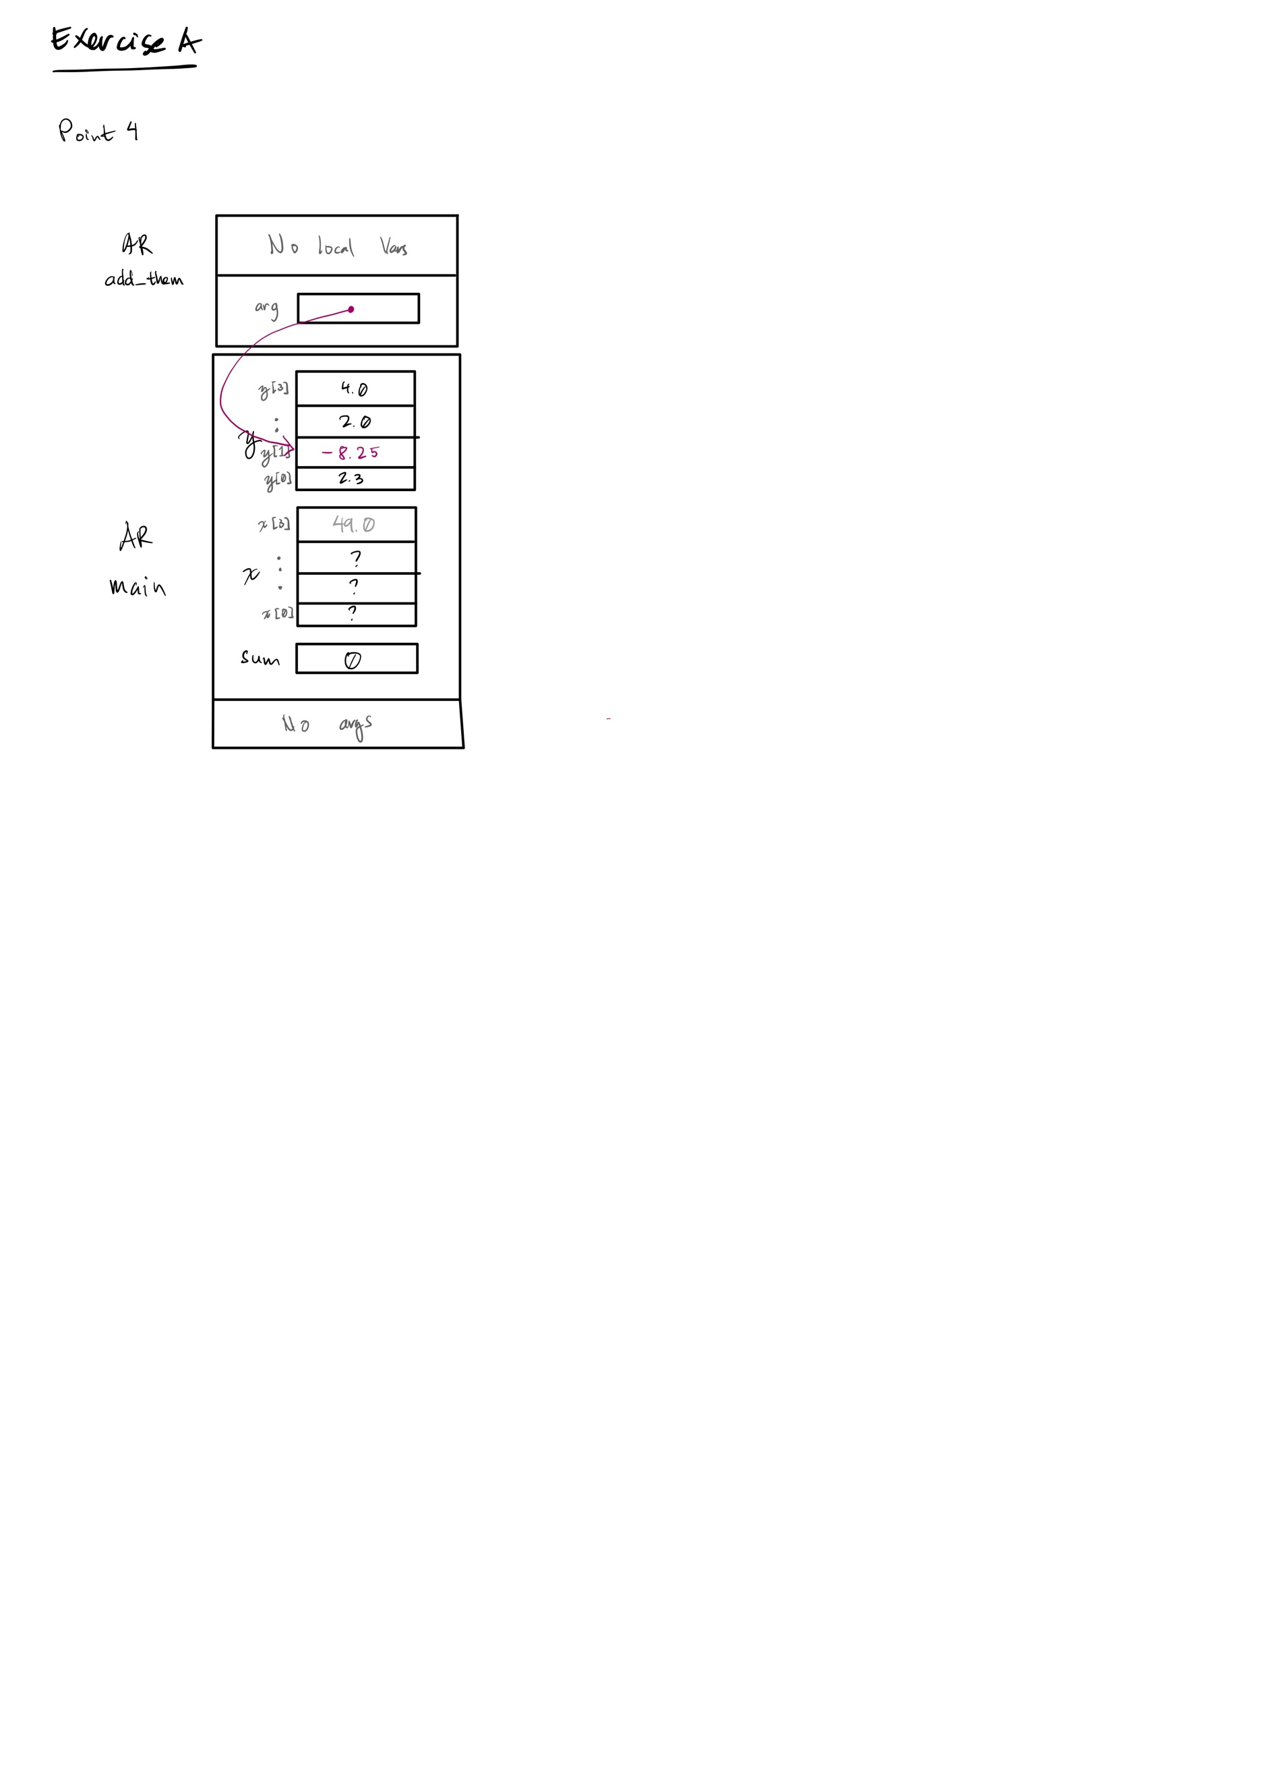

**Exercise B**

my_lab2exe_B.cpp source file:

/*

* File Name: my_lab2exe_B.cpp

* Assignment: Lab 2 Exercise B

* Completed by: Redge Santillan

* Submission Date: Sept 27, 2023

*/

**int** my_strlen(**const** **char** *s);

/* Duplicates strlen from <cstring>, except return type is int.

* REQUIRES

* s points to the beginning of a string.

* PROMISES

* Returns the number of chars in the string, not including the

* terminating null.

*/

**void** my_strncat(**char** *dest, **const** **char** *source, **int** n);

/* Duplicates strncat from <cstring>, except return type is void.

* REQUIRES

* dest points to the beginning of a string

* source points to the beginning of a string

* n - integer, first n number of characters to copy from source to dest.

* PROMISES

* Appends the dest c-string with the first n characters of source c-string.

*/

**int** my_strcmp(**const** **char** *str1, **const** **char** *str2);

/* Compares string1 and string2

* REQUIRES

* str1 points to the beginning of a string

* str2 points to the beginning of a string

* PROMISES

* Returns 0 if str1 and str2 are identical.

* Returns a positive integer if str1 > str2.

* Returns a negative integer if str1 < str2.

*/

#include <iostream>

#include <cstring>

**using** **namespace** std;

**int** main(**void**)

{

**char** str1[7] = "banana";

**const** **char** str2[] = "-tacit";

**const** **char**\* str3 = "-toe";

/* point 1 */

**char** str5[] = "ticket";

**char** my_string[100]="";

**int** bytes;

**int** length;

/* using strlen libarary function */

length = (**int**) my_strlen(my_string);

cout << "\nLine 1: my_string length is " << length;

/* using sizeof operator */

bytes = **sizeof** (my_string);

cout << "\nLine 2: my_string size is " << bytes << " bytes.";

/* using strcpy libarary function */

strcpy(my_string, str1);

cout << "\nLine 3: my_string contains: " << my_string;

length = (**int**) my_strlen(my_string);

cout << "\nLine 4: my_string length is " << length << ".";

my_string[0] = '\0';

cout << "\nLine 5: my_string contains:\"" << my_string << "\"";

length = (**int**) my_strlen(my_string);

cout << "\nLine 6: my_string length is " << length << ".";

bytes = **sizeof** (my_string);

cout << "\nLine 7: my_string size is still " << bytes << " bytes.";

/* strncat append the first 3 characters of str5 to the end of my_string */

my_strncat(my_string, str5, 3);

cout << "\nLine 8: my_string contains:\"" << my_string << "\"";

length = (**int**) my_strlen(my_string);

cout << "\nLine 9: my_string length is " << length << ".";

strncat(my_string, str2, 4);

cout << "\nLine 10: my_string contains:\"" << my_string << "\"";

/* strncat append ONLY up ot '\0' character from str3 -- not 6 characters */

my_strncat(my_string, str3, 6);

cout << "\nLine 11: my_string contains:\"" << my_string << "\"";

length = (**int**) my_strlen(my_string);

cout << "\nLine 12; my_string has " << length << " characters.";

cout << "\n\nUsing strcmp - C library function: ";

cout << "\n\"ABCD\" is less than \"ABCDE\" ... strcmp returns: " <<

my_strcmp("ABCD", "ABCDE");

cout << "\n\"ABCD\" is less than \"ABND\" ... strcmp returns: " <<

my_strcmp("ABCD", "ABND");

cout << "\n\"ABCD\" is equal than \"ABCD\" ... strcmp returns: " <<

my_strcmp("ABCD", "ABCD");

cout << "\n\"ABCD\" is less than \"ABCd\" ... strcmp returns: " <<

my_strcmp("ABCD", "ABCd");

cout << "\n\"Orange\" is greater than \"Apple\" ... strcmp returns: " <<

my_strcmp("Orange", "Apple") << endl;

**return** 0;

}

/* Duplicates strlen from <cstring>, except return type is int.

* Counts the number of non-'\0' characters in a char array.

* Returns the number of non-'\0' characters in a char array.

*/

**int** my_strlen(**const** **char** *s){

**bool** endOfArray = **false**;

**int** counter = 0;

**while** (!endOfArray) {

**if** (s[counter] == '\0'){

endOfArray = **true**;

} **else** {

counter++;

}

}

**return** counter;

}

/* Appends the first n characters of string source to string dest, and returns a char* to dest. If the length of the C-string in source is less than n, only the content up to the terminating null character '\0' is copied.

*/

**void** my_strncat(**char** *dest, **const** **char** *source, **int** n){

// If given n > strlen(source), only copy strlen(source)

**int** sourceLength = my_strlen(source);

**int** destLength = my_strlen(dest);

**if** (n > sourceLength){

n = sourceLength;

}

// Look for the first '\0' in dest - this will be n + 1. Loop thru

**for** (**int** i = 0; i < n; i++){

dest[i + destLength] = source[i];

}

dest[n + destLength] = '\0';

}

/** Compares 2 c-strings.

Returns 0 if str1 and str2 are identical.

Returns a positive integer if str1 > str2.

Returns a negative integer if str1 < str2.

\*\**/*

**int** my_strcmp(**const** **char** *str1, **const** **char** *str2){

// as soon as you find the difference until you subtract - don't need the lengths.

**int** result = 0;

// The while condition ensures that as soon as str1 and str2 are pointing to values that are NOT the same, the program will exit the loop

// Check if str1 is pointing to a '\0' value to ensure that neither pointers will point to inaccessible memory

**while** ((*str1 == *str2) && *str1 != '\0') {

str1++;

str2++;

}

result = *str1 - *str2;

**return** result;

}

**Exercise C**

Point 1 – second function call

**Exercise E**

/*

* lab2exe_E.cpp

* Implementation file for complex number module

* Assignment: Lab 2 Exercise E

* Section: B01

* Completed by: Christian Valdez and Redge Santillan

* Submission date: Sep 27, 2023

*/

#include "lab2exe_E.h"

cplx cplx_add(cplx z1, cplx z2) {

cplx result;

result.real = z1.real + z2.real;

result.imag = z1.imag + z2.imag;

return result;

}

void cplx_subtract(cplx z1, cplx z2, cplx* difference) {

difference->real = z1.real - z2.real;

difference->imag = z1.imag - z2.imag;

}

void cplx_multiply(const cplx* z1, const cplx* z2, cplx* difference) {

difference->real = (z1->real * z2->real) - (z1->imag * z2->imag);

difference->imag = (z1->real * z2->imag) + (z1->imag * z2->real);

}