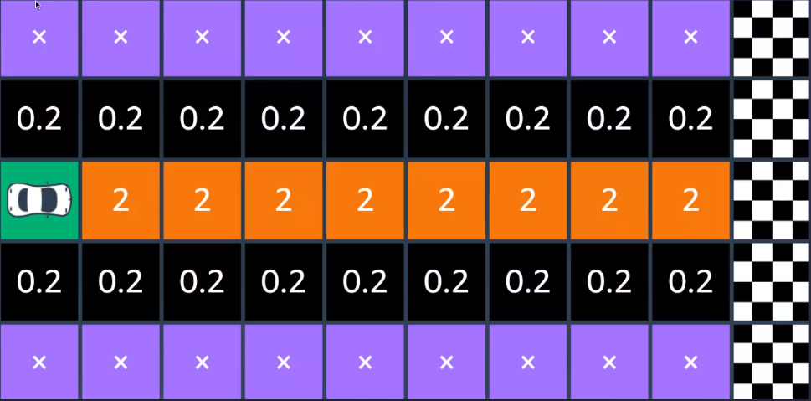

How to turn corners

1. Brake to maximum capacity at your braking point
2. Move your vision to the apex point
3. Turn-in your car at the turn-in point
4. Make the apex of the ideal racing line
5. Begin to introduce the accelerator
6. Open up steering to the corner’s exit point

Poponut’s reward function:

import math

def reward_function(params):

*# Read input variables*

    waypoints = params['waypoints']

    closest_waypoints = params['closest_waypoints']

    heading = params['heading']

*# Initialize the reward with typical value*

    reward = 1.0

*# Calculate the direction of the center line based*

    next_point = waypoints[closest_waypoints[1]]

    prev_point = waypoints[closest_waypoints[0]]

*# Calculate the direction in radius, arctan2(dy, dx)*

    track_direction = math.atan2(

        next_point[1] - prev_point[1], next_point[0] - prev_point[0])

*# Convert to degree*

    track_direction = math.degrees(track_direction)

*# Calculate the difference between the track direction and the heading direction of the car*

    direction_diff = abs(track_direction - heading)

*if* direction_diff > 180:

        direction_diff = 360 - direction_diff

*# Penalize the reward if the difference is too large*

    DIRECTION_THRESHOLD = 10.0

*if* direction_diff > DIRECTION_THRESHOLD:

        reward *= 0.5

*return* float(reward)