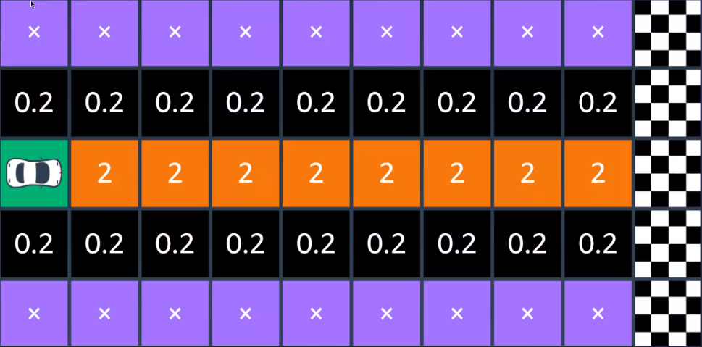

How to turn corners

1. Brake to maximum capacity at your braking point
2. Move your vision to the apex point
3. Turn-in your car at the turn-in point
4. Make the apex of the ideal racing line
5. Begin to introduce the accelerator
6. Open up steering to the corner’s exit point

