Project Development Phase
Electricity Consumption Analysis Project

Overview
This phase covers the hands-on build work: pre-processing the raw dataset in SQL Server, designing the Tableau dashboards and story, and preparing the dataset for downstream use. Per the project's GitHub structure, the deliverables for this phase are two PDFs (pre-processing steps & business questions with visualization; dashboard/story screenshots with Tableau Public links) plus the dataset itself. Placeholders and available links are included below — insert the actual PDFs into the GitHub folder alongside this document.

1st PDF — Pre-processing Steps & Business Questions with Visualization
[Placeholder: attach the PDF covering data cleaning/pre-processing steps and the business questions answered, each with a supporting visualization.]

2nd PDF — Dashboard & Story Screenshots, Tableau Public Links
[Placeholder: attach the PDF containing dashboard screenshots, story screenshots, and the corresponding Tableau Public links.]
Reference screenshots from the results section of the master report are shown below as a starting point:
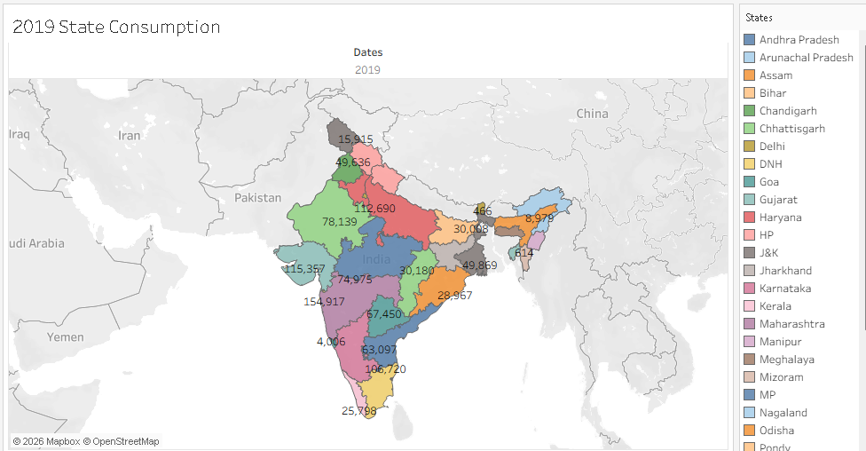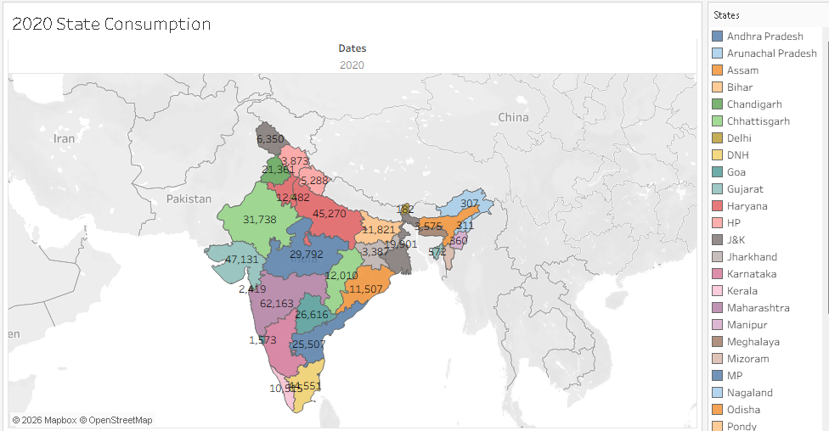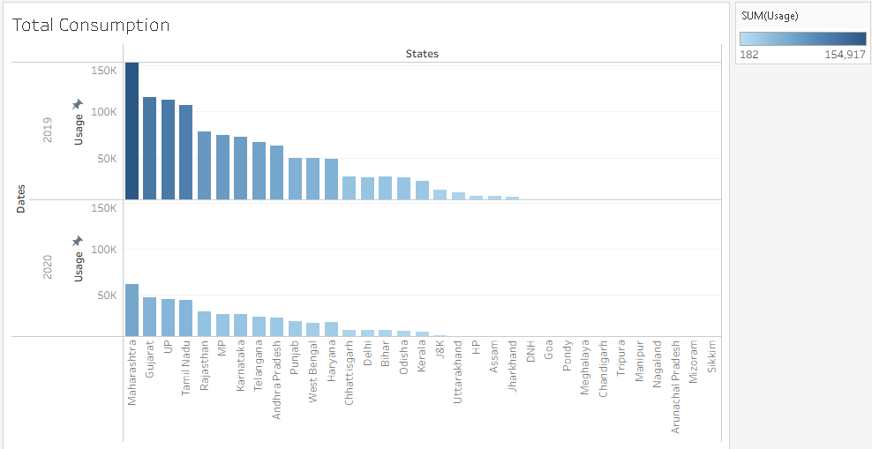
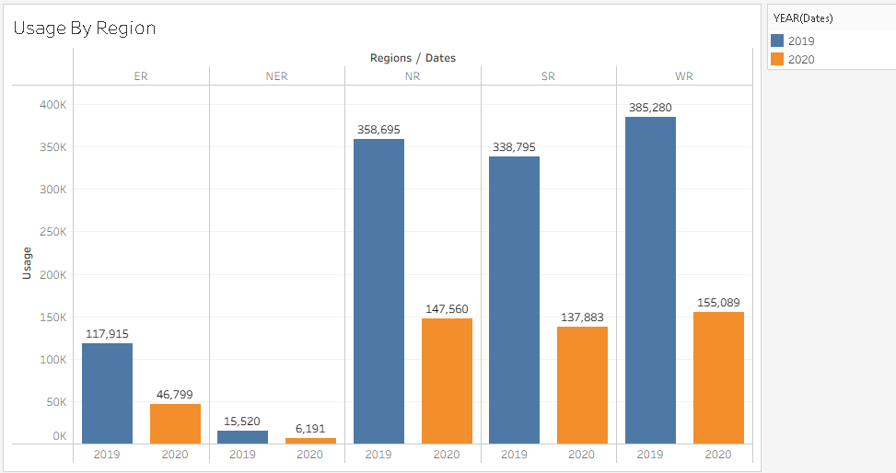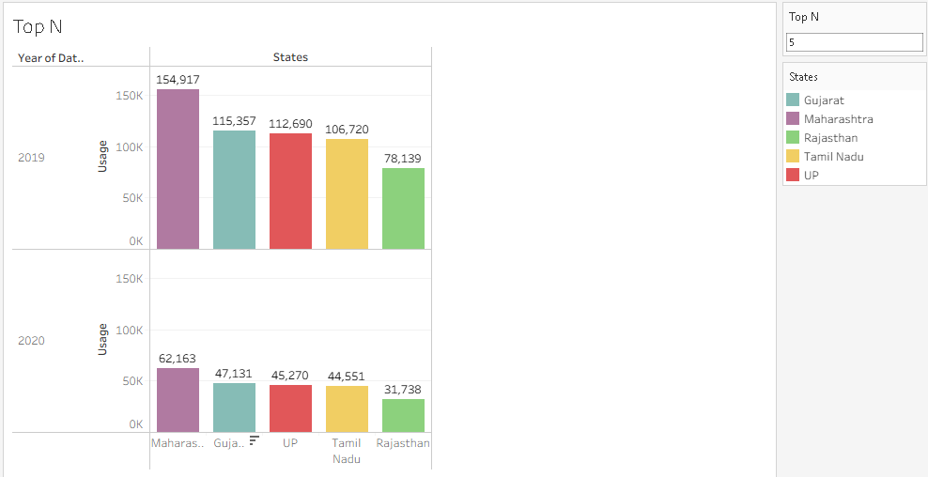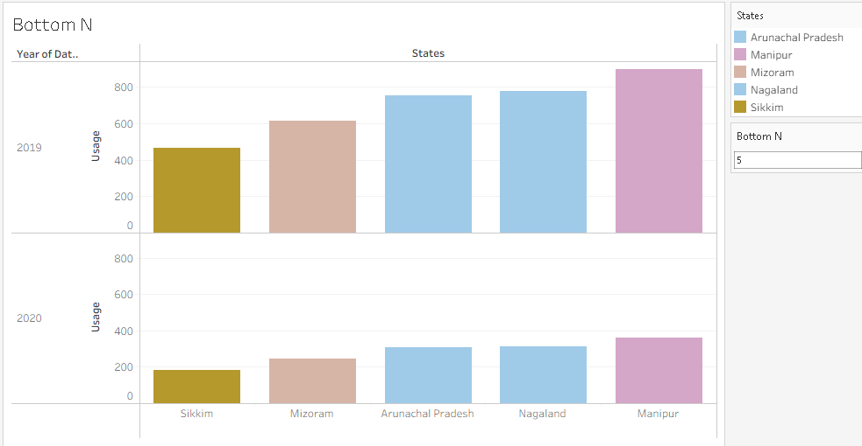

Dataset
Dataset link:
https://drive.google.com/file/d/1JxIkHNwXxjFztKq7ad0_KtkukCqTckNy/view

