Doc and Demo
Electricity Consumption Analysis Project

Final Report
The complete project report — 'Plugging Into the Future: An Exploration of Electricity Consumption Patterns' — covers the introduction, ideation, requirement analysis, project design, planning, testing, results, advantages/disadvantages, conclusion, and future scope. Place the full report PDF/DOCX in this folder alongside this document.

Output Screenshots (from Results section)
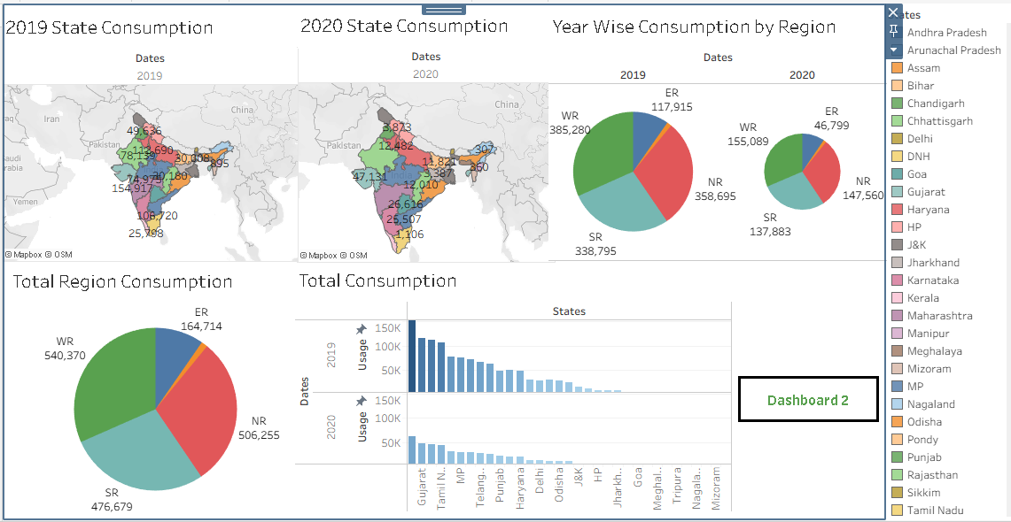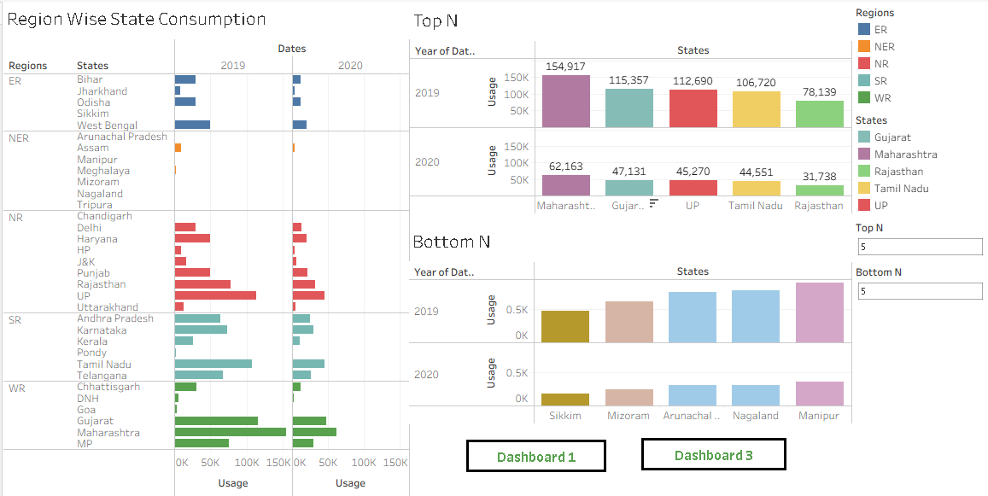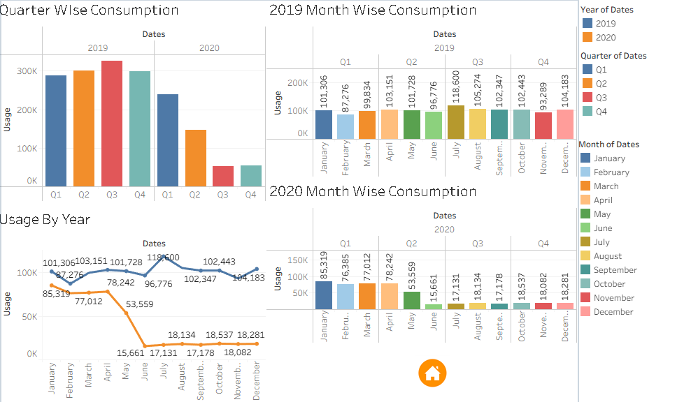
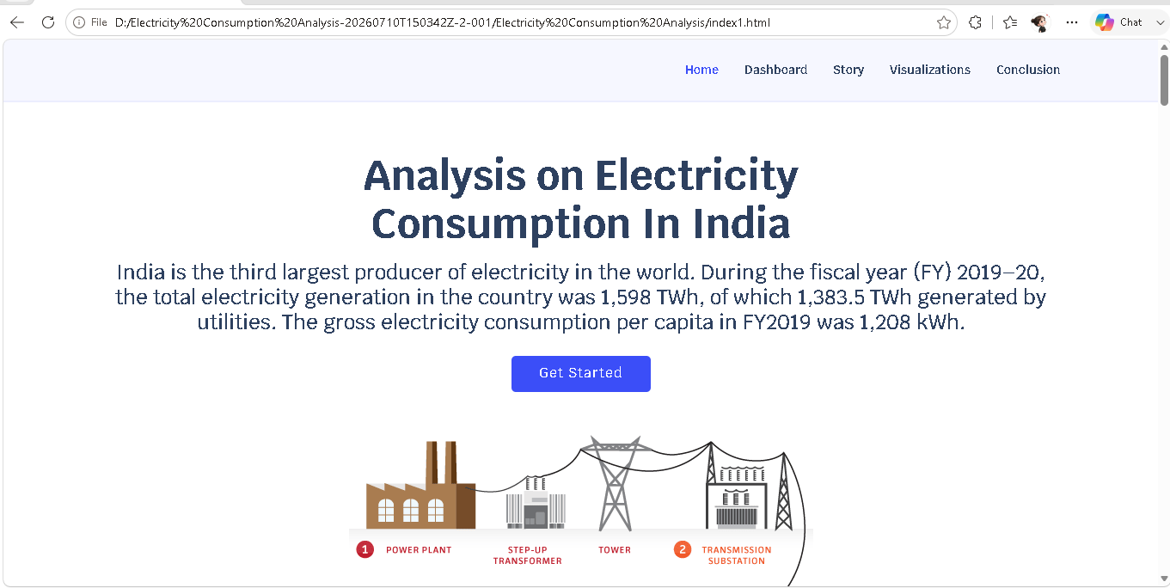
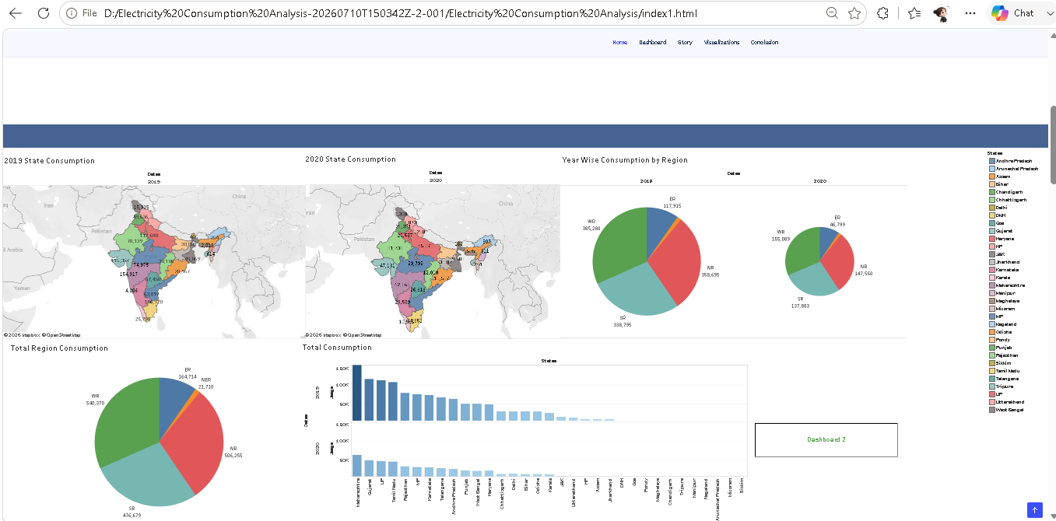
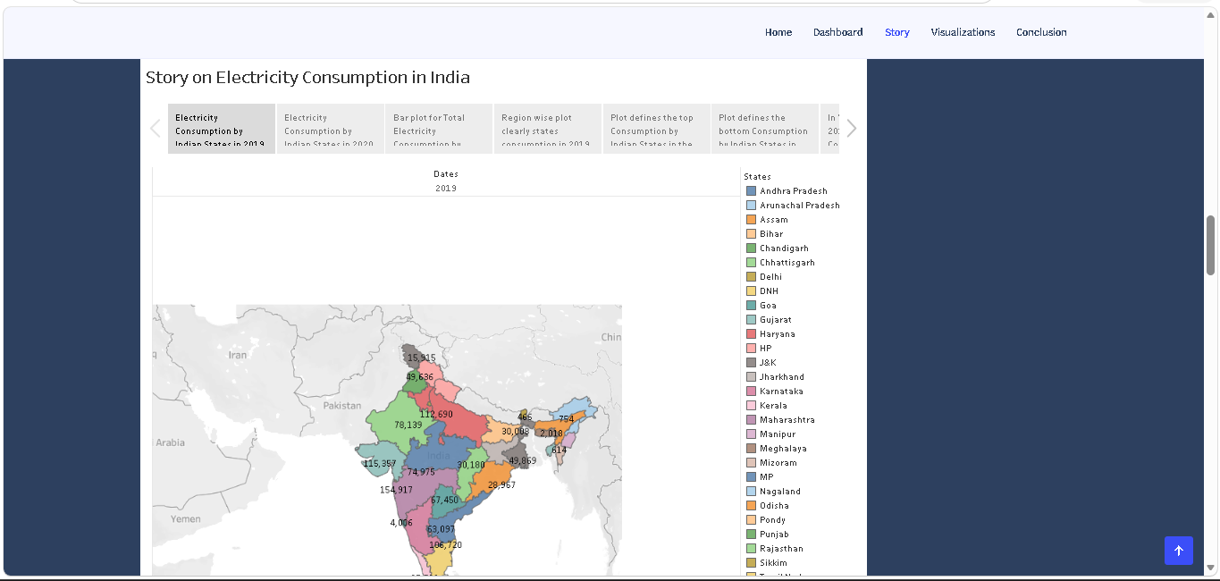

Demonstration Video
The project demonstration video (Video_Demo.mp4) is included alongside this document in the Doc and Demo folder.

GitHub & Project Demo Link
https://github.com/chvedasri/ElectricityConsumption

