Requirement Analysis
Electricity Consumption Analysis Project

3.1 Customer Journey Map
Stage | User Experience
Awareness | User recognizes the need to understand state-wise electricity consumption.
Data Access | Raw consumption dataset is collected and made available for processing.
Pre-processing | Data is cleaned and structured in Microsoft SQL Server.
Exploration | User explores trends and comparisons through Tableau dashboards.
Access via Web | User accesses the dashboards/insights conveniently through the Flask web application.
Decision-Making | User draws conclusions and uses insights for planning or reporting.

3.2 Solution Requirement
- Functional: Import, clean, and query raw electricity consumption data in SQL Server.
- Functional: Generate state-wise, region-wise, and time-based aggregated views.
- Functional: Build interactive Tableau dashboards connected to the processed data.
- Functional: Serve the dashboards/insights through a Flask web application.
- Non-functional: The system should be accurate, easy to navigate, and reasonably fast to load.
- Non-functional: The pipeline should be maintainable and extensible for future datasets.

3.3 Data Flow Diagram
Raw Dataset → Microsoft SQL Server (Cleaning, Transformation, Querying) → Processed/Aggregated Data → Tableau (Visualization & Dashboards) → Flask Web Application (Presentation Layer) → End User (Browser).
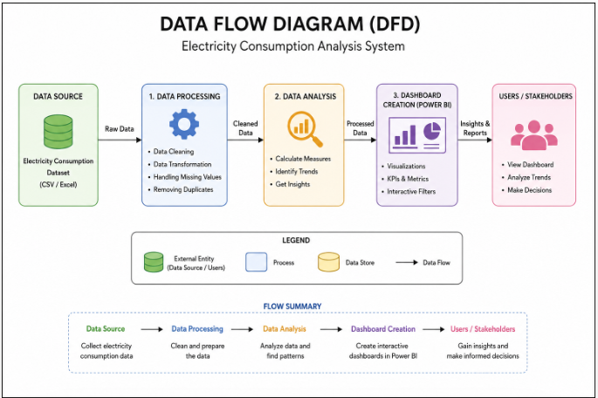

3.4 Technology Stack
Layer / Component | Technology
Database / Data Pre-processing | Microsoft SQL Server
Data Cleaning & Querying | T-SQL (Structured Query Language)
Data Visualization | Tableau
Backend / Web Framework | Flask (Python)
Programming Language | Python, SQL
Frontend (served via Flask) | HTML, CSS, embedded Tableau dashboards
Version Control | Git & GitHub

