RAPPORT TP

PAPA SAMBA THIAM & CYLIA HADDOUCHE

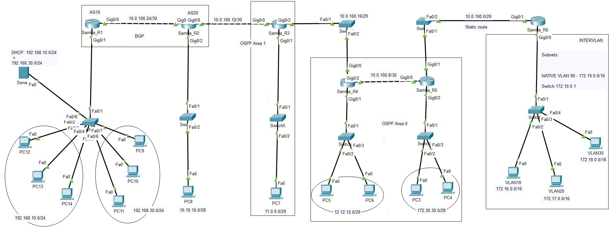

**Config de tous les routeurs:**

Samba_R1#sho run

Current configuration : 1120 bytes

!

version 15.1

hostname Samba_R1

!

ip cef

no ipv6 cef

license udi pid CISCO2911/K9 sn FTX152475QO-

!

spanning-tree mode pvst

!

interface GigabitEthernet0/0

ip address 10.0.100.26 255.255.255.252

duplex auto

speed auto

!

interface GigabitEthernet0/1

no ip address

duplex auto

speed auto

!

interface GigabitEthernet0/1.10

encapsulation dot1Q 10

ip address 192.168.10.1 255.255.255.0

ip helper-address 192.168.30.3

!

interface GigabitEthernet0/1.30

encapsulation dot1Q 30

ip address 192.168.30.1 255.255.255.0

ip helper-address 192.168.30.3

!

interface GigabitEthernet0/2

no ip address

duplex auto

speed auto

shutdown

!

interface Vlan1

no ip address

shutdown

!

router bgp 10

bgp router-id 1.1.1.1

bgp log-neighbor-changes

no synchronization

neighbor 10.0.100.25 remote-as 20

network 192.168.30.0

network 192.168.10.0

!

ip classless

ip route 172.16.0.0 255.252.0.0 10.0.100.25

!

ip flow-export version 9

!

line con 0

!

line aux 0

!

line vty 0 4

login

!

end

Samba_R1

Samba_R2#sho run

!

version 15.1

!

hostname Samba_R2

!

ip cef

no ipv6 cef

!

license udi pid CISCO2911/K9 sn FTX1524E546-

!

spanning-tree mode pvst

!

interface GigabitEthernet0/0

ip address 10.0.100.14 255.255.255.252

duplex auto

speed auto

!

interface GigabitEthernet0/1

ip address 10.0.100.25 255.255.255.252

duplex auto

speed auto

!

interface GigabitEthernet0/2

ip address 10.10.10.1 255.255.255.240

duplex auto

speed auto

!

interface Vlan1

no ip address

shutdown

!

router ospf 1

log-adjacency-changes

redistribute bgp 20 subnets

network 10.0.100.12 0.0.0.3 area 1

network 10.10.10.0 0.0.0.15 area 1

!

router bgp 20

bgp router-id 2.2.2.2

bgp log-neighbor-changes

no synchronization

neighbor 10.0.100.26 remote-as 10

network 10.10.10.0 mask 255.255.255.240

redistribute ospf 1

!

ip classless

!

ip flow-export version 9

!

!

line con 0

!

line aux 0

!

line vty 0 4

login

!

!

!

end

Samba_R2

Samba_R3#sho run

Current configuration : 879 bytes

!

version 15.1

no service password-encryption

!

hostname Samba_R3

!

ip cef

no ipv6 cef

!

license udi pid CISCO2911/K9 sn FTX1524PB8S-

!

spanning-tree mode pvst

!

interface GigabitEthernet0/0

ip address 10.0.100.13 255.255.255.252

duplex auto

speed auto

!

interface GigabitEthernet0/1

ip address 11.0.0.1 255.255.255.248

duplex auto

speed auto

!

interface GigabitEthernet0/2

ip address 10.0.100.18 255.255.255.248

duplex auto

speed auto

!

interface Vlan1

no ip address

shutdown

!

router ospf 1

log-adjacency-changes

network 10.0.100.16 0.0.0.7 area 0

network 10.0.100.12 0.0.0.3 area 1

network 11.0.0.0 0.0.0.7 area 1

!

ip classless

!

ip flow-export version 9

!

!

!

!

!

line con 0

!

line aux 0

!

line vty 0 4

login

!

!

!

end

Samba_R3

Samba_R4#sho run

Current configuration : 882 bytes

!

version 15.1

no service password-encryption

!

hostname Samba_R4

!

ip cef

no ipv6 cef

!

!

!

!

license udi pid CISCO2911/K9 sn FTX15246196-

!

spanning-tree mode pvst

!

interface GigabitEthernet0/0

ip address 10.0.100.17 255.255.255.248

duplex auto

speed auto

!

interface GigabitEthernet0/1

ip address 12.12.12.1 255.255.255.248

duplex auto

speed auto

!

interface GigabitEthernet0/2

ip address 10.0.100.10 255.255.255.252

duplex auto

speed auto

!

interface Vlan1

no ip address

shutdown

!

router ospf 1

log-adjacency-changes

network 10.0.100.8 0.0.0.3 area 0

network 12.12.12.0 0.0.0.7 area 0

network 10.0.100.16 0.0.0.7 area 0

!

ip classless

!

ip flow-export version 9

!

line con 0

!

line aux 0

!

line vty 0 4

login

!

!

!

end

Samba_R4

Samba_R5#show run

Building configuration...

!

version 15.1

no service password-encryption

!

hostname Samba_R5

!

ip cef

no ipv6 cef

!

license udi pid CISCO2911/K9 sn FTX15245RWD-

!

spanning-tree mode pvst

!

interface GigabitEthernet0/0

ip address 10.0.100.9 255.255.255.252

duplex auto

speed auto

!

interface GigabitEthernet0/1

ip address 10.0.100.2 255.255.255.248

duplex auto

speed auto

!

interface GigabitEthernet0/2

ip address 172.30.30.1 255.255.255.240

duplex auto

speed auto

!

interface Vlan1

no ip address

shutdown

!

router ospf 1

log-adjacency-changes

redistribute static subnets

network 10.0.100.8 0.0.0.3 area 0

network 172.30.30.0 0.0.0.15 area 0

network 10.0.100.0 0.0.0.7 area 0

!

ip classless

ip route 172.16.0.0 255.240.0.0 10.0.100.1

!

ip flow-export version 9

!

line con 0

!

line aux 0

!

line vty 0 4

login

!

!

!

end

Samba_R5

Samba_R6#sho run

Current configuration : 1121 bytes

!

version 15.1

no service password-encryption

!

hostname Samba_R6

!

ip cef

no ipv6 cef

!

license udi pid CISCO2911/K9 sn FTX15245QFG-

!

spanning-tree mode pvst

!

interface GigabitEthernet0/0

no ip address

duplex auto

speed auto

!

interface GigabitEthernet0/0.10

encapsulation dot1Q 10

ip address 172.16.0.1 255.255.0.0

!

interface GigabitEthernet0/0.20

encapsulation dot1Q 20

ip address 172.17.0.1 255.255.0.0

!

interface GigabitEthernet0/0.30

encapsulation dot1Q 30

ip address 172.18.0.1 255.255.0.0

!

interface GigabitEthernet0/0.99

encapsulation dot1Q 99 native

ip address 172.19.0.1 255.255.0.0

!

interface GigabitEthernet0/1

ip address 10.0.100.1 255.255.255.248

duplex auto

speed auto

!

interface GigabitEthernet0/2

no ip address

duplex auto

speed auto

shutdown

!

interface Vlan1

no ip address

shutdown

!

ip classless

ip route 0.0.0.0 0.0.0.0 GigabitEthernet0/1

!

ip flow-export version 9

!

!line con 0

!

line aux 0

!

line vty 0 4

login

!

end

Samba_R6

**Config de tous les switch**

Switch0

As part of the requirements of the exercise, no interface on the switch was left connected to VLAN 1. A new native VLAN was created, which is 99. And all ports were added to it.

Switch1

Also, an IP address was assigned to each of the switches as seen in the figures

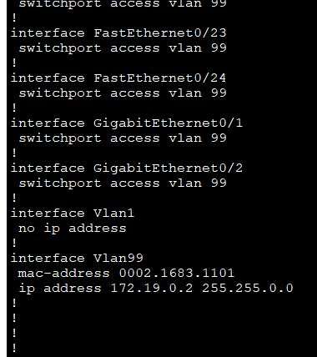

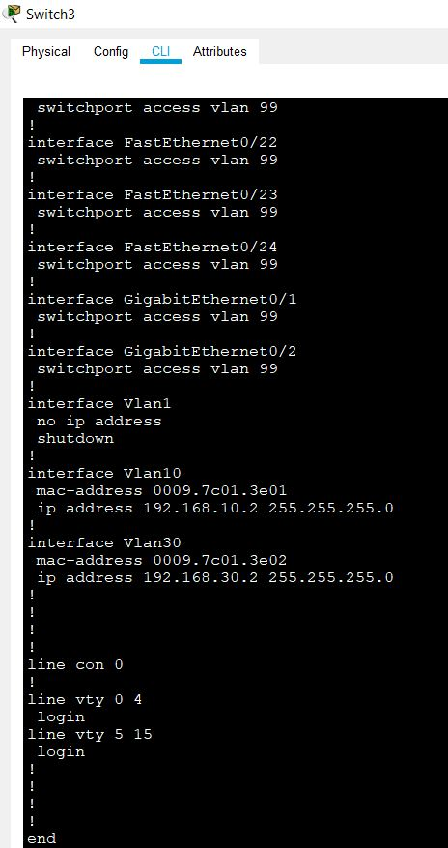

Switch3

Switch4

Switch5

Switch6

Switch7

**DHCP Server**

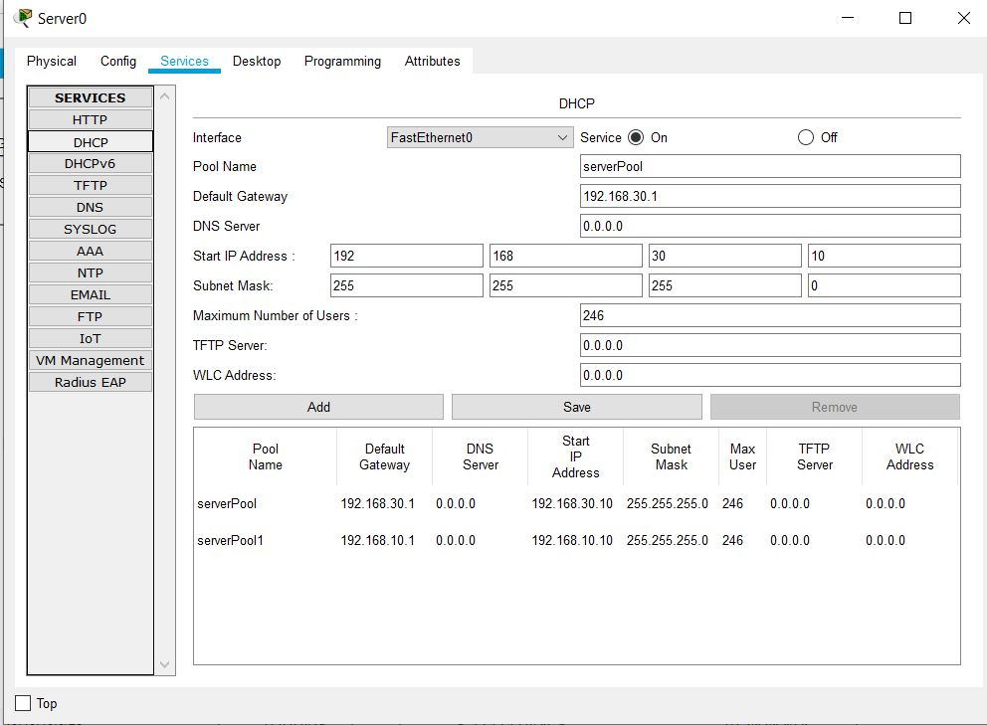

Using Ip helper address command on the router interfaces, client PCs were able to acquire IP addresses.

PC10

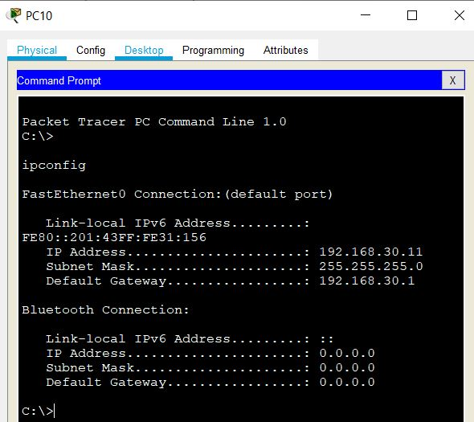

PC12

**Ping Test**

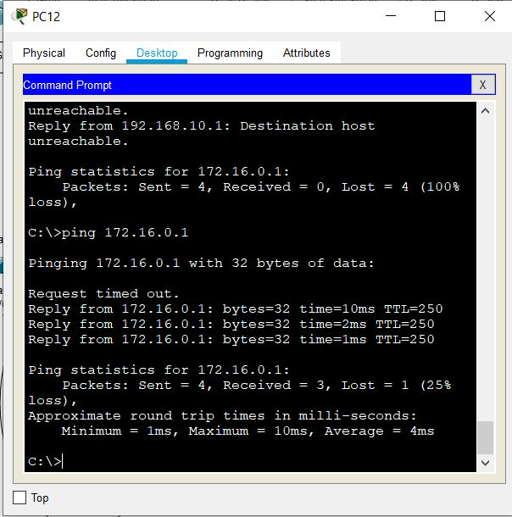

PC12 pings VLAN10

PC10 pings PC4