Installation instructions

1) Install Python Interpreter(3.8.10)

Download the python interpreter program

https://www.python.org/ftp/python/3.8.10/python-3.8.10-amd64.exe

2) Install python module

The library requires for the developed program.

At window command prompt

run: **pip install** -r **requirements**.**txt** in your shell.

You need to have the requirements.txt before you can run.

Download from my google drive drive.

https://drive.google.com/drive/folders/15X8nFwf0RVwbprkqI6ZAG24ZF9ce3nlK?usp=sharing

3)The python web server prediction python program.

caseprediction.py – the web server prediction program

predictrecords.db – a sqlite database

models – a folder contain subfolder bert_modelv1, the trained content use by the casepredicttion.py

The total file size for the above are 1.3GB (mainly the bigger file is the model)

4) Run the prediction model with webserver

At window command prompt run

Run: python casepredict.py

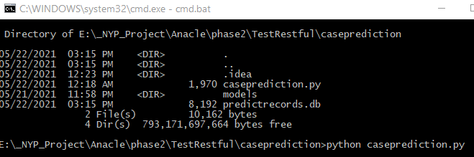

The webserver with the prediction model load successfully. It uses the local IP address. In this case for my test, it is using my computer ip address 192.168.50.86. The IP address will be depending on your server or computer or cloud you installed.

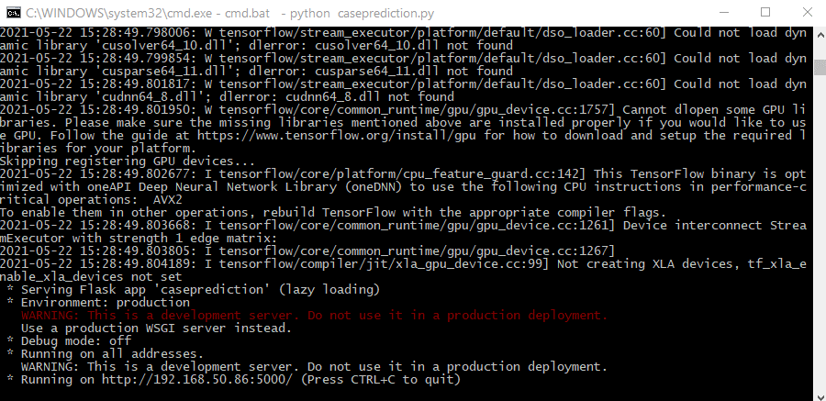

Test using the Postman application. <https://www.postman.com/>

API : <http://192.168.50.86.:5000/predict>

Request: Post

Header: Content-Type", "application/json

Parameter: application/json

{"query" : "Water found leaking at the corridor. I have report 2 weeks ago but no action\"}

Response: {"prediction": "attention", "confidence": 0.9956396818161011}

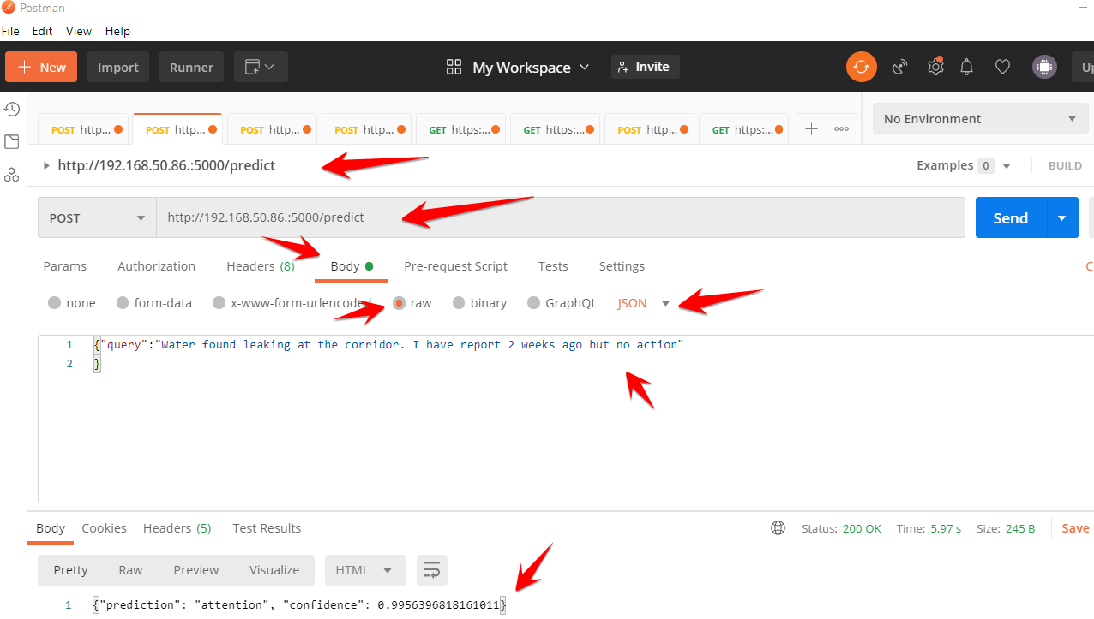

API : <http://192.168.50.86.:5000/test>

Request: Get

Response: server ok

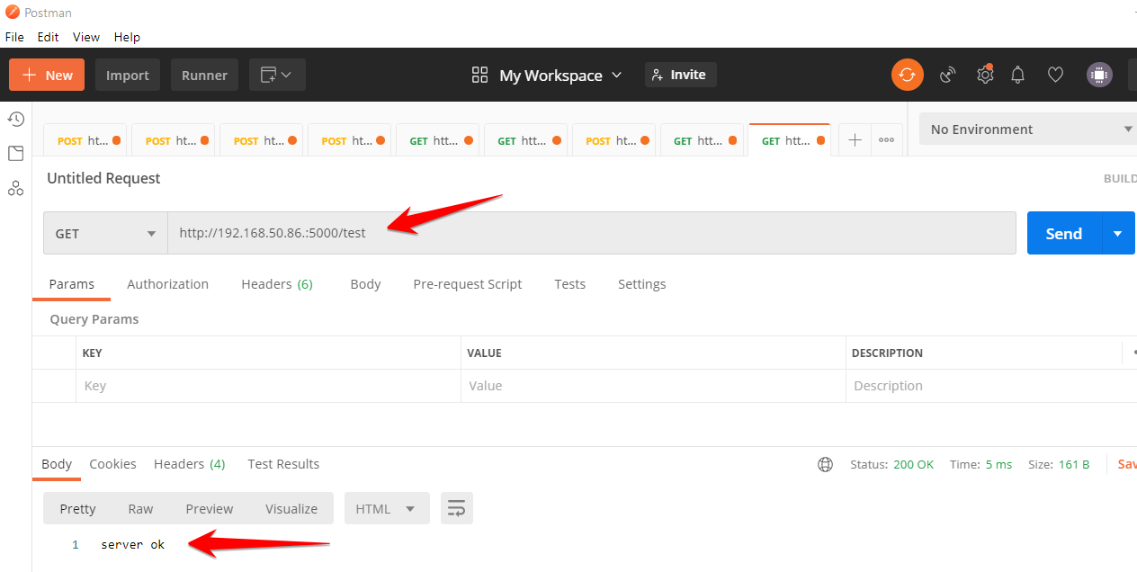

5) Client use the API

Python client

import requests

import json

#POST Test

url = 'http://192.168.50.86.:5000/predict'

myobj = {'query': 'I have my windows issue. Pls send office to check'}

json_object = json.dumps(myobj)

x = requests.post(url, json = myobj).json()

print(x['prediction'])

print(x['confidence'])

C# client

using System;

using RestSharp;

namespace csharpclient

{

    class Program

    {

        static void Main(string[] args)

        {

            var client = new RestClient("http://192.168.50.86.:5000/predict");

            client.Timeout = -1;

            var request = new RestRequest(Method.POST);

            request.AddHeader("Content-Type", "application/json");

            request.AddParameter("application/json", "{\"query\":\"Water found leaking at the corridor. I have report 2 weeks ago but no action\"\r\n}", ParameterType.RequestBody);

            IRestResponse response = client.Execute(request);

            Console.WriteLine(response.Content);

        }

    }

}