# **Practical : Webot Simulator Line follower**

# Simulator : Setup Simulator

Go to <https://cyberbotics.com/>

Download webot installation. Then install program

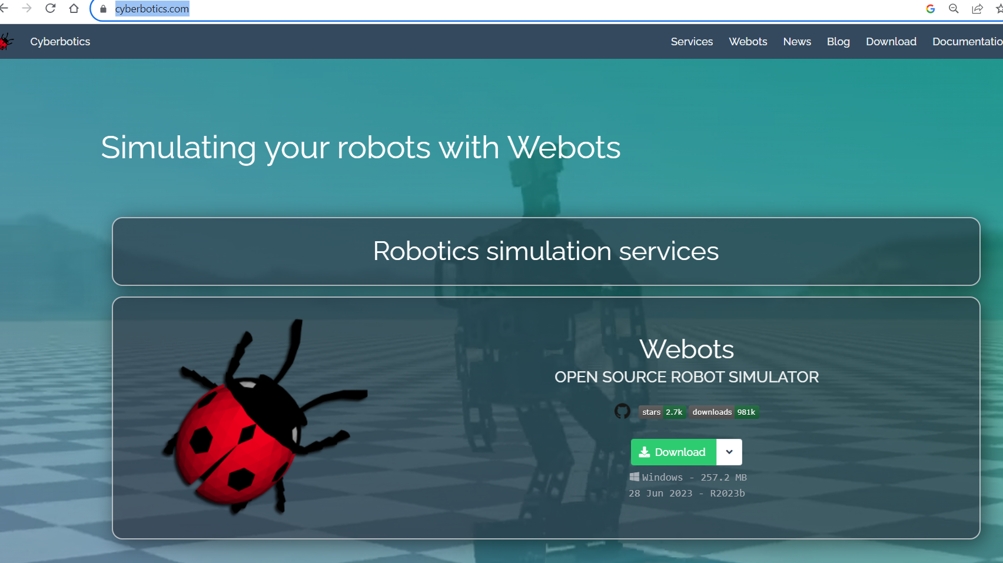

**Install Webots - Windows**

**Download the latest version of Webots (i.e. webots-R2023b_setup.exe) from the official website**

**Double click on this file**

**Follow the installation instructions**

**Manual Installation - Windows**

**Install:**

**Python(tested with python 3.11)**

**Make sure you tick "Add Python 3.X to PATH"**

**pip3 install -r requirements.txt**

**Set the required environment variables**

**Click the "Windows Key" and write "Edit the system environment variables"**

**Create variable “WEBOTS_HOME” with content “C:\Program Files\Webots”**

**Create variable “PYTHONPATH” with content “%WEBOTS_HOME%/lib/controller/python”**

**Add to “PATH”**

**“%WEBOTS_HOME%\lib\controller”**

**“%WEBOTS_HOME%\msys64\mingw64\bin”**

**“%WEBOTS_HOME%\msys64\mingw64\bin\cpp”**

**Create variable “PYTHONIOENCODING” with content “UTF-8”**