Q&M AI-Powered Enquiry & Enrollment System
Business Workflow & Data Schema Documentation

System: WhatsApp-based Agentic AI Backend (Python CrewAI + FastAPI + PostgreSQL)
Scope: Data schema and end-to-end business workflows implemented in backend/app

1. Introduction & Scope
This document records the business-facing data schema and workflow design of the Q&M Dental Group WhatsApp enquiry-to-enrollment-to-payment system. The system is implemented as a Python CrewAI agentic backend with three specialised agent modules (A, B, C) sitting behind a single WhatsApp conversation, backed by a PostgreSQL 16 database.
Section 2 documents every database table and field with its business purpose. Section 3 documents every business workflow, grouped by owning module, including a data-flow diagram, the actors involved, the data exchanged (mapped to exact table.field names), the process flow, and the database tables touched.
Module summary:
- Module A: Enquiry & Lead Nurturing — FAQs, fees, schedules, lead capture, staff escalation.
- Module B: Enrollment, Invoice & Payment Pipeline — validate, enroll, invoice, status.
- Module C: Payment Verification & Accounts — vision-verifies payment proofs, receipts, credit notes, accounts reporting.

2. Data Schema
PostgreSQL 16, 9 business tables plus 3 document-numbering sequences. All business logic reads/writes exclusively through backend/app/repositories.py — no other module issues SQL directly.

2.1 customers
Purpose: Central identity and verification store. Every WhatsApp sender gets exactly one row, keyed by the stable whatsapp_id. This is the authoritative reference used by all modules and the registration gate.
Field | Type | Purpose
id | SERIAL PK | Internal surrogate key.
whatsapp_id | TEXT, unique | Stable WhatsApp JID (e.g. 6591234567@c.us or 153811586920512@lid). The only reliable identifier present on every inbound message; used as the primary partition key for multi-user isolation.
phone | TEXT, unique when set | Real E.164 phone number. Auto-filled for @c.us accounts; supplied by the user for @lid accounts.
phone_confirmed | BOOLEAN | TRUE once the phone number is trusted (auto-resolved or user-confirmed). Gates access to Modules A/B/C.
display_name | TEXT | WhatsApp notify-name, refreshed on every contact.
full_name | TEXT | Legal name captured during registration.
nric | TEXT | NRIC/FIN captured during registration.
email | TEXT | Contact email captured during registration.
preferred_course | TEXT | Course of interest, if volunteered during enquiry.
status | TEXT (enum) | Lifecycle state: new / enquiry / awaiting_response / enrolled / escalated / closed.
follow_up_count | INTEGER | Number of automated nurture follow-ups already sent (drives the 24h/72h/7d cadence).
last_contact_at | TIMESTAMPTZ | Timestamp of the last contact; used to compute follow-up due dates.
escalated | BOOLEAN | TRUE while an open staff escalation exists for this customer.
escalation_reason | TEXT | Reason text for the current/last escalation.
created_at / updated_at | TIMESTAMPTZ | Row audit timestamps.

2.2 leads (legacy alias)
Purpose: Deprecated table superseded by customers, but still actively written by Module A's lead-capture and staff-escalation tools for backward compatibility. New identity data should be read from customers; this table records enquiry-stage details volunteered mid-conversation.
Field | Type | Purpose
id | SERIAL PK | Internal surrogate key.
phone | TEXT, unique | Contact phone number (legacy identity key).
whatsapp_id | TEXT, unique | WhatsApp JID, mirrored from customers where available.
phone_confirmed | BOOLEAN | Legacy confirmation flag.
name / nric / dob / email | TEXT / DATE | Contact details volunteered during enquiry.
preferred_course / course_date | TEXT | Course and intake the prospect expressed interest in.
status | TEXT (enum) | enquiry / awaiting_response / enrolled / escalated / closed.
follow_up_count / last_contact_at | INTEGER / TIMESTAMPTZ | Legacy nurture-cadence tracking (superseded by customers for scheduling).
escalated / escalation_reason | BOOLEAN / TEXT | Legacy escalation flag and reason.
created_at / updated_at | TIMESTAMPTZ | Row audit timestamps.

2.3 courses
Purpose: Master catalogue of training courses offered. Source of truth for Module A's fee/enquiry answers and Module B's fee computation at enrollment.
Field | Type | Purpose
id | SERIAL PK | Internal surrogate key.
code | TEXT, unique | Internal course code (e.g. DACERT, INFCTRL).
course_id | TEXT | Short display code shown to participants (e.g. C2601).
name | TEXT | Course name shown in all participant-facing text.
full_fee | NUMERIC(10,2) | Full course fee before subsidy.
sf_subsidy_cap | NUMERIC(10,2) | Maximum SkillsFuture Credit subsidy applicable.
description / learning_outcomes / entry_requirements / job_pathways | TEXT | FAQ content used by Module A to answer enquiries without inventing facts.
active | BOOLEAN | Whether the course is currently offered/listed.
created_at | TIMESTAMPTZ | Row audit timestamp.

2.4 course_schedules
Purpose: Intake dates per course, with live seat capacity. Seats are adjusted automatically as enrollments are created (Module B) or cancelled (Module C), never edited directly.
Field | Type | Purpose
id | SERIAL PK | Internal surrogate key.
course_id | INTEGER FK → courses.id | Parent course.
schedule_id | TEXT | Short display code shown to participants (e.g. SH2601).
label | TEXT | Human-readable intake description (dates/session).
start_date / end_date | DATE | Intake date range.
seats | INTEGER | Total seats available for this intake.
seats_taken | INTEGER | Seats currently committed; +1 on enrollment, -1 on cancellation.
active | BOOLEAN | Whether this intake is currently offered.

2.5 enrollments
Purpose: Module B's enrollment pipeline record — one row per enrollment, tracking the participant's course, fee breakdown, and status from enquiry through receipt_issued or cancelled.
Field | Type | Purpose
id | SERIAL PK | Internal surrogate key.
whatsapp_id / phone | TEXT | Owning participant (FK to customers.whatsapp_id by convention; phone denormalised for human reference).
course_id | INTEGER FK → courses.id | Enrolled course.
course_name / course_date | TEXT | Denormalised course name and intake label for fast display.
schedule_id | INTEGER FK → course_schedules.id | Specific intake reserved.
full_name / nric / email | TEXT | Participant details captured at enrollment (may differ from customers if entered fresh).
fee | NUMERIC(10,2) | Full course fee at time of enrollment.
sf_subsidy | NUMERIC(10,2) | SkillsFuture subsidy applied.
net_payable | NUMERIC(10,2) | Fee minus subsidy — amount the participant must pay via PayNow.
invoice_no | TEXT, unique | Generated invoice number (from invoice_seq).
receipt_no | TEXT, unique | Set once the enrollment is fully paid and receipted.
status | TEXT (enum) | State machine: enquiry / enrolled / invoice_sent / awaiting_payment / paid / receipt_issued / cancelled.
created_at / updated_at | TIMESTAMPTZ | Row audit timestamps.

2.6 payments
Purpose: Module C's payment verification ledger. One row per payment proof screenshot submitted; an invoice may need more than one proof (a SkillsFuture claim and/or a PayNow transfer), so completion is decided by summing all confirmed rows against the invoice fee.
Field | Type | Purpose
id | SERIAL PK | Internal surrogate key.
enrollment_id | INTEGER FK → enrollments.id | Invoice this proof applies to.
invoice_no | TEXT | Denormalised from enrollments for quick lookup.
whatsapp_id / phone | TEXT | Submitting participant.
payment_type | TEXT (enum) | paynow or skillsfuture_claim.
expected_amount | NUMERIC(10,2) | Outstanding balance for this payment type at time of submission.
detected_amount | NUMERIC(10,2) | Amount extracted from the screenshot by the vision LLM.
reference | TEXT | Transaction/claim reference number extracted from the screenshot.
paid_at_text | TEXT | Date/time text as shown on the screenshot.
verdict | TEXT (enum) | pending / confirmed / mismatch / unreadable — the verification outcome.
confidence | NUMERIC(4,3) | Vision model's confidence score (0–1) in the extraction.
raw_extract | JSONB | Full raw JSON returned by the vision model, kept for audit.
notes | TEXT | Human-readable explanation of the verdict.
receipt_no | TEXT | Receipt number issued once this specific proof is confirmed.
created_at | TIMESTAMPTZ | Row audit timestamp.

2.7 chat_memory
Purpose: Per-user conversation history, keyed by whatsapp_id. Read by every agent (Router, Module A/B/C) to resolve multi-turn context such as pronoun references or bare confirmations ("yes", "intake 2").
Field | Type | Purpose
id | SERIAL PK | Internal surrogate key.
whatsapp_id | TEXT | Owning participant.
role | TEXT (enum) | user or assistant — which side of the conversation this turn came from.
content | TEXT | The message text.
created_at | TIMESTAMPTZ | Turn timestamp, used to order the recent-history window.

2.8 staff_queue
Purpose: Escalation inbox for items needing human review — raised by Module A (unclear/sensitive enquiries) or Module C (payment mismatches). Resolved by staff via the Admin Dashboard.
Field | Type | Purpose
id | SERIAL PK | Internal surrogate key.
whatsapp_id / phone | TEXT | Participant the escalation concerns.
reason | TEXT | Short escalation reason code (e.g. payment_mismatch).
message | TEXT | Full context message for the staff reviewer.
module | TEXT | Originating module: A, B, or C.
payload | JSONB | Structured supporting data (e.g. the raw vision extraction for a payment mismatch).
status | TEXT (enum) | open or resolved.
created_at | TIMESTAMPTZ | Escalation timestamp.

2.9 credit_notes
Purpose: Cancellation/refund workflow records. Requested by Module C when an enrollment is cancelled, approved by an accountant via the Admin/Accountant Portal.
Field | Type | Purpose
id | SERIAL PK | Internal surrogate key.
enrollment_id | INTEGER FK → enrollments.id | Cancelled enrollment this credit note covers.
credit_note_no | TEXT, unique | Generated credit note number (from credit_note_seq).
reason | TEXT | Cancellation reason.
amount | NUMERIC(10,2) | Total confirmed amount paid to date, refunded/credited.
status | TEXT (enum) | requested / approved / rejected.
created_at / resolved_at | TIMESTAMPTZ | Request and approval/rejection timestamps.

2.10 Document number sequences
Three PostgreSQL sequences support document numbering, not business tables in themselves: invoice_seq (starts at 847) generates enrollments.invoice_no; receipt_seq (starts at 847) generates payments.receipt_no; credit_note_seq (starts at 1) generates credit_notes.credit_note_no.

3. Business Workflows
Thirteen business workflows are implemented, grouped below by the CrewAI module that owns them. Each workflow includes a data-flow diagram, its purpose, the actors (entities) that interact in it, the data exchanged mapped to exact database table.field names, the process flow, and the database tables it touches.

Module A — Enquiry & Lead Nurturing

3.1 Customer Registration (Onboarding Gate)
Module A — Enquiry & Lead Nurturing
Purpose: Verify the identity (phone, full name, NRIC, email) of every first-time WhatsApp sender before any enquiry, enrollment, or payment activity is allowed, ensuring one authoritative record exists per person regardless of WhatsApp account type (@c.us or @lid).
Workflow Diagram
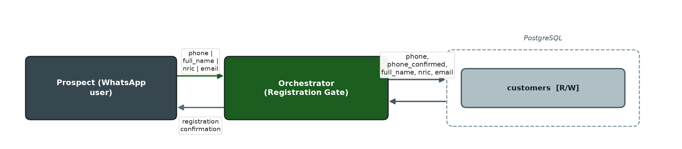

Entities (Actors)
Actor / Entity | Role in this Workflow
Prospect (WhatsApp user) | Sends the initial message and the registration reply.
Orchestrator (system gate) | Runs before any module; parses the registration reply and enforces the gate on every inbound message.
WhatsApp Gateway | Delivers inbound messages and the registration prompt/confirmation reply.

Process Flow
- Prospect sends any first message; the orchestrator creates/looks up their customers row by whatsapp_id.
- If phone, full_name, nric, and email are not all set, the orchestrator replies with the registration prompt.
- Prospect replies in "phone | full name | NRIC | email" format (or a 3-field shortcut if phone is already auto-confirmed on @c.us).
- Orchestrator validates the format and phone uniqueness, saves the record, and sends a confirmation inviting the next step (course enquiry, funding, or enrollment).
- Only once registered does the message proceed to the Intent Router and Module A/B/C.

Data Interaction (Database Fields)
Database Field | Read / Write | Description
customers.whatsapp_id | READ/WRITE | Stable identity key; row is created on first contact.
customers.phone | WRITE | Parsed from the registration reply or auto-resolved from the gateway for @c.us accounts.
customers.phone_confirmed | WRITE | Set TRUE once the phone is validated/trusted.
customers.full_name | WRITE | Parsed from the registration reply.
customers.nric | WRITE | Parsed from the registration reply.
customers.email | WRITE | Parsed from the registration reply, validated for '@'.
customers.display_name | WRITE | Refreshed from the WhatsApp notify-name on every contact.
customers.updated_at | WRITE | Bumped on every save.

Related Database Tables: customers
Note: Implemented in the shared orchestrator (backend/app/orchestrator.py) rather than inside a CrewAI agent, since it gates access to all three modules equally. Classified under Module A because it is the entry point into the enquiry/nurturing conversation that follows.

3.2 Course Enquiry & FAQ
Module A — Enquiry & Lead Nurturing
Purpose: Answer a prospect's questions about courses, fees, SkillsFuture funding, and intake schedules using only the course catalogue as the source of truth — never inventing fees, dates, or funding amounts.
Workflow Diagram
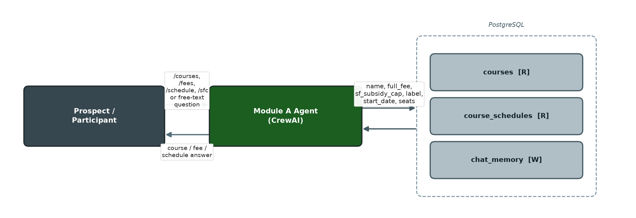

Entities (Actors)
Actor / Entity | Role in this Workflow
Prospect / Participant | Asks free-text or /command questions (e.g. /courses, /fees, /schedule, /sfc).
Module A Agent (CrewAI) | Reasons over free text and calls catalogue tools to answer.
OpenAI LLM | Powers the conversational agent for free-text messages (deterministic /commands bypass it).

Data Interaction (Database Fields)
Database Field | Read / Write | Description
courses.name / full_fee / sf_subsidy_cap | READ | Course identity and fee facts returned verbatim in replies.
courses.description / learning_outcomes / entry_requirements / job_pathways | READ | FAQ knowledge base content.
courses.active | READ | Filters to currently offered courses.
course_schedules.label / start_date / end_date / seats / seats_taken | READ | Intake options shown for a course.
chat_memory.content | WRITE | Each user/assistant turn is persisted after the reply.

Related Database Tables: courses, course_schedules, chat_memory

3.3 Lead Capture
Module A — Enquiry & Lead Nurturing
Purpose: Persist contact and course-interest details a prospect volunteers mid-conversation, even before they formally enroll, so no interest is lost.
Workflow Diagram
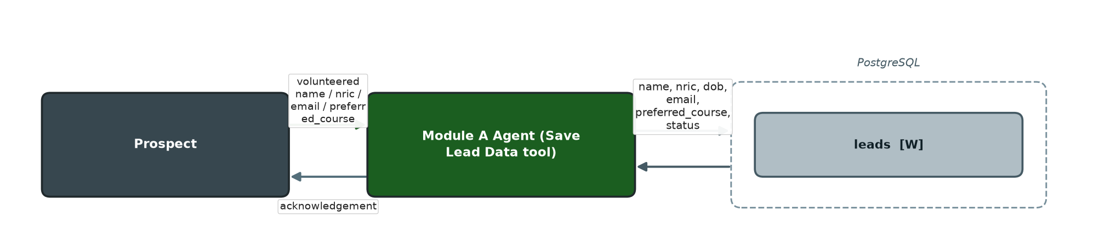

Entities (Actors)
Actor / Entity | Role in this Workflow
Prospect | Volunteers name/NRIC/email/preferred-course details in free text.
Module A Agent (Save Lead Data tool) | Detects volunteered details and persists them.

Data Interaction (Database Fields)
Database Field | Read / Write | Description
leads.name / nric / dob / email | WRITE | Contact details volunteered by the prospect.
leads.preferred_course / course_date | WRITE | Course/intake interest expressed.
leads.status | WRITE | Advanced from enquiry to awaiting_response once captured.
leads.last_contact_at / updated_at | WRITE | Bumped on capture.

Related Database Tables: leads
Note: Lead capture currently persists to the legacy leads table (services/leads.py: save_lead()); primary identity for the same person also lives in customers.

3.4 Staff Escalation — Enquiry
Module A — Enquiry & Lead Nurturing
Purpose: Route an enquiry the AI cannot confidently or safely answer to a human staff member, and allow staff to resolve it.
Workflow Diagram
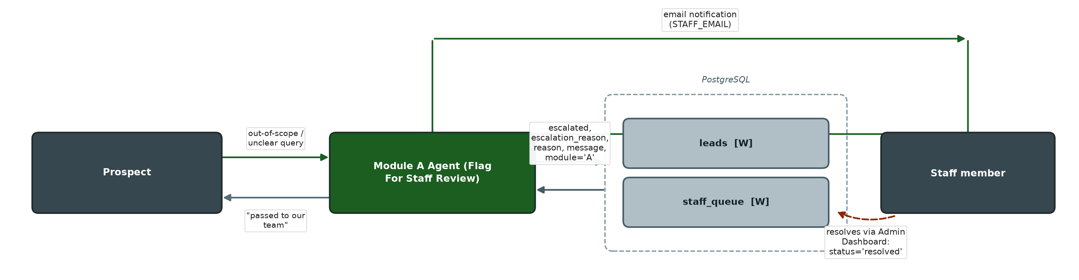

Entities (Actors)
Actor / Entity | Role in this Workflow
Prospect | Raises a query that is out of scope or ambiguous.
Module A Agent (Flag For Staff Review tool) | Decides to escalate and raises the task.
Staff member | Receives an email notification and resolves the item via the Admin Dashboard.

Process Flow
- Module A agent judges a query is out of scope or it isn't confident in the answer.
- It calls Flag For Staff Review with a reason and message.
- The lead's escalation state is updated and a staff_queue task is created.
- An email notification is sent to STAFF_EMAIL.
- Staff review and resolve the item via the Admin Dashboard (/admin/staff-queue).

Data Interaction (Database Fields)
Database Field | Read / Write | Description
leads.escalated | WRITE | Set TRUE.
leads.escalation_reason | WRITE | Reason for escalation.
leads.status | WRITE | Set to escalated.
staff_queue.whatsapp_id / phone | WRITE | Identifies the prospect.
staff_queue.reason / message | WRITE | Escalation reason and full context for the reviewer.
staff_queue.module | WRITE | Recorded as 'A'.
staff_queue.status | WRITE | Created as open; updated to resolved by staff via the Admin Dashboard.

Related Database Tables: leads, staff_queue

3.5 Automated Lead Follow-up
Module A — Enquiry & Lead Nurturing
Purpose: Nudge non-responsive prospects at 24-hour, 72-hour, and 7-day intervals to reduce drop-off between enquiry and enrollment, stopping after three follow-ups.
Workflow Diagram
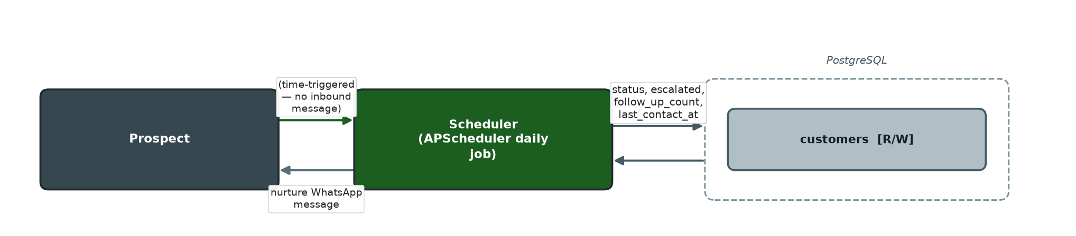

Entities (Actors)
Actor / Entity | Role in this Workflow
Scheduler (APScheduler background job) | Runs daily at a configured hour (SGT) and selects due customers.
Prospect | Receives the nurture message on WhatsApp.
WhatsApp Gateway | Delivers the outbound follow-up message.

Process Flow
- Scheduler queries customers whose status is enquiry/awaiting_response, not escalated, and past their next follow-up threshold.
- For each due customer, a follow-up message is chosen based on follow_up_count (0/1/2 → 24h/72h/7d message).
- Message is sent via the WhatsApp gateway using whatsapp_id.
- customers.follow_up_count is incremented and last_contact_at refreshed.

Data Interaction (Database Fields)
Database Field | Read / Write | Description
customers.status / escalated / follow_up_count / last_contact_at | READ | Determines which customers are due and which message variant to send.
customers.whatsapp_id / phone | READ | Routing target for the outbound message.
customers.follow_up_count | WRITE | Incremented by 1 after sending.
customers.last_contact_at / updated_at | WRITE | Refreshed after sending.

Related Database Tables: customers

Module B — Enrollment, Invoice & Payment Pipeline

3.6 Course Enrollment & Invoicing
Module B — Enrollment, Invoice & Payment Pipeline
Purpose: Validate a participant's enrollment details, reserve an intake seat, compute the fee/SkillsFuture subsidy/net payable breakdown, and issue an invoice (PDF + PayNow QR) by email.
Workflow Diagram
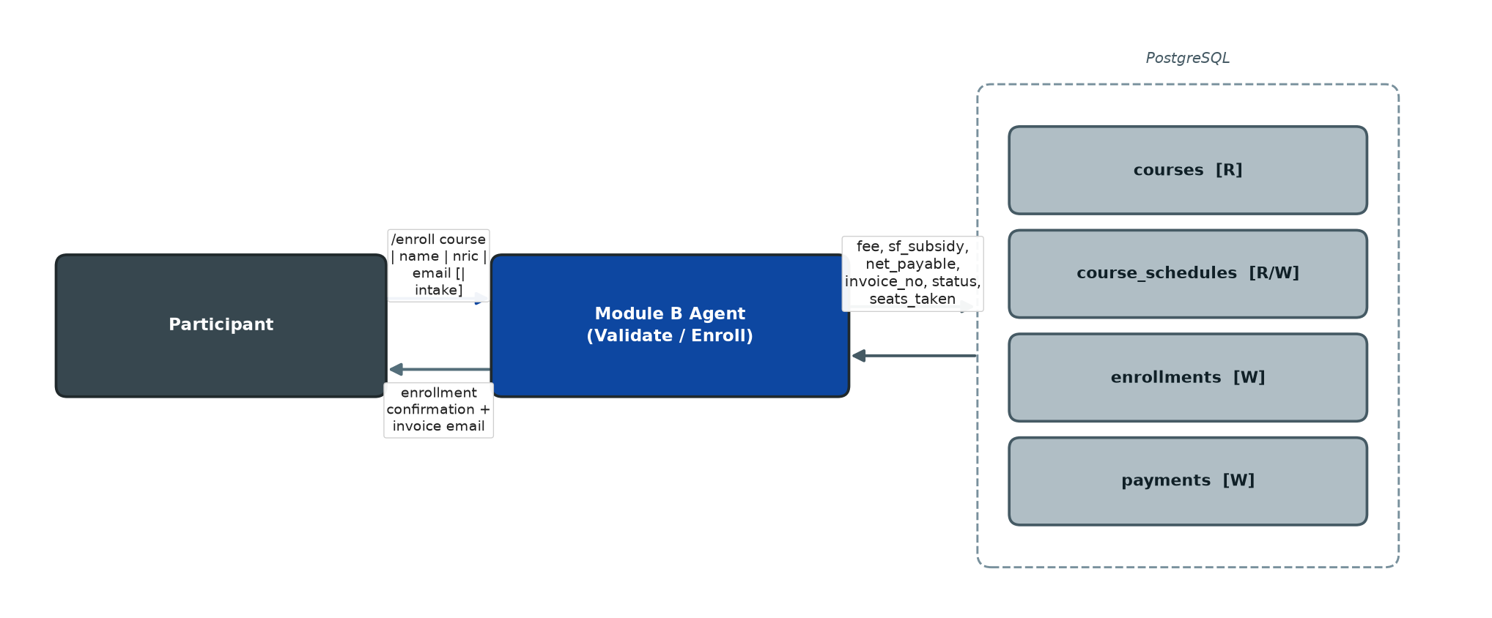

Entities (Actors)
Actor / Entity | Role in this Workflow
Participant | Provides course, name, NRIC, email, and optionally a chosen intake.
Module B Agent (Validate Enrollment / Enroll Participant tools) | Resolves the course/intake, validates fields, and commits the enrollment.
Course/Schedule catalogue | Supplies fee and seat-availability facts.

Process Flow
- Participant states a course (and optionally an intake) to enroll in, with name/NRIC/email.
- Agent validates fields and resolves the course via Validate Enrollment; if the intake is not yet known, it shows options and stops (never enrolls without a confirmed intake).
- Once course and intake are established, Enroll Participant checks for an existing active enrollment, then computes fee/subsidy/net payable.
- A new enrollments row is created with status='enrolled'; course_schedules.seats_taken is incremented.
- customers.status (and legacy leads.status, if present) is advanced to enrolled.
- An invoice PDF is generated and emailed; enrollments.status advances to invoice_sent.
- A placeholder payments row (verdict='pending', expected_amount = full fee) is created for Module C to update once payment proof arrives.

Data Interaction (Database Fields)
Database Field | Read / Write | Description
courses.full_fee / sf_subsidy_cap | READ | Basis for the fee computation.
course_schedules.seats / seats_taken / label | READ/WRITE | Availability check; seats_taken incremented on success.
enrollments.whatsapp_id / phone / course_id / course_name / course_date / schedule_id | WRITE | Identifies the participant and the chosen course/intake.
enrollments.full_name / nric / email | WRITE | Participant details captured at enrollment.
enrollments.fee / sf_subsidy / net_payable | WRITE | Computed fee breakdown.
enrollments.invoice_no | WRITE | Generated from invoice_seq.
enrollments.status | WRITE | enrolled → invoice_sent.
payments (new row) | WRITE | Placeholder ledger row, verdict='pending', expected_amount=fee.
customers.status | WRITE | Set to enrolled.
leads.status | WRITE | Set to enrolled, if a legacy leads row exists for the phone.

Related Database Tables: courses, course_schedules, enrollments, payments, customers, leads

3.7 Enrollment Status & Invoice Resend
Module B — Enrollment, Invoice & Payment Pipeline
Purpose: Let a participant check the status of their latest enrollment or every enrollment on record, or get a forgotten invoice re-sent, without staff involvement.
Workflow Diagram
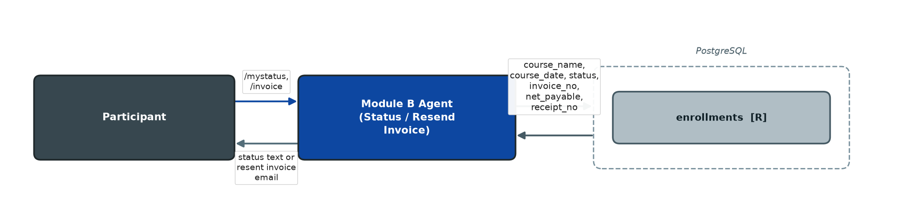

Entities (Actors)
Actor / Entity | Role in this Workflow
Participant | Requests status (/mystatus) or invoice resend (/invoice).
Module B Agent (Enrollment Status / My Enrollments / Resend Invoice tools) | Looks up and returns enrollment records.

Data Interaction (Database Fields)
Database Field | Read / Write | Description
enrollments.course_name / course_date | READ | Displayed to the participant.
enrollments.status | READ | Mapped to a human-readable status label.
enrollments.invoice_no / net_payable | READ | Shown when an invoice exists; used to regenerate/resend the invoice PDF.
enrollments.receipt_no | READ | Shown once payment is complete.
enrollments.email | READ | Delivery address for a resent invoice.

Related Database Tables: enrollments

Module C — Payment Verification & Accounts

3.8 Payment Submission & AI Verification
Module C — Payment Verification & Accounts
Purpose: Accept a PayNow or SkillsFuture-claim screenshot, extract the amount and proof type using a vision LLM, and validate it against the invoice's outstanding balance for that specific payment type.
Workflow Diagram
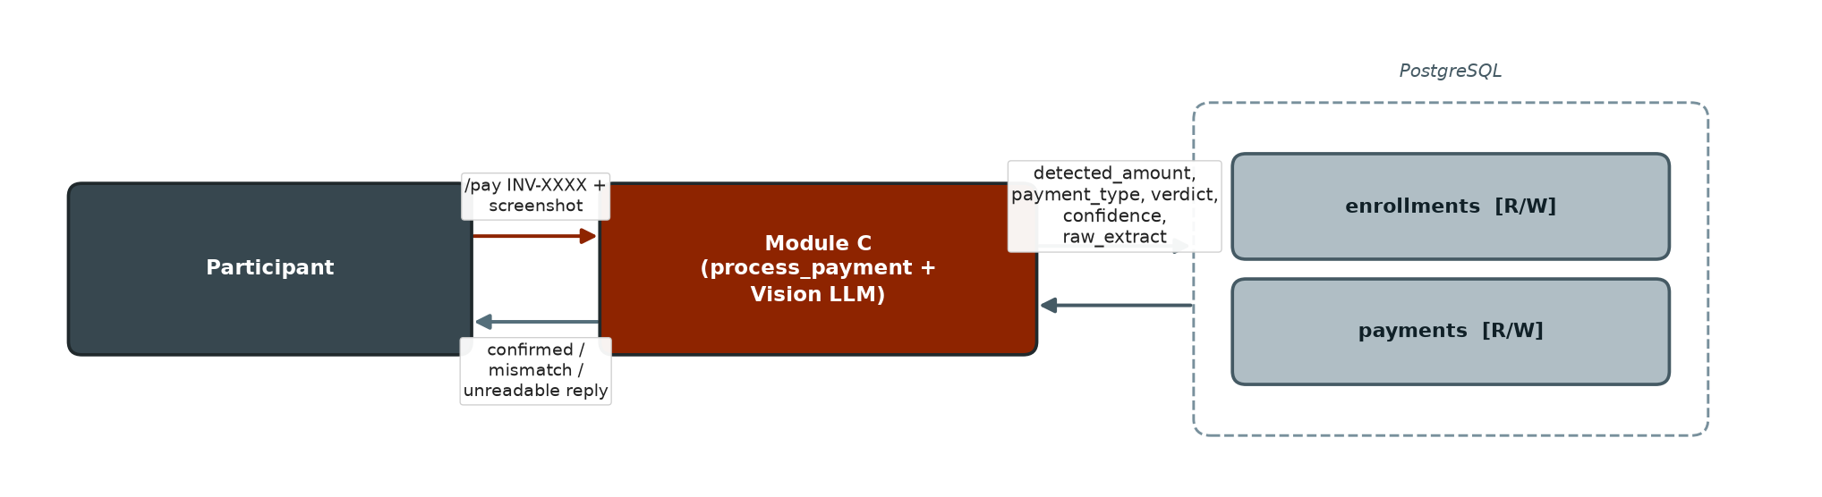

Entities (Actors)
Actor / Entity | Role in this Workflow
Participant | Sends /pay with a screenshot attached.
Module C (process_payment — deterministic path) | Runs whenever an image is attached; the CrewAI agent only handles payment talk with no image.
OpenAI Vision LLM | Extracts amount, payment type, reference, and confidence from the screenshot.

Process Flow
- Participant sends /pay INV-XXXX with a screenshot (or the system infers their latest outstanding invoice).
- System looks up the enrollment by invoice_no and confirms it belongs to the sender and is not already fully paid.
- Vision LLM extracts is_payment_proof, payment_type, detected_amount, reference, confidence from the image.
- Remaining balance per payment type is computed from all previously confirmed payments rows.
- A verdict (confirmed / mismatch / unreadable) is decided by comparing the detected amount, type, and confidence against the remaining balance and the auto-confirm threshold.
- The invoice's pending placeholder payments row is updated in place for the first proof; subsequent proofs (a second type, or a retry) insert a new row.

Data Interaction (Database Fields)
Database Field | Read / Write | Description
enrollments.status | READ/WRITE | Confirms eligibility to pay; advances invoice_sent → awaiting_payment.
enrollments.whatsapp_id / phone / sf_subsidy / net_payable / fee | READ | Ownership check and balance computation basis.
payments (confirmed rows).detected_amount / payment_type | READ | Sums already-settled amounts per type.
payments.payment_type / detected_amount / reference / paid_at_text | WRITE | Facts extracted from the screenshot.
payments.verdict / confidence / raw_extract / notes | WRITE | Verification outcome and audit trail.
payments.expected_amount | WRITE | Outstanding balance for this proof's type at submission time.

Related Database Tables: enrollments, payments

3.9 Payment Mismatch Escalation
Module C — Payment Verification & Accounts
Purpose: Route a payment screenshot that fails auto-verification (amount mismatch, low confidence, or unreadable) to staff for manual review, so the money path never depends solely on automated judgement.
Workflow Diagram
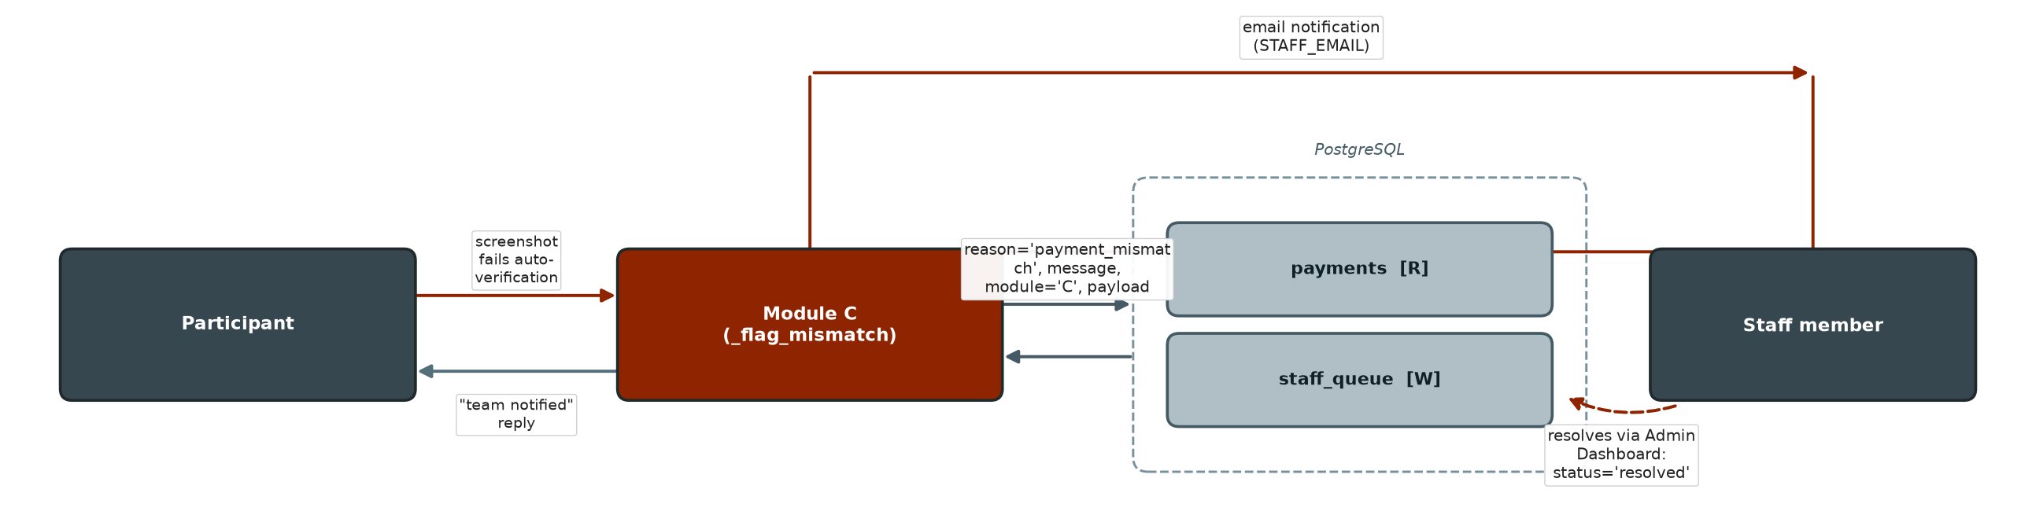

Entities (Actors)
Actor / Entity | Role in this Workflow
Participant | Submitted the screenshot that could not be auto-confirmed.
Module C (_flag_mismatch) | Raises the escalation and notifies staff.
Staff member | Receives an email notification and resolves the item via the Admin Dashboard.

Data Interaction (Database Fields)
Database Field | Read / Write | Description
staff_queue.whatsapp_id / phone | WRITE | Identifies the participant.
staff_queue.reason | WRITE | Recorded as payment_mismatch.
staff_queue.message | WRITE | Includes invoice number, detected amount, type, and confidence.
staff_queue.module | WRITE | Recorded as 'C'.
staff_queue.payload | WRITE | Raw vision-extraction JSON for auditability.
staff_queue.status | WRITE | Created as open; updated to resolved by staff via the Admin Dashboard.

Related Database Tables: staff_queue, payments

3.10 Receipt Issuance & Resend
Module C — Payment Verification & Accounts
Purpose: Issue a receipt for each individually confirmed payment proof, and allow the participant to have all receipts for an enrollment re-sent on request.
Workflow Diagram
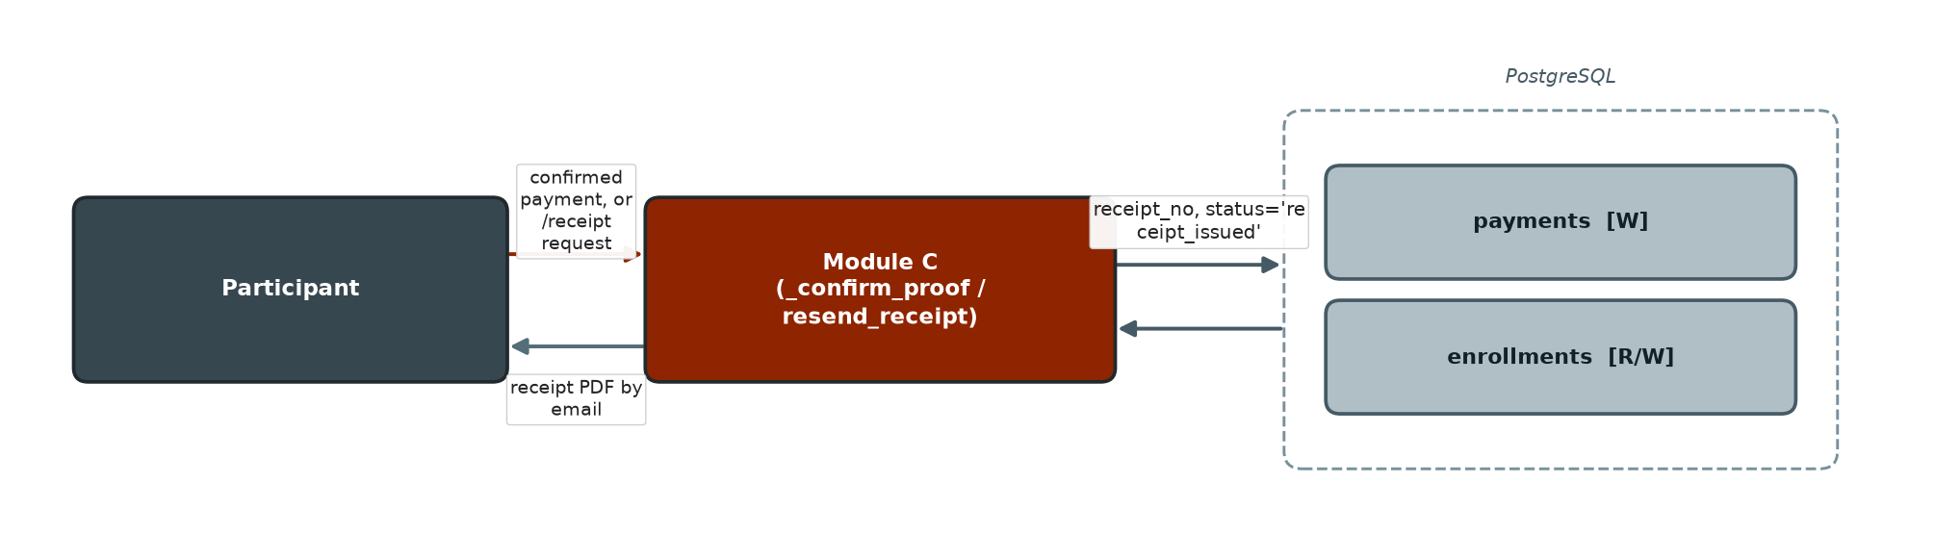

Entities (Actors)
Actor / Entity | Role in this Workflow
Participant | Receives receipts by email automatically, or requests a resend via /receipt.
Module C (_confirm_proof / resend_receipt) | Generates the receipt PDF and sends it.

Process Flow
- On a confirmed verdict, a receipt number is generated and attached to that payments row.
- A receipt PDF is generated and emailed to the participant.
- All confirmed payments for the enrollment are summed against the full fee; if fully settled, the enrollment is marked receipt_issued.
- If a balance remains, the reply itemises what proof type is still needed.

Data Interaction (Database Fields)
Database Field | Read / Write | Description
payments.receipt_no | WRITE | Generated from receipt_seq for this confirmed proof.
enrollments.status | WRITE | Advanced to receipt_issued once the full fee is reconciled.
enrollments.receipt_no | WRITE | Set on final settlement.
enrollments.full_name / course_name / course_date / email | READ | Used to render and address the receipt PDF/email.

Related Database Tables: payments, enrollments

3.11 Payment Balance Inquiry
Module C — Payment Verification & Accounts
Purpose: Give a participant an itemised breakdown of what is still owed — SkillsFuture portion, PayNow portion, or both — at any point before the invoice is fully settled.
Workflow Diagram
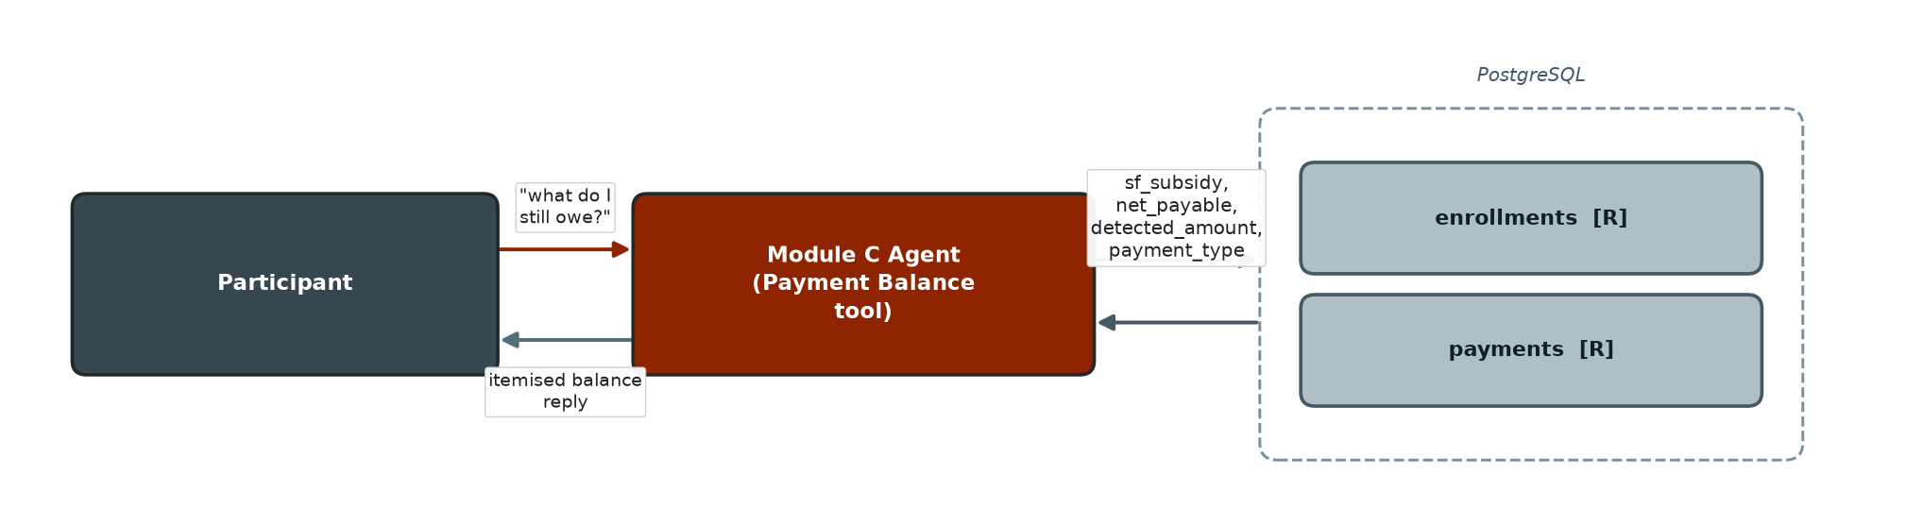

Entities (Actors)
Actor / Entity | Role in this Workflow
Participant | Asks what they still owe (/pay or free text, or Payment Balance tool).
Module C Agent (Payment Balance tool) | Computes and returns the itemised remainder.

Data Interaction (Database Fields)
Database Field | Read / Write | Description
enrollments.sf_subsidy / net_payable / status | READ | Total amounts owed per type and whether already fully paid.
payments (confirmed rows).detected_amount / payment_type | READ | Amounts already settled per type, subtracted from the totals.

Related Database Tables: enrollments, payments

3.12 Credit Note / Cancellation
Module C — Payment Verification & Accounts
Purpose: Process an enrollment cancellation: issue a credit note request, release the reserved intake seat immediately, and route the request to an accountant for approval before the credit note is issued to the participant.
Workflow Diagram
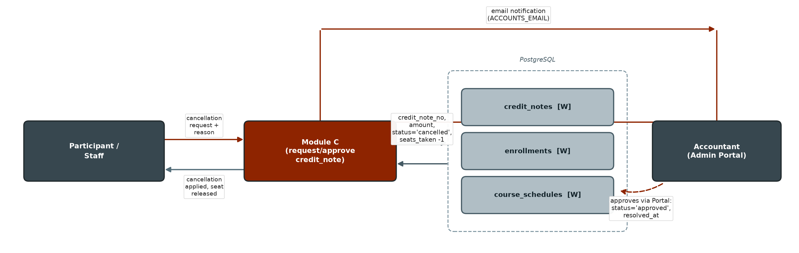

Entities (Actors)
Actor / Entity | Role in this Workflow
Participant or Staff | Initiates the cancellation request.
Module C (request_credit_note / approve_credit_note) | Creates the credit note and applies the cancellation.
Accountant (Admin/Accountant Portal) | Reviews and approves the credit note.

Process Flow
- A credit note is requested for an enrollment with a reason.
- Total confirmed payments to date are summed as the credit amount; a credit note number is generated.
- The enrollment is marked cancelled and its reserved schedule seat is released (seats_taken -1).
- The accounts team is notified by email to approve from the accountant portal.
- On approval, a credit note PDF is generated and emailed to the participant; credit_notes.status and resolved_at are updated.

Data Interaction (Database Fields)
Database Field | Read / Write | Description
credit_notes.enrollment_id / reason / amount | WRITE | Created at request time.
credit_notes.credit_note_no | WRITE | Generated from credit_note_seq.
credit_notes.status | WRITE | requested → approved (or rejected).
credit_notes.resolved_at | WRITE | Set on approval/rejection.
enrollments.status | WRITE | Set to cancelled.
course_schedules.seats_taken | WRITE | Decremented by 1 to release the seat.

Related Database Tables: credit_notes, enrollments, course_schedules

3.13 Nightly Accounts Report
Module C — Payment Verification & Accounts
Purpose: Give the accounts team a daily CSV summary of every enrollment by payment status, emailed automatically without manual pulling of data.
Workflow Diagram
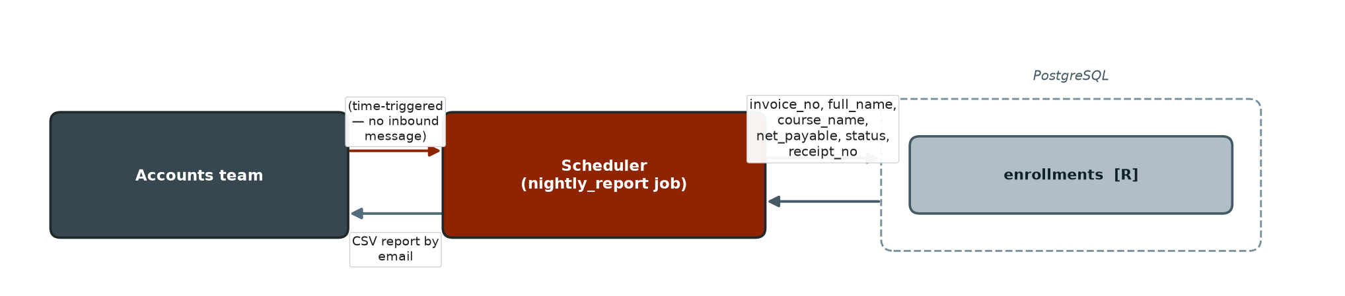

Entities (Actors)
Actor / Entity | Role in this Workflow
Scheduler (APScheduler background job) | Runs nightly at a configured hour (SGT).
Accounts team | Receives the CSV report by email.

Data Interaction (Database Fields)
Database Field | Read / Write | Description
enrollments.invoice_no / full_name / course_name / course_date | READ | Row-level report content.
enrollments.net_payable / status / receipt_no / created_at | READ | Financial and status detail per enrollment; also aggregated into a status-count summary.

Related Database Tables: enrollments

