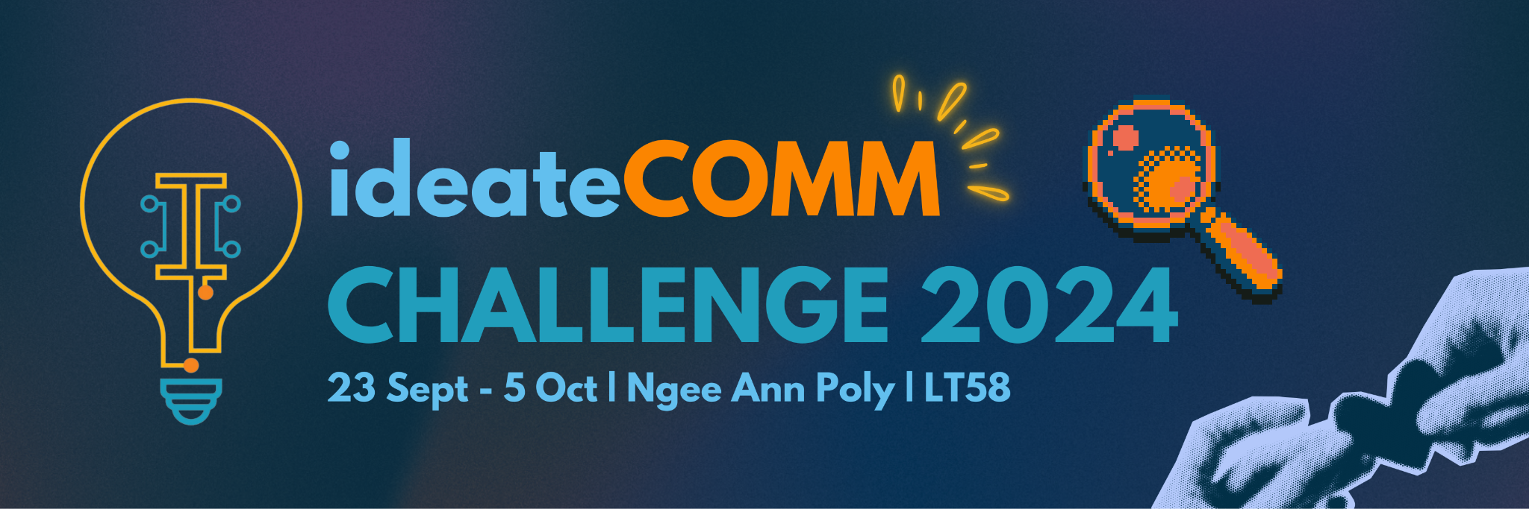

Dear Students,  
  
**Do you want to showcase your ideas while positively impacting society?** Form a team of 3 to 5 and challenge yourselves to develop technological solutions to address prevalent social issues in Singapore.  
  
Organised by Toa Payoh East Youth Network, Marymount Youth Network and Ngee Ann Polytechnic’s Engineering Interest Group (EIG), ideateCOMM Challenge provides a platform for youths to demonstrate their innovative solutions to prevalent social issues.

Why should you join? Here’s 3 simple reasons.

* **Plethora of industry relevant workshops:**   
  Sales & Marketing | Digital Fabrication | UI/UX with Figma and Wix
* **Attractive Prizes & Networking Opportunities:**  
  Stand a chance to win prizes of up to $2,000 shopping vouchers and network with industry experts.
* **Positively impact society:**  
  Our partners intend to execute feasible and innovative ideas so that you will have the chance to impact the world for real.

Registration is FREE! **Join ideateCOMM Challenge NOW!**

**REGISTER & FIND OUT MORE:**Visit the official website [https://www.ideatecomm.com](https://www.ideatecomm.com/) for more details on the competition, and follow us on Instagram: @ideate.comm for more updates. Please contact ideateCOMM organising committee at ideatecomm@gmail.com if you have any enquiries about the competition.