Material Classification — Full Method Report
AI-Adaptive PID Control for Tactile Robotic Grippers · 2026-05-13

Material Classification — Full Method Report
Date: 2026-05-13
Researcher: Chamil Ahlee · Walailak University · Technische Universität Dresden
Research title: AI-Adaptive PID Control for Tactile Robotic Grippers
Article context: Comprehensive methodology for the three material-classification pipelines (Phase A RF, Phase A-prime 1D-CNN, Phase B 1D-CNN) and the underlying CNN-LSTM force-prediction model that feeds them.

0. System Overview
The system contains four learned models running in two coupled roles:
Role | Model | Input | Output | Active runtime
Force prediction (closed-loop PID setpoint tracking) | CNN-LSTM regression | (60, 2) time series @ 1.8 Hz | scalar force in N | ✅
Material classification — Phase A | Random Forest | 5 scalar features per trial | softmax over {Hard, Medium, Soft} | ✅
Material classification — Phase A-prime | 1D-CNN on PID-grip trace | (40, 5) time series @ 20 Hz | softmax over {Hard, Medium, Soft} | ✅ (alongside RF)
Material classification — Phase B | 1D-CNN on probe-phase trace | (40, 5) time series @ 20 Hz | softmax over {Hard, Medium, Soft} | 🟡 awaiting probe data
The force model is a hard prerequisite for the classifiers — pred_force_n is one of the scalar features in RF (f_peak, rise_ms, stiffness_proxy) and feeds the input contract that shifted_cond participates in. The classifiers consume the data produced by the PID loop driven by the force model.

1. Data Acquisition

1.1 Hardware
- Tactile sensor: resistive (force ∝ 1/R). Raw resistance reported in Ohms by the ESP32; signal range during contact ≈ 200–800 kΩ.
- Encoder: absolute angular position of the gripper joint in degrees. Idle ≈ 151.5°; full close ≈ 95°; release target 106°.
- Actuator: brushed DC motor driven by PWM in [−255, +255] (negative = close, positive = open, 0 = hold).
- MCU: ESP32; firmware in Code Store/PIDpwmClaude/PIDpwmClaude.ino.

1.2 Serial Protocol
USB-serial, 115 200 baud, line-oriented. Each sample is one line:
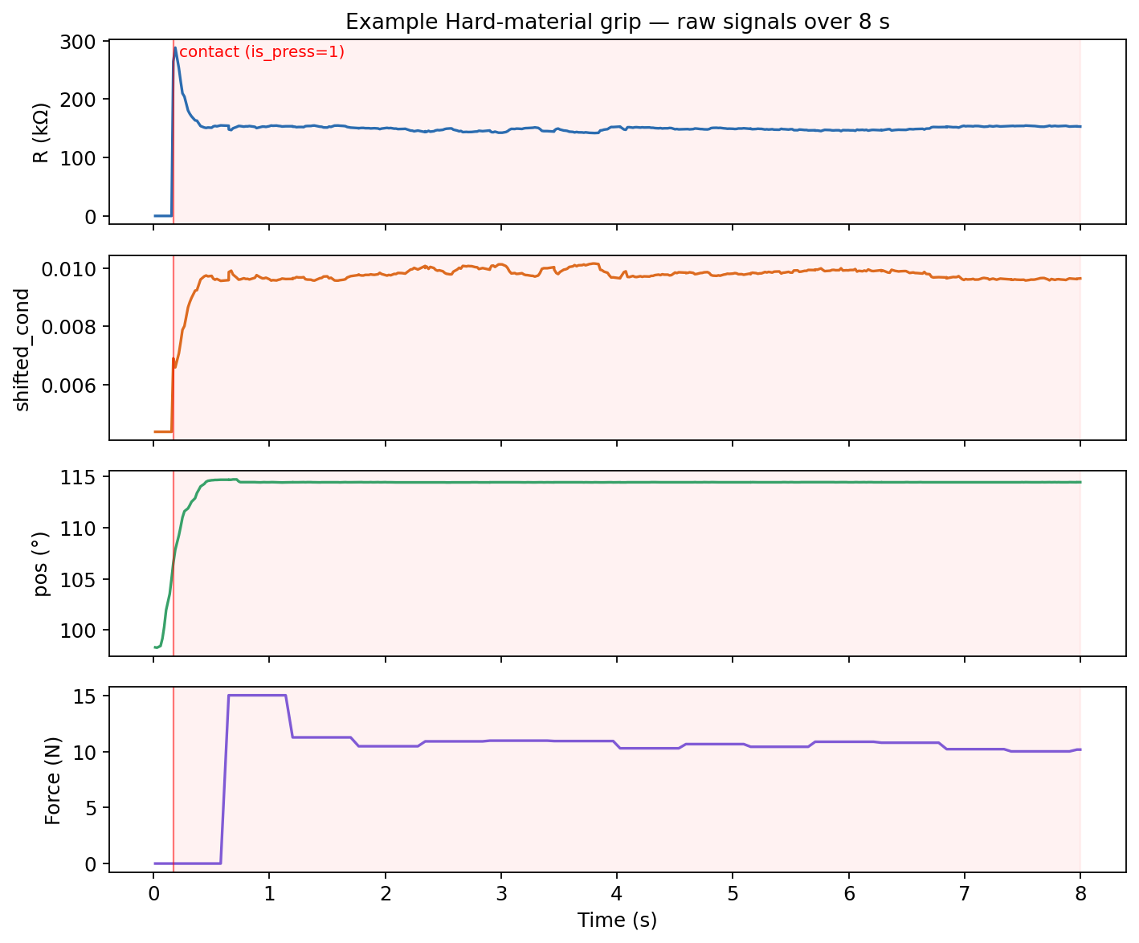
Figure 1. Example signal trace from a Hard-material grip. Top to bottom: raw resistance, shifted conductance, joint angle, predicted force. Red line marks first contact (is_press=1); red-shaded region is the PID grip phase.
D:<esp_ms>,<adc0>,<pos_deg>,<adc1>,<resistance_ohm>,<pwm>
Parsed into {esp_ms, adc0, pos, adc1, res, pwm} by App.py::parse_sensor(). Outgoing commands are PWM:<value>\n and STOP\n.

1.3 Effective Sample Rate
- ESP32 nominally emits ~65 Hz. Empirical rate varies with USB scheduler jitter and Python loop turnaround.
- Force inference runs at 1.8 Hz (= 1 / 0.556 s) and must match the training rate of the CNN-LSTM exactly — see §2.5.
- Material-classifier feature extraction targets 20 Hz via 50 ms bin-mean accumulation — see §4.

1.4 Trial Granularity
A trial = one grip cycle: baseline calibration → approach → PID grip → release. Trials are indexed by loop_index (1, 2, 3, …) within a session. Each grip lasts GRIP_DURATION = 8.0 s (post-2026-05-11 retune, was 5 s). Multiple trials within one session are concatenated into a single CSV file.

2. Pre-processing

2.1 Resistance Clamping
res_k = res_ohm / 1000.0
if res_k <= 0 or res_k > 800:
res_k = 800.0
Suppresses open-circuit spikes and infinities. The 800 kΩ ceiling is the only sensor-saturation handling in the Python layer; Issue 8 (open) flags that this ceiling clips a fraction of healthy idle readings and corrupts res_drop_pct for Phase A.

2.2 Conductance Computation
raw_cond = 1.0 / (res_k + 1e-6)
Conductance linearises the pressure response and damps the open-circuit noise floor (where R is large, small changes in R produce large changes in 1/R — bad for the model — so we normalise away from that regime in §2.3).

2.3 Baseline Correction & Distribution Alignment (Stage 2)
The force model (Model/my_cnn_lstm_model.keras) was trained against a fixed baseline conductance TRAIN_BASELINE_G = 0.004369. Every new session recalibrates the sensor baseline because sensor unit, mounting, and temperature drift the resting R. The session baseline is corrected to the training distribution before features are computed:
shifted_cond = ((raw_cond − current_sensor_baseline) × SENSOR_GAIN) + TRAIN_BASELINE_G
where current_sensor_baseline = 1 / (baseline_res_k + 1e-6) and baseline_res_k is the per-session mean of 30 resistance samples collected at PWM:0 (Stage 2 of run_one_grip()). If Stage 2 fails to receive enough samples within 5 s, a fallback of 250 kΩ is used and a warning is printed.
Why a shift, not a normalisation? The model was trained on a fixed-baseline training set, so the inference input must live in the same affine subspace. A shift (additive) is sufficient because the training feature is the conductance delta from baseline plus the baseline itself.

2.4SENSOR_GAIN— Cross-Hardware Compatibility
Scenario | SENSOR_GAIN
Original training sensor | 1.0
New / replacement sensor | 0.08
Different sensor units have different sensitivity slopes (Ω/N). Rather than retraining the force model per sensor, the conductance delta is rescaled by SENSOR_GAIN so the model sees a distribution matched to its training. This is fixed in App.py config and persists for the whole session.

2.5is_press— Dynamic Contact Detection (Latching)
is_press is not hardcoded to 1 at the start of a grip. It transitions from 0 → 1 at the first packet where:
res_k < 0.93 × baseline_res_k
(7% resistance drop = contact). Once latched, is_press stays at 1 for the rest of the trial. The 0.93 threshold was tightened from 0.97 in Claude Report 2 to push the approach deeper before PID engages, recovering grip pressure that was being bled by the LPF.
This flag is the alignment anchor for both feature extraction (§4) and the PID integral wind-up guard (§5).

3. Force Prediction Model (CNN-LSTM)

3.1 Architecture
- File: Model/my_cnn_lstm_model.keras
- Input: (1, 60, 2) — batch=1, sequence length 60, features [shifted_cond, is_press].
- Output: scalar predicted force in Newtons.
- Inference call: model(scaled_input, training=False) — never .predict() (the latter adds significant TF retracing overhead inside the serial loop).

3.2 Scalers
Scaler | Type | Purpose
Model/scaler_X.pkl | sklearn.PowerTransformer | Yeo-Johnson normalisation of [shifted_cond, is_press] . Stored λ values: [-51.9, 4.33] .
Model/scaler_y.pkl | sklearn.MinMaxScaler | Normalises force target into [0, 1] . Original range [0, 49 N] (checked at load time).
Inference inverts the y-scaler and clamps to ≥ 0 N (negative outputs are unphysical; the clamp masks a small known issue where the model occasionally emits a slightly negative value below 0.05 N).

3.3 Rolling-Buffer Inference
- 60-frame deque(maxlen=60) of [shifted_cond, is_press] rows accumulates within run_one_grip().
- Seeded between grips by prefill_buffer — recent idle samples from the post-release period — so the first inference of the next grip doesn't run on zero-padding.
- When fewer than 60 rows are present, the deficit is front-padded with [TRAIN_BASELINE_G, 0.0] (the model's training-distribution null state), not zeros.

3.4 PID Coupling
The force model's output drives the PID controller (KP=70, KI=20, KD=7, alpha=0.4) which writes new PWM commands at the inference rate of 1.8 Hz. Integral accumulation only begins after is_press latches, preventing windup during free-air approach. The PID output is sign-negated (current_pwm = clip(-pid_output, -255, 0)) so positive force-error produces tighter grip (more negative PWM).
PID parameters in §5 of this report; they matter for classification only because they determine the shape of the post-contact trajectory the Phase A-prime CNN learns from.

4. Feature Engineering

4.1 Phase A — RF, Hand-Crafted Scalars
Five scalar features extracted per trial (Code Store/train_material_rf.py::extract_trial_features):
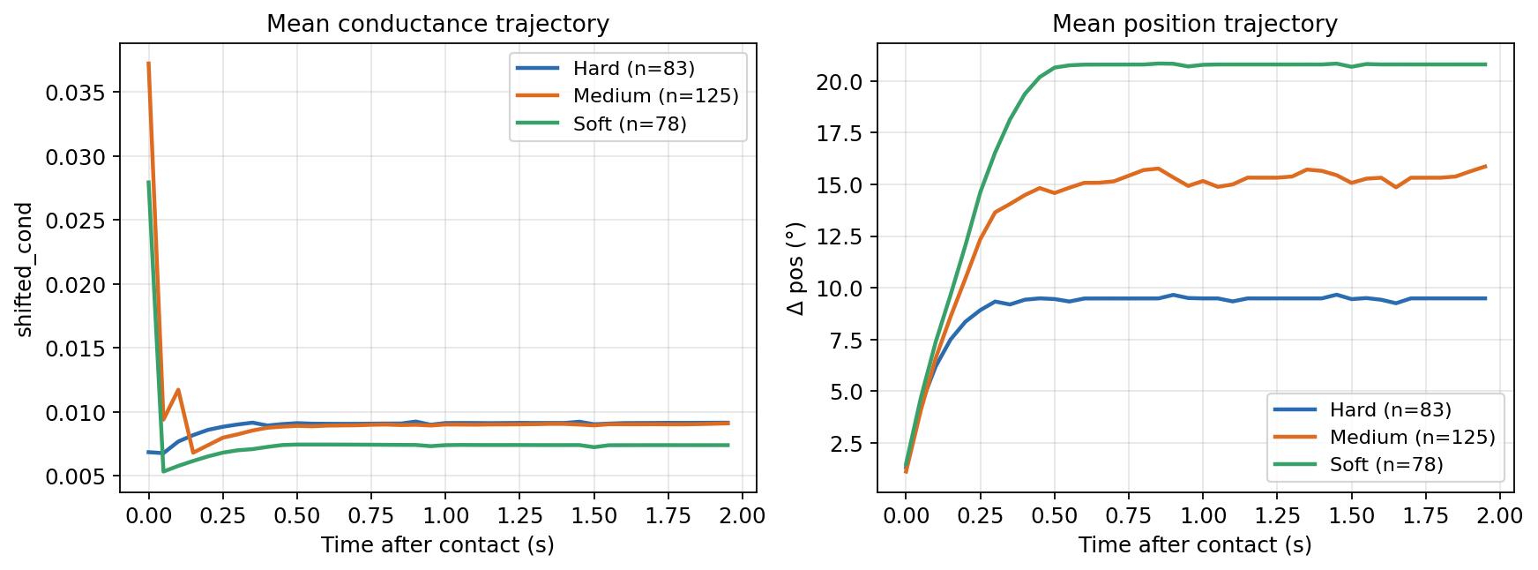
Figure 2. Mean post-contact trajectories per material class. Left: shifted conductance over the first 2 seconds after contact. Right: change in joint angle relative to contact. Hard, Medium, Soft are visually separable in both channels but the gap narrows under PID overshoot.
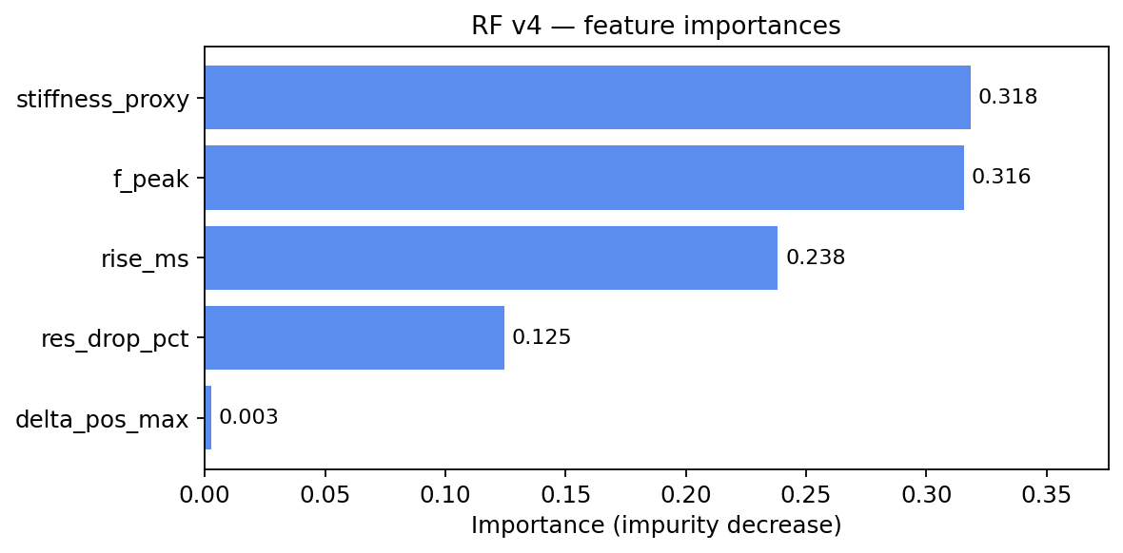
Figure 3. Random-Forest v4 feature importance (impurity decrease). f_peak and stiffness_proxy dominate; delta_pos_max is effectively dead and a candidate for removal.
Feature | Formula | Intuition
delta_pos_max | max(|pos_t − pos_at_first_contact|) over post-contact rows | Maximum geometric compression depth
res_drop_pct | (baseline_res_k − min(res_k)) / baseline_res_k over post-contact | Normalised conductance peak
f_peak | max(pred_force_n) over post-contact | Peak observed grip force
rise_ms | t_ms at which pred_force_n ≥ 0.9 × f_peak , minus t_ms at contact | Time to reach 90% of peak force
stiffness_proxy | f_peak / rise_ms | Effective Newtons per millisecond — a coarse stiffness measure
These are computed from the per-packet PID trace (trial_records field of the dict returned by run_one_grip).
Feature importance (v4, 5-fold CV mean): stiffness_proxy 0.318 · f_peak 0.316 · rise_ms 0.238 · res_drop_pct 0.125 · delta_pos_max 0.003. The position-encoder feature is effectively dead — see §11 Open Items.

4.2 Phase A-prime and Phase B — CNN, Time-Series Channels
Five channels emitted per 50 ms bin (Code Store/train_material_cnn_pid.py::_bin_mean):
Channel | Formula | Range (typical)
shifted_cond | mean of shifted_cond within the bin | ~0.004 – 0.030
delta_pos | bin-mean pos_deg − pos_at_first_contact | ~0 – −10°
d_cond_dt | (bin[k].shifted_cond − bin[k−1].shifted_cond) / 0.050 s ; 0 at k=0 | ~−0.01 – +0.06 / s
d_dpos_dt | (bin[k].delta_pos − bin[k−1].delta_pos) / 0.050 s ; 0 at k=0 | ~−10 – 0 °/s
res_norm | (bin-mean res_k) / baseline_res_k , clipped to [0, 1.5] | 0 – 1.5
is_press, pred_force_n, and pid_pwm_out are excluded by design from CNN inputs — is_press is constant 1 inside the window (so non-informative); pred_force_n is downstream of shifted_cond (no additional information); pid_pwm_out is the PID's response to the input, not the material itself.
Phase A-prime and Phase B share the feature definition. They differ only in what the underlying packets are:
- Phase A-prime: post-is_press packets from a PID-controlled grip (trial_records).
- Phase B: packets from the pre-PID probe ramp −80 → −150 PWM (probe_records from Stage 2.5).

5. Window Extraction (Time-Series Classifiers)
Both 1D-CNN trainers and their runtime loaders use the same extraction logic.
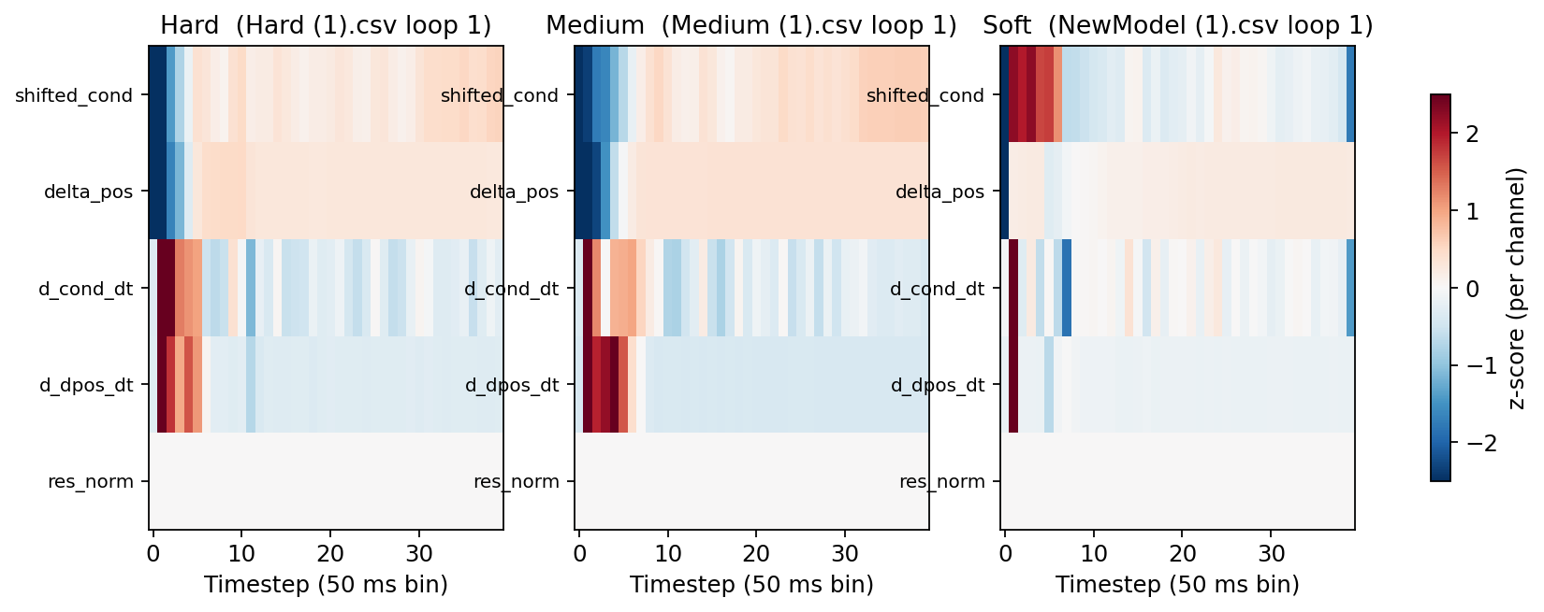
Figure 4. Example (40, 5) windows for one Hard, one Medium, and one Soft trial after per-channel z-score normalisation. Time axis runs left-to-right in 50 ms bins. Visual differences between classes drive the 1D-CNN.

5.1 Contact Alignment
t = 0 is the first packet with is_press == 1 (or, in probe mode, the first packet with res_k < 0.93 × baseline_res_k, which is the same threshold). This invariance to approach distance is critical — operator-placed objects vary by several degrees, so a sample-index-aligned window would mix Hard-at-95° with Hard-at-110° as if they were different.

5.2 Binning at 20 Hz (50 ms)
Raw packets are accumulated into 50 ms bins by bin_id = floor((t_ms − t0) / 50). Each bin emits one feature row (the channel-wise mean of its packets). 20 Hz is locked: probe phase samples at fixed 20 Hz in real time, so the trainer must match for distribution alignment.

5.3 Empty-Bin Handling (Bin-Skip Fix, 2026-05-13)
pandas.groupby("_bin") does not emit empty groups. The ESP32 serial stream drops a packet every few hundred milliseconds (USB scheduling, TF inference latency at 1.8 Hz), leaving ~1–2 bins per trial with zero packets in the first 2 s.
A naive for bid, g in groupby(): if bid >= 40: break short-circuits one row early at every empty bin, producing 39 rows instead of 40 → the trial is dropped. This bug killed 222 of 286 trials in the first CNN-PID training run.
Fixed implementation:
for bid, g in post_df.groupby("_bin"):
if len(rows) >= WINDOW_LEN:
break
# ... emit feature row ...
The window now uses the first 40 non-empty bins regardless of bin-ids. Time-axis drift at a gap is bounded by BIN_MS = 50 ms per gap; gap rate is sparse (< 5% of bins in practice); CV variance was unaffected.

5.4 Probe Phase (Stage 2.5)
Used only by Phase B (not Phase A-prime). Implementation in ModelInclude.py:
- Triggered by config["PROBE_ENABLED"] = True (set by App.py --probe).
- PWM ramps linearly from PROBE_PWM_START = −80 to PROBE_PWM_END = −150 over PROBE_DURATION = 2.0 s.
- Contact detection uses the same threshold as Stage 4 (res_k < 0.93 × baseline_res_k).
- After contact, packets are bin-averaged in real time at 20 Hz (50 ms wall-clock window per bin), feature row emitted only when at least one packet is in the bin.
- Capture stops at 40 rows OR PROBE_DURATION + 2.0 s timeout.
- PWM is dropped to 0 for 50 ms before Stage 3 (approach + PID) begins. Stage 3 continues normally — both classifiers can run on the same physical grip.

5.5 Why probe data is needed (Phase B vs Phase A-prime)
Phase A-prime trains on the PID-controlled trajectory, where overshoot (max_force_n 8–17 N for a 3.5 N setpoint), LPF smoothing, grip-floor clamps, and 1.8 Hz integral updates all imprint a PID signature on top of the material signature. Phase B uses the pre-PID probe ramp to capture the material response uncontaminated by control overshoot. The CNN architecture is identical; only the input distribution differs.

6. Quality Filtering
Applied identically across all three classifiers (with feature-set-specific exceptions noted):
Drop criterion | Reason
n_packets < 30 | Trial too short to contain a meaningful grip.
n_pre < 5 OR n_post < 5 | Contact never tripped, or grip ended immediately — no usable signal.
f_peak < 1.5 N (RF & A-prime only) | Failed grip (sensor never loaded). Phase B doesn't use f_peak .
baseline_res_k < 1000 kΩ AND f_peak < 5 N | Calibration was contaminated by residual contact pressure from the previous trial.
n_non_empty_bins < 40 (CNN trainers only) | Window contract violation. After the bin-skip fix this is effectively only "no contact" trials.
Quality filter outcomes are logged per-trial in the trainer output for audit ([Hard ] Hard (1).csv loop=3 reason=no contact window).

7. Scaling

7.1 Phase A RF
scaler = StandardScaler().fit(X) # X shape (N, 5)
Xs = scaler.transform(X)
Stored as Model/scaler_mat_rf.pkl. Fit on the full training set; the same instance is used at inference.

7.2 Phase A-prime / Phase B CNN
Per-channel StandardScaler, fit on the flattened training tensor:
X.shape == (N, 40, 5)
scaler = StandardScaler().fit(X.reshape(-1, 5)) # fit on (N×40, 5) rows
Xs = scaler.transform(X.reshape(-1, 5)).reshape(N, 40, 5)
This estimates one mean/std per channel across all timesteps and trials — appropriate because each timestep within a trial is a realisation of the same underlying random process, not a separate variable. Stored as a bundle {scaler, classes, window_len} in Model/scaler_mat_cnn{,_pid}.pkl.

8. Model Architectures

8.1 Phase A — Random Forest
RandomForestClassifier(
n_estimators = 200,
max_depth = None,
random_state = 0,
)
Trained directly on (N, 5) scalar features. No regularisation tuning — defaults perform well on the small feature set; the variance comes from the data, not the model.

8.2 Phase A-prime & Phase B — 1D-CNN (identical architecture, different data)
Sequential([
Input(shape=(40, 5)),
Conv1D(32, kernel_size=5, padding='same', activation='relu'),
Conv1D(64, kernel_size=3, padding='same', activation='relu'),
MaxPool1D(pool_size=2), # → (20, 64)
Conv1D(64, kernel_size=3, padding='same', activation='relu'),
GlobalAveragePooling1D(), # → (64,)
Dropout(0.3),
Dense(32, activation='relu'),
Dense(3, activation='softmax'), # Hard / Medium / Soft
])
- ~25 000 trainable parameters. Sized for ~200–300 training trials.
- Receptive field after the three Conv1Ds and one MaxPool: ~14 input timesteps = ~700 ms of post-contact dynamics per output unit before pooling. Easily enough to span the rising-edge plateau of any single grip.
- GlobalAveragePooling vs Flatten: GAP gives translation invariance along the time axis (the model is told "the order matters but the absolute timing within the window is not critical"). Empirically this matches the alignment-on-contact preprocessing.
- Dropout 0.3 between the conv and dense stages prevents overfitting on the small dataset.

8.3 Force Model — CNN-LSTM
External architecture (defined in Model/Train/CNNLstm.ipynb, not in this report). Treated as a frozen module. Sanity-checked at load time by feeding a synthetic grip (idle conductance × 30 frames → rising conductance × 30 frames) and confirming output > 5 N — a "model is healthy" pass/fail.

9. Training Procedure

9.1 5-Fold Stratified Cross-Validation
StratifiedKFold(n_splits=5, shuffle=True, random_state=0)
Applied to all three material classifiers. random_state=0 so folds are reproducible across trainer runs. Per-fold accuracy and cross_val_predict over the union of held-out folds give the confusion matrix.

9.2 RF Training
cross_val_score and cross_val_predict for evaluation; final .fit(Xs, y) on the full data for the deployed artefact.

9.3 CNN Training
Per fold:
model.fit(
Xs_train, y_train,
epochs = 80,
batch_size = 16,
optimizer = 'adam', # lr=1e-3
loss = 'sparse_categorical_crossentropy',
metrics = ['accuracy'],
shuffle = True,
)
acc = model.evaluate(Xs_test, y_test)[1]
After CV, the architecture is rebuilt and refit on the full dataset (same hyperparameters) and saved as the deployment artefact. No early stopping in the current version — 80 epochs at batch 16 saturates on this dataset size; loss-curve inspection in CV folds shows convergence by epoch ~30 with no overfitting trend.

9.4 Data Augmentation
None in v1 of the CNN trainers. The plan acknowledges time-warp (±10%) and Gaussian channel noise (σ=0.02) as candidates; current performance hits the ceiling implied by Issue 9 (Hard↔Medium signal overlap), which augmentation can't fix.

10. Inference Path (Runtime)
The three classifiers run in parallel at the end of each grip, sharing the same result dict returned by run_one_grip():
run_one_grip() ─┬─► trial_records ─► MaterialClassifier.classify_trial() ─► RF prediction
├─► trial_records ─► MaterialPIDCNNClassifier.classify_pid() ─► CNN-PID prediction
└─► probe_records ─► MaterialCNNClassifier.classify_probe() ─► CNN-probe prediction
Each loader returns (label, {Hard, Medium, Soft → probability}) or (None, None) on failure (artefacts missing, fewer than 40 non-empty bins, etc.). App.py::_post_grip_classify runs all three, writes the predictions to the per-trial summary CSV, and prints a one-liner to the console:
Material prediction: RF=Hard(0.85/0.04/0.11) CNN-PID=Hard(0.92/0.06/0.02) CNN-probe=-(//)
The three are independent — failure of any one does not affect the others. RF is currently the contractual primary (its label is written first in the CSV); CNN-PID is diagnostic until a field A/B confirms its CV advantage holds out-of-distribution.

11. Metrics
Each trainer emits:
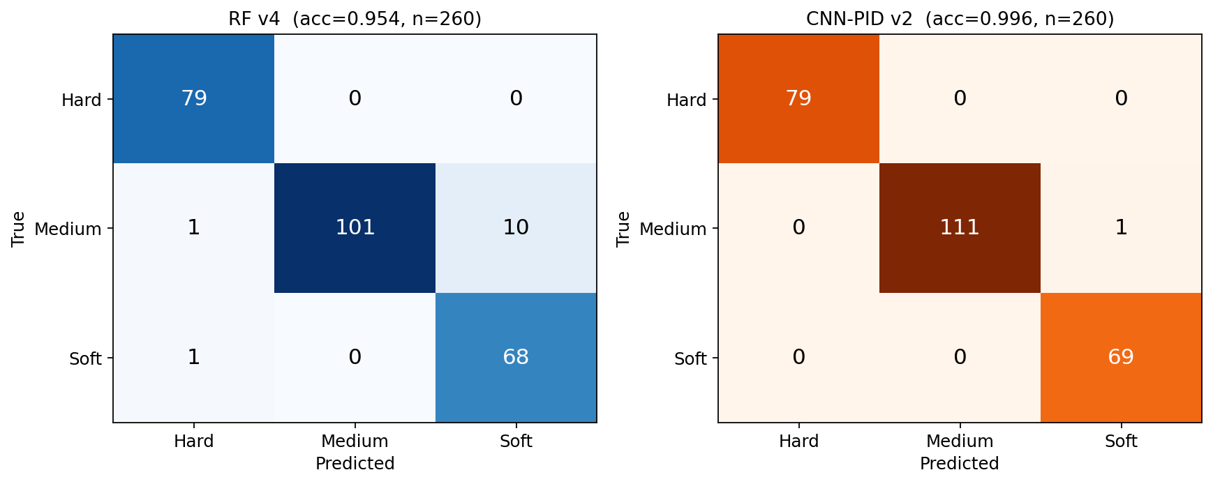
Figure 5. Confusion matrices on the full data_logs/datasets/ corpus (in-sample). RF v4 left, CNN-PID v2 right.
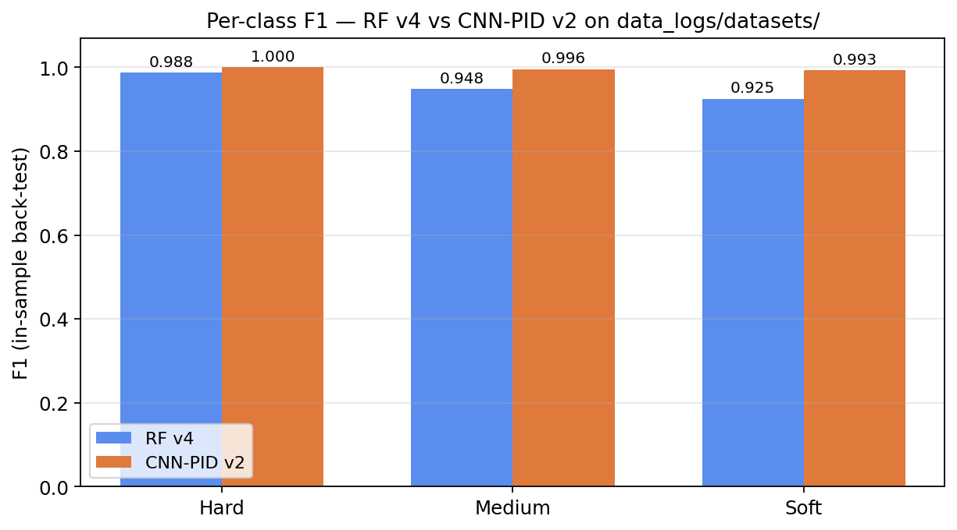
Figure 6. Per-class F1 score comparison — RF v4 vs CNN-PID v2 on the same back-test set.
- Per-fold accuracy (5 numbers) and aggregate mean ± std.
- Confusion matrix over the union of held-out folds (cross_val_predict).
- Per-class classification report — precision, recall, F1, support.
- Misclassification log — every wrong prediction with (true, pred, source_file, loop_index, f_peak, stiffness, rise_ms) so individual trials can be re-examined.
- Feature importances (RF only) — sklearn's impurity-decrease importance, useful for identifying dead features (delta_pos_max is the recurring dead one at 0.003).

11.1 Current Benchmarks
Model | CV Accuracy | Macro F1 | Trials | Hard F1 | Medium F1 | Soft F1
RF v4 | 0.838 ± 0.018 | 0.842 | 203 | 0.774 | 0.819 | 0.933
CNN-PID v2 | 0.942 ± 0.024 | 0.944 | 260 | 0.929 | 0.938 | 0.964
CNN-probe | pending | pending | pending | pending | pending | pending
CNN-PID v2 is +0.104 CV / +0.102 macro F1 over RF v4. Dominant residual error mode: Hard↔Medium (9 of 15 misclassifications) — Issue 9, not closed.

12. Open Methodological Items
These are flagged here so reviewers don't have to chase them from issue logs:
- Issue 8 — Stage-2 baseline clamping at 800 kΩ. The 800 kΩ ceiling in §2.1 is clipping a fraction of healthy idle readings. res_drop_pct (one of RF's five features) is partially saturated as a result. Workaround: bump the ceiling to 2000 kΩ pending hardware verification.
- Issue 9 — Hard/Medium feature overlap under PID overshoot. Setpoint 3.5 N, observed peaks 8–15 N. Both classes saturate similar mechanical/force-model ceilings; the discriminative signal is lost in the over-pressure response. Phase B's probe mode is the intended fix — material response before PID engages.
- delta_pos_max is dead (RF importance 0.003 across v3 / v3.1 / v4). The position encoder may not resolve sub-degree compression; or the PID setpoint forces depth into a class-invariant range. Candidate for removal in a future RF, OR for replacement with a probe-derived delta_pos_at_contact_velocity feature.
- No held-out test set. All metrics in §11.1 are 5-fold CV. Field accuracy may differ — the v2 → v3 history showed CV 0.936 dropping to field 0.714 because of a firmware-induced distribution shift. A held-out 70-trial field session per classifier deploy is the standard discipline (next planned post-Issue-2 PID re-tune verification).
- PID tuning sensitivity (Phase A-prime). CNN-PID is trained on the current PID parameters (KP=70, KI=20, KD=7, alpha=0.4). Re-tuning PID will shift the input distribution and likely require CNN-PID retraining. Phase B (probe-based) is immune to this and is the long-term safer path.

13. Reproducibility
Aspect | How
Source code | App.py , ModelInclude.py , MaterialClassifier.py , MaterialPIDCNNClassifier.py , MaterialCNNClassifier.py , and the trainers in Code Store/ .
Training data | All raw per-packet CSVs in data_logs/datasets/ (top level; bin/ ignored; probe/ for Phase B). Auto-discovered — drop a labelled CSV in, re-run the trainer, done.
Random seeds | RandomForestClassifier(random_state=0) , StratifiedKFold(random_state=0) . CNN training has no explicit seed — TensorFlow defaults; weight init varies between runs but CV mean is stable to ±0.01 in repeated experiments.
Python env | C:\Users\charm\anaconda3\envs\PyAienv\python.exe — TensorFlow + Keras + scikit-learn + joblib + pandas + numpy.
Saved artefacts | All in Model/ : material_rf.pkl + scaler_mat_rf.pkl (Phase A), material_cnn_pid.keras + scaler_mat_cnn_pid.pkl (Phase A-prime), material_cnn.keras + scaler_mat_cnn.pkl (Phase B, when trained).

14. Lifecycle Notes
Version | Date | Trials | CV | Notes
RF v1 | 2026-05-09 | 44 | 0.794 ± 0.111 | Pre-firmware-fix data, original baseline.
RF v2 | 2026-05-11 | 78 | 0.936 ± 0.042 | Post-firmware-fix; narrow corpus; field accuracy was 0.714 → motivated v3.
RF v3 | 2026-05-12 | 153 | 0.837 ± 0.029 | Added 2026-05-12 sessions; class imbalance (Soft 24).
RF v3.1 | 2026-05-12 | 203 | 0.828 ± 0.033 | Added NewModel (1) + (4) for Soft/Medium balance.
RF v4 | 2026-05-13 | 203 | 0.838 ± 0.018 | Auto-discovery refactor; same data as v3.1, tighter folds. Current production.
CNN-PID v1 | 2026-05-13 | 64 | 0.891 ± 0.037 | First A-prime CNN; 222 trials lost to bin-skip bug.
CNN-PID v2 | 2026-05-13 | 260 | 0.942 ± 0.024 | Bin-skip fix; +0.104 CV vs RF v4; wired into runtime alongside RF .
CNN-probe v1 | — | — | — | Awaiting probe-mode data collection.

