**Mini Project Report on**



**EVALUATION OF ACADEMIC PERFORMANCE**



**Submitted in partial fulfillment of the requirement for the award of the degree of**

**BACHELOR OF TECHNOLOGY**

**IN**

**COMPUTER SCIENCE & ENGINEERING**

**Submitted by:**

**Yash Chauhan University Roll No.: 2019241**

***Under the Mentorship of***

**Dr. Aditya Pai H**

**Associate Professor**

**Department of CSE**



**Department of Computer Science and Engineering**

**Graphic Era (Deemed to be University)**

**Dehradun, Uttarakhand**

**January 2023**



**CANDIDATE’S DECLARATION**

I hereby certify that the work which is being presented in the project report entitled “Evaluation of academic performance” in partial fulfillment of the requirements for the award of the Degree of Bachelor of Technology in Computer Science and Engineering of the Graphic Era (Deemed to be University), Dehradun shall be carried out by the under the mentorship of Dr. Aditya Pai H, Associate Professor, Department of Computer Science and Engineering, Graphic Era (Deemed to be University), Dehradun.

**Yash Chauhan University Roll No.: 2019241**

**Table of Contents**

|  |  |  |
| --- | --- | --- |
| **Chapter No.** | **Description** | **Page No.** |
| **Chapter 1** | **Introduction** | **1-2** |
| **Chapter 2** | **Literature Survey** | **3-4** |
| **Chapter 3** | **Methodology** | **5-6** |
| **Chapter 4** | **Result and Discussion** | **7-13** |
| **Chapter 5** | **Conclusion and Future Work** | **14** |
|  | **References** | **15** |

**Chapter 1**

**Introduction**

### **Problem Statement**

To make a project for evaluation of academic performance.

* 1. **Introduction**

Academic performance evaluation is an important aspect of education as it helps to assess the progress and understanding of students in their respective fields of study.

This project report aims to evaluate the academic performance of students by analyzing various factors such as their grades and participation in class. The report will also examine the result of a school, class-wise as well as individually.

The project will help the management to create a student record, delete a student record, and modify a student record.

The project will also help the management to access the records for an individual or of a whole class or all the reports together.

The findings of this project will provide valuable insights for educators and administrators to ensure that students are reaching their full potential.

* 1. **Objectives**

Since it is very important to evaluate the academic performance of a student to track their overall development. To attain this goal, I have developed a console application for teachers to keep a record of students and their performance.

Various objectives of the application could be:

* Assessing the knowledge and skills of students in a particular subject or course.
* Measuring student progress and determining areas where additional support is needed.
* Providing feedback to students, teachers, and parents on student performance.
* Identifying and addressing any learning gaps or deficiencies.
* Assisting in the decision-making process for academic placement, promotion, and graduation.
* Meeting external accreditation and accountability requirements.
* Improving the overall quality of education and instruction.

**Chapter 2**

**Literature Survey**

Evaluating academic performance is the process of measuring a student's progress and understanding in their field of study. It is an important aspect of education as it helps educators and administrators identify areas of strength and weakness, and make decisions about how to improve the overall quality of education.

There are various methods to evaluate academic performance. Those include:

* Grades or marks: This is the most traditional method of evaluating academic performance, and involves assigning a letter or numerical grade to a student's work.
* Standardized tests: These tests are designed to measure a student's knowledge and skills in a specific subject area and are often used for college or graduate school admissions.
* Portfolios: This method involves collecting a student's work over a while and using it to evaluate their progress and achievement.
* Self-assessment: This method involves having students reflect on their learning and progress and evaluate their performance.
* Peer assessment: This method involves having students evaluate the work of their classmates.
* Observation: This method involves observing the student in the classroom or laboratory and taking note of their participation, engagement, and behavior.

* Project-based evaluations: This method involves evaluating student performance on specific projects or assignments that are designed to demonstrate their knowledge or skills in a particular area.
* Oral or written exams: This method involves testing students on their knowledge and understanding of a particular subject through oral or written means.

* Attendance: This is the method where a student is assessed for regularity, for how regular a student is. This method is generally considered by teachers to provide sessional marks to a student.

**Chapter 3**

**Methodology**

As our goal is to evaluate academic performance, we need to add the data of the students. After inputting the data, the data has to be written in a binary file for future use. Then, data can be read from the file as per the requirement of the user.

The evaluation is done based on subject marks (70%) and co-curricular activities (30%). The grades are given after adding up both marks.

The Grade criteria is as under: -

|  |  |
| --- | --- |
| Percentage | Grade |
| 95 or above | A+ |
| 90 – 94.9 | A |
| 80 – 89.9 | B |
| 70 – 79.9 | C |
| 60 – 69.9 | D |
| 40 – 59.9 | E |
| Below 40 | Fail |

**Table 3.1 Grade Criteria table**

To add or modify any record, the user needs to authenticate himself by entering the password. After authentication, the user can add, delete, modify, or can search a particular record.

If the user is not authentic, then it takes the user back to the welcome page.

The following flowchart demonstrates the working of the system.



Enter the System

Result Enter/Edit Exit

Incorrect

Password

Class Result Back to main

Menu

Correct

Student Report

Card Create Delete Back to main

menu

Display all Modify

**Fig. 3.1 Flowchart for working of System**

**Chapter 4**

**Result and Discussion**

The following snapshots are the result of the application.

**4.1 Intro Window**

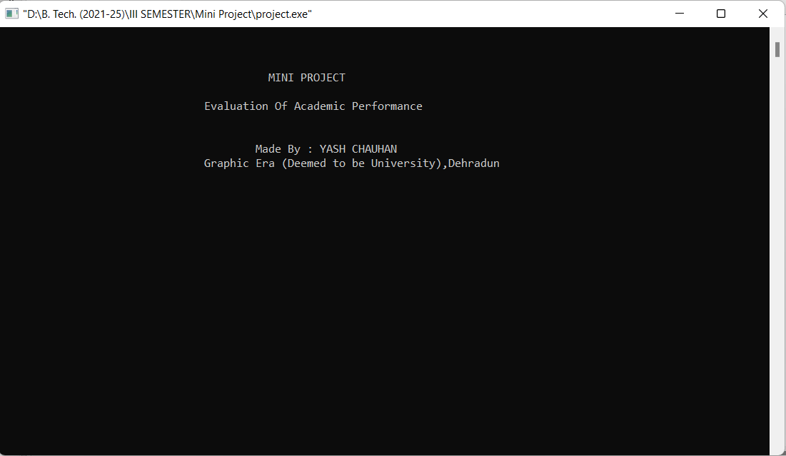

**4.2 Main Menu Window**

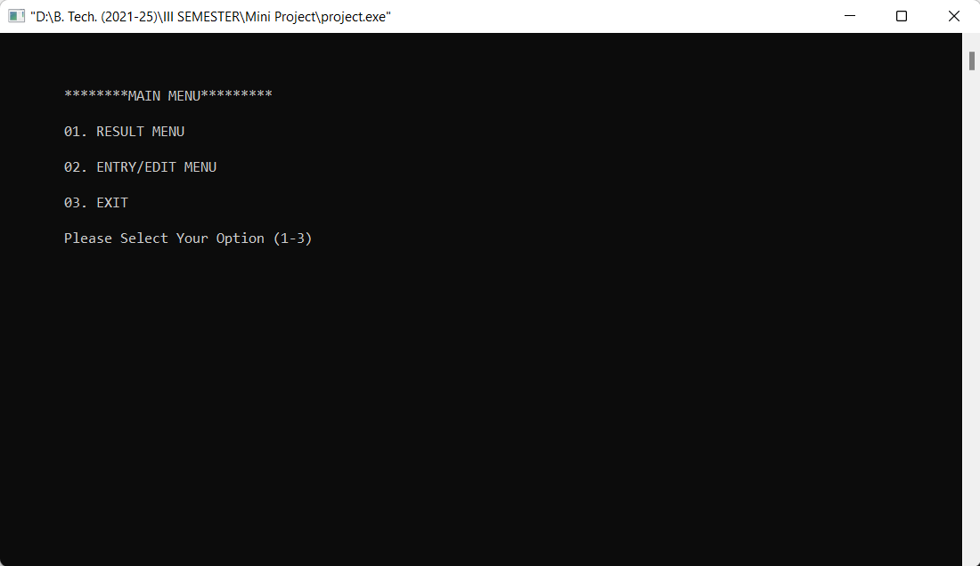

**4.3 Result Menu**

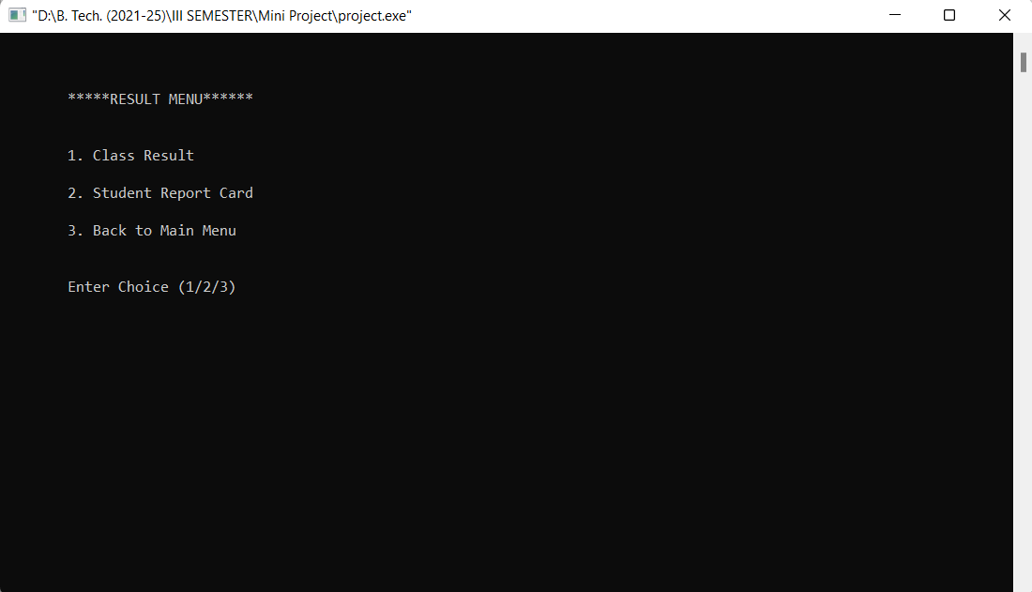

**4.4 Class Result Menu**

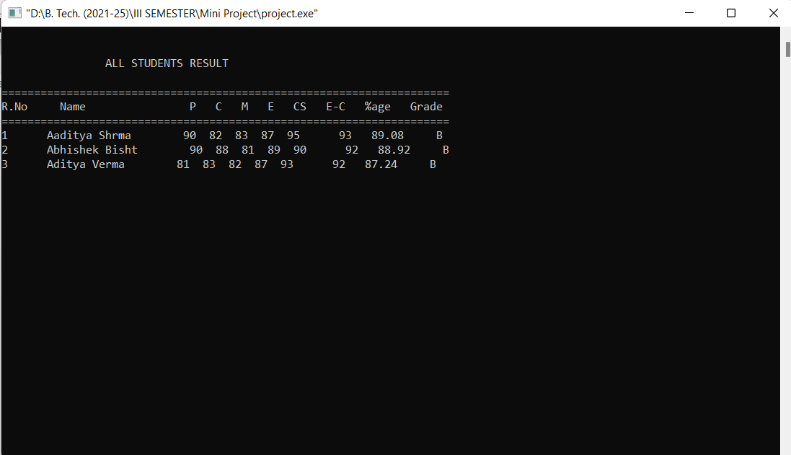

**4.5 Student Report Card Menu**

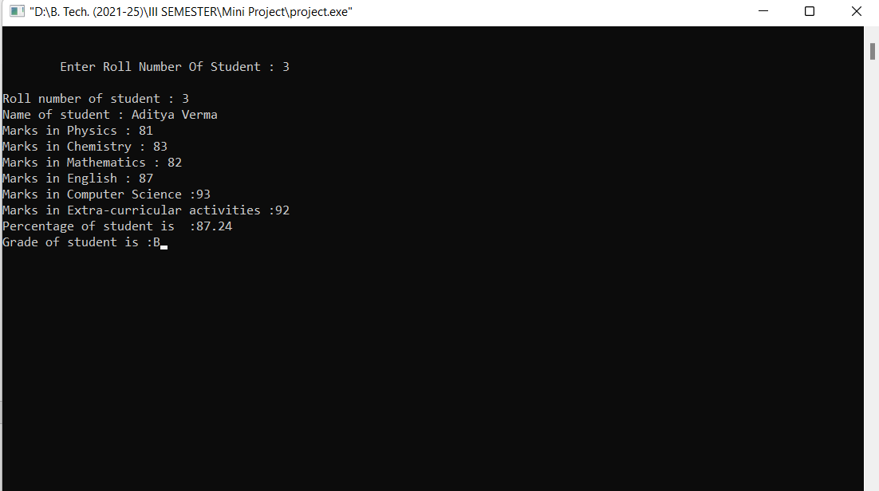

**4.6 Entry / Edit Menu**

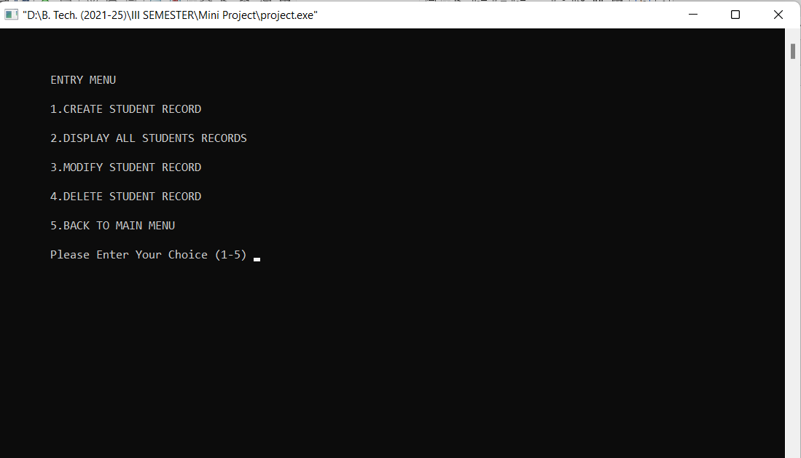

**4.7 Create Student Record Menu**

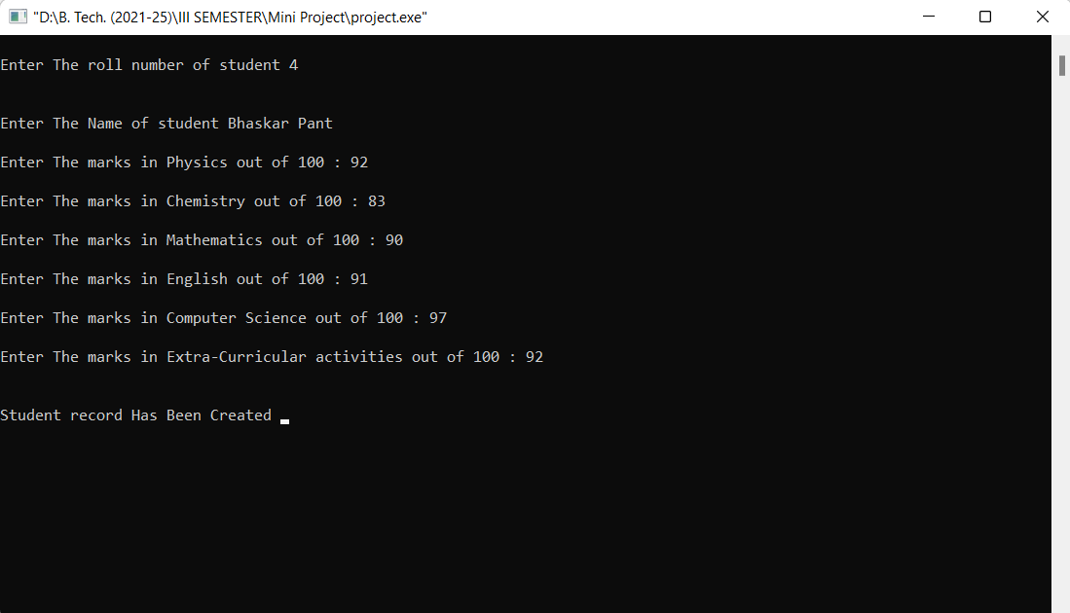

**4.8 Display all record Menu**

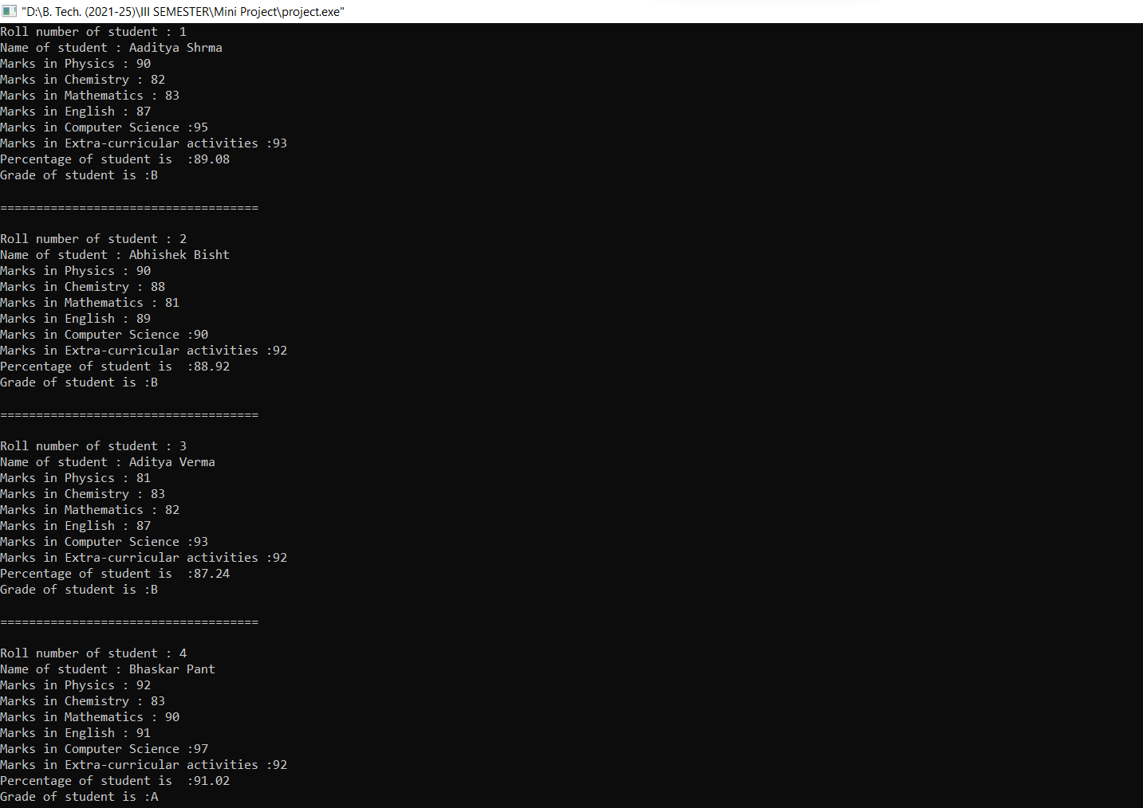

**4.9 Update Menu**

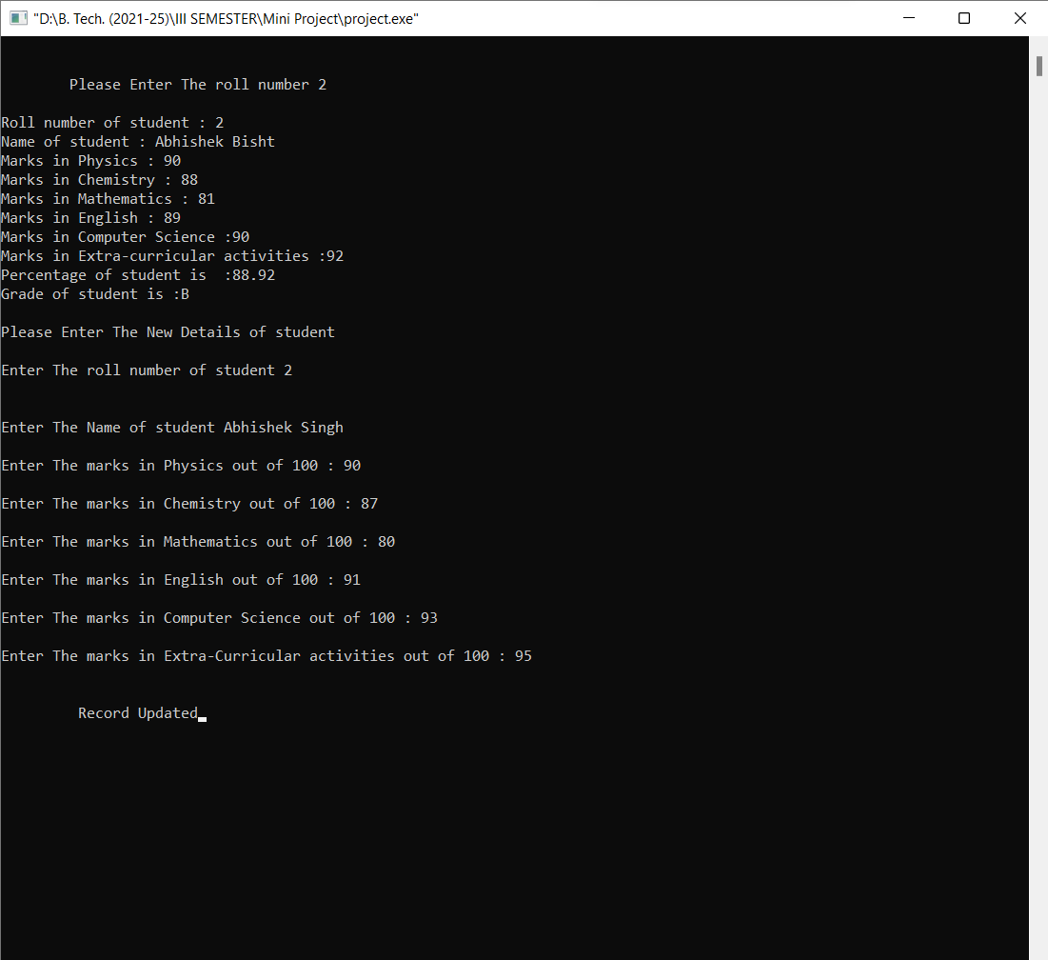

**4.10 After Updation**

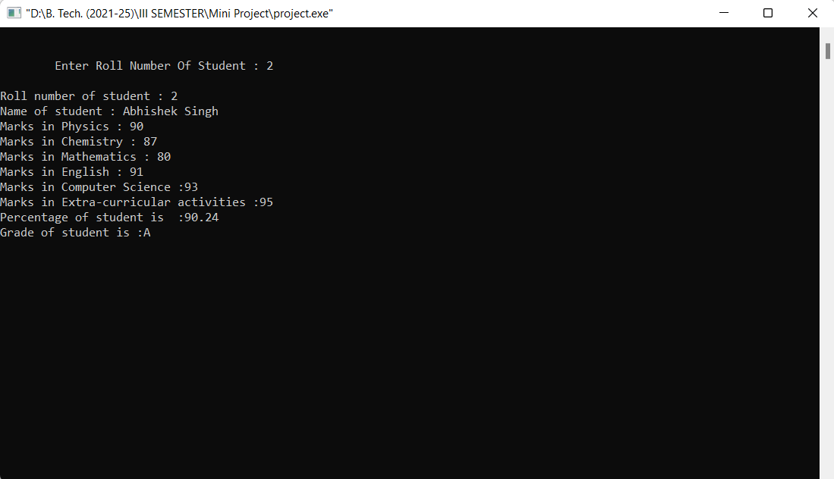

**4.11 Delete Record Menu**

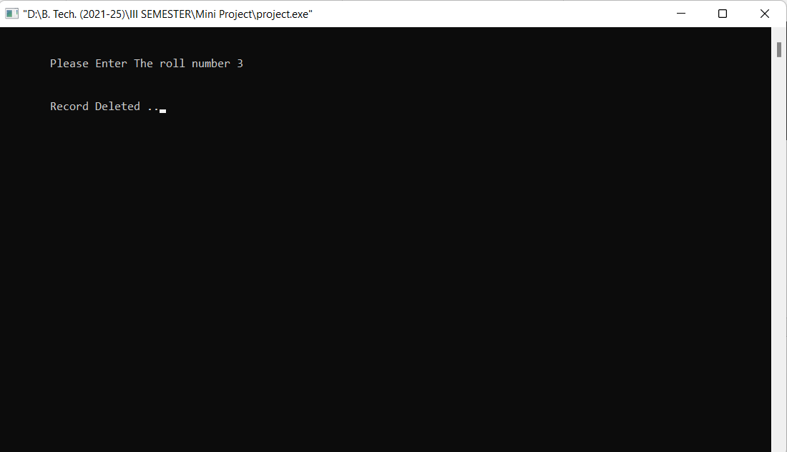

**4.12 After Deletion**

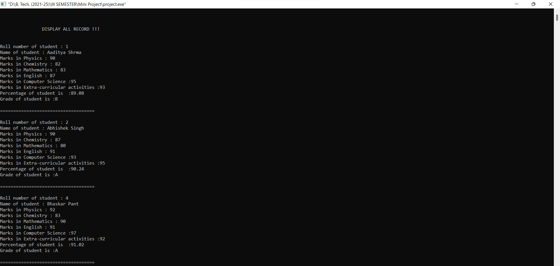

**4.13 Exiting**

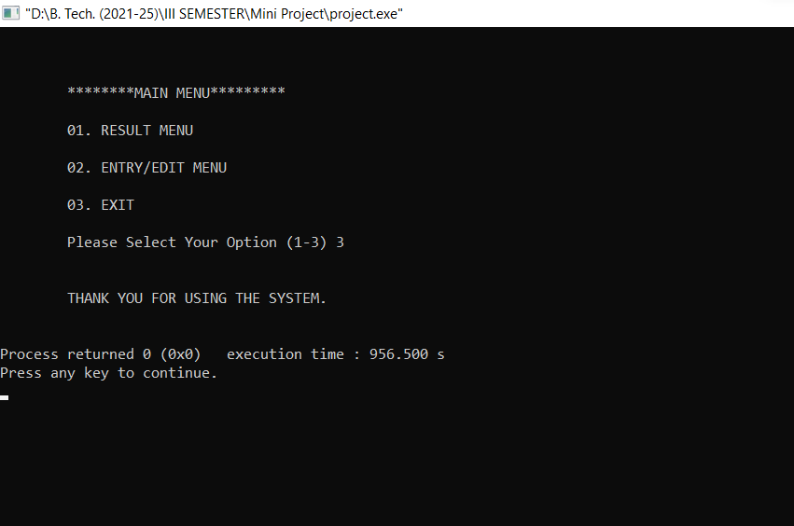

The system can be used to evaluate the student performance based on the marks of different subjects and co-curricular activities.

The system is suitable for small schools and organizations.

**Chapter 5**

**Conclusion and Future Work**

**5.1 Conclusion**

The work done is suitable to store the record of students and evaluate the students based on their academic performance as well as extra-curricular activities.

Adding and updating the current can be implemented using Database management and can be made efficient to deal with a large number of records and a large number of fields.

This work can be further used to evaluate the performance of students in many other fields.

**5.2 Advantages**

* Reduce paperwork.
* Easy to handle and access.
* Safe and secure.
* Data Backup.
* Data can be shared easily.

Every system has some Pros as well as Cons. Below mentioned are some disadvantages of the system.

**5.3 Disadvantages**

* Difficult to store a greater number of fields.
* Error Prone.
* Lack of real-time updates.

**References**

**[1]** The Complete Reference C++ [Fourth Edition] by Herbert Schildt.

**[2]** Online: Accessed on 19th January 2023. <https://courses.cs.vt.edu/~cs2604/fall00/binio.html>

**[3]** Geeks for Geeks [Online]. Accessed on 20th January 2023.

<https://www.geeksforgeeks.org/cpp-program-to-modify-the-content-of-a-binary-file/>

**[4]** Tutorials point [Online]. Accessed on 22nd January 2023. <https://www.tutorialspoint.com/reading-and-writing-binary-file-in-c-cplusplus>