Going to the Movies

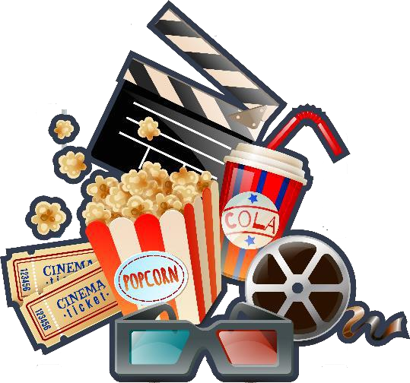My class is going to the movies on a field trip next week. We have to get permission slips signed before we go. We also need to ask our parents if they will drive to the movie theater. We are going to see a movie that tells the story from a book we read. We love it when movies are made from books. It is fun to compare the movie to the book. I

usually like the book better.

We get to the movie early so we can buy popcorn. Some of us buy candy and slushes

too. We all enjoy watching the movie. When we return to school, we talk about things that were in the movie and the book. The movie and book are similar. We all agree that we like the book better though. Books let you picture the characters any way you want to picture them.