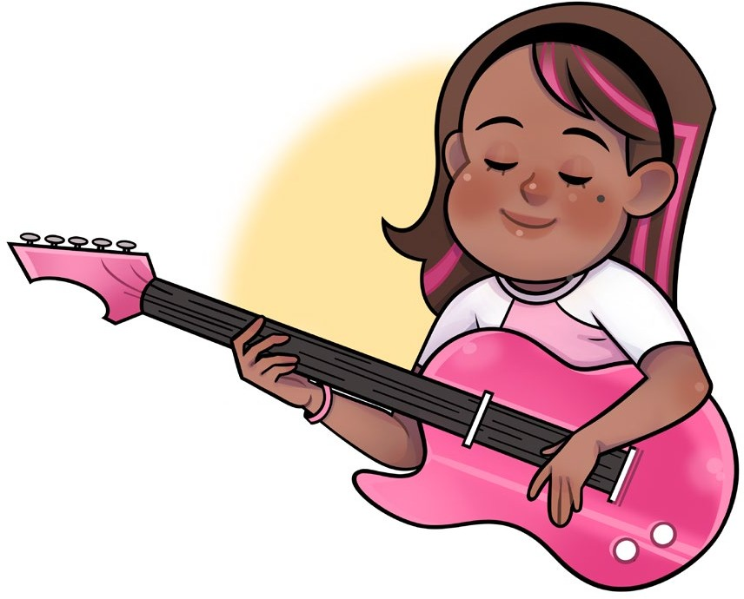**Rock Band**

“Let’s make a rock band,” said Beth. “Great,” said Rob. “I can play the drums.” He hit the drums. Rat a tat tat.

Kim smiled. “I will play the guitar.” Strum strum.

Jim picked up a keyboard. He pushed the keys. “Cool, I will play this.” Ting, ting, tong.

Bill started to sing. La, la, la.

Beth looked around. “What should I play?” She dug in a box.

She pulled out a big bell. “Look a cowbell.” Bang, bang, bong.

“Let’s rock!”

They played and sang all night long.