Left Out

Trish was playing basketball with her brother outside when she saw a car pull up in Josie’s driveway. Josie jumped out of the car, and Trish could hear a lot of voices laughing and saying goodbye to Josie.

Trish stopped dribbling the basketball and watched as the car drove away and Josie skipped to her front door. Trish

could feel her body start to get uncomfortably warm, and her eyes started to water.

“Hey, what’s wrong?” Daniel asked.

“Nothing. I don’t want to play anymore.” Trish **stormed** inside and slammed the door. She heard the door open again behind her, but she didn’t

turn around and went straight to her room. Trish could hear Daniel talking to her mom downstairs, but she didn’t want to talk to anyone.

She heard a knock on the door, but ignored it. Her mom called though the door, “Trish, are you OK?” Trish ignored it and put her pillow over her head like earmuffs. “I’ll be downstairs if you want to talk later. It’s a good choice to calm yourself down first.”

Eventually Trish calmed down and went to talk with her mom. Her mom always had some good ideas to help her.

“What’s going on, Trish?” Mom asked when Trish appeared in the living room. Trish took a seat.

“Josie went somewhere with our friends and she didn’t invite me,”

Trish said. “Why wouldn’t she invite me? That’s not very nice. I thought we were friends.”

“Oh, honey, I’m sorry. I’d be pretty upset too if I felt left out. Maybe Josie knew that you wouldn’t like what they were going to do,” Mom suggested.

“Maybe…” Trish didn’t sound convinced.

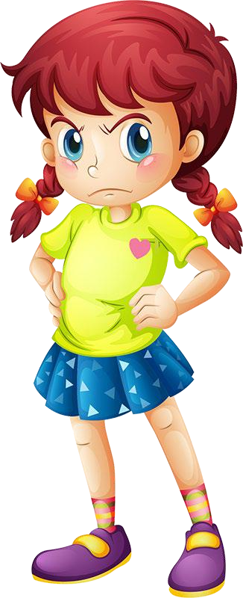“Why don’t you talk with Josie about it at school on Monday?” Mom said.

“I don’t want to talk to her, I’m mad! I’m just going to ignore her.”

“Well… sometimes ignoring another person is a good choice, but I don’t think this is the right time for that solution. If you ignore her, how are you ever going to solve the problem? Not talking about it is just going to make it worse, and might mean you could lose Josie as a friend,” replied Mom.

“I still want Josie to be my friend, but talking about it is uncomfortable. I just want her to know what’s wrong and say she’s sorry.”

“That might happen, but it might not. Josie might not realize that she did something wrong, so then she’ll just get mad at you for ignoring her. I really think talking to her about how you feel is the best way to solve the problem.”

“OK, Mom, I ’ll talk to her at school. Thanks,” Trish said.

And guess what? Trish’s mom was right! Josie knew Trish didn’t like snakes, and she and the other girls had gone to the zoo to see the new snake exhibit. Trish was glad she’d talked to Josie to solve the problem.

