*Read the short story. Then answer each question.*

The Best Vacation Ever

Winter break was fast approaching, and all Scott wanted to do was go snowboarding. Unfortunately, Scott’s parents had different plans. They had booked a weeklong tropical cruise. Scott hated warm weather and asked i f he could just stay at his best friend’s house so he could

snowboard every day with his buddies at the local mountain. His parents

didn’t want to hear anything of i t. He kept debating them about the

topic, but they would not change their minds. Family time was important to them, and i t was tradition that they spend winter break together.

The week of the cruise arrived, and Scott continued to mumble his

complaints as he and his family left their house to head south. Scott’s dad

told him that he would only make the vacation worse for himself i f he

didn’t change his attitude and open his mind to a new experience. Scott still couldn’t stop thinking about all of the snow he was leaving behind.

When they arrived at the port to board the ship, Scott had a hard time admitting that he was actually

impressed with the size of the ship. He had seen the brochures but seeing the ship in person was a

whole different animal. Then he remembered that the brochure said something about a surfing pool.

Maybe surfing would be somewhat l ike

snowboarding. After all, i t involved r iding a board.

Scott climbed aboard the ship with his parents, and then they walked

around to check everything out. He couldn’t believe how extravagant the

accommodations were. The dining room looked l ike a royal hall; the

game room had all of his favorite games and then some; the ship’s deck

had several different swimming pools for different purposes . Then Scott

saw the surfing pool. I t was incredible. I t wasn’t a big pool, but i t had big

waves, and the girl who was demonstrating how to r ide the waves made i t look l ike a ton of fun.

Scott asked his parents i f he could go put his swim shorts on so tha t he could try surfing. They said, “Of course.” They wanted to put their swim suits on as well, and, much to Scott’s surprise, they wanted to try surfing too.

When Scott and his parents had their swim suits on, they headed back to the surfing pool. There was a l ine, but i t wasn’t too long. Scott’s dad went first and only lasted about five seconds before he wiped out. Then i t was his mom’s turn. She actually made i t longer than his dad did. When i t was Scott’s turn, he was excited and nervous. He hopped on t he board and

took a stance similar to his snowboarding stance. Then the waves started.

I t felt similar to snowboarding but different at the same t ime. On his first r ide, Scott rode for almost 30 seconds before wiping out. He was hooked though.

A lot of the passengers tried surfing the first day of the cruise, but only

eight people or so really took to i t, so for the remainder of the cruise the

l ines weren’t very long, and Scott got to know the regulars quite well.

By the time the weeklong cruise was over, Scott had new friends he

planned to keep in touch with, a new hobby, and great memories. He

apologized to his parents for initial moaning and groaning, and told them i t was his best vacation ever.

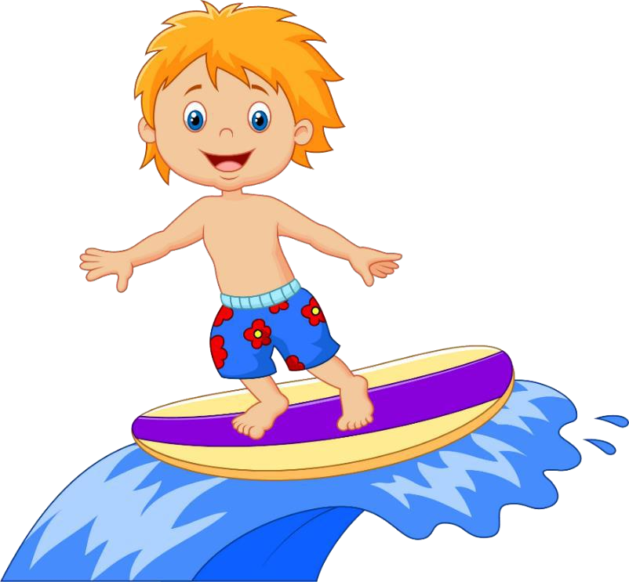

# Questions:

1. Based on the context, what type of climate i s considered tropical?
2. What do you think the word *“ tradition”* means?
3. The phrase *“a whole different animal”* i s an informal way of saying what?
4. Why do you think Scott was surprised that his parents wanted to try surfing?
5. Based on the context, what do you think the word *“extravagant”*

means?

1. Why would Scott have wanted to apologize to his parents?

# Answers:

1. Based on the context, what type of climate i s considered tropical? Based on the context of the story, the tropical cl imate is warm.
2. What do you think the word *“ tradition”* means?

*Tradition* means it’s something the fami ly does together regularly. In

this case they spend winter break together every year.

1. The phrase *“a whole different animal”* i s an informal way of saying what?

*A whole different animal* means completely different.

1. Why do you think Scott was surprised that his parents wanted to try surfing?

Answers wi ll vary.

1. Based on the context, what do you think the word *“extravagant”*

means?

*Extravagant* means very fancy and very expensive.

1. Why would Scott have wanted to apologize to his parents?

Answers wi ll vary, but one appropriate answer is he’s want to

apologize because he was rude about wanting to not go on a

vacation they had spent time, effort and money on booking f or the fami ly.