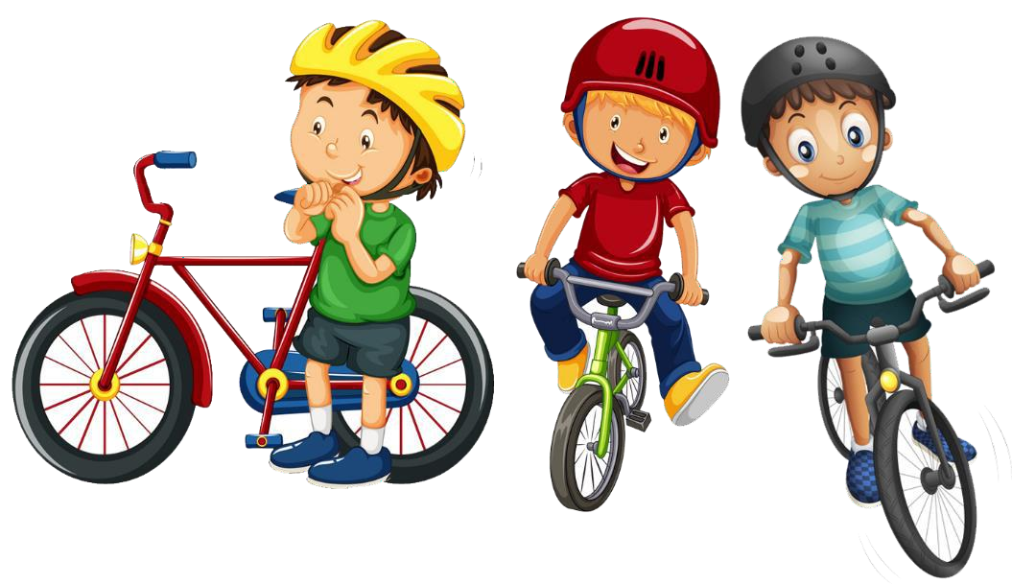*Read the short story. Then answer each question.*

Finders Keepers

I t was the middle of the day on a bright sunny Saturday, and Jay and his friends Mike and Tony were r iding their dirt bikes on one of their favorite off- road trails. They usually didn’t r ide early in the day or in the evening because hikers and runners l iked the trail too, but the hikers and runners generally used the trail in the mornings and evenings.

The trail twisted and turned through some incredible foliage.

Occasionally Jay and his

friends would stop to climb a tree and find a

comfortable branch to sit on so they could

take a break from

r iding in the heat. They also l ike to observe the

newer bikers as they rode ov er of the unpredictable

bumps on the trail and wiped out. Jay, Mike and Tony did have their mischievous sides.

On this particular day, Jay and the boys were perched in one of their

preferred trees when Jay spotted something shiny on the ground. “ What do you think that could be?” he asked Mike and Tony as he pointed out the object reflecting the sun.

They all hopped down from their individual branches and went to take a closer look. What they found was incomprehensible to them. I t was a gold money clip holding five hundred dollars.

Mike immediately exclaimed, “ Awesome! We can split up the money, and

we will each be much closer to being able to buy the new bikes we want.

“Not so fast,” said Tony. “Jay was the one who spotted the cash. To be

fair, he should get more than us. He should get three hundred dollars, and we should each get one hundred dollars.

“ What are you guys, crazy?” asked Jay. “ We can’t keep the money. I t

i sn’t ours. Aren’t we more mature than to play finders keepers l ike we did

when we were kids?”

“Stop being such an advocate for honesty,” groaned Mike and Tony.

“ Whoever lost the money wasn’t very responsible and should learn a lesson about walking around with that much cash on them anyhow,” added Mike.

“Let’s all go home and think about this,” said Jay, knowing that he could have made the call because he was the one who spotted the money clip in the first place.

Mike and Tony agreed to Jay’s suggestion. Jay kept the money, and they

all rode their bikes home. They decided to meet up after dinne r at the head of the off- road trail.

Mike and Tony l ived on the same street so they rode

home most of the way together. They were able to talk

a bit more without Jay’s input. The more they talked,

they came to see Jay’s point. They also thought about how upset they would be i f they accidentally dropped and lost something that was important to them.

When Jay, Mike and Tony met back up after dinner,

Mike and Tony conceded that Jay was r ight. They all

rode their bikes to the police station together to turn in the money clip and i ts holdings. The police officer who took the report about the found money clip told them that he was

impressed with their honesty. He also said that i f no one claimed the lost i tem, i t would r ightfully be theirs. He

took Jay’s phone number just in case.

Jay left knowing he did the r ight thing. Mike and Tony even felt better about the situation.

The next morning, a man called the police station to report his lost money clip. When he found out i t had been turned in, he was thrilled. He asked who turned i t in and learned about Jay and his friends.

Shortly thereafter, Jay received a phone call asking him to go to the

police station. He was a bit nervous, but when he got there, he learned

that the money clip had been claimed, and the owner wanted to reward the individuals who turned i t in.

When Jay got to the station, the police officer handed him a gift certificate from the local bicycle shop for one hundred dollars.

Jay met up with Mike and Tony later that day and told them what

happened. Mike and Tony thought about their initial reactions to the find and realized that i t i s far better to not be a keeper. Neither of them had even thought that there would be a reward, so i t was i t was a happy

ending for all involved.



# Questions:

1. How do you think sitting in a tree would provide a break f rom the heat for Jay and his friends?
2. Why would watching newer bikers wipe out indicate that the boys have mischievous sides?
3. What do you think a synonym for the word *“incomprehensible”*

might be?

1. I f the boys had split the money up evenly, approximately how much would each boy receive?
2. When a person i s an advocate for something, do they support or oppose i t?
3. Why was the ending happy for all involved?

# Answers:

1. How do you think sitting in a tree would provide a break f rom the heat for Jay and his friends?

Sitting in a tree would provide a break from the heat as the branches create shade from the sun.

1. Why would watching newer bikers wipe out indicate that the boys have mischievous sides?

Liking to watch bikers wi ll less ski l ls fall off their bikes is a mischievous thing to do.

1. What do you think a synonym for the word *“incomprehensible”*

might be?

Answers wi ll vary, but appropriate answers include baffl ing, not understandable or unimaginable.

1. I f the boys had split the money up evenly, approximately how much would each boy receive?

Each boy would have received about $165 each, if they had spl it the money evenly.

1. When a person i s an advocate for something, do they support or oppose i t?

An advocate supports something.

1. Why was the ending happy for all involved?

There was a happy ending for all involved because the rightful owner of the money got his money back and the three boys

received a reward from the owner.