**Fairy Followers**

Drawing is my passion. I draw the land around me, and lands I make up in my head. I draw people I see, and fictional creatures. I draw anything and everything that gives me inspiration. Lately, though, something strange is happening with my drawings.

I have a desk set up in my bedroom, with my art supplies and other decorations that my parents helped me buy for motivation.

Whenever I leave a drawing there overnight, it disappears! I search everywhere for my drawings, but I can never find them! Something has to be done, I don’t want to keep losing y favorite pieces of artwork! I decide to enlist my brother’s help. He loves to read spy novels, and he might have some good ideas to help me discover where my missing drawings are.

“Tony, I need your help! My drawings keep disappearing, and I really don’t want to keep losing them. Can you help me spy on my desk overnight?” I ask.

“Sure, sis. I think I might be able to set up my tablet to record video all night so we can see what’s happening,” he answers. “Awesome!”

Tony gets to work setting up his spy station. I have a hard time falling asleep because I can’t wait to see what we’ll find out in the morning! “Jamie, bet up! It’s time to check the video!” Tony prods me awake.

We walk over the tablet and Tony pulls up the video from the night before. It’s a long time before anything happens, but when we see how my drawing disappears, we stare in disbelief.

“Did you see what I just saw? Are you sure you set up the tablet correctly? That can’t be real!” Tony replies, “I can’t believe it either, but I’m sure I set it up correctly! What do we do now?”

We had seen fairies take my drawing! Four of them, one for each corner of the paper. Fairies! They picked up my paper, and a little door appeared right next to the window by my desk! If I didn’t know that Tony had set it up correctly, I would have thought it was some sort of prank.

“I wonder if they can read, maybe we should leave them a note. I want to find out more about them, and why they’re taking my drawings!” I tell Tony.

We sit down at my desk and draft a note to the fairies. I draw a little picture on it for good luck. The note says, “Hi Fairies, we’re Jamie and Tony. Why are you taking my drawings? I hope you like them! We’d love to meet you, so please come visit again! From, Jamie and Tony.”

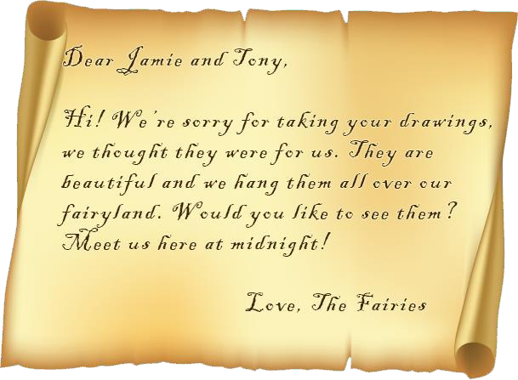Again, I have trouble sleeping because I’m so excited. The next morning, I see a paper still on my desk. I hope it’s a note from the fairies, and not our note from last night! I go get Tony before I look. We look at the paper together, and it’s a note back from the fairies!

All day Tony and I can’t stop talking about the fairyland will be like. Will it be filled with magical creatures? Will the trees look like our trees? What do fairies eat? We are filled with questions and excitement.

We camp out in my bedroom, playing games to keep us awake until midnight. As the clock turns from 11:59 to 12:00, we see a light by my window. It’s the door opening! Out fly the same 4 fairies that we saw on the camera! They introduce themselves to us, and ask us if we’re ready for an adventure. Of course we are!

“But, I’m not sure how we’re going to fit through your little fairy door. We’re bigger than you are,” I say.

“Don’t worry,” the smallest fairy replies, “Just imagine yourself getting smaller with every step you take towards the door. “Tony and I look at each other and nod. We walk towards the door, thinking small with each step.

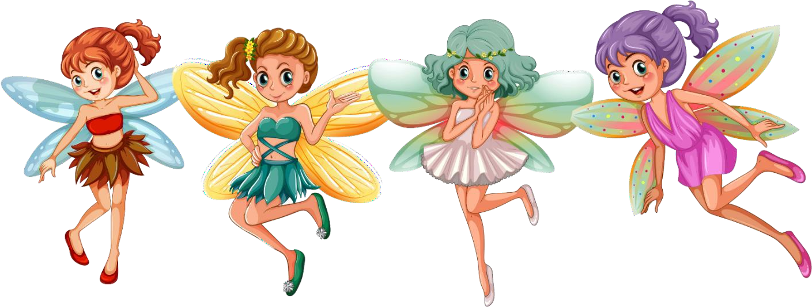Suddenly, we’re through the little fairy door, in a world like nothing we’ve ever seen. There are little houses and shops and trees like in our world, but mixed in are unusual plants and animals. Some of the trees have blue leaves and purple trunks. Some of the flowers are in the shapes of stars and hearts and even animals! Somehow it all works together, and the land is beautiful. We cannot wait to go explore and find out more about the fairies.