Website: <https://chyh1024.github.io/>

At beginning of this project, my first intuition is to draw the map from json file. After I have visualization of the map, I need to mark up all the pump and deaths. Then, I analyze those deaths and draw three charts about the timeline of total deaths, ages of total deaths, and gender of total deaths. I mark pumps as red, in contrast, I mark each deaths as green.

I use line chart for timeline of total deaths and put a dot for each data point to show the relationship of each dot, when you mouse over the dot, it will show detail data for the point.

I use bar chart to present Total death for ages. The bar chart show the total deaths for each age range. According to data, we use 0-10, 11-20, 21-40, 41-60, 61-80, and > 80 as x axel, total deaths for y axel. Bar chart can directly show the analysis easily. When readers see the chart, they can understand the death rate of Cholera related to ages.

I also use bar chart to present total deaths of gender but twist the way of bar chart. I think gender doesn’t make different in front of deaths.

This should be a rigorous explanation of the design choices you made. For example,

Describe how you used your visualizations to discover facts or answer questions you had. Include evidence to support your findings as screenshots from the visualization.

When I see the map, I notice that there is a pump (red dot) in the among of deaths (green dots).

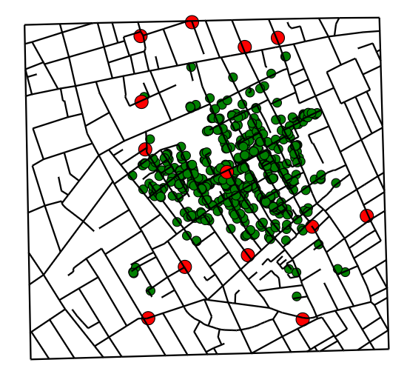

By looking at the map, we can conclude that Cholera must have positive relationship with the center pump. We can draw a circle and the center of the circle is the pump. Maybe the disease is originated from the center pump?

Even thought my map doesn’t correspond with timeline chart, we can inspect each element to see first 20 location of deaths. According to deaths_age_sex.csv data, the each death also correspond with timeline chart. For example, the first death is in (13.58801, 11.0956) it also happened in 8/19/2019. We can check elements to see the location.

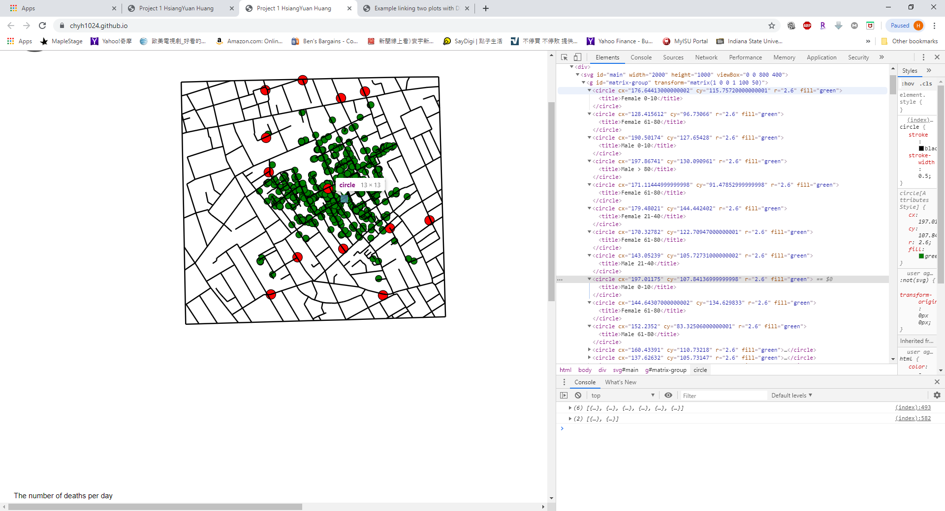

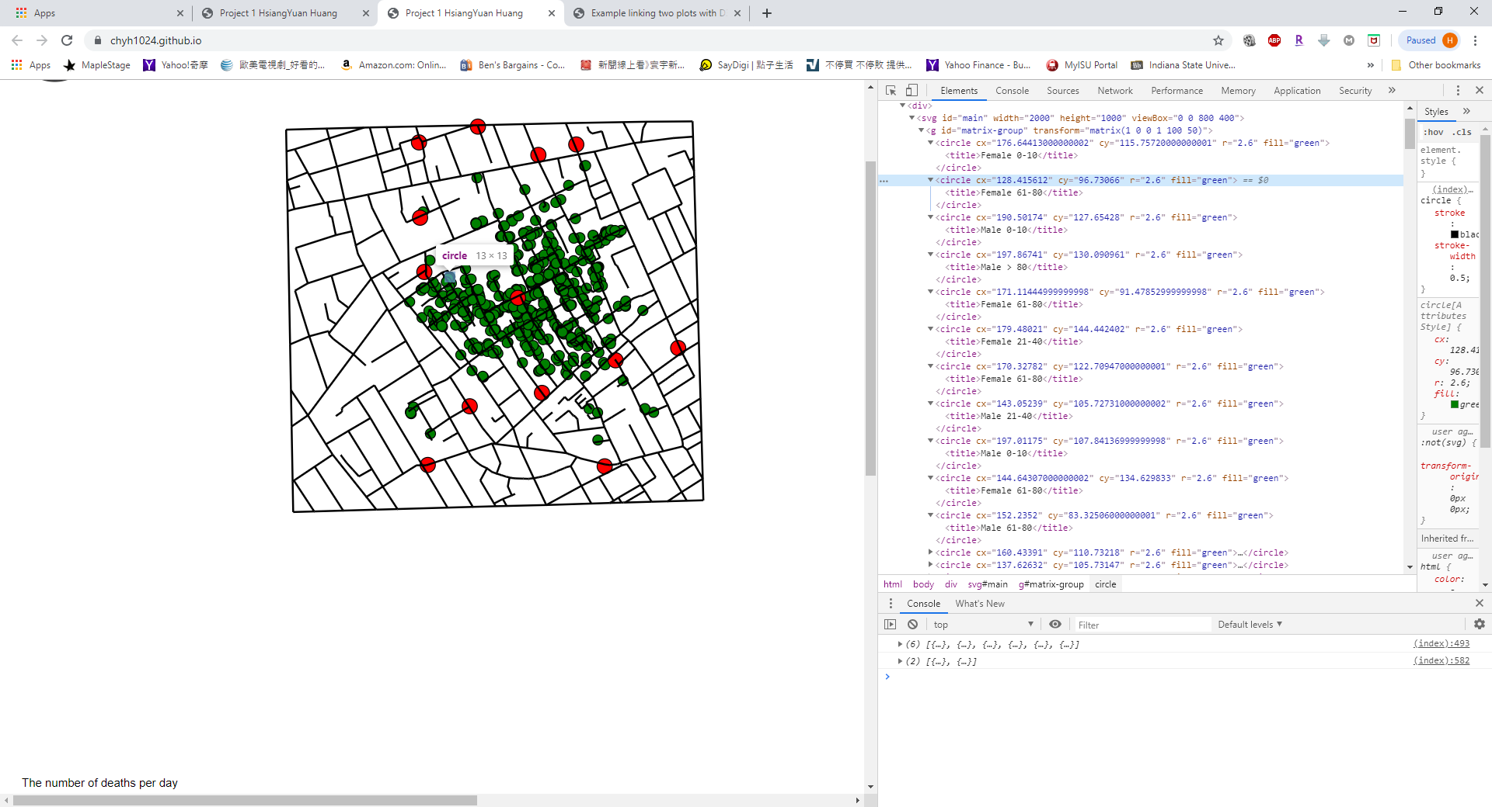

After I check first twenty locations, they can break into three sections, upper right, down right, and left of the center red dot. The three section may have something to do with the center pump, but more likely they are outbreak by death people.

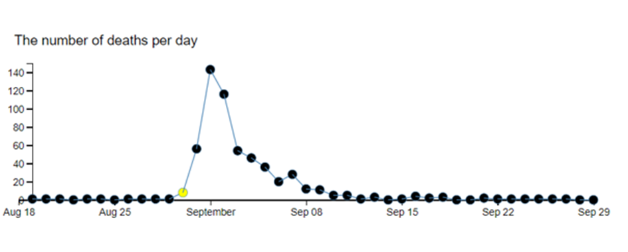

When I point the dots from the timeline chart, the dot will high lighted and pop out the detail data (can’t screen shot, will show in video). I believe the first outbreak was in Aug 30, 2019 with 8 deaths.

The Total deaths for ages show us that the Cholera have significant deaths rate on ages between 0-10 and >80.

The total deaths of gender chart present the deaths rate doesn’t has much difference on gender. Both male and female are almost the same deaths.

In this case, we have a clear hypothesis to start with, but are there other nuggets of insights one can uncover?