Phase 1 Test Cases

Project Name: Cruise Liner Management Service

Date: 9/19/2023

Project Manager: Neon Sapkota

Introduction
The Graphical User Interface (GUI) is a pivotal component of any software application as it forms the primary interaction point between the user and the system. An intuitive and error-free GUI ensures that users can efficiently navigate and utilize the application, leading to a positive user experience. This test plan details the testing methodology for the GUI of the Cruise Management System, specifically focusing on its tabbed navigation feature.

1.1 Purpose
The primary purpose of this GUI test plan is to ensure that the tabbed navigation within the Cruise Management System is functional and intuitive. Each tab should redirect to its corresponding section without glitches, ensuring smooth transitions and accurate content display. This test plan aims to identify and address any inconsistencies or errors in the tabbed navigation, ensuring that the final product meets the highest quality standards.

2.0 Test Strategy
2.1 Objective
The main objective of the GUI tests for the Cruise Management System is to ensure that:

- Each tab, when selected, displays the correct corresponding content.
- The transitions between tabs are smooth without any lags or errors.
- The visual elements of each tab (e.g., text, images, icons) are displayed correctly and are consistent with the system's design guidelines.

2.2 Approach
The testing will be conducted manually, with testers simulating the role of end-users. The following steps will be adhered to during the testing process:

  - Launch the Cruise Management System application.
  - Navigate to the section housing the tabs.
  - Sequentially click on each tab, observing the resultant content display and the transition behavior.
  - Document the actual result against the expected outcome in the provided test case template.

3.0 Test Cases
Test case # | Description | Inputs | Expected Result | Actual Result | Pass/Fail
1 | Test "OVERVIEW" tab selection | Click "OVERVIEW" | "OVERVIEW" content should be displayed | "OVERVIEW" content is displayed | Pass  (refer to Figure 1)
2 | Test "CRUISES" tab selection | Click "CRUISES" | "CRUISES" content should be displayed | "CRUISES" content is displayed | Pass  (refer to Figure 2)
3 | Test "MAINTENANCE" tab selection | Click "MAINTENANCE" | "MAINTENANCE" content should be displayed | "MAINTENANCE" content is displayed | Pass  (refer to Figure 3)
4 | Test "MANIFEST" tab selection | Click "MANIFEST" | "MANIFEST" content should be displayed | "MANIFEST" content is displayed | Pass  (refer to Figure 4)
5 | Test "BILLING" tab selection | Click "BILLING" | "BILLING" content should be displayed | "BILLING" content is displayed | Pass  (refer to Figure 5)
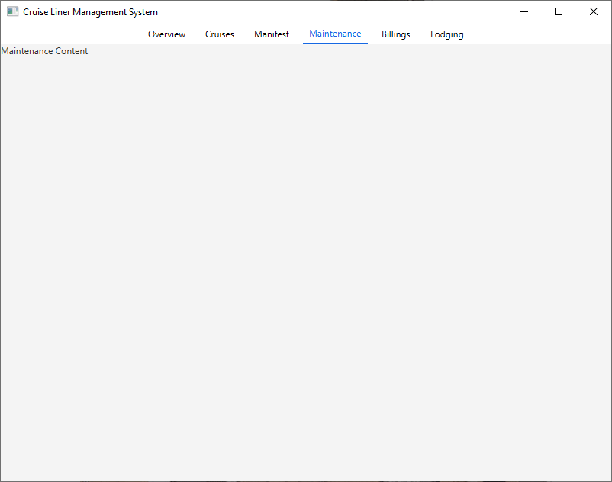  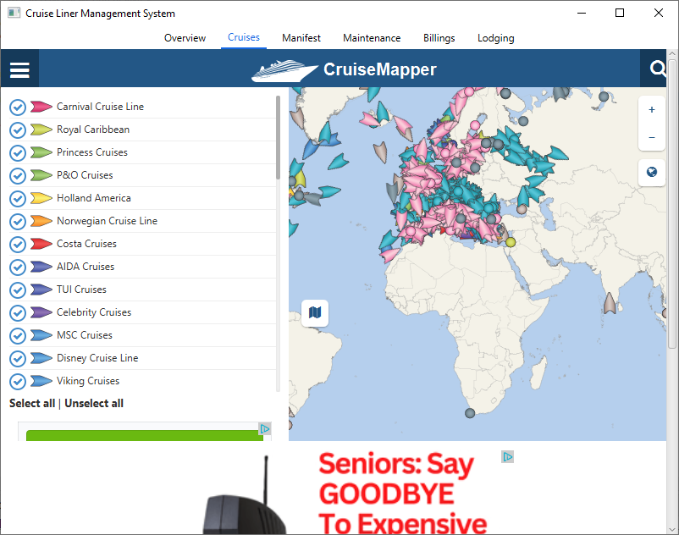  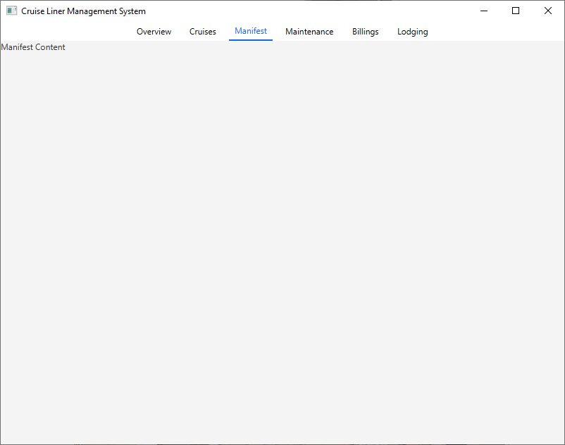  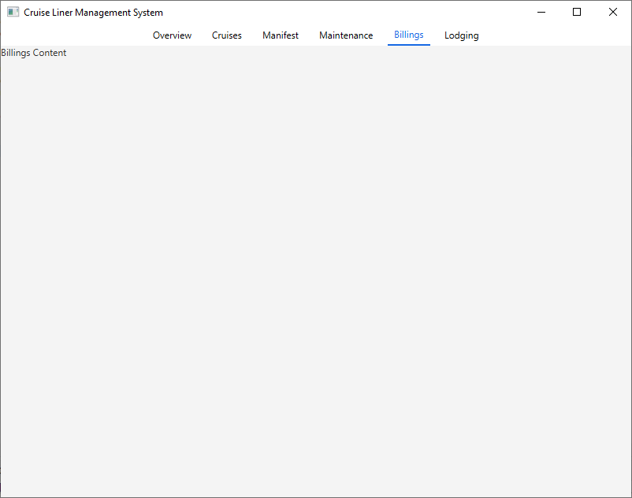  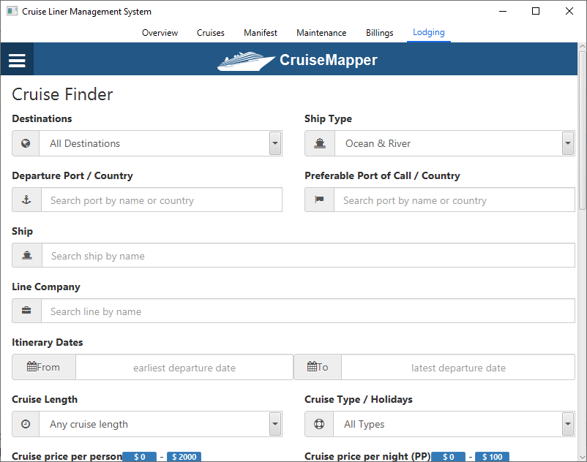  6 | Test "LODGING" tab selection | Click "LODGING" | "LODGING" content should be displayed | "LODGING" content is displayed | Pass  (refer to Figure 6)

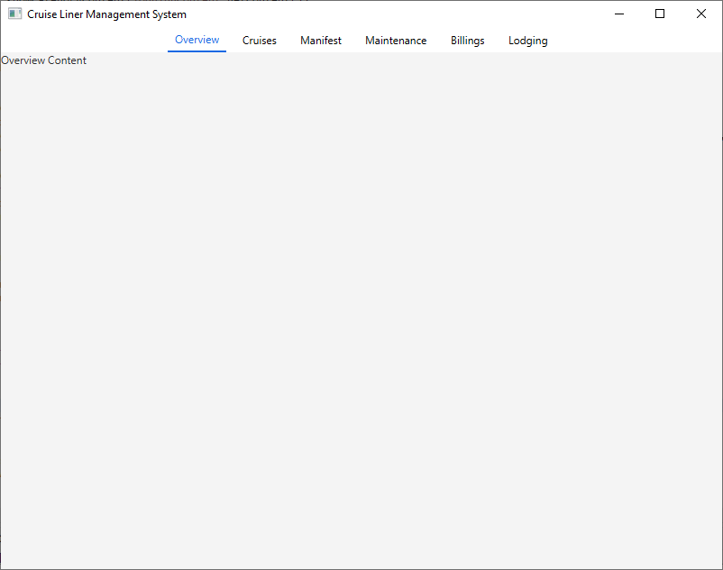

Figure. 1
Figure. 3
Figure. 2

Figure. 4
Figure. 5
Figure. 6
4.0 Approvals

Prepared by:
_Ti-Andre Sabur__________________ _9/19/2023____
Project Manager Date

Approved by:

__________________________________ _____________
Project Sponsor Date

__________________________________ _____________
Executive Sponsor Date

__________________________________ _____________
Client Sponsor Date

