Cruise Liner Management Services
Product Design Specification
Version 1.0
09/12/2023

VERSION HISTORY
Version  # | Implemented  By | Revision  Date | Approved  By | Approval  Date | Reason
UP Template Version: 12/31/07

TABLE OF CONTENTS
1 Introduction 5
1.1 Purpose of The Product Design Specification Document 5
2 General Overview and Design Guidelines/Approach 5
2.1 Assumptions / Constraints / Standards 5
3 Architecture Design 5
3.1 Logical View 5
3.2 Hardware Architecture 5
3.3 Software Architecture 5
3.4 Security Architecture 5
3.5 Communication Architecture 5
4 System Design 6
4.1 Use-Cases 6
4.2 Database Design 6
4.3 Data Conversions 6
4.4 Application Program Interfaces 6
4.5 User Interface Design 6
4.6 Performance 6
4.7 Section 508 Compliance 6
5 Product Design Specification Approval 7
Appendix A: References 8
Appendix B: Key Terms 9

Introduction

Purpose of The Product Design Specification Document

The product design specification document serves as a comprehensive reference that captures and manages essential information necessary for the effective definition of system architecture and design. Its primary purpose is to provide clear guidance to the development team regarding the architectural aspects of the system to be developed. This document plays a pivotal role in shaping the project's technical foundation and aligning it with the project's goals and objectives.

General Overview and Design Guidelines/Approach
This section describes the principles and strategies to be used as guidelines when designing and implementing the system.

Assumptions / Constraints / Standards

ASSUMPTIONS

The project assumes the availability of modern development tools and technologies to support the proposed system's design and implementation.

It is assumed that the development team possesses the necessary expertise and skills required to implement the design effectively.

The project assumes access to relevant data sources and APIs for real-time ship tracking and data retrieval.

Users will have access to devices with standard web browsers for accessing the system.

2.1.2 CONSTRAINTS

The design process must adhere to a fixed project timeline, necessitating efficient resource allocation and task management.

The system is primarily designed for desktop and laptop users; mobile responsiveness is not a priority in the initial release.

The project operates with a limited budget, requiring cost-effective design decisions and resource management.

2.1.3 STANDARDS

The development team will adhere to industry standard coding practices and conventions, promoting code readability and maintainability.

The design and implementation must comply with relevant security standards, including data encryption, user authentication, and access control.

The user interface (UI) design will follow established usability and accessibility standards to ensure a user-friendly experience.

The project will adhere to data privacy regulations to protect user data and privacy.

Architecture Design
This section outlines the system and hardware architecture design of the system that is being built.

Logical View
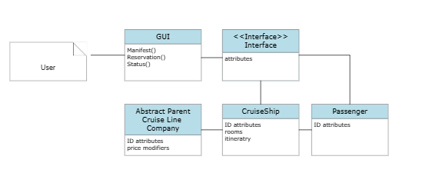

Hardware Architecture
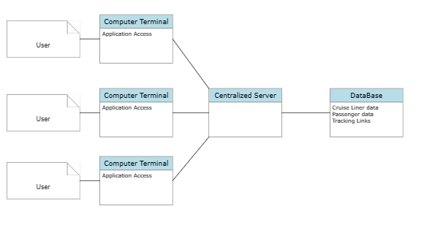

Software Architecture
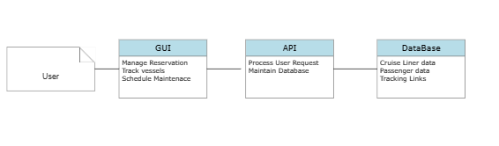

Security Architecture
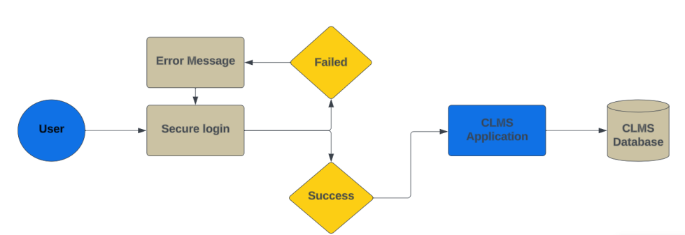
Figure

Communication Architecture
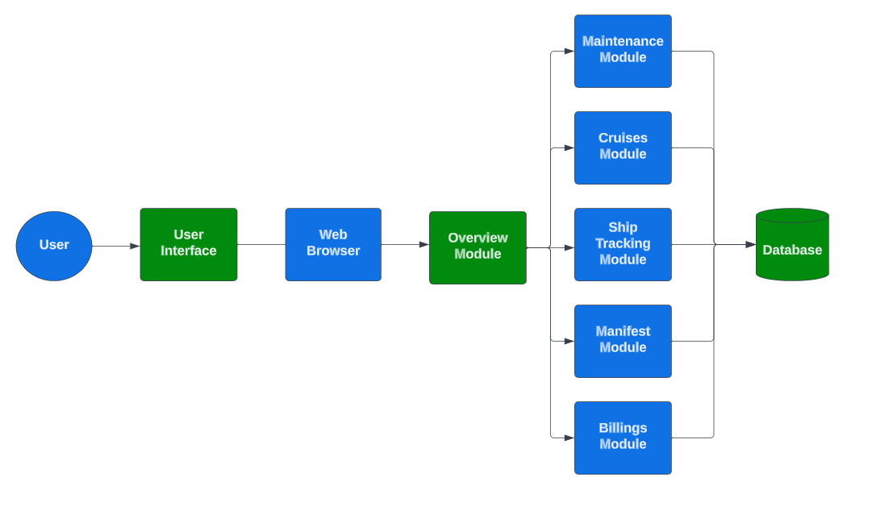
Figure

System Design

Use-Cases

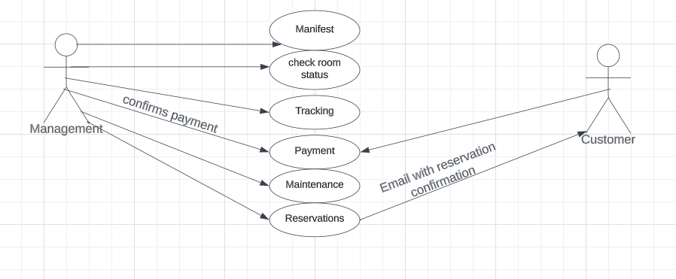Database Design
The database for the Cruise Liner Management Services application has been created in an Excel workbook.

Data Conversions
The data from the Excel workbook can be directly accessed from the Cruise Liner Management Services application.

Application Program Interfaces
The CLMS application will utilize various APIs for data retrieval, integration with external services, and communication with other systems. For detailed documentation of these APIs and their usage refer to CLMS project documentation.

User Interface Design
The User interface will be a Graphical User Interface (GUI) designed using Java Frameworks.

Performance
The performance of the CLMS application is a critical aspect of its design and implementation. Key performance factors include response times, data processing speed, and system scalability to accommodate a growing user base. Ensuring that the CLMS application meets performance requirements is essential to providing an efficient user experience. Performance testing will be integral parts of the development process to identify and address any performance issues. For detailed documentation of these performance metrics refer to CLMS project documentation.

Section 508 Compliance
All end user query and administrative interfaces to the CLMS system shall support Section 508 of the Rehabilitation Act (29 U.S.C. 794d), as amended by the Workforce Investment Act of 1998.

Product Design Specification Approval
The undersigned acknowledge they have reviewed the Cruise Liner Management Services Product Design Specification document and agree with the approach it presents. Any changes to this Requirements Definition will be coordinated with and approved by the undersigned or their designated representatives.

Signature: |  | Date:
Print Name:
Title:
Role:

Signature: |  | Date:
Print Name:
Title:
Role:

Signature: |  | Date:
Print Name:
Title:
Role:

