Text Analytics of Course Reviews on Coursera Platform

Chan Huan Yang  
*School of Computer Science*   
*University Science of Malaysia*Penang, Malaysia  
chyng2000@gmail.com

Ramindhran Raja Mohan  
*School of Computer Science*   
*University Science of Malaysia*Penang, Malaysia  
rampg08@hotmail.com

*Abstract*— Ratings and reviews are always the major consideration factor by online course seekers before they joining the course. However, it can be time-consuming to read all the information especially the course reviews. In this research work, our objective is to propose a text analytics pipeline that includes text cleaning, text lemmatization, sentiment analysis, text mining, and visualization that can help course seekers to gain a quick insight into the courses as well as enables them to make a quick comparison between multiple courses. The proposed text analytic pipeline was created in Python Jupyter Notebook and three different Python-related courses were chosen for the study and demonstration. The proposed text analytics pipeline solution was proved able to achieve our research objective. It can help course seekers to gain a quick insight including the positive and negative reviews into the courses as well as enables them to make a quick comparison between multiple courses. The n-gram analysis and word cloud generated were sufficient enough to provide an accurate and informative glance into the course. However, it fell short on sentiment analysis especially in detecting the negative reviews.

Keywords—text mining, n-gram, word cloud, reviews, sentiment analysis, Textblob, Vader

# Introduction

The concept of traditional education has changed drastically within the last couple of years. With the rise of the internet and new technologies, being physically present in a classroom isn’t the only learning option anymore. Nowadays, we can access a quality education whenever and wherever we want, as long as we have access to a computer. We are now entering a new era - the revolution of online learning.

Some of the best online learning platforms include Coursera, Skillshare, Udemy, Codecademy, Edx, Pluralsight, Future Learn, and Moodle. These online courses deliver a series of lessons to a web browser or mobile device which are conveniently accessible by the internet users at any time, anyplace. From working professionals to recent high school graduates, especially after the advent of Covid-19, many of them have found the reasons to take all or some of their courses online.

Ratings and reviews are always the major consideration factor by online course seekers before they joining the course. However, it can be time-consuming to read all the information especially the course reviews. In this research work, two different text analytics techniques such as term frequency and sentiment analysis are used to develop a simple model for online course seekers to gain quick insight into their shortlisted courses. The data source used in this work is the course reviews and ratings given by students on the Coursera platform. Three different Python-related courses from Coursera were chosen for the study and demonstration of the various text analytics techniques. The outputs of this work are word cloud that represents the positive and negative reviews of each course, which can provide quick insights about each course as well as offering simple comparison or similarity between courses.

# PROBLEM STATEMENT

There are many advantages to online education, but there are plenty of factors to consider before becoming an online student. It is always better to explore all the preferable courses before jumping into any decision. Opting for a course that is not appropriate for us can knock down our confidence and harm our potential and abilities. Although the plethora of choices available online can confuse us and making a decision can turn out to be very difficult.

In the world of online shopping, often buyers will purchase an item only after they see that other people also like it. And the easiest way to find out consumer sentiment is based on reviews. According to Fan & Fuel [1], 94% of online customers read reviews before making any purchasing decisions. For product-specific information, Spiegel Research Centre [2] shows that 95% of shoppers read reviews before making a purchase. Small Business Trends [3] shows 83% of job seekers use reviews to support their decisions on which companies to apply to and 84% of patients use online reviews to evaluate physicians before checking in. Authentic reviews are a valuable tool when we try to compare among different courses. They can help us make important decisions by learning about someone else’s experience

However, it could be time-consuming to review all the comments to identify the positives and negatives of a course. Furthermore, a course searching process will usually involve multiple courses. Therefore, an effective system is needed to assist in the review of all the student's comments.

# Research Question

In this research work, our objective is to create a text analytics-based solution for online course seekers to improve their course seeking process efficiency. The research questions for this work were:

* How text analytics techniques such as n-gram analysis, Wordcloud, and sentiment analysis can be applied to improve the online course searching process?
* What insights can be obtained by using text analytics techniques such as n-gram analysis, Wordcloud, and sentiment analysis?

# Purpose of the Study

In this research work, our objective is to propose a text analytics pipeline that includes text cleaning, text lemmatization, sentiment analysis, text mining, and visualization that can help course seekers to gain a quick insight into the courses as well as enables them to make a quick comparison between multiple courses.

# Research method

We have created a text analytic pipeline in Python Jupyter Notebook that can help course seekers to gain a quick insight into their shortlisted courses. The overall flow of text analytics is as below:

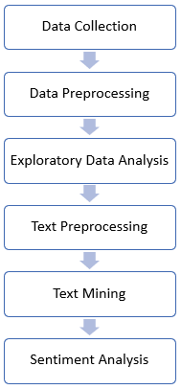

**Figure 1. The flow of text analytics used in Coursera’s course review analysis**

## Data Collection

The data used in this work is freely available at Kaggle <https://www.kaggle.com/imuhammad/course-reviews-on-coursera>. This dataset has a total of 1.4M student reviews on 604 different Coursera courses. The table below describes the column features of the dataset.

**Table 1. Description of dataset features**

|  |  |  |
| --- | --- | --- |
| variable | class | description |
| reviews | character | Course review |
| reviewers | character | The name of the reviewer who wrote the review |
| date_reviews | date | Date when the review was posted |
| rating | integer | The rating score which is given by the reviewer to the course |
| course_id | character | Course ID |

We only selected three different Python-related courses for the study and demonstration of the text analytics pipeline. The courses selected from the dataset are the following:

**Table 2. Three selected courses**

|  |  |  |
| --- | --- | --- |
| name | course_id | no_of_review |
| Programming for Everybody (Getting Started with Python) | python | 45218 |
| Python Data Structures | python-data | 33543 |
| Introduction to Data Science in Python | python-data-analysis | 14289 |

All three selected courses are highly related to Python. For example, the course “Programming for Everybody (Getting Started with Python) aims to teach everyone the basics of programming computers using Python. It covers the basics of how one constructs a program from a series of simple instructions in Python. The second course “Python Data Structures” aims to introduce the core data structures of the Python programming language. It will move past the basics of procedural programming and explore how a student can use the Python built-in data structures to perform increasingly complex data analysis. The third shortlisted course“ Introduction to Data Science in Python” aims to introduce the learner to the basics of the python programming environment, including fundamental python programming techniques. It will also introduce data manipulation and cleaning techniques using the popular python pandas data science library.

## Data Preprocessing

In this stage, data preprocessing and cleaning were performed to ensure the validity of the data. We have removed the duplicate reviews from the dataset. Besides, we also removed those reviews with string’s length less than three from our dataset. Finally, we used the package “langid” to label the language used in each review. “langid” is pre-trained from 5 different sources and able to recognize 97 different languages. We only selected those English labeled reviews for our study. Below is the number of reviews of each shortlisted courses after data preprocessing and cleaning:

**Table 3. Before and after data preprocessing**

|  |  |  |
| --- | --- | --- |
| name | no of review before data preprocessing | no of review after data preprocessing |
| Programming for Everybody (Getting Started with Python) | 45218 | 14642 |
| Python Data Structures | 33543 | 10571 |
| Introduction to Data Science in Python | 14289 | 4601 |

## Exploratory Data Analysis

In the exploratory data analysis stage, we analyzed data sets and summarized their main characteristics. We first took a look at the ratings given by students of each shortlisted course.

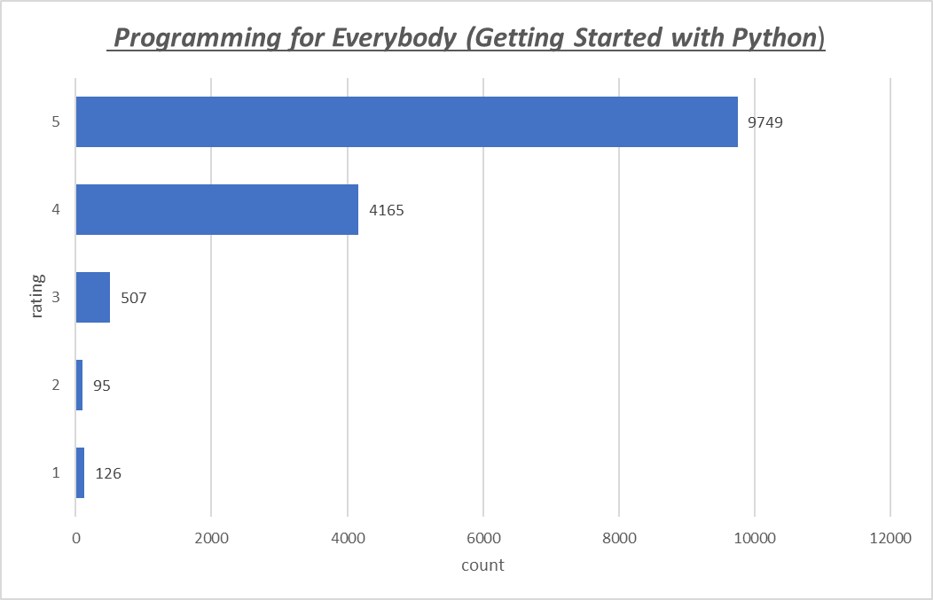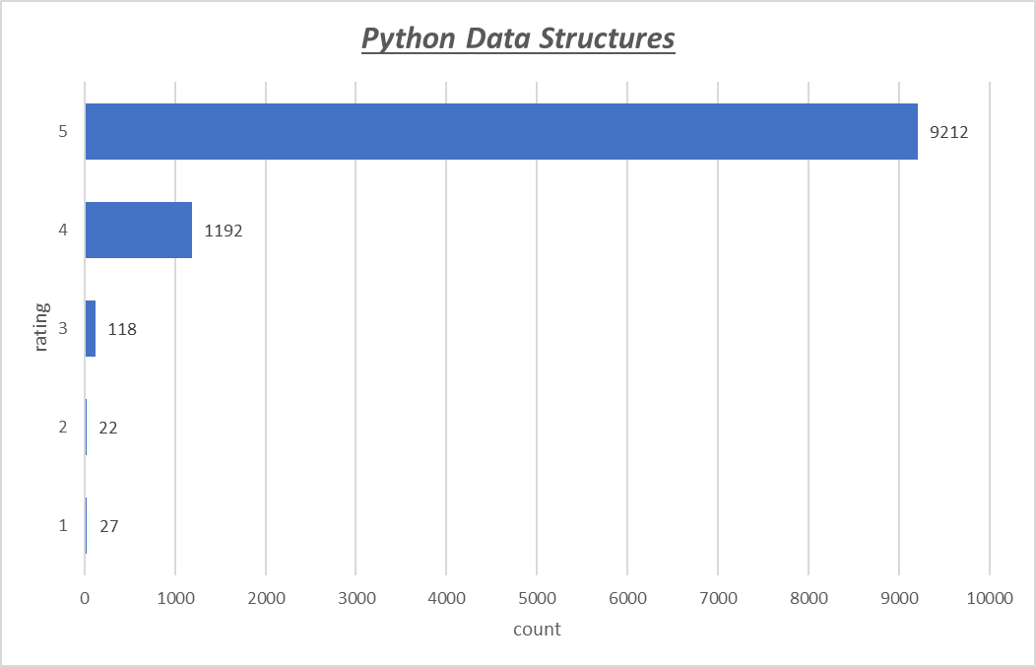

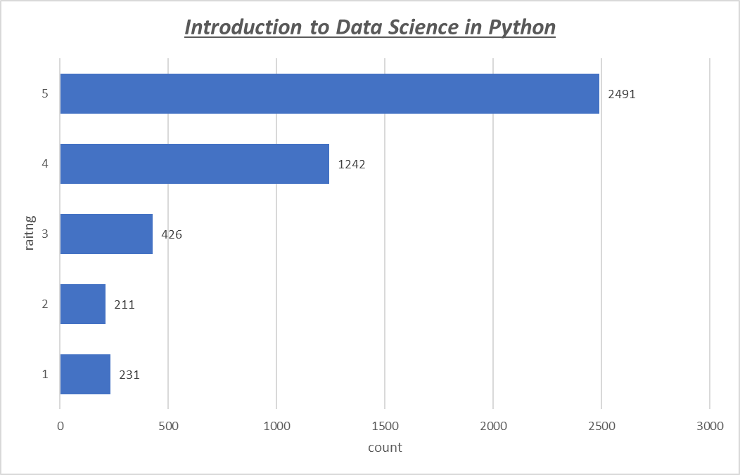

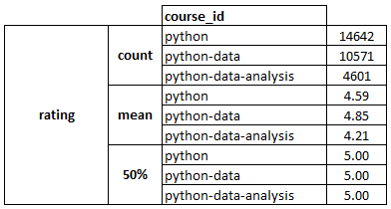

**Figure 2. Rating of each course**

From Figure 2, we can see that “Python Data Structures” has the highest average rating (4.85/5.00) among the three courses. We next looked at the review text length.

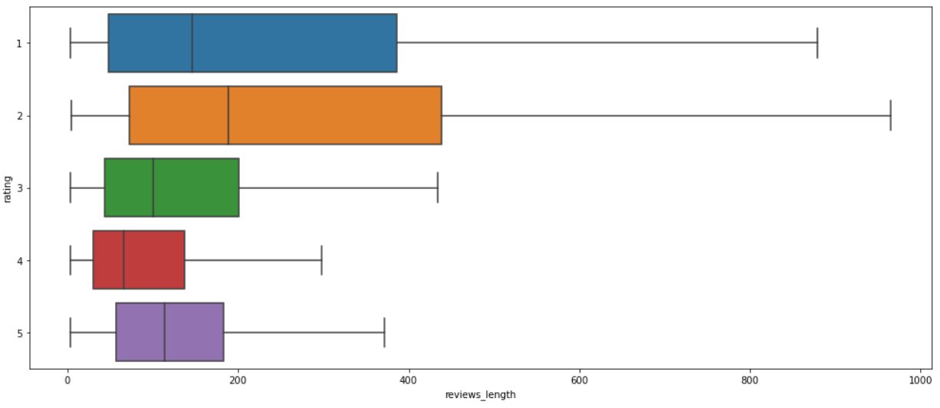

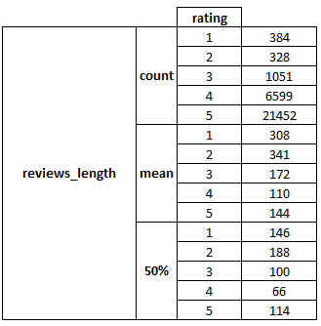

**Figure 3. Reviews length of each rating**

From Figure 3, seems like the length of reviews also tends to be higher when a lower rating (1 - 2) was given.

## Text Preprocessing

After exploratory data analysis, we performed text preprocessing and normalizing on the raw reviews in anticipation of text mining or NLP task. Numerous steps were taken to help us put all text on equal footing, many of which involve the comparatively simple ideas of substitution or removal. These include:

1. *Tokenization:* It is a step that splits longer strings of text into smaller pieces or tokens.
2. *Lowercasing:* It is a step that converts all uppercase characters in a string into lowercase characters
3. *Expanding Contractions:* Contractions are a shortened version of words or syllables. These shortened versions or contractions of words are created by removing specific letters and sounds. For example in English, (do not) to (don’t) and (I would) to (I’d). Converting each contraction to its expanded, original form helps with text standardization.
4. *Punctuation Removal:* It is a step that removes all punctuations from a string.
5. *Lemmatization:* Lemmatization on the surface is very similar to stemming, where the goal is to remove inflections and map a word to its root form. The only difference is that lemmatization tries to do it the proper way. It doesn’t just chop things off, it transforms words to the actual root.
6. *Stopword Removal:* Stop words are a set of commonly used words in a language. The intuition behind using stop words is that, by removing low information words from a text, we can focus on the important words instead.

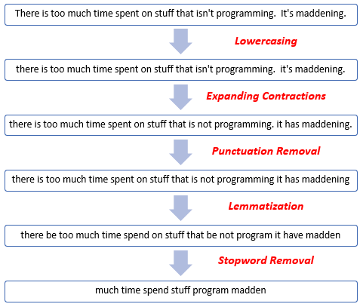

**Figure 4. Text preprocessing example of a review**

## Text Mining

To identify the significant insights from the course reviews, basic text analytic techniques which are word frequency or collocation have been applied. Word frequency can be used to identify the most recurrent terms or concepts in a set of data. Collocation refers to a sequence of words that commonly appear near each other. The most common types of collocations are bigrams (a pair of words that are likely to go together. Identifying collocations and counting them as one single word helped us to improve the granularity of the text, allows a better understanding of its semantic structure, and leads to more accurate text mining results. For this research works, we applied bigram and trigram analysis on all three shortlisted courses.

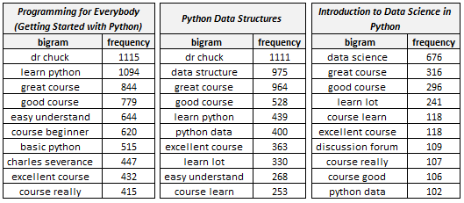

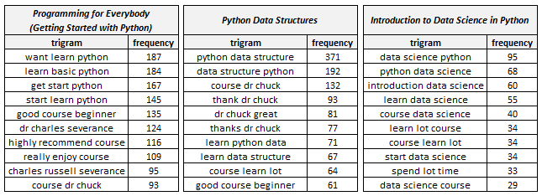

**Figure 5. Top 10 bigram and trigram of each shortlisted course**

Data visualization is the presentation of data in a pictorial or graphical format. It enables decision-makers to see analytics presented visually, so they can grasp difficult concepts or identify new patterns. In order to help the course seekers to has a glance of insight into the reviews, we also created six different word clouds based on the data generated from bigram and trigram analysis. Figure 6 are the word clouds generated using n-gram data.

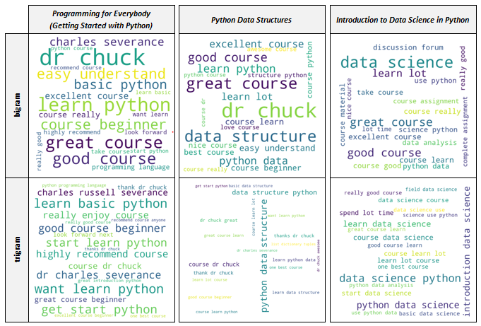

**Figure 6. Word cloud of each shortlisted course**

By looking at the bigram and trigram analysis, we can easily get some quick insights from them. For example, course 1 is conducted by someone called Dr. Chuck or Charles Severance. It is somehow a Python programming course and generally has positive reviews. For course 2, it is also taught by someone called Dr. Chuck or Charles Severance. It is somehow a Python data structure course and generally has very positive reviews too. For course 3, it is somehow related to data science and Python.

## Sentiment Analysis

After performed basic text mining techniques, we proceed to apply sentiment analysis to the course reviews. Sentiment analysis (or opinion mining) is a natural language processing technique used to determine the polarity (positive, negative, neutral) of the data. It was performed on the course reviews to help course seekers to have a quick insight into the possible positive and negative reviews of their shortlisted courses. It is extremely important for course seekers because it helps them to quickly understand the overall opinions of the previous students. By automatically sorting the sentiment behind reviews, we can make a faster and more accurate decision

There are many packages available in Python which use different methods to do sentiment analysis. For this work, we used Vader and Textblob to analyze the polarity of our shortlisted course reviews. Both Textblob and Vader using rule-based sentiment analysis algorithms. A rule-based system automatically performs sentiment analysis based on a set of manually crafted rules. Here’s a basic example of how a rule-based system works [4]:

* Defines two lists of polarized words.
* Counts the number of positive and negative words that appear in a given text.
* If the number of positive word appearances is greater than the number of negative word appearances, the system returns a positive sentiment and vice versa. If the numbers are even, the system will return a neutral sentiment.

Textblob is a simple python library that offers API access to different NLP tasks such as sentiment analysis, spelling correction, etc. Textblob sentiment analyzer returns polarity which is a float that lies between [-1,1]. -1 indicates negative sentiment and +1 indicates positive sentiments [5]. It will ignore the words that it doesn’t know, it will consider words and phrases that it can assign polarity to and averages to get the final score.

Valence aware dictionary for sentiment reasoning (Vader) is another popular Python sentiment analyzer. It uses a list of lexical features (e.g. word) which are labeled as positive or negative according to their semantic orientation to calculate the text sentiment [6]. Same as Textblob, Vader sentiment analyzer also returns polarity which is a float that lies between [-1,1]. -1 indicates negative sentiment and +1 indicates positive sentiments.

We performed the sentiment polarity on the reviews of shortlisted courses using both Textblob and Vader and then get the average polarity score of them. All three shortlisted courses show negatively skewed distribution which meant that they have a relatively positive sentiment. However, we observed that the course “Introduction to Data Science in Python” clearly has some negative sentiment in which the polarity value is lower than 0. Below is the distribution of sentiment polarity of the three shortlisted courses.

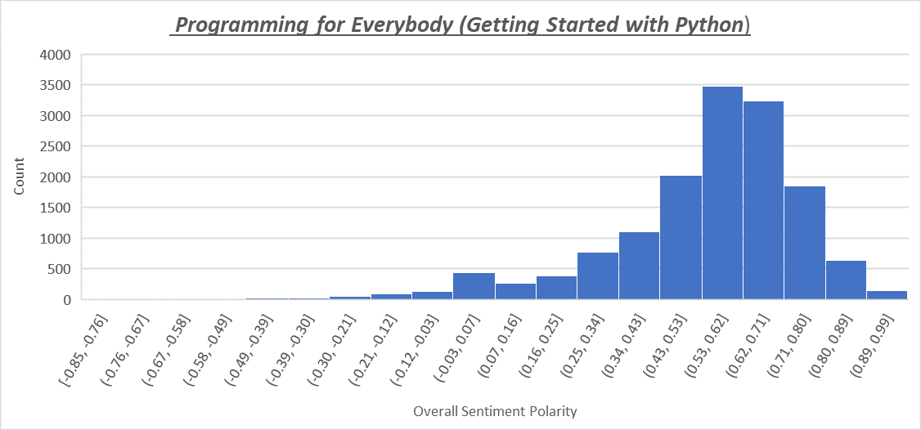

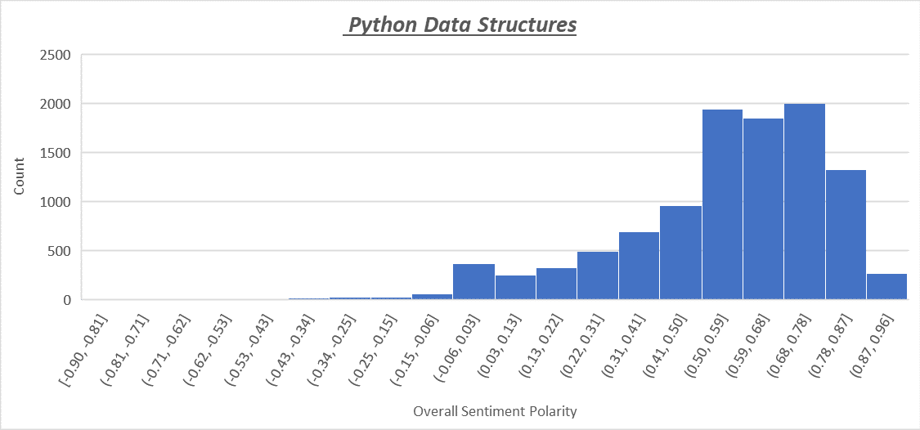

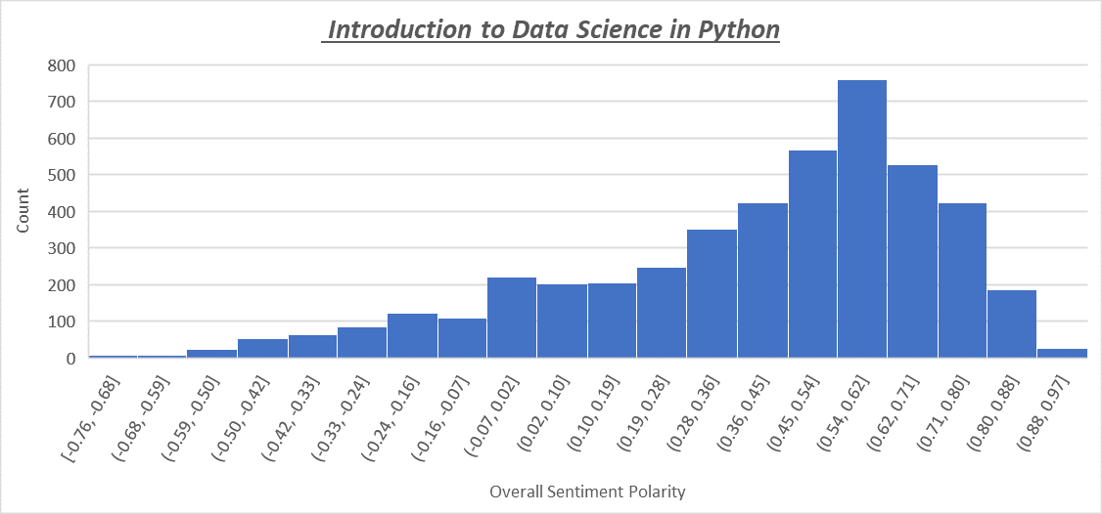

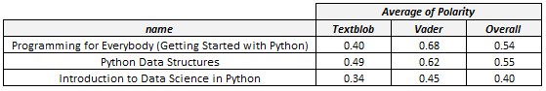

**Figure 7. Sentiment polarity of each shortlisted course**

After obtained the polarity of each review, we labeled those polarities that score greater than 0 as positive reviews, lower than 0 as negative reviews. Normally a course seeker will always check for negative and positive reviews before they decide whether to purchase or not. Hence, we also created n-gram analysis and word cloud to help course seeker to has a glance of insight into the negative and positive reviews of each shortlisted course. Below is the n-gram analysis of all three shortlisted courses' negative and positive reviews.

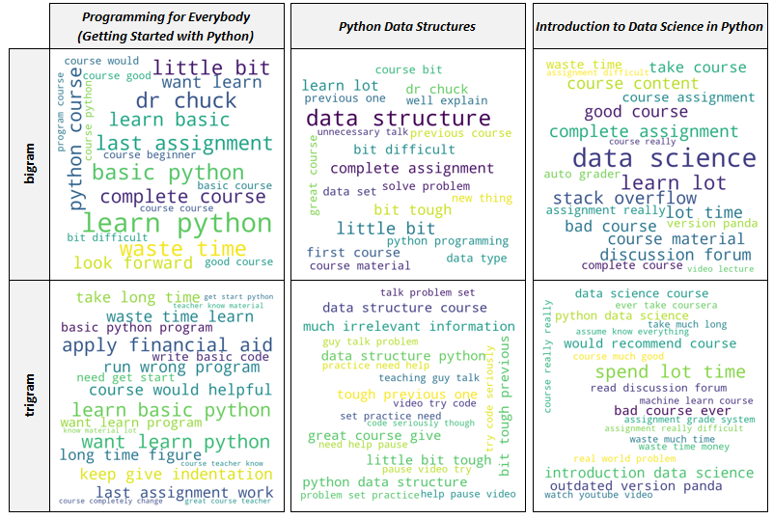

**Figure 8. Word cloud of each shortlisted course’s negative reviews**

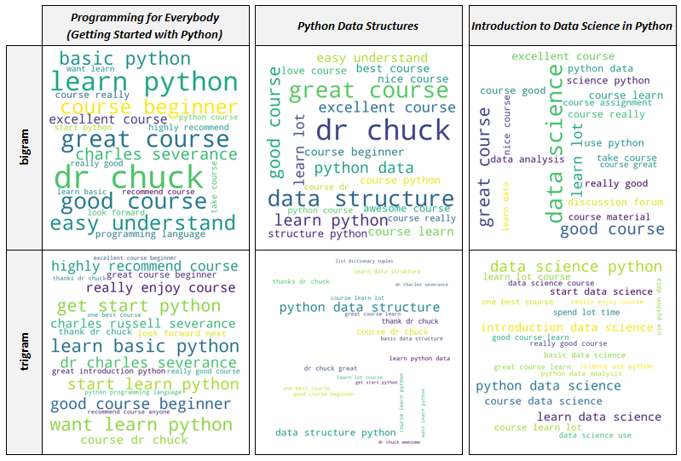

**Figure 9. Word cloud of each shortlisted course’s positive reviews**

Our review polarity data is negatively skewed. Hence, from Figure 9, we can notice that very little new insight can be extracted from the positive review word clouds as the bigrams and trigrams generated is similar to the word clouds in Figure 6. However, some interesting insights can be found in the negative review word clouds (Figure 8). For example, for the course “Introduction to Data Science in Python” some reviews highlight that it using an outdated version of Pandas and the assignment is really difficult.

# DISCUSSIONS AND FINDINGS

In this work, a qualitative evaluation method was used to evaluate the usability of the n-gram/word cloud platform to represent the company’s insight. In the evaluation part, the information was collected from the Internet and Coursera itself to verify whether the n-gram/word cloud in Figures 5 and 6 are accurate and useful in representing the overall insight about the shortlisted courses. The summary of the evaluation is shown in Figure 10.

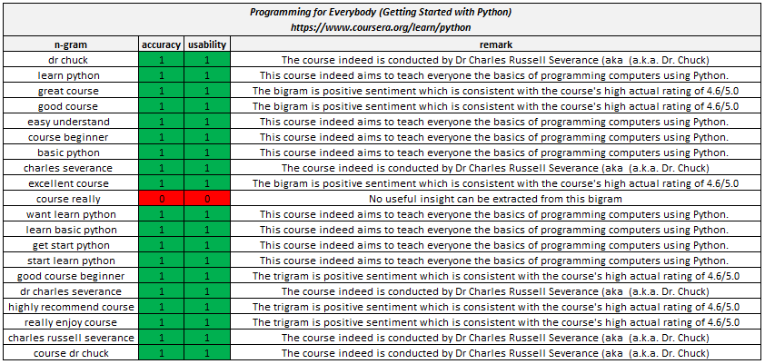

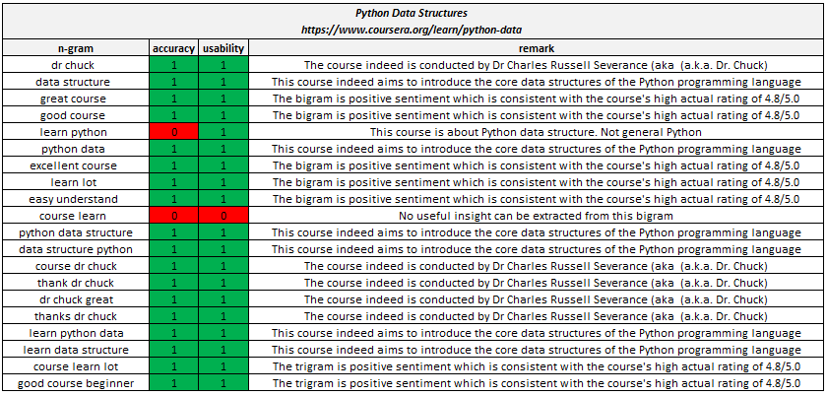

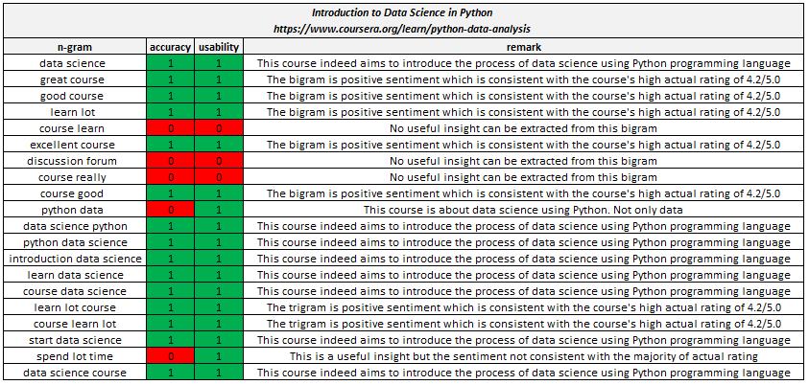

**Figure 10. Evaluation of accuracy and usability of n-gram**

The evaluation result shows that our n-gram analysis performs well by scoring 52/60 in accuracy and 55/60 in usability respectively. Overall, the system can portray the overall insight of the shortlisted course correctly and informatively. However, there is some concern about repetitive or redundant information is generated from n-gram analysis. For example, trigram “data science python” and “python data science” both actually carry the same insight but only different in their term sequence.

The sentiment polarity score generated using Textblob/Vader was evaluated by comparing them with the actual rating given by the previous students.

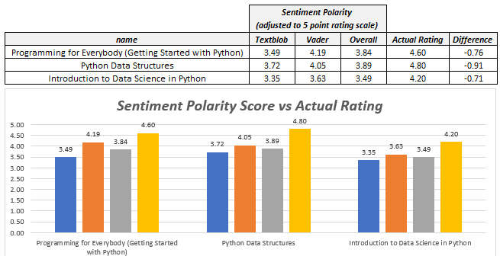

**Figure 11. Evaluation of sentiment polarity score**

As we can see from Figure 11, the overall sentiment polarity score generated by Textblob/Vader averagely lower than the actual rating by about 0.8. Although the error is quite big there (-16%) however the system still able to get the ranking right which is the course “ Python Data Structures” > “Programming for Everybody” > “Introduction to Data Science in Python”.

The sentiment classification performance of the Textblob/Vader also was evaluated by comparing it with the actual rating. For those actual rating with value > 3, we labeled them as “positive” and vice versa. The model performance of Textblob/Vader was then evaluated using a confusion matrix and classification report.

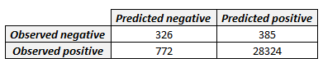

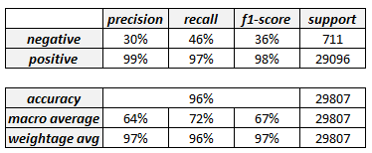

**Figure 12. Confusion matrix and classification report**

As we can see from Figure 12, the model shows a 96% accuracy. Accuracy is the number of correct predictions made by the model by the total number of records. However, for an imbalanced dataset, accuracy is not a valid measure of model performance as the positive reviews of our dataset already consist of 97% of the total review. So accuracy is not the right measure for model performance in this scenario. The model has a high true positive rate of 97% which indicated it performs well when coming to predict positive sentiment. However, it is quite poor when comes to predict negative sentiment as the true negative rate is only 46%.

The major challenging issues in sentiment analysis is highly related to the correct interpretation of the context in which certain words are used. It is still difficult for a vast majority of tools such as Textblob and Vader to precisely evaluate what truly is a negative and a positive statement. Both the Textblob and Vader simply not advanced enough to successfully deal with the sarcasm or context of some of the discussions. Think of an example of someone being sarcastic in their reviews. Have a look at the simple review below which is picked from our dataset:



**Figure 13. Example review from the dataset**

This review went through all the text preprocessing/normalization steps and had been reduced to:

*“easy course complete day without much effort really get much think would”*

Both the Textblob and Vader labeled it as positive with a polarity score of 0.17 and 0.44 respectively. The reason for it is the word “easy” which is positive in its essence. However, in this particular case, it was used to express disappointment and isn’t a good thing for the student’s expectation. Still, it’s a perfect example that in some instances, a pair of eyes of a person is essential to properly evaluate the sentiment of a piece of social media content.

# CONCLUSION

In conclusion, the proposed text analytics pipeline solution able to achieve our research objective. It is able to help course seekers to gain a quick insight including the positive and negative reviews into the courses as well as enables them to make a quick comparison between multiple courses. The quick insight can serve as a good reference for the course seekers and helps them to save time during the course selection process. The solution also can serve as a good platform for the course provider to study and understand their course strength and weakness. In this work, the n-gram analysis and word cloud are sufficient enough to provide an accurate and informative glance into the course. However, it falls short on sentiment analysis especially in detecting the negative reviews.

##### Acknowledgment

The authors gratefully acknowledge the contribution of Dr. Gan Keng Hoon upon providing necessary guidance, knowledge, and support throughout this work.

##### References

1. <https://fanandfuel.com/no-online-customer-reviews-means-big-problems-2017/>
2. <https://spiegel.medill.northwestern.edu/_pdf/Spiegel_Online%20Review_eBook_Jun2017_FINAL.pdf>
3. <https://smallbiztrends.com/2017/04/importance-of-online-reviews.html>
4. <https://monkeylearn.com/sentiment-analysis/>
5. <https://textblob.readthedocs.io/en/dev/>
6. <https://pypi.org/project/vaderSentiment/>

**IEEE conference templates cont**

**ain guidance text for composing and formatting conference papers. Please ensure that all template text is removed from your conference paper prior to submission to the conference. Failure to remove template text from your paper may result in your paper not being publis**