Assignment 1
Part A
Gary Geunbae Lee
CSED342 - Artificial Intelligence

Contact: TA Yejin Min (yeajinmin@postech.ac.kr), Sujin Woo (happysujin@postech.ac.kr)

Before moving onto the main part of the assignment (Part B), you will complete several simple review questions. Refer to the class slides before answering the questions. Write your answers to Word and save the file as "PartA_studentID.docx".

Note: There is no partial credit in this section of the assignment.

A-1 CSP

You are planning a travel package for a family trip. There are several choices, each represented as a variable:
(A)ttraction, (B)oarding Option, (C)uisine, and (D)estination Memory. The domains of the variables are as follows:

(A)ttraction: (m)useum, (p)ark
(B)oarding Option: (t)rain, (f)light, (b)us
(C)uisine: (st)reet food, (r)estaurant, (h)otel buffet
(D)estination Memory: (ph)oto book, (s)ouvenir, (d)iary

It must obey the following constraints:

- The chosen package must include either an attraction that is a museum or a cuisine that is street food or hotel buffet.
- If the chosen attraction is a park, then the boarding option must be ‘train’.
- The package must include at least one of the following: boarding option bus, destination memory souvenir, or destination memory diary.

Q1. Draw the constraint graph over the variables A, B, C, and D. (2points)
- C - A- B- D

Q2. Imagine we first assign A = p. Cross out eliminated values to show the domains of the variables after forward checking.
Note: In this step, you should not treat other variables as newly assigned even if their domain is reduced to a single value. (2points)
- A: {p}
B: {t}
C: {st, h}
D: {ph, s, d}

Q3. Again imagine we first assign A = p. Cross out eliminated values to show the domains of the variables after arc consistency has been enforced. (2points)
- A: {p}
B: {t}
C: {st, h}
D: {s, d}

Q4. Assume that exactly one value is chosen from the domain of each variable (i.e., one attraction, one boarding option, one cuisine, and one destination memory must be selected).
Give at least two solutions for this CSP, or state that none exists. (2points)
- 1) A = m / B = b / C = r / D = ph
  - 검증) (i) A=m이므로 참 / (ii) A ≠p이므로 참 / (iii) B = b이므로 참
- 2) A = p / B = t / C = st / D = s
  - 검증) (i) C = st이므로 참 / (ii) A = p, B = t이므로 참 / (iii) D = s이므로 참

A-2 Search
We are dealing with a search problem modeled as a graph. The initial node is S, and the single goal node is G. Whenever a heuristic is required, please apply the one specified below.

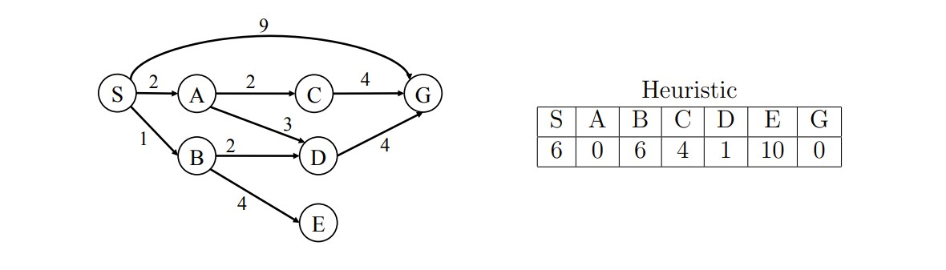

Q5. What path will BFS tree search return? (2points)
- S-G

Q6. What path will UCS tree search return? (2points)
- S-B-D-G

Q7. For the A* graph search, complete the table below by writing the path expanded, and the fringe (ordered by path) step by step, until the goal state is reached. Hint: For ‘path expanded’, write the optimal path from S up to this step.
For ‘closed list’, write the set of searched nodes up to this step. (2points)

Path expanded  S  S->A  S->A->D  S->B  S->A->C  S->A->C->G | Closed list  {S}  {S, A}  {S, A, D}  {S, A, D, B}  {S, A, D, B, C}  {S, A, D, B, C, G} | Fringe(ordered by path. For example, S-A-C (cost))  S-A(2), S-B(7), S-G(9)  S-A-C(8), S-A-D(6), S-B(7), S-G(9)  S-A-C(8), S-A-D-G(9), S-B(7), S-G(9)  S-A-C(8), S-A-D-G(9), S-B-E(15), S-G(9)  S-A-C-G(8), S-A-D-G(9), S-B-E(15), S-G(9)  Goal Reached

