Assignment 2. Car Tracking
Gary Geunbae Lee CSED342 - Artificial Intelligence
Contact: TA Yejin Min(yeajinmin@postech.ac.kr), Sujin Woo(happysujin@postech.ac.kr)

Part A

Before moving onto the main part of the assignment (Part B), you will complete several simple review questions. Refer to the class slides before answering the questions. Write your answers to Word and save the file as "PartA_studentID.pdf".

Note: There is no partial credit in this section of the assignment.

Write all answers either as irreducible fractions or rounded to three decimal places.

A-1 Probability

Q1. Jackpot? (2pts)

A casino has a slot machine that operates in “jackpot mode” only 1 hour out of every 40. When the machine is in jackpot mode, its lights flash with a probability of 80%. Even when it is not in jackpot mode, due to occasional malfunctions the lights may still flash, with a probability of 10%. One customer reports seeing the slot machine’s lights flashing. What is the probability that the machine is actually in jackpot mode at this time?

- Slot machine이 jackpot mode인 사건을 J, slot machine의 빛이 flash하는 사건을 F라 하면 문제에서 구해야 하는 확률은 P(J | F)이다.
문제에서 알 수 있는 확률은 P(J)=1/40, P($J^{c}$)=39/40, P(F | J)=0.8, P(F | $J^{c}$)=0.1
베이즈 정리에 의해
P(J | F) = P(F | J) * P(J) / P(F)
P(F) = P(F | J) * P(J) + P(F | $J^{c}$)*P( $J^{c}$)=0.1175 이므로 P(J | F) = 8/47
- Answer: 8/47 $≈$ 0.170

Instruction: Be sure to write out the full solution process. To receive credit, both the final answer and the solution must be entirely correct.

A-2 Bayes’ Net

Assume we are given the following Bayes’ net, with the associated conditional probability tables (CPTs).
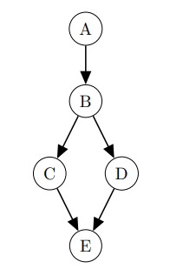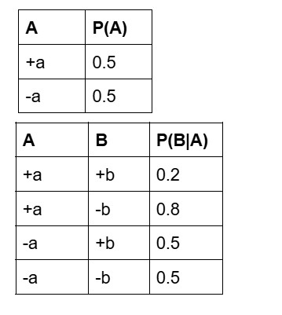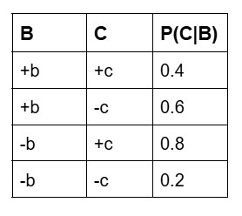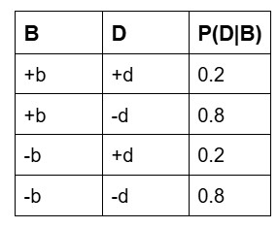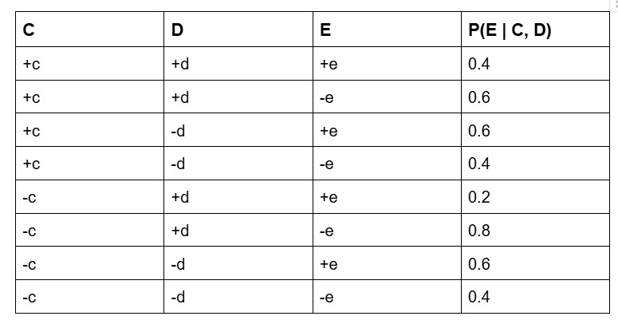

You are given a set of the following samples, but are not told whether they were collected with rejection sampling or likelihood weighting.

−a −b +c +d +e
−a +b +c −d +e
−a −b −c −d +e
−a −b +c −d +e
−a +b +c +d +e

Q2. Assuming these samples were generated from rejection sampling, what is the sample based estimate of P(+b | −a, +e)? (2pts)
- 주어진5개의 sample이 -a, +e를 만족하고 그 중 -a, +b, +c, -d, +e / -a, +b, +c, +d, +e 가 +b에 해당되므로 답은 2/5
- Answer: 2/5 = 0.4

Q3. Assuming these samples were generated from likelihood weighting, what is the sample-based estimate of P(+b | −a, +e)? (2pts)
- 각 샘플의 가중치(w_i)를 P(-a) * P(+e | c_i, d_i)로 계산한 결과는 아래와 같다.
샘플 1: w_1 = P($-$a) * P(+e | +c, +d) = 0.5 * 0.4 = 0.2
샘플 2: w_2 = P($-$a) * P(+e | +c, -d) = 0.5 * 0.6 = 0.3
샘플3: w_3 = P($-$a) * P(+e | -c, -d) = 0.5 * 0.6 = 0.3
샘플 4: w_4 = P($-$a) * P(+e | +c, -d) = 0.5 * 0.6 = 0.3
샘플 5: w_5 = P($-$a) * P(+e | +c, +d) = 0.5 * 0.4 = 0.2
- 전체 가중치 합: 1.3, 쿼리를 만족하는 샘플(2, 5)의 가중치 합: 0.5 -> 추정치: 5/13

- Answer: 5/13 $≈$ 0.385

Q4. Again, assume these samples were generated from likelihood weighting. However, you are not sure about the original CPT for P(E | C, D) given above being the CPT associated with the Bayes’ Net: With 50% chance, the CPT associated with the Bayes’ Net is the original one. With the other 50% chance, the CPT is actually the
CPT below. Given this uncertainty, what is the sample-based estimate of P(+b | −a, +e)? (2pts)
- 아래 CPT 기준 가중치(w_i)를 P(-a) * P_2(+e | c_i, d_i) = 0.5 * P_2(+e | c_i, d_i)로 계산한 결과는 아래와 같다.
샘플 1: w_1 = 0.5 * P_2(+e | +c, +d) = 0.5 * 0.8 = 0.4
샘플2: w_2 = 0.5 * P_2(+e | +c, -d) = 0.5 * 0.4 = 0.2
샘플 3: w_3 = 0.5 * P_2(+e | -c, -d) = 0.5 * 0.6 = 0.3
샘플 4: w_4 = 0.5 * P_2(+e | +c, -d) =0.5 * 0.4 = 0.2
샘플 5: w_5 = 0.5 * P_2(+e | +c, +d) = 0.5 * 0.8 = 0.4
샘플별 기대 가중치(E(w_i) = (원래 CPT에서 계산된 가중치+아래 CPT에서 계산된 가중치) / 2는 아래와 같다.
E(w_1) = 0.3, E(w_2) = 0.25, E(w_3)= 0.3, E(w_4) = 0.25, E(w_5) = 0.3
- 전체 기대 가중치 합: 1.4, 쿼리를 만족하는 샘플(2, 5)의 기대 가중치 합: 0.55 -> 0.55/1.4
- Answer: 11/28 $≈$ 0.393
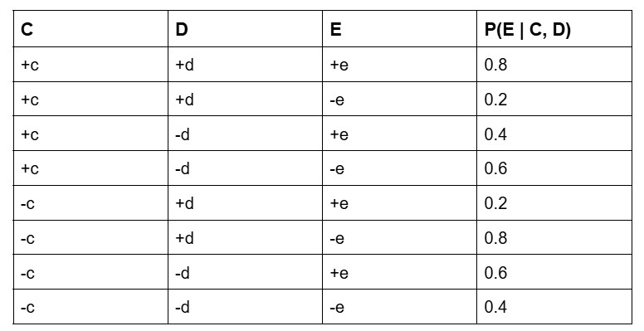

Q5. Suppose you choose to use Gibbs sampling to estimate P(B, E | +c, −d). Assume the CPTs are the same as the ones for parts (a) and (b). Currently your assignments are the following:

−a −b +c −d +e

Q5-1. Suppose the next step is to resample E. What is the probability that the new assignment to E will be +e? (2pts)
- E의 확률은 부모 노드인 C, D에만 의존함
- P(+e | +c, −d) = 0.6

Q5-2. Instead, suppose the next step is to resample A. What is the probability that the new assignment to A will be +a? (2pts)
- P(+a | -b)는 P(+a)P(-b | +a)에 비례함
A= +a 일 때 P(+a) * P(-b | +a) = 0.5 * 0.8 = 0.4
A= -a일 때 P(-a) * P(-b | -a) =0.5 * 0.5 = 0.25이므로 답은 0.4/(0.4+0.25) = 8/13
- Answer: 8/13 $≈$ 0.615

Q5-3. Instead, suppose the next step is to resample B. What is the probability that the new assignment to B will be +b? (2pts)
- P(B | -a, +c, -d, +e)는 P(B | -a)P(+c | B)P(-d | B)에 비례함
B= +b일 때 P(+b | -a)*P(+c | +b)*P(-d | +b) = 0.5 * 0.4 * 0.8 = 0.16
B= -b일 때 P(-b | -a)*P(+c | -b)*P(-d | -b) = 0.5 * 0.8 * 0.8 = 0.32
따라서 답은 0.16 / (0.16 + 0.32) = 1/3
- Answer: 1/3$≈$ 0.333

