Monthly Education Insights Analysis
Analysis of attendance seasonality, year-level attendance patterns, and the relationship between attendance and assessment outcomes.

Purpose Of This Report
This report provides an analyst interpretation of monthly attendance and assessment patterns across 2024 and 2025. It is intended to turn dashboard metrics into a concise evidence narrative for stakeholder reporting.
The analysis uses selected charts from the Power BI dashboard and complements the dashboard by explaining the main trends, cohort differences, caveats, and possible follow-up actions. It does not document the underlying data engineering pipeline.
The report focuses on three questions: when attendance risk increases, which year-level groups require closer monitoring, and how attendance bands are associated with assessment outcomes. The data is synthetic and should be read as portfolio evidence rather than real student or school performance reporting.

Executive Summary
This report presents a clear monthly attendance story across 2024 and 2025:
- attendance declines during winter months, especially June to August;
- Year 7 transition and senior secondary cohorts show different attendance behaviour from other year levels;
- senior secondary year levels have the highest share of student-months below the 80% attendance threshold;
- higher attendance bands are associated with stronger assessment scores across Reading, Numeracy, and Writing.

Key Statistics
The table below summarises the key statistics used in this analysis. The figures are drawn from the Power BI reporting outputs and are based on synthetic data developed for this portfolio project.
Statistic | Value | Brief interpretation
Overall attendance rate | 88.81% | Attendance sits below a perfect participation benchmark and shows room for targeted monitoring.
Winter attendance rate | 83.91% | Attendance is materially lower during June to August.
Non-winter attendance rate | 90.68% | Attendance is stronger outside winter months.
Winter gap | -6.78 pp | The winter decline is large enough to require seasonal planning.
Year 7 attendance rate | 85.86% | Year 7 transition attendance is weaker than the overall rate.
Years 8-10 attendance rate | 88.67% | Middle secondary attendance is closer to the overall average.
Senior secondary attendance rate | 83.55% | Senior secondary attendance is the weakest headline cohort metric.
Year 12 below-80% student-month share | 26.97% | Senior secondary students show the highest share of high-concern attendance records.
Average assessment score | 418.87 | Baseline assessment score across selected assessment records.
Assessment record count | 60336 | Assessment analysis has enough volume for aggregate comparison.
High attendance average score | 431.27 | High-attendance students have stronger average outcomes.
Low attendance average score | 381.69 | Low-attendance students have weaker average outcomes.
High-low assessment score gap | 49.58 | The attendance band gap is visible and consistent with the analytics story.

Attendance Seasonality

Attendance follows a clear recurring seasonal pattern. The main finding is a winter decline: attendance is substantially lower in June to August than in non-winter months. This pattern is visible across the monthly trend, regional comparison, year-level group trend, and month-by-year-level heatmap.

Key Statistics
Statistic | Value | Brief interpretation
Overall attendance rate | 88.81% | Attendance sits below a perfect participation benchmark and shows room for targeted monitoring.
Winter attendance rate | 83.91% | Attendance is materially lower during June to August.
Non-winter attendance rate | 90.68% | Attendance is stronger outside winter months.
Winter gap | -6.78 pp | The winter decline is large enough to require seasonal planning.

Overall attendance is 88.81%, winter attendance is 83.91%, non-winter attendance is 90.68%, and the winter gap is -6.78 percentage points. This gap is large enough to be treated as an operational signal rather than minor month-to-month noise.

Seasonal Pattern By Month

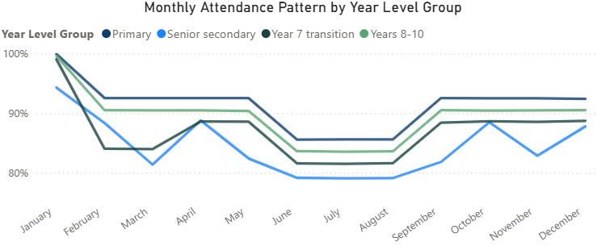
Figure 1: Monthly Attendance Pattern by Year Level Group
This chart shows a clear seasonal pattern: attendance starts high in January, drops after the start of the school year, reaches its lowest point in winter from June to August, and recovers from September. January should be interpreted cautiously because it has very few possible school days; the main seasonal pattern is clearer from February onward.

Primary students have the highest and most stable attendance. Years 8-10 follow a similar but slightly lower pattern. Year 7 transition students sit below Years 8-10 for most months, suggesting transition-related attendance risk. Senior secondary students show the most volatility, with sharper drops in March, winter, and November.
Overall, attendance is both seasonal and cohort-specific, with Year 7 and senior secondary students needing closer monitoring.

Monthly Attendance Trend

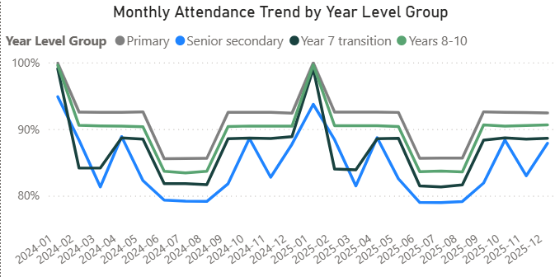
Figure 2: Monthly Attendance Trend
This chart confirms that the seasonal attendance pattern repeats across both 2024 and 2025. Attendance drops during the winter months in each year and recovers from September.
The year-level ranking is also consistent: primary students have the highest attendance, Years 8-10 sit slightly lower, Year 7 transition students are lower again, and senior secondary students show the most volatility. January should be interpreted cautiously because it contains only a small number of possible school days.

Winter Dip by Region

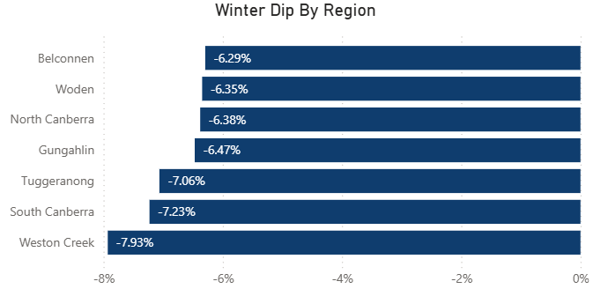
Figure 3: Winter Dip by Region
The regional bar chart shows that the winter dip is shared across regions but not identical in magnitude, which confirms the seasonal attendance pattern. Belconnen, Woden, and North Canberra have smaller declines, around -6.3 percentage points, while South Canberra and Weston Creek show larger winter drops.
Weston Creek has the largest decline at -7.93 percentage points, suggesting it may need closer winter attendance monitoring or earlier seasonal intervention.

Month x Year Level Heatmap

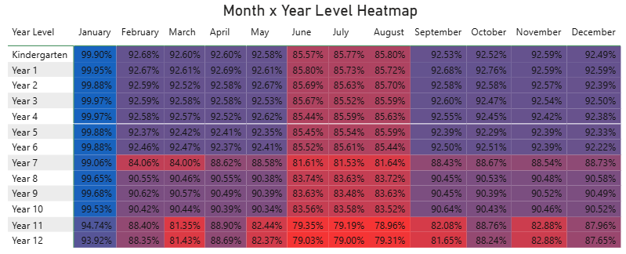
Figure 4: Month x Year Level Heatmap
This heatmap reinforces the same pattern at a more detailed year-level view. Attendance is strongest in January, but January should be interpreted cautiously because it has very few possible school days.
From February onward, the winter dip is visible across nearly all year levels, with lower values concentrated in June, July, and August. Primary year levels remain relatively stronger, while Year 7 and senior secondary year levels show lower attendance. Years 11 and 12 are the most concerning, with several months below 80%, especially during winter.
Overall, the heatmap supports the conclusion that the winter decline affects the system broadly, but Year 7 and senior secondary cohorts require closer monitoring.

Interpretation: Attendance planning should start before winter. The analysis supports early identification of regions and cohorts where engagement support may reduce the seasonal dip.

Year-Level Patterns

Year-level analysis shifts the focus from overall attendance to cohort-level variation. This is important because system-wide attendance rates can mask different patterns for transition years and senior secondary students.

Key Statistics
Statistic | Value | Brief interpretation
Year 7 attendance rate | 85.86% | Year 7 transition attendance is weaker than the overall rate.
Years 8-10 attendance rate | 88.67% | Middle secondary attendance is closer to the overall average.
Senior secondary attendance rate | 83.55% | Senior secondary attendance is the weakest headline cohort metric.
Year 12 below-80% student-month share | 26.97% | Senior secondary students show the highest share of high-concern attendance records.

The overall attendance rate is 88.81%, but the year-level statistics show important variation: Year 7 attendance is 85.86%, Years 8-10 attendance is 88.67%, and senior secondary attendance is 83.55%. The difference confirms that a single whole-system attendance rate is not enough for decision-making.

Share of Student-Months Below 80% Attendance

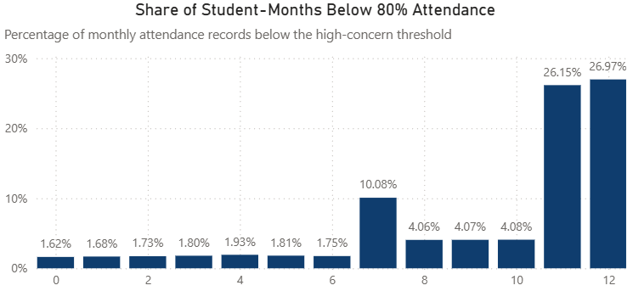
Figure 5: Share of Student-Months Below 80% Attendance

This chart shows the share of monthly attendance records below the 80% attendance threshold. Each record represents one student observed in one reporting month, so the measure reflects the proportion of student-month observations with high attendance concern.
Most primary and lower secondary year levels have low at-risk shares, generally below 5%. Year 7 is higher at about 10%, which supports the transition-risk pattern. The largest concern is in senior secondary: Years 11 and 12 have much higher at-risk shares, around 26-27%.
This suggests attendance risk is concentrated in transition and senior secondary cohorts, rather than being evenly spread across all year levels.

Attendance Band Distribution by Year Level

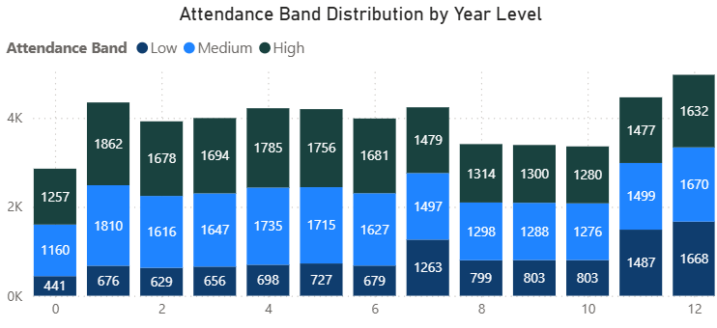
Figure 6: Attendance Band Distribution by Year Level

This bar chart shows the distribution of monthly attendance records by attendance band across year levels. Most year levels have a broadly balanced mix of medium and high attendance, with a smaller low-attendance segment.

The main exception is senior secondary. Years 11 and 12 have much larger low-attendance counts than earlier year levels, indicating a higher concentration of students below the desired attendance range. Year 7 also shows a noticeable increase in low-attendance records compared with Years 0-6, which supports the transition-risk pattern identified elsewhere in the analysis.

Monthly Attendance Rate by Starting Cohort

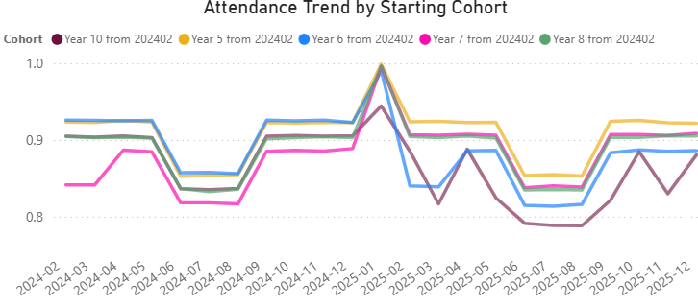
Figure 7: Attendance Trend by Starting Cohort
A starting cohort means the group of students who were in a given year level in February 2024. For example, “Year 6 from 202402” refers to students who were in Year 6 in February 2024; the line then follows their attendance as they move into later year levels.
The Year 5 starting cohort has the strongest attendance pattern across most of the period. This suggests that attendance is more stable before students reach the main transition years.
The Year 6 cohort also has relatively high attendance during 2024. However, its attendance falls in 2025, when these students move into Year 7. This supports the idea that the move into Year 7 is associated with additional attendance risk.
The Year 7 cohort has the lowest attendance while students are in Year 7 during 2024. In 2025, after these students move into Year 8, their attendance improves and becomes similar to the Year 8 starting cohort, which has moved into Year 9. This suggests that the Year 7 attendance dip may be partly transitional rather than permanent.
The Year 10 cohort moves into Year 11 in 2025 and records the weakest attendance pattern in that year. This highlights senior secondary attendance as a separate risk area, particularly after students enter Year 11.
Overall, the chart shows that attendance risk changes as cohorts move through school. It is not enough to compare year levels at one point in time; following the same starting cohorts helps show when attendance risk emerges and whether it continues or improves over time.

Year 7 Transition Compared with Years 8-10

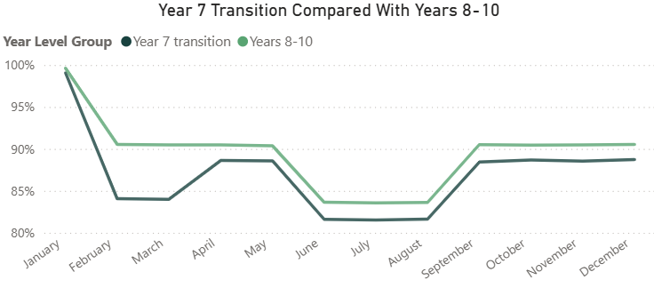
Figure 8: Year 7 Transition Compared with Years 8-10
This comparison isolates the transition story. Year 7 attendance is lower than Years 8-10 after January, and the difference remains visible across the year. This supports closer monitoring of transition cohorts, particularly during seasonal pressure points.
Interpretation: Year-level analysis should focus on two distinct risks: transition risk in Year 7 and high-concern attendance share in senior secondary cohorts.

Attendance And Assessment
Assessment outcomes are analysed by attendance band to identify whether lower attendance is associated with weaker results. These findings should be interpreted as evidence of association, not as proof that attendance alone causes assessment performance.

Key Statistics
Statistic | Value | Brief interpretation
Average assessment score | 418.87 | Baseline assessment score across selected assessment records.
Assessment record count | 60336 | Assessment analysis has enough volume for aggregate comparison.
High attendance average score | 431.27 | High-attendance students have stronger average outcomes.
Low attendance average score | 381.69 | Low-attendance students have weaker average outcomes.
High-low assessment score gap | 49.58 | The attendance band gap is visible and consistent with the analytics story.

The page reports an average assessment score of 418.87 across about 60336 records. Students in the high-attendance band average 431.27, while students in the low-attendance band average 381.69. The high-low score gap is 49.58 points, which is a clear aggregate difference.

Assessment Score by Attendance Band

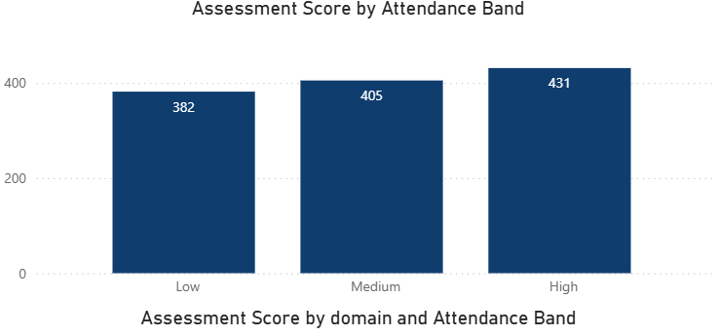
Figure 9: Assessment Score by Attendance Band
The bar chart shows a a clear positive relationship between attendance band and assessment score. Students in the low-attendance band have the lowest average score, at about 382. The medium-attendance band is higher, at about 405, and the high-attendance band has the strongest result, at about 431.
The pattern suggests that stronger attendance is associated with stronger assessment outcomes. It should be interpreted as an association, not proof that attendance alone causes higher scores.

Assessment Score by Year Level and Attendance Band

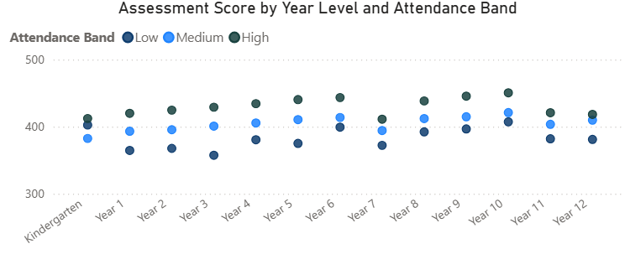
Figure 10: Assessment Score by Year Level and Attendance Band
This chart shows that the attendance-score relationship is visible across most year levels. In nearly every year level, students in the high-attendance band have higher average assessment scores than students in the medium and low bands.
The gap is especially clear across the primary and middle secondary years. Year 7 shows a lower overall pattern than nearby year levels, which is consistent with the transition-risk story. Overall, the chart suggests that the relationship between attendance and assessment outcomes is not isolated to one cohort; it appears across the school system.

Assessment Score by Domain and Attendance Band

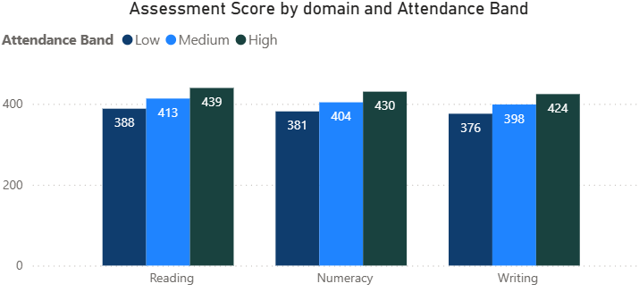
Figure 11: Assessment Score by Domain and Attendance Band
This chart shows that the attendance-score relationship is consistent across all three assessment domains. In Reading, Numeracy, and Writing, the high-attendance band has the highest average score, followed by the medium-attendance band, then the low-attendance band.
The size of the gap is similar across domains, which suggests the pattern is broad rather than limited to one subject area. Reading has the highest overall scores, while Writing is slightly lower, but the same attendance gradient appears in each domain.

High-Low Score Gap by Domain

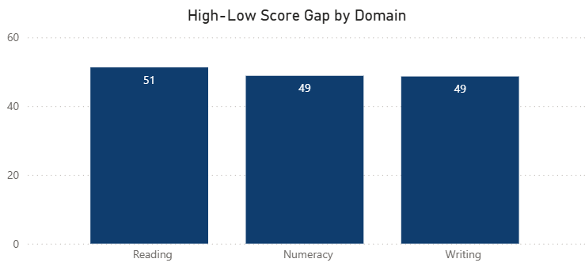
Figure 12: High-Low Score Gap by Domain
The high-low score gap is the difference between the average assessment score for students in the high-attendance band and the average score for students in the low-attendance band.
In this chart, the gap is similar across all three domains: about 51 points in Reading and 49 points in both Numeracy and Writing. This means the assessment difference between high- and low-attendance students is consistent across subject areas, rather than being concentrated in one domain.
Interpretation: Attendance bands can be used as a practical monitoring signal for learning outcomes, but the report should not claim causality without further analysis.

Overall Interpretation
Together, the analysis represents a coherent reporting story. Attendance is seasonal, cohort patterns differ across year levels, and lower attendance bands are associated with weaker assessment outcomes. This supports monthly stakeholder reporting that goes beyond raw tables and helps guide decisions about timing, cohort focus, and follow-up action.
- Winter attendance decline should be treated as a predictable risk period.
- Year 7 transition and senior secondary attendance should be monitored separately.
- Student-month at-risk share is a better dashboard measure than counting distinct students across a long period.
- Assessment results are consistently stronger for high-attendance bands, but this should be communicated as association rather than causation.

Suggested Stakeholder Actions
- Review winter attendance plans before June, rather than after the seasonal decline appears.
- Use region and year-level breakdowns to prioritise attendance support rather than relying on whole-system averages.
- Monitor Year 7 and senior secondary attendance as separate reporting groups.
- Use low attendance bands as a prompt for further learning-outcome review.
- Keep assessment interpretation cautious: the dashboard identifies an important relationship, not a causal proof.

Notes On Scope
This report is based on synthetic portfolio data. It is designed to demonstrate analytics storytelling, Power BI interpretation, and stakeholder reporting. It does not represent real student or school performance data, and it intentionally excludes data engineering implementation details.

