Linux Assignment
- Creating and Renaming Files/Directories
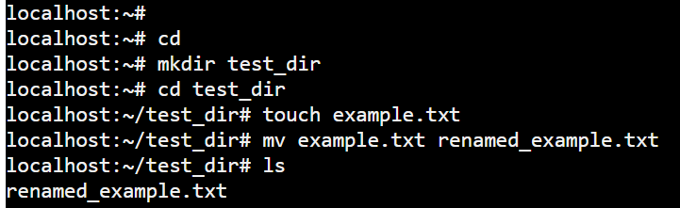
EXPLANATION:
- mkdir test_dir created a new directory named test_dir.
- cd test_dir navigates into the created directory.
- touch example.txt creates an empty file.
- mv example.txt renamed_example.txt renames the file.

- Viewing File Contents
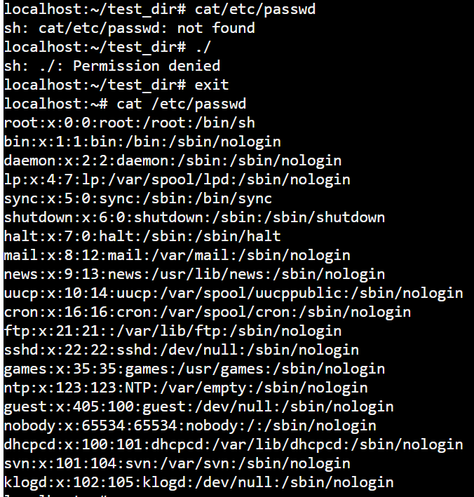
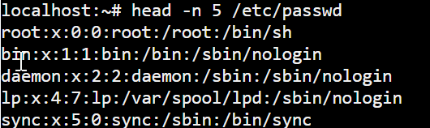
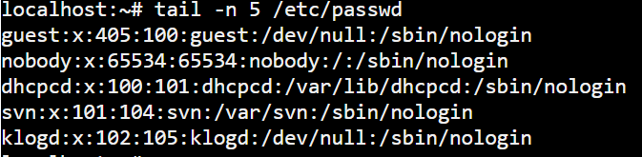

EXPLANATION:
- cat displays the entire content of the file.
- head -n 5 shows the first 5 lines of the file.
- tail -n 5 shows the last 5 lines of the file

- Searching for Patterns

Explanation:
- grep searches for specific text in a file.
- This command finds all lines containing the word “root” in the file.
- Zipping and Unzipping
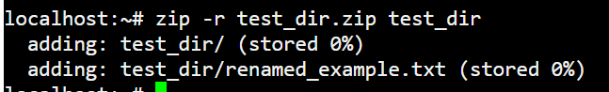
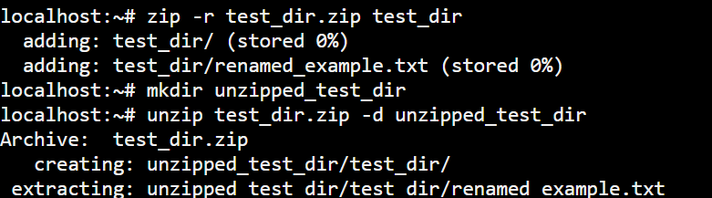
EXPLANATION:
- zip -r compresses the directory and its contents into a zip file.
- unzip extracts the contents of the zip file into a specified directory.
- Downloading Files
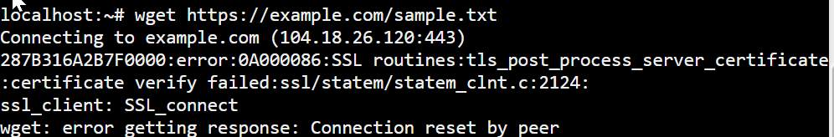
EXPLANATION:
- wget downloads files from the internet using a URL.
- The file is saved in the current directory.
- Changing Permissions

EXPLANATION:
touch creates a new file.
chmod 444 sets the file to read-only for all users (owner, group, others).

- Working with Environment Variables
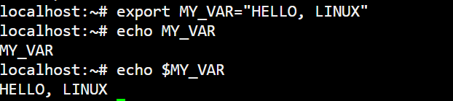

EXPLANATION:
- export creates an environment variable.
- echo $MY_VAR displays the value stored in the variable.

