**Software Requirements Specification**

For

**Asset Management System**

**Version 1.0 not yet approved**

**Prepared by**

Jobin Joseph (U101116FCS053)

Mamidi Lokesh (U101116FCS063)

PSK Vamsi (U101116FCS088)

Pradeep Yadav (U101116FCS089)

PVNSSK Chaitanya (U101116FCS085)

Software Engineering

NIIT University

22nd September 2018

Table of Contents

Table of Contents ii

1. Introduction 1

1.1 Purpose 1

1.2 Document Conventions 1

1.3 Intended Audience and Reading Suggestions 1

1.4 Product Scope 1

1.5 References 1

2. Overall Description 2

2.1 Product Perspective 2

2.2 Product Functions 2

2.3 User Classes and Characteristics 2

2.4 Operating Environment 2

2.5 User Documentation 2

2.6 Assumptions and Dependencies 3

3. External Interface Requirements 3

3.1 User Interfaces 3

3.2 Hardware Interfaces 4

3.3 Software Interfaces 4

4. System Features 5

4.1 Create Asset 5

4.2 Add Asset 5

4.3 Add Multiple Asset 6

4.4 View Asset Status 6

4.5 View Assets 7

4.6 View Asset Location 8

4.7 View Shifting History 8

4.8 Update Asset Status 9

4.9 Update Asset Location 10

4.10 Remove Asset 10

4.11 Login……………………………………………………………………………………………..11

5. Other Nonfunctional Requirements 12

5.1 Performance Requirements 12

5.2 Safety Requirements 12

5.3 Security Requirements 12

5.4 Business Rules 12

**1.     Introduction**

**1.1     Purpose**

This document is related to the software tool developed by the students of NIIT University as a part of one of the courses, Software Engineering in the B. Tech CSE 3rd Year. This is the first draft report by the author. Newer versions and upgradations yet to be developed.

                  The purpose of the project is to keep track of all the asset in the University. Providing user friendly information in creating reports for Beyond Economic Repair, Asset Movement History and Insurance claim reports.

**1.2     Document Conventions**

The basic convention followed in the report is with the System Features. Where, 1 refers to a higher priority, 2 refers to a slightly lower priority and soon.

**1.3     Intended Audience and Reading Suggestions**

This document is intended to all the administrative staff, auditor and the staff dealing with the asset management in the organization. It is advised to have a basic knowledge of the movement procedure of an Asset in the Organization and the campus. Knowing all the places of the campus to a good extent is preferred.

**1.4     Product Scope**

The Scope of this software or the tool being built is to keep track of all the asset in the university, this software helps the administrator or the staff building a report for the list of Beyond Economic Report. It even helps to create a comprehensive movement report of all the asset in the campus. Audit of the asset of the organization is a simple process.

**1.5     References**

Template used for creating this Document is IEEE SRS document found on any platform. (IEEE Std 830-1998)

**2. Overall Description**

**2.1 Product Perspective**

This product is the first ever of this kind. It is being built from scratch and is not development of any existing tool or software. Any existence of a software of this kind is just a co-incidence.

This software is best for any administrator for asset management for any campus or organization with small changes. The basic idea of this project is to create an environment where there’s no need of any knowledge of excel for the user. It is a better option rather than maintaining a simple excel as the tool can help you by supplying a detailed a report for shifting history of a single asset.

**2.2 Product Functions**

This tool allows you to locate an asset by providing a unique id to the asset. It can even help the user in shifting an asset. It allows you to update the location every time to move the asset. The software allows the user to update the working condition of the asset on a daily basis.

The software allows you to view the asset you have on the basis of many other attributes to the asset. Like, working state, Location and other details. The software can even show you the entire shifting history of the asset from the day it has entered the campus to the present location based on the unique ID given.

**2.3 User Classes and Characteristics**

Set of users we have can be divided into majorly 3 different categories. 1) Admin – Is given the power of doing any change in the system at any point, All the data is accessible to this user. All the view options are open to admin. 2) Auditor – This kind of user has the access to data which is related to auditing the whole asset. Can even get access to the reports produced according to the organization’s policies. 3) Staff – Has a limited access. Can update location of an asset. Can update status of an asset. View damaged assets’ location.

**2.4 Operating Environment**

As it is a web-based software an active internet connection with a decent browser will do good. (Decent browser includes Chrome 45.0.2454, Internet Explorer 10, Mozilla Firefox 37.0, Safari 6.2.8 or Opera 27). Preferable with laptops, PC and tablets.

**2.5 User Documentation**

A user manual with a detailed guide for the usage of this software will be provided. All the basic demonstration of the software to be done by the team. A help section will also be provided for an immediate referral.

**2.6 Assumptions and Dependencies**

The software is designed in a user-friendly way with simple language to avoid any ambiguity. It can provide with a specific and clear-cut results provided that, the user the full knowledge of the data and the control over it. The operations, data feeding and related use of the software lies in the hands of the user. For a better view and best use of the software referring to the user manual is recommended.

**3. External Interface Requirements**

**3.1 User Interfaces**

The user interface will be consisting firstly of, a login page where the users will be logging in with a UID and the features respective to their authority, that is, in ascending order Staff<Auditor<Admin Head, will be given access to. On login page there will be a logo which will be devised for our initiative, a link leading to a help page which will be including troubleshooting and FAQ related resources and a forgot password/reset password link.

**Page after login:**

1. **Admin Head**
2. **Create an Asset**

Introducing an Asset to the system.

1. **Add an Asset**

Establishing a new batch of predefined Asset.

1. **Add Multiple Assets**

Establishing a new batch of multiple predefined Assets.

1. **View Asset Status**

Determining whether the asset is Working, Damaged, Repairing, cannot be repaired.

1. **Update Asset Status**

Re-Assigning asset status after reviewing the Asset particulars.

1. **View Asset Location**

Determining current location of an Asset.

**vii) View Assets**

Retrieving all information about an Asset or a set of assets.

1. **View Asset Shifting History**

Retrieving asset location logs over a specified period of time.

1. **Auditor**
2. **View Asset Shifting History**

Retrieving asset location logs over a specified period of time.

1. **View Assets**

Retrieving all information about an Asset or a set of assets.

1. **Remove Assets**

Discarding the Asset particular(s) which is/are rendered beyond repair.

1. **View Asset Location**

Determining current location of an Asset.

**c) Staff**

1. **Update Asset Status**

Re-Assigning asset status after reviewing the Asset particulars.

1. **Update Asset Location**

Re-Assigning present Asset location of Asset particulars after shifting or related operations.

1. **View Asset Location**

Determining current location of an Asset.

**3.2 Hardware Interfaces**

Minimum Requirements for host system are:

1. 32-bit Operating System
2. 2 GB RAM
3. Network Card
4. 8 GB ROM

**3.3 Software Interfaces**

The system must consist of:

JRE

Image Processing

MySQL (RDBMS)

Web Browser support

**4. System Features**

**4.1 Create Asset**

**4.1.1 Description and Priority:** Admin can create a new asset that are not defined before.

**4.1.2 Stimulus/Response Sequence:** After logging into the portal admin has to click the create asset button and should give the name of an asset and then should click button create

**4.1.3 Functional Requirements:** This function is required to check whether the asset is already present or not. If it was present then no need to create the asset. User has to login to access this feature.

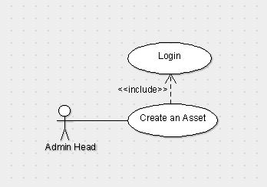

**4.2 Add Asset**

**4.2.1 Description and Priority:** Admin can add pre-defined asset and this

Will also generate unique id to the asset and by default location will be the reception. Only admin can do this function.

**4.2.2 Stimulus/Response Sequence:** Click the add asset button and then drop-down menu option appears select an asset and then click add.

**4.2.3 Functional Requirements:** This function is required toadd to the particular asset we should not add the number of a particular asset to others because it leads to the difference in the number.

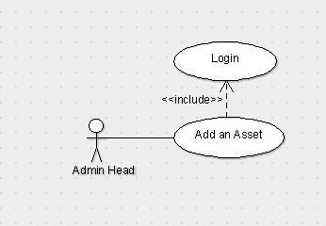

**4.3 Add Multiple Asset**

**4.3.1 Description and Priority:** It is the extension of the add Asset feature. By this admin will able to add multiple assets of same type at a time.

**4.3.2 Stimulus/Response Sequence:** Click Add multiple asset and then select the asset type and then select the number of assets you want to add then click add.

**4.3.3 Functional Requirements:** This function is required for adding number of multiple assets of a particular one. (For example, if we are having 60 chairs and 20 tables we can add all 60 chairs by giving them id at a time.)

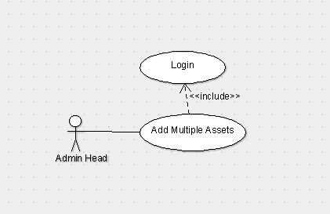

**4.4 View Asset Status**

**4.4.1 Description and Priority:** Admin can see the status of any particular asset i.e. whether it is damaged, working, repairing and cannot be repaired etc.

**4.4.2 Stimulus/Response Sequence:** Click Asset Status and then select the type of asset and then enter the respective unique id that is related to that asset and then click show Status.

**4.4.3 Functional Requirements:** This function is required to seethe status of a particular asset of a particular type. (For example, if there is an asset with id Table_23 we can see the status of that particular one whether it is damaged, working, repairing and cannot be repaired etc.)

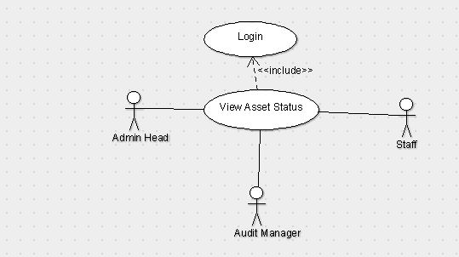

**4.5 View Asset**

**4.5.1 Description and Priority:** Admin can see the location, status, shift history etc.

**4.5.2 Stimulus/Response Sequence:** Click View Assets and then search for particular id of a particular asset type and then we can see its status, location, shift history.

**4.5.3 Functional Requirements:** This function is required for checking purpose or to just for knowing the existence of an asset (For example, if we are having an asset with Id mirror_107 by searching that we can get its location-UG-2 3306, status – working, shift history – reception->store room of UG->UG-2 3306.)

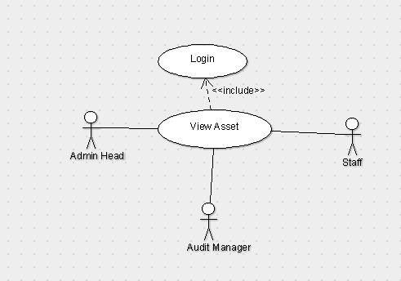

**4.6 View Asset Location**

**4.6.1 Description and Priority:** Admin can see the location of the particular asset.

**4.6.2 Stimulus/Response Sequence:** Click asset location and then enter the unique id of an asset then click show.

**4.6.3 Functional Requirements:** This function is required to check the asset Id is exists.

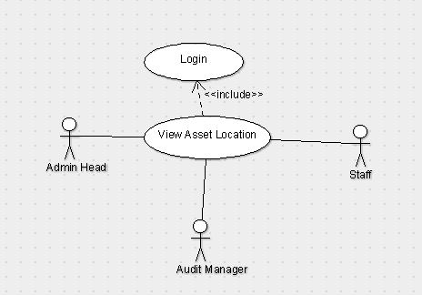

**4.7 View Shifting History**

**4.7.1 Description and Priority:** Admin can see the location history of the asset from the time that it has been created.

**4.7.2 Stimulus/Response Sequence:** Click on Shifting History and then give the unique id of the asset then click show.

**4.7.3 Functional Requirements:** This Function is required to check the asset history that from where the particular asset has been shifted (For example reception->Store room.)

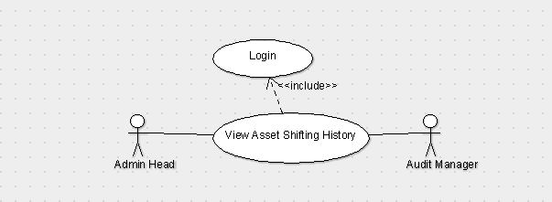

**4.8 Update Asset Status**

**4.8.1 Description and Priority:** Staff can update the status of the asset whether is it working, damaged or can’t be repaired.

**4.8.2 Stimulus/Response Sequences:** Any staff he/she having credentials will login to the page and then click on Update asset status in which we have to search for the asset with its id and then change the status of the asset to either working, damaged or can’t be repaired.

**4.8.3 Functional Requirements:** This function is required for updating the status if there is any problem with the asset otherwise the data will be corrupted if we don’t change the status. (For example, if there is a product which was damaged in the past and it was repaired. Then the change of status will be working->damaged->repaired->working.)

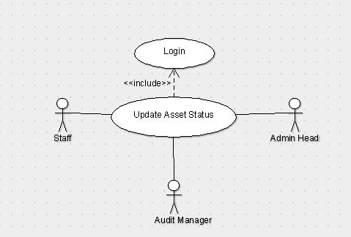

**4.9 Update Asset Location**

**4.9.1 Description and Priority:** Staff can update the location of the asset as of where the asset is present at which place.

**4.9.2 Stimulus/Response Sequences:** After staff login page we have to click on update location in which we have to search for the asset with its id by changing its room number and its location.

**4.9.3 Functional Requirements:** This function is required forupdating the location of the asset if we don’t update the place then there will be a mismatch or missing of the asset and which it will be difficult to identify. (For example, if the asset is present in UG-2, 1301 and the location is changed to UG-1, 3307 then we have to update the location.)



**4.10 Remove Asset**

**4.10.1 Description and Priority:** Audit can remove any asset by checking its condition. After updating status of the asset audit can check the assets which can’t be repaired and he can remove those assets.

**4.10.2 Stimulus/Response Sequences:** After audit login page we have to click on the remove asset and enter asset Id and remove them.

**4.10.3 Functional Requirements:** Here for data purification we are removing the assets and storing them separately as they are removed. (For example, we can remove the asset by seeing the status of its if the status is can’t be repaired then we can remove it.)

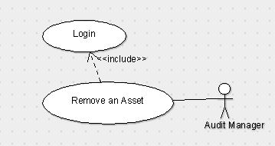

**4.11 Login**

**4.11.1 Description and Priority:** The one who wants to enter into this software should first login using the credentials provided by the developer.

**4.11.2 Stimulus/Response Sequences:** After entering the site address you there will be a text fields to enter the details after entering it click login button.

**4.11.3 Functional Requirements:** Login can be done to those who has the correct credentials, anonymous person can’t login username and password will be provided by the developer you will also have the option to reset the password. Those details shouldn’t be shared to others.

**Use Case Diagram**

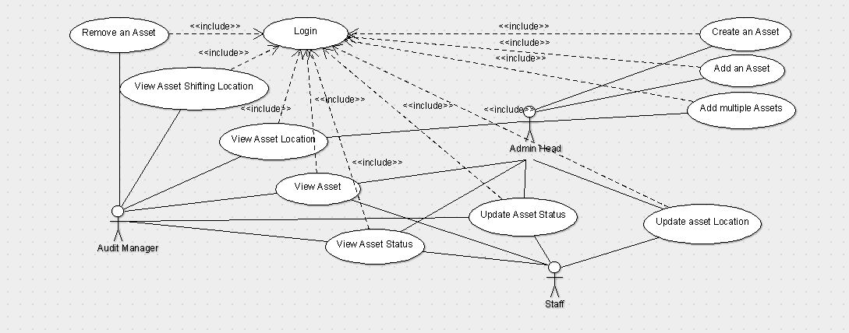

**5. Other Non-functional Requirements**

**5.1 Performance Requirements**

Internet Speed should be responsive and sound.

None of the authoritative actor can login at two different systems during the same session. The host system should be capable enough to support up to 20-30 client nodes in a single session.

**5.2 Safety Requirements**

The Operational update by the staff user may not tally with the actual facts and information, thus it’s the responsibility of the Auditor to take care of such wrong transactions.

**5.3 Security Requirements**

User will be provided a username and password to login. We will also be providing separate login credential for separate class of users, that is, an admin will have a separate login ID and staff will have a separate login ID.

**5.4 Business Rules**

Creating and adding of an asset can only be done by Admin and they can check the asset shifting history, status and location of a particular asset. Auditor has the authority to remove an asset, view an asset and can check the shifting history of the assets. Staff can only update and view asset location and status. To protect sensitive information about some of the assets, we are giving different login IDs to different type of users.