**Software Requirements Specification**

for

**Asset management System**

**Version 1.0 not yet approved**

**Prepared by M.Lokesh**

U101116FCS063

Software Engineering

NIIT University

Dt: 22-9-18

**Table of contents**

**1. Introduction**

1.1 Purpose

1.2 Document Conventions

1.3 Intended Audience and Reading Suggestions

1.4 Product Scope

1.5 References

**2. Overall Description**

2.1 Product Perspective

2.2 Product Functions

2.3 User Classes and Characteristics

2.4 Operating Environment

2.5 User Documentation

2.6 Assumptions and Dependencies

**3. External Interface Requirements**

3.1 User Interfaces

3.2 Hardware Interfaces

3.3 Software Interfaces

**4. System Features**

4.1 Create Asset

4.2 Add Asset

4.3 Add Multiple Asset

4.4 View Asset Status

4.5 View Assets

4.6 View Asset Location

4.7 Shift History

4.8 Update Asset Status

4.9 Update Asset Location

**5. Other Non-functional Requirements**

5.1 Performance Requirements

5.2 Safety Requirements

5.3 Security Requirements

5.4 Business Rules

**1. Introduction**

**1.1 Purpose**

To keep track of all the assets that are in hostels we are trying to develop a Hostel asset management system.

**1.2 Document Conventions**

The one which has low priority number has High priority for example let’s say priority is 1 so it has the highest priority.

**1.3 Intended Audience and Reading Suggestions**

This document is intended for organization staff, Administration team and the users. This document mainly contains the detailed structure of this product like features included, purpose, scope, requirements to use, security details etc.

**1.4 Product Scope**

Generally it is very hard to keep track of the assets particularly for large scale organizations, there won’t be any particular up to date information but by this software we are trying to automate this we can keep track of each and every asset at any point of time.

**1.5 References**

SRS IEEE template

**2. Overall Description**

**2.1 Product Perspective**

It is a self contained product.

**2.2 Product Functions**

This software provides Staff/Admin to check the count of every asset and where those assets are placed. If any asset is moved to one room to other it allows you to change the place and also this is stored in the asset history. We can also see that the asset is damaged or not.

**2.3 User Classes and Characteristics**

There will be three types of users to use this software they are 1) Students – Can only see the details assets in his room 2) Admin – Can mange everything 3) Staff – Can have the access to change the place of assets etc.

**2.4 Operating Environment**

Basically as this is web based software it requires internet and it will work on computers, laptops and smart phones

**2.5 User Documentation**

We are going to provide one user manual so that the user can easily understand how to use this software and we also provide “help” section in our software user can raise the question and admin can answer that.

**2.6 Assumptions and Dependencies**

This software can give you the correct results if the staff who is using this software should update the asset details correctly whenever it was changed.

**3. External Interface Requirements**

**3.1 User Interfaces**

The user interface will be consisting firstly of, a login page where the users will be logging in with a User ID and will be given access to particular features respective to their authority.

**Inside login page:**

1. **Admin**
2. **Creating an Asset**

Introducing an Asset to the system.

1. **Adding an Asset**

Adding a new predefined Asset.

1. **Adding Multiple Assets**

Adding multiple predefined Assets at a time.

1. **Viewing Asset Status**

Determining whether the asset is Working, Damaged, Repairing, cannot be repaired.

1. **Updating Asset Status**

Admin can change the asset location whenever there is any change in the location

1. **Viewing Asset Location**

Shows current location of an Asset.

1. **Viewing Assets**

Shows current location of an Asset.

1. **Viewing Asset Shifting History**

It shows the asset’s previous location history

1. **Audit Manager**
2. **Viewing Asset Shifting History**

It shows the asset’s previous location history

1. **Viewing Assets**

Can see the some set of assets according to the selection that we made.

1. **Remove Assets**

Can delete the asset if the asset is no longer in use.

1. **Viewing Asset Location**

Shows current location of an Asset.

1. **Staff**
2. **Updating Asset Location**

Staff can change the asset location whenever there is any change in the location

1. **Viewing Asset Location**

Shows current location of an Asset.

**3.2 Hardware Interfaces**

Minimum Requirements for host system are:

1. 32-bit Operating System
2. 4 GB RAM
3. 20 GB ROM

**3.3 Software Interfaces**

The system must consist of:

JRE

MySQL

Web Browser

**4. System Features**

**4.1 Create Asset**

**4.1.1 Description and Priority:** Admin can create new asset that are not been defined before. It has the priority of 1

**4.1.2 Stimulus/Response Sequence:** After logging into the portal admin has to click the create asset button and should give the name of an asset and then should click button create

**4.1.3 Functional Requirements:** Function is required to check whether the asset is already present or not.

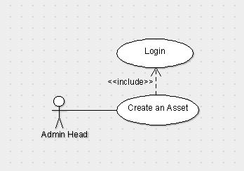

**4.2 Add Asset**

**4.2.1 Description and Priority:** Admin can add pre-defined asset and this

Will also generate unique id to the asset and by default location will be the reception. Only admin can do this function. It has the priority of 2

**4.2.2 Stimulus/Response Sequence:** click the add asset button and then drop down menu option appears select an asset and then should click add

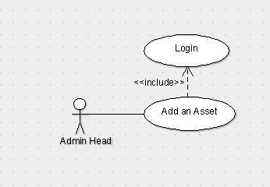

**4.3 Add Multiple Asset**

**4.3.1 Description and Priority:** It is actually the extension of the add Asset feature By this admin will able to add multiple assets of same type at a time. It has the priority of 3.

**4.3.2 Stimulus/Response Sequence:** Click add multiple asset and then select the asset type and then select the no. of assets you want to add then click add.

**4.3.3 Functional Requirements:**

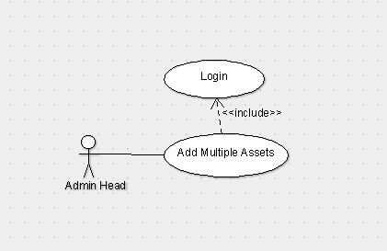

**4.4 Asset Status**

**4.4.1 Description and Priority:** Admin can see the status of any particular asset i.e whether it is damaged, working, cannot be repaired etc. It has the priority of 6.

**4.4.2 Stimulus/Response Sequence:** Click Asset Status and then select the type of asset and then enter the respective unique id that is related to that asset and then click show Status.

**4.4.3 Functional Requirements:** Function is required to check the asset Id is exists.

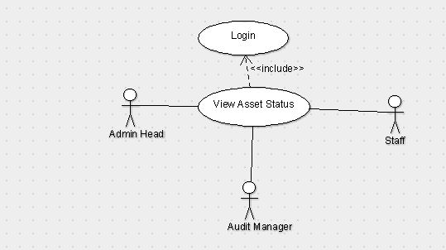

**4.5 View Assets**

**4.5.1 Description and Priority:** Admin can see the assets which are damaged, working etc. It has the priority of 5.

**4.5.2 Stimulus/Response Sequence:** Click View Assets and then select then you can select the Building, floor, type i.e working, damaged etc. And then click Show.

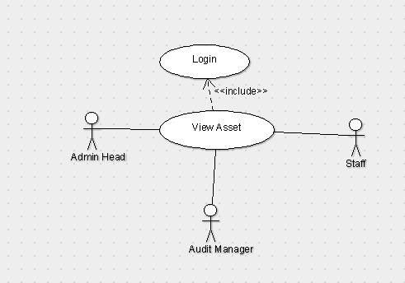

**4.6 Asset Location**

**4.6.1 Description and Priority:** Admin can see the location of the particular asset. It has the priority of 3.

**4.6.2 Stimulus/Response Sequence:** Click asset location and then enter the unique Id of an asset then click show.

**4.6.3 Functional Requirements:** Function is required to check the asset Id is exists.

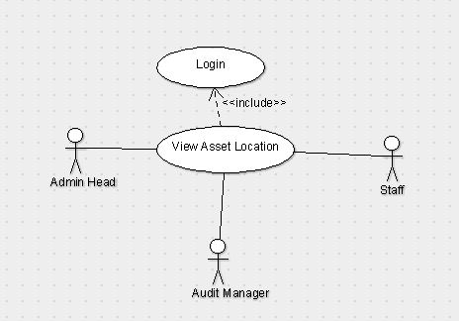

**4.7 Shift History**

**4.7.1 Description and Priority:** Admin can see the location history of the asset from the time that it has been created. It has the priority of 7.

**4.7.2 Stimulus/Response Sequence:** Click on Shift History and then give the unique id of the asset then click show.

**4.7.3 Functional Requirements:** Function is required to check the asset Id is exists.

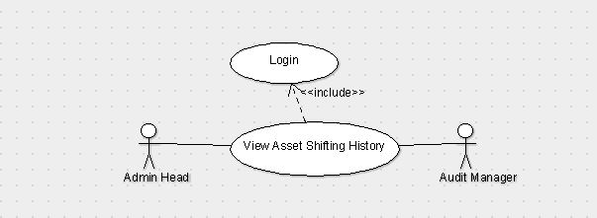

**4.8 Update Asset Status**

**4.8.1 Description and Priority:** Staff can update the status of the asset whether is it working, damaged or can’t be repaired. It has the priority of 8.

**4.8.2 Stimulus/Response Sequences:** Any staff he/she having credentials will login to the page and then click on Update asset status in which we have to search for the asset with its id and then change the status of the asset to either working, damaged or can’t be repaired.

**4.8.3 Functional Requirements:** We have to update the status if there is any problem with the asset otherwise the data will be corrupted if we don’t change the status.

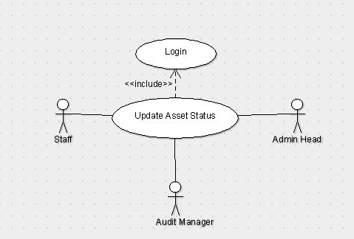

**4.9 Update Location**

**4.9.1 Description and Priority:** Staff can update the location of the asset as of where the asset is present at which place It also ha sthe priority level of 3.

**4.9.2 Stimulus/Response Sequences:** After staff login page we have to click on update location in which we have to search for the asset with its id and change its room number and then click update.

**4.9.3 Functional Requirements:** We have to update the location of the asset if we don’t update the place then there will be a mismatch or missing of the asset and which it will be difficult to identify.



**Use Case Diagram**

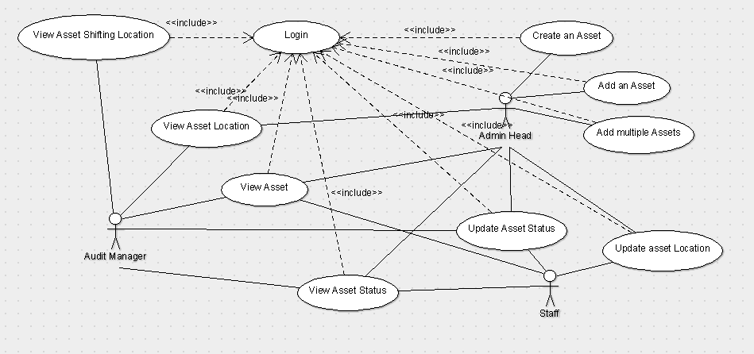

**5. Other Non-functional Requirements**

**5.1 Performance Requirements**

Internet Speed should be good for speed response. No one can login at two or more places at a time.

**5.2 Safety Requirements**

Staff who is using the software may change location, status wrong so there will be a Audit login in that Audit manager will be able to check the transaction histories of everything. So it’s the responsibility of the Audit manager to take care of such wrong transactions.

**5.3 Security Requirements**

User will be provided username and password by those credentials they can login to the software and can access whatever he/she wants. No other person can’t access this software

**5.4 Business Rules**

Create and Add Asset can only be done by Admin and they can check the asset shifting history, status, location of the particular asset. Audit has the access to removing Asset, view Asset and can check the shifting history of the assets. Staff can only update and view asset location and status.