**Software Requirements Specification**

For

**Hostel Asset Management**

**Version 1.0 not yet approved**

**Prepared by**

Jobin Joseph (U101116FCS053)

Mamidi Lokesh (U101116FCS063)

PSK Vamsi (U101116FCS088)

Pradeep Yadav (U101116FCS089)

PVNSSK Chaitanya (U101116FCS085)

Software Engineering

NIIT University

10th October 2018

**Table of contents**

**1. Introduction4**

1.1 Purpose4

1.2 Document Conventions4

1.3 Intended Audience and Reading Suggestions4

1.4 Product Scope4

1.5 References 4

**2. Overall Description 5**

2.1 Product Perspective5

2.2 Product Functions5

2.3 User Classes and Characteristics5

2.4 Operating Environment5

2.5 User Documentation5

2.6 Assumptions and Dependencies5

**3. External Interface Requirements6**

3.1 User Interfaces6

3.2 Hardware Interfaces8

3.3 Software Interfaces8

**4. System Features** **9**

4.1. Login9

4.2 Create an Asset10

4.3 Add an Asset11

4.4 Add Multiple Assets12

4.5 View Asset Status13

4.6 View Asset Location14

4.7 View Assets15

4.8 View Asset Shifting History by Date16

4.9 View Asset Shifting History by assetID17

4.10 View Asset Shifting History by by staffID18

4.11 View Comprehensive Report by Date19

4.12 View Comprehensive Report by assetID20

4.13 View Comprehensive Report by staffID21

4.14 Remove Asset22

4.15 Update Asset Location23

4.16 Update Asset Status24

**5. Other Non-functional Requirements25**

5.1 Performance Requirements25

5.2 Safety Requirements25

5.3 Security Requirements25

5.4 Business Rules25

**6. UseCase Diagram26**

**1. Introduction**

**1.1 Purpose**

We are aiming to develop a Hostel Asset Management System, to keep track of all asset particulars that are currently being used in hostels.

**1.2 Document Conventions**

Priority decreases with increase in numerical denomination.

**1.3 Intended Audience and Reading Suggestions**

This document is intended for board of organization, Administrative board and the Staff or request generator. This document specifies the detailed structure of our product, that is, features included, purpose, scope, required environment to use, security details etc.

**1.4 Product Scope**

For a University or campus scale of asset management, it is usually found to be uneasy to follow the flow of assets and their management.

With proper flow control, we are in a process to guarantee hour deep measure of information of a particular asset.

**1.5 References**

We took the reference from the IEEE-SRS template (IEEE-SRS 830-1998) provided by our course In-Charge to prepare this document.

**2. Overall Description**

**2.1 Product Perspective**

It is a self-contained product.

**2.2 Product Functions**

This software provides Admin/Audit Manager to keep the count of every asset and where the assets are assigned. If any asset is moved from one room to another, it allows you to change the location and the track of this transaction is recorded in the asset history, also for a particular asset the status information can be retrieved for the Admin/Audit manager’s use.

**2.3 User Classes and Characteristics**

There will be three types of users to use this software they are:

1) Admin – Oversees all operations and maintains exclusive rights.

2) Audit Manager – oversees staff operations and reports to Admin, holds the right to remove a particular asset.

3) Staff – Oversees basic asset operations and reports to Audit manager as well as Admin.

**2.4 Operating Environment**

Web Application, requires basic support providing peripherals, with internet access to run on JRE supported machine.

**2.5 User Documentation**

We will be providing a user manual so that the user can easily comprehend working of this product and for FAQs and troubleshooting we will be providing all online as well as offline support required.

**2.6 Assumptions and Dependencies**

This software can give you the correct results if the staff who is using this software should update the asset details correctly whenever it was changed.

**3. External Interface Requirements**

**3.1 User Interfaces**

The user interface will be consisting firstly of, a login page where the users will be logging in with a UID and the features respective to their authority, that is, in ascending order Staff<Audit Manager<Admin Head, will be given access to. On login page there will be a logo which will be devised for our initiative, a link leading to a help page which will be including troubleshooting and FAQ related resources and a forgot password/reset password link.

**Inside login page:**

1. **Admin Head**
2. **Creating an Asset**

Introducing an Asset to the system.

1. **Adding an Asset**

Establishing a new batch of predefined Asset.

1. **Adding Multiple Assets**

Establishing a new batch of multiple predefined Assets.

1. **Viewing Asset Status**

Determining whether the asset is Working, Damaged, Repairing, cannot be repaired.

1. **Updating Asset Status**

Re-Assigning asset status after reviewing the Asset particulars.

1. **Viewing Asset Location**

Determining current location of an Asset.

1. **Viewing Assets**

Retrieving all information about an Asset or a set of assets.

1. **Viewing Asset Shifting History by Date**

Retrieving asset location logs over a specified period of time.

1. **Viewing Asset Shifting History by AssetID**

Retrieving asset location logs through AssetID.

1. **Viewing Asset Shifting History by UserID**

Retrieving asset location logs through UserID.

1. **Viewing Comprehensive Report by Date**

Complied report of all events and activities related to hostel asset in a specified date interval.

1. **Viewing Comprehensive Report by AssetID**

Complied report of all events and activities related to hostel asset through order of AssetID.

1. **Viewing Comprehensive Report by UserID**

Complied report of all events and activities related to hostel asset through order of UserID.

1. **Auditor**
   1. **Viewing Asset Shifting History by Date**

Retrieving asset location logs over a specified period of time.

* 1. **Viewing Asset Shifting History by AssetID**

Retrieving asset location logs through AssetID.

* 1. **Viewing Asset Shifting History by UserID**

Retrieving asset location logs through UserID.

* 1. **Viewing Assets**

Retrieving all information about an Asset or a set of assets.

* 1. **Remove Assets**

Discarding the Asset particular(s) which is/are rendered beyond repair.

* 1. **Viewing Asset Location**

Determining current location of an Asset.

* 1. **Viewing Comprehensive Report by Date**

Complied report of all events and activities related to hostel asset in a specified date interval.

* 1. **Viewing Comprehensive Report by AssetID**

Complied report of all events and activities related to hostel asset through order of AssetID.

* 1. **Viewing Comprehensive Report by UserID**

Complied report of all events and activities related to hostel asset through order of UserID.

1. **Staff**
2. **Updating Asset Status**

Re-Assigning asset status after reviewing the Asset particulars.

1. **Updating Asset Location**

Re-Assigning present Asset location of Asset particulars after shifting or related operations.

1. **Viewing Asset Location**

Determining current location of an Asset.

**3.2 Hardware Interfaces**

Minimum Requirements for host system are:

1. 64-bit Operating System
2. 2 GB RAM
3. Network Card
4. 8 GB ROM

**3.3 Software Interfaces**

The system must consist of:

1. JRE
2. Image Processing
3. MySQL (RDBMS)
4. Web Browser support

**4. System Features**

**4.1 Login**

**4.1.1 Description and Priority**

Staff, Audit Manager, Admin can access features respective to their roles in this software.

**4.1.2 Stimulus/Response Sequences**

i)Homepage

ii)Entering UID and password

iii)Beginning the session by logging in

**4.1.3 Functional Requirements**

To act as the bridge to guide different actors to their roles and at the same time protecting the system as a whole against various threats and factors leading to data compromise.

Also providing with user guidelines as well as any and every help required to the actors e.g. help, reset password.

**4.2 Create an Asset**

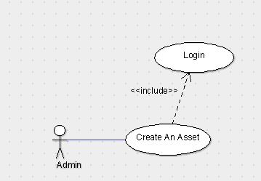

**4.2.1 Description and Priority**

Admin can create and define a new asset if it does not exist yet.

**4.2.2 Stimulus/Response Sequence**

i) Admin login

ii) Calling Create Asset function

iii) Entering information about the asset entity

iv) Saving changes

**4.2.3 Functional Requirements**

Checking whether the asset already exists or not, creates asset if it does not exist.

**4.3 Add an Asset**

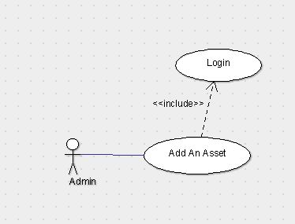

**4.3.1 Description and Priority**

Admin can add pre-defined assets to the current inventory simultaneously assigning a UID to the asset with default location as hostel reception.

**4.3.2 Stimulus/Response Sequence**

i)Admin login

ii)Calling Add Asset function

iii)choosing asset type and other necessary details from the drop-down menu

iv)Saving changes.

**4.3.3 Functional Requirements**

Adding singular particular asset at a time committing to the changes the singular particular asset causes.

**4.4 Add Multiple Asset**

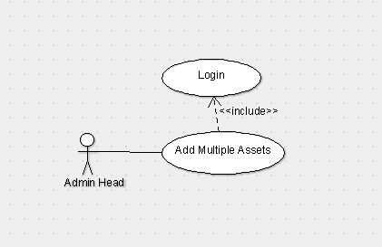

**4.4.1 Description and Priority**

Extension of the add Asset feature; adding mass asset entry to the inventory at a time.

**4.4.2 Stimulus/Response Sequence**

i) Admin login

ii)Calling Add Multiple Asset function

iii)Selecting asset type from sub-menu

iv)Entering the required number of assets

v) Saving changes

**4.4.3 Functional Requirements**

Admin is enabled to add multiple asset particulars to the inventory.

**4.5 View Asset Status**

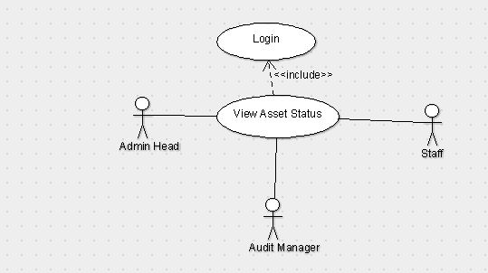

**4.5.1 Description and Priority:**

User can see the status of an asset particular i.e. whether it is damaged, working, repairing or cannot be repaired.

**4.5.2 Stimulus/Response Sequence**

i)User login

ii)Providing UID to search for an asset particular

iii)Calling View Asset Status function

iv)retrieving asset status.

**4.5.3 Functional Requirements**

To be able to see the status of an asset particular.

**4.6 View Asset Location**

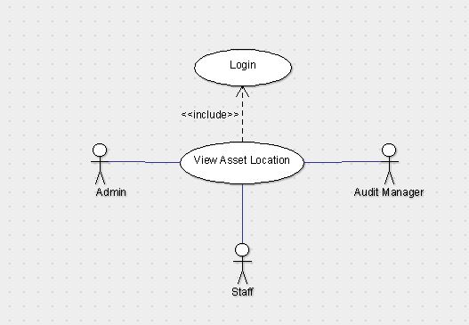

**4.6.1 Description and Priority**

User can view the location of an asset particular.

**4.6.2 Stimulus/Response Sequence**

i)User login

ii)Entering UID of an asset particular.

Iii)Retrieve result.

**4.6.3 Functional Requirements**

To determine or cross check the location of an asset.

**4.7 View Assets**

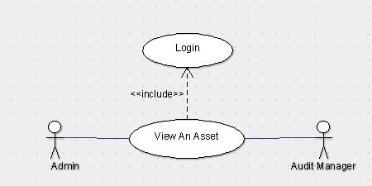

**4.7.1 Description and Priority**

Admin/Auditor can see the location, status, shifting history and other related information about the asset particular.

**4.7.2 Stimulus/Response Sequence**

i) Admin/Auditor login

ii) Providing UID to search for an asset particular

iii) Calling View Asset function

iv) Retrieving asset information

**4.7.3 Functional Requirements**

To cross check the information related to an asset particular and/or to confirm the existence of an asset particular.

**4.8 View Asset Shifting History by Date**

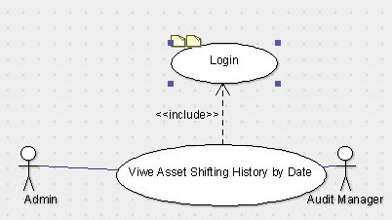

**4.8.1 Description and Priority**

Admin/Auditor are able to see the location history of an asset in the inventory sorted by the date interval.

**4.8.2 Stimulus/Response Sequence**

i) Admin/Auditor login

ii)Entering UID

iii)Specifying date interval

iv)Retrieving result

**4.8.3 Functional Requirements**

To know the whereabouts of an asset particular in a specified time frame.

**4.9 View Asset Shifting History by AssetID**

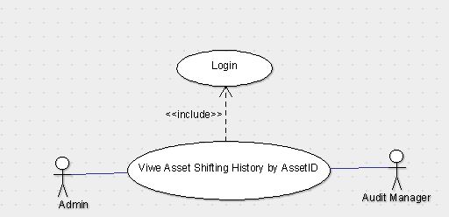

**4.9.1 Description and Priority**

Admin/Auditor are able to see the location history of an asset in the inventory sorted by the AssetID series.

**4.9.2 Stimulus/Response Sequence**

i) Admin/Auditor login

ii)Entering UID

iii)Specifying AssetID series

iv)Retrieving result

**4.9.3 Functional Requirements**

To know the whereabouts of an asset particular in a collective of similar assets.

**4.10 View Asset Shifting History by UserID**

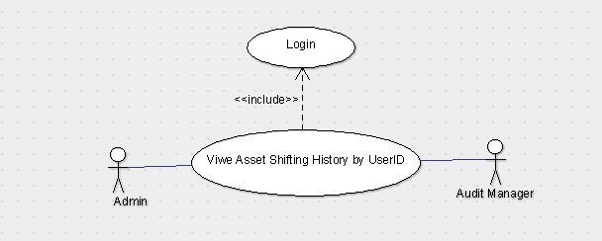

**4.10.1 Description and Priority**

Admin/Auditor are able to see the location history of an asset in the inventory sorted by the UserID of undertaking User.

**4.10.2 Stimulus/Response Sequence**

i) Admin/Auditor login

ii)Entering UID

iii)Specifying UserID

iv)Retrieving result

**4.10.3 Functional Requirements**

To know the whereabouts of an asset particular in the inventory by operating User through UserID.

**4.11 View Comprehensive Report by Date**

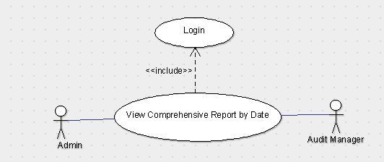

**4.11.1 Description and Priority**

Admin/Auditor is able to see the comprehensive report of all operations and activities on the inventory sorted by the date interval.

**4.11.2 Stimulus/Response Sequence**

i) Admin/Auditor login

ii)Entering UID

iii)Specifying date interval

iv)Retrieving comprehensive report

**4.11.3 Functional Requirements**

To compile all information with proper mapping of events, operations and activities in the specified interval of time.

**4.12 View Comprehensive Report by AssetID**

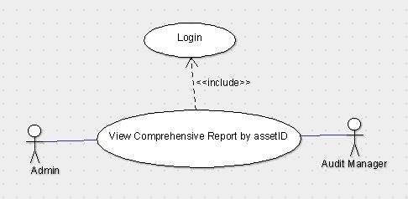

**4.12.1 Description and Priority**

Admin/Auditor are able to see the comprehensive report of all operations and activities on the inventory sorted by the AssetID series.

**4.12.2 Stimulus/Response Sequence**

i) Admin/Auditor login

ii)Entering UID

iii)Specifying AssetID series

iv)Retrieving comprehensive report

**4.12.3 Functional Requirements**

To compile all information with proper mapping of events, operations and activities on an asset particular in a collective of similar assets.

**4.13 View Comprehensive Report by UserID**

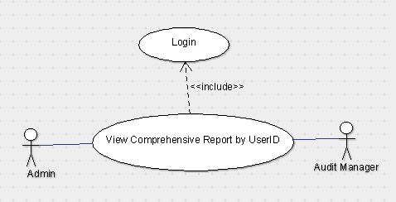

**4.13.1 Description and Priority**

Admin/Auditor are able to see the comprehensive report of all operations and activities on the inventory sorted by the UserID of undertaking User.

**4.13.2 Stimulus/Response Sequence**

i)Admin/Auditor login

ii)Entering UID

iii)Specifying UserID

iv)Retrieving comprehensive report

**4.13.3 Functional Requirements**

To compile all information with proper mapping of events, operations and activities on the inventory by operating User through UserID.

**4.14 Update Asset Status**

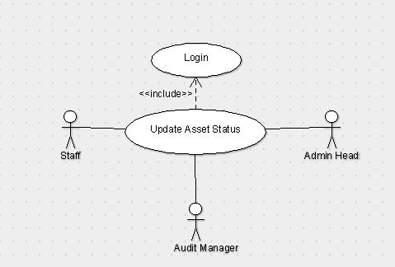

**4.14.1 Description and Priority**

User can update the status of the asset to whether it is working, damaged or can’t be repaired.

**4.14.2 Stimulus/Response Sequences**

i)User login

ii)Calling Update Asset Status

iii)Searching an asset particular using UID

iv)Updating status of the asset particular

**4.14.3 Functional Requirements**

To confirm and update the status of an asset particular after an operation e.g. location update, repair update etc.

**4.15 Update Asset Location**

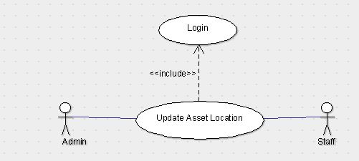

**4.15.1 Description and Priority**

User can update the location of the asset indicating where the asset has been shifted and for what purpose.

**4.15.2 Stimulus/Response Sequences**

i)User login

ii)Calling Update Asset Location function

iii)Specifying AssetID

iv)providing necessary information

v)Updating and saving changes

**4.15.3 Functional Requirements**

To make the system reliable by providing the actors with accurate and efficient information.

**4.16 Remove Asset**

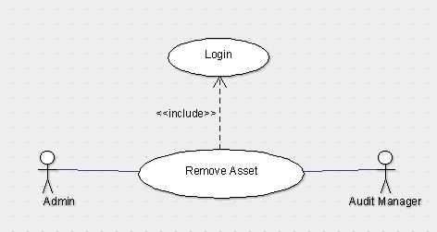

**4.16.1 Description and Priority**

Auditor can remove any asset by reviewing the condition of the asset particular if the asset particular is rendered not repairable.

**4.16.2 Stimulus/Response Sequences**

i)Auditor login

ii)Reviewing asset status

iii)Preparing possible solutions

iv)removing assets that have been rendered unrepairable

**4.16.3 Functional Requirements**

To review the asset status and for data purification by removing the assets and storing them separately as they are removed.

**5. Other Non-functional Requirements**

**5.1 Performance Requirements**

Internet Speed should be responsive and sound.

None of the authoritative actor can login at two different systems during the same session. The host system should be capable enough to support up to 20-30 client nodes in a single session..

**5.2 Safety Requirements**

The Operational update by the staff user may not tally with the actual facts and information, thus it’s the responsibility of the Audit Manager to take care of such wrong transactions.

**5.3 Security Requirements**

User will be provided with a username and password by Admin head to login. We will also be providing separate login credential for separate class of users, that is, an admin will have a separate login ID and staff will have a separate login ID.

**5.4 Business Rules**

Creating and adding of an asset can only be done by Admin and they can check the asset shifting history, status and location of a particular asset. Audit Manager has the authority to remove an asset, view an asset and can check the shifting history of the assets. Staff can only update and view asset location and status. To protect sensitive information about some of the assets, we are giving different login IDs to different type of users.

**Use Case Diagram**

