**Software Requirements Specification**

For

**Hostel Asset Management**

**Version 1.0 not yet approved**

**Prepared by**

Jobin Joseph (U101116FCS053)

Software Engineering

NIIT University

22nd September 2018

**Table of contents**

**1. Introduction**

1.1 Purpose

1.2 Document Conventions

1.3 Intended Audience and Reading Suggestions

1.4 Product Scope

1.5 References

**2. Overall Description**

2.1 Product Perspective

2.2 Product Functions

2.3 User Classes and Characteristics

2.4 Operating Environment

2.5 User Documentation

2.6 Assumptions and Dependencies

**3. External Interface Requirements**

3.1 User Interfaces

3.2 Hardware Interfaces

3.3 Software Interfaces

**4. System Features**

4.1 Create Asset

4.2 Add Asset

4.3 Add Multiple Asset

4.4 View Asset Status

4.5 View Assets

4.6 View Asset Location

4.7 Shift History

4.8 Update Asset Status

4.9 Update Asset Location

4.10 Remove Asset

**5. Other Non-functional Requirements**

5.1 Performance Requirements

5.2 Safety Requirements

5.3 Security Requirements

5.4 Business Rules

**1. Introduction**

**1.1 Purpose**

We are aiming to develop a Hostel Asset Management System, to keep track of all asset particulars that are currently being used in hostels.

**1.2 Document Conventions**

Priority decreases with increase in numerical denomination.

**1.3 Intended Audience and Reading Suggestions**

This document is intended for board of organization, Administrative board and the Staff or request generator. This document specifies the detailed structure of our product, that is, features included, purpose, scope, required environment to use, security details etc.

**1.4 Product Scope**

For a University or campus scale of asset management, it is usually found to be uneasy to follow the flow of assets and their management.

With proper flow control, we are in a process to guarantee hour deep measure of information of a particular asset.

**1.5 References**

We took the reference from the IEEE-SRS template(IEEE-SRS 830-1998) provided by our course In-Charge to prepare this document.

**2. Overall Description**

**2.1 Product Perspective**

It is a self contained product.

**2.2 Product Functions**

This software provides Admin/Audit Manager to keep the count of every asset and where the assets are assigned. If any asset is moved from one room to another, it allows you to change the location and the track of this transaction is recorded in the asset history, also for a particular asset the status information can be retrieved for the Admin/Audit manager’s use.

**2.3 User Classes and Characteristics**

There will be three types of users to use this software they are:

1) Admin – Oversees all operations and maintains exclusive rights.

2) Audit Manager – oversees staff operations and reports to Admin, holds the right to remove a particular asset.

3) Staff – Oversees basic asset operations and reports to Audit manager as well as Admin.

**2.4 Operating Environment**

Web Application, requires basic support providing peripherals, with internet access to run on JRE supported machine.

**2.5 User Documentation**

We will be providing a user manual so that the user can easily comprehend working of this product and for FAQs and troubleshooting we will be providing all online as well as offline support required.

**2.6 Assumptions and Dependencies**

This software can give you the correct results if the staff who is using this software should update the asset details correctly whenever it was changed.

**3. External Interface Requirements**

**3.1 User Interfaces**

The user interface will be consisting firstly of, a login page where the users will be logging in with a UID and the features respective to their authority, that is, in ascending order Staff<Audit Manager<Admin Head, will be given access to. On login page there will be a logo which will be devised for our initiative, a link leading to a help page which will be including troubleshooting and FAQ related resources and a forgot password/reset password link.

**Inside login page:**

1. **Admin Head**
2. **Creating an Asset**

Introducing an Asset to the system.

1. **Adding an Asset**

Establishing a new batch of predefined Asset.

1. **Adding Multiple Assets**

Establishing a new batch of multiple predefined Assets.

1. **Viewing Asset Status**

Determining whether the asset is Working, Damaged, Repairing, cannot be repaired.

1. **Updating Asset Status**

Re-Assigning asset status after reviewing the Asset particulars.

1. **Viewing Asset Location**

Determining current location of an Asset.

1. **Viewing Assets**

Retrieving all information about an Asset or a set of assets.

1. **Viewing Asset Shifting History**

Retrieving asset location logs over a specified period of time.

1. **Audit Manager**
2. **Viewing Asset Shifting History**

Retrieving asset location logs over a specified period of time.

1. **Viewing Assets**

Retrieving all information about an Asset or a set of assets.

1. **Remove Assets**

Discarding the Asset particular(s) which is/are rendered beyond repair.

1. **Viewing Asset Location**

Determining current location of an Asset.

1. **Staff**
2. **Updating Asset Status**

Re-Assigning asset status after reviewing the Asset particulars.

1. **Updating Asset Location**

Re-Assigning present Asset location of Asset particulars after shifting or related operations.

1. **Viewing Asset Location**

Determining current location of an Asset.

**3.2 Hardware Interfaces**

Minimum Requirements for host system are:

1. 32-bit Operating System
2. 2 GB RAM
3. Network Card
4. 8 GB ROM

**3.3 Software Interfaces**

The system must consist of:

1. JRE
2. Image Processing
3. MySQL (RDBMS)
4. Web Browser support

**4. System Features**

**4.1 Create Asset**

**4.1.1 Description and Priority**

Admin can create a new Asset right from scratch.

**4.1.2 Stimulus/Response Sequence**

After logging into the portal, admin has to click the create asset button and should give the name of an asset and then should click button create

**4.1.3 Functional Requirements**

Function is required to check whether the asset is already present or not. If it was present then no need to create the asset. User has to login to access this feature.

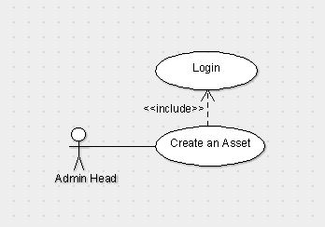

**4.2 Add Asset**

**4.2.1 Description and Priority**

Admin can add pre-defined asset and this will also generate unique id to the asset and by default location will be the reception. Only admin can do this function.

**4.2.2 Stimulus/Response Sequence**

click the add asset button and then drop-down menu option appears select an asset and then click add.

**4.2.3 Functional Requirements**

We have toadd to the particular asset we should not add the number of a particular asset to others because it leads to the difference in the number.

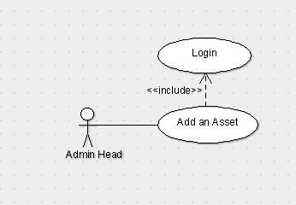

**4.3 Add Multiple Asset**

**4.3.1 Description and Priority**

It is actually the extension of the add Asset feature. By this admin will able to add multiple assets of same type at a time.

**4.3.2 Stimulus/Response Sequence**

Click Add multiple asset and then select the asset type and then select the number of assets you want to add then click add.

**4.3.3 Functional Requirements**

We can add number of multiple assets of a particular one. (For example, if we are having 60 chairs and 20 tables we can add all 60 chairs by giving them id at a time but we can’t add tables and chairs at a time.)

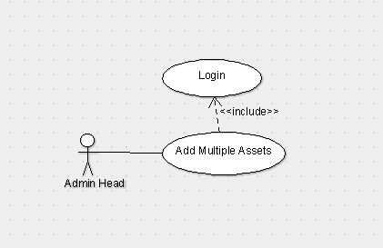

**4.4 View Asset Status**

**4.4.1 Description and Priority:**

Admin can see the status of any particular asset i.e. whether it is damaged, working, repairing and cannot be repaired etc.

**4.4.2 Stimulus/Response Sequence**

Click Asset Status and then select the type of asset and then enter the respective unique id that is related to that asset and then click show Status.

**4.4.3 Functional Requirements**

We can see the status of a particular asset of a particular type. (For example, if there is an asset with id Table_23 we can see the status of that particular one whether it is damaged, working, repairing and cannot be repaired etc.)

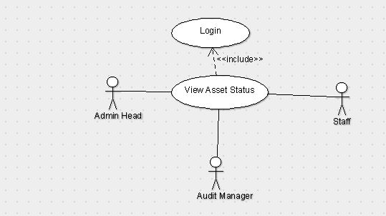

**4.5 View Asset**

**4.5.1 Description and Priority**

Admin can see the location, status, shift history etc.

**4.5.2 Stimulus/Response Sequence**

Click View Assets and then search for particular id of a particular asset type and then we can see its status, location, shift history.

**4.5.3 Functional Requirements**

It is for checking purpose or to just for knowing the existence of an asset (For example, if we are having an asset with Id mirror_107 by searching that we can get its location-UG-2 3306, status – working, shift history – reception->store room of UG->UG-2 3306.)

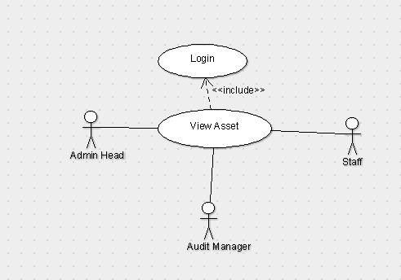

**4.6 View Asset Location**

**4.6.1 Description and Priority**

Admin can see the location of the particular asset.

**4.6.2 Stimulus/Response Sequence**

Click asset location and then enter the unique id of an asset then click show.

**4.6.3 Functional Requirements**

Function is required to check the asset Id is exists.

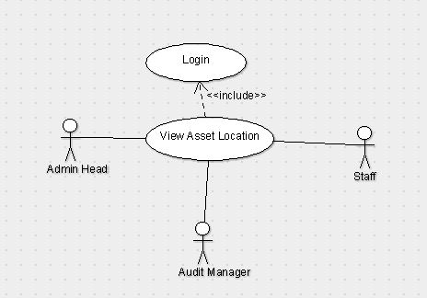

**4.7 View Shift History**

**4.7.1 Description and Priority:**

Admin can see the location history of the asset from the time that it has been created.

**4.7.2 Stimulus/Response Sequence**

Click on Shift History and then give the unique id of the asset then click show.

**4.7.3 Functional Requirements**

Function is required to check the asset history that from where the particular asset has been shifted (For example reception->Store room.)

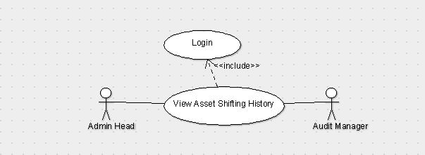

**4.8 Update Asset Status**

**4.8.1 Description and Priority**

Staff can update the status of the asset whether is it working, damaged or can’t be repaired.

**4.8.2 Stimulus/Response Sequences**

Any staff he/she having credentials will login to the page and then click on Update asset status in which we have to search for the asset with its id and then change the status of the asset to either working, damaged or can’t be repaired.

**4.8.3 Functional Requirements**

We have to update the status if there is any problem with the asset otherwise the data will be corrupted if we don’t change the status. (For example, if there is a product which was damaged in the past and it was repaired. Then the change of status will be damaged->working.)

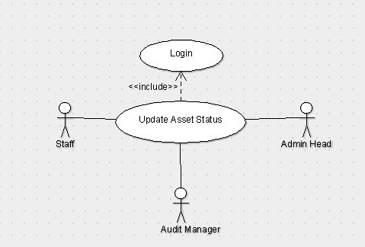

**4.9 Update Asset Location**

**4.9.1 Description and Priority**

Staff can update the location of the asset as of where the asset is present at which place.

**4.9.2 Stimulus/Response Sequences**

After staff login page we have to click on update location in which we have to search for the asset with its id by changing its room number and its location.

**4.9.3 Functional Requirements**

We have to update the location of the asset if we don’t update the place then there will be a mismatch or missing of the asset and which it will be difficult to identify. (For example, if the asset is present in UG-2, 1301 and the location is changed to UG-1, 3307 then we have to update the location.)



**4.10 Remove Asset**

**4.10.1 Description and Priority**

Audit can remove any asset by checking its condition. After updating status of the asset audit can check the assets which can’t be repaired and he can remove those assets.

**4.10.2 Stimulus/Response Sequences**

After audit login page we have to click on the remove asset and enter asset Id and remove them.

**4.10.3 Functional Requirements**

Here for data purification we are removing the assets and storing them separately as they are removed. (For example, we can remove the asset by seeing the status of its if the status is can’t be repaired then we can remove it.)

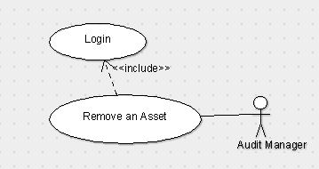

**4.11 Login**

**4.10.1 Description and Priority**

The one who wants to enter into this software should first login using the credentials provided by the developer.

**4.10.2 Stimulus/Response Sequences**

After entering the site address you there will be a text fields to enter the details after entering it click login button.

**4.10.3 Functional Requirements**

Login can be done to those who has the correct credentials, anonymous person can’t login username and password will be provided by the developer you will also have the option to reset the password. Those details shouldn’t be shared to others.

**Use Case Diagram**

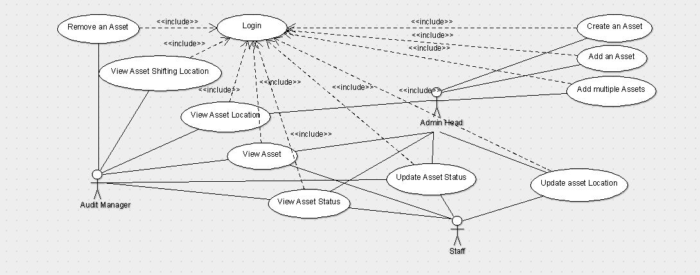

**5. Other Non-functional Requirements**

**5.1 Performance Requirements**

Internet Speed should be responsive and sound.

None of the authoritative actor can login at two different systems during the same session. The host system should be capable enough to support up to 20-30 client nodes in a single session..

**5.2 Safety Requirements**

The Operational update by the staff user may not tally with the actual facts and information, thus it’s the responsibility of the Audit Manager to take care of such wrong transactions.

**5.3 Security Requirements**

User will be provided a username and password to login. We will also be providing separate login credential for separate class of users, that is, an admin will have a separate login ID and staff will have a separate login ID.

**5.4 Business Rules**

Creating and adding of an asset can only be done by Admin and they can check the asset shifting history, status and location of a particular asset. Audit Manager has the authority to remove an asset, view an asset and can check the shifting history of the assets. Staff can only update and view asset location and status. To protect sensitive information about some of the assets, we are giving different login IDs to different type of users.