Software Requirements Specification
for
Hostel assets management
Version 1.0 not approved yet
Prepared by-:
Pradeep yadav (U101116FCS089)
Software Engineering
NIIT UNIVERSITY
Date -30/08/2018

Table of contents

Table of Contents ii
1. Introduction 1
1.1 Purpose 1
1.2 Document Conventions 1
1.3 Intended Audience and Reading Suggestions 1
1.4 Product Scope 1
1.5 References 1
2. Overall Description 2
2.1 Product Perspective 2
2.2 Product Functions 2
2.3 User Classes and Characteristics 2
2.4 Operating Environment 2
2.5 User Documentation 2
2.6 Assumptions and Dependencies 3
3. External Interface Requirements 3
3.1 User Interfaces 3
3.2 Hardware Interfaces 3
3.3 Software Interfaces 3
4. System Features 4
4.1 Create Asset 4
4.2 Add Asset 4
4.3 Add Multiple Asset 4
4.4 View Asset Status 4
4.5 View Assets 4
4.6 View Asset Location 4
4.7 Shift History 4
4.8 Update Asset Status 4
4.9 Update Asset Location 4
4.10 Remove Asset 4
4.11 Login…………………………………………………………………………………………….. 4
5. Other Nonfunctional Requirements 4
5.1 Performance Requirements 4
5.2 Safety Requirements 5
5.3 Security Requirements 5
5.4 Business Rules 5

1. Introduction

1.1 Purpose
To take care of all the assets that are in hostels and Academic Blocks(AC1,AC2) our group is trying to develop a Hostel asset management system.

1.2 Document Conventions
1.3 Intended Audience and Reading Suggestions
This document is intended for organization staff, Administration team,Management office, Studends ,Wardens and the users. This document mainly contains structure of this product like features included, purpose, scope, requirements to use, security details etc.

1.4 Product Scope
Generally it is very hard to keep track of the assests particularly for large organizations like big School, Collage , there wont be any particular up to date information but by this software we are trying to automate this we can keep track of each and every asset at any point of time.If the student change his/her room then also we can track all the information about assets.

1.5 References
We took the reference from the SRS template form ieee uploaded in Moodle,Youtube to prepare this document.

2. Overall Description

2.1 Product Perspective
It is a self contained product.

2.2 Product Functions
This software provides Guard/Warden/Staff/Admin to take care of the count of every asset and where those assets are placed and replaced if replaced then where is the old one. If any asset is moved to one room to other it allows you to change the location and also this is stored in the asset history. We can also see that the asset is damaged or not.with a unique asset ID which is also written on it.

2.3 User Classes and Characteristics
There will be 4 types of users to use this software they are
1) Students – Can only see the details assets in his room.
2) Admin – Can mange everything.
3) Staff – Can have the access to change the place of assets.
4)Guard – can only see the details of assets in the room etc.

2.4 Operating Environment
Basically as this is web software it requires Data connection,Wi-fi and it will work on PC , laptops and smart phones there is no specification.

2.5 User Documentation
We are going to provide one user manual so that the user can easily understand how to use this software and we also provide “help” section in our software user can raise the question and admin can answer that.

2.6 Assumptions and Dependencies
This software can give you the correct results if the staff who is using this software should update the asset details correctly whenever it was changed.

3. External Interface Requirements

3.1 User Interfaces
The user interface will be consisting firstly of, a login page where the users will be logging in with a UID and the features respective to their authority, that is, in ascending order Staff<Audit Manager<Admin Head, will be given access to. On login page there will be a logo which will be devised for our initiative, a link leading to a help page which will be including troubleshooting and FAQ related resources and a forgot password/reset password link.

Inside login page:
- Admin Head
- Creating an Asset
Introducing an Asset to the system.
- Adding an Asset
Establishing a new batch of predefined Asset.
- Adding Multiple Assets
Establishing a new batch of multiple predefined Assets.
- Viewing Asset Status
Determining whether the asset is Working, Damaged, Repairing, cannot be repaired.
- Viewing Asset Location
Determining current location of an Asset.
- Viewing Asset Shifting History
Retrieving asset location logs over a specified period of time.

- Audit Manager
- Viewing Asset Shifting History
Retrieving asset location logs over a specified period of time.
- Remove Assets
Discarding the Asset particular(s) which is/are rendered beyond repair.
- Viewing Asset Location
Determining current location of an Asset.
- Staff
- Updating Asset Status
Re-Assigning asset status after reviewing the Asset particulars.
- Updating Asset Location
Re-Assigning present Asset location of Asset particulars after shifting or related operations.

3.2 Hardware Interfaces
Minimum Requirements for host system are:
- 32-bit Operating System
- 2 GB RAM
- Network Card
- 8 GB ROM

3.3 Software Interfaces
The system must consist of:
JRE
Image Processing
MySQL (RDBMS)
Web Browser support

4. System Features

4.1 Create Asset

4.1.1 Description and Priority: Admin can create new asset that are not been defined before.
4.1.2 Stimulus/Response Sequence: After logging into the portal admin has to click the create asset button and should give the name of an asset and then should click button create
4.1.3 Functional Requirements: Function is required to check whether the asset is already present or not. If it was present then no need to create the asset. User has to login to access this feature.

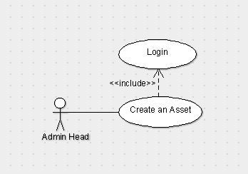

4.2 Add Asset

4.2.1 Description and Priority: Admin can add pre-defined asset and this
Will also generate unique id to the asset and by default location will be the reception. Only admin can do this function.
4.2.2 Stimulus/Response Sequence: click the add asset button and then drop-down menu option appears select an asset and then click add.
4.2.3 Functional Requirements: We have to add to the particular asset we should not add the number of a particular asset to others because it leads to the difference in the number.

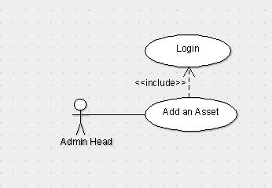

4.3 Add Multiple Asset

4.3.1 Description and Priority: It is actually the extension of the add Asset feature. By this admin will able to add multiple assets of same type at a time.
4.3.2 Stimulus/Response Sequence: Click Add multiple asset and then select the asset type and then select the number of assets you want to add then click add.
4.3.3 Functional Requirements: We can add number of multiple assets of a particular one. (For example, if we are having 60 chairs and 20 tables we can add all 60 chairs by giving them id at a time but we can’t add tables and chairs at a time.)

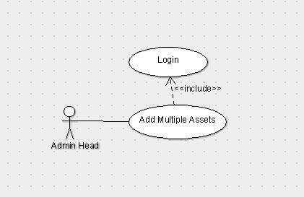

4.5 View Asset

4.5.1 Description and Priority: Admin can see the location, status, shift history etc.
4.5.2 Stimulus/Response Sequence: Click View Assets and then search for particular id of a particular asset type and then we can see its status, location, shift history.
4.5.3 Functional Requirements: It is for checking purpose or to just for knowing the existence of an asset (For example, if we are having an asset with Id mirror_107 by searching that we can get its location-UG-2 3306, status – working, shift history – reception->store room of UG->UG-2 3306.)

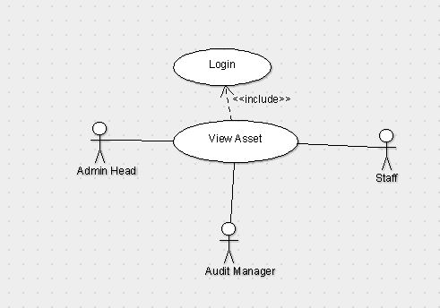

4.6 View Asset Location

4.6.1 Description and Priority: Admin can see the location of the particular asset.
4.6.2 Stimulus/Response Sequence: Click asset location and then enter the unique id of an asset then click show.
4.6.3 Functional Requirements: Function is required to check the asset Id is exists.

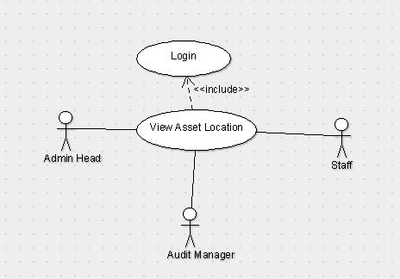

4.7 View Shift History

4.7.1 Description and Priority: Admin can see the location history of the asset from the time that it has been created.
4.7.2 Stimulus/Response Sequence: Click on Shift History and then give the unique id of the asset then click show.
4.7.3 Functional Requirements: Function is required to check the asset history that from where the particular asset has been shifted (For example reception->Store room.)

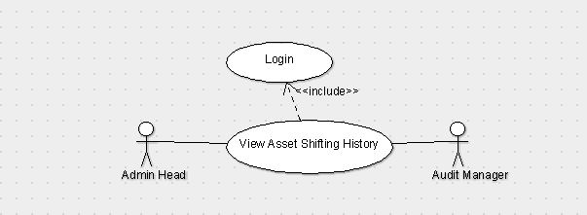

4.8 Update Asset Status

4.8.1 Description and Priority: Staff can update the status of the asset whether is it working, damaged or can’t be repaired.
4.8.2 Stimulus/Response Sequences: Any staff he/she having credentials will login to the page and then click on Update asset status in which we have to search for the asset with its id and then change the status of the asset to either working, damaged or can’t be repaired.
4.8.3 Functional Requirements: We have to update the status if there is any problem with the asset otherwise the data will be corrupted if we don’t change the status. (For example, if there is a product which was damaged in the past and it was repaired. Then the change of status will be damaged->working.)

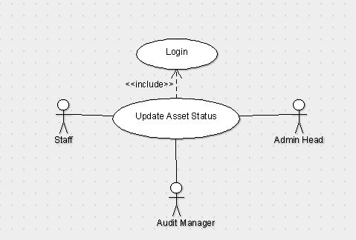

4.9 Update Asset Location

4.9.1 Description and Priority: Staff can update the location of the asset as of where the asset is present at which place.
4.9.2 Stimulus/Response Sequences: After staff login page we have to click on update location in which we have to search for the asset with its id by changing its room number and its location.
4.9.3 Functional Requirements: We have to update the location of the asset if we don’t update the place then there will be a mismatch or missing of the asset and which it will be difficult to identify. (For example, if the asset is present in UG-2, 1301 and the location is changed to UG-1, 3307 then we have to update the location.)

4.10 Login
4.10.1 Description and Priority: The one who wants to enter into this software should first login using the credentials provided by the developer.
4.10.2 Stimulus/Response Sequences: After entering the site address you there will be a text fields to enter the details after entering it click login button.
4.10.3 Functional Requirements: Login can be done to those who has the correct credentials, anonymous person can’t login username and password will be provided by the developer you will also have the option to reset the password. Those details shouldn’t be shared to others.

Use Case Diagram
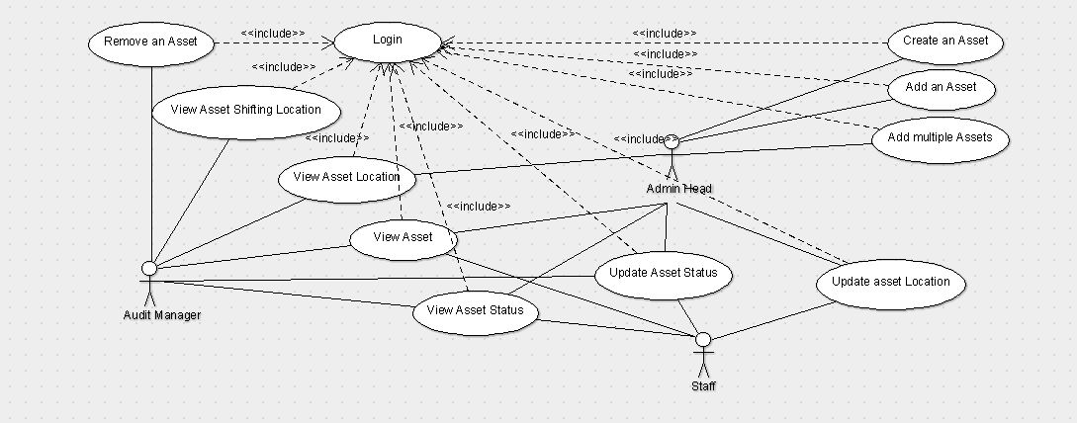

5. Other Non-functional Requirements

5.1 Performance Requirements
Internet Speed should be good for speed response. No one can login at two or more places at a time. 20-30 people can login at a time.
5.2 Safety Requirements
Staff who is using the software may change location, status wrong so there will be a Audit login in that Audit manager will be able to check the transaction histories of everything. So it’s the responsibility of the Audit manager to take care of such wrong transactions.
5.3 Business Rules
Create and Add Asset can only be done by Admin and they can check the asset shifting history, status, location of the particular asset. Audit has the access to removing Asset, view Asset and can check the shifting history of the assets. Staff can only update and view asset location and status. As there is some private information about assets so we are giving different logins to different type of users.

