**Gartner for Enterprise Architecture and Technology Innovation Leaders Tool**

CTO Charter Template

**January 2024**

Unless otherwise marked for external use, the items in this Gartner Tool are for internal noncommercial use by the licensed Gartner client. The materials contained in this Tool may not be repackaged or resold. Gartner makes no representations or warranties as to the suitability of this Tool for any particular purpose, and disclaims all liabilities for any damages, whether direct, consequential, incidental or special, arising out of the use of or inability to use this material or the information provided herein.

**The instructions, intent and objective of this template are contained in the source document. Please refer back to that document for details.**

**TABLE OF CONTENTS**

Guidelines for Creating the CTO Charter 3

Executive Summary 3

Mission and Purpose 4

Guidelines for Writing the Mission Statement *<<delete after completing the template* >> 4

Guide to Determining the Purpose of the OCTO *<<delete after completing the template* >> 4

Objectives and Metrics 5

Guide to Objectives and Metrics *<<delete after completing the template >>* 5

Roles and Responsibilities 6

Guide to Roles and Responsibilities <<delete after completing the template >> 6

Deliverables 8

Guide to Deliverables <<delete after completing the template >> 8

Charter Amendment 9

# Guidelines for Creating the CTO Charter

CTOs are often expected to deliver on a broad set of responsibilities and handle competing priorities. The establishment of a CTO organization, including an OCTO, can help them improve their chances of successfully delivering on those responsibilities. Furthermore, navigating organizational politics and the need to drive cultural change are common barriers to CTO success. These barriers can be overcome if the CTO can build the right relationships in the organization, especially with senior business executives. Since CTOs are usually accountable for driving technology innovation and leading digital product development, they also need to ensure close working relationships with business executives who they regularly interface with.

The CTO should work with their manager, direct teams and key stakeholders, who either reside in or work with the CTO organization and the OCTO, to create the CTO charter. This ensures that all parties can agree on how to work together to support the CTO organization and the OCTO and interface with its key capabilities. These stakeholders may include, but are not limited to:

* CIO
* Chief Enterprise Architect
* Chief Innovation Officer and/or Head of Technology Innovation
* Chief Data Officer
* Chief Information Security Officer
* Head of Infrastructure and Operations (if this team does not report directly to the CTO)
* Head of Digital Product Development (if this team does not report directly to the CTO)
* Head of Application Development (if this team does not report directly to the CTO)
* Head of Project and Portfolio Management, or Project Management Office
* Head of Sourcing, Procurement and Vendor Management (if this team does not report directly to the CTO)
* C-level business executives including sales, marketing, customer experience, supply chain, and research and development

Share a draft of the CTO charter with these key stakeholders before finalizing it. This ensures the CTO has the opportunity to better understand attitudes toward the CTO organization and the OCTO and capture any pain points, challenges or opportunities that could be used to develop communication and action plans.

Figure 1 shows the correlation between a formal OCTO and an organization’s performance against business objectives. About 70% have formal OCTO and they are performing better in terms of optimizing costs and innovating business models than the remaining 30% with informal (or no) OCTO, according to the 2023 Gartner Changing Role of the CTO Function Survey.1

CTOs should prioritize establishing OCTO to meet business outcomes on delivering digital transformation and innovation. Identify and prioritize your key stakeholders and create value propositions to meet their expectations. Find innovative ways of leveraging technology to address stakeholder priorities and concerns (see [The Gartner Enterprise Value Equation: It’s Time to Rethink Outdated Enterprise Value Formulas](https://www.gartner.com/document/4016711?ref=solrAll&refval=385378232&)).

**Figure 1: Comparison of Organizational Performance by OCTO Function Type**

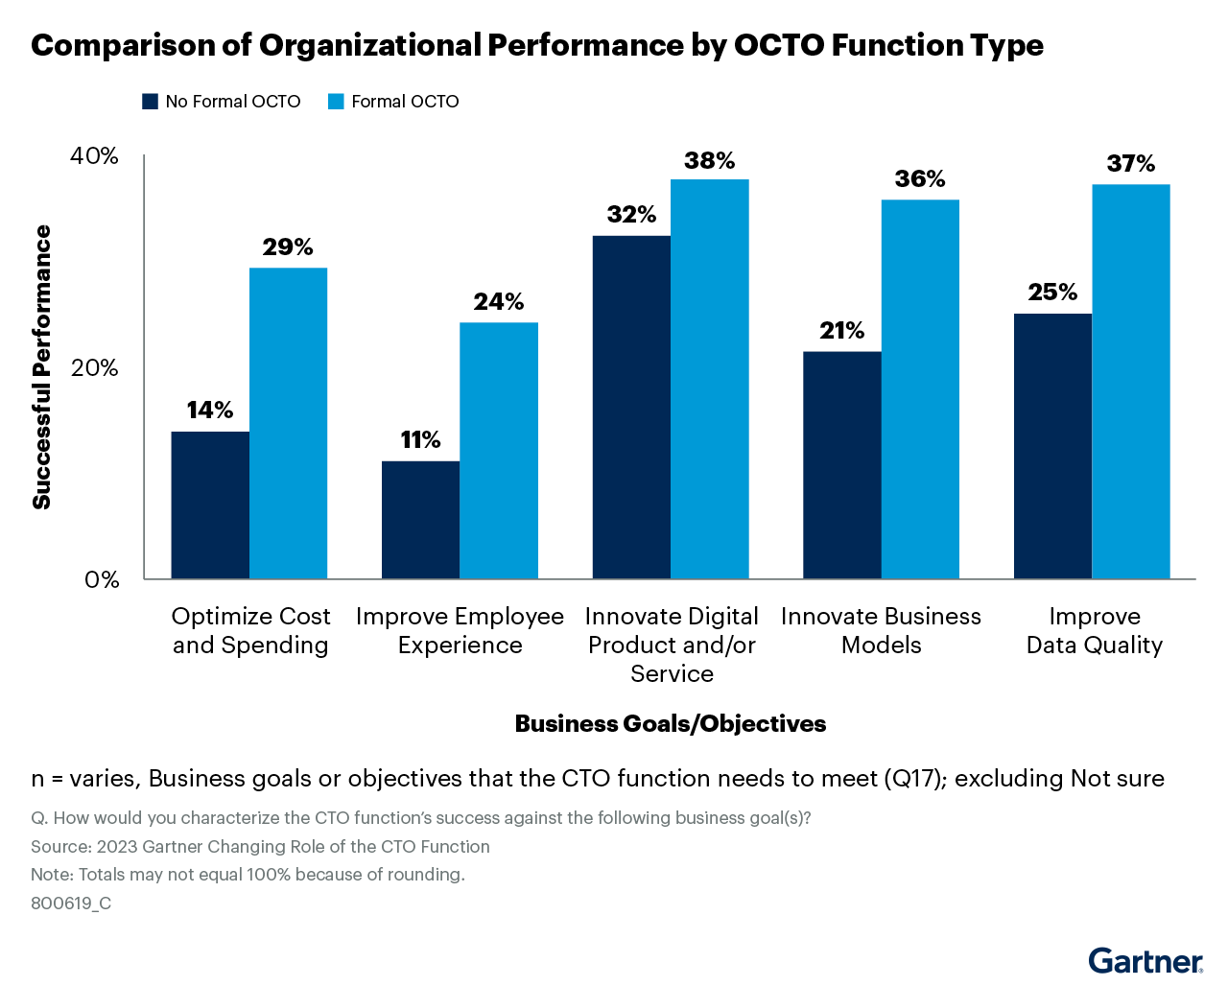

Please note that each of the following sections of the template includes a guidance section to provide advice on how to fill out that section of the charter. These guidelines should be deleted and replaced with your own text as you fill out this charter.

# Executive Summary

This section provides a single paragraph, which provides an overview of the document. It outlines why the CTO organization and OCTO has been set up, what it will deliver, who is involved and how it will contribute to leveraging technology to deliver the organization’s overall business strategy by contributing to strategic business outcomes. Use this section to also explain the context of what the organization is trying to achieve.

## Mission and Purpose

### Guidelines for Writing the Mission Statement *<<delete after completing the template* >>

A mission statement is a clear, concise and inspiring statement about a function’s purpose and role in the organization. An example of a mission statement is shown in Figure 2. The mission of the CTO organization should focus on investing in and leveraging technology to enable one or more of the following:

* Develop and implement the technology strategy
* Optimize the organization’s current business and/or IT operations
* Lead technology innovation to drive transformation and enable new business models
* Enable digital business by providing the right technologies to build digital business platforms and creating digital products and services
* Evolve talent within the IT organization to acquire the skills to better exploit technology
* Manage the CTO organization and OCTO

*Insert your mission statement for the* CTO organization *in the box below.*

**Figure 2: Mission Statement for the CTO organization**



**Source: Gartner (January 2024)**

### Guide to Determining the Purpose of the CTO organization *<<delete after completing the template* >>

The purpose of the CTO organization is to provide the right technology capabilities to support the organization’s current business models and its longer-term strategy. The teams or functions that reside within the CTO organization then support the CTO in establishing and delivering these capabilities. The capabilities outlined in Figure 3 are the key capabilities required to enable digital business transformation. CTOs may either lead or support each of these capabilities in partnership with IT executive leaders. Therefore, there needs to be clarity on which capabilities may be the direct responsibility of other IT executives like the CIO, chief digital officer, chief data officer or chief information security officer.

CTOs are accountable for a broad range of tasks involving technology life cycle management. The reality is they are often expected to deliver more than is realistically possible, while their key responsibilities are poorly defined. This is where both the CTO organization and OCTO are critical to the CTO’s success. CTOs can delegate certain responsibilities to the teams within the CTO organization to help ensure that all key responsibilities are defined and executed. This means deciding which technologies to modernize and retire, optimizing the current technology stack, and deciding when to invest in new, emerging technologies that will drive technology innovation. Furthermore, technology evolves fast. The CTO organization should track and respond to this through technology innovation, while also ensuring that IT systems and business processes are agile enough to adapt to this rate of technological change. The OCTO then oversees strategic execution, performance management, financial management, and talent management, as well as supporting communication and cultural change.

**Figure 3: Key Capabilities for Enabling Digital Business Transformation**

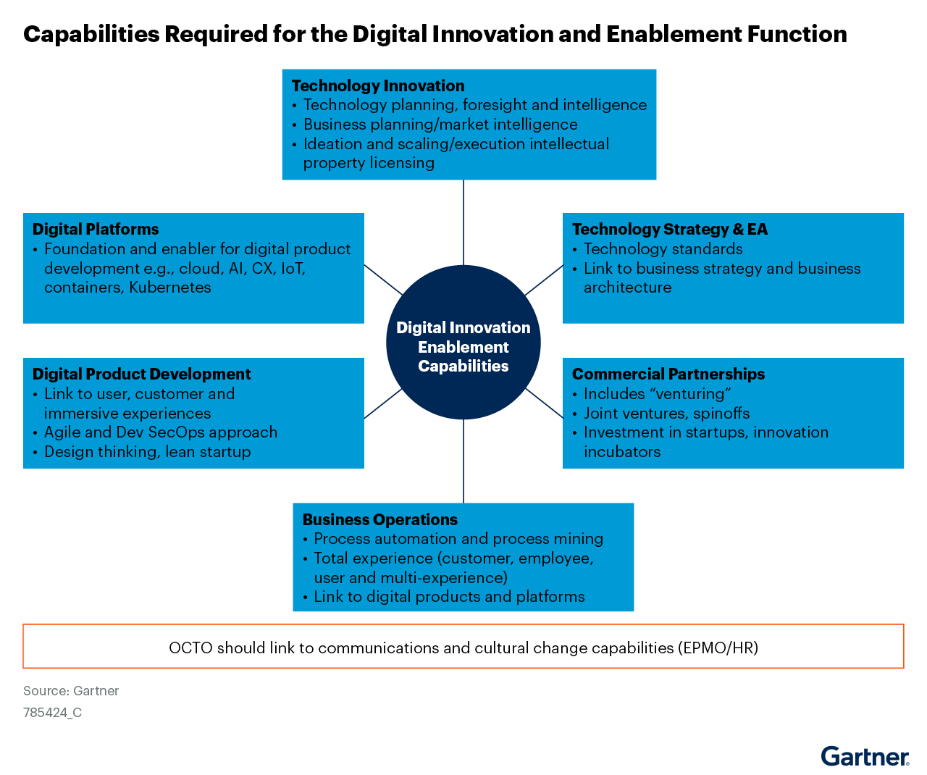

**Source: Gartner (January 2024)**

Full details of what each of these capabilities should provide is explained in [How CTOs Can Create a Winning Digital Innovation and Enablement Function](https://www.gartner.com/document/4475499?ref=solrAll&refval=383235854&). Once it has been decided which capabilities the CTO organization requires, it becomes easier to establish the required roles and responsibilities, and work out the right organizational structure. Gartner’s IT Score for CTO maturity assessment outlines 29 activities that a mature CTO function should perform (see [IT Score for CTO](https://www.gartner.com/document/4004426?ref=solrResearch&refval=326744103) and [Quick Answer: What Does Gartner’s IT Score for CTOs Deliver?](https://www.gartner.com/document/code/797885?ref=ddisp&refval=797885)).

## Objectives and Metrics

## Guide to Objectives and Metrics *<<delete after completing the template >>*

The success of the CTO organization depends on delivering business value to the organization. To achieve this, the CTO should establish quantifiable objectives that guide how the OCTO will leverage technology to support the business strategy. These objectives should align with key business outcomes outlined in the organization’s business strategy.

The best way to do this is to define quantifiable business outcomes to be achieved in a certain time frame and document them (see Table 1). If a more detailed approach to objective setting is required, consider using objectives and key results (OKRs), see [How Executives Can Use OKR to Deliver Strategic Outcomes](https://www.gartner.com/document/4659299?ref=solrResearch&refval=388740805&) and [Toolkit: 5 Workshop Templates to Kickstart Your OKR Program](https://www.gartner.com/document/code/806180?ref=dochist)).

**Table 1: Objectives of the Office of the CTO**

| **Business Goal** | **Objective** | **Target Business Outcome** |
| --- | --- | --- |
| Example 1: Empower our employees to have the right tools and information at their fingertips | Provide technology that supports employees in the tasks they need to perform to enhance productivity and employee satisfaction | Improvement of 10% in employee satisfaction and productivity with applications and digital services in the next six months |
| Example 2: Deliver an outstanding customer experience that anticipates their every need | Invest in technologies that will enhance customer experience | Improvement of 15% in customer satisfaction with our digital products and services in the next 12 months |
| Example 3: Succeed in innovating our products and services to outperform our competitors | Explore how new technologies can enable further product/service innovation to meet customer needs | 5% increase in revenue from new products and services |

**Source: Gartner (January 2024)**

You then need to determine how you will measure the contribution of the CTO organization’s activities and decisions in contributing to these business outcomes. Identify metrics that are designed to not only track progress to achieving business outcomes, but also provide the right information to decide what action will help you realize those business outcomes. Record the chosen metrics in Table 2, alongside the relevant target business outcome.

**Table 2. Metrics to Measure the Performance of the OCTO**

| **Targeted Business Outcome** | **Metrics** |
| --- | --- |
| Improvement of 10% in employee satisfaction with applications and digital services in the next six months | Employee satisfaction index measuring satisfaction in key applications and digital services; |
| Improvement of 15% in customer satisfaction with our digital products and services in the next 12 months | Net Promoter Score, customer retention rate |
| 5% increase in revenue from new products and services | Revenue generated from new products and services, based on technology provided by the OCTO; rate of new product/service innovation (new prototypes generated) |

**Source: Gartner (January 2024)**

# Roles and Responsibilities

## Guide to Roles and Responsibilities <<delete after completing the template >>

This section should outline the key stakeholders who work with the CTO, even if they don’t report to the CTO, as well as the teams and functions within the CTO organization that report to the CTO. In some organizations, multiple CTOs may be involved. Often the CTO organization will need to work with other teams in areas such as technology innovation, digital product management, application development, data and analytics, and program and portfolio management. Business and technology executives that the CTO/OCTO works with, such as the chief data officer, chief information security officer or chief marketing officer should also be included in Table 3.

**Table 3. Key Stakeholder Roles and Responsibilities**

| **Key Stakeholder Role** | **Responsibilities** |
| --- | --- |
| CIO | Ensure alignment of the IT strategy, governance, performance and organization, including OCTO with business needs. Work with the CTO to build digital business platforms and enable digital business transformation. |
| VP of Customer Experience | Provide input and customer feedback to align technology innovation with validated customer needs. |
| Chief Information Security and Risk Management Officer | Evaluate the security impact of implementing new technologies on the organization. |
| Chief Data Officer | Leverage technology to build data science platforms. Assess the potential of new technologies to generate and monetize valuable data for the organization. |
| Head of HR | Work with OCTO to communicate new technology projects and lead cultural change. |

**Source: Gartner (January 2024)**

Next, the CTO should work with her or his manager (usually the CEO or CIO) to agree on which teams report directly to the CTO, and therefore form part of the OCTO (if this hasn’t been decided yet). Some teams may report to the CIO, but still have an indirect working relationship with the CTO organization. Each team and its core set of responsibilities should be summarized in Table 4. Our research shows that the technology innovation, EA, infrastructure and operations, cloud, AI, platform engineering, software engineering, and digital product development teams often report directly to the CTO. However, this may look different in different organizations, according to the CTO’s goals and the operating model required to deliver them. A responsible, accountable, consulted, informed (RACI) matrix can be used to provide further detail, if required. Note that some of these teams may report to the CIO or elsewhere in some organizations.

**Table 4. Teams or Functions Residing Within the OCTO**

| **Team or Function** | **Responsibilities** |
| --- | --- |
| Enterprise Architecture | Determine how the architecture should evolve to support current or new business models/operations. Assess the impact of implementing new technologies on the existing architecture. |
| Infrastructure and Operations | Modernize infrastructure to support current or new business models/operations. Evaluate how the infrastructure needs to adapt to support new technologies. |
| Technology Innovation | Perform trendspotting activities to track emerging technologies and determine which ones the organization should respond to. Evaluate new technologies to develop new products, services or solutions to meet business and customer needs. |
| Digital Product Development | Work with the CTO and CIO to enable the shift toward product-centric delivery to support transformation, innovation, and creating new digital products and platforms. |
| Software engineering | Create, improve and deliver digital solutions and products for the organization both for internal and external use. |
| Platform engineering | Product team(s) responsible for optimizing developer experience through building and operating self-service internal developer platforms (IDPs) for software delivery and product life cycle management. |

**Source: Gartner (January 2024)**

# Deliverables

## Guide to Deliverables <<delete after completing the template >>

Table 5 outlines the key deliverables that the OCTO should develop to help fulfill its objectives.

**Table 5. Key Deliverables That the OCTO Will Produce**

| **Deliverable** | **Stakeholder and/or Teams Responsible** |
| --- | --- |
| Enterprise technology strategy | CTO |
| Technology strategic plan | CTO |
| Technology roadmaps | CTO, Enterprise Architecture |
| Technology investment portfolio analysis | CTO |
| Business capability models | Enterprise Architecture |
| Current and future-state architectures with gap analysis | Enterprise Architecture |
| Technology innovation strategy | Technology Innovation |
| Trendspotting analysis | Technology Innovation |
| Emerging technology radar and wheel | Technology Innovation |
| CTO organization monthly scorecard | CTO |
| Skills gap analysis | CTO/OCTO, CIO and/or HR partner |
| Cultural change management plan | CTO and Head of HR |

**Source: Gartner (January 2024)**

# Charter Amendment

**Table 6. OCTO Charter Modification History**

| **Version** | **Version Date** | **Authorized By** | **Change Summary** |
| --- | --- | --- | --- |
|  |  |  |  |
|  |  |  |  |
|  |  |  |  |
|  |  |  |  |

**Source: Gartner (January 2024)**

**Evidence**

1 **2023 Changing Role of the CTO Function Survey:** This study was conducted to understand the CTO function design and how CTOs and their organizations are changing their operating models and enabling digital business model innovation and transformation. The research was conducted online from 15 May through 6 July 2023 among 404 participants from North America (n = 204), Europe (n = 147) and Asia/Pacific (n = 53). Participants were leaders in their organization who were knowledgeable about the roles and responsibilities of the CTO. Respondents were screened for industry, job title, company size (at least $500 million in annual revenue), knowledge on organizational structure and their reporting level away from the CTO. Industries surveyed include banking/investment services, manufacturing, healthcare providers, insurance, natural resources, government, services, energy, retail, utilities, health payer, communications service provider, transportation, education provider and wholesale.

*Disclaimer: Results of this survey do not represent global findings or the market as a whole, but reflect the sentiments of the respondents and companies surveyed.*