Robohat

Robohat hardware description

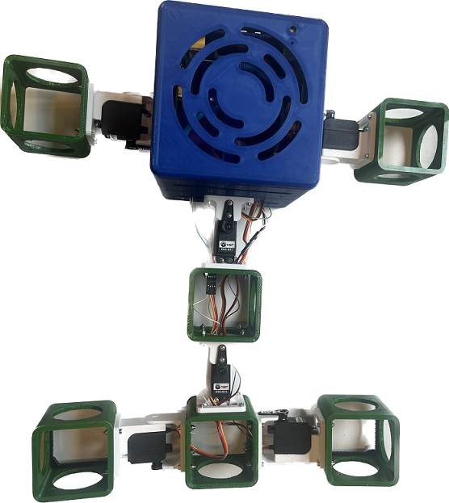

ProjectID: 2022-2823-01

ProjectName: RaspberryRobohat_2

Contact: A. Denker, M. Molenaar, N. Althuisius

E-mail: [a.denker@vu.nl](mailto:a.denker@vu.nl), [m.molenaar@vu.nl](mailto:m.molenaar@vu.nl), [n.althuisius@vu.nl](mailto:n.althuisius@vu.nl)

Changelog

|  |  |  |
| --- | --- | --- |
| Who | When | What |
|  |  |  |
|  |  |  |

Table of contents

1 Precautions 2

2 General Description 3

2.1 Intended use 3

3 Installation Procedure 3

4 Connections and Controls 3

5 Specifications 3

# Precautions

**This device contains a LiPo batterie pack which must be handled with care.**



* LiPo batteries are intended to be used with compatible radio controlled (R/C) models and airsoft guns only. Any damage caused by misuse or modifications can cause serious injury.
* General Safety Guidelines
* NEVER use a NiCd/NiMH charger to charge LiPo batteries. Only use chargers designed for Lithium Polymer (LiPo) batteries.
* NEVER store LiPo batteries in any location that exceeds 40-80° F (e.g., in a car, garage, or in the sun)
* NEVER leave charging batteries unattended. Keep watch on the charging process & react to any potential problems that may occur.
* NEVER let the battery’s positive and negative leads to touch. This can cause the battery to short and lead to a FIRE. If for any reason you need to cut the terminal wires, it will be necessary to cut each wire SEPARATELY, to make sure the wires do NOT touch each other.
* ALWAYS charge batteries in a fireproof container and away from combustible material. Do NOT charge on surfaces that can catch fire – this includes wood, cloth, carpet, or in the application’s device.
* ALWAYS inspect the battery to make sure there are no signs of damage, deformity, or swelling before charging. If there are, STOP charging the battery and follow the proper procedure to dispose of the battery.
* NEVER charge a swollen or ballooned or damaged battery (even if swollen upon purchase). Continuing to charge a battery that has begun to swell will result in a fire.
* Don’t strike battery with any sharp edge parts.
* ALWAYS store LiPo batteries in cool, dry places between 5- 27°C (40-80° F).

Follow these steps if battery is swollen, ballooned or damaged or reaches high temperatures:

- if charging, STOP the charging process and disconnect battery immediately

- If connected to device, disconnect battery from the device immediately

- Watch it for approx. 30 minutes from a safe distance away of flammable products

- Follow proper procedure to dispose of battery

# General Description

Describe your apparatus from a general, user-oriented view.

## Intended use.

For which situation this instrument is designed. Exclude everything else.

# Installation Procedure

All the user needs to know before operating this instrument.

# Connections and Controls

Describe all connections and user controls.

# Specifications

All technical specifications such as rated mains voltage, power consumption, fuses, etc.

The Robohat consist of multiple printed circuit boards (PCBs)

The heart of the Robohat are the ‘Servo assembly boards’ These boards drives the servos of the Robohat. Each ‘Servo assembly board’ can drive 16 servos. So in total when using 2 servo assembly boards, 32 servos can be used. The Robohatlib will auto detect if only 1 or 2 servo assembly boards are used.

## Powering the Robohat

The Robohat can be powered by 2 batteries.

Because batteries are dangerous and should be prevented against undervoltage and shortages, the power delivery of the system goes through a power-management board, called ‘PWR Management’. Each batterie has such ‘PWR Management’ board.

When an undervoltage, a short or another problem is detected, the ‘PWR Management’ board will shutdown the whole Robohat. Note. His can corrupt the data on the Raspberry PI. So the user should aways use the proper shutdown routine.

Onto the ‘PWR Management’ board is the ‘button’ board connected. A status LED and a power button is present onto this board.

Power on The Robohat can only be turned on when the battery has enough capacity. To power on, the user has to press the power-on switch. When the switch is pressed the LED will blink 3 times. After the blinking period, the LED will flash multiple times. The user should release the power switch before the flashing stops. Nothing will happen, when the user releases the button after flashing is finished. This is done, to prevent accidentally turning on the Robohat.

Turning off the power must be done the same way (pressing the button (and holding it while the LED is blinking and releasing it while the LED flashing) Note. A hard power-shutdown can destroy disk-data. Use the shutdown API-function of the Robohat library, or type *sudo shutdown now* in the console of the Raspberry.

Although the Robohat can be powered by 2 batteries, it is also possible to use only 1 battery.

# Connection scheme

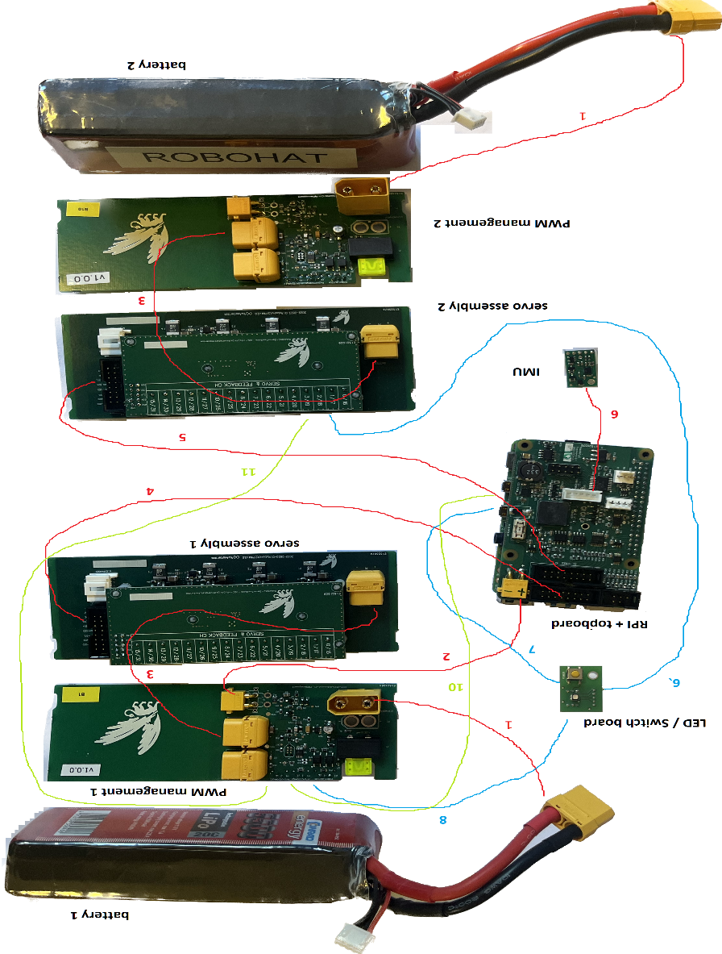

## Connection table

|  |  |  |  |  |  |  |
| --- | --- | --- | --- | --- | --- | --- |
| **ID** | **Connection name** | **from** | **from connector** | **to** | **to connector** | **type of cable** |
| **1** | battery connection | battery | - | pwm management board | P1 | cable attached to battery |
| **2** | topboard power connection | pwm management board 1 | J5 | topboard | P5 | 2 wire connection with 2 (small) yellow connectors |
| **3** | servo assembly power connection | pwm management board (1 + 2) |  | servo assembly (1 + 2) | P1 | 2 wire connection with 2 (big) yellow connectors |
| **4** | servo assembly control connection 1 | topboard plug | P3 | servo assembly 1 | P3 | flat cable |
| **5** | servo assembly control connection 2 | topboard plug | P4 | servo assembly 2 | P3 | 16 pole flat cable with 2 black headers |
| **6** | IMU connection | topboard | P1 | IMU | - | 5 pole flatcable with 2 white plugs ( 30 cm) |
| **7** | LED connction | topboard | RGB-LED | LED / Switch board | P2 | 5 pole flastcable with 2 whte plugs (30) |
| **8** | PWR button connection | LED / Switch board | P1 | pwm management board 1 | P3 | 3 pole flatcable with 2 white plugs (20 cm) |
| **9** | Pass through PWR connection | LED / Switch board | P3 | pwm management board 2 | POWER-BUTTON | 3 pole flatcable with 2 white plugs (30 cm) |
| **10** | Shutdown connection | pwm management board 1 | PI SHUTDOWN #1 | topboard | PWR-DOWN | 2 pole flatcable with 2 white plugs (30 cm) |
| **11** | Pass through shutdown connection | pwm management board 1 | PI SHUTDOWN #2 | pwm management board 2 | PI SHUTDOWN #1 | 2 pole flatcable with 2 white plugs (30 cm) |