**GSM Based Automatic Meter Reading System Using**

**ARM Controller**

**PROBLEM STATEMENT**

**Now a days the automation in every field is becoming necessary. The service provider for energy still uses conventional methods for getting the energy consumed by individual customer. The proposed system automatically reads the energy consumed and sends it to the service provider using the existing short messaging services (SMS).**

**INTRODUCTION**

**Today the energy meter which is placed in our home/office collects the data of the energy consumed and displays it on either a number dial or digital display. At the end of every billing cycle the person from service provider has to visit the place where the meter is placed to get the reading and either note it down or takes an image of energy meter for further data processing (i.e. For generating the bill). The proposed system automatically reads the energy meter data and sends it to the service provider on reception of a specific message from service provider. It uses a GSM modem for this purpose. The system can also provide the facility to disconnect the supply of a customer in case of any payment related issue.**

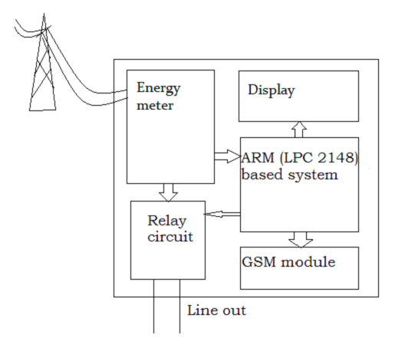

**PROPOSED WORK**

**The digital energy meter is having a LED which blinks for a specific number of times to indicate the energy consumed (e .g. 1 Unit = 1600 pulses). These pulses are fed to ARM based system which is programmed to count these pulses. The system reads these pulses and after counting specific number of pulses it increments the internal counter by one which indicates the number of units consumed Now, when the service provider sends a message to read the energy meter data, GSM modem, which is connected through UART interface, interrupts ARM. This causes ARM(*Universal Asynchronous Receiver/Transmitter is a piece of*** [***computer hardware***](http://en.wikipedia.org/wiki/Computer_hardware) ***that translates data between*** [***parallel***](http://en.wikipedia.org/wiki/Parallel_communication) ***and*** [***serial***](http://en.wikipedia.org/wiki/Serial_communication) ***forms*) to read the number of units burnt and sends the data to the UART. Further, the UART sends the data to GSM modem which sends this meter reading data to service provider. If, now, the service provider detects that the previous bills are pending for a specific user, the message will be sent by the service provider, which results in disconnection of energy supply for that user. For this purpose, the supply goes further to home/office through a relay circuit, which is again controlled by ARM system. The service provider can now inform the customer regarding the current bill or status using the customer’s registered phone number by either a message or a phone call.**

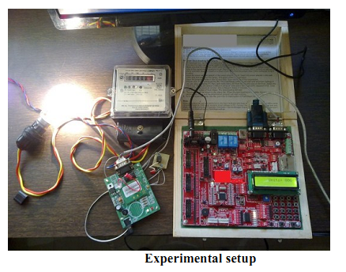

**HOW IT WORKS?**

**The system is designed around an ARM LPC 2148 based board. The LPC 2148 have a on-chip timer, interrupt, UART and ports for interfacing energy meter. The code is written using standard C programming used for programming the ARM. The energy meter used provides output pulse indicating the energy burnt. It provides 1600 pulses when it consumes 1 unit of energy. The pulses are given as input to the ARM based system which counts the pulses and increments the internal counter, which is intended to count the unit, after counting 1600 pulses. When a message is received, the interrupt service routine interrupts the ARM which first checks the message type and returns either energy meter reading or disconnects the supply. The code itself test the contents of message received and takes the decision. While the system is performing the task of sending message, the counting of pulses from meter is going on in another ISR.**

1. ***ISR – 1 routine:-***

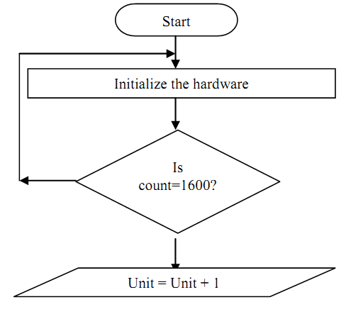

***2.ISR – 2 routine:-***

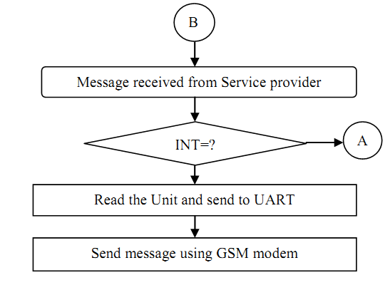

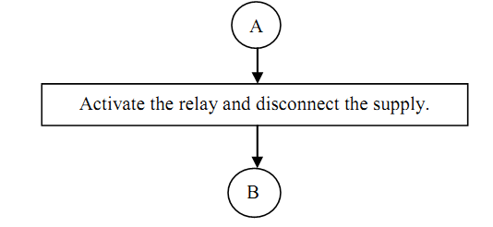

**WHAT WE NEED?**

**PRIMARY COMPONENTS:**

1. ***Meter Interface Module:-***

* **Electro - optical interface**
* **Signal Processing Electronics**
* **RAM & Program Memory**

1. ***Communication System:-***

* **GSM Modems.**

1. ***Central Office Equipment:-***

* **Central server.**
* **Client Software for data acquisition and data analysis.**

**Advantages Of AMR System**

**ELECTRIC COMPANY BENEFITS**

1. **Smart automated processes instead of manual work**
2. **Accurate information from the network load to optimize maintenance and investments**
3. **Customized rates and billing dates.**
4. **Streamlined high bill investigations.**
5. **Detection of tampering of Meters.**
6. **Accurate measurement of transmission losses.**
7. **Better network performance and cost efficiency.**
8. **Demand and distribution management.**
9. **More intelligence to business planning.**
10. **Better company credibility.**
11. **Improved security and tamper detection for equipment.**
12. **Transparency of “cost to read” metering.**

**CUSTOMER BENEFITS**

1. **Precise consumption information**
2. **Clear and accurate billing**
3. **Automatic outage information and faster recovery**
4. **Better and faster customer service**
5. **Flag potential high consumption before customer gets a high bill.**

**Applications**

**1. Electricity departments.**

**2. Household Energy meter monitoring.**

**3. Railway electrical systems.**

**4. Industrial Energy remote monitoring.**

**5. Remote controlling systems.**

**THE END**

**//////////////////////////////////////////////////////**