# Out of focus plug-in

Description:

The main purpose of the plugin is to detect out-of-focus regions within a slide's image. The 'out of focus threshold' option allows the user to update their decisions and once ran, the results are displayed accordingly.

**Installation:**

-Close Sedeen Viewer

-Copy dll file to the “C:\Program Files (x86)\Sedeen Viewer\plugins”

**Image Requirements:**

-The resolution should be 20x or 40x.

-At least 2 pyramid levels

**Usage:**

-Load a new image

-Select the algorithm from the Analysis Manager menu

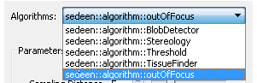

-Change paremeters (optional)

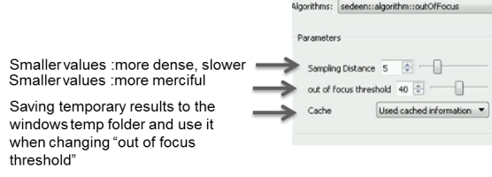

-Press Run

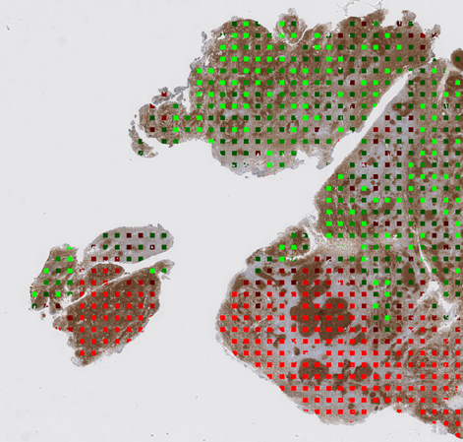



*Please note that plugin creates a log file (C:\Users\%USERNAME%\AppData\Local\Temp) for each image.

If you face with a problem please send us that log file.