
PROKERA PERISTALTIC FILLING PUMP STATION
Equipment Documentation Manual
Microcontroller-Based Filling Pump for Prokera Production Support
User-End Interface and Mechanical Layout Drawing Placeholder Included

Document Field | Value
Equipment Name | Prokera Peristaltic Filling Pump Station
Document Type | Equipment Documentation Manual
Revision | R4 - Interface and Drawings Updated
Prepared For | BioTissue production and calibration personnel
Operation Mode | Standalone production operation using the activation switch

1. Purpose
This manual documents the Prokera Peristaltic Filling Pump Station used for controlled dispensing during Prokera production support. It describes the equipment configuration, normal operating procedure, calibration and service interface, maintenance, troubleshooting, and bill of materials.

2. System Overview
The equipment is a compact peristaltic filling pump station controlled by an internal microcontroller. During normal production use, the operator runs the equipment as a standalone unit using the external activation switch. The Windows application is not used during routine filling.
Normal operation note
The communication connector is hidden inside the equipment case and is accessible only to an authorized calibration technician after removing the bottom cover. The cover must be reinstalled and secured before returning the equipment to normal operation.

3. Safety and Handling
Use the equipment only for the intended Prokera filling support process.
Do not operate the pump with loose covers, exposed wiring, or damaged tubing.
Keep fingers, loose clothing, and tools away from the pump head while the motor is active.
Do not spray cleaning fluid directly into electrical openings or onto the internal service connector.
Only authorized calibration or service personnel may access internal electrical connections.

4. Main Components
Item | Description | Function
Pump head | Peristaltic pump assembly | Moves liquid through disposable tubing without contacting the pump mechanism.
Motor | Pump drive motor | Provides controlled rotation for fill and purge cycles.
Activation switch | External operator switch | Starts normal fill or purge/prime sequence depending on press duration.
Microcontroller | Internal control board | Stores parameters and controls pump timing, speed, direction, and service logic.
Power supply | Regulated DC power | Provides controlled power for the internal electronics and pump drive.
Tubing | Disposable process tube | Single-use fluid path for one lot only.

5. Electrical Configuration
The pump station uses a closed-loop stepper motor controlled through a CL42T V4.1 driver. The microcontroller sends step and direction signals to the driver using a common-anode input arrangement. Low-voltage control wiring must remain separated from AC mains wiring.
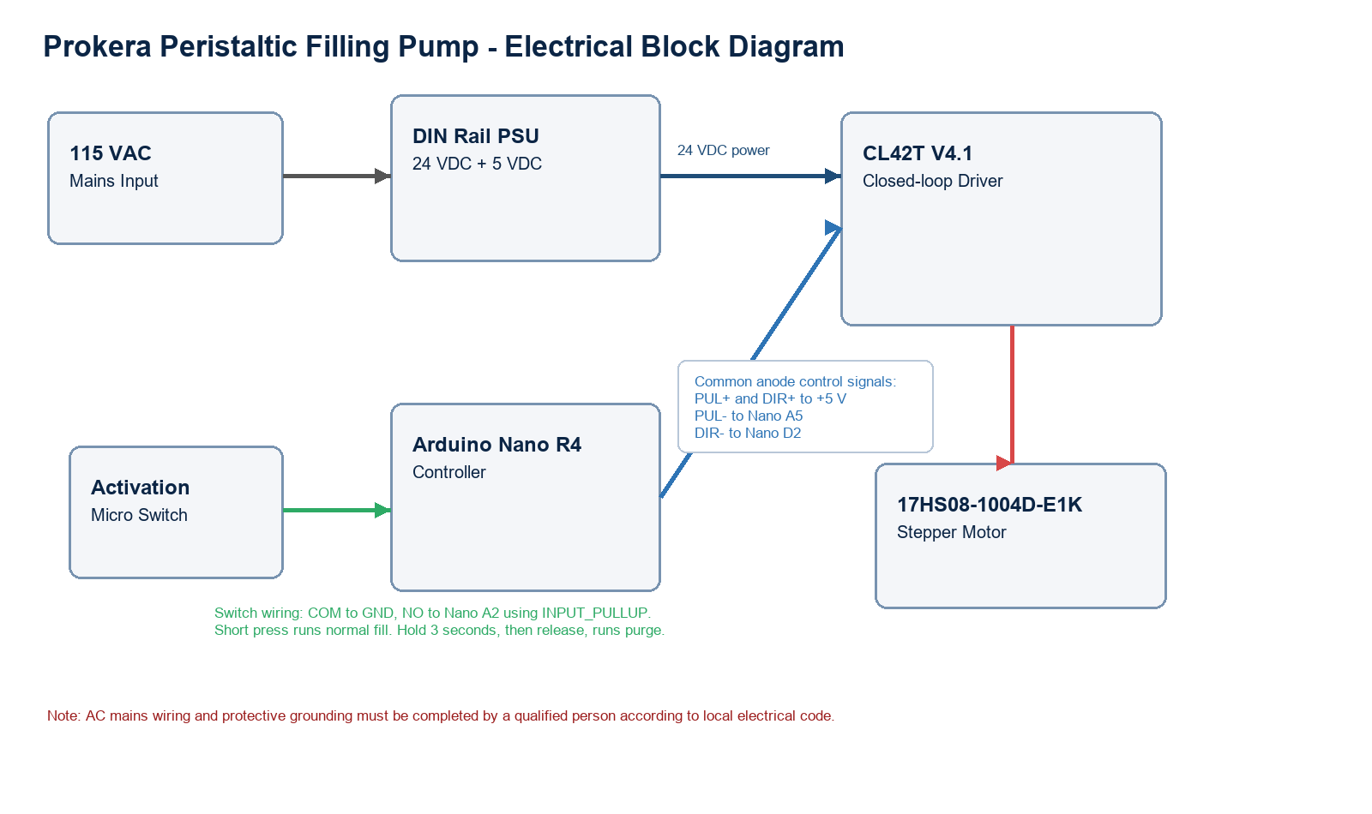
Figure 2. Electrical block diagram for the microcontroller, CL42T driver, motor, activation switch, and dual-output power supply.

5.1 Power Distribution
AC input: 100-240 VAC supply input, typically operated from 115-120 VAC in the intended location.
24 VDC output: connect to the CL42T driver power input as specified by the driver manual.
5 VDC output: connect to the microcontroller 5 V input/GND and to the CL42T signal common anode inputs as described below.
0 V reference: the 5 VDC supply negative, microcontroller GND, and low-voltage control references must be common where required for signal operation.

5.2 CL42T Common-Anode Signal Wiring
CL42T terminal | Connection | Function
PUL+ | +5 VDC regulated | Common anode for step input
PUL- | Microcontroller A5 | Step pulse. Active LOW in current firmware.
DIR+ | +5 VDC regulated | Common anode for direction input
DIR- | Microcontroller D2 | Direction control
ENA+ | +5 VDC regulated, optional | Enable common anode if enable input is used
ENA- | Microcontroller A1, optional | Driver enable control. Leave ENA disconnected during initial test if driver enables by default.
VDC / GND | 24 VDC supply output | Driver motor power input
Motor connector | StepperOnline closed-loop motor cable | Motor phase and encoder feedback per CL42T/motor documentation

5.3 Activation Switch Wiring
The activation switch is wired as a low-voltage dry-contact input. Do not route mains voltage through the microcontroller input circuit.
Switch COM: connect to microcontroller GND.
Switch NO: connect to microcontroller A2.
Firmware input mode: INPUT_PULLUP. The input is normally HIGH and becomes LOW when pressed.
Short press and release: normal run using configured steps.
Press and hold for at least 3 seconds, then release: purge run using fixed 15,000 steps.

6. Firmware and Default Settings
Serial command set: GET, SET STEPS <value>, SET SPEED <value>, RUN, RUN <steps> <speed_us>, PURGE, STOP, and PING.
Parameter | Default / Range | Notes
Firmware label | V3-0 Nano R4 Peristaltic filling by G.C. | Displayed by firmware and used as the active sketch version label.
Serial baud rate | 115200 | Used by Windows application over USB COM port.
Default fill steps | 32,000 | Stored in controller memory when Save is used.
Allowed fill steps | 10 to 50,000 | Firmware rejects values outside this range.
Default speed | 210 us | Microseconds between step events; lower value is faster.
Allowed speed | 210 to 5,000 us | Increase value for slower motion or difficult fluids.
Purge | 15,000 steps fixed | Purge does not change the saved fill quantity.
Activation hold time | 3,000 ms | Hold switch at least 3 seconds to select purge.

7. Normal Operating Procedure

7.1 Startup
Verify that the unit is clean, dry, and visually intact.
Install a new tube before beginning a new lot.
Confirm that the tube is properly seated in the pump head and connected to the process path.
Confirm that the bottom cover is installed and secured.
Power on the equipment and verify that the unit is ready for standalone operation.

7.2 Purge / Prime
Purge / Prime must be performed before the first normal filling cycle each time a new tube is installed. The operator must also repeat purge if visible bubbles remain in the tube.
Hold the activation switch for at least 3 seconds to initiate the purge / prime cycle.
Observe the tube during purge and confirm that liquid fills the tube path.
If bubbles remain visible, repeat the purge / prime cycle.
Begin normal filling only after the tube is completely primed and no bubbles are visible.

7.3 Normal Fill
Place the receiving container or process target in the correct filling position.
Press and release the activation switch briefly to start one normal fill cycle.
Allow the pump to complete the programmed cycle without interrupting the equipment.
Inspect the dispensed fill and continue only if the result is acceptable for the process.

7.4 Tubing Use Per Lot
Tubing requirement
The tube is single-use only and may be used for one lot only. A new tube must be installed at the start of each lot, purged before the first normal filling cycle, and removed and discarded after the lot is complete.

7.5 Shutdown
Complete the final fill cycle for the lot.
Remove and discard the used tube according to the applicable procedure.
Clean accessible equipment surfaces as required.
Power off the equipment when work is complete.

8. Windows User-End Interface
The Windows user-end interface displays machine state, current settings, progress, operating commands, and communication log messages. The interface layout shown below is the released V3-0 Nano Peristaltic filling by G.C. screen. (can be downloaded here: https://github.com/ciammaricone-spec/Prokera-filling-pump/blob/main/windows-app/Nano_R4_Pump_Control/Run_NanoR4PumpControl_Silent.vbs)

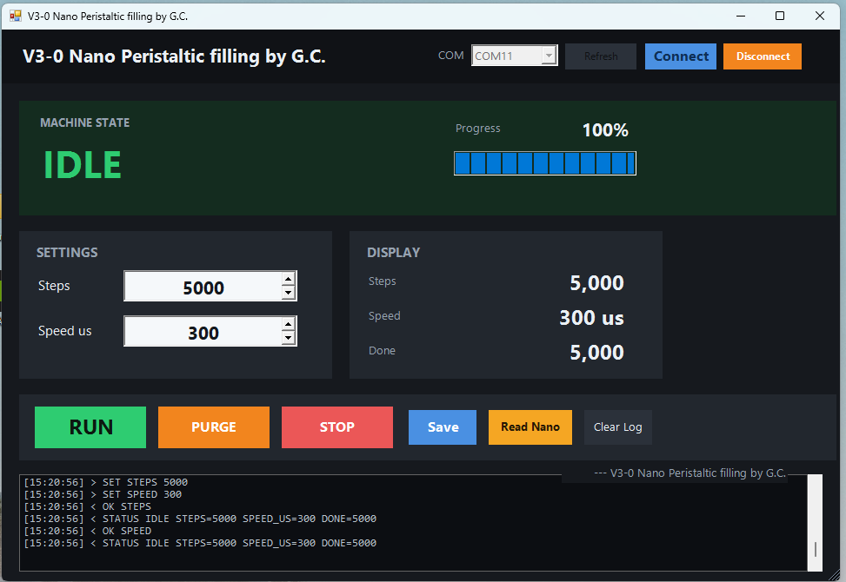
Figure 1. Windows user-end interface screen.

User-End Area | Displayed Function
Machine State | Shows current status such as IDLE and displays progress percentage.
Settings | Allows entry of Steps and Speed us values used by the pump cycle.
Display | Shows current Steps, Speed, and Done values read from the controller.
Command Buttons | Provides RUN, PURGE, STOP, Save, Read Nano, and Clear Log controls.
Communication Log | Shows command and status messages returned by the controller.

8.1 Operator Controls
Control | Use
Connect | Open the selected controller COM port.
Read Nano | Request current controller status and saved settings.
Steps | Set target step count for the normal fill run.
Speed us | Set the step interval in microseconds. Higher value equals slower movement.
Save | Save the displayed steps and speed to the controller.
RUN | Start a normal fill using the current steps and speed.
PURGE | Run 15,000 fixed steps for priming or clearing tubing.
STOP | Stop motion as soon as the controller receives the command.
Clear Log | Clear the application log display.

9. Calculation Formulas
The following formulas are used to establish and verify pump settings during calibration. Actual production settings must be confirmed by authorized calibration personnel using measured dispense results.
Calculation | Formula | Purpose
Steps per mL | Steps per mL = Calibration Steps / Measured Volume (mL) | Determines the pump calibration factor from a measured dispense test.
Target Steps | Target Steps = Target Fill Volume (mL) x Steps per mL | Calculates the Steps value entered in the user-end interface.
Measured Volume | Measured Volume (mL) = Dispensed Weight (g) / Liquid Density (g/mL) | Converts gravimetric verification results to volume.
Approximate Fill Time | Fill Time (sec) = (Steps x Speed us) / 1,000,000 | Estimates cycle duration based on the selected Steps and Speed us settings.
Flow Rate | Flow Rate (mL/sec) = Dispensed Volume (mL) / Fill Time (sec) | Verifies dispense rate during calibration or service testing.
Percent Error | Percent Error = ((Measured Volume - Target Volume) / Target Volume) x 100 | Documents how close the measured dispense is to the target fill volume.
Formula note
Speed us is the microsecond timing value shown in the interface. Lower Speed us values increase motor step rate; higher values decrease motor step rate. Calibration acceptance limits must follow the approved process requirement.

10. Calibration and Verification
Remove the bottom cover only if authorized for calibration or service.
Connect the Windows service application to the internal communication connector.
Read current parameters and verify that the expected configuration is loaded.
Run controlled test cycles as required by the calibration procedure.
Adjust parameters only when required and document the change.
Disconnect the service cable, reinstall the bottom cover, and secure the equipment before returning it to normal operation.

10.1 Calibration Workflow
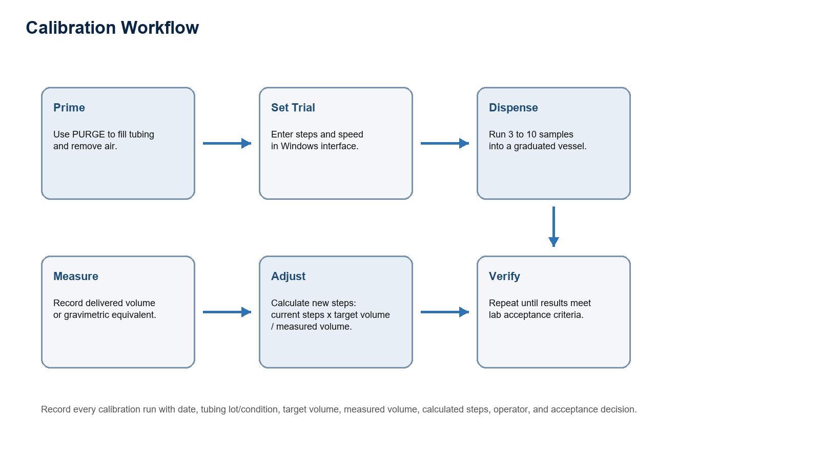
Figure 3. Calibration workflow.

10.2 Calibration Conditions
Use the same tubing type, tubing size, pump head compression, liquid, speed, and outlet height that will be used during operation.
Prime the line before collecting data.
Use a calibrated balance or volumetric device appropriate for the target fill volume.
Define acceptance criteria before calibration, such as mean volume tolerance and repeatability requirement.

10.3 Step Adjustment Formula
New Steps = Current Steps x Target Volume / Measured Volume
Example: if 32,000 steps dispense 9.60 mL and the target is 10.00 mL, then New Steps = 32,000 x 10.00 / 9.60 = 33,333 steps.

10.4 Calibration Record
Run | Target volume | Current steps | Measured volume | Calculated steps | Operator | Accept / Reject
1
2
3
Mean

11. Mechanical Layout Drawings
DRAWINGS COMING SOON..
Mechanical layout drawings will be inserted in this section when released. This placeholder intentionally remains in the manual so reviewers know the drawing package is pending.

The following approved project artifacts should be inserted before document release:
Electrical wiring drawing with terminal numbers and wire colors.
Mechanical drawing of stainless enclosure, pump head mount, panel openings, and DIN rail layout.
Photographs of internal wiring after final assembly.
Photographs of final exterior front panel and tubing path.
Windows interface screenshots showing connected, idle, running, purge, and alarm/error states.

12. Cleaning and Maintenance

12.1 Routine Cleaning
Clean accessible surfaces before and after each use according to the applicable cleanroom cleaning procedure.
Use IPA alcohol wipes on accessible external surfaces.
Do not spray IPA directly into the pump head, electrical openings, switch, or internal connector area.
Allow all surfaces to fully dry before use.
Do not open the case or remove covers as part of routine cleaning.

12.2 Maintenance
Frequency | Inspection / Action | Acceptance Criteria
Before each use | Inspect tubing, pump head, switch, and accessible surfaces. | No visible damage, contamination, loose parts, or tubing defects.
Before each use and weekly | Check power cable, external case, and labels. | Cable and case are intact; labels remain legible.
Per PM schedule | Verify pump function and calibration status. | Equipment performs programmed cycles within accepted limits.
After maintenance | Perform functional check before returning to use. | Normal fill and purge / prime functions operate as expected.

12.3 Maintenance Checks from Preview
Frequency | Check | Acceptance
Before use | Visual inspection of enclosure, tubing, switch, and cables | No damage, moisture, loose fittings, or exposed conductors
Before batch or study | Run calibration or verification shot | Within predefined fill tolerance
Monthly or per use rate | Inspect terminal blocks, power supply mount, driver mount, and labels | Secure, legible, and free of corrosion
After maintenance | Functional test: Read, Run, Purge, Stop, and switch activation | All functions respond correctly

13. Troubleshooting
Condition | Possible Cause | Corrective Action
Pump does not start | Power is off, switch issue, or internal fault. | Verify power, inspect external switch condition, and remove from service if fault remains.
Inconsistent fill | Tube not seated, bubbles present, or parameter issue. | Reseat tube, perform purge / prime, and request calibration review if condition persists.
Visible bubbles | New tube not fully primed or air in fluid path. | Repeat purge / prime until no bubbles are visible before normal filling.
Service application cannot connect | Internal connector, cable, or communication setting issue. | Authorized technician verifies connection after opening bottom cover.

13.1 Technical Troubleshooting from Preview
Symptom | Likely Cause | Recommended Action
App cannot connect | COM port is in use by Arduino IDE or another app. | Close Serial Monitor, close other pump app windows, reconnect USB, then select the COM port again.
Upload denied on COM port | Windows application or Serial Monitor is holding the port. | Disconnect/close the app before uploading firmware.
Motor energized but not moving | Incorrect common-anode wiring, wrong pulse pin, disabled driver, or speed too fast. | Verify PUL+ and DIR+ to +5 V, PUL- to A5, DIR- to D2, ENA state, and start with slower speed such as 1000 us.
Motor vibrates only | Direction/step signal issue, motor cable/phase issue, driver current/switch setting mismatch, or mechanical load. | Check CL42T settings, motor cable, common-anode signal wiring, and pump head load.
Inconsistent fill volume | Air in line, tubing slip, changing viscosity, worn tubing, or speed too high. | Purge, inspect tubing, reduce speed, and recalibrate under actual process conditions.
Driver alarm | Closed-loop following error, overload, wiring fault, or supply issue. | Stop operation, inspect motor/encoder wiring, mechanical load, supply voltage, and driver documentation.

14. Bill of Materials
BOM Item | Description | Notes
Control board | Microcontroller Arduino Nano R4 powered from regulated 5 VDC. | USB used for Windows interface and firmware upload.
Pump motor | DC motor or stepper pump drive as configured. | Controlled by internal electronics.
Peristaltic pump head | Tubing-contact pump mechanism. | Supports disposable process tube.
Activation switch | External momentary switch. | Short press starts fill; long press starts purge / prime.
Power supply | Regulated DC supply. | Sized for motor and control electronics.
Tubing | Disposable process tube. | One use only per lot.
Enclosure | Equipment case with removable bottom cover. | Internal connector is service-access only.

14.1 Detailed Technical Components from Preview
Item | Component | Specification / Notes
1 | Arduino Nano R4 | Controller powered from regulated 5 VDC. USB used for Windows interface and firmware upload.
2 | Stepper driver | CL42T V4.1 closed-loop stepper driver, operated from 24 VDC in this system.
3 | Motor | StepperOnline 17HS08-1004D-E1K, 1.0 A, 0.14 Nm, closed-loop stepper motor.
4 | Activation switch | Waterproof micro switch, long straight hinge lever, NO/NC/COM wiring, 10 A at 125/250 VAC rating, 30 cm cable. Used only as low-voltage control input in this design.
5 | Power supply | DIN rail dual output 24 VDC and 5 VDC, 10 W class, input 100-240 VAC. Verify the actual nameplate ratings before installation.
6 | Enclosure | Custom stainless steel box with appropriate glands, strain relief, grounding, and labeling.
7 | Internal wiring | Rated conductors, ferrules, terminal blocks, protective earth bonding hardware, and separated AC/DC routing.
8 | Pump wetted path | Tubing, fittings, and pump head selected and qualified by laboratory for the intended fluid.

15. Revision Summary
Revision | Description
R4 | Updated manual with Windows interface image and Mechanical Layout Drawings placeholder text: DRAWINGS COMING SOON..
Prior updates | Standalone operation clarified; routine production does not use the Windows application. Tubing single-use per lot and purge / prime requirements added.
Rev2 + Preview updates | Added missing preview content: electrical configuration, firmware/default settings, operator controls, calibration workflow/record, maintenance checks, technical troubleshooting, and detailed component table.

