PROKERA PERISTALTIC FILLING PUMP STATION
Technical and Operating Manual for Pharmaceutical Laboratory Use

Document Field | Value
Equipment | Custom stainless steel peristaltic filling pump station
Controller | Arduino Nano R4
Firmware | V3-0 Nano R4 Peristaltic filling by G.C.
Document revision | Draft V1.0
Effective date | 2026-07-27
Prepared by | G.C.
Status | Engineering draft. Requires site approval before controlled GMP use.
Controlled Use Notice
This manual supports laboratory operation, calibration, and maintenance of the pump station. It does not by itself establish GMP validation, sterile processing suitability, or product-specific release acceptance. Qualification, calibration acceptance criteria, and change control must be defined by the laboratory quality system before regulated use.

1. Purpose and Scope
This document describes the design, components, default configuration, operating method, calibration method, and routine checks for a custom peristaltic filling pump station controlled by an Arduino Nano R4 and a Windows operator interface.
The station is intended for controlled small-volume dispensing and development or laboratory filling tasks where the pump is calibrated against the actual tubing, liquid, speed, and target volume used in the process.
- Use only with materials, tubing, containers, and cleaning agents approved by the laboratory.
- Do not use for aseptic or sterile filling unless the complete system has been qualified for that application.
- Do not operate with exposed mains wiring, loose terminal connections, liquid ingress, or damaged cables.

2. System Overview
The pump station uses a closed-loop stepper motor controlled through a CL42T V4.1 driver. The Arduino Nano R4 sends step and direction signals to the driver using a common-anode input arrangement. The Windows application sends operator commands through the USB serial connection and displays machine state, target steps, speed, completed steps, and progress.
Subsystem | Description
Power | DIN rail dual-output supply provides 24 VDC for the driver/motor circuit and 5 VDC for Arduino/controller power.
Motion control | Arduino Nano R4 firmware generates pulse signals for the CL42T driver.
Motor and feedback | StepperOnline 17HS08-1004D-E1K closed-loop stepper motor, 1.0 A, 0.14 Nm.
Activation | Waterproof long straight hinge lever micro switch with NO/NC/COM wires. Firmware uses an input pullup signal.
Operator interface | Windows app provides connect, read, save, run, purge, stop, clear log, settings, and status display functions.
Enclosure | Custom stainless steel enclosure for laboratory use. Final ingress protection depends on build quality, glands, seals, and openings.
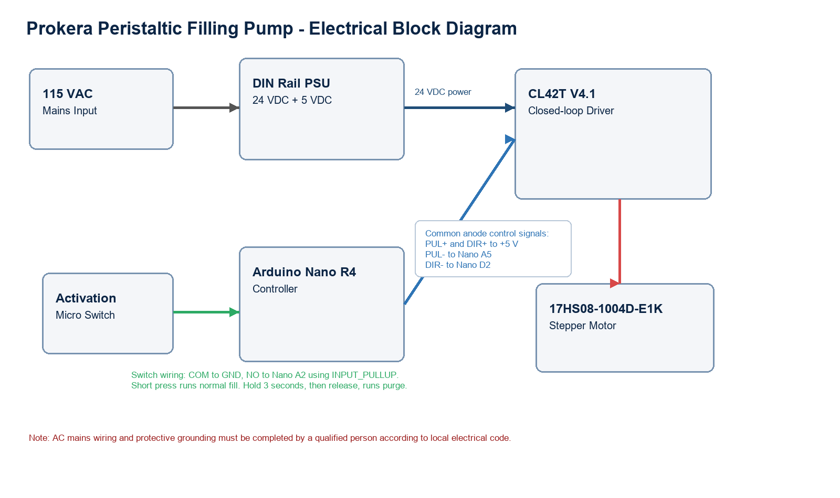
Figure 1. Electrical block diagram for the Nano R4, CL42T driver, motor, activation switch, and dual-output power supply.

3. Bill of Materials
Item | Component | Specification / Notes
1 | Arduino Nano R4 | Controller powered from regulated 5 VDC. USB used for Windows interface and firmware upload.
2 | Stepper driver | CL42T V4.1 closed-loop stepper driver, operated from 24 VDC in this system.
3 | Motor | StepperOnline 17HS08-1004D-E1K, 1.0 A, 0.14 Nm, closed-loop stepper motor.
4 | Activation switch | Waterproof micro switch, long straight hinge lever, NO/NC/COM wiring, 10 A at 125/250 VAC rating, 30 cm cable. Used only as low-voltage control input in this design.
5 | Power supply | DIN rail dual output 24 VDC and 5 VDC, 10 W class, input 100-240 VAC. Verify the actual nameplate ratings before installation.
6 | Enclosure | Custom stainless steel box with appropriate glands, strain relief, grounding, and labeling.
7 | Internal wiring | Rated conductors, ferrules, terminal blocks, protective earth bonding hardware, and separated AC/DC routing.
8 | Pump wetted path | Tubing, fittings, and pump head selected and qualified by laboratory for the intended fluid.

4. Electrical Configuration
Electrical Safety
The enclosure contains or may contain mains voltage. AC input wiring, fusing, protective earth bonding, strain relief, and labeling must be installed and inspected by qualified personnel. Keep mains wiring physically separated from low-voltage control wiring.

4.1 Power Distribution
- AC input: 100-240 VAC supply input, typically operated from 115-120 VAC in the intended location.
- 24 VDC output: connect to the CL42T driver power input as specified by the driver manual.
- 5 VDC output: connect to the Arduino Nano R4 5 V input/GND and to the CL42T signal common anode inputs as described below.
- 0 V reference: the 5 VDC supply negative, Arduino GND, and low-voltage control references must be common where required for signal operation.

4.2 CL42T Common-Anode Signal Wiring
CL42T terminal | Connection | Function
PUL+ | +5 VDC regulated | Common anode for step input
PUL- | Arduino Nano R4 A5 | Step pulse. Active LOW in current firmware.
DIR+ | +5 VDC regulated | Common anode for direction input
DIR- | Arduino Nano R4 D2 | Direction control
ENA+ | +5 VDC regulated, optional | Enable common anode if enable input is used
ENA- | Arduino Nano R4 A1, optional | Driver enable control. Leave ENA disconnected during initial test if driver enables by default.
VDC / GND | 24 VDC supply output | Driver motor power input
Motor connector | StepperOnline closed-loop motor cable | Motor phase and encoder feedback per CL42T/motor documentation

4.3 Activation Switch Wiring
The activation switch is wired as a low-voltage dry-contact input. Do not route mains voltage through the Arduino input circuit.
- Switch COM: connect to Arduino GND.
- Switch NO: connect to Arduino Nano R4 A2.
- Firmware input mode: INPUT_PULLUP. The input is normally HIGH and becomes LOW when pressed.
- Short press and release: normal run using configured steps.
- Press and hold for at least 3 seconds, then release: purge run using fixed 15,000 steps.

5. Firmware and Default Settings
Parameter | Default / Range | Notes
Firmware label | V3-0 Nano R4 Peristaltic filling by G.C. | Displayed by firmware and used as the active sketch version label.
Serial baud rate | 115200 | Used by Windows application over USB COM port.
Default fill steps | 32,000 | Stored in controller memory when Save is used.
Allowed fill steps | 10 to 50,000 | Firmware rejects values outside this range.
Default speed | 210 us | Microseconds between step events; lower value is faster.
Allowed speed | 210 to 5,000 us | Increase value for slower motion or difficult fluids.
Purge | 15,000 steps fixed | Purge does not change the saved fill quantity.
Activation hold time | 3,000 ms | Hold switch at least 3 seconds to select purge.
Serial command set: GET, SET STEPS <value>, SET SPEED <value>, RUN, RUN <steps> <speed_us>, PURGE, STOP, and PING.

6. Windows Operator Interface
The Windows application provides the routine operator controls. The app should be closed before uploading firmware to the Arduino because only one program can use the COM port at a time.
Control | Use
Connect | Open the selected Arduino COM port.
Read | Request current controller status and saved settings.
Steps | Set target step count for the normal fill run.
Speed us | Set the step interval in microseconds. Higher value equals slower movement.
Save | Save the displayed steps and speed to the controller.
RUN | Start a normal fill using the current steps and speed.
PURGE | Run 15,000 fixed steps for priming or clearing tubing.
STOP | Stop motion as soon as the controller receives the command.
Clear Log | Clear the application log display.
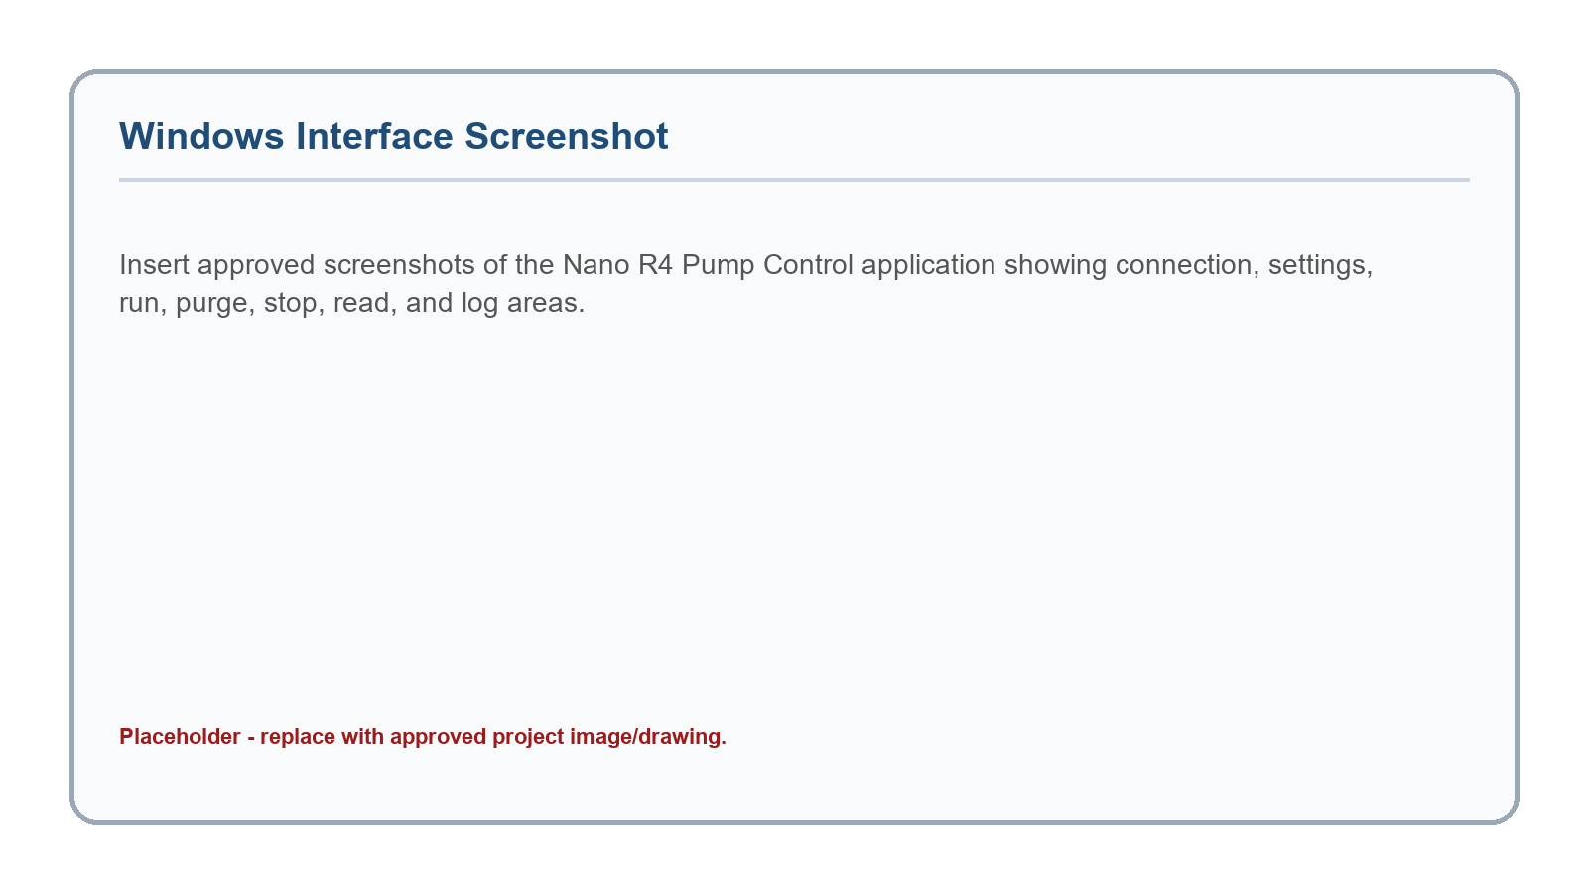
Figure 2. Placeholder for approved Windows operator interface screenshots.

7. Operating Procedure

7.1 Pre-Use Inspection
- Verify that the enclosure is clean, dry, closed, and labeled.
- Verify that tubing is correctly installed in the pump head and that fittings are tight.
- Verify that the CL42T driver, Arduino, power supply, and motor cables are secure.
- Verify that the activation switch moves freely and returns to its normal position.
- Confirm that the Windows app is closed if firmware upload is required, then open the app for operation.

7.2 Startup
- Apply AC power to the station.
- Connect the USB cable between the Nano R4 and the Windows computer.
- Open the Windows pump control application.
- Select the correct COM port and press Connect.
- Press Read and confirm the displayed steps, speed, firmware response, and machine state.

7.3 Normal Fill
- Enter the approved steps and speed for the product, tubing, and target volume.
- Press Save if the setting must remain stored after power cycle.
- Place the receiving vessel in the correct position.
- Press RUN in the app or use a short activation switch press.
- Observe the progress indicator and delivered volume. Press STOP if abnormal motion or fluid behavior is observed.

7.4 Purge / Prime
- Place outlet tubing into an approved waste or collection vessel.
- Press PURGE in the app, or press and hold the activation switch for at least 3 seconds and release.
- Confirm tubing is fully primed and air has been removed.
- Repeat only as needed. Document priming volume if required by the procedure.

7.5 Shutdown
- Stop pump motion and verify machine state is idle.
- Close or disconnect the Windows application.
- Remove product tubing or cap lines according to the laboratory procedure.
- Clean the external enclosure and work area.
- Remove power if the station will not remain in supervised standby.

8. Calibration Procedure
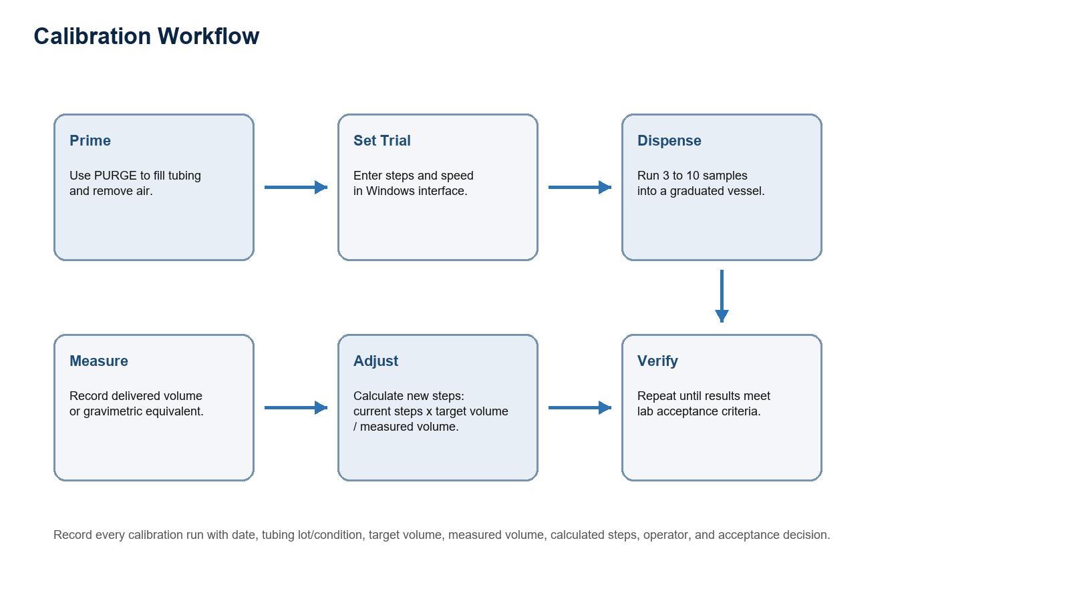
Figure 3. Calibration workflow.

8.1 Calibration Conditions
- Use the same tubing type, tubing size, pump head compression, liquid, speed, and outlet height that will be used during operation.
- Prime the line before collecting data.
- Use a calibrated balance or volumetric device appropriate for the target fill volume.
- Define acceptance criteria before calibration, such as mean volume tolerance and repeatability requirement.

8.2 Step Adjustment Formula
New Steps = Current Steps x Target Volume / Measured Volume
Example: if 32,000 steps dispense 9.60 mL and the target is 10.00 mL, then New Steps = 32,000 x 10.00 / 9.60 = 33,333 steps.

8.3 Calibration Record
Run | Target volume | Current steps | Measured volume | Calculated steps | Operator | Accept / Reject
1
2
3
Mean

9. Cleaning and Maintenance
- Clean external stainless surfaces using approved laboratory cleaning agents. Prevent liquid ingress into electrical openings.
- Inspect tubing before each use for wear, flattening, swelling, leaks, or contamination risk.
- Inspect the activation switch and cable for mechanical damage.
- Verify terminal tightness and grounding during scheduled maintenance.
- Replace tubing and wetted components according to product risk, cleaning validation, and laboratory SOP requirements.
Frequency | Check | Acceptance
Before use | Visual inspection of enclosure, tubing, switch, and cables | No damage, moisture, loose fittings, or exposed conductors
Before batch or study | Run calibration or verification shot | Within predefined fill tolerance
Monthly or per use rate | Inspect terminal blocks, power supply mount, driver mount, and labels | Secure, legible, and free of corrosion
After maintenance | Functional test: Read, Run, Purge, Stop, and switch activation | All functions respond correctly

10. Troubleshooting
Symptom | Likely Cause | Recommended Action
App cannot connect | COM port is in use by Arduino IDE or another app. | Close Serial Monitor, close other pump app windows, reconnect USB, then select the COM port again.
Upload denied on COM port | Windows application or Serial Monitor is holding the port. | Disconnect/close the app before uploading firmware.
Motor energized but not moving | Incorrect common-anode wiring, wrong pulse pin, disabled driver, or speed too fast. | Verify PUL+ and DIR+ to +5 V, PUL- to A5, DIR- to D2, ENA state, and start with slower speed such as 1000 us.
Motor vibrates only | Direction/step signal issue, motor cable/phase issue, driver current/switch setting mismatch, or mechanical load. | Check CL42T settings, motor cable, common-anode signal wiring, and pump head load.
Inconsistent fill volume | Air in line, tubing slip, changing viscosity, worn tubing, or speed too high. | Purge, inspect tubing, reduce speed, and recalibrate under actual process conditions.
Driver alarm | Closed-loop following error, overload, wiring fault, or supply issue. | Stop operation, inspect motor/encoder wiring, mechanical load, supply voltage, and driver documentation.

11. Drawings and Photographs to Add
The following approved project artifacts should be inserted before document release:
- Electrical wiring drawing with terminal numbers and wire colors.
- Mechanical drawing of stainless enclosure, pump head mount, panel openings, and DIN rail layout.
- Photographs of internal wiring after final assembly.
- Photographs of final exterior front panel and tubing path.
- Windows interface screenshots showing connected, idle, running, purge, and alarm/error states.
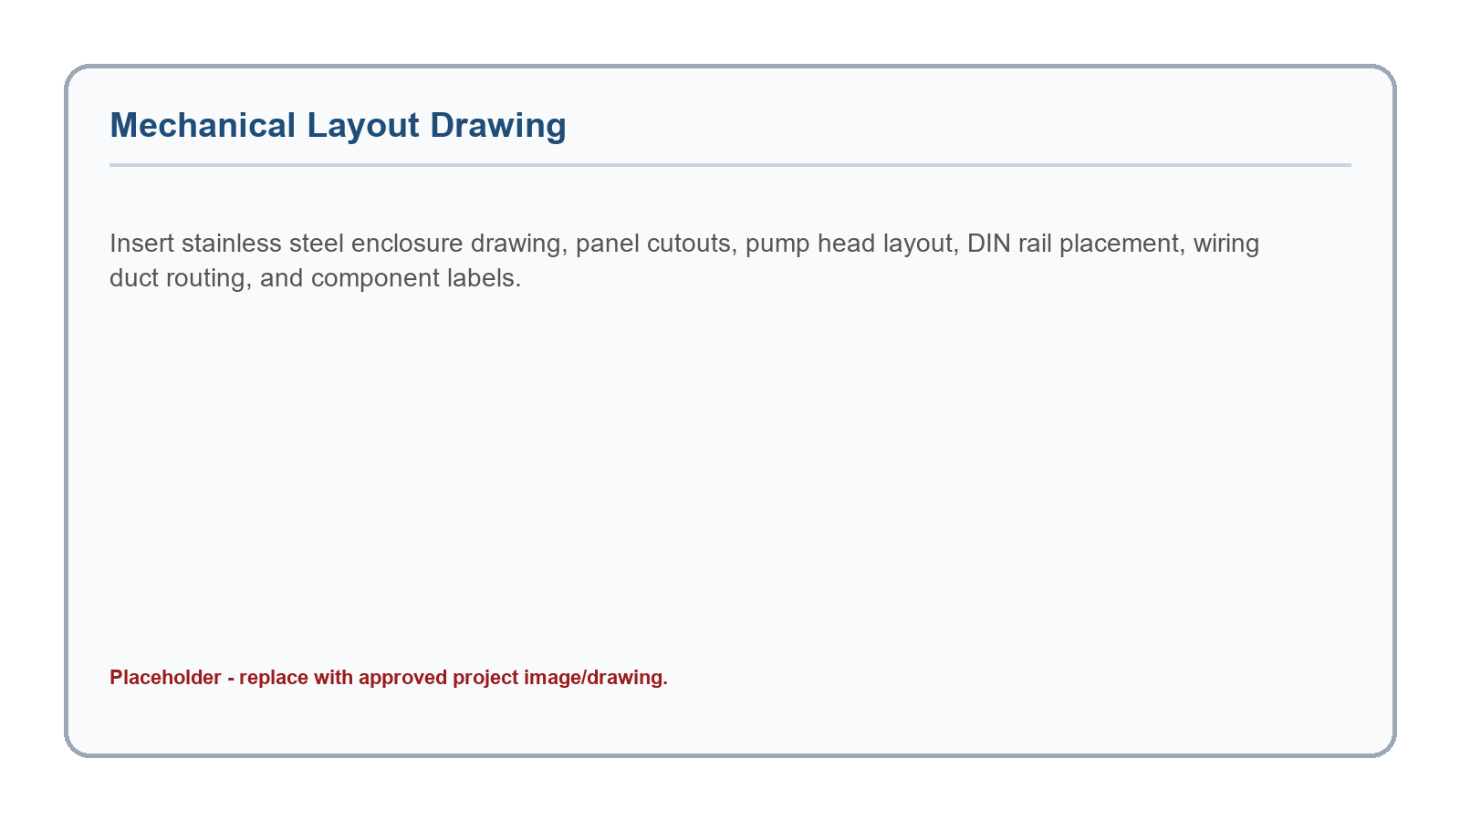
Figure 4. Placeholder for mechanical drawing.

12. Revision History
Revision | Date | Description | Author
Draft V1.0 | 2026-07-27 | Initial pharmaceutical laboratory style technical manual for Nano R4 pump station. | G.C. / Codex

