

Mapping the Spoken Word:
A Geo-Spatial Machine Learning Approach to Irish Accent Recognition
Final Project Report

TU856
BSc in Computer Science

Cianán Ó Finn
C22393223

Supervisors: Akshay Vellanki, Fadoua Rafii

School of Computer Science
Technological University, Dublin

28/03/2026

Abstract

Declaration

I hereby declare that the work described in this dissertation is, except where otherwise stated, entirely my own work and has not been submitted as an exercise for a degree at this or any other university.

Signed:

_________________________
Cianán Finn

17/04/2026

Acknowledgements

Body text

Table of Contents
Abstract i
Declaration ii
Acknowledgements iii
1. Introduction 1
1.1. Project Background 1
1.2. Project Description 1
1.3. Project Aims and Objectives 2
1.4. Project Scope 3
1.5. Thesis Roadmap 3
2. Literature Review 4
2.1. Introduction 4
2.2. Alternative Existing Solutions 4
2.3. Technologies Researched 4
2.4. Other Relevant Research 4
2.5. Existing Final Year Projects 4
2.6. Conclusions 4
3. System Analysis 5
3.1 System Overview 5
3.2 Requirements Gathering 5
3.2.1 Key Stakeholders 5
3.2.2 Requirement Collection 5
3.2.3 Initial Requirements 6
3.3 Requirements Analysis 6
3.3.1 Frontend Layer: 7
3.3.2 Backend Layer: 7
3.3.3 Machine Learning Module: 7
3.3.4 Data Storage Layer 7
3.4 Logical Architecture of System 7
System Flow Diagram: 8
3.5 Initial System Specification 8
3.5.1 Functional Requirements: 8
3.5.2 Non-Functional Requirements: 9
3.5.3 Architectural Design: 9
3.6 Conclusions 9
4. System / Experiment Design 10
4.1 Introduction 10
4.2. Software Methodology 10
4.3 Project Planning 10
4.3.1 Project Schedule 11
4.5. Overview of System 11
Experimental Data Pipeline 11
Feature Extraction Approaches 12
Model Evaluation 12
Model Selection and System Integration 13
4.5.1 Fulfilment of System Requirements 13
4.X. Other Sections as needed 14
4.X. Conclusions 14
5. System / Experiment Development 15
5.1. Introduction 15
5.2. Experimental Pipeline Development 15
5.2.1 Dataset Creation and Collection 15
5.2.2 Audio Preprocessing and Standardisation 17
5.2.3 Metadata Construction and Evolution 17
5.2.4 Feature Extraction and Representation 18
5.2.5 Model Training and Experimental Setup 19
5.2.6 Batch Experimentation System 21
5.3. Backend Development 23
5.3.1 Fast API 23
5.3.2 Audio Handling and Processing 23
5.3.3 Model Registration and Selection 24
5.3.4 Prediction Endpoint 24
5.3.5 Response Structure and Error Handling 24
5.4. Frontend Development 25
5.4.1 User Interface Design 25
5.4.2 Audio Recording and Upload (MediaRecorder) 26
5.4.3 Displaying the Prediction and Probabilities 27
5.4.4 Map Visualisation 27
5.4.5 Prediction History and Feedback System 28
5.5. Model Integration and Plugin Architecture 29
5.5.1 Plugin Structure 29
5.5.2 Model Loading and Registration 29
5.5.3 Runtime Model Selection 30
5.6. Challenged Faced During Development and Iterations 30
5.6.1 Dataset and Problem Constraints 30
5.6.2 Model Development and Feature Extraction Challenges 31
5.6.3 System Integration and Frontend Challenges 31
5.X. Conclusions 33
6. Testing and Evaluation 34
6.1. Introduction 34
6.2. System Testing 34
6.2.1 Functional Testing 34
6.2.2 Backend Testing 35
6.2.3 Frontend Testing 35
6.2.4 Audio Processing Testing 36
6.3. System Evaluation 37
6.3.1 Evaluation Methodology 37
6.3.2 Evaluation Metrics 38
6.3.3 Comparison of MFCC and Wav2Vec Performance 38
6.3.4 Task Difficulty and Class Structure 39
6.3.5 Impact of Dataset Limitations 40
6.3.6 Model Selection for Deployment 41
6.3.7 Summary of Findings 41
6.4. Evaluate Project Management 42
6.4.1 Evaluate Project Plan 42
6.4.2 Evaluate Project Execution 43
6.6. Conclusions 43
7. Conclusions and Future Work 43
7.1. Introduction 43
7.2. Future Work 43
7.3. Conclusions 44
References 45
Appendix A: System Testing Evidence 1
A.1 – Full System Run Through 1
A.2 – Backend API Testing 12
A.3 - Plugin Architecture Validation (ST-11) 21
Appendix B: Experiment Results and Evaluation Charts 1
B1. Irish MFCC Results 1
B2. Irish Wav2Vec Results 5
B3. Common Voice MFCC Results 12
B.4 Confusion Matrices Irish Data MFCC 13
B.5 Summary of Data Distribution in the Irish Dataset 15
Appendix C: System Tests 17
Appendix D: Additional Code Samples 19
Backend Architecture 20
Appendix E: Machine Learning Training 1

1. Introduction

Project Background
The Hiberno-English accent refers to the variety of English spoken in Ireland, shaped by historical interaction with the Irish language, Gaeilge. The term originates from Hibernia, the Roman name for Ireland, often interpreted as “land of winter” (Etymonline, 2026). The name itself is derived from the Proto-Celtic root Īweriū, which is thought to mean “fertile land” (Matasović, 2009). English varies significantly across regions worldwide, reflecting social, cultural, and geographic influences, from class-based distinctions within the United Kingdom (The Guardian, 2022) to regional dialect variation in the United States (Anglophonia, 2021; Bauer, 2013). Within this global context, Hiberno-English stands out as a distinct dialect, influenced by translation patterns and linguistic structures inherited from Gaeilge.
Within the island of Ireland, distinct sub-dialects have developed, often corresponding to geographic or administrative boundaries, such as city-specific accents or broader provincial variations. Historically, limited mobility between regions contributed to the emergence of localised speech patterns, reinforcing regional linguistic identity. This project aims to explore whether such subtle variation can be systematically detected using machine learning techniques.
Machine learning techniques have been widely applied to speech analysis, including accent classification tasks, where models are trained to identify patterns within audio data (Sabuj et al., 2023). A common approach involves extracting acoustic features such as Mel-Frequency Cepstral Coefficients (MFCCs), which aim to represent speech in a manner aligned with human auditory perception (Davis and Mermelstein, 1980). These features are then used in supervised learning models to classify speech samples. While such approaches have demonstrated strong performance when distinguishing between accents across large geographic regions, their effectiveness decreases as the linguistic and geographic distance between accents becomes smaller, resulting in greater overlap between classes.
In the context of Hiberno-English, this presents a particularly challenging problem. Regional accents exist within a relatively small geographic area and share many overlapping phonological features, forming what has been described as a continuum of variation rather than clearly separable categories (Hickey, 2007). Despite ongoing research in accent classification, relatively limited work has focused specifically on fine-grained regional classification within Ireland. One contributing factor is the lack of publicly available datasets containing geographically labelled Irish speech data, which restricts both training and evaluation (Radford et al., 2022).
Furthermore, while accent classification systems have been developed, few approaches integrate geospatial visualisation of results, limiting both how interpretable it is and practical application. This highlights an opportunity to explore not only the technical challenges of fine-grained accent classification, but also the potential for more intuitive, map-based representations of speech variation.

Project Description
This project, “Mapping the Spoken Word: A Geo-Spatial Machine Learning Approach to Irish Accent Recognition”, presents a research-driven system that combines experimental machine learning with a user-facing web application for visualisation. The project investigates the feasibility of classifying regional Hiberno-English accents and representing the results geographically, within the constraints of limited and imperfect speech data.
At its core, the system accepts speech input from users through a web-based interface, either via audio recording or file upload. This audio is processed and analysed using machine learning models trained on geographically labelled Irish speech data. In the final implementation, feature representations are extracted using a pre-trained wav2vec 2.0 model (Baevski et al., 2020), which has been shown to capture high-level acoustic and temporal characteristics of speech more effectively than traditional handcrafted features. These representations are then passed to trained classifiers to predict the most likely region of origin of the speaker.
The system is designed to support multiple classification tasks with varying levels of granularity. These include binary classifications, such as Leinster vs Rest, Ulster vs Rest, and Northern Ireland vs Republic of Ireland, as well as multi-class classifications, such as Four Provinces and Ulster vs Leinster vs Rest. Each task is evaluated across multiple machine learning models, with the best-performing configurations selected for integration into the frontend. This allows users to explore how classification performance varies depending on task complexity and regional grouping.
To enhance interpretability, the system incorporates geospatial visualisation using the Leaflet JavaScript library (Leaflet, 2011). Prediction results are displayed both textually and visually, with the predicted region highlighted as a polygon on a map of Ireland. This provides an intuitive link between the model’s output and its geographic meaning, improving user understanding of the results.
In addition, the system maintains a history of previous predictions using browser-based local storage (Mozilla Developer Network, 2024), allowing users to revisit past results and provide feedback on prediction accuracy. This introduces an interactive element to the application and supports informal evaluation of model performance from a user perspective.
Overall, the system provides a complete pipeline for speech-based accent classification, combining data processing, machine learning, and geospatial visualisation within a single user-facing platform. It demonstrates both the technical challenges associated with fine-grained accent classification and the value of geographic visualisation as a tool for interpreting model outputs.

A detailed system flow diagram illustrating the interaction between the frontend, backend, and machine learning components is presented in Section 3.4.

Project Aims and Objectives
The primary aim of this project is to investigate the feasibility of classifying regional Hiberno-English accents using machine learning techniques and to present the results through a geospatial interface.
To achieve this aim, the following objectives were defined:
- To collect and construct a valid and high quality dataset of geographically labelled Hiberno-English speech data.
- To preprocess and standardise the audio data (e.g. segmentation, resampling and cleaning) to ensure consistency of the data for model training.
- To investigate and evaluate suitable machine learning approached for regional accent classification, for both traditional feature-based methods and modern deep-learning techniques.
- To design and implement reusable feature extraction pipelines, including both MFCC-based features and embeddings from a pre-trained wav2vec2 model.
- To train and evaluate multiple classification models across a range of tasks, including both binary and multi-class classification.
- The analyse the models performance using evaluation metrics (e.g. balanced accuracy, F1 macro score), and identify the most effective approaches for fine grained accent classification.
- To design and develop a web-based application that enables users to upload or record speech samples and receive accent predictions.
- To integrate the trained models into the application, allowing users to select from multiple models at runtime.
- To implement geospatial visualisation of predictions using Leaflet, to make the visualised results be more intuitive.

Project Scope
The aim of this project was to research, design and implement a machine learning system capable or regionally classifying Hiberno-English accents and then visualising the results geographically. The primary focus of the project was on the development of backend components, including dataset construction, audio processing, feature extraction, and the evaluation of multiple machine learning models.
The scope of the system includes the development of a processing pipeline that accepts and audio sample, extracts relevant features and applies the trained machine learning models to predict the most likely region of origin of the speaker. The initial work involved working with MFCCs (Mel-Frequency Cepstral Coefficients) for feature extraction; however, due to limited performance on fine-grained tasks, this approach was extended to use embeddings from a pre-trained wav2vec 2.0 model, which improved both accuracy and consistency. The final system performs classification at a regional level, including both binary distinctions and province-level classification, and maps predictions to corresponding geographic regions using polygon-based visualisation.
A significant portion of the project was dedicated to dataset creation and preparation. Due to the lack of publicly available geographically labelled Irish speech data, a custom dataset was constructed from multiple sources, including Dáil Éireann recordings, Oireachtas proceedings, Northern Irish political speech, and the Mozilla Common Voice dataset (Mozilla, 2023). This process required substantial manual effort, including audio sourcing, speaker isolation, quality validation, segmentation, and metadata construction. Despite these efforts, the resulting dataset remains limited in size, balance, and speaker diversity when compared to typical datasets used in speech classification research (Radford et al., 2022), which constrained overall model performance.
The scope of the project was intentionally limited to demonstrating the feasibility of regional accent classification within Ireland, rather than achieving production level accuracy. The system is designed as an experimental and exploratory platform, prioritising the investigation of feature extraction methods, model performance, and task design under realistic data constraints. While a functional web-based interface was developed to support interaction and visualisation, advanced features such as large-scale deployment, user authentication, and persistent backend data storage were considered outside the scope of this project and instead mention in Section 7 for future development.
In summary, this project focuses on exploring the challenges of fine-grained accent classification within Ireland and evaluating how geospatial visualisation can support the interpretation of model predictions, within the constraints of limited and imperfect data.

Thesis Roadmap
The rest of this report will be structured as follows:
- Chapter 2 – Literature Review
This chapter examines existing research, technologies, and systems related to accent classification, speech processing, and geospatial visualisation, identifying key gaps that this project aims to address.

- Chapter 3 – System Analysis
This chapter outlines the system requirements, stakeholder considerations, and the overall architecture of the proposed solution.

- Chapter 4 – System and Experiment Design
This chapter describes the design decisions behind both the machine learning pipeline and the system architecture, including the chosen methodology and planning approach.

- Chapter 5 – System and Experiment Development
This chapter details the implementation of the dataset, experimental pipeline, backend services, and frontend application.

- Chapter 6 – Testing and Evaluation
This chapter presents the results of system testing and model evaluation, analysing performance across different classification tasks and feature extraction approaches.

- Chapter 7 – Conclusions and Future Work
This chapter summarises the key findings of the project and outlines potential areas for further development.

2. Literature Review

2.1. Introduction
This chapter reviews existing research, technologies, and systems relevant to the development of this project, a geo-spatial accent recognition system. The project combines three key areas: web-based technologies, machine learning approaches to accent classification, and the study of regional linguistic variation. While each of these domains has been explored extensively in isolation, there is relatively limited work that integrates them into a single, cohesive system.
The aim of this literature review is to examine existing solutions and academic research across these areas, with a particular focus on their applicability to regional accent classification within Ireland. This includes an evaluation of machine learning techniques used in speech and accent recognition, as well as the technologies used for processing, representing, and visualising geographic data. In addition, the challenges associated with speech datasets—particularly in terms of availability, quality, and geographic labelling—are considered, as these play a critical role in determining system performance.
By bringing these areas together, this chapter aims to identify gaps in both existing research and practical systems, particularly in relation to combining fine-grained accent classification with geospatial visualisation in a single application. This gap is the foundation for the system developed in this project.

2.2. Alternative Existing Solutions
A number of tools and systems have already been developed in the area of speech recognition and accent analysis. however, most of the systems focus on general speech-to-text transcription, or large region accent detection, rather than fine-grained regional classification, paired with geographic visualisation.
One such system is Google Cloud’s Speech-to-Text (Google Cloud, 2023). This system focuses on converting spoken word into text, supporting multiple different languages. While it includes some level of accent robustness, it still struggles with regional dialects (The Guardian, 2016), rather focusing on its primary goal of accurate transcription rather than identifying speaker’s regionality. As a result, it doesn’t have functionality to accent classification or geographic interpretation.
Amazon’s Transcribe (Amazon Web Services, 2023) provide automatic speech recognition for services with a focus on business scalability and integration into cloud applications. Similarly to Google, it focuses on transcription and does not attempt to classify or visualise accents. These too tools show how industry-level tools put more value into usability and accuracy regarding transcription, rather than linguistic analysis, at least publicly.
Research driven tools, such as systems based on wav2vec 2.0 (Baevski et al., 2020) have demonstrated strong performance in extracting useable representations from raw audio. While these models are only tools, not end-to-end products, they are key elements of many modern speech processing systems. Their ability to capture high-level speech features makes them highly relevant for accent classification tasks, even though they do not provide built-in geographic visualisation.

Canúint (RTÉ Archives, 2025) is a project that was developed by RTÉ in collaboration with Dublin City University to document Gaeilge speakers across the island of Ireland. The system presents recordings on an interactive map of Ireland, where users can select markers on the map, which represent speakers, and listen to archived samples. Although the project focuses on Gaeilge rather than the Hiberno-English accent, it demonstrates an effective approach to visualising regional speech data through a simple and intuitive interface. Its use of map visualisation provided the inspiration of the visual design and user interaction patterns implemented in this project.
Vocal Image (Vocal Image 2023) is an accent training application designed to help users improve their pronunciation and communication skills. Its accent test feature allows users to submit speech and receive an estimated country of origin, which is displayed visually on a world map. This makes it one of the closest existing systems to the concept explored in this project. However, its predictions are limited to broad national categories and do not attempt to classify accents at a regional level. As such, while it provides useful inspiration for front-end interaction and visual feedback, it does not address fine-grained regional accent classification which was the aim of this system.
The alternative existing solutions reviewed show a clear divide between technical capability and practical application. Industry tools such as Google Speech-to-Text and Amazon Transcribe prioritise transcription accuracy and scalability, while research tools such as wav2vec focus on feature extraction without providing user-facing systems. At the same time, interactive platforms such as Canúint and Vocal Image demonstrate effective approaches to visualising speech data, but lack the ability to perform fine-grained regional accent classification. None of the systems examined combine speech input, machine learning-based regional accent prediction, and geo-spatial visualisation within a single platform. This gap forms the basis for the system developed in this project.

2.3. Technologies Researched
The development of this project required a significant amount of research across a wide range of different technologies, from web development, audio processing, machine learning to geospatial visualisation.

Web Technologies
The frontend of the system was built using the default web technologies, including HTML, CSS, and JavaScript. These technologies were widely supported for developing the interactive web app planned. JavaScript was used for managing the application’s state, handling user interactions, and communicating with the backend through HTTP requests.
To support persistent the client-side storage, local storage was used using the browser’s Storage API (Mozilla Developer Network, 2024). This allows prediction history and user feedback to be stored locally within the browser, avoiding the need for a backend database while maintaining user privacy.

Backend Frameworks
The backend system was implemented using FastAPI (FastAPI, 2018), which is a modern Python web framework designed for high performing APIs. It was selected due to its simplicity and support for asynchronous request handling. It allowed for the RESTful endpoints to be developed and changed easily as changes occurred, making it well suited for handling the audio uploads and returning the prediction results.
Comparing it to the more traditional frameworks such as Django which was originally used in the prototype for the interim report (MENTION), FastAPI provides a more lightweight approach, which aligns with the experimental and modular nature of the project.

Audio Processing Libraries
How the audio data is handled and processed is critical to the system. The librosa library (McFee et al., 2015) was used to load, process, and transform audio signals. It provides functionality for resampling audio, converting between formats, and extracting features such as Mel-Frequency Cepstral Coefficients (MFCCs).
MFCCs, originally proposed by Davis and Mermelstein (1980), are widely used in speech processing as they try to replicate the human auditory perception. Their use in this project formed the basis of the initial feature extraction approach before the project transitioned to more the modern method of wav2vec 2.0 (Baevski et al., 2020).

Machine Learning Frameworks
As the system was developed with an experimental ideology in mind, a range of different machine learning techniques were explored including Logistic Regression, Support Vector Machines, Random Forests and k-Nearest Neighbour (see Figure B1.1.1, Appendix B). These models were decided through researching academic sources (Subuj, H.H. et al. , 2023) which confirmed that they work well using MFCCs. (SHOULD I ADD DESCRIPTION OF ALL MODELS USED? ALSO I SHOULD MENTION WHY I DIDN’T USE ALL MODELS I USED IN MFCC SYSTEM IN WAV2VEC, ONLY USED A FEW).
Expanding the research domain, modern representation-based methods were also investigated, leading to wav2vec (Baevski et al., 2020) being used. This deep learning model enabled the extraction of high-level representations directly from the raw audio, with its ability to be able to capture complex acoustic patterns making it very relevant to accent classification tasks, especially while dealing with a dataset with such subtle differences.
These technologies allowed for direct comparison between handcrafted feature extraction methods and learned representations, which was a central focus of the experimental pipeline.

Geospatial Technologies
A core element of the system is the visualisation of the predicted labels geographically. The Leaflet JavaScript library (Leaflet, 2011) was used to implement an interactive map in the frontend, enabling the rendering of geographic data and supporting dynamic interaction, which allowed for the highlighting of predicted region polygons.
The data of the boundaries of these polygons was represented using GeoJSON sourced from the Irish Government’s public data (Department of Public Expenditure Infrastructure Public Service, 2026). GeoJSON (Internet Engineering Task Force, 2015 ) is a standard format for encoding spatial data structures. QGIS (QGIS, 2002) was used to prepare and refine these datasets for efficient use in the application.
OpenStreetMap (OpenStreetMap, 2004) provided the base map data used in the visualisations. These technologies together enabled the integration of the developed machine learning predictions to be visualised in intuitive geographic visualisations.

2.4. Other Relevant Research
Regional accent classification has been widely studied within the field of speech processing, particularly in contexts where accent groups are clearly distinguishable. Much of this research focuses on classification tasks involving accents from different countries or continents, where linguistic variation is more pronounced. In these scenarios, machine learning models have demonstrated strong performance, as clear phonetic differences between accent groups make classification more straightforward (Sabuj et al., 2023).
However, this level of performance is not representative of more complex, fine-grained classification tasks. As the linguistic distance between accent groups decreases, distinctions between them become less clearly defined, making classification significantly more challenging. This is particularly evident in the context of Irish English. Hickey (2007) describes Irish English as a continuum of regional variation, where overlapping phonological features are common across regions. This means that accents cannot always be separated into clearly defined categories, which directly impacts the performance of classification models. This helps to explain the confusion observed between regions such as Leinster, Munster, and Connacht during the model evaluation phase of this project.
In terms of technical approaches, traditional accent classification systems have relied heavily on feature extraction methods such as Mel-Frequency Cepstral Coefficients (MFCCs). Originally introduced by Davis and Mermelstein (1980), MFCCs aim to represent audio signals in a way that reflects human auditory perception. These features have been widely adopted due to their efficiency and ability to capture key spectral characteristics of speech. When combined with classical machine learning models, such as those explored by Sabuj et al. (2023), MFCC-based approaches can perform well, particularly in controlled environments with clearly separable classes. However, they are limited in their ability to capture more complex temporal and contextual aspects of speech, which are often necessary for distinguishing subtle accent differences.
More recent research has shifted towards representation-based approaches using deep learning. One of the most significant developments in this area is wav2vec 2.0 (Baevski et al., 2020), which enables the extraction of high-level representations directly from raw audio. Unlike MFCCs, which rely on manually designed features, wav2vec learns feature representations through self-supervised training on large speech datasets. This allows the model to capture more complex characteristics of speech, including temporal dynamics such as rhythm, intonation, and pronunciation patterns. These properties make wav2vec-based approaches particularly well suited to accent classification tasks, where subtle variations in speech delivery are often more informative than static spectral features alone.
Despite these advancements, the effectiveness of modern machine learning approaches remains strongly dependent on the availability of large, high-quality datasets. Radford et al. (2022) highlight that state-of-the-art speech models are typically trained on extremely large datasets containing thousands of hours of audio, enabling them to generalise effectively across a wide range of speakers and accents. In contrast, smaller and more specialised datasets introduce significant limitations in both model performance and generalisability.
This challenge is particularly evident in research focused on Irish accent classification. Nolan (2024) found that performance was constrained by both dataset size and the subtle nature of regional variation within Ireland. While some models were able to achieve moderate success, the results highlighted the difficulty of distinguishing between closely related accent groups. These findings align closely with the challenges encountered in this project, where limited data and overlapping accent features reduced classification performance, particularly in multi-class tasks.
Overall, the literature demonstrates that while machine learning techniques provide powerful tools for speech analysis, fine-grained regional accent classification remains a challenging problem. This is especially true in contexts such as Ireland, where linguistic variation exists along a continuum and available datasets are limited. These challenges justify the experimental approach taken in this project, including the comparison of traditional MFCC-based methods with modern representation-based approaches such as wav2vec, as well as the focus on evaluating performance across tasks with varying levels of complexity.

2.6. Conclusions
This chapter has reviewed the key areas relevant to the development of a geo-spatial accent classification system, including existing solutions, technologies, and academic research.
The analysis of alternative systems highlighted a clear gap. Industry tools prioritise transcription accuracy, while research tools focus on feature extraction without user-facing applications. Interactive platforms demonstrate effective visualisation of speech data, but do not support fine-grained accent classification. This separation between technical capability and practical application highlights the opportunity addressed in this project. The technologies reviewed confirmed the suitability of the chosen approach, particularly the use of modern representation-based methods such as wav2vec, which offer advantages over traditional feature extraction techniques in capturing complex speech patterns.
The literature also emphasised the difficulty of fine-grained accent classification, especially within Ireland, where accents exist along a continuum and datasets are limited. These challenges reinforce the need for an experimental approach and careful task design.
Overall, while the individual components required for accent classification systems are well established, there is limited work that combines regional classification with geospatial visualisation in a single system. This gap forms the foundation of this project.

3. System Analysis

3.1 System Overview
The system is a user-facing web application that allows users to submit speech samples and receive a regional accent classification, which is then visualised on a map of Ireland. Users can provide input either by recording audio directly within the browser or by uploading an existing audio file.
Once an audio sample is submitted, it is transmitted to the backend for processing. The backend performs audio analysis and applies the selected machine learning model to generate a prediction representing the most likely region of origin of the speaker. The resulting classification is returned to the frontend and presented to the user both as textual output and as a highlighted geographic region on the map.
In addition to real-time predictions, the system maintains a history of previous interactions. Predictions are stored locally within the browser, allowing users to revisit earlier results, review associated confidence values, and view any feedback provided regarding prediction accuracy. This functionality enhances the interactivity of the system and enables users to reflect on model behaviour across multiple inputs
Overall, the system provides an end-to-end pipeline, integrating audio input, machine learning inference, and geospatial visualisation within a single interface.

3.2 Requirements Gathering
The requirements for this system were gathered through research, iterative development and experimentation. Due to the technical nature and nicheness of the project, a user survey didn’t seem appropriate. Instead, requirements were informed by analysing existing systems, reviewing relevant academic literature, and identifying practical constraints related to data availability and machine learning performance.

3.2.1 Key Stakeholders
The key stakeholders of this system include:
- The General Public – The end users of the system who interact with the web-application submitting and viewing the results.
- Researchers and Linguists – Individuals with an academic interest in accent variation and geographic linguistic visualisation.
- Project Supervisor – Providing guidance, feedback and evaluation during the system development.
- The Author – Responsible for the overall design, implementation and evaluation of the system.

3.2.2 Requirement Collection
The requirement collection approaches were:
- Reviewing Existing Systems
Existing tools related to accent analysis, speech processing, and linguistic mapping were analysed to establish expected functionality and user interaction patterns. This informed decisions relating to feature extraction, model selection, and overall system design.

- Review of Academic Research
Academic literature on speech processing and accent classification, including both traditional feature-based approaches and modern representation-based methods, was reviewed. This provided insight into effective modelling techniques and common challenges, informing decisions on feature extraction, model selection, and evaluation strategies.

- Dataset Investigation and Construction
A significant portion of the requirements emerged from the challenge of obtaining suitably labelled training data. Publicly available datasets containing geographically labelled Irish speech data are extremely limited, making the construction of a custom dataset a necessity. This involved sourcing audio from Dáil Éireann recordings, Oireachtas proceedings, and Northern Irish political speech, followed by manual speaker isolation, quality validation, segmentation, and metadata construction.
Additional datasets, such as the Mozilla Common Voice dataset (Mozilla, 2023), were used for comparative experimentation. The limitations encountered during dataset creatio, particularly in terms of size, class imbalance, and speaker diversity, directly influenced the system requirements, especially in relation to model selection and evaluation.

- Web-Mapping Research
Knowledge gained from prior study in web-mapping and GIS informed the design of the geospatial visualisation component. This included the use of GeoJSON for representing regional boundaries and the implementation of interactive mapping through technologies such as Leaflet.

- Iterative and Experiment Driven Design
Requirements continuously changed and evolved throughout the project as experimental results were obtained and issues were identified. Early decisions, such as the use of MFCC-based features, were revised following results showing limited performance, leading to the transitioning to wav2vec-based embeddings. This iterative process ensured that system requirements remained aligned with both technical constraints and experimental findings.

3.2.3 Initial Requirements
Based on the above processes, the following requirements were identified:
- The system must accept user-recorded or uploaded speech samples.
- The system must process and analyse the audio data for accent classification.
- The system must support multiple classification tasks with varying levels of regional granularity.
- The system must provide predictions of speaker’s most likely place of origin based on the result of trained machine learning models.
- The system must present all results and findings in a clear and intuitive way.
- The system must include a geographic visualisation of the results.
- The system must retain a history of previous predictions, along with all associated data, and allow for users to interact with these results.
- The system must be modular, allowing for different tasks and models to be integrated and selected dynamically.
- The system must operate to as high a standard as possible while staying within the constraints of a limited and imperfect dataset.

3.3 Requirements Analysis
After identifying the systems requirements, the project was structured into a set of modular components that reflect both the function needs of the system while adhering to the constraints of the data and academic timeline.
The system has been divided into four main components:

3.3.1 Frontend Layer:
The frontend layer provides the user interface, through which the user can interact with the system. It allows for the user to record or upload audio samples, to view the prediction results both textually as well as geographically, as well as to be able to interact with previous outputs. The design prioritises simplicity and usability, ensuring accessibility for users with varying levels of technical expertise. This is achieved through a structured interface that clearly separates input controls, prediction outputs, and visualisation components.

3.3.2 Backend Layer:
The backend acts as the centre of the system, handling all API requests, processing the incoming audio data and coordinating all communication between system components. It exposes RESTful endpoints for model retrieval and prediction execution. The backend was implemented using FastAPI, a lightweight Python framework well-suited for building high-performance APIs. Its support for asynchronous processing and rapid development aligns with the requirements of handling audio input and returning prediction results efficiently.

3.3.3 Machine Learning Module:
The machine learning module is integrated within the backend in code, but is logically separated as an independent module. As a module it processes the audio data, extracts features from the audio, and performs the classification.
Throughout the project, two machine learning approaches were explore: a traditional MFCC-based feature extraction approach, as well as a representation-based method using embeddings from a pre-trained wav2vec 2.0 model. The final system uses the wav2vec approach as it was proven to consistently perform better during the experiments performed.
A key architectural feature is the use of a plugin-based model system. This allows multiple trained models, each corresponding to different classification tasks or feature extraction approaches, to be dynamically loaded and selected at runtime. This design supports experimentation, simplifies model comparison, and enables future extension without requiring changes to core system logic.

3.3.4 Data Storage Layer
A lightweight data storage approach was adopted in place of a traditional database. Training data is stored as audio files with associated metadata, while trained models are stored as artefact files. Prediction history and user feedback are stored locally within the browser using the Web Storage API (Mozilla Developer Network, 2024). This approach reduces system complexity and aligns with the prototype-driven and experimental nature of the project. It also avoids the need for backend data persistence, which was considered to be outside the scope of the system.

3.4 Logical Architecture of System
The logical architecture of the system describes how data flows through the application, from initial user input to final output. The system follows a sequential processing pipeline, ensuring a clear and consistent flow of data between components.
The process begins at the frontend, where the user either records an audio sample or uploads an existing audio file. This input is transmitted to the backend via a REST API POST request.
Upon receiving the audio input, the backend validates and processes the data before routing the request to the appropriate model plugin based on the selected model identifier. This routing mechanism enables dynamic selection of different classification tasks and models at runtime.
Within the selected model pipeline, the audio is first standardised into a consistent format suitable for feature extraction. Depending on the chosen approach, different feature extraction methods are applied. In the traditional pipeline, Mel-Frequency Cepstral Coefficients (MFCCs) are extracted as numerical representations of the audio signal (Davis and Mermelstein, 1980). In the alternative approach, the audio is passed through a pre-trained wav2vec 2.0 model to generate high-level embeddings that capture both acoustic and temporal characteristics of speech (Baevski et al., 2020). These feature representations are then used as input to the classification model.
Following feature extraction, the model performs inference and produces a prediction, including the predicted label and associated probability distribution. The backend formats this output into a structured response and returns it to the frontend.
The frontend then updates the user interface to display the prediction results, including the predicted region, confidence values, and probability breakdown. The predicted region is also visualised geographically on the map interface. Users are given the option to provide feedback on the prediction, which is stored locally alongside the corresponding result.
This architecture ensures a clear separation of concerns between the user interface, backend processing, and machine learning components. The use of a plugin-based model system further enhances flexibility, allowing new models and classification tasks to be integrated without modifying the core system structure.

System Flow Diagram:
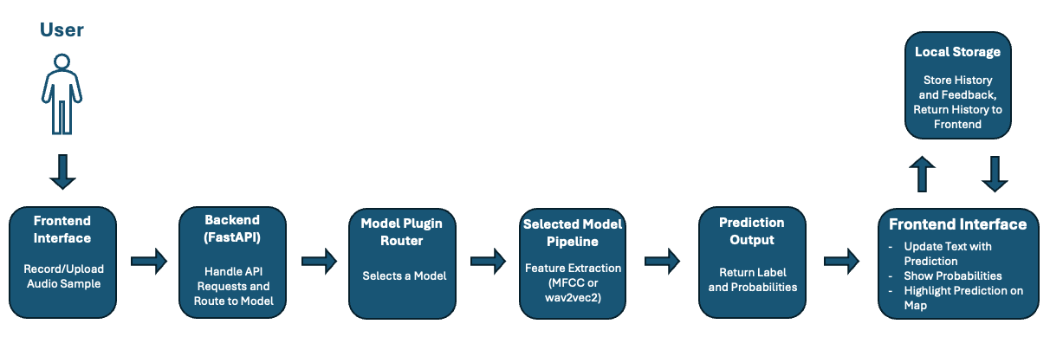
Figure 1 - System Flow Diagram.

3.5 Initial System Specification

3.5.1 Functional Requirements:
- The system must provide a web-based interface, with consideration to user accessibility.
- The system must allow users to record an audio sample within the browser, or to upload an audio sample from an existing audio file.
- The system must send both the audio sample and the selected model identifier to the backend to start processing.
- The system must process the audio sample and extract features to allow for machine learning classification.
- The system must support multiple machine learning models and classification tasks, supported through the modular plugin-based architecture of the system.
- The system must generate a prediction, and return the prediction alongside the associated confidence values and probability distributions to the frontend.
- The system must map the prediction to a corresponding geographic region.
- The system must display the results (including the predicted label, the probability distribution and the geographic visualisation) in a clear and understandable manner.
- The system must retain a history of previous predictions and user feedback locally within the browser using local storage.
- The system must allow users to revisit and interact with the previous predictions.

3.5.2 Non-Functional Requirements:
- The system should provide predictions within a reasonable response time to improve user experience.
- The system should provide feedback to the user during interaction (e.g. recording status, processing state.
- The system should be simple, intuitive and accessible to users with varying levels of technical knowledge.
- The system should be modular, allowing components to be easily updated or replaced.
- The system should be robust to different audio formats and quality.
- The system should operate within the limitations of the small and imperfect dataset.
- The system should preserve user privacy by storing prediction history and feedback locally rather than on a remote server.

3.5.3 Architectural Design:
The system adopts a modular architecture, as outlined in Sections 3.3 and 3.4, separating the frontend, backend, and machine learning components. This separation of concerns ensures that each component can be developed, tested, and modified independently, improving maintainability and flexibility.
A key feature of the architecture is the use of a plugin-based model system within the backend, allowing each of the trained models to be able to be selected during runtime. This design supports the experimental nature of the project, enabling direct comparison between models and facilitating future extensions without requiring changes to the core system.
Data management follows a lightweight approach, avoiding the use of a traditional database. Instead, training data is stored as audio files with associated metadata, while trained models are stored as artefacts. Prediction history and user feedback are stored locally within the browser using local storage. This approach aligns with the prototype-driven nature of the project, reducing system complexity while remaining sufficient for the intended functionality.

3.6 Conclusions
This chapter outlined the analysis and design considerations for the proposed system. It consistently referred to the intended user experience while progressing through requirements gathering and system analysis. The system architecture was designed to meet the functional needs of the application while remaining within practical constraints, particularly those related to dataset availability and, consequently, model performance.
A modular, plugin-based design was adopted to support flexibility and experimentation throughout development, while maintaining a clear separation of concerns between system components. The resulting specification provides a structured foundation for the implementation and evaluation of the system presented in the following chapters.

4. System / Experiment Design

4.1 Introduction
In this chapter the design of both the system and experimental framework will be described. Building off the requirements identified in the previous chapter, the system has been designed to support machine learning experimentation while also presenting the resulting findings within a user-facing application. Emphasis has been placed on the iterative development process, the design of the experimental pipeline, and the integration of machine learning models into a modular system. The chapter outlines the methodology used, the planning approach, and the key design decisions that influenced the final implementation.

4.2. Software Methodology
For this project a traditional Waterfall methodology was initially considered, but as development began it was found to be unsuitable due to its rigid, linear structure. The project required constant experimentation and continuous refinement of both the dataset and the machine learning models, making a more flexible approach necessary.
Instead, an iterative development methodology was adopted, which was noted by J. A. Osorio, et al. (2011) to allow “the development team to deliver value earlier and on a more frequent basis as a consequence of the iterative development approach.”, which fitted the project style. This approach allowed the system to evolve through a series of short development cycles, with each cycle improving on the previous iteration based on experimental results and identified issues.
During the early stages of development, the primary focus was on experimenting with different machine learning models using small Hiberno-English speech datasets. As results were evaluated, the system was progressively refined to align with the evolving objectives of the project.
Each development cycle consists of four short repeatable stages:
- Planning – Define a small set of achievable goals for the cycle.
- Implementation – Develop or modify system components in order to achieve these goals.
- Evaluation – Test all changes made and analyse the results.
- Revision – Refine any changes and address any identified issues for next cycle.
GitHub was used as the project’s version control system, allowing all changes to be tracked throughout development. This enabled reversion to earlier versions when required and supported the iterative workflow.
Overall, this methodology proved well suited to the project, enabling continuous improvement while accommodating the experimental nature of the machine learning pipeline and the evolving dataset.

4.3 Project Planning
Due to the experimental nature of the project, a structured yet flexible planning approach was adopted. This approach allowed for the definition of key milestones while also enabling the project timeline to adapt in response to findings arising from experimentation.

4.3.1 Project Schedule
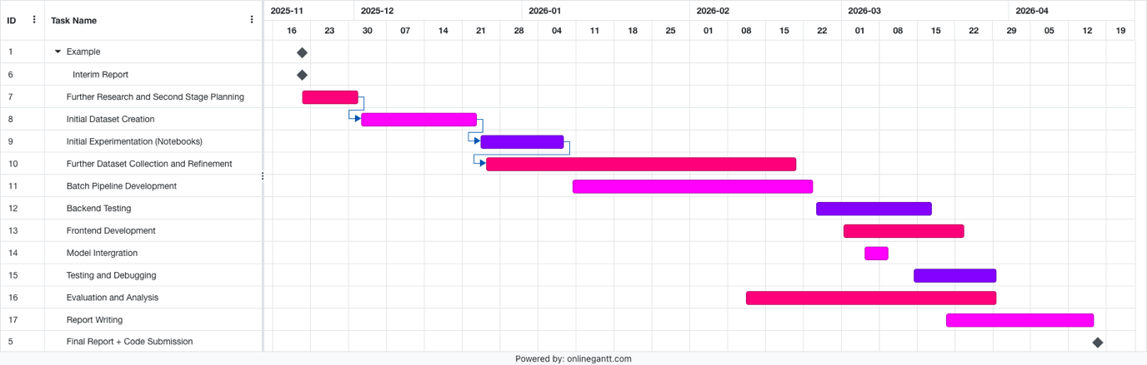
Figure 2 - Gantt Chart of project timeline post Interim Report.
In the Gantt chart, multiple stages continue to overlap rather than follow a waterfall, linear progression. This is due to the experimental nature of the project where findings from one stage directly influenced the previous and next stages. For example, the Evaluation and Analysis stage directly influenced the frontend and backend development, leading to them stages having to be revisited multiple times. As a result an iterative development approach was adopted, as mentioned above in Section 4.2. This allowed for the necessary flexibility to adapt to challenges as they came, such as the dataset limitations.

4.4. Experimental Pipeline and System Design
The system was designed to support both machine learning experimentation and the deployment of a user-facing web application. This led to a design centred around a functional experimental pipeline that processes audio data, evaluates model performance, and integrates the most effective models into the final system.
The pipeline was implemented in a modular manner, allowing experiments to be executed systematically and results to directly inform system development. This structure ensured consistency between the experimentation environment and the deployed application, with components developed during experimentation reused within the backend processing pipeline.

4.4.1 Experimental Data Pipeline
The largest part of the project, the experimental pipeline was continuously developed throughout the development process, evolving iteratively through continuous changes and improvements. The main dataset used was for the Irish accent classification. This consisted of two custom-built datasets: one made up of Dáil Éireann recordings, and the other constructed from Northern Ireland political speech clips, all data collected from the internet.
Due to the limited availability of geographically labelled speech data, a large chunk of the project was dedicated to creating and preparing the datasets. Audio samples were gathered from publicaly available recordings, which were then segmented into usable clips, and then manually validated to ensure quality and speaker clarity. This process included ensuring the speakers were isolated, any overlapping speech was removed and removing unusable segments from the dataset.
After this, all audio data was standardised before analysis could begin. The standardisation was to convert all audio to mono format, to resample it to 16kHz and to segment clips into 10 seconds segments. Then the loudness was normalised to reduce the variation between the recordings. Clips that didn’t meet the standard were cut from the dataset, but a record of them was kept.
The creation of valid metadata played an important role in the pipeline, and the necessary data columns continuously changed throughout the project. The initial metadata included attributes such as speaker identity, their political party, the constituency they represented, and their place of origin, including town name and coordinates. However due to poor performance at such a fine geographic level, the classification task was made to be more coarse and the project evolved to provincial classification. This decision helped to mitigate the effect of having a small dataset, improving model performance and ensured a more balanced class representation (before cities like Dublin dominated).
To compliment this, a larger dataset based on Mozilla’s Common Voice was used to compare experiment results. This dataset included 40,000 English-language samples, across multiple accent groups (Britain, Northern Ireland, Ireland, North American, Oceanian), which allowed for the evaluation of the models performances on a much coarser regional accents. These trained models surprisingly did worse throughout classification experiments, and therefore were not included in the final deployed system, but they were essential in developing an understand on the difficulty of fine-grained accent classification within Ireland.
The final experiment pipeline combined both the Dáil dataset and the Northern Ireland dataset, using speaker aware grouping to prevent data leakage between the training and testing. After all experimentation, the final key metadata attributes were: file path, speaker name, dataset source (Dáil or Northern Ireland dataset), regional label.

4.4.2 Design Influence from Existing Systems
The design of the geospatial visualisation component was influenced in part by existing linguistic mapping systems, particularly the Canúint project (RTÉ Archives, 2025). Canúint presents archived recordings of Gaeilge speakers as interactive markers across a map of Ireland, allowing users to explore regional speech variation through geographic interaction. While the project focuses on Gaeilge rather than Hiberno-English, it demonstrates how speech data can be effectively linked to geographic representations in an intuitive and accessible manner.
This approach informed early design considerations within this project, where initial concepts explored representing predictions using continuous geographic coordinates, allowing for precise placement of predicted speaker origins. However, due to limitations in dataset size, class imbalance, and the classification-based nature of the models used, this approach was not feasible. As a result, the system was adapted to use region-based classification, with predictions mapped to predefined geographic areas such as provinces.
Despite this shift, the influence of map-based interaction remains central to the system design, with geographic visualisation used to improve interpretability and user engagement.

4.4.3 Feature Extraction Approaches
In the development of the system, two different feature extraction approaches were explored: a traditional MFCC-based approach and a representations-based approach using a pre-trained wav2vec 2.0.
The MFCC-based approach involved extracting Mel-Frequency Cepstral Coefficents (MFCCs) from each audio sample, which converts the raw audio into a time series of numerical features, creating the audio signal. These features were then summarised using stat measures and became a fixed-length vector which was suitable to be used as input for a classical machine learning model. This approach had difficulties in capturing the differences within accents, especially due to the limited size and imperfect nature of the dataset. The results showed this, with performance across more fine-grained classification tasks being very limited.
To handle these issues, a wav2vec embeddings-based approach was implemented. This pipeline took each audio sample and passed it through a pre-trained wav2vec model, which generated high-level feature representations. These embeddings were then aggregated into fixed-length vectors which could be used as input to classification models. This was much more effective as it was able to pick up on more complex patterns within the speech, which resulted in much more accurate and consistently better performance across the tasks.

4.4.4 Model Evaluation
The models performance was evaluated using a range of classification metrics, with results being recorded in summary datasets containing: task name, model name, number of samples total, the class distribution and the model type. The primary evaluation metrics were accuracy, balanced accuracy and the macro-average F1 score. The most important evaluation metric was the balanced accuracy due to the imbalance of samples within the dataset. The balanced accuracy ensured that the performance wasn’t weighted towards the more represented classes.
All experiment results were aggregated and stored in summary CSV files, which were then used to compare performances across different models and different classification tasks, by representing the results as charts created in Excel. These charts allowed for clear comparisons between the two feature selection approaches and model selection.

4.4.5 Model Selection and System Integration
Using the results of the experiments, the most effective model and feature extraction method for each task were selected and then integrated into the final system. Rather than having a single mode, the system was developed so multiple classification tasks could be supported, each with their own best-suited model.
To do this a modular plugin-based architecture was developed and implemented in the backend, so that each trained model became a plugin, allowing it to dynamically selected during runtime. The frontend has a model selector dropdown, enabling users to select whichever available model they wish to use, and the selected model identifier will be passed to the backend during the prediction requests.

4.5 Fulfilment of System Requirements
In this chapter the system has been shown to fulfil the functional and non-functional requirements which were identified in Section 3.5. The logical architecture of the system, as described in Section 3.4, serves as the guide for this implementation.
From a functional perspective, the system has been successful at enabling users to submit speech audio data, either through an existing audio file or through recording in browser, through a web-application. As described in the logical architecture, Section 3.4, this input is processed through the backend and then passed to the user’s selected model pipeline, which fulfils the requirement of the audio processing and classification that was stated.
The requirement of modularity and to be able to support multiple classification tasks is fulfilled through the plugin-based architecture that’s in the backend. This allows for different models and classification tasks to be dynamically selected at runtime, which is important and inherent to the systems experimental design and enables the deployment of the best models.
The requirement of transforming the raw audio to meaningful predictions is fulfilled. Within the pipeline, the audio samples are processed, then converted into numerical representations using MFCC or wav2vec, and then classified to get a predicted label and the probabilities.
Regarding the requirement for a clear presentation of the results, the frontend displays prediction outputs in an easily interpretable format, showing the predicted label and the confidence probabilities. The results are also visualised geographically, by highlighting the prediction region on a map of Ireland.
The requirement for a data persistence is fulfilled though the use of the browsers local storage. All previous predictions and the user feedback is stored locally and can be retrieved through the interface, allowing users to revisit and view their previous results without a traditional database needed.
Regarding non-functional requirements, the system has been designed to fulfil the previously stated requirements. Its modular structure supports maintainability and allows for future extension to the system. The iterative design methodology chosen allows the system to evolve in response to the datasets limitations, and all of the model performance issues encountered. Also, storing user data locally supports user privacy by avoiding unnecessary storage of user data on a remote server.
Overall, the system shows a clear alignment between the requirements that were outline in Chapter 3 and the final developed system.

4.6 Conclusions
This chapter outlined the design of both the experimental pipeline and the overall system, building on the requirements identified in Chapter 3. Due to the experimental nature of the project, an iterative approach was adopted, allowing the design to evolve based on ongoing results.
A modular experimental pipeline was developed to support consistent and repeatable evaluation of multiple models, tasks, and feature extraction approaches. This ensured that model selection decisions were based on structured experimentation rather than isolated results.
The comparison between MFCC-based features and wav2vec embeddings was a key design focus. The limitations of MFCCs in capturing subtle accent variation led to the adoption of wav2vec as the primary feature representation in the final system.
From a system perspective, a plugin-based architecture was implemented to support flexibility and integration of multiple models. This design allows the system to remain extensible while maintaining a consistent structure.
Overall, the design reflects an iterative and evidence-driven process, linking experimental findings directly to the final system implementation.

5. System / Experiment Development

5.1. Introduction
This chapter focuses on the development of both the experimental pipeline, and the system that the experiment results ended up creating. Using the decisions that were decided on in Chapter 4, the development process focused on converting the planned system architecture into a working system, while constantly refining the machine learning pipeline through iterative experimentation. The project did not develop linearly, instead it was a more stage orientated progression. Initially the project began with early experimentation using a small pre-made Dáil dataset using Jupyter notebooks. These notebooks showered how the basic features, such as feature extraction and machine learning models were functioning in isolation. As the project progressed, the data expanded with it. The experimentation continued with Jupyter notebooks initially, but with the amount of models that needed to be tested it grew unmanageable. A more structured pipeline was introduced using Python scripts. This allowed for the automation of many experiments in one batch, making the pipeline much more scalable and repeatable.
The system developed in the interim report represented an early prototype with limited functionality. It supported a single machine learning model, used a Django-based backend, accepted only file uploads, and displayed predictions as text without any geographic visualisation. Input validation was minimal, and the system lacked the modularity required to support ongoing experimentation. As development progressed, the system evolved significantly. The backend was redesigned using FastAPI to support a lightweight API-driven architecture, and a plugin-based model system was introduced to allow multiple models and classification tasks to be dynamically selected. Audio input functionality was expanded to include in-browser recording, alongside improved validation for input length and format. The frontend was also enhanced to include geospatial visualisation using Leaflet, allowing predictions to be displayed both textually and as highlighted regions on a map. These changes reflect a transition from a basic proof-of-concept to a more complete and interactive system.
Following the results of these experiments, the system was extended into a full application, where the best performing models (as shown within the experiment results) were integrated into a backend service and exposed through a web-application. This required the implementation of API endpoints, the mechanism to handle the machine learning model selection an the frontend logic.
This chapter outlines how the experimental pipeline was implemented, the development of the system’s components and the key technical decisions that were made during the development. A main focus will be highlighting the iteratively improving machine learning approach, with the transition from the MFCC-based feature extraction to wav2vec-based embeddings, as well as the development of a modular plugin-based architecture for the models integration.

5.2. Experimental Pipeline Development

5.2.1 Dataset Creation and Collection
Collecting and creating a suitable dataset for Hiberno-English accent classification was a major part of this project. Unlike other machine learning tasks I investigated, there are extremely few publicly available datasets of geographically labelled Irish speech data. As a result a significant amount of development time was dedicated to the collection and creation of a custom dataset from publicly available sources that would suffice the information need of the project.
The primary dataset used for Hiberno-English accent classification was a amalgamation of two separate custom datasets: one that consisted of Dáil Éireann and Oireachtas recordings, and a dataset which was constructed from Northern Irish political speech. Both of the datasets were created manually using media sources available to the public. Initially the project began with a pre-existing Dáil dataset of 195 Hiberno-English speech samples that were geographically labelled. This was used for early experimentation and as a proof of concept. As it showed promise initially, it inspired the use of Irish political speech to find geographically labelled media. However, it was not expanded into the final custom dataset. The self-made dataset was created by sourcing Dáil and Oireachtas speech, isolating individual speakers, and segmenting usable clips manually. This custom dataset also led to custom accompanying metadata being developed, with a structure specific for the dataset, and based on requirements that emerged throughout the evolution of this project.
The custom Dáil dataset contained 1,282 audio samples, each which required resource-consuming manual processing. All recordings were sourced from publicly available Irish political videos, which were then reviewed to isolate all valid individual speakers and extract valid speaking intervals. This involved listening to all clips, noting all valid interval times and the later segmenting them times. After this a secondary review was conducted and any clips found to be insufficient quality were excluded.
As the Dáil Éireann does not yet include Northern Ireland, a secondary custom dataset was developed to address the lack of representation of the Northern Irish accents. This dataset consisted of 392 clips, which required a much more manual and time consuming approach, as these exists no centralised source of Northern Irish political speech, and the boycotting of parliament from certain political parties. This increased the difficulty of sourcing valid audio, and each speaker had to be individually searched for existing samples, from existing interviews, speeches, and other media appearances. This clips had to be then reviewed manually to isolate the speakers which was much more difficult due to the sample quality reduction, then valid audio intervals were noted, these were then extracted into segments, which had to be reviewed to ensure clean high quality audio.
For both datasets, the segments were trimmed to 10 seconds long to become more suitable for machine learning analysis. These datasets were then combined to create the primary Hiberno-English labelled speech dataset.
To complement the experiments conducted with the custom built Irish dataset, a larger external dataset was sourced from Mozilla’s Common Voice English dataset. This data set was used for comparison, and consisted of 40,000 English language speech samples from different accent groups, split evenly between British, North American, Oceanian, and Irish speakers. The Irish group set was later split into samples from Northern Ireland (3,500 samples) and samples from the Republic of Ireland (6,500 samples). This dataset allowed for experimentation of broader, less finely-grained accent classification tasks, but it showed reduced performance and was therefore excluded from the final deployed system.
The dataset creation process was one of the most time consuming parts of the project, but it was essential to the development and evaluation of the machine learning models chosen for accent classification within Ireland, especially while dealing with such reduced datasets.

5.2.2 Audio Preprocessing and Standardisation
Following the dataset creation, all audio samples collected had to be standardised to ensure audio sample consistency throughout the dataset to make them suitable for machine learning tasks. Due to the variation of the data collected, there was a large spread in audio sample format, length and quality. To ensure this consistency a preprocessing pipeline was created and implemented to normalise all audio before feature extraction and model training.
The first step in the process was to convert all audio in the same format; mono and a frequency of 16 kHz. This is a requirement for both MFCC feature extraction and wav2vec-based embedding approaches. The audio samples were then segmented into a fixed length of 10 seconds. Any clips longer were trimmed and any clips shorter were excluded from the dataset. These decisions ensured consistency in the training data, allowing for feature extraction form the speech data.
Then all samples were manually validated, ensuring each sample contained clear speech from a single speaker with minimal background noise, all clips that had any issues were excluded from the dataset. While time intensive this step was essential to maintaining data quality due to the variation of sources used.
After this, all data was consistent structurally and in quality and therefore ready to be for the feature extraction stage. These constraints ensured the differences within the audio was as isolated as possible to the accent signal itself, and not other factors.

5.2.3 Metadata Construction and Evolution
The development of the metadata was as essential to the project as the collection and curation of the dataset itself to the experimental pipeline. Due to the extremely limited availability of labelled Irish speech data, a custom metadata schema had to be designed, implemented and iteratively refined throughout the project.
The metadata for the Dáil dataset was initially highly detailed, including columns such as speaker, most recent political party, constituency, native city, native county as well as the speakers geographic coordinates of both the native city and native province. Additionally, attributes representing the segment file were created such as start and end times of clip (in contect of entire video), the segment ID (some videos produced multiple segments), the clip name and unique identified code as well as the system’s file-path of the clip. The created metadata table was highly detailed, containing a large amount of attributes per row. This level of detail, although slow to gather, was useful during early exploration, particularly while the idea of fine grained geographic classification was being explored (e.g. predicting exact coordinates of speaker origin). However this became unfeasible as experimentation progressed due to the limited availability of the dataset. The limited amount of samples per class, as well as the very subtle differences between accents led to poor performance while trying highly specific classification tasks.
As a result, the project moved to a more coarse classification level, focusing on provincial classification and binary regional classification (e.g. Northern Ireland vs the Republic of Ireland). This shift then simplified the metadata structure, reducing the amount of columns needed for training.
The metadata pipeline was refined multiple times throughout the project, including the introduction of cleaned and standardised audio, clip duration tracking and Loudness normalisation indicators. Most attribute columns were kept to support experimentation and validation, but for the final training pipeline, the metadata was massively reduced to the minimal required features required for machine learning.
The final training dataset consisted of four attributes:
- Filepath – the system’s location of the processed audio file.
- Speaker – the speaker identifier, used for grouping and preventing data leakage.
- Label – the target classification label (e.g. province or binary class).
- Dataset – the source of the sample (e.g. Dáil or Northern Ireland dataset).

This simplification improved the efficiency of the training pipeline and reduced any risks of introducing irrelevant or noisy features into the model training. Retaining the speaker identifier was essential as it allowed the use of speaker aware validation techniques, which ensured samples from the same speaker didn’t appear in both the training and testing data to prevent overfitting and improving model generalisation to unseen samples.
The evolution of the metadata reflects the experimental nature of the project as a whole, with a constantly transitioning schema from highly detailed to highly minimal. This shows how the system adapted to the constraints found throughout the development of the system.

5.2.4 Feature Extraction and Representation
A key stage in the development of the experimental pipeline was transforming the raw audio into a suitable format that could be used for machine learning models. Two different approaches were used: a traditional MFCC-based approach and a more modern representation based approach using a pre-trained wav2vec 2.0 model.

MFCC-Based Feature Extraction
The initial approach used Mel-Frequency Cepstral Coefficients (MFCCs), a method commonly used in speech processing. MFCCs are designed to approximate how humans perceive sound. As MFCCs are produced in a time series (a sequence of feature vectors over time), the MFCC features were extracted from sample and then statistically aggregated to convert them into fixed length representations which are suitable for classical machine learning models. This included calculating the summary statistics such as the mean and the standard deviation across each coefficient. The aggregated feature vectors then were used as input to traditional classifiers such as Logistic Regression, k-Nearest Neighbours and Random Forest models. MFCCs created very cleanly structured and interpretable representations of the audio but were not able to consistently capture the subtle patterns that represent variations between various Hiberno-English accents. This issue became even more apparent in the experiment results as the classification tasks became more fine-grained.

Wav2Vec-Based Feature Extraction
Since the results of the MFCC experiments were unsatisfactory, a second approach was implemented using a pre-trained wav2vec 2.0 model. Unlike MFCCs which rely on self-decided features, wav2vec learns high-level representations directly from the raw audio using deep learning. The pipeline designed ensured each sample was converted each audio sample into 16 kHz and mono format before it was passed to the wav2vec model. The model output a sequence of embedding vectors which represent the audio at a higher level of abstraction. These were then aggregated into fixed-length feature vectors by averaging across time, which managed to capture more complex patterns within the speech signal. This included both phonetic and temporal (how notes change ie. rhythm, timing) flow characteristics which are difficult to capture using the MFCC-based approached. These embeddings were then used as input into the same classifiers as were used in the MFCC-based approach.

Comparison: MFCC-Based Approach vs Wav2Vec Based Approach
The MFCC-based approach relied on manually decided audio feature that are computationally inexpensive and lightweight, but seem to struggle with the subtle nature of accent distinctions within Ireland.
In comparison, the Wav2Vec embeddings approach benefits massively from leveraging a deep learning model that has been pre-trained on large speech datasets, which enabled the capturing of much more complex and abstract speech signal patterns within the data.
Throughout experimentation, the wav2vec-based approach fared much better, consistently outperforming the MFCC-based approach in every metric tested. As a result the Wav2Vec approach was chosen for the final deployed system, while MFCC-based models were used for comparison during analysis.

5.2.5 Model Training and Experimental Setup
The training process of the models was designed to evaluate both feature extraction approaches on a variety of different classification models and classification tasks. A reusable experiment structure was used to ensure result reproducibility and to ensure fair comparison between all models and tasks.

Classification Tasks
Multiple classification tasks were created to test different levels of regional granularity:
- Ulster vs Rest
- Leinster vs Ulster
- Leinster vs Ulster vs Rest
- Four Provinces (Connacht, Leinster, Munster, Ulster)

Models Used
A range of various machine learning models were tested on various tasks on both MFCC and wav2vec feature representations:
- Logistic Regression (Both Weighted and Unweighted)
- Naïve Bayes
- Random Forest
- Support Vector Machines ( Both Linear and RBF Kernel)
- k-Nearest Neighbours (Multiple k Values)
These models were selected as they are suited to structured feature inputs and have been proven to perform well on smaller, restricted datasets.

Training Strategy
Speaker aware training was enforced as to ensure valid evaluation. Instead of randomly splitting the data between Training Data and Testing Data, data was grouped by speaker so that no speaker appeared in both the Training and Testing data. This prevented the model from learning speaker-specific traits and ensured that the results were representational of a generalised result on unseen speakers. The results were Cross-Validated across multiple splits, and results were averaged to show the stable performance result.

Feature and Model Pipeline
For each experiment:
- Audio samples were converted into feature representations (MFCC or wav2vec embeddings).
- Features were passed to the selected model.
- Predictions were generated for validation data.
- The performance metrics were recorded.
This pipeline allowed for direct comparison between all extraction methods and models.

The Evaluation Metrics
The metrics used for model evaluation were:
- Accuracy
- Balanced Accuracy
- Macro F1 Score
The Balanced Accuracy quickly became apparent as the most important metric due to the imbalance in the dataset, ensuring that the results weren’t biased towards the more dominant classes.

Results were then stored in automatically created CSV files containing:
- Task Name (e.g. Leinster vs Rest)
- Model Name
- Number of Samples and Speakers
- Class Distribution amongst the samples
- Performance Metrics
These results were then used to create visual comparisons between the models and tasks.

Experimental Outcome
The experiments showed clear differences between the feature extraction approaches. The MFCC0-based approach clearly struggled with finer classification tasks, barely keeping above the baseline, while wav2vec-based models performed much better, consistently achieving higher performance standards. Both approaches achieved better results as the classification tasks grew coarser. Due to these results, the wav2vec-based models were selected for use in the final deployed system.

5.2.6 Batch Experimentation System
The initial experiments were conducted using Jupyter Notebooks, where each change in model or classification task required duplicating the base notebook, editing the code, and then re-running the entire pipeline. The outputs were then manually saved, renamed and then archived alongside the notebook. An experiment write up was also written, showing hypothesises and results’ reflections, which then were used to inform later design decisions. However, as the number of experiments increased, this initial method of using notebook based workflows became evidently inefficient and difficult to manage. To fix this, a batch experimentation system was developed so that experiments were automated and consistency was maintained across all tasks, models and feature representation approaches.

Pipeline Structure
The experimentation system was built modularly, so that each component was reusable for different experiments:
- Task Definitions (task_defs.py)
Here the classification tasks were defined (e.g. Ulster vs Rest), including label mapping and dataset filtering.

- Model Definitions (model_defs.py)
Here the machine learning models and associated configurations were defined (e.g. k-Nearest Neighbour k = 7)

- Pipeline Utilities (pipeline_utils.py)
This file contained the logic for:
  - Loading and preparing the data
  - Extracting the features
  - Training and evaluating
  - Metric Calculation

- Batch Runner (run_batch.py)
This files purpose was to iterate through all task – model combination, executing the full pipeline automatically for each configuration.

This structure allowed for all experiments to be executed systematically with no manual intervention, which helped ensure consistency across runs.

Separate Experiment Pipelines
Each feature extraction approach was contained within its own folder. Each approach maintained its own pipeline to ensure separation. The pipeline’s overall structure remained the same, but different feature extraction methods and datasets were used. This ensured clarity, as well as allowing for direct comparison between approaches.

Results Storage and Aggregation
Each batch produced both individual experiment outputs (e.g. confusion matrices) as well as an overall single summary csv file which contained aggregated results for all task-model combinations.
The summary csv contained the following columns:
- Task name
- Model name
- Number of samples, speakers and classes.
- Class distribution
- Average accuracy
- Average balanced accuracy
- Average macro F1 score
- Accuracy standard deviation
This summary file was the main source of data for analysis, while the individual outputs were kept for deeper analysis if needed.

Analysis and Visualisation
The summary results were converted from a csv file to a XLSX file and analysed using Microsoft Excel. A range of visualisations were created in order to compare the model performance, which supported data-driven decision making.
These visualisations included:
- Bar charts comparing the balanced accuracy across models for each tasks.
- Bar charts showing the best performing model per task.
- Bar charts comparing the average performance per task.
- Bar charts of the improvement over baseline performance.
- Scatter plots comparing the accuracy and balanced accuracy (for wav2vec experiments).
- Comparisons of macro F1 scores across all models.

Role in the Final System
The batch experiments system was used to evaluate all models and feature combinations. Based on the results, the best-performing models for each classification task were selected and integrated into the final system. This approach ensured that the model selection was based on consistent and repeatable experimentation instead of single experiment results.
*show run_batch.py, task_defs.py, model_defs.py, pipeline_utils.py

5.3. Backend Development

5.3.1 Fast API
The final backend system was implemented using FastAPI. Unlike the originally planned Django backend, the final system’s backend was better suited to a lightweight API, with the primary purposes of receiving audio input, exposing the available models, performing prediction and returning structured JSON responses. The backend was designed around the core HTTP endpoints: to check system health, to expose the list of available models, and to accept prediction requests. The FastAPI app also serves the frontend’s home page and the static assets. This allows the final system to function as a single application, with the frontend and backend connected, but still with a clear separation of responsibilities.
The use of FastAPI aligned with the modularity based backend architecture which was designed during the project. the model selection and the prediction logic remained lightweight and easy to extend, which was especially useful regarding the plugin-based model architecture used in the system.
Reference app.py all APIs

5.3.2 Audio Handling and Processing
One of the main responsibilities of the backend is to receive, decode and prepare the audio sample data before it is passed to the machine learning model. This ensures that all input audio is in a consistent format, regardless of how it was recorded or how it was uploaded. The audio is submitted to the system through the exposed prediction endpoint as a file upload. The backend reads the raw audio and performs some validation checks to ensure that the file has been received soundly. If the file is missing or invalid, then an error message is returned to the user.
If valid, the audio is then processed using audio.py, the dedicated audio handling module (see Figure D1.2, Appendix D) . This module converts the input into a standardised 16,000 Hz sample and mono format which ensures it is suitable for feature extraction and model inference.
The steps for processing are:
- Convert the audio into mono format.
- Resample to 16 kHz sampling rate.
- Handle different input file types (e.g. WAV, WebM, MP3).
Standardising the audio samples allowed for compatibility with both MFCC-based and wav2vec-based pipelines, removing all irregularities that could influence the models performance negatively.
The audio handling layer also improved the overall robustness of the system as it allowed for multiple different input file formats, and then provided fallback mechanisms where possible. This was particularly important due to the file uploading aspect of the system, as it gives the user more freedom to upload any file type. After the audio is processed, it is passed to the selected model’s pipeline where the features are extracted and the classification is performed.
*add services/audio.py include load_audio_from_bytes()

5.3.3 Model Registration and Selection
A key feature of the backend is the use of a model registration and selection component. It enables multiple different models to be supported within the one system, rather than having just one fixed classifier. To do this the backend maintains a registry of available models, each one is implemented as a separate independent plugin.
At the application startup, all available models are dynamically loaded and registered into an in-memory register (MAYBE EXPAND/EXPLAIN). Each model is assigned an ID (model_id), which is used as a reference during prediction requests. This registry approach allows the backend to manage multiple models simultaneously without requiring any changes to the API logic.
During a prediction request, the frontend includes the selected model_id alongside the audio file. The backend then uses this ID to retrieve the corresponding model from the registry and route the received input data through the correct pipeline. This allows for multiple different models, feature extraction methods, and classification tasks to be executes transparently, depending on the user’s choices.
This design resonates with the experimental nature of the project, supporting the comparison and deployment of multiple different models within the system. It also allows for easier future development as new models can be added simply by adding a new plugin and registering it, without modifying any other elements of the backend.
*add plugin_loader.py (load_plugins()), registry.py(register_model(), registry.py(get_model())

5.3.4 Prediction Endpoint
The core functionality of the backend is implemented through the prediction endpoint, which is exposed as a RESTful API route as ` POST /api/predict `. This endpoint receives the submitted audio, processes through the selected model pipeline and the returns the prediction result to the frontend.
A request to this endpoint comes in the form of a multi-part payload containing the audio file and the model_id of the selected model. Upon receiving the request, the backend performs validation checks to ensure both the audio and the model identifier are valid. If not an appropriate HTTP error response is returned. If it passes validation then the backend retrieves the model from the registry and executes its pipeline. The audio is processed and transformed into a suitable feature representation depending on the selected model’s type.
For MFCC-based models, this involves extracting statistical summaries of the acoustic features, while for wav2vec-based models the audio is converted to high level embeddings using a pre-trained neural network. After feature extraction, the model performs classification and produces a predicted label as well as confidence probabilities. These results are formatted into JSON and returned to the frontend.
This endpoint is the central execution point of the system, connecting the user input, the model inference and the result delivery into a clean process. It ensure consistency across all models while maintaining flexibility through the model selection mechanism.
*add app.py (predict()) route handler
*plugin predict() methods
*add feature extraction functions

5.3.5 Response Structure and Error Handling
The backend was designed to consistently return structured JSON responses for all prediction requests, ensuring clean integration with the frontend. Each successful response includes the predicted label and the confidence probabilities.
A typical response contains:
- The selected model’s ID.
- The predicted label.
- A confidence value representing the model’s certainty.
- A list of class probabilities for all possible labels.
This ensures that all results from different models remain consistent and comparable, regardless of what configuration was used.
The backend also includes basic error checking to manage invalid inputs and runtime issues. Validation checks are done to ensure that the incoming requests have the valid required fields. If any check fails, an appropriate HTTP error response is sent.
Common errors are:
- Missing or invalid audio file.
- Invalid or unregister model_id.
- Failures during audio processing or model inference.
*app.py (predict())

5.4. Frontend Development

5.4.1 User Interface Design
The frontend of the system was designed as a single page web-application. It was designed to have a clear and structured layout, supporting both usability and accessibility. The interface is divided into two main areas: a dashboard section for displaying results and receiving interaction, as well as a map section for the geographic visualisation. On larger screen, they layout follows a two-column structure, where the left side contains the main dashboard (organised as a 2x2 grid of panels) and the right side contains the map. On smaller screen the layout becomes responsive, with all components stacking vertically.
The user interface consists of five main components:
- The Control Panel
This provides the primary interaction mechanism for the user. It includes a model selection dropdown, audio recording controls, file upload controls and a button to start the prediction. The model selector is dynamically populated from the backend model register and it allows the users to select which machine learning model they wish to use for their prediction. Changing the selection updates the internal applications state, but a prediction isn’t started until the button is clicked, ensuring that the users actions remain controlled.

- The Current Prediction Panel
This displays the results returned from the backend. It included the selected model, the predicted label, a confidence score and a breakdown of the class probabilities. The probability distribution is presented as a list, making it easier for the users to interpret.

- The Prediction History Panel
This panel provides a record of the previous predictions made during the session. Each record includes metadata such as the predicted label, the confidence score, a timestamp and the model used. The history is designed to be interactive, allowing users to select previous predictions and restore the selected prediction to the map and results section.

- The Feedback Panel
This panel allows the users to evaluate the prediction accuracy. Users can indicate whether a prediction is correct using “Yes” or “No” options. If the prediction was marked as incorrect, a new input in displayed and the user can select the correct province. This design supports basic evaluation of the models performance from a user perspective and the data is stored locally within the browser.

- The Map Panel
This panel provides a geographic visualisation of the predictions by using a map of Ireland. When an accent sample is classified, the associated region’s polygon is highlighted on the map. The map also includes controls such as a reset view button allowing users to return the map to the default position.
The interface has been designed to clearly guide the user through the system, from the audio input to the prediction being visualised, and then through inputting feedback. The modular panel based design ensures that each sub-component is clearly separated, while still maintaining a smooth and intuitive user experience.

5.4.2 Audio Recording and Upload (MediaRecorder)
The has been designed to support two methods of audio input: direct recording within the browser, and uploading pre-existing audio files. This dual approach was implemented to maximise accessibility for users, ensuring flexibility for how speech data can be uploaded to the system for prediction.
For the in-browser recording, the MediaRecorder API was used. This API allows for the application to access the user’s microphone and capture audio directly without requiring any other external software. When a recording startsm the application requests permission to access the microphone and begins to capture audio in real time. The recording process is controlled through two buttons, one to start and one to stop the recording. The interface ensures continuous feedback to the user through status messages and a countdown timer. To ensure consistency with the experimental pipeline, the countdown timer enforces a 10 second length clip. If a user attempts to stop the recording before the 10 seconds, the recording is discarded and the prediction functionality remains disabled.
When a recording is successfully completed, the audio is becomes available for playback in the interface so that users can review their input before submitting. The recorded audio is encoded in WebM, a format most browsers support, and is stored temporarily in memory until it is sent to the backend.
As well as recording, users are able to upload pre-existing audio files through a file input system. The system is able to accept various common audio file formats, including WAV, MP3, M4A, OGG and FLAC. Simple client side validation is performed to ensure that the file that a file has been selected for upload before prediction is enabled. This is complemented by deeper validation found in the backend. All uploaded files are decoded in the backend to confirm that they are valid audio, then they are checked to ensure that they meet the minimum duration of 10 seconds (duration_seconds = len(waveform) / sr ). If longer than 10 seconds the clip is trimmed, the first 10 seconds of the clip being used. This ensures that uploaded audio has the same constraints as the training data and prevents invalid or unsuitable inputs from entering the model pipeline.
Both input methods produce an audio file that is submitted to the backend through a multi-part HTTP request. Alongside the audio file the selected model’s model_id is sent which allows the backend to correctly route the request to the appropriate model pipeline. This architecture has been designed with user usability and flexibility in mind, while still creating a consistent machine learning application.
*add recording.js, MediaRecorder handling functions, recording validation logic

5.4.3 Displaying the Prediction and Probabilities
After a prediction has been processed by the backend, the returned results are displayed to the user within the ‘Current Prediction’ panel in the user interface. The frontend takes the returned JSON and converts it into a clear format for the user. The prediction response returns the selected model, the predicted label and the probabilities of the prediction. These elements are displayed on a structured layout, and allow users to interpret the results easily.
The most prominent element of the display is the predicted label, which is then accompanied by a confidence percentage representing the model’s highest probability output. this is easy to understand, allowing the user to quickly grasps the prediction result. A full class breakdown of probabilities is also displayed to the user, allowing the user to understand how the model distributes the likelihood of the sample originating from each region. This can be especially interesting as it shows cases where predictions may be less clear. This complements the experimental nature of the project, allowing users to better understand the strengths and limitations of the different models and tasks.
The frontend dynamically updates this panel when a new prediction is made or when a prediction is selected from the history panel. When a prediction is selected from the history panel, the same display is restored which ensures consistency between current and past results. It was quite challenging to ensure that the prediction display, the feedback system and the map visualisation all remained synchronised throughout the whole process.
*add snippets from prediction.js -> renderPredition() and renderError()

5.4.4 Map Visualisation
Geospatial visualisation is a main component of the frontend, and is a primary feature of the project. to implement this, the system uses Leaflet, a JavaScript library, to display an interactive map of Ireland, and visually show the model’s predictions. The map is rendered within a dedicated panel in the interface. It initialises with a default centre and zoom level to focus on Ireland.
Rather than the previous idea of placing point markers, the system evolved to instead use a polygon-based approach, where each region’s boundary is loaded from a GeoJSON file and rendered as the regional layer. Each province is initially shown using just a grey divider on the region boundary, while the predicted region is highlighted using a blue polygon fill. This approach was chosen as the final system’s classification tasks were on more coarse regional areas, making polygon highlighting a clearer visual method than coordinate plotting.
After a prediction is returned from the backend, the frontend attempts to match the predicted label to a region name in the GeoJSON layer. If a match is found then the corresponding polygon is highlighted on the map. A reset view button was included, allowing users to return the map to the default centre and zoom without clearing the current prediction, improving usability and helping less tech savvy users have a more positive experience.
Throughout the development process of the map, a key decision was made to stop zooming to the highlighted region when a prediction is made. Instead the map remains stable unless the user interacts with it. This provides a more smooth and predictable experience for the user, especially when the user wishes to perform multiple predictions in sequence.
The map component is linked with the prediction history system, allowing previous predictions to be displayed on the map when they are selected by the user. This requires the frontend to keep the map, the prediction panel and the feedback state synchronised.
One limitation of the current map design is that it works most naturally for province-level outputs. Where the predicted label does not correspond directly to a province polygon, such as broader binary categories, the map may not be able to represent the prediction visually in the same way. Despite this, the polygon-based design provides an intuitive and effective geographic interpretation of the majority of system outputs, supporting the overall goal of linking accent classification with spatial visualisation.

*add snippets from map.js -> updateMap(), clearMapHighlight()

5.4.5 Prediction History and Feedback System
To enhance users experience and to promote the experimental nature of the system, a result feedback and a prediction history system was created to allow for interactivity from users. This allows users to revisit previous predictions made, and optionally provide feedback on the prediction result.
All predictions are stored locally in the browser using the localStorage API (SOURCE FOR THIS). Each stored entry contains information on predictions, including a unique ID, a timestamp to mark when the prediction happened, the selected model’s ID, the predicted label, the confidence value, the full distribution of class probabilities and the optional user feedback. The decision was made to store this data locally as to avoid the need for a backend database, increasing complexity, while also preserving user privacy.
The prediction history is shown as a selectable list in the frontend interface. Each entry in it corresponds to a previous prediction that is stored in local storage. When an entry is selected, the system updates the current prediction display to display the data from the selected entry, updating both the text and the highlighted map polygon.
Users are also given the option to provide feedback on the accuracy of each result. The feedback interface was kept simple, allowing users to click whether the prediction was correct or incorrect. If the prediction was marked incorrect, then the feedback asks the user to select the correct region from a list. This corrected label is then stored alongside the original prediction within the local storage. This system provides a lightweight manner to get user evaluated performance without massively adding complexity to the backend.
The prediction history and the feedback system enhances the usability of the application by allowing users to interact with past results, while also supporting the experiment-driven approach to the project’s development by exposing model evaluation to the user.
*add prediction.js (savePrediction() and updatePredictionFeedback(), add store.js

5.5. Model Integration and Plugin Architecture
A key architectural feature of the system is the system modular plugin system designed, which allows for the integration of multiple trained machine learning models, which each use separate feature extraction methods and classification tasks, to be deployed in the same system without modifying the core logic of the system.
The system was separated into three main components: a backend with shares services for audio processing and feature extraction, a registry for managing the available models, and plugins that encapsulate model-specific prediction logic. This ensures consistency across all models, while also staying open to experimentation and expansion.

5.5.1 Plugin Structure
The system has been designed to use a plugin-based approach to represent trained learning models as independent self-contained components. Each plugin has a common plugin interface, and contains model specific prediction logic, while the preprocessing functionality is shared through reusable backend services.
Plugins are implemented as python classes, all following a consistent structure. The consistent structure ensures all models are able to be used interchangeably within the system. The standard prediction function is an example of this, where it accepts processed audio input and returns a output containing the predicted label and the probabilities. While each plugin encapsulates the inference logic for a specific model, not all stages of the pipeline are handled independently. Various functionality is shared, such as audio decoding and audio standardisation, which are handled by common backend services. Some feature extraction steps are shared when possible, such as MFCC-based model plugins sharing MFCC computation. This ensures that duplicated logic is avoided and all preprocessing remains consistent across all models.
Even though there are differences in plugin implementation, all plugins work with the same external interface, which allows the backend to treat each model the same, regardless of what task, classification, or whether it users MFCC-based features or wav2vec embeddings. This design promotes modularity and future expansion within the system, allowing new models to be easily integrated simply by adhering to the same interface, without having to make changes to the frontend.
*add plugin files examples, add shared predict() interface

5.5.2 Model Loading and Registration
The backend’s dynamic model loading and registration mechanism was designed to support the plugin-based architecture that was just described in Section 5.5.1. Its responsible for discovering all available model plugins and making them available for prediction at run time.
When the application initialises, a loader module scans for all of the available plugins and instantiates them. These instances are then registered into an in-memory registry which is the central lookup structure for all available models. The registered plugins are referenced during runtime using a unique ID (model_id).
The registry enables the backend to keep a selection of models available to the user without hardcoding any model-specific logic into the API layer. After being registered, the available models are exposed through the `/api/models` endpoint, allowing for the frontend to dynamically retrieve and display the list of models. This use of an in-memory registry avoids needing to reload models repeatedly, making the system more efficient.
The separation of loading and registration from the prediction logic maintains the system’s separation of concerns.
*add plugin_loader.py load_plugins(), add registry.py

5.5.3 Runtime Model Selection
During a prediction request, the frontend sends the selected model_id alongside the audio file. Once the request is received by the backend, the backend retrieves the corresponding plugin instance from the in-memory registry using the provided model_id. The audio input is processed in shared backend services, such as decoding and validation. Depending on the model type, the appropriate feature extraction is then performed using shared modules.
After the preprocessing the prepared input gets passed to the selected plugin which performs the classification and returns the prediction. This mechanism allows the system to support having multiple different models simultaneously , giving users the option of switching between different classification tasks and models at runtime. It also means that the models operate using the same input constraints and API structure so that evaluation and comparison is consistent.

*add app.py predict(), registry.py get_model()

5.6. Challenged Faced During Development and Iterations

5.6.1 Dataset and Problem Constraints
A major challenge that was encountered during development was the limited availability of geographically labelled Irish speech data. Unlike other more widely studied speech classification tasks, there are very few publicly available datasets that provide regional labels within Ireland. Due to this, a huge portion of this project was dedicated to constructing a custom dataset from publicly available sources such as the Dáil and Northern Irish political speech.
This process introduced several constraints that impacted the final system. The dataset required very time consuming manual effort, such as sourcing the audio, isolating the individual speakers, researching the speakers, and validating audio quality. As well as this, there was no centralised source for Northern Irish speech, which made data collection more time consuming and resulted in uneven representations between the regions.
The limited size and imbalance of the dataset also affected model performance throughout experimentation. Some regions were much more represented than others, which risked bias during training and evaluation. The limited amount of samples per class also made it difficult to perform fine-grained classification tasks, such as predicting constituencies or cities. As a result, the classification tasks were adjusted to operate at a coarser regional level, such as province classification. This improved the class balance and led to more stable results.
As well as the dataset size, the nature of Hiberno-English consisting of regional accents within the small nation of Ireland presented an additional challenge. Due to the proximity of regions, accents often shared many overlapping linguistic and phonetic features, making them more difficult to distinguish using machine learning techniques. This reduced separation between the classes and reduced the accuracy on more detailed classification tasks.
These constraints heavily influenced the final system design, causing the aim change from highly granular prediction to more feasible coarser predictions to stay within the realistic data limitations. This ensured that the system aligned with the available data, while still being able to support interesting experimentation and analysis.

5.6.2 Model Development and Feature Extraction Challenges
A second key challeng in the development of the system was identifying which feature extraction approach to use for capturing the subtle differences between regional accents in Ireland. The project initially was developed with a traditional MFCC-based approach, as this is commonly used within speech processing and has been shown to be well suited to smaller datasets (ACADEMIC SOURCE). MFCC features were extracted and the aggregated into fixed-length vectors, which were then used as input for machine learning models.
Although this approach provided a structured and computationally efficient representation of the audio, it struggled to capture the accent defining speech patterns required for regional accent classification within Ireland. As the experiments progressed, results showed that the MFCC-based models were only performing slightly better than the baseline, performing worse as the amount of classes increased. This showed that the chosen acoustic features weren’t sufficient for modelling the complexity of the speech patterns present within the dataset.
To overcome these limitations, the project switched to a representation-based approach using a pre-trained wav2vec 2.0 model. Unlike MFCCs, which rely on manually designed features, the wav2vec approach learns high-level representations directly from raw audio using deep learning. This allowed the system to capture more abstract patterns within the speech signal that are very difficult to capture using traditional methods. This led to instant improved performance across all tasks, producing more consistent results. The transition was a key development point within the project, shifting the focus from a personally designed feature extraction system to leveraging pre-trained deep learning representations.
However, this approach did introduce some challenges. The wav2vec pipeline required more computational resources and added more complexity to the system, particularly in dependency management and integration with the backend. Although this constituted more time and work, the improved results justified it and wav2vec models were chosen to be deployed in the final system.
The progression from MFCC-based features to wav2vec embeddings shows the experimental and iterative nature of the project, showing how initial assumptions were tested and revised based on experiment results, creating a more effective solution to the problem of regional accent classification of regional accent classification on the island of Ireland.

5.6.3 System Integration and Frontend Challenges
Trying to introduce the trained machine learning models into a functional end-to-end system introduces a new set of challenges across both the frontend and backend. While individual elements, like data processing and model training were developed and tested individually, bringing them together into a single cohesive application required careful coordination between the system’s various layers.
Within the backend, one of the main challenges was ensuring consistent integration of multiple models through the plugin-based architecture. Issues started to pop up during development during model registration and instantiation, especially during the dynamic loading of plugins at runtime. An example was incorrectly registered plugin classes led to runtime errors during the prediction requests. Resolving these issues required refining the loading mechanism to ensure that all plugins were correctly initialised and accessible through the registry.
Dependency management also turned out to be a particularly challenging area, especially around wav2vec-based models, which introduced external libraries for deep learning frameworks and transformed based components. Keeping all required dependencies correctly configured and installed properly was essential for having the models correctly execute.
The frontend had its own unique challenges. Maintaining synchronisation between the interface components was a significant challenge, as the system consisted of multiple interconnected components, such as the prediction display, the map visualisation, the prediction history and the feedback system. Ensuring that these components stayed consistent with each other while displaying either new predictions or historic predictions required explicit state management within the application.
The map visualisation was quite tricky as well, as it added further complexity to the frontend. The system needed to match the predicted labels to the geographic regions on the map, which were defined using a simplified GeoJSON file using QGIS (QGIS, 2026). The system was also built with robustness in mind, so that it could handle cases where the predicted label didn’t match directly with any corresponding region. As well as this, throughout development map features were adjusted to improve the user experience, such as disabling auto-zooming and creating a reset view button.
Another challenge relating to the map, but also generally to the frontend was to ensure robustness if any aspect of the frontend failed to load or if there were resource failures. As an example, the system has been designed to continue functioning even if the map has failed to load, preventing a single component from breaking the entire app.
These challenges highlight how complex the application became while transition from isolated machine learning experiments into a fully integrated application. Fixing these issues required the iterative short cycle driven approach as described in Section 4.2, continuously refining the application until a system that was both robust and had a smooth user experience was created.

RETURN AND ADD EVIDENCE LATER:
5.2 Experimental Pipeline
You can include:
- dataset sizes
- number of speakers
- example metadata structure
- maybe 1 small table or figure
5.3 Backend
Minimal evidence:
- API structure
- maybe example request/response (optional)

5.4 Frontend
Optional:
- screenshots of UI
- map visualisation

5.X. Conclusions

6. Testing and Evaluation

6.1. Introduction
In this chapter I am to show how the project was evaluated both on the technical performance of the machine learning modules, as well as the overall behaviour of the system. The focus of this section will be on two aspects:
- How well the models perform across different classification tasks, based on different configurations.
- How the system operates as a complete application, from its audio input to the geographic visualisation of the prediction result.
Evaluation was based on controlled experiments carried out during development,using speaker-aware validation to ensure performance was as generic as possible. The results presented in this chapter are mostly from the batch experimentation described in Section 5.2.6.

6.2. System Testing

6.2.1 Functional Testing
Functional testing was done to ensure that the system’s core functions worked as intended, aligning with the functional requirements that were defined in Section 3.5.1.
The following functionalities were tested:
- Audio was submitted by file upload (including WAV, MP3, WebM, M4A and FLAC formats) and by in-browser recording using the MediaRecorder API.
- Input into the system was validated, including the handling of non-audio file formats.
- A selection of machine learning models were selected via the frontend interface.
- Prediction requests were sent to the backend.
- The displayed prediction results, including the predicted label, the confidence score and the class probability distribution.
- The predicted regions were visualised on a map of Ireland by highlighting the correct polygon.
- Previous predictions were able to be stored and retrieved from in-browser local storage.
- User feedback was submitted, and the corrected labels were stored alongside the incorrect predictions.
Each component was tested individually to ensure it behaved correctly in isolation before it was then tested as a part of the complete end-to-end system. These tests confirmed that an audio input could be submitted successfully, classified and then have the result displayed to the user with the correct visual and textual output.
Additionally, robustness tested was conducted to ensure that when the system did fail in certain scenarios, such as when an invalid file type was submitted, the entire system didn’t fail.
A structured system set of system tests were used to validate each major component of the app, which can be found in Appendix C.

6.2.2 Backend Testing
Backend testing validates the behaviour of the system’s API endpoints, ensuring correct handling of requests, model execution and error management over a range of conditions. The primary endpoints that were tested were `/api/models` , `/api/predict` and `/api/health`.
The /api/models endpoint was tested to ensure that all available model plugins were correctly loaded and exposed to the frontend. Successful responses return a JSON response listing all of the available models, returning their ID, name and description (see Figures A2.04 and A2.05, Appendix A). This result confirmed that the plugin registration and in-memory model registry functioned as expected.
The /api/predict endpoint is the core functionality of the entire application. Due to this, the endpoint was tested rigourously, under both valid and invalid conditions. Being a post request, for the valid requests audio files were submitted alongside the model_id, and the system returned a correctly structured JSON response containing the predicted label, the confidence score and the class probability distribution (see Figures A2.07 and A2.11, Appendix A). These results showed that with correct input the full-pipeline (audio processing, feature extraction, model inference and response formatting) worked correctly and produced valid results. Error handling was tested by submitting invalid inputs to the API. This included uploading unsupported file formats in one test, and by submitting a valid file but an invalid model ID in another. Both tests resulted in the appropriate HTTP 400 response with error messages explaining what went wrong where (see Figures A2.08 and A2.09, Appendix A). These results showed that input validation and error handling mechanisms in the backend were functioning and correctly prevented invalid data from entering the system.
The /api/health endpoint was tested to confirm that the backend service was running and accessible. Successful responses returned just a simple status message saying “System: ok” showing that the system was working (see Figure A2.03, Appendix A).
Additional backend tests were done using Swagger UI which confirmed that the system’s behaviour remained consistent across different interaction methods (see Figures A2.01 to A2.10, Appendix A).
These tests showed that the backend APIs were behaving as expected, with the correct handling of valid requests, and that invalid inputs were dealt with appropriately, demonstrating that the system is reliable and capable of completing the end-to-end workflow.
*add snippets from all api models as well as the swagger UI

6.2.3 Frontend Testing
Frontend testing ensured that the user interface functioned correctly, was responsive to the user and displayed accurate and up-to-date data reflecting the systems current state throughout the user’s session.
When the app initialises, it was tested to ensure that the initial loading state is the replaced with the available model options. Then the model selection interface was tested to make sure that the available models were correctly populated from the backend and that selecting a model updated the application’s state. As the selection changed, it was tested to ensure it maintained the correct selected model throughout the prediction process and all app usage (see Figures A1.02 and A1.03, Appendix A).
The audio input interface was tested for both recording the audio sample and for uploading a pre-existing file from the system. For recording, the frontend correctly restricted the length of the audio to 10 seconds by rejecting any audio shorter than 10 seconds, and by way of an countdown mechanism, the recording stops after 11 seconds, trimming the audio to 10 seconds (MAYBE EXPLAIN IT WAS TO FIX A BUG?) to ensure consistency with the training data. Prediction then only became enabled when a valid recording was completed. For file uploads, the interface validated user input and updated to reflect the selected file before allowing predictions (see Figures A1.04 to A1.12, Appendix A). The frontend also enforced the minimum audio sample duration for file uploaded, rejecting shorter submissions and providing a clear error message to the user (see Figure A1.13, Appendix A).
The prediction panel was tested to ensure that the results that were returned from the backend were presented clearly and consistently. It was ensured that the interface correctly displayed the selected model, the predicted label, the confidence score and the probability distribution. As new predictions were returned, the frontend’s display dynamically updated to display the previous results. It was also ensured that when the user chose to display a previous prediction, that the display would auto-populate with the chosen prediction’s data (see Figures A1.08, A1.12 and A1.19, Appendix A).
The map visualisation component was tested to confirm that the predicted regions’ polygons were correctly highlighted on the map. It was checked to confirm that the textual output from the prediction geographically correlated to the highlighted polygon, and that only the current prediction was highlighted with previous predictions cleared (see Figures A1.08 and A1.15 to A1.18, Appendix A).
The prediction history and feedback system was tested to confirm that predictions were successfully stored within the local storage (see Figure A1.21., Appendix A) and could be retrieved and redisplayed on the interface. All functionality regarding users being able to provide feedback on predictions was tested, and confirmed to be stored alongside the original prediction (see Figures A1.13 to A1.17, Appendix A).
The frontend testing confirmed that all features of the UI behaved correctly across all user scenarios. The system provided clear feedback consistently, stayed consistent across the various components and provided a smooth user experience.
MAKE USER SCENARIO DIAGRAM?
*add snippets from recording.js, prediction.js, map.js, store.js

6.2.4 Audio Processing Testing
Audio processing tests were done as it was decided that it was a fail-point for the system pipeline. To validate the audio processing pipeline, tests were done on the system’s ability to correctly handle, standardise and prepare the audio input for model inference. I conducted tests on the systems compatibility on a variety of input file formats (including audio types and not), the enforcement of input constraints was tested and the consistency throughout the training pipeline.
A range of audio file formats were tested, including WAV, MP3, M4A, FLAC, OGG, WebM, AIFF AND AMR (see ST-03, Appendix C). The backend successfully decoded and processed all but one of the formats, allowing them to be converted into a consistent representation (16kHz, mono, 10 seconds long) for feature extraction. WMA files weren’t able to be successfully processed through the frontend, but were in the backend, which highlighted the different validation used. This was easily fixed by adding WMA to the list of accepted file types. Non-audio file type formats were also tested, ensuring the file was rejected and an appropriate error message was returned (see Figure A2.08, Appendix A).
The system enforced a minimum audio sample duration of 10 seconds to stay consistent with the preprocessing pipeline that was applied during the dataset preparation. Any audio samples shorter than the threshold were rejected, with validation on both the frontend and the backend. This ensured that only valid inputs were passed to the pipeline and prevented any inconsistencies between the training and inference data (see Figures A2.12 and A2.13, Appendix A).
All of the valid audio inputs were standardised before feature extraction took place. The audio was converted to mono format and resampled to 16,000 Hz which ensured the data was compatible with both the MFCC and the wav2vec pipelines. Testing confirmed that all samples were converted and resampled.
Variations in the prediction outputs for the same file were found based on the different audio format used, particularly for compressed formats like AMR, which suggests that encoding and compression may have some influence on the extracted features, and therefore, the models predictions.
*add snippets from services/audio.py -> load_audio_from_bytes()

6.3. System Evaluation

6.3.1 Evaluation Methodology
The evaluation on the system was done using a structured experimental approach that was designed to assess how various machine learning models would perform across a variety of different classification tasks. The main goal was to determine how effectively Hiberno-English accents could be classified using the different models, as well as different feature extraction methods.
(i should speak about what mfcc features I chose and why somewhere in this report)
All of the experiments were done using a batch experiment pipeline that was described in Section 5.2.6. The pipeline ensured that each model and task were evaluated under consistent conditions, which allowed for fair and repeatable results.
Overfitting was a major issue in previous iterations, so a speaker-aware cross-validation strategy was used to avoid this. Samples were grouped by speakers, ensuring that no speaker appeared in both the training and testing data. this approach was essential to prevent the models learning speaker specific features, instead of generalisable accent features.
Multiple different classification tasks were defined to test the performance of the models at different levels of regional granularity. There were binary classification (e.g. Ulster vs Rest and Dáil Dataset vs NI Dataset) as well as multi-class classification(e.g. Four Provinces) (See Figure B5.1.1, Appendix B).
Each task was evaluated on was a range of machine learning models using both MFCC-based features and wav2vec-based embeddings. The results of these experiments were aggregated and averaged across multiple validation folds to provide stable performance results. These were then stored in a summary CSV which were visualised into charts in Appendix B.
I also conducted experiments using a dataset based upon Mozilla Common Voice dataset during development (see Section 5.2.1), these were primarily used for exploratory analysis due the poor performance (see Figures B3.1 and B3.2, Appendix B), and were therefore excluded from the final system. As a result, the evaluation in this section solely focuses on the Hiberno-English dataset, which forms the basis of the deployed system.

6.3.2 Evaluation Metrics
The performance of the classification models was evaluated using accuracy, balanced accuracy and macro-averaged F1 score. These metrics were selected to provide a detailed view of the model performance, especially while dealing with such large class imbalance within the dataset.
Accuracy measures the proportion of samples that were correctly classified comparing the total number of predictions. It provided a general indication of performance, but due to the imbalance within the dataset, it provided a misleading representation as more dominant classes would be predicted more often causing a higher accuracy rate than accurate.
To address this, balanced accuracy was used as the main evaluation metric. Balanced accuracy takes the average recall across all classes, which ensures that each class contributes equally to the final score regardless of its size (sample count). I decided this was most appropriate for this project, as certain regions (Ulster and Leinster) were much more dominant than others (see Figure B5.2.1, Appendix B).
The Macro-Averaged F1 was also used to evaluate the balance between the precision and recall across as classes, treating all class equally, providing further insight into how the model performed on less represented classes (see Figure B2.2, Appendix B).
These metrics are used in-conjunction to provide a well-rounded evaluation of the model performance, capturing the accuracy, as well as how well the models generalise across all classes. Balanced accuracy became the most important metric within the experiments as to avoid bias towards the more dominant classes (see Figure B1.1 and B2.1, Appendix B).

6.3.3 Comparison of MFCC and Wav2Vec Performance
A key point of development in the project was the poor evaluation of the effectiveness of traditional MFCC-based feature extraction, which led to pivoting to the more modern wav2vec-based
MFCC-based models produced relatively limited performance, with results decreasing further as task complexity increased. For example, in the four-province classification task, MFCC-based models achieved a mean balanced accuracy of 36.12% (see Figure B1.1.1, Appendix B), while wav2vec-based models achieved a mean balanced accuracy of 42.61% (see Figure B2.1.1, Appendix B), representing an improvement of 6.49 percentage points. Although the overall performance of both approaches remained constrained, this improvement is significant within the context of the problem.
Due to regional Irish accents existing within a small geographic area, many overlapping phonetic features are shared making it difficult to distinguish classes. (need source and need to explain how this could be dealt with, reference notes for use in section 7). Due to this, even small improvements in performance indicates a significant improvement in the model’s ability to capture speech patterns within the data.
The difference between the two approaches is most apparent when analysing specific classification tasks. As shows below, wav2vec-based models consistently outperform MFCC-based models across all compared tasks.
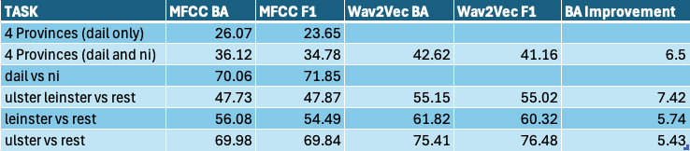
Table 1 - Comparison of wav2vec against MFCC across various performance metrics.
Using the table, we can see that in the Ulster vs Rest task, the balanced accuracy increased from 69.98%(MFCC) to 75.41%(wav2vec), while the macro-F1 score increased similarly from 69.84% to 76.48%. This was consistent across all tasks, with an average balanced accuracy improvement of 6.27%. The Ulster, Leinster vs Res task had the largest improvement, jumping up to a 7.42% increase.
These results show that wav2vec-based representations are more effective at capturing subtle distinctions between the Irish accent groups, likely due to wav2vec models being able to learn high-level representations from pre-training with massive datasets. It shows how this approach out performs the self-curated features chosen when using MFCCs.
Despite the improvement, the overall performance gap remains moderate suggesting that feature representation alone isn’t the sole factor limiting the result. Instead, most likely at fault is the dataset limitations, the class imbalance and the difficult nature of niche regional accent classification.

6.3.4 Task Difficulty and Class Structure
The results from the previous section show a clear variation in the model performance across various classification tasks. the variation can be explained mostly due to differences in task complexity, class structure and how the dataset is distributed.
Binary classification consistency achieved the highest results, with Ulster vs Leinster achieving a balanced accuracy of 75.41% using the wav2vec models, where the four provinces task achieved a lower balanced accuracy of 42.61%. this difference reflects the increased difficulty involved in classifying accent groups that are so closely related.
A key influencing factor is the number of classes that each task has. As the number of classes increases, the classification becomes more complex and the likelihood of a misclassification increases. The four province task is a clear example of this, as performance tends to drop comparing to tasks with less classes, as the four provinces task must distinguish between Leinster, Ulster, Connacht and Munster which each share many traits. This is shown clearly in the Confusion Matrix for MFCC-based four-province classification (see Figure B4.1, Appendix B), where these regions are frequently misclassified as another.
Within the confusion matrix mentioned above, it is clear that Ulster is clearly more separable from the rest of Ireland. The distinction of the Ulster accent, which is also culturally and politically unique, is seen in the results of the balanced accuracy charts, where Ulster vs Rest was able to achieve a result of 78.44%, beating the other binary classification task, Leinster vs Rest which achieve 68.10%, by 10.34 percentage points. This shows clearer decision boundaries, suggesting that certain regional accents are more distinguishable than others.
Class distribution plays a significant role in task difficulty, with there being a clear imbalance in sample counts and speaker representation across various classes (see Figure B5.2, Appendix B). In the binary classification, this becomes more pronounced. As an example Ulster vs Rest results in Ulster having 541 Ulster samples with only 30 speakers, while Rest has 1134 samples from 176 speakers. While balanced accuracy and macro-F1 scores help to mitigate the impact of this imbalance, the uneven distribution of speakers impacts the models ability to generalise.
In the MFCC-based feature extraction, the task “Four Provinces (Dáil Only)” shows how task design massively influences performance. In the Dáil only version the Ulster class only has 165 samples from 14 speakers (see Figure B5.2.4, Appendix B). This reduced representation compared to the “Four Provinces (Dáil and NI)” (see Figure B5.2.3, Appendix B) limits the models ability to learn distinguishing features for that class, with “Four Provinces (Dáil Only)” getting a top balance accuracy results of 27.21%, 12.18 percentage points less than “Four Provinces (Dáil and NI)”, which achieved a score of 39.39% (see Figures B1.1.2 and B1.1.4, Appendix B).

6.3.5 Impact of Dataset Limitations
A major influencing factor of the project was the limitation of the dataset that was used for both training and evaluation. Throughout all configurations, the overall performance was always limited by the size, imbalance and the quality of the available data.
The dataset only contained 1675 audio samples across 212 speakers; significantly smaller than typical datasets used in speech classification studies (REFERENCE ACADEMIC SOURCE). This restricts the model’s ability to learn generalisable patterns, becoming increasingly apparent as tasks with more classes are introduced.
On top of the limited size, class imbalance is another challenge. Certain regions are much more heavily represented than others (see Figure B5.2.1, Appendix B). Both Ulster and Leinster are much more represented than Connacht. And Munster. This is directly tied to a population imbalance on the island of Ireland, as seen in the table below:
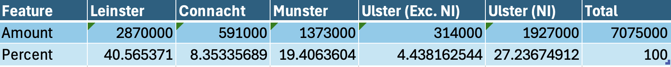
Table 2 - Population of Ireland by Province. (sources in references fix later)
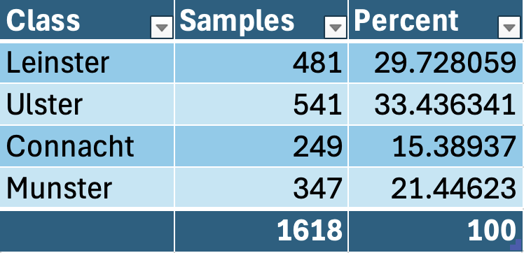
Table 3 - Percentage of Samples by Province.
Even with class balancing implemented, this population distribution appears clearly in the data sample collection.
Even more influential is the speaker imbalance within the dataset. While sample counts may appear moderately balanced, the unique speaker count is very low. This is most apparent in Ulster, where 541 clips are sourced from 30 speakers. This limits the diversity of speech patterns analysed, and therefore

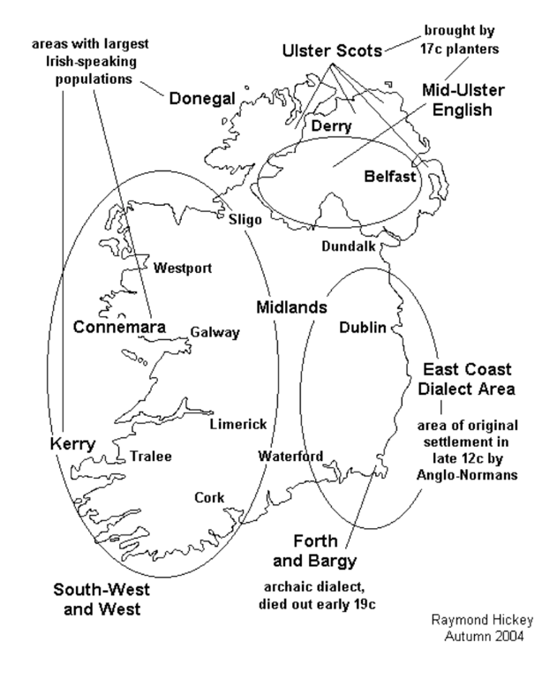
ABOVE IS RAYMOND HICKEY 2004 LINGUISTIC MAP OF IRELAND SHOWING HOW ULSTER SCOTS, EAST COAST DIALECT AND SOUTH-WEST AND WEST ARE THE THREE DISTINCT ACCENT REGIONS WHICH IS WHY LEINSTER ULSTER VS REST IS A THING. EXPLAIN LATER

6.3.6 Model Selection for Deployment
After evaluation of multiple different models, different feature extraction methods and different classification tasks, a selection of models were chosen for integration into the final system. This selection was made using decisions based on the performance metrics analysed and keeping user interest in mind.
As demonstrated in Section 6.3.3, wav2vec-based models outperformed MFCC-based approaches across all tasks. although the improvement was moderate, wav2vec models consistently achieved higher balanced accuracy averages and macros F1 scores across all comparable tasks (see Table 1, Section 6.3.3). These results led to wav2vec-models dominating the model selection for deployment in the final system.
However, model selection wasn’t solely based on selecting the best single model overall, but instead the best performing model per classification task (see Figure B2.5, Appendix B). As a result each of the various different classification tasks that the system supports were paired with their own most suitable model.
Variety also played a role in the selection process. Due to the experimental nature of the project, it was considered important not only to include the highest-performing models, but also to provide users with the ability to explore a range of different approaches. For this reason, a selection of MFCC-based models was retained within the system, alongside models that did not achieve the highest performance. This allows users to observe differences in model behaviour and better understand the impact of feature extraction methods on classification results.
The tasks selected for final deployment are:
- Four Provinces task, MFCC-based Logistic Regression model.

- Ulster vs Rest task, wav2vec-based Random Forest Model.

- Leinster vs Rest task, wav2vec-based Logistic Regression Model.

- Ulster, Leinster vs Rest task, wav2vec-based Logistic Regression Model.

- Four Provinces, wa2vec-based Logistic Regression.
See Figure C1.1, Appendix C.
Each model was then integrated into the system using the plugin system as described in Section 5.5. This allowed for the models to be chosen, then dynamically loaded, then selected in the user interface for inference at runtime, ensuring flexibility to highlight the experimental nature of the system.

6.3.7 Summary of Findings
After evaluating the system, these were the key findings observed:
- Wav2vec-based models consistently outperformed MFCC-based models across all classification tasks, although gains remained small.
- The performance of models was strongly linked to class complexity, with binary tasks achieving higher accuracy than multi-class tasks.
- Certain geographic regions, such as Ulster, were more distinguishable, while other regions, such as Connacht and Munster, have more shared features making classification more difficult, showing greater overlap and confusion.
- Dataset limitations (small size, class imbalance, and limited speaker diversity) were the main constraints that limited the model performance.
- Improvements in feature extraction were insufficient to overcome these limitations to a satisfactory degree, indicating the dataset was the most influential aspect of the accent classification performance.
- The final system design reflects these findings by prioritising wav2vec models, while also deploying a variety of other approaches to support exploration and experimentation.

6.4. Evaluate Project Management
The goal of this section was to evaluate how well the project was planned and then executed. Due to the experimental side of the project, traditional grid planning didn’t work and therefore a more flexible, iterative approach was used. This allowed the project to continuously adapt in response to the findings, dataset limitations and any technical challenges I faced.

6.4.1 Evaluate Project Plan
The project plan had a structured plan with key development stages outlined, such as:
- Dataset creation
- Experimentation
- System implementation
- Evaluation
These were clear progression points to follow and ensured that the main objectives were defined from the start.
However, as development progressed, it became apparent that I couldn’t follow a linear plan. Much more time was spent on dataset construction than was expected, due to tasks such as sourcing suitable audio samples, isolating the speakers, gathering metadata based on these selected speakers, and validating clip quality all took up significant amount of time due to their manual nature, which impacted the original plan massively.
The divergence from the approach defined in the interim report show this clearly. The plans create in the interim report were made with the assumption that the creation of sufficiently large and high quality datasets would be manageable, and that MFCC-based feature extraction would be effective in accent classification. As experimentation progressed, these assumptions were proven to be inaccurate, with the limitations on the dataset, the class imbalance and the subtle nature of regional Irish accents making fine-grained accent classification much more difficult than expected. The project direction ended up shifting at this point, with classifications being made more coarse larger regions, and the feature extraction approach shifting from MFCC-based representations to wav2vec-based embeddings (see Section 5.2.4), improving performance results.
These changes, although splitting from the original plan, were essential to keeping the system aligned with realistic constraints and allowing for the system to produce improved results.
Despite the changes made, the project plan was still used as a high level guide, with its milestones helping to keep me on track and ensured that all the major components of the system were successfully developed. The ability to adapt the plan in response to the experiment results shows the iterative and evidence driven approach to project management.

6.4.2 Evaluate Project Execution
This project

6.6. Conclusions

7. Conclusions and Future Work

7.1. Introduction

7.2. Future Work
The frontend interface could also be further developed through user-centred evaluation. Conducting usability testing with users from different demographics, regions, and levels of technical experience would provide valuable insights into how effectively the system communicates predictions and supports interaction. These findings could inform improvements to accessibility, clarity of feedback, and overall user experience, ensuring the system is intuitive and usable for a wider audience.
In addition to interface improvements, future work could expand the range of classification tasks supported by the system. While the current implementation focuses on regional Irish accent classification, there is potential to introduce broader tasks using datasets such as Mozilla Common Voice. For example, models could be developed to distinguish between Irish and non-Irish speech, or to compare Irish accents with other English-speaking regions. Supporting such tasks would extend the system beyond a purely national focus and allow for more generalised accent classification.
To complement this, the frontend map visualisation could also be extended beyond Ireland. Currently, predictions are displayed using province-level polygons on a map of Ireland. Future iterations could introduce country-level or global maps, allowing predictions from broader classification tasks to be visualised geographically using international boundary polygons. This would maintain the geospatial focus of the project while scaling it to a wider context.
Another area for future improvement is the system’s testing strategy. While functional and system testing were conducted during development, a more comprehensive automated testing framework could be introduced. This could include unit tests for audio decoding, validation, feature extraction, plugin registration, and model outputs, as well as integration tests for key API endpoints such as /api/health, /api/models, and /api/predict. Additional system-level testing could validate full user workflows, including recording or uploading audio, generating predictions, interacting with the map, and submitting feedback. Expanding testing in this way would improve system reliability and maintainability.
In terms of system architecture, the current implementation relies on browser-based local storage for prediction history and feedback. While this simplifies development and preserves user privacy, future work could explore the use of a backend database to enable persistent storage, multi-user support, and more advanced analysis of user interactions. This could be combined with authentication and user management if the system were to be deployed more broadly.
Further improvements could also be made to the machine learning pipeline. While wav2vec-based models showed improved performance over MFCC-based approaches, the overall gains remained moderate. Future work could involve more systematic hyperparameter tuning, experimentation with additional model architectures, or combining multiple feature representations. Additionally, the existing feedback system could be extended into a human-in-the-loop pipeline, where corrected predictions are collected and used to support future model retraining.
Finally, further work could focus on optimising and deploying the system as a production-ready application. This would involve improving backend performance to handle concurrent requests, introducing logging and monitoring, and implementing model versioning to track changes over time. Deploying the system as a publicly accessible web service would allow for real-world usage and provide valuable data for continued evaluation and improvement.

7.3. Conclusions

References
Anglophonia (2021) Is creaky voice a valley girl feature? Stancetaking and evolution of a linguistic stereotype. Available at: https://journals.openedition.org/anglophonia/4104 (Accessed: 16 April 2026).

The Guardian (2016) Can Google Translate understand a Liverpool accent? Available at: https://www.theguardian.com/technology/2016/feb/01/can-google-translate-understand-a-liverpool-accent?

Bauer, M.K. (2013) Twang and slang: Regional origin and perceptual dialectology in Ohio. Available at: https://kb.osu.edu/items/de500e73-7856-5948-89e5-69cd8c5530a5 (Accessed: 16 April 2026).

Baevski, A., Zhou, H., Mohamed, A. and Auli, M. (2020) wav2vec 2.0: A framework for self-supervised learning of speech representations. Available at: https://www.proquest.com/working-papers/wav2vec-2-0-framework-self-supervised-learning/docview/2416047903/se-2 (Accessed: 16 April 2026).

Central Statistics Office (2022) Census of Population 2022. Available at: https://www.cso.ie/en/statistics/population/censusofpopulation2022/ (Accessed: 16 April 2026).

Davis, S. and Mermelstein, P. (1980) ‘Comparison of parametric representations for monosyllabic word recognition in continuously spoken sentences’, IEEE Transactions on Acoustics, Speech, and Signal Processing, 28(4), pp. 357–366. doi: 10.1109/TASSP.1980.1163420.

Etymonline (no date) Hibernia. Available at: https://www.etymonline.com/word/Hibernia (Accessed: 16 April 2026).

FastAPI (2018) FastAPI documentation. Available at: https://fastapi.tiangolo.com/ (Accessed: 16 April 2026).

Gourisaria, M.K. et al. (2024) Comparative analysis of audio classification with MFCC and STFT features using machine learning techniques. Available at: https://doaj.org/article/a5230b33e86949eeb59d6b5e666f5a82 (Accessed: 16 April 2026).

Hickey, R. (2007) Irish English: History and present-day forms. Available at: https://www.academia.edu/66954079/Irish_English_history_and_present_day_forms (Accessed: 16 April 2026).

Leaflet (2011) Leaflet API reference. Available at: https://leafletjs.com/reference.html (Accessed: 16 April 2026).

McFee, B. et al. (2015) librosa: Audio and music signal analysis in Python. Available at: https://brianmcfee.net/papers/scipy2015_librosa.pdf (Accessed: 16 April 2026).

Matasović, R. (2017) Addenda et corrigenda to ‘Etymological Dictionary of Proto-Celtic’ (Brill, Leiden 2009). Available at: https://www.academia.edu/1489376/Addenda_et_Corrigenda_to_Etymological_Dictionary_of_Proto_Celtic_Brill_Leiden_2009_ (Accessed: 16 April 2026).

Mozilla (2023) Common Voice dataset. Available at: https://commonvoice.mozilla.org (Accessed: 16 April 2026).

Mozilla Developer Network (2024) Storage API. Available at: https://developer.mozilla.org/en-US/docs/Web/API/Storage_API (Accessed: 16 April 2026).

Northern Ireland Statistics and Research Agency (2022) Population statistics. Available at: https://www.nisra.gov.uk/statistics/people-and-communities/population (Accessed: 16 April 2026).

OpenStreetMap (2004) OpenStreetMap. Available at: https://www.openstreetmap.org/ (Accessed: 16 April 2026).

QGIS (2002) QGIS resource hub. Available at: https://qgis.org/resources/hub/ (Accessed: 16 April 2026).

Radford, A., Kim, J.W., Xu, T., Brockman, G., McLeavey, C. and Sutskever, I. (2022) Robust speech recognition via large-scale weak supervision. Available at: https://www.proquest.com/working-papers/robust-speech-recognition-via-large-scale-weak/docview/2748631235/se-2 (Accessed: 16 April 2026).

Sabuj, H.H. et al. (2023) ‘A comparative study of machine learning classifiers for speaker’s accent recognition’, in 2023 IEEE World AI IoT Congress (AIIoT). Seattle, WA: IEEE, pp. 627–632. doi: 10.1109/AIIoT58121.2023.10174511. Available at: https://ieeexplore-ieee-org.tudublin.idm.oclc.org/document/10174511/references#references (Accessed: 16 April 2026).

The Guardian (2022) Bias against working-class and regional accents has not gone away. Available at: https://www.theguardian.com/inequality/2022/nov/03/bias-against-working-class-and-regional-accents-has-not-gone-away-report-finds (Accessed: 16 April 2026).

Google Cloud (2023) Speech-to-Text documentation. Available at: https://cloud.google.com/speech-to-text (Accessed: 16 April 2026).

Amazon Web Services (2023) Amazon Transcribe. Available at: https://aws.amazon.com/transcribe/ (Accessed: 16 April 2026).

Nolan, P. (2024) Machine Learning for Feature Extraction and Classification of English-language Accents in Ireland. MSc thesis. National College of Ireland. Available at: https://norma.ncirl.ie/8600/1/peternolan.pdf (Accessed: 16 April 2026).

RTÉ Archives (2025) Canúint. Available at: https://www.rte.ie/archives/category/archives/2025/0303/1499960-canuint/ (Accessed: 16 April 2026).

Vocal Image (2023) Vocal Image: Voice and Accent Training. Available at: https://vocalimage.ai (Accessed: 16 April 2026).

Department of Public Expenditure Infrastructure Public Service (2026), Ireland’s Open Data Portal. Available at: https://data.gov.ie/. (Accessed: 16 April 2026).

Internet Engineering Task Force (2015), The GeoJSON Specification. Available at: https://datatracker.ietf.org/wg/geojson/charter/ (Accessed: 16 April 2026).

Hickey, R. (2004), A Sound Atlas of Irish English, number 48 in ‘Topics in English Linguistics’, Walter de Gruyter: Berlin.

J. A. Osorio, et al. (2011), "Moving from Waterfall to Iterative Development: An Empirical Evaluation of Advantages, Disadvantages and Risks of RUP," 2011 37th EUROMICRO Conference on Software Engineering and Advanced Applications, Oulu, Finland, 2011, pp. 453-460, doi: 10.1109/SEAA.2011.69. Available at: https://ieeexplore-ieee-org.tudublin.idm.oclc.org/document/6068383 (Accessed: 16 April 2026).

Appendix A: System Testing Evidence
This appendix provides visual evidence of system testing, with a full system interaction, backend API validation, and verification of the plugin architecture.

A.1 – Full System Run Through

Initial Interaction
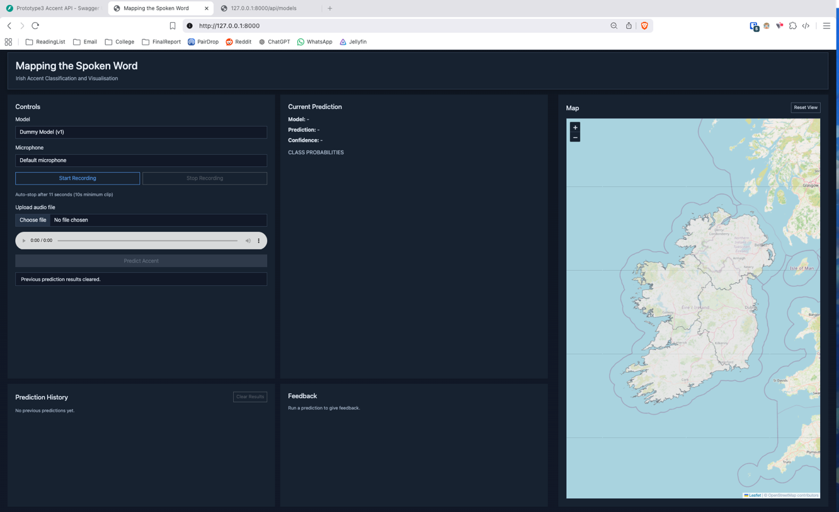
Figure 3 A1.01 System's initial state upon loading the application's interface.
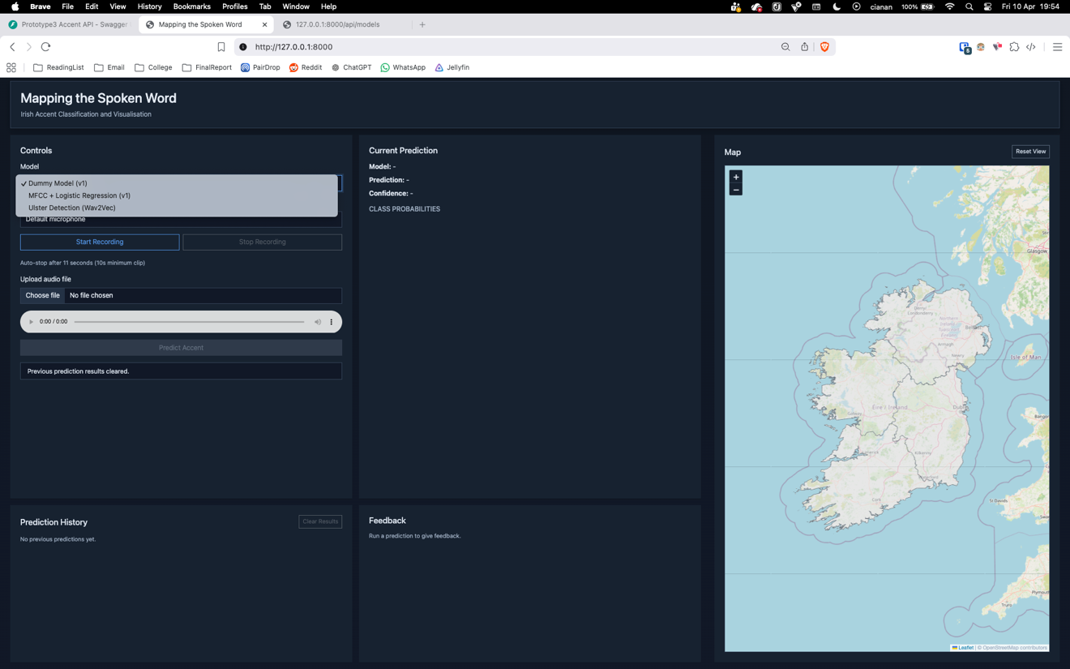
Figure 4 - A1.02 Model selection dropdown expanded showing available models.

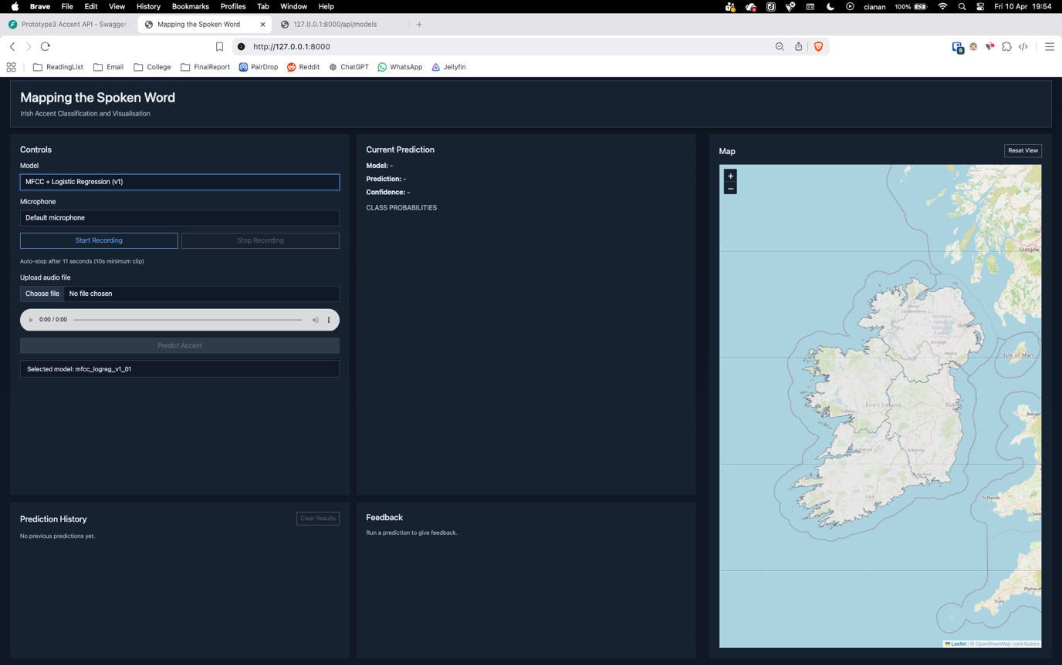
Figure 5 - A1.03 Selection of a model from the dropdown list.

Recording Workflow
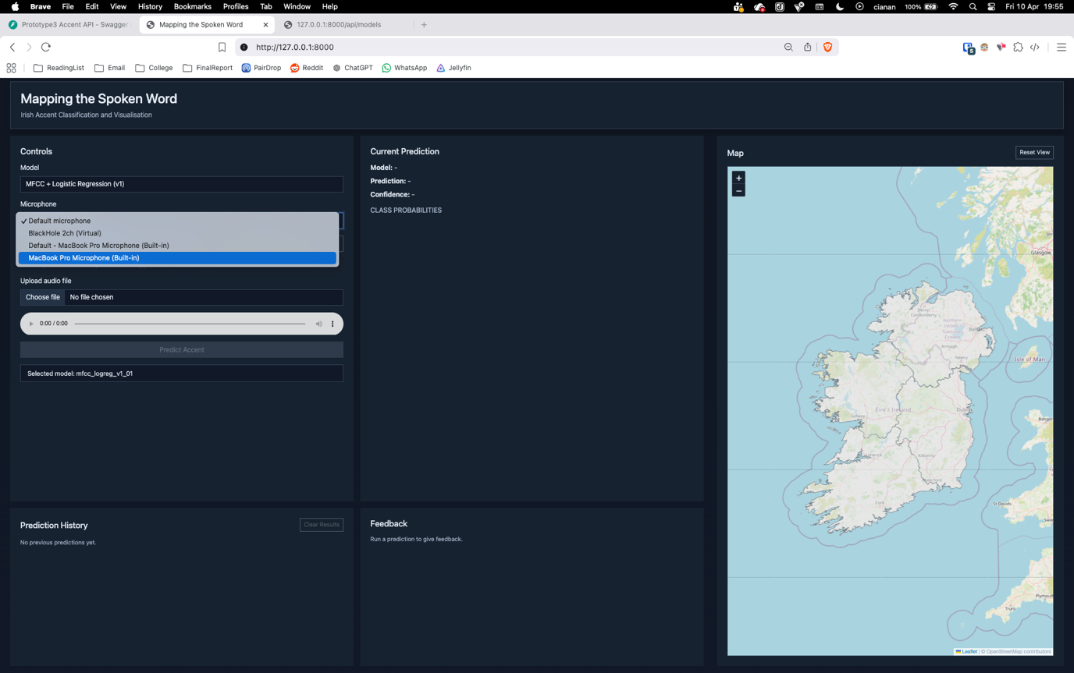
Figure 6 - A1.04 Selection of microphone from the microphone dropdown list.
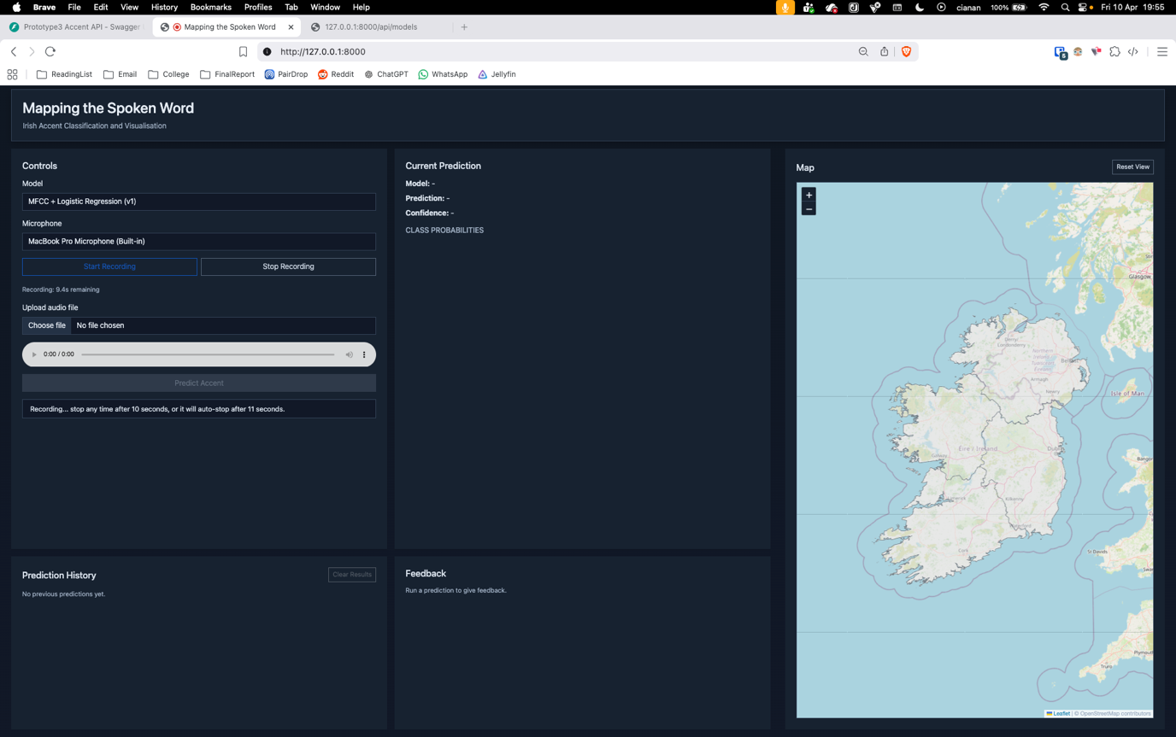
Figure 7 - A1.05 Recording process initiated by the user.

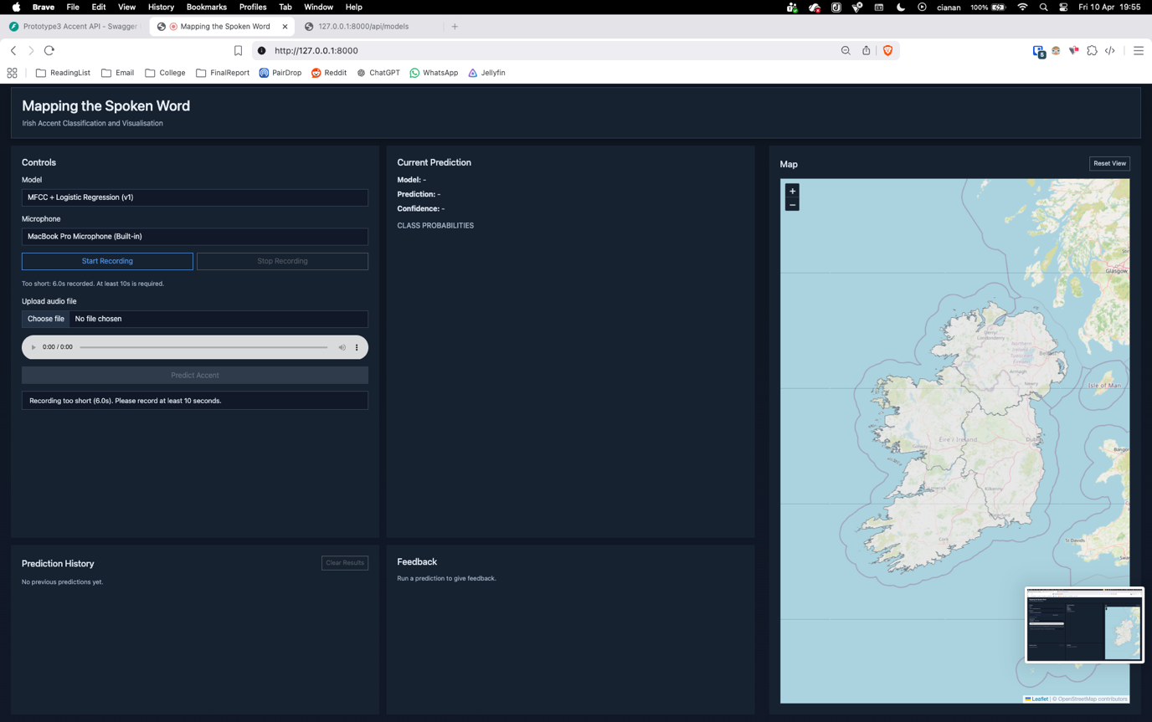
Figure 8 - A1.06a Recording stopped before minimum duration requirement.
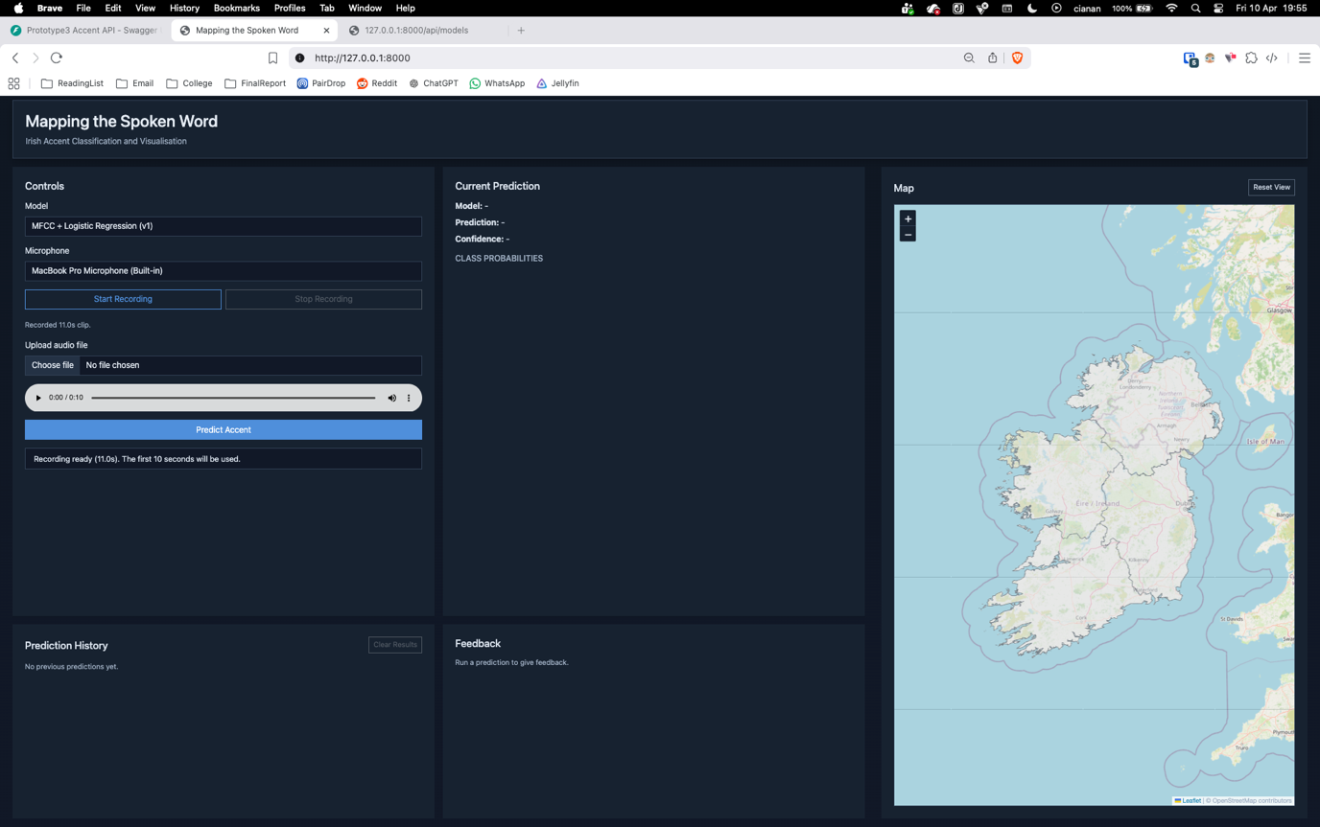
Figure 9 - A1.06b Recording successfully completed after required duration.

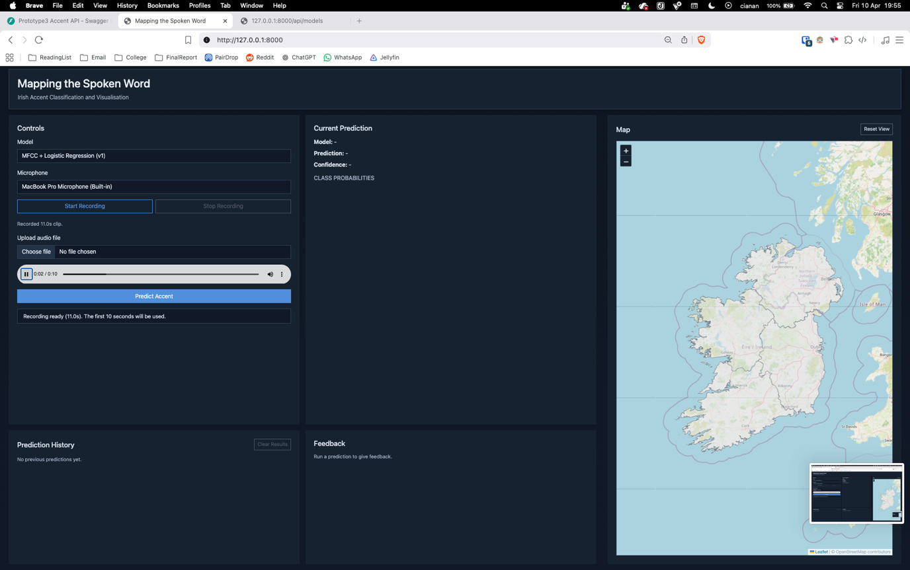
Figure 10 - A1.07 Playback of recorded audio sample before submission.

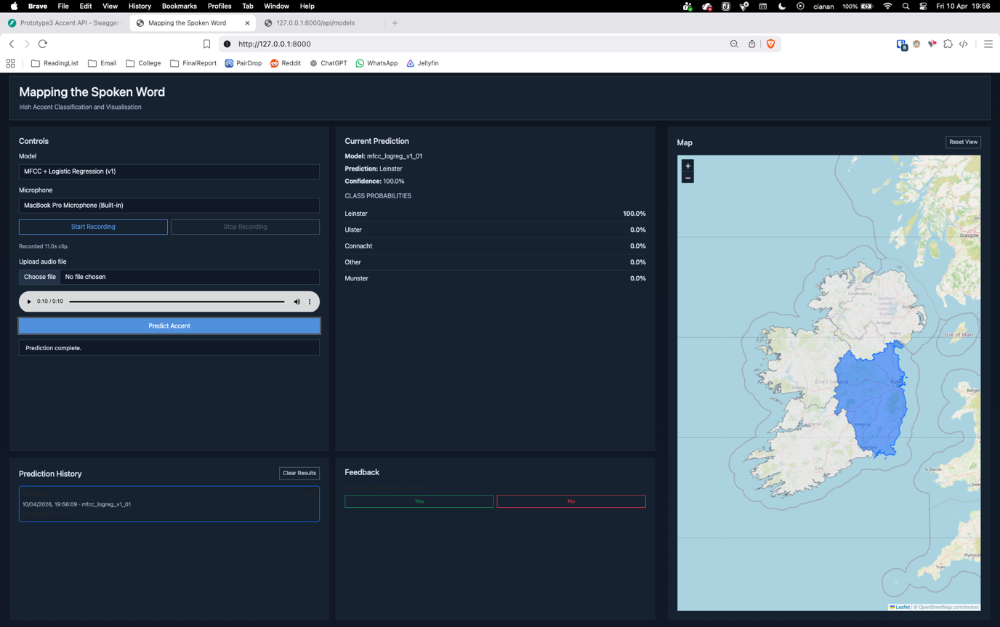
Figure 11 - A1.08 Prediction made from recorded audio sample with result displayed.

File Upload Workflow
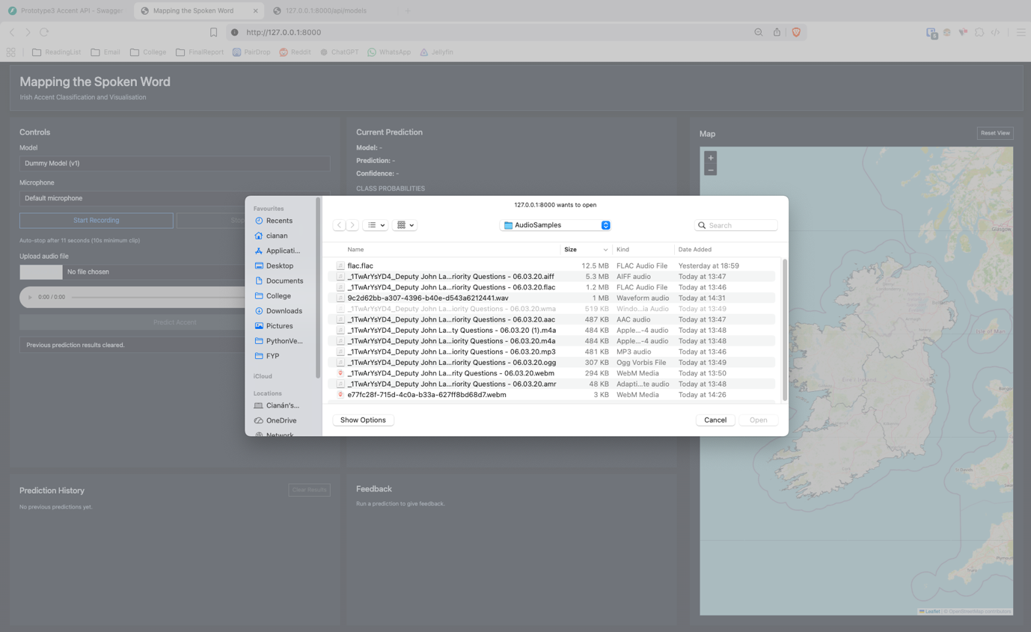
Figure 12 - A1.09 File upload interface. Valid file types remain usable while invalid file types are greyed out.
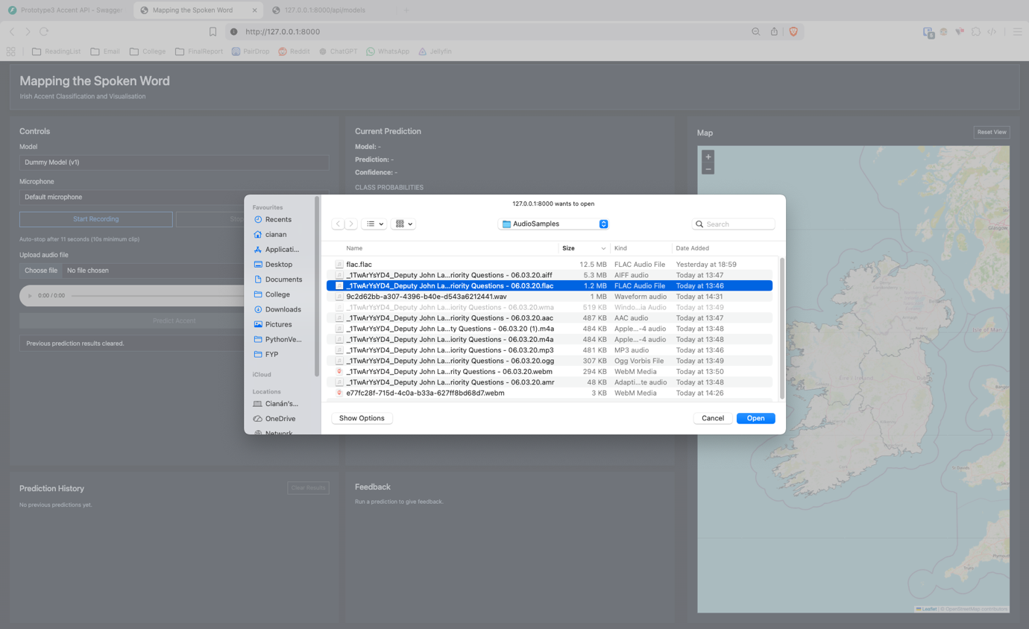
Figure 13 - A1.10 Selection of an audio file for upload.

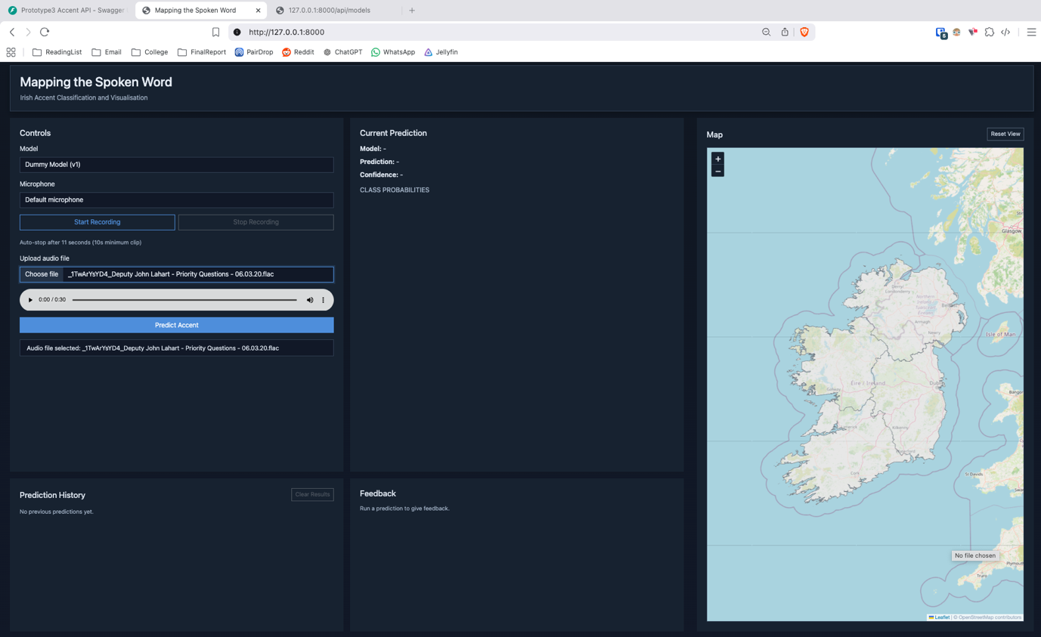
Figure 14 - A1.11 Interface updated with selected file ready for prediction.

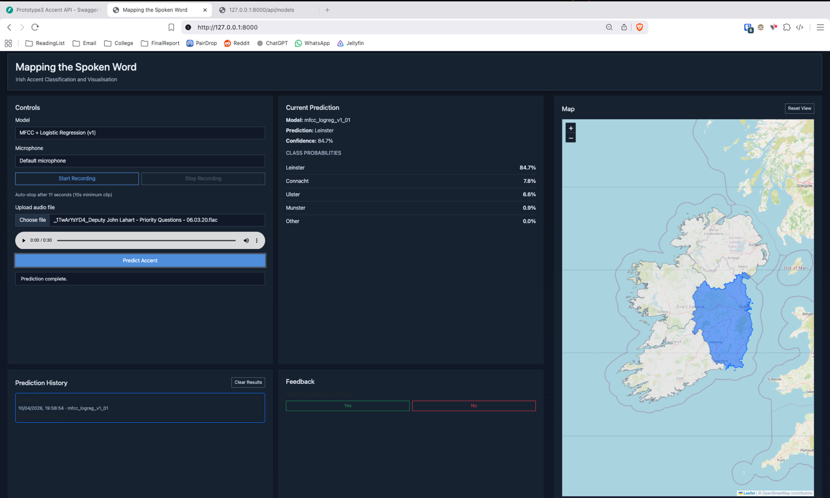
Figure 15 - A1.12 Prediction generated from uploaded file with result displayed.

Model Comparison and Feedback
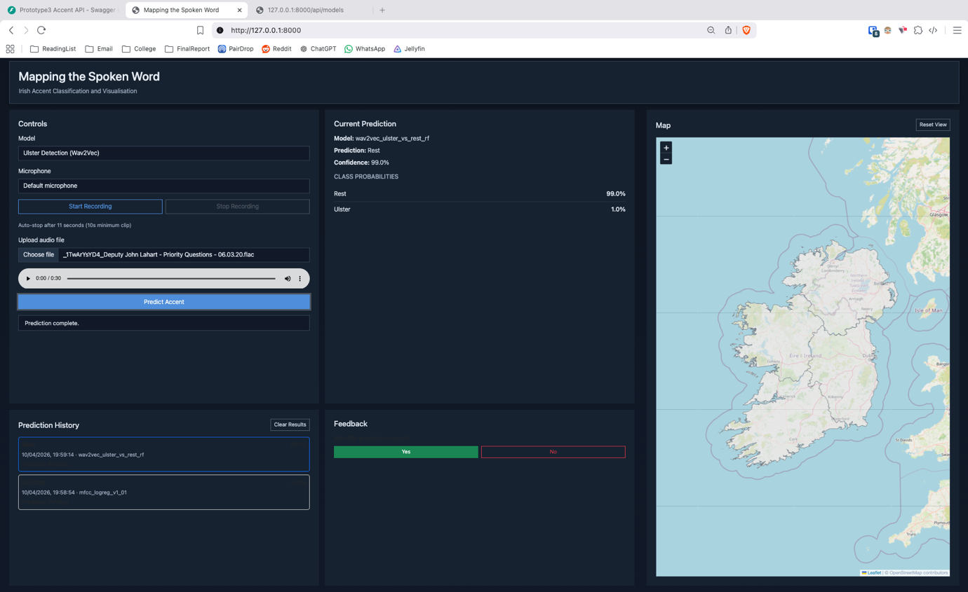
Figure 16 - A1.13 Prediction performed using a different model with user marking result as correct.

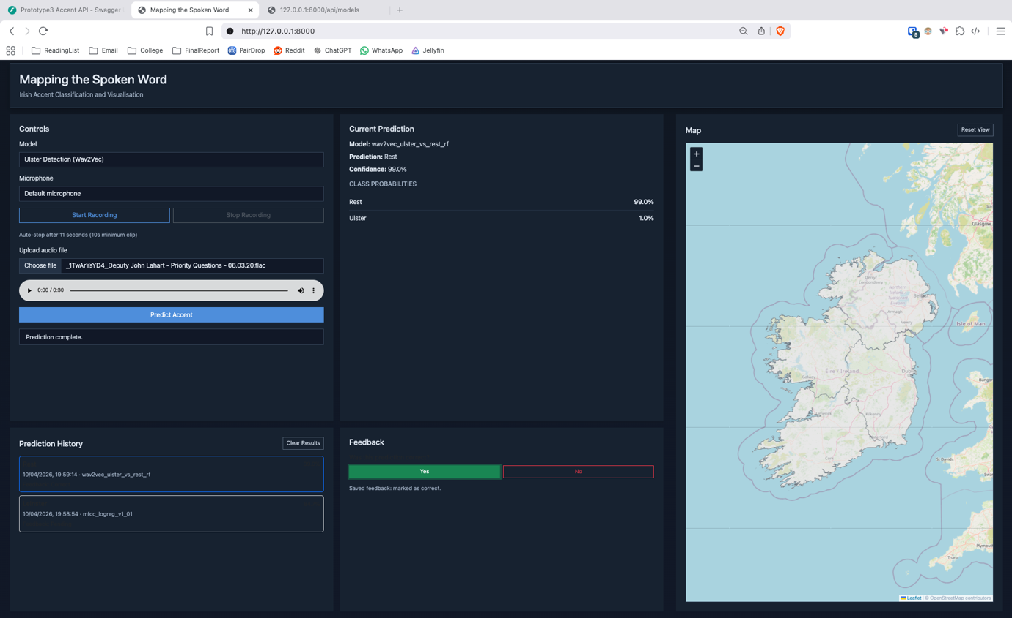
Figure 17 - A1.14 Confirmation message indicating feedback has been successfully saved.

Prediction History and Interaction
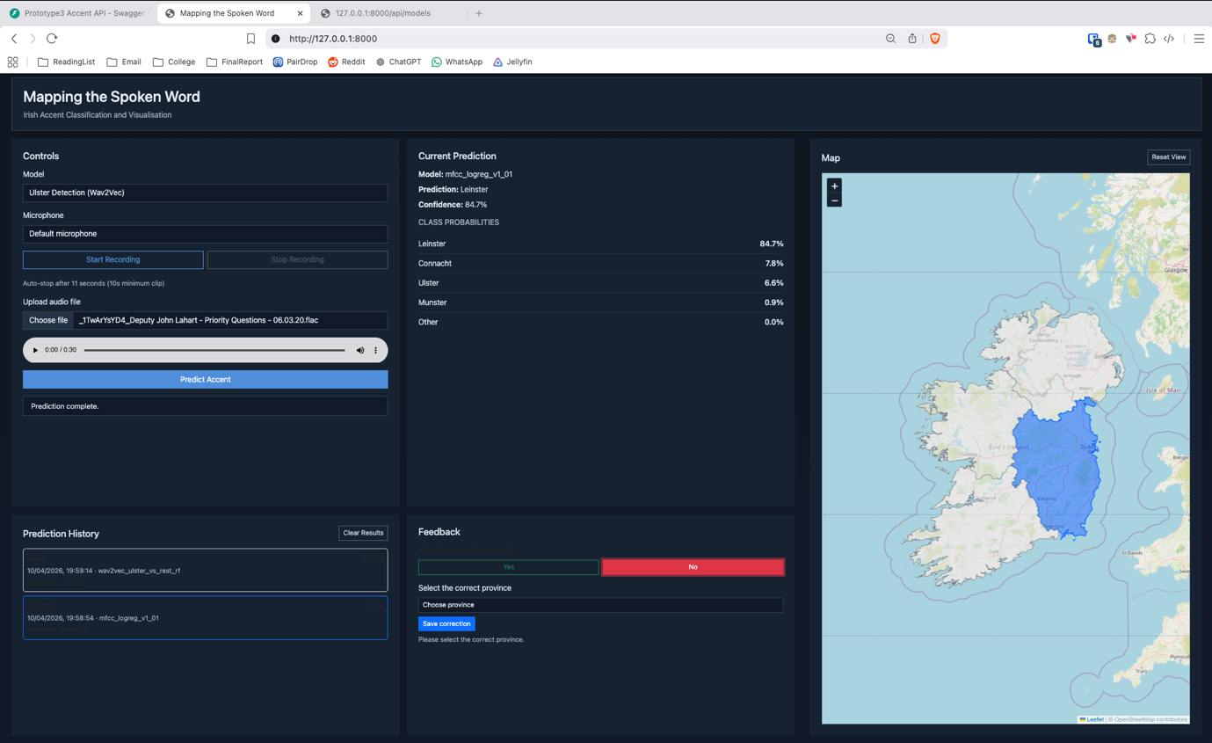
Figure 18 - A1.15 Selection of a previous prediction from history with user marking it as incorrect.

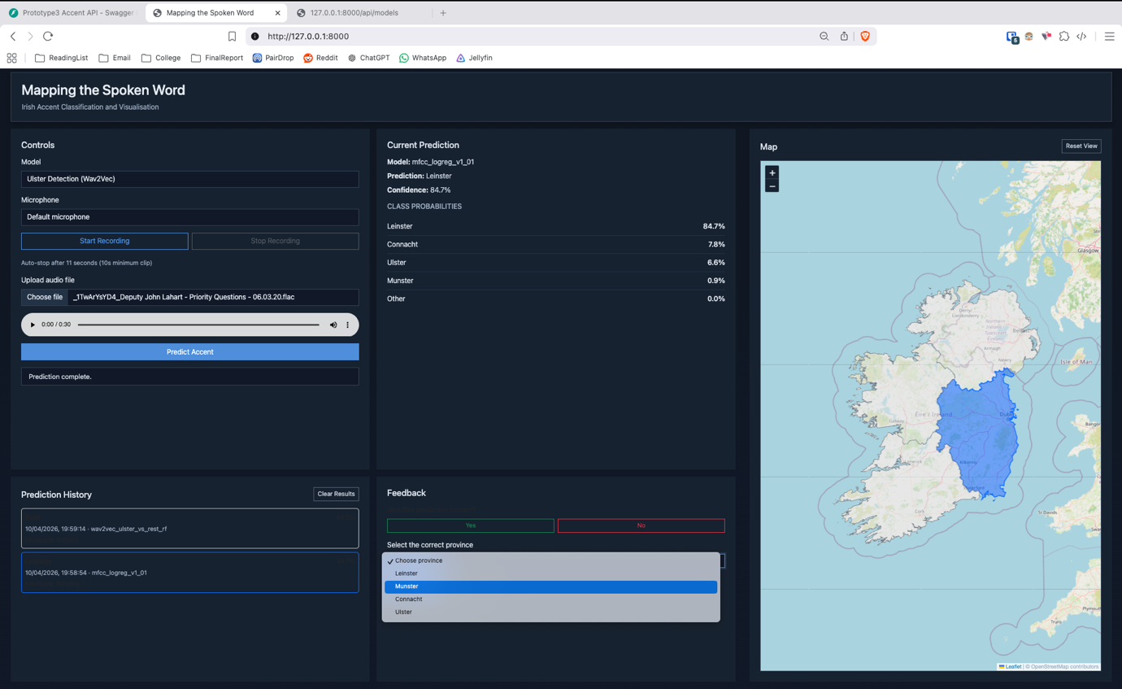
Figure 19 - A1.16 Updated prediction history reflecting incorrect feedback entry.

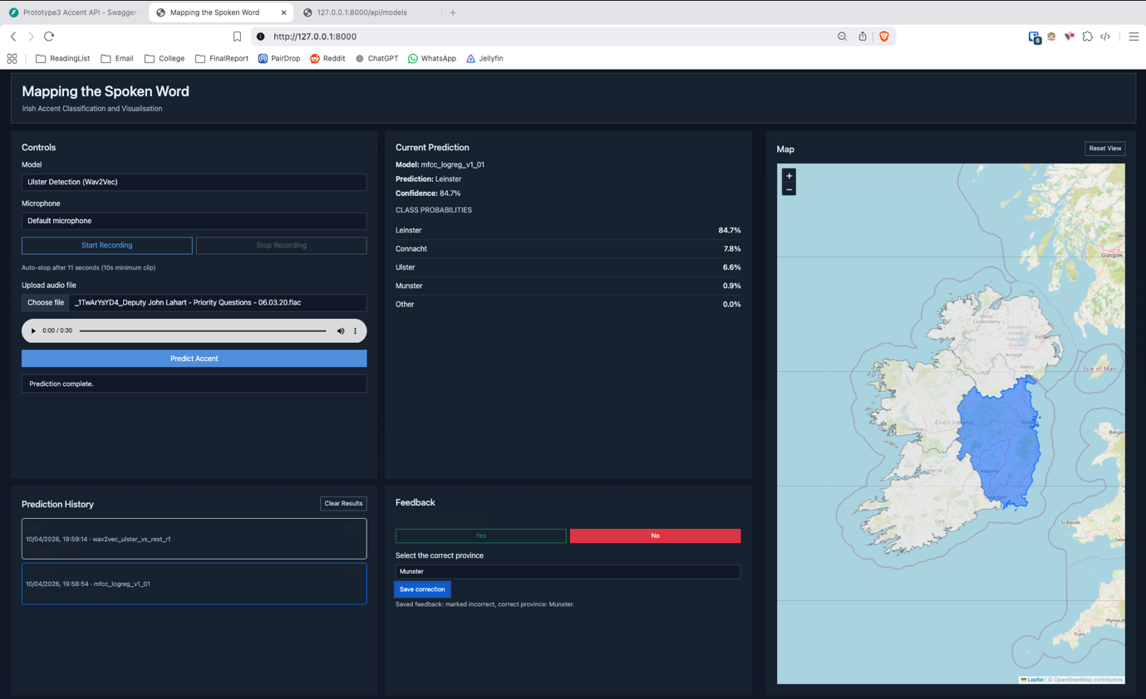
Figure 20 - A1.17 Selection of corrected prediction result from available options.

System Interaction and State Management
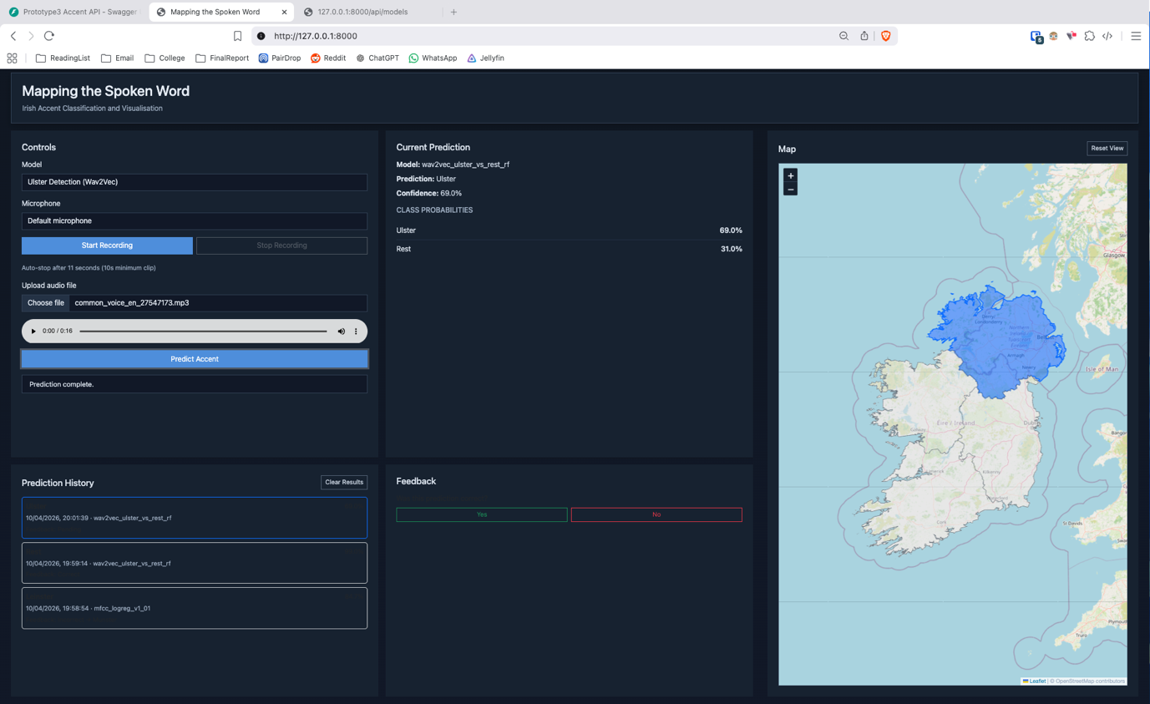
Figure 21 - A1.18 Execution of a new prediction and display of updated result.

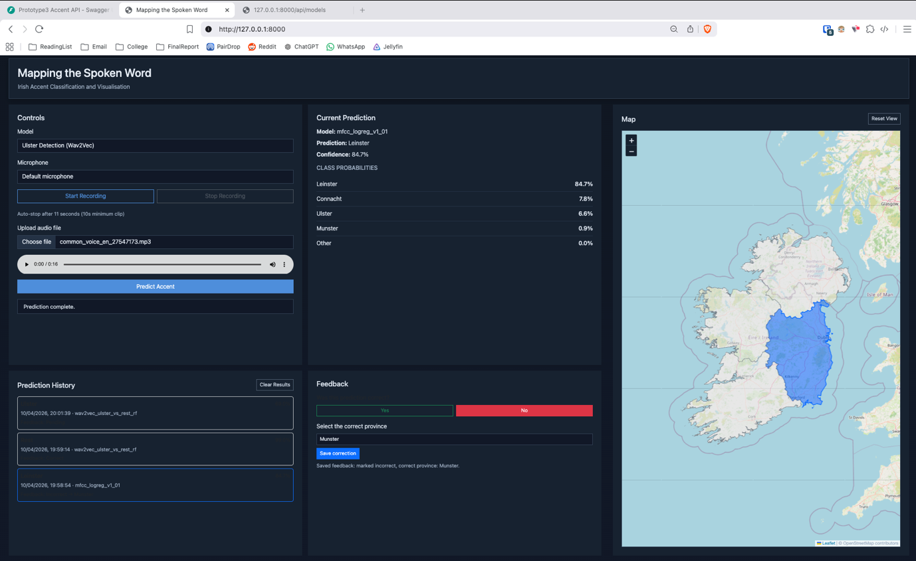
Figure 22 - A1.19 Re-selection of a previous prediction with corresponding result restored.

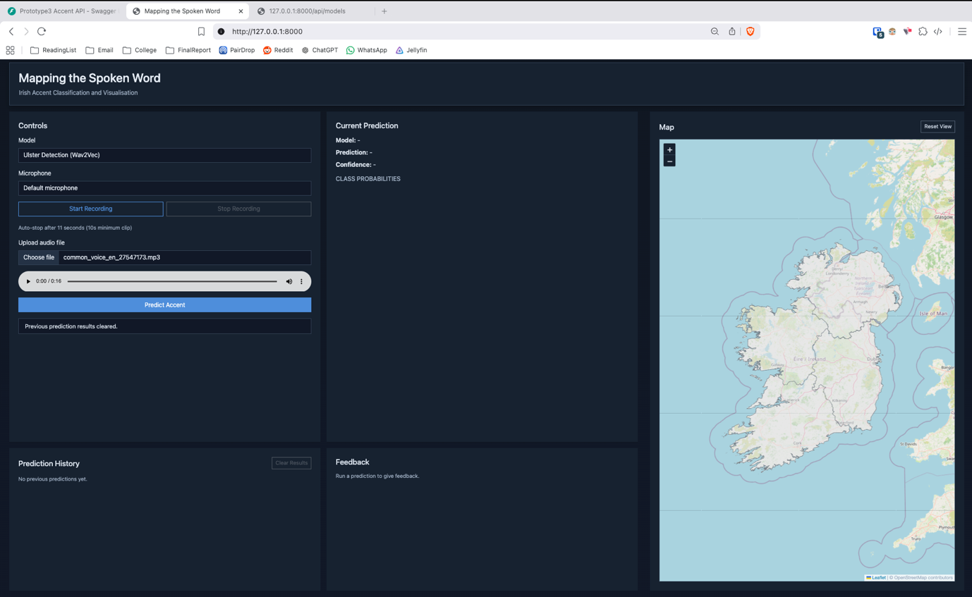
Figure 23 - A1.20 Clearing of stored prediction history via user action.

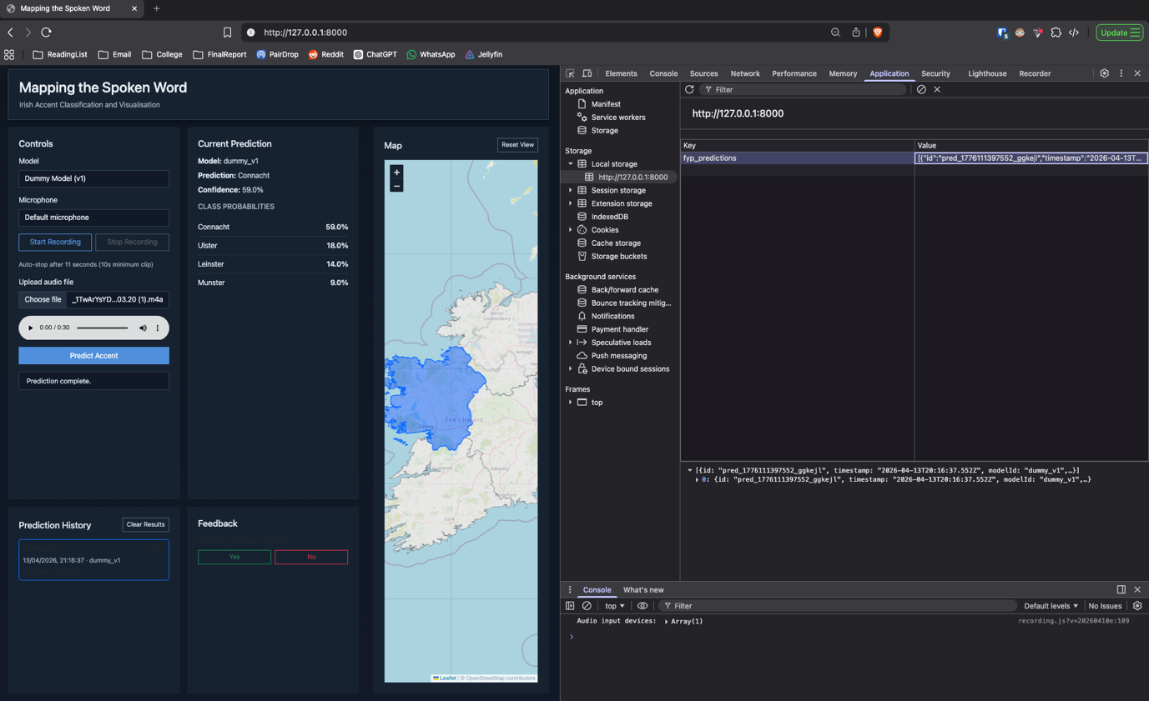
Figure 24 - A1.21 Example of prediction data stored in browser local storage.

A.2 – Backend API Testing
This section shows evidence of my backend API testing, showing behaviour of the system endpoints under both valid and invalid input conditions. Testing was performed using Swagger UI and direct HTTP requests for `/api/health`, `/api/models`, and `/api/predict`.
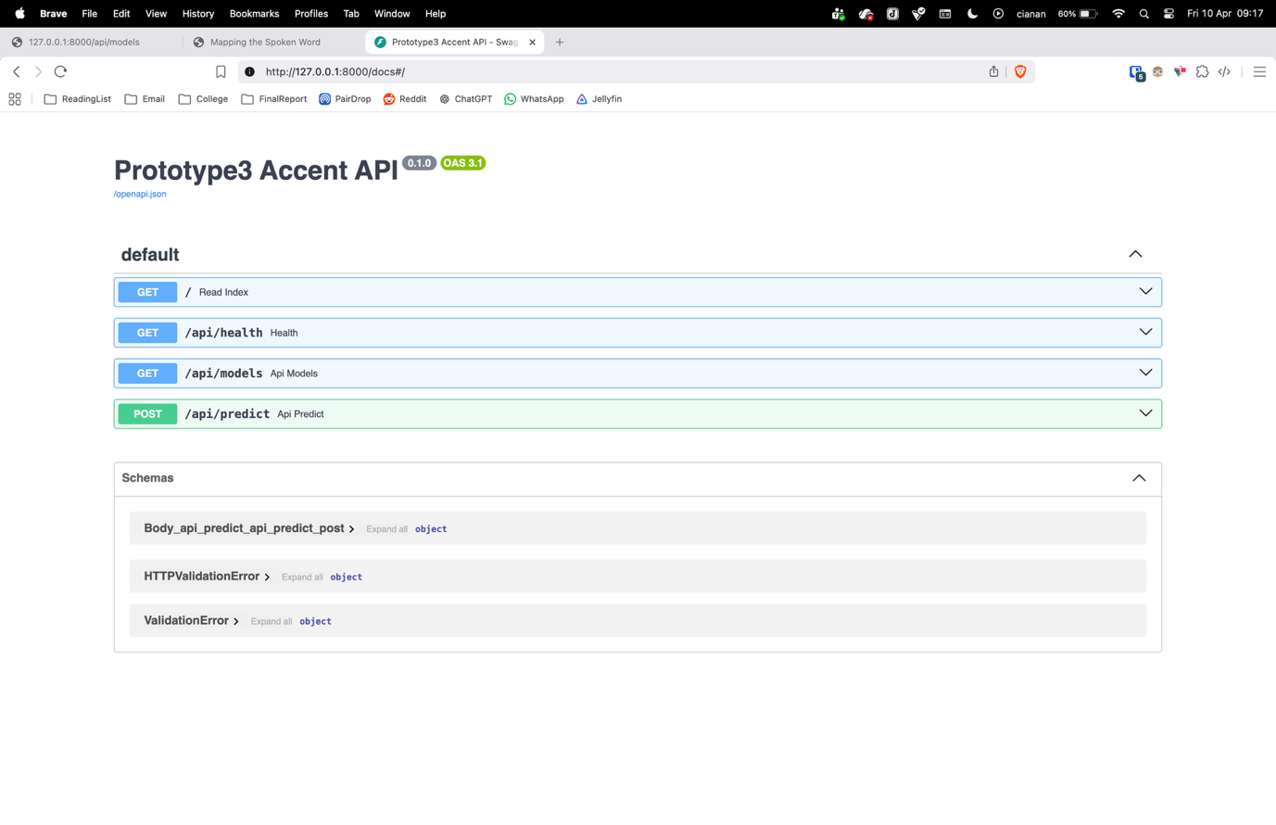
Figure 25 - A2.01 Swagger API docs interface.
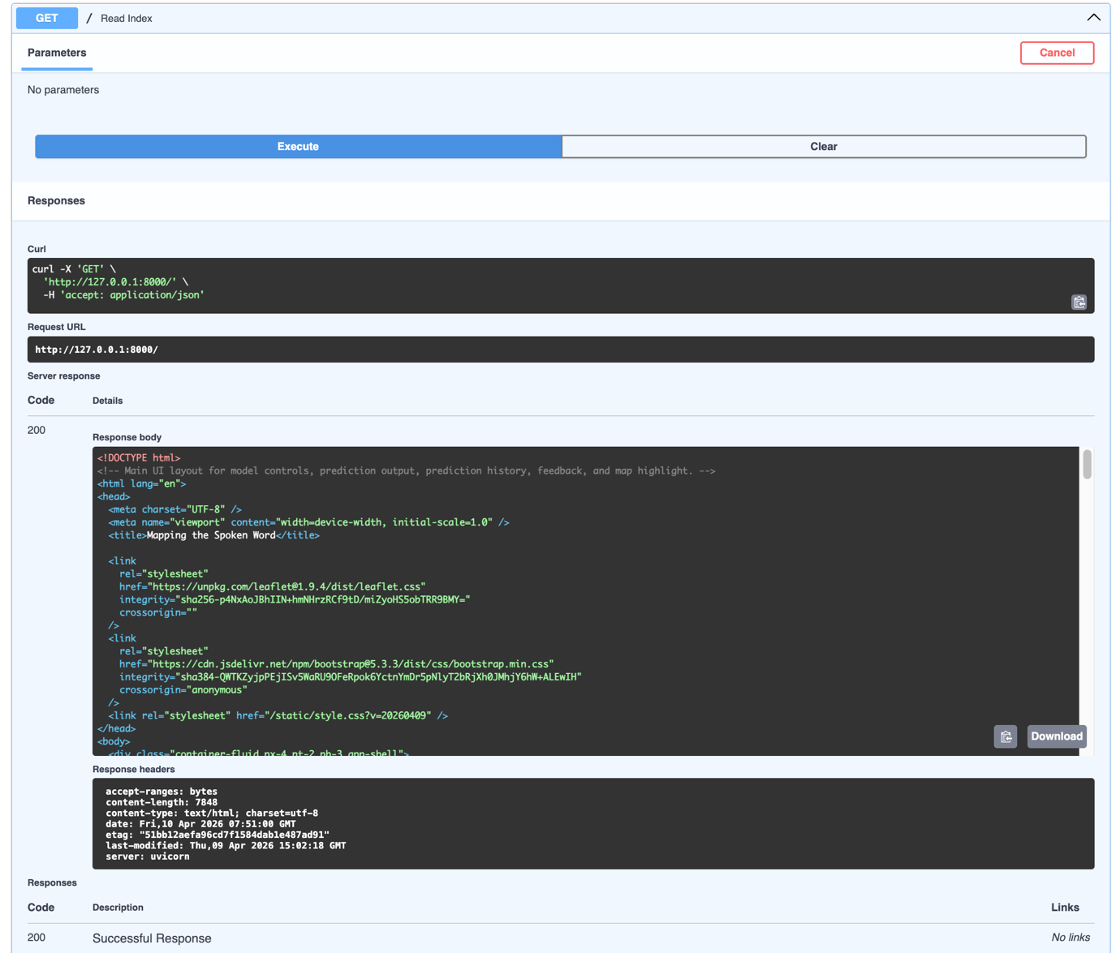
Figure 26 - A2.02 Successful loading of frontend index route via backend server.

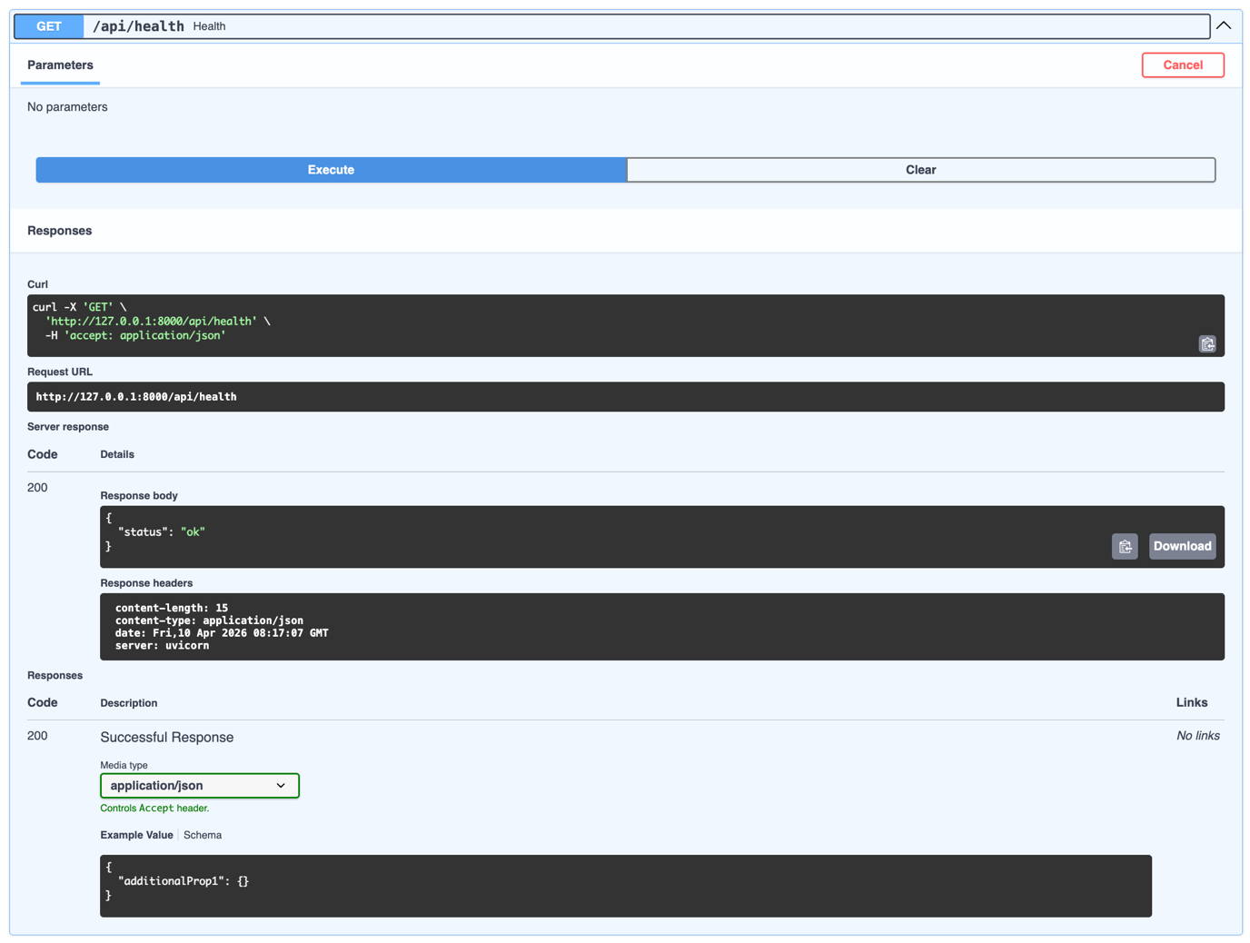
Figure 27 - A2.03 Successful /api/health endpoint response confirming system availability.

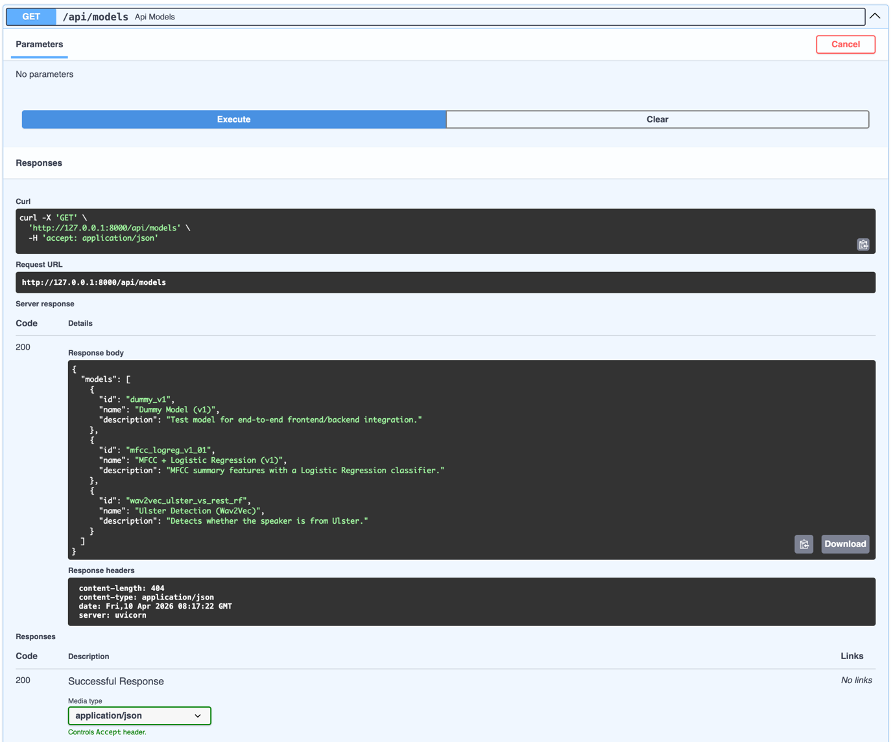
Figure 28 - A2.04 /api/models endpoint accessed through Swagger UI showing the available model plugins.

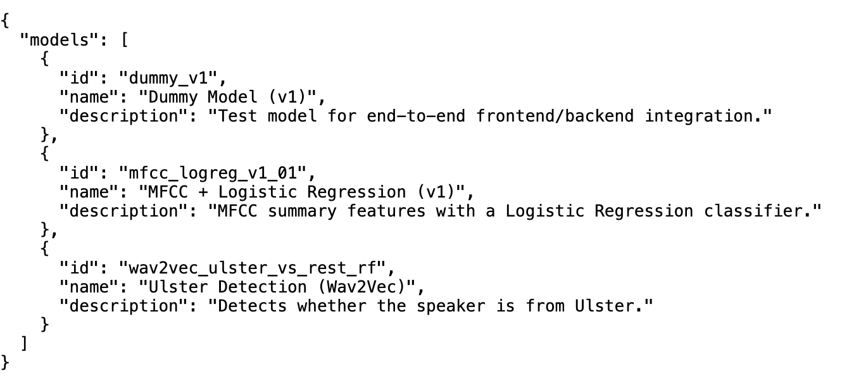
Figure 29 - A2.05 /api/models endpoint JSON response listing the registered models

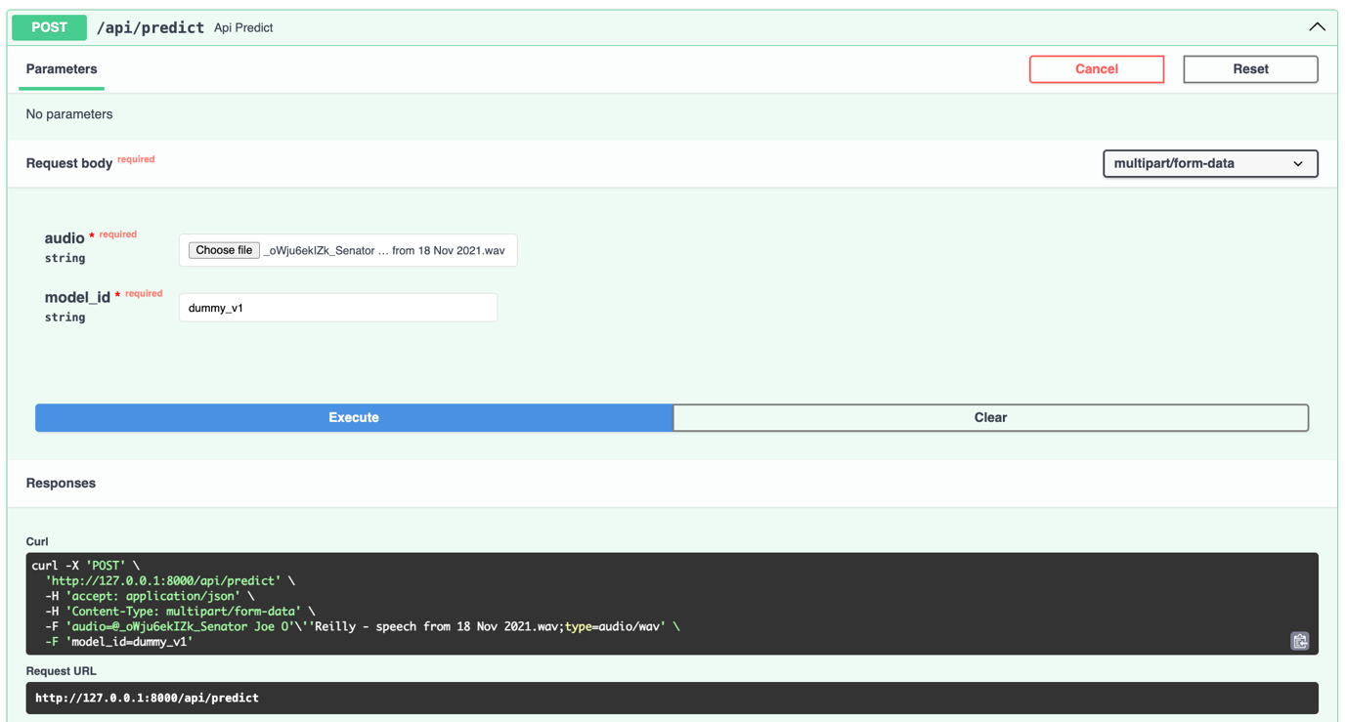
Figure 30 - A2.06 Swagger interface used to submit a /api/predict POST request with audio input.

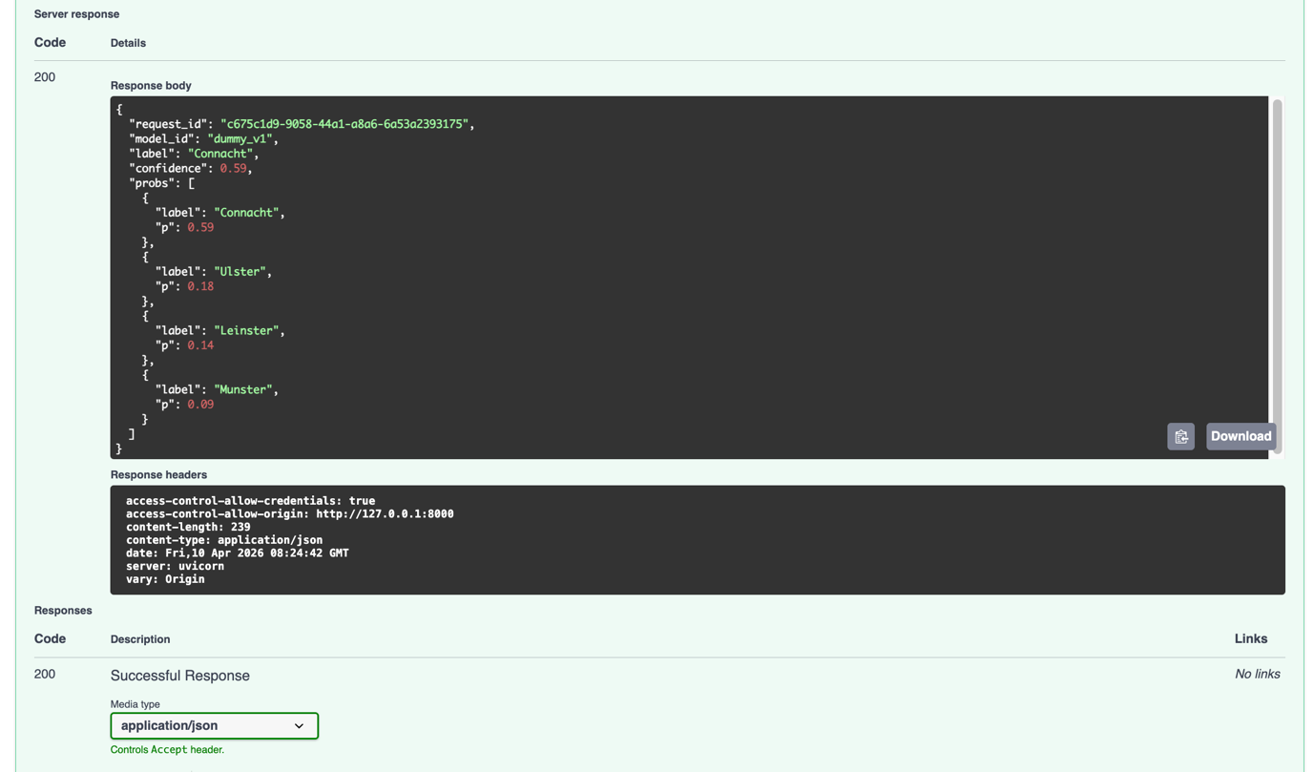
Figure 31 - A2.07 Successful /api/predict response including predicted label and probability distribution (HTTP 200 OK).

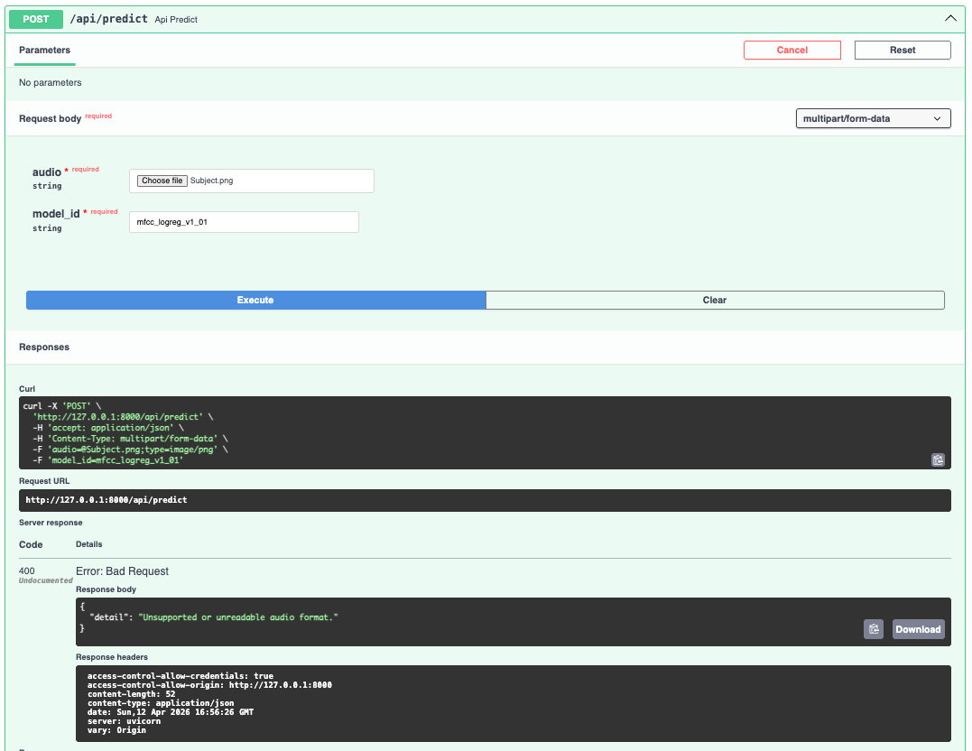
Figure 32 - A2.08 /api/predict response for invalid or unsupported file type (HTTP 400 Bad Request).

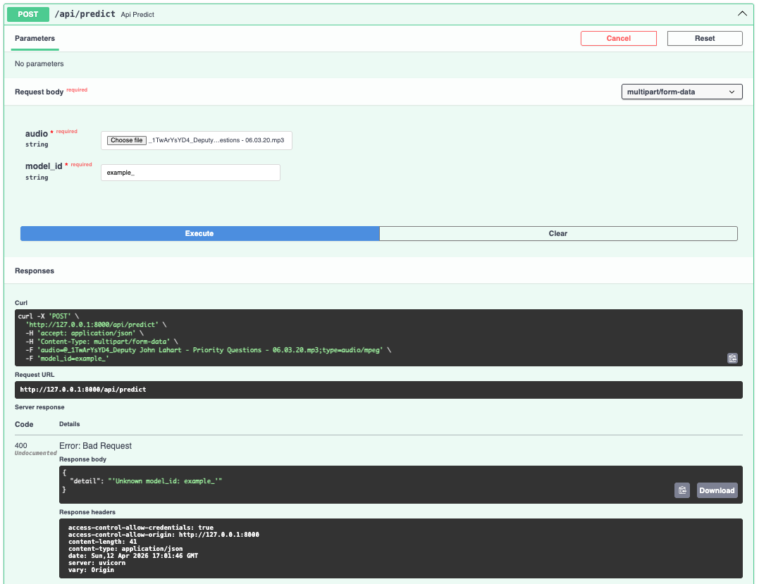
Figure 33 - A2.09 /api/predict response for invalid or unregistered model_id (HTTP 400 Bad Request).

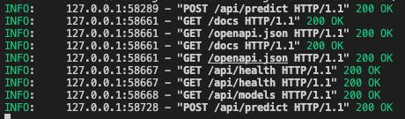
Figure 34 – A2.10 Terminal-based HTTP request demonstrating successful API response.

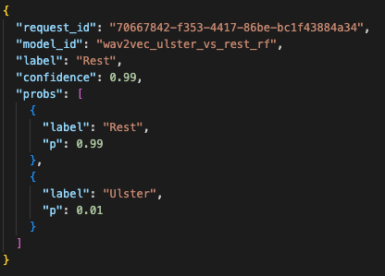
Figure 35 - A2.11 Successful prediction JSON Response.

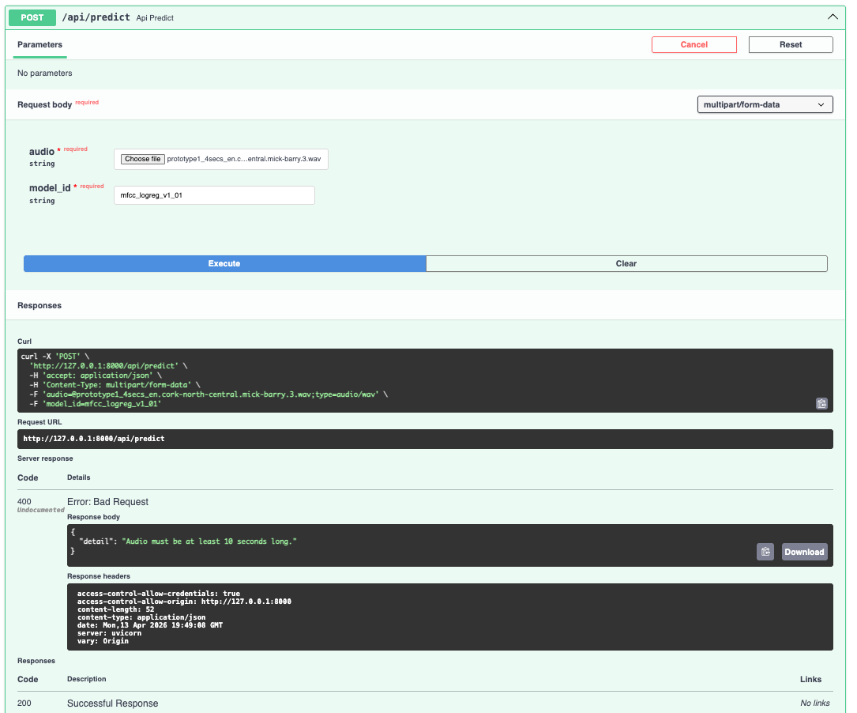
Figure 36 - A2.12 Swagger /api/predict response rejecting audio shorter than 10 seconds.

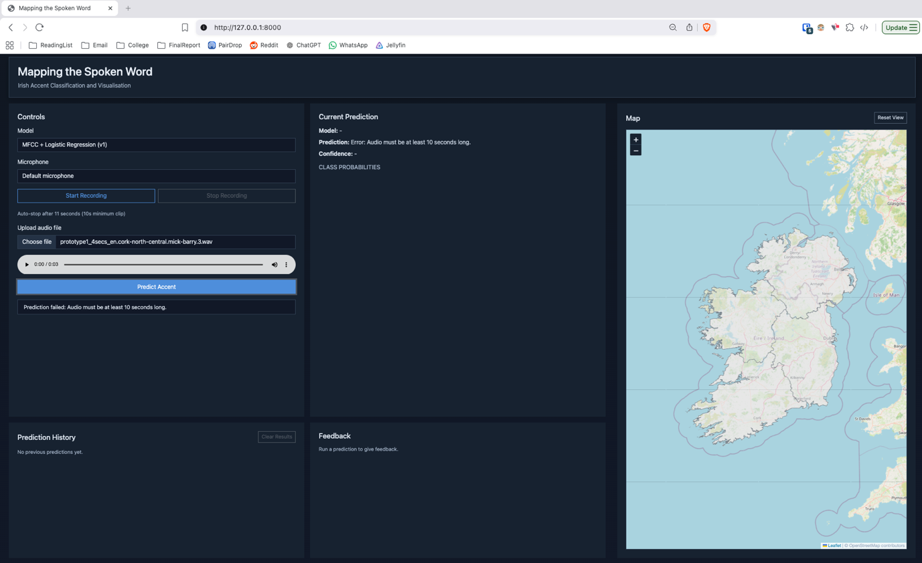
Figure 37 - A2.13 Frontend validation rejecting uploaded audio shorter than 10 seconds.

A.3 - Plugin Architecture Validation (ST-11)
The purpose of this test was to validate the system’s plugin-based architecture by demonstrating that models can be added or removed at the backend level without requiring any modifications to the frontend.
This test involved removing a model plugin from the backend by modifying the plugin loading configuration. The system was then restarted to observe the effect across the backend API and frontend interface.

Before removal of Dummy Model Plugin:
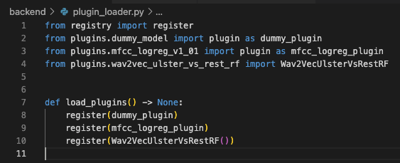
Figure 38 – A3.1 backend/plugin_loader.py with Dummy Model Plugin.
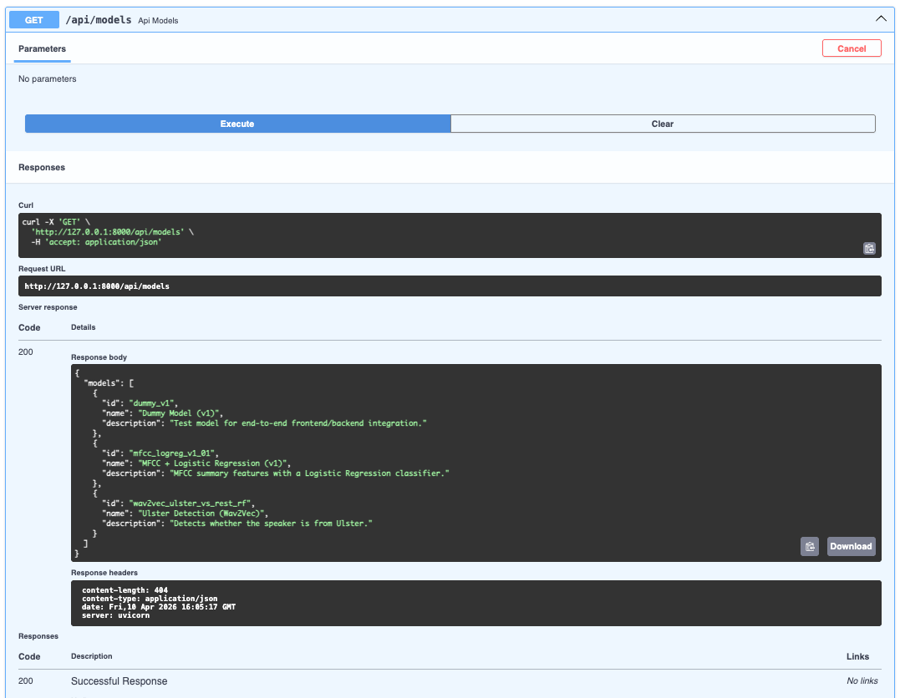
Figure 39 – A3.2 /api/models with Dummy Model Plugin.

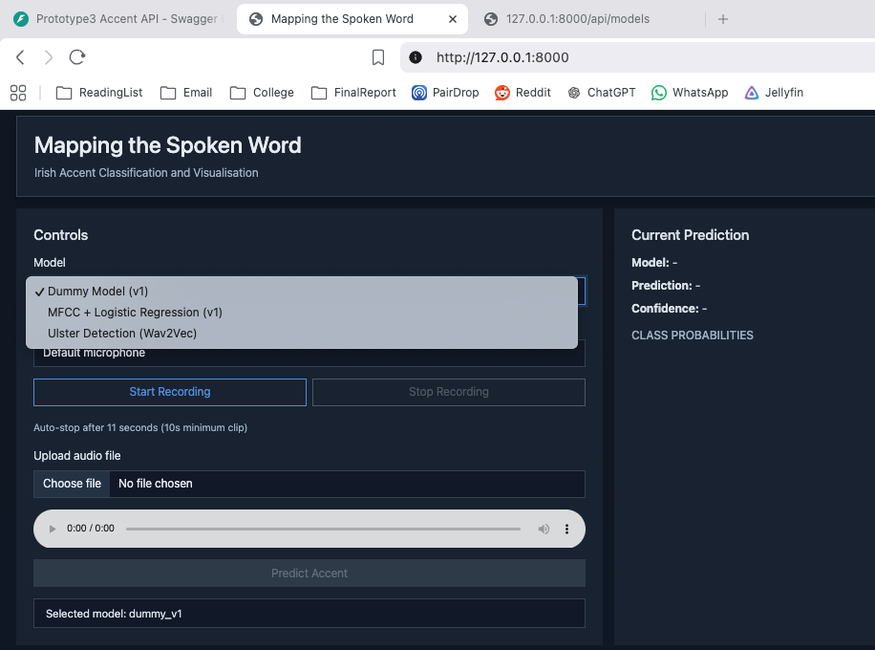
Figure 40 – A3.3 Frontend with Dummy Model Plugin.

After removal of Dummy Model Plugin:

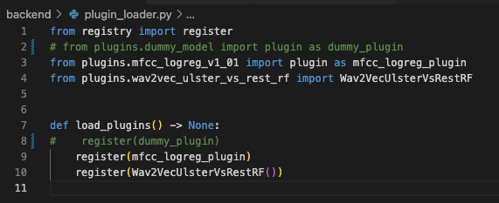
Figure 41 – A3.4 backend/plugin_loader.py with Dummy Model Plugin removed.

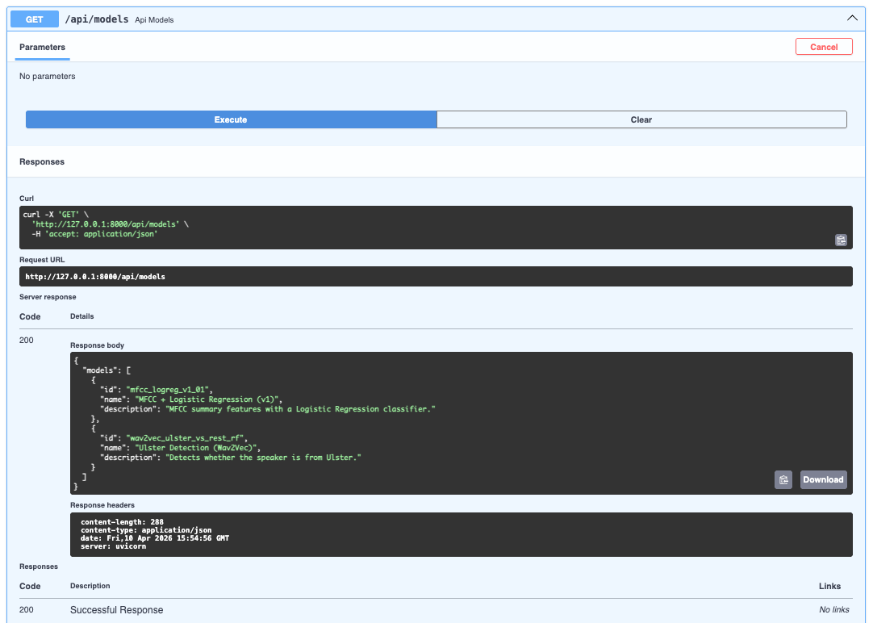
Figure 42 – A3.5 /api/models with Dummy Model Plugin removed.

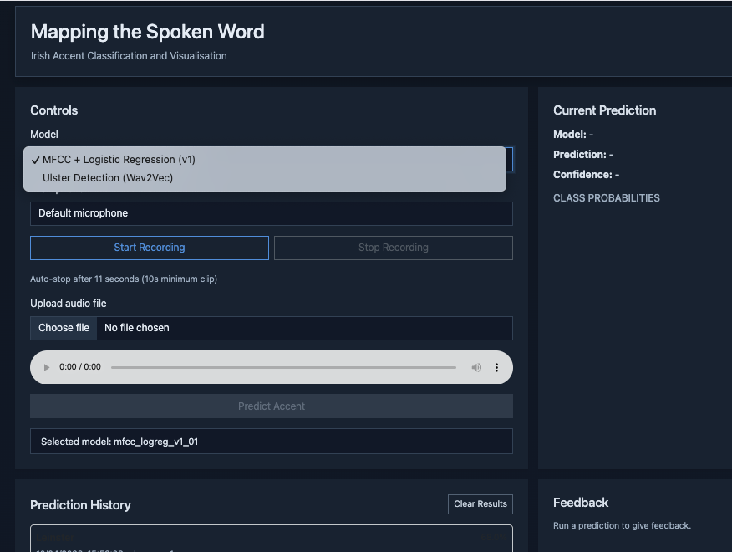
Figure 43 – A3.6 Frontend with Dummy Model Plugin removed.

Appendix B: Experiment Results and Evaluation Charts
This appendix contains the experimental results used to evaluate model performance across different feature extraction approaches and classification tasks.

B1. Irish MFCC Results

B1.1 Balanced Accuracy
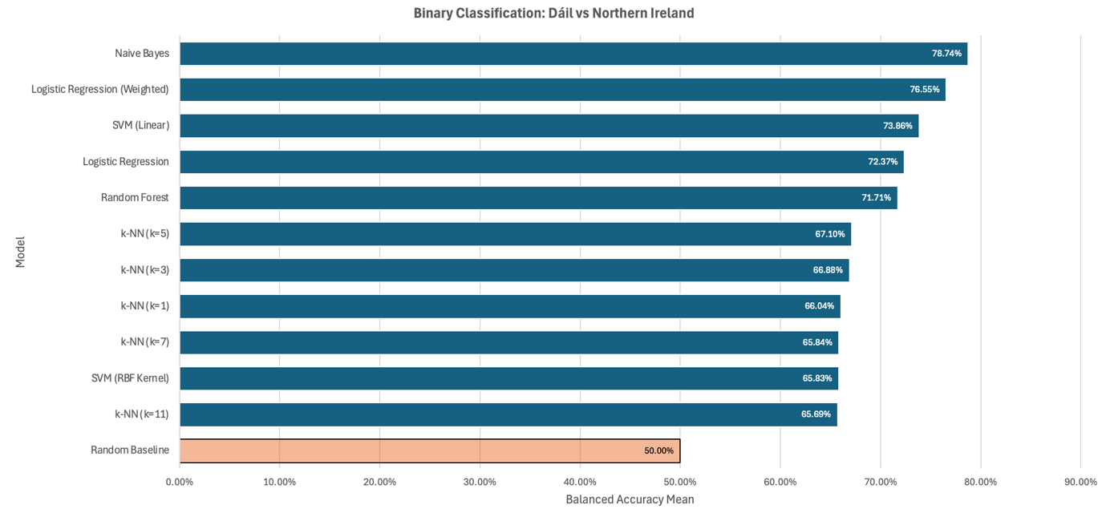
Figure 44 – B1.1.1 Balanced Accuracy: Dáil vs NI Datasets.

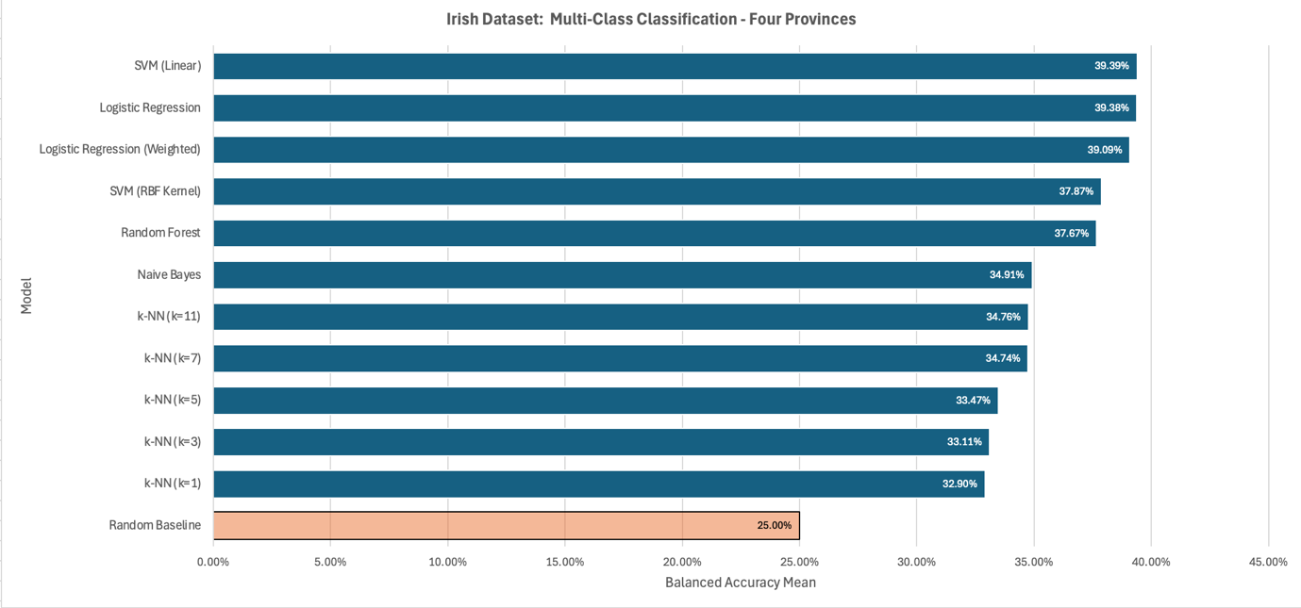
Figure 45 – B1.1.2 Balanced Accuracy: Four Provinces (Dáil and NI datasets).

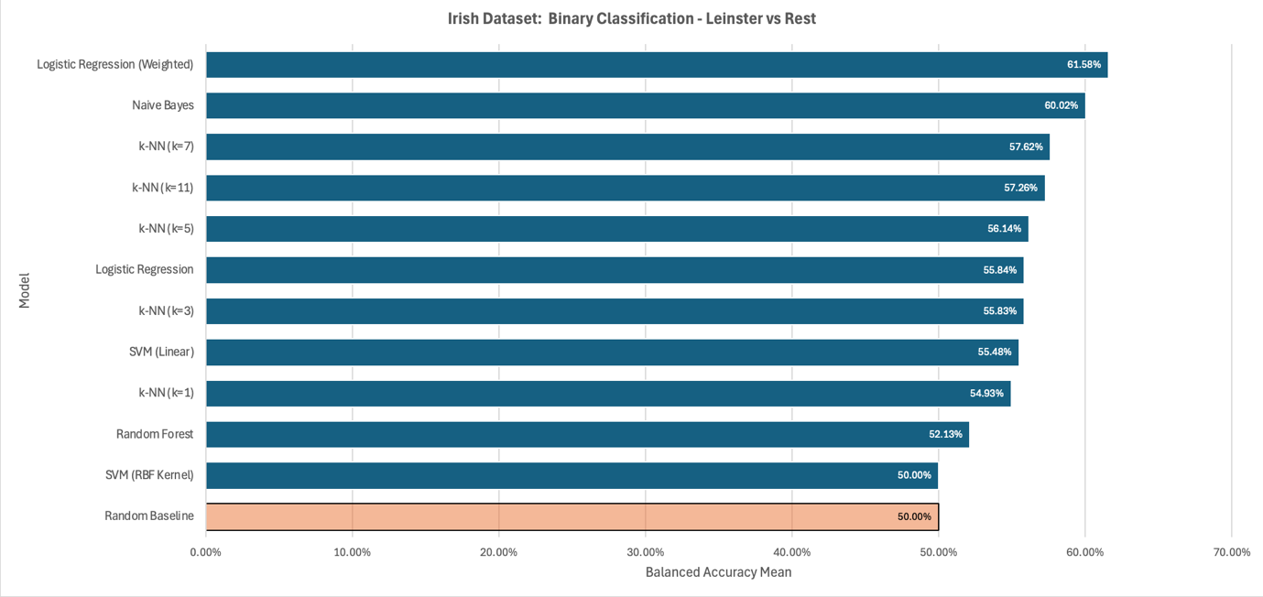
Figure 46 – B1.1.3 Balanced Accuracy: Leinster vs Rest.

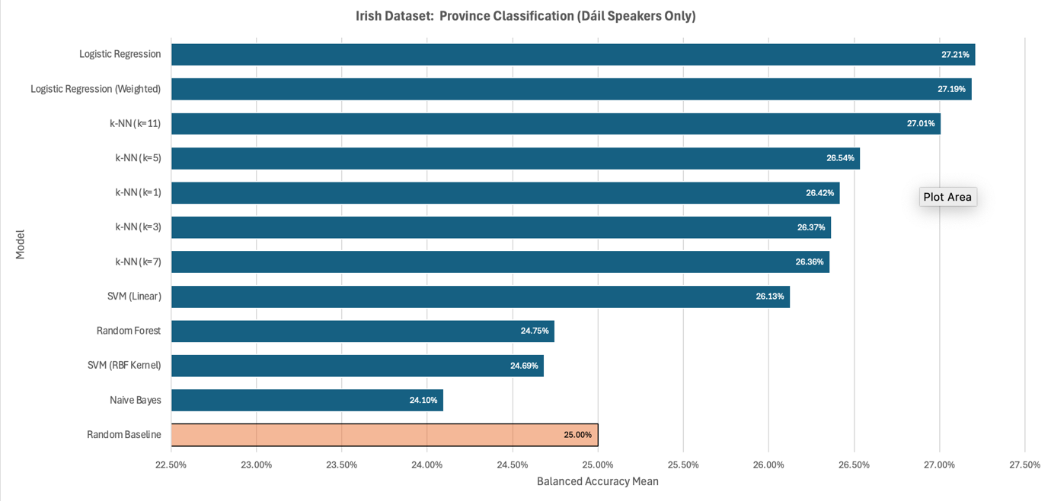
Figure 47 – B1.1.4 Balanced Accuracy: Four Provinces (Dáil dataset only).

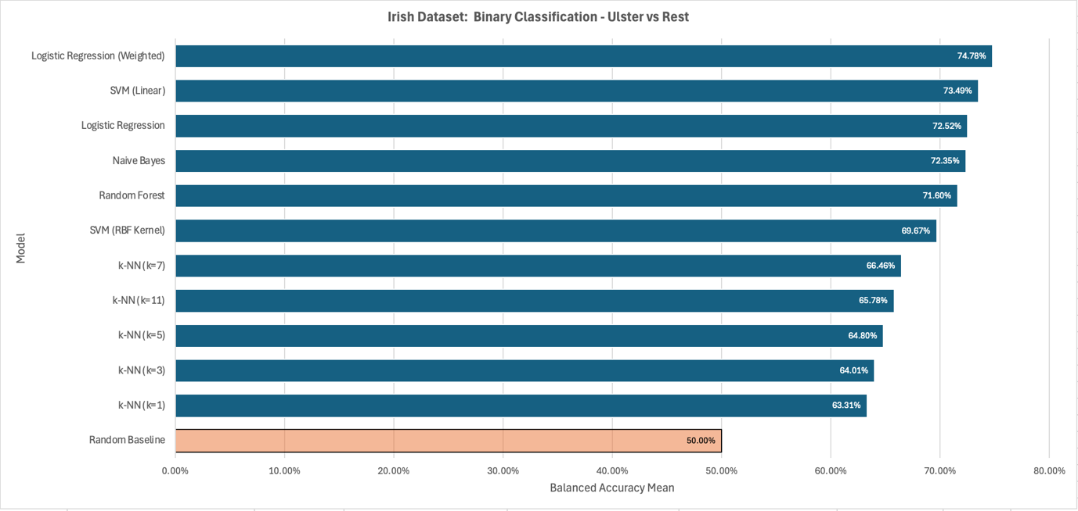
Figure 48 – B1.1.5 Balanced Accuracy: Ulster vs Rest

B1.2 Best Model Per Task
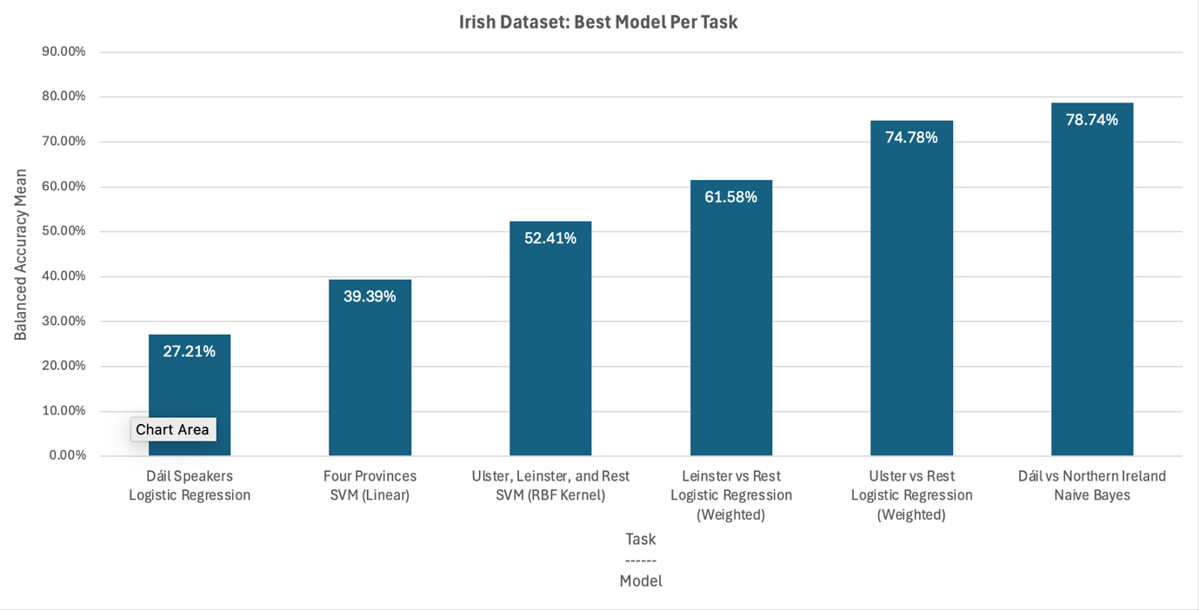
Figure 49 - B1.2.1 Best Model Per Task

B1.3 Balanced Accuracy Per Task
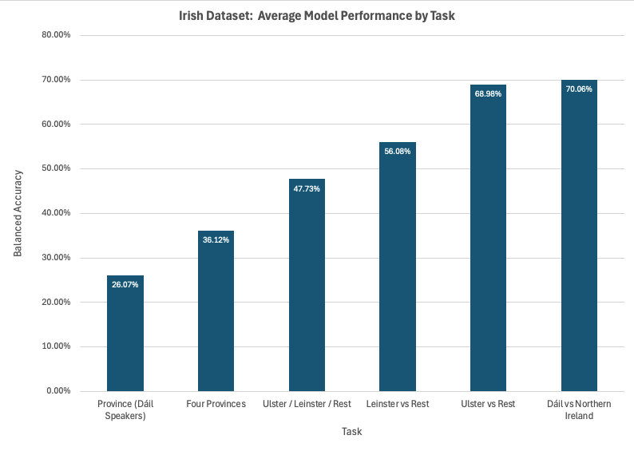
Figure 50 - B1.3.1 Balanced Accuracy Per Task

B1.4 Average Improvement over the Baseline by Model
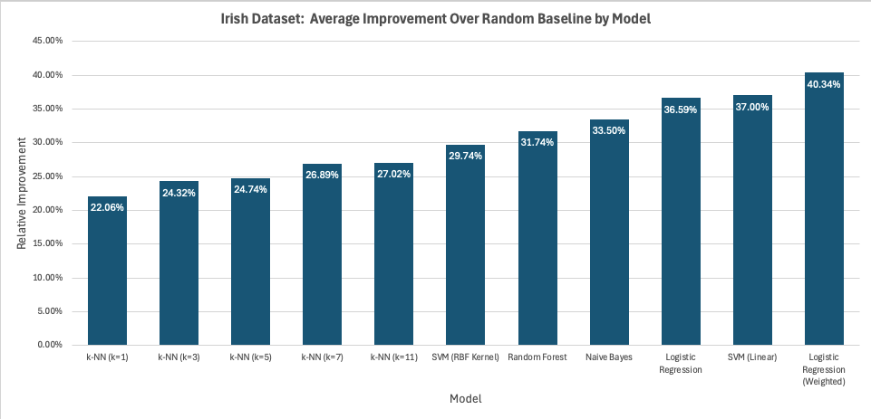
Figure 51 – B1.4.1 Average Improvement over the Baseline by Model

B2. Irish Wav2Vec Results

B2.1 Balanced Accuracy
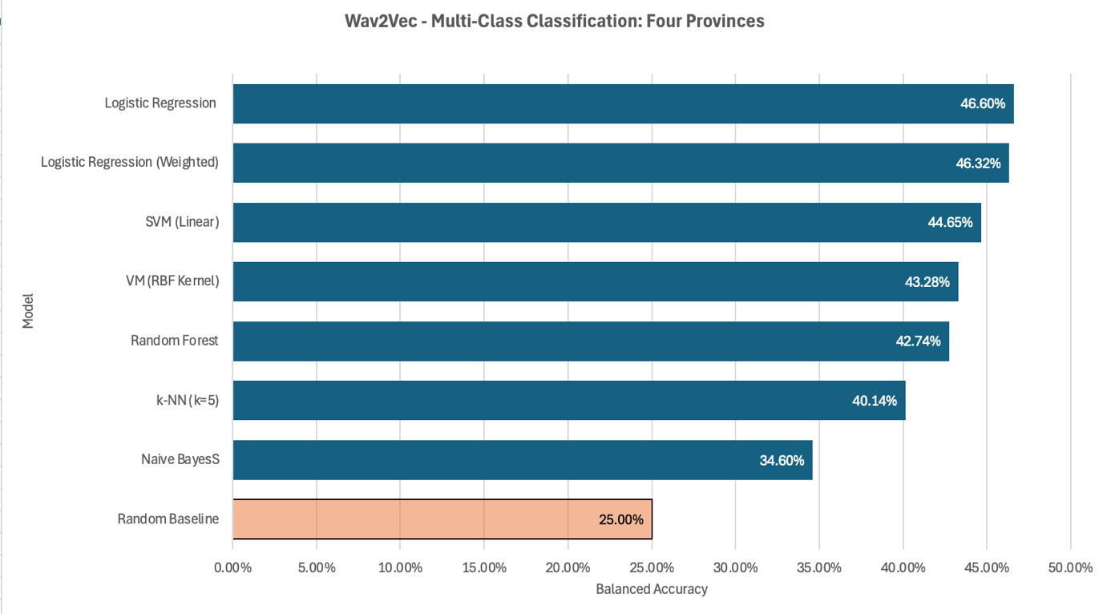
Figure 52 – B2.1.1 Balanced Accuracy: Four Provinces (Dáil and NI datasets).

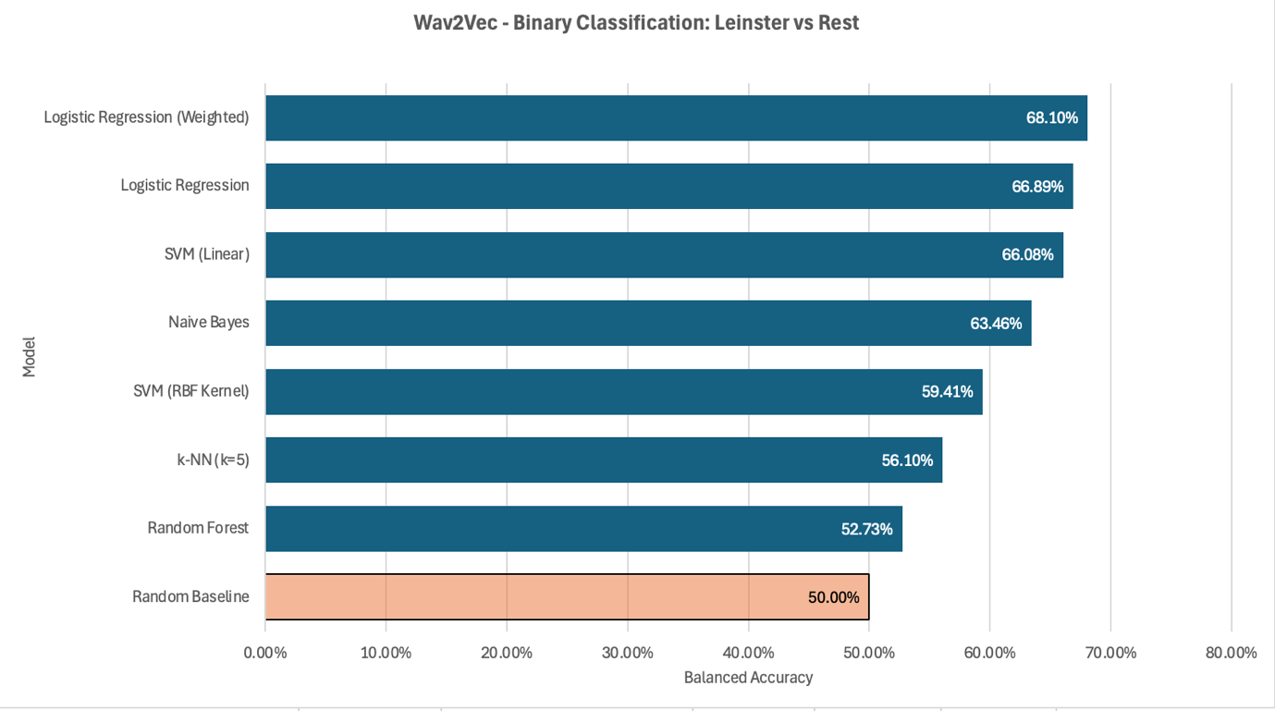
Figure 53 – B2.1.2 Balanced Accuracy: Leinster vs Rest.

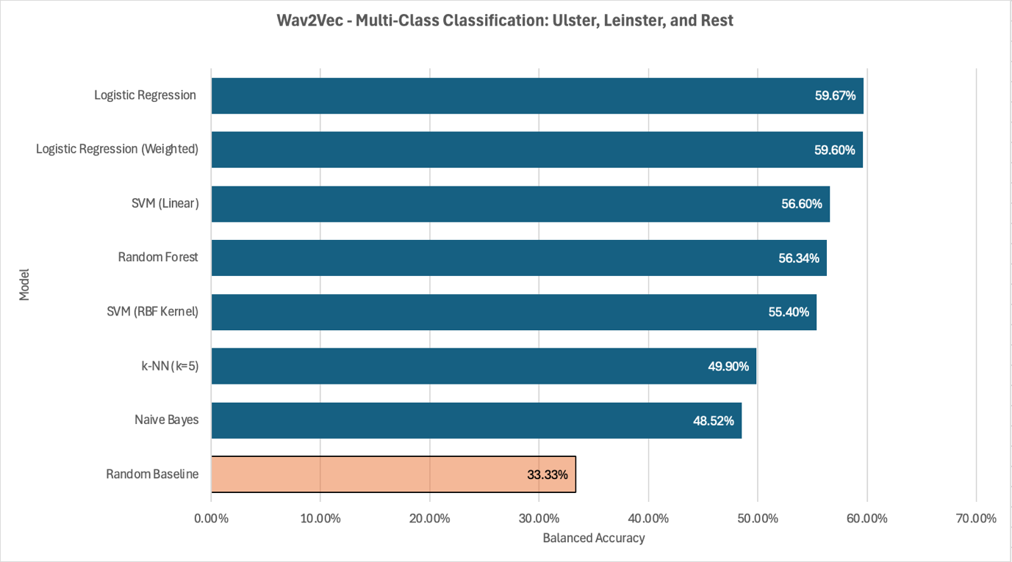
Figure 54 – B2.1.3 Balanced Accuracy: Ulster, Leinster vs Rest.

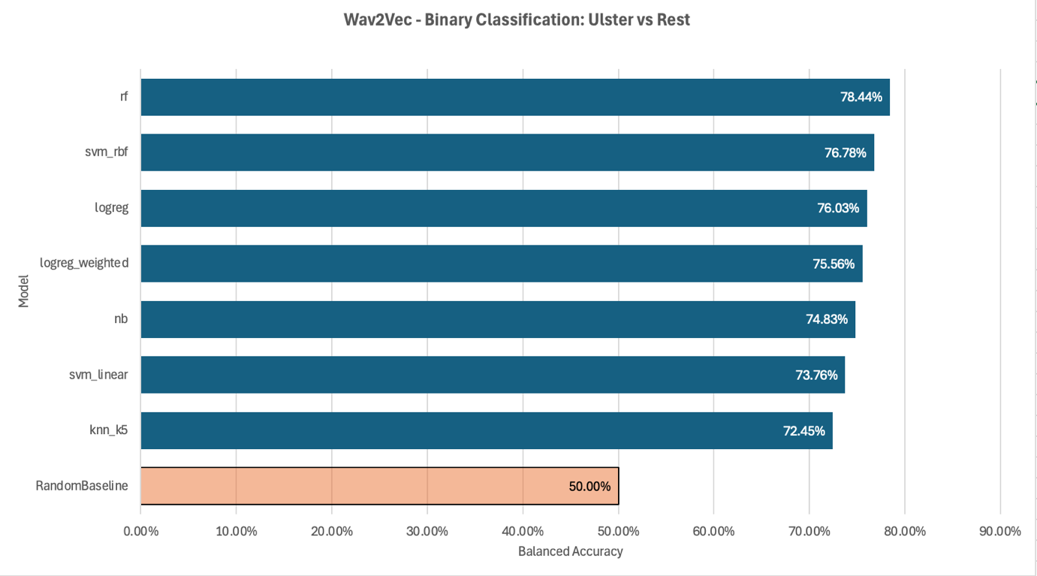
Figure 55 – B2.1.4 Balanced Accuracy: Ulster vs Rest.

B2.2 Macro F1 Per Task
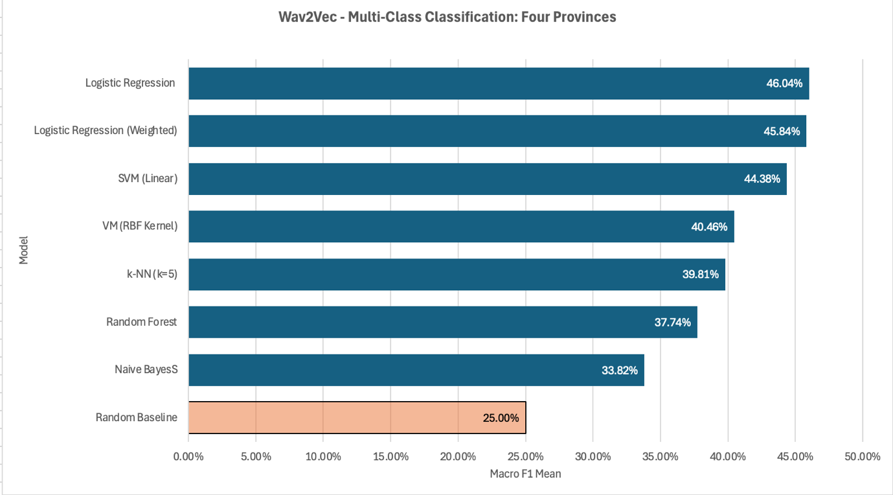
Figure 56 - B2.2.1 Macro F1: Four Provinces (Dáil and NI datasets).

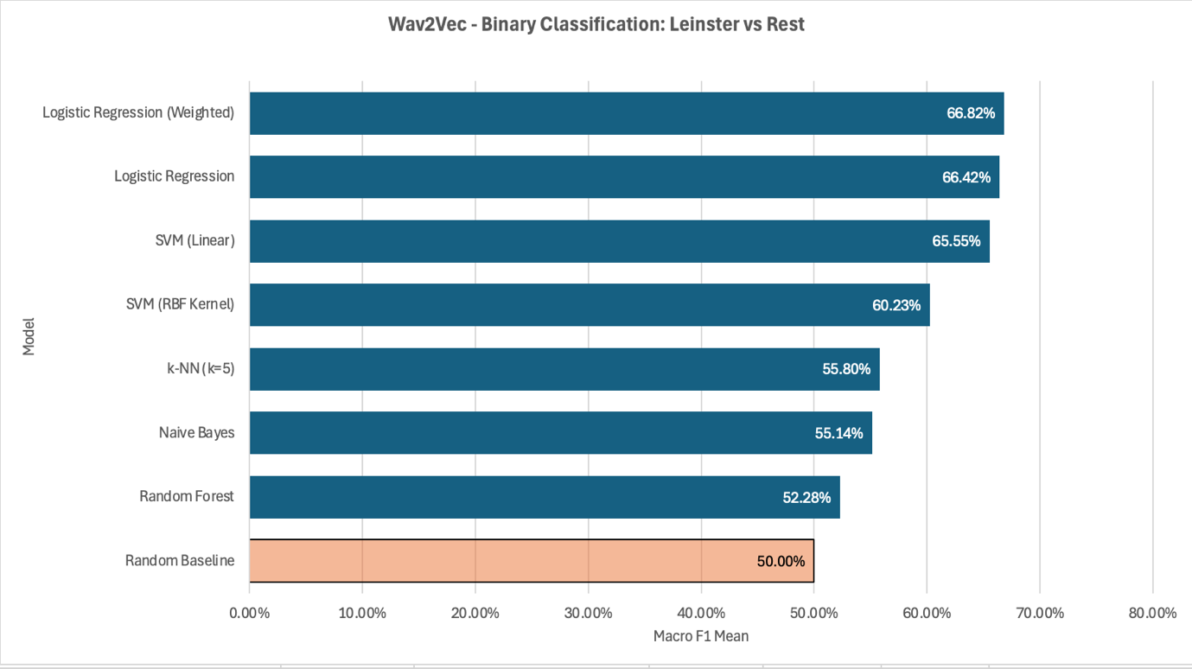
Figure 57 - B2.2.2 Macro F1: Leinster vs Rest.

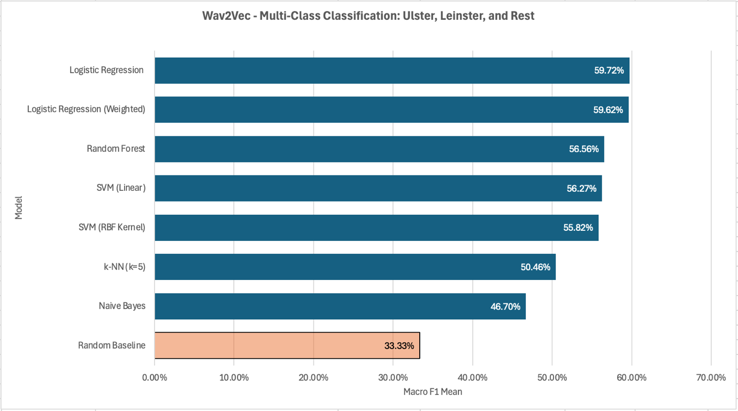
Figure 58 - B2.2.3 Macro F1: Ulster, Leinster vs Rest.

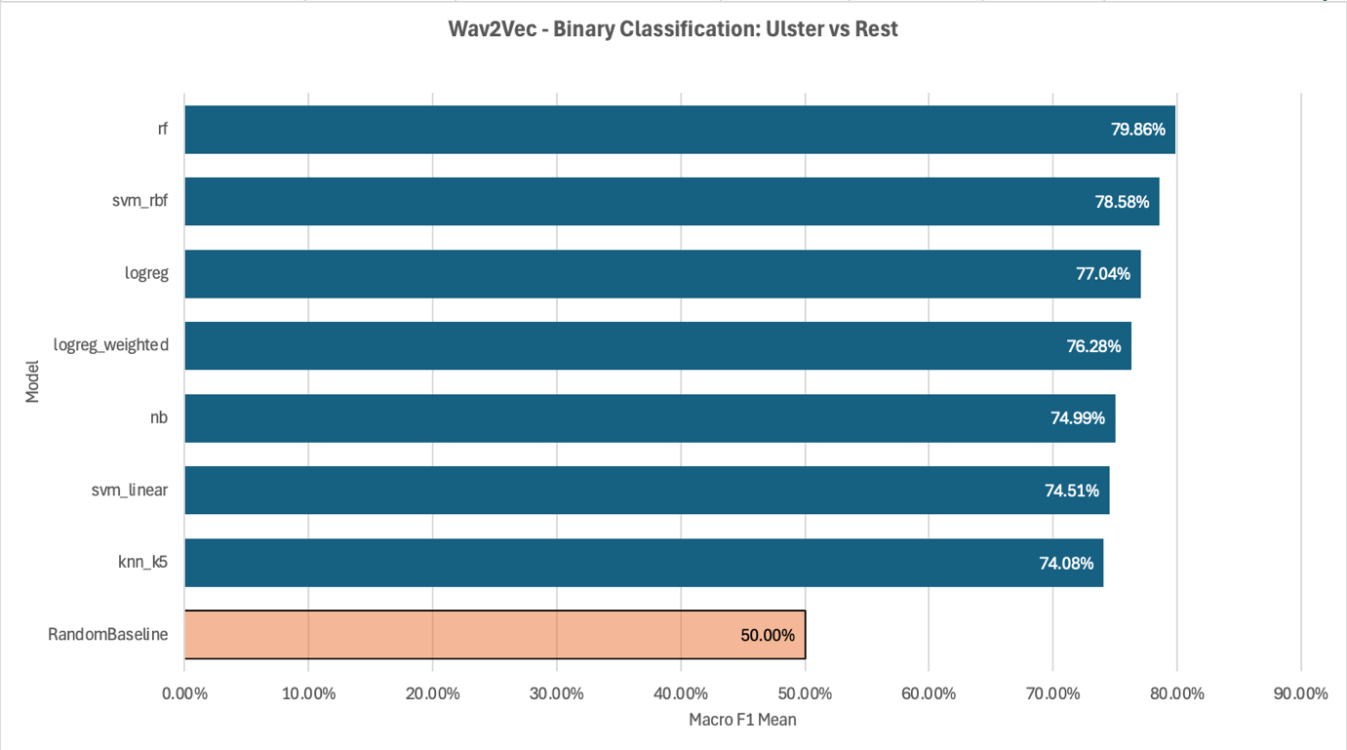
Figure 59 - B2.2.4 Macro F1: Ulster vs Rest.

B2.3 Averaged Accuracy vs Averaged Balanced Accuracy per Task
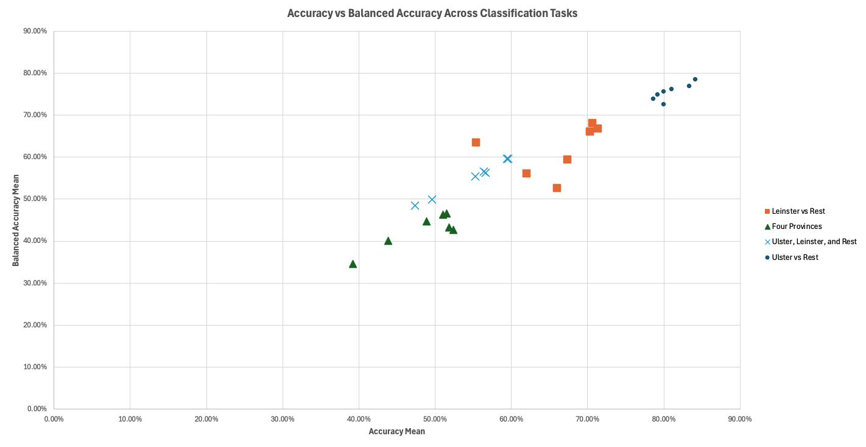
Figure 60 - B2.3.1 Averaged Accuracy vs Averaged Balanced Accuracy: All Tasks.

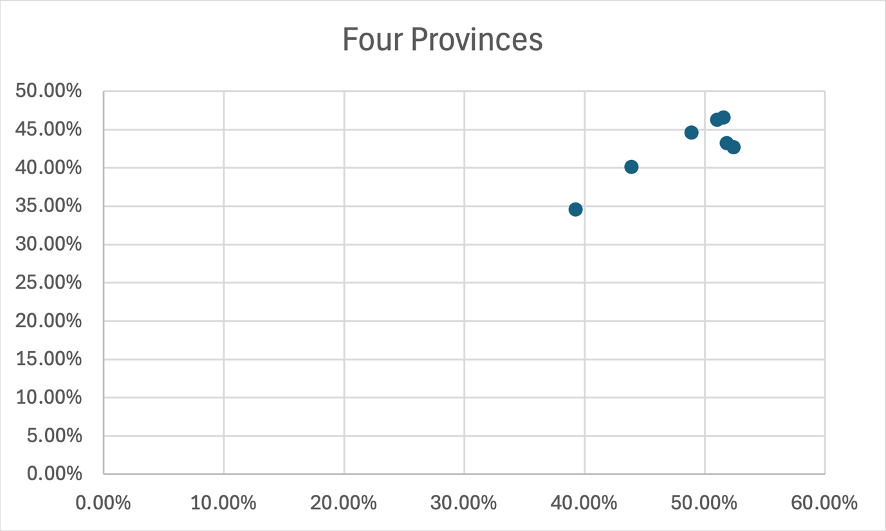
Figure 61 - B2.3.2 Averaged Accuracy vs Averaged Balanced Accuracy: Four Provinces (Dáil and NI datasets).

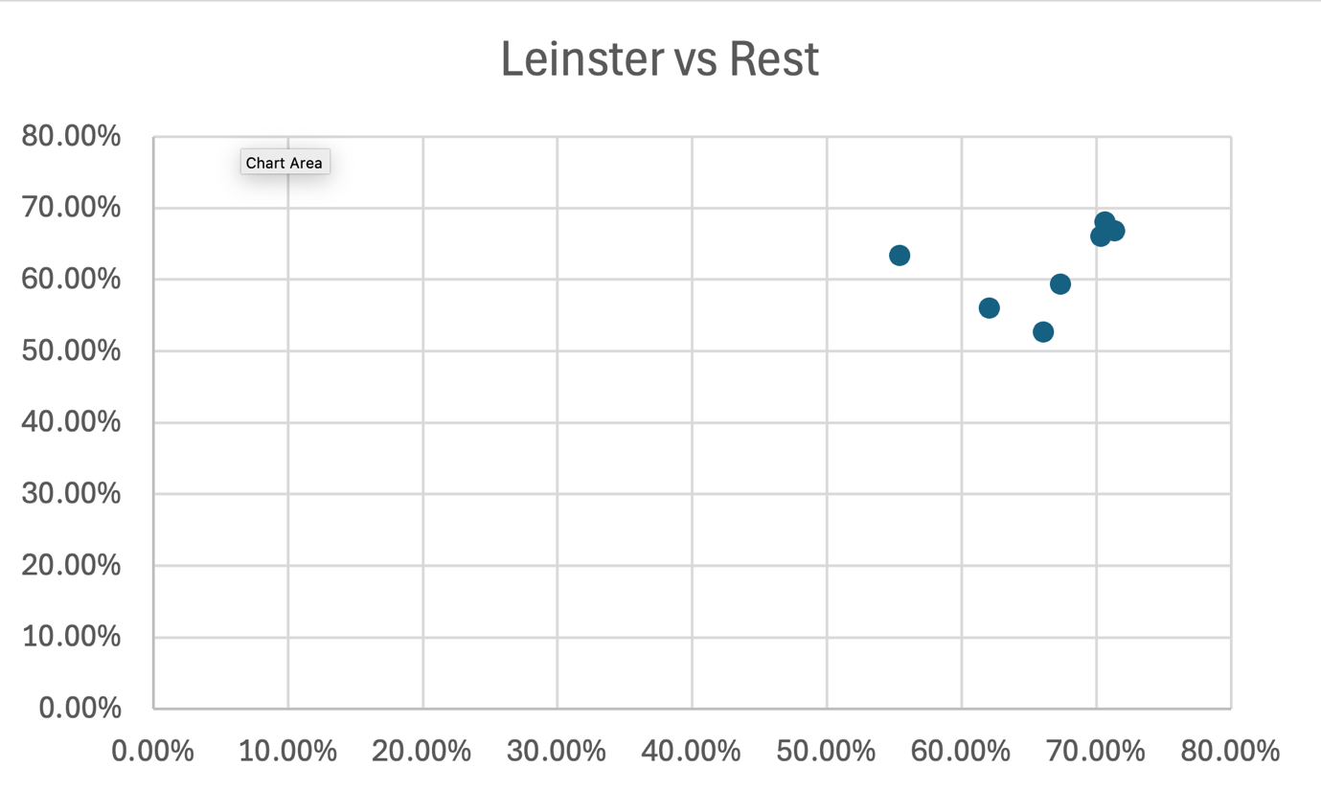
Figure 62 - B2.3.3 Averaged Accuracy vs Averaged Balanced Accuracy: Leinster vs Rest.

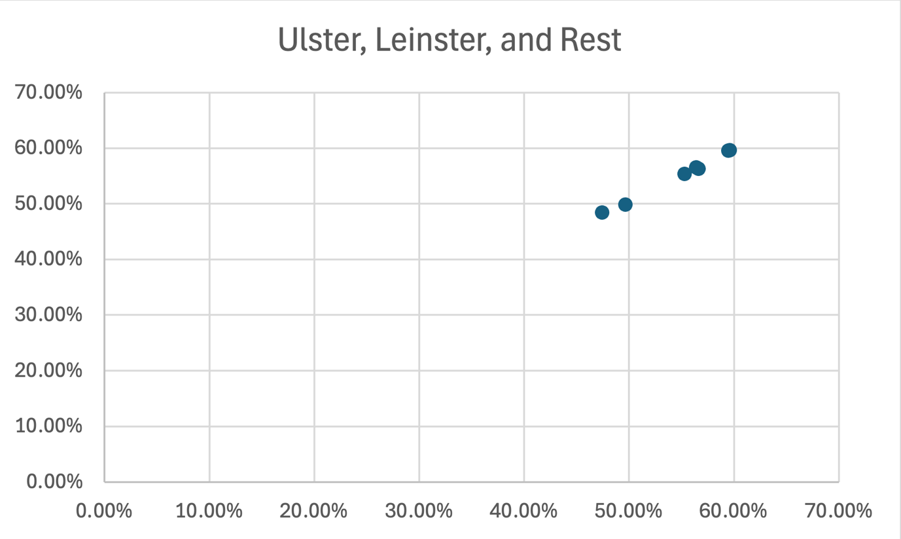
Figure 63 - B2.3.4 Averaged Accuracy vs Averaged Balanced Accuracy: Ulster, Leinster vs Rest.

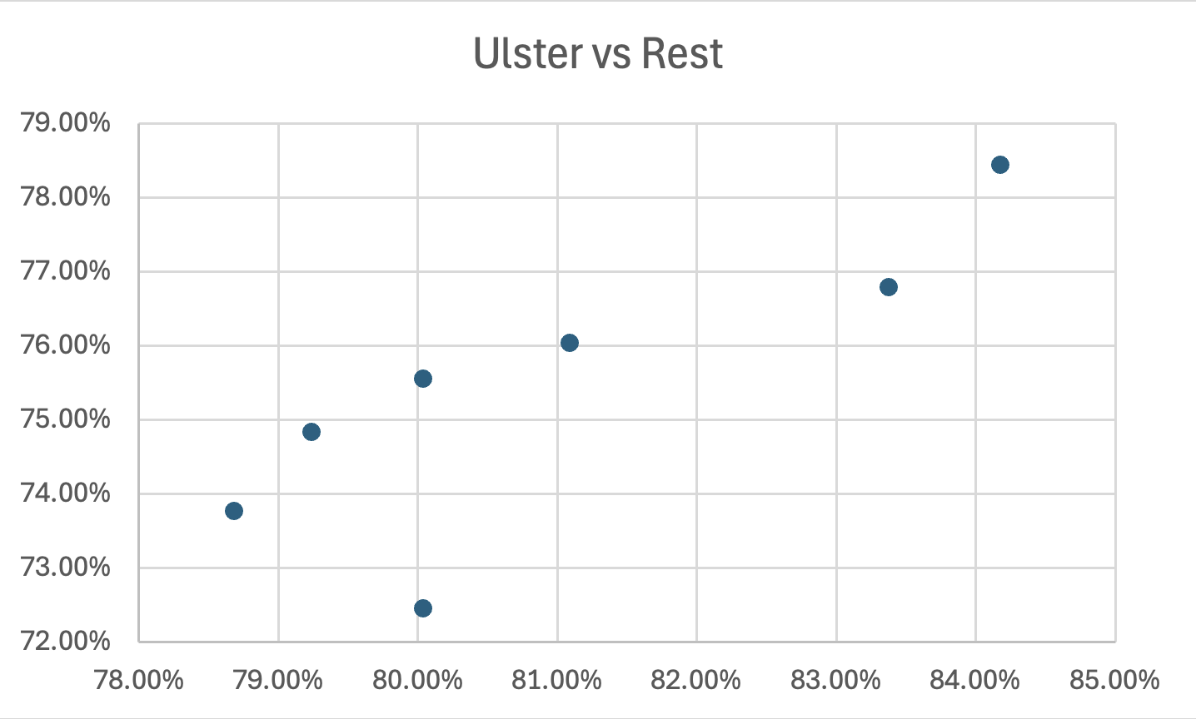
Figure 64 - B2.3.5 Averaged Accuracy vs Averaged Balanced Accuracy: Ulster vs Rest.

B2.4 Average Balanced Accuracy per Task
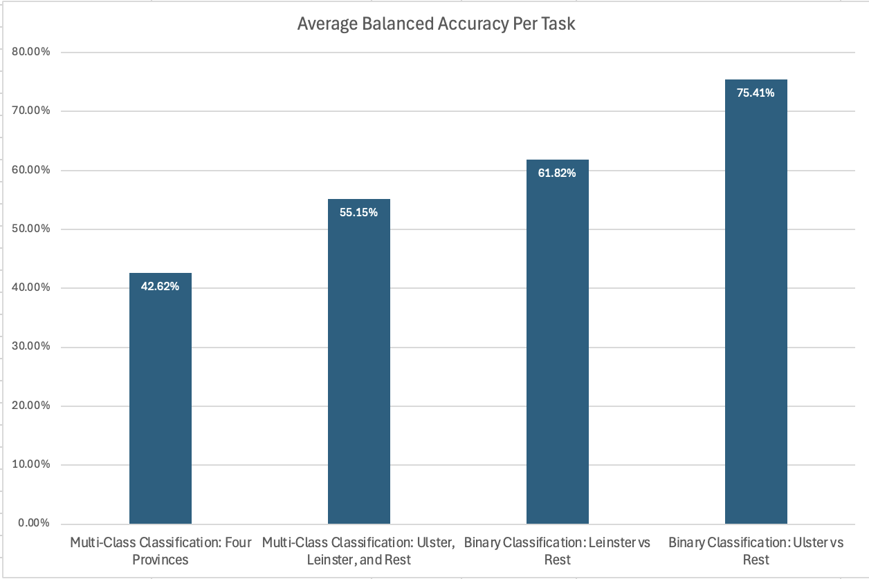
Figure 65 - B2.4.1 Averaged Balanced Accuracy per Task.

B2.5 Best Model Per Task
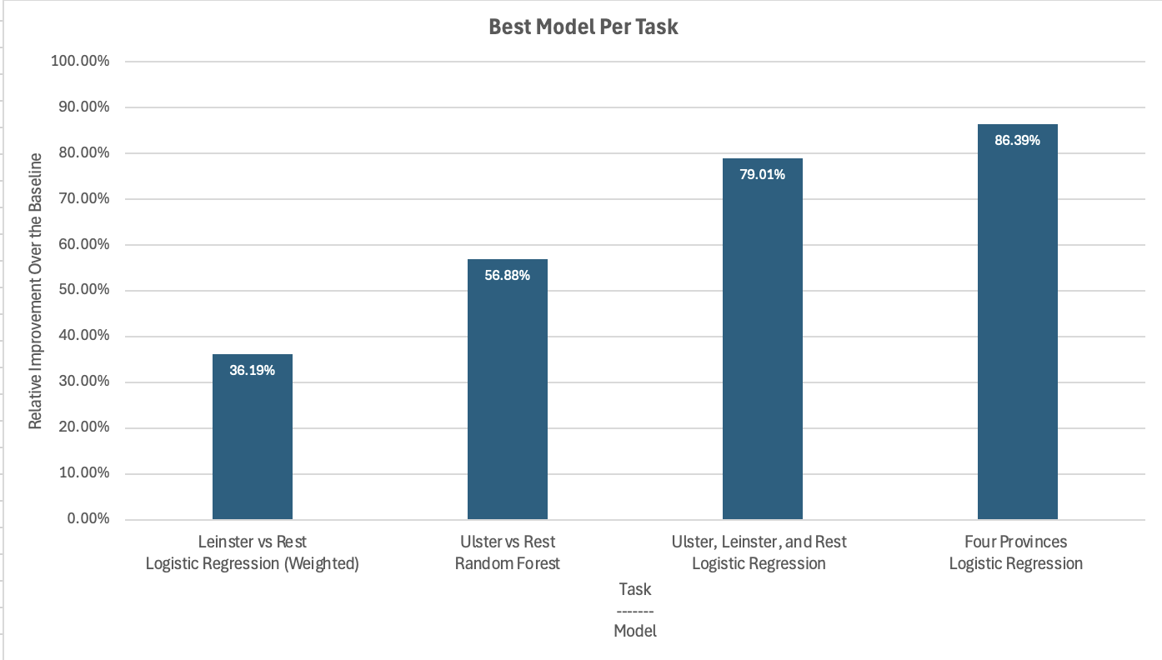
Figure 66 - B2.5.1 Best Model Per Task, using Relative Improvement over the baseline.

B3. Common Voice MFCC Results
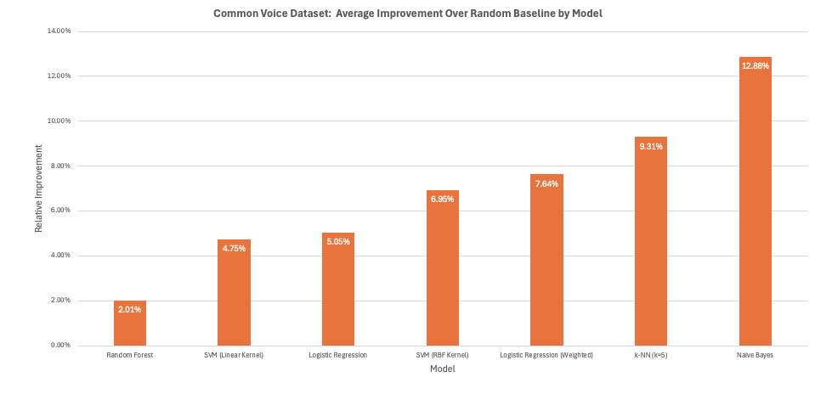
Figure 67 - B3.1 Average Improvement over the Baseline per Model.

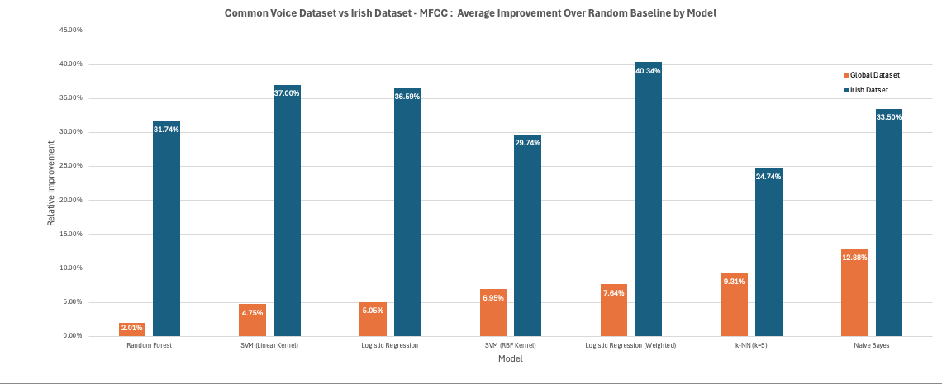
Figure 68 - B3.2 Average Improvement over the Baseline per Model: Irish Dataset vs Common Voice Dataset Comparison.

B.4 Confusion Matrices Irish Data MFCC

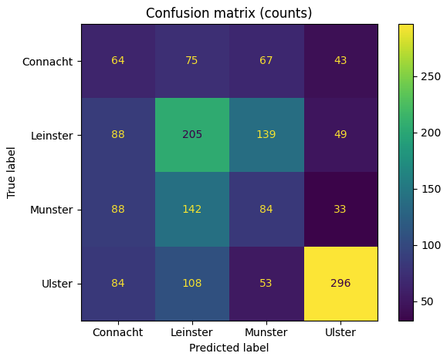
Figure 69 - B4.1 Confusion Matrix for MFCC-based four-province classification.

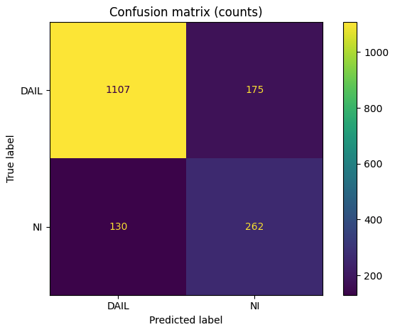
Figure 70 - B4.2 Confusion Matrix for MFCC-based Dáil Dataset vs Northern Ireland Dataset classification.

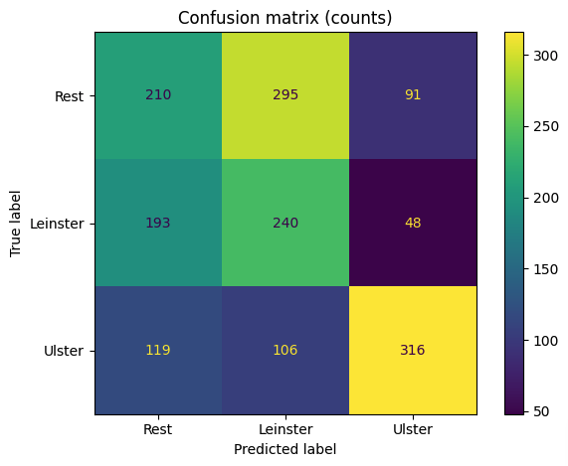
Figure 71 - B4.3 Confusion Matrix for MFCC-based Ulster, Leinster vs Rest classification.

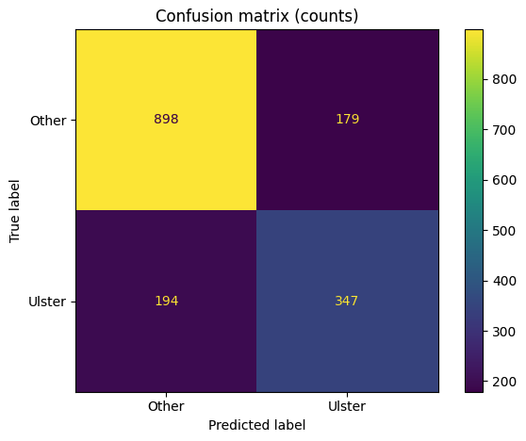
Figure 72 - B4.4 Confusion Matrix for MFCC-based Ulster vs Rest classification.

B.5 Summary of Data Distribution in the Irish Dataset

B5.1 Summary Across All Tasks
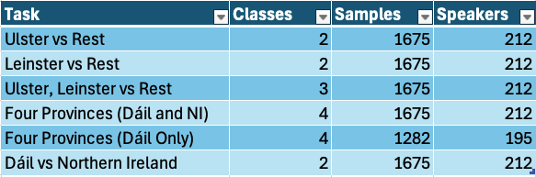
Figure 73 – B5.1.1 Summary of classification tasks, dataset size and speaker count.

B5.2 Class Distribution Across Tasks

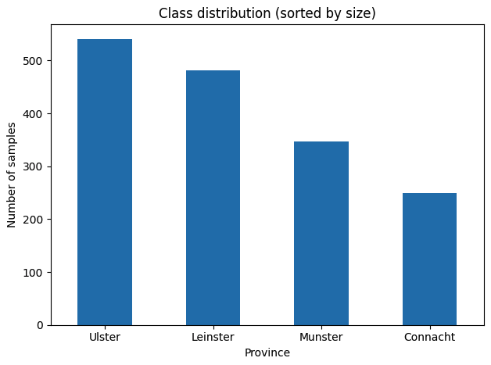
Figure 74 - B5.2.1 Class Distribution across Four Provinces (Bar Chart).

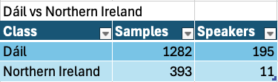
Figure 75 - B5.2.2 Class Distribution of Dáil Dataset vs Northern Ireland Dataset.

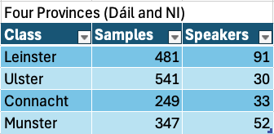
Figure 76 - B5.2.3 Class Distribution of Four Provinces (Dáil and NI).

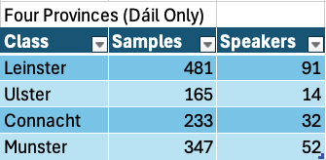
Figure 77 - B5.2.4 Class Distribution of Four Provinces (Dáil only).

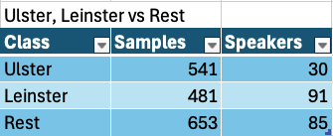
Figure 78 - B5.2.5 Class Distribution of Ulster, Leinster vs Rest.

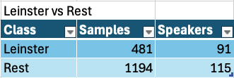
Figure 79 - B5.2.6 Class Distribution of Leinster vs Rest.

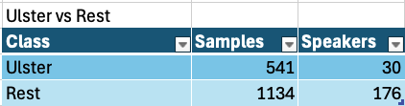
Figure 80 - B5.2.7 Class Distribution of Ulster vs Rest.

Appendix C: System Tests
Test ID | Objective | Expected Result | Actual Result | Status
ST-01 | Verify that the full system starts correctly. | - Main frontend loads successfully.  - Swagger docs load successfully.  - No immediate console or backend startup errors. | The frontend interface loaded successfully without errors, and the Swagger documentation was accessible. No issues were observed during backend startup. | Pass
ST-02 | Verify that available backend models appear in the UI. | - “Loading models…” is replaced with actual model names.  - A default model is selected.  - Status message updates to selected model. | The model dropdown populated correctly with available models. A default model was automatically selected, and the interface updated to reflect the selected model. | Pass
ST-03 | Verify end-to-end prediction using uploaded audio. | - Predict button becomes enabled after upload.  - Request is sent to /api/predict.  - Prediction result appears in the prediction panel.  - Province highlight updates on the map.  - No frontend or backend error occurs. | End-to-end prediction was successful for most tested formats, including AIFF, FLAC, AAC, M4A, MP3, OGG, WebM, AMR and WMA.All supported formats produced predictions without system errors. | Pass
ST-04 | Verify end-to-end prediction using browser microphone recording. | - Recording countdown works correctly.  - Predict button becomes enabled after valid recording.  - Audio playback preview is shown.  - Prediction result appears.  - Map updates correctly. | Audio recording functioned as expected, including countdown enforcement and playback preview. Predictions were successfully generated, and the map visualisation updated correctly. | Pass
ST-05 | Verify frontend validation for minimum clip length. | - Recording is rejected.  - Predict button remains disabled.  - Status message clearly explains minimum 10-second rule.  - No prediction request is sent. | Recordings shorter than 10 seconds were correctly rejected. The predict button remained disabled, and an appropriate message informed the user of the minimum duration requirement. | Pass
ST-06 | Verify correct handling when no model is available or selected. | - System does not attempt prediction.  - Predict button remains grey/ unclickable.  - No crash occurs. | The frontend prevented prediction without a selected model by automatically assigning a default model. Direct API testing without a valid model resulted in an appropriate HTTP error response. | Pass
ST-07 | Verify graceful handling of invalid file types through recording. | - Backend rejects the file safely.  - Frontend shows clear error message.  - System remains usable afterward. | Non-speech or invalid recorded audio did not cause system failure. The backend processed the input and returned a prediction, although results were not meaningful. System stability was maintained. | Pass
ST-08 | Verify graceful handling of invalid file types through upload. | - Backend rejects the file safely.  - Frontend shows clear error message.  - System remains usable afterward. | The frontend restricted file selection to supported formats. When invalid files were submitted via API testing, the backend returned a clear error response without crashing. | Pass
ST-09 | Verify correct rendering of prediction data. | - Selected model name is shown.  - Predicted label is shown.  - Confidence value is shown.  - Probability list is populated correctly. | The prediction panel displayed all expected values, including model name, predicted label, confidence score, and probability distribution. A minor UI visibility issue was identified and resolved. | Pass
ST-10 | Verify that the correct province is highlighted after prediction. | - Only the predicted province is highlighted.  - Previous highlight is cleared.  - Highlight matches prediction text exactly. | The map correctly highlighted the predicted province, cleared any previous highlights, and remained consistent with the displayed prediction output. | Pass
ST-11 | Verify modular plug-and-play architecture. | - Frontend updated after reload.  - No frontend code changes required.  - Prediction still worked. | After modifying backend plugins, the /api/models response updated accordingly. The frontend reflected these changes upon reload without requiring code modifications. Prediction functionality remained fully operational. | Pass

Appendix D: Additional Code Samples
Organised by Logical Architecture

Backend Architecture
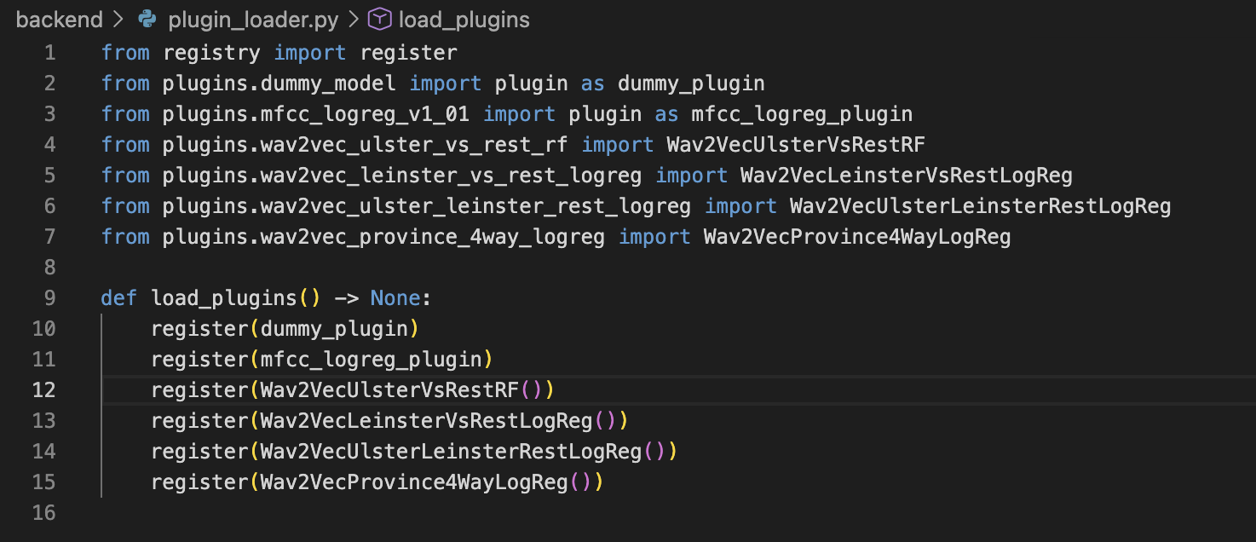
Figure 81 – D1.1 Final deployed model plugins – plugin_loader.py

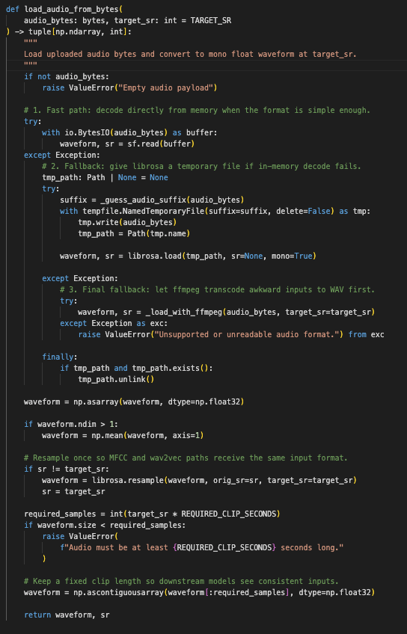
Figure 82 – D1.2 load_audio_from_bytes Function from services/audio.py.

Appendix E: Machine Learning Training

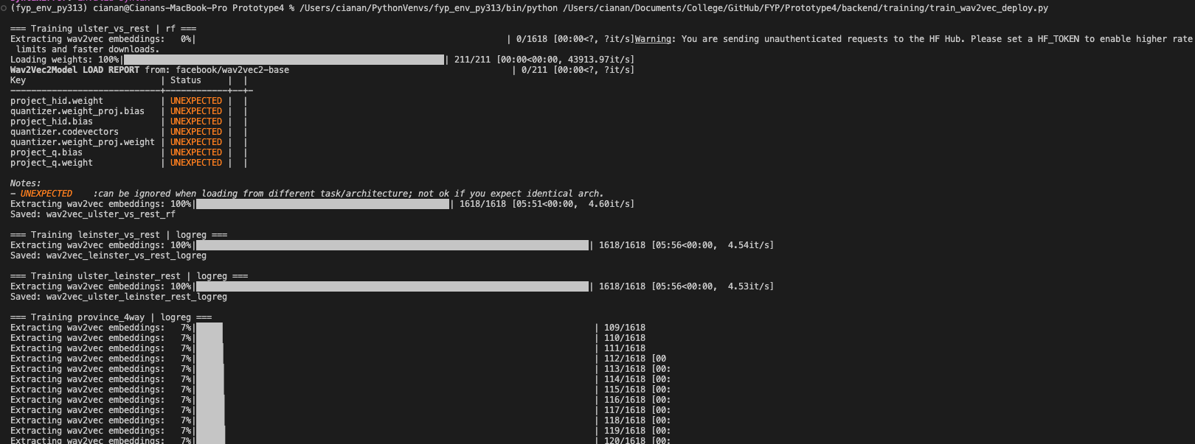
Figure 83 - E1.1 wav2vec beginning of model training.
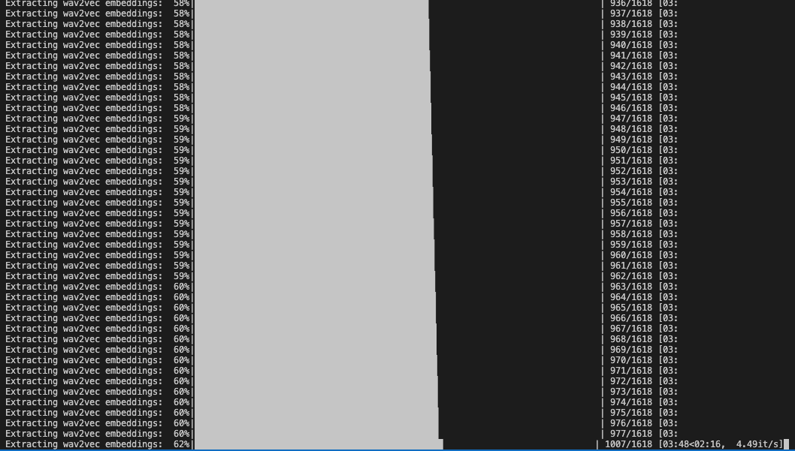
Figure 84 - 1.2 wav2vec end of model training.

