Name: ____________ Inequalities Worksheet Date: ________
1. Can you write the names for these symbols?
< | >
≤ | ≥

2. Use the number line and the inequality symbols to compare these numbers:

254 | 359 | 551 | -650
75-7 | -355 | -85-2 | 254

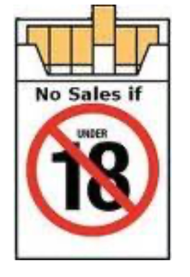
3. Can you turn these pictures into an inequality?
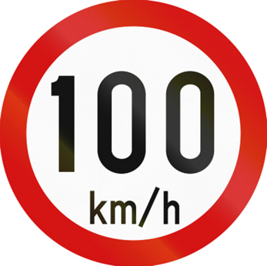
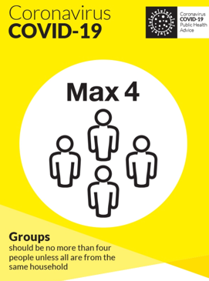
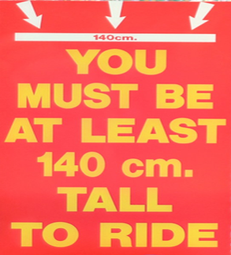
a) b) c) d)

height ≥ 140 cm

4. Match the different number types on the left to the correct description on the right.

Natural Numbers |  | Symbol is Z.  Negative and positive whole numbers  e.g. -2, -1, 0, 1, 2, 3
Integers |  | Symbol is N.  Positive whole numbers  e.g. 1, 2, 3, 4, 5 ...
Real Numbers |  | Symbol is R. All positive and negative numbers, including fractions and decimals  e.g. -3, 0.5, $\frac{2}{9}$, 4
6. Graph each of the following inequalities on the number line given.
NOTE: $x$ is an element of a different set (N, Z, or R) in each case.
5. Graph each of the following inequalities on the number line given.
NOTE: $x$ is an element of a different set (N, Z, or R) in each case.
(a) $x$ $>$–3, where $x$ ∈ Z
(b) $x$ $>$–3, where $x$ ∈ N
(c) $x$ $>$ –3, where $x$∈ R
(a) $x$ $≤ 2$, where $x$ ∈ N
(b) $x$ $≤ 2$, where $x$ ∈ Z
(c) $x$ $≤ 2$, where $x$∈ R

7. Solve the inequality 2x - 4 ≤ 6, where $x$ ∈ N. List the possible values of x.
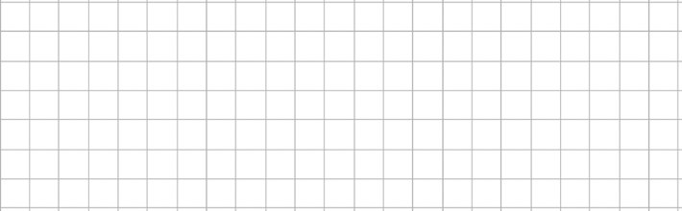

8. Solve the inequality $5x - 3 ≥ 12 , where$ $x$∈ R, and display it on a number line.


