Name: Nets of 3D Objects Date:

- A net is a _________________________________________________________
- We use nets to help us: ____________________________
____________________________
A. Inspect each of these shapes and decide if it is a net of a cube. Write net or not a net in the box below each shape. Can they fold into a cube?
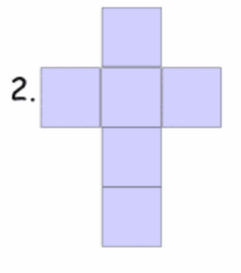
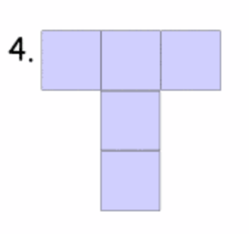
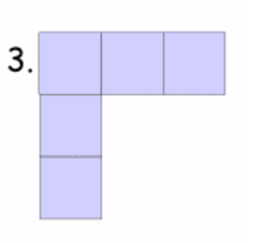
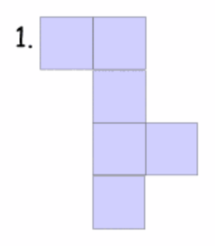

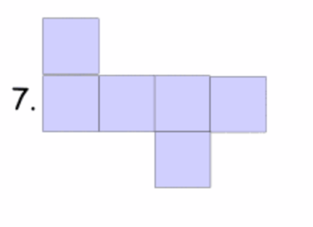
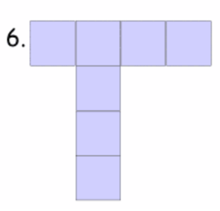
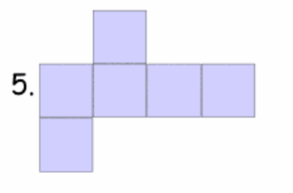

B. Investigating the net of cube:

1. How many sides does a cube have? What shape is each side?

2. If each side of a cube is 4 cm, how do we calculate the area of each side?

3. Draw the net of a cube with each side 4 cm. Use the coloured paper, and a ruler.

4. Before cutting out the net, write the area on each side.

5. Cut out the net and fold it to see if it correctly makes a cube.

6. What is the total surface area of the cube?

B. Investigating the net of a cylinder:

1. How many sides does a cylinder have? What shape is each side?

2. If the radius of the cylinder is 2 cm, how do we calculate the area of each side?

3. Draw the net of a cylinder with radius 2 cm and height 8 cm.

Use the coloured paper, a compass, and a ruler.

4. Before cutting out the net, write the area on each side.

5. Cut out the net and fold it to see if it correctly makes a cylinder.

5. What is the total surface area of the cylinder?

