Calculate the Surface area of the following 3D shapes:
Green
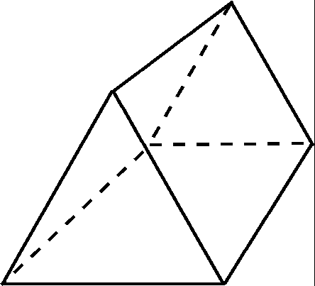
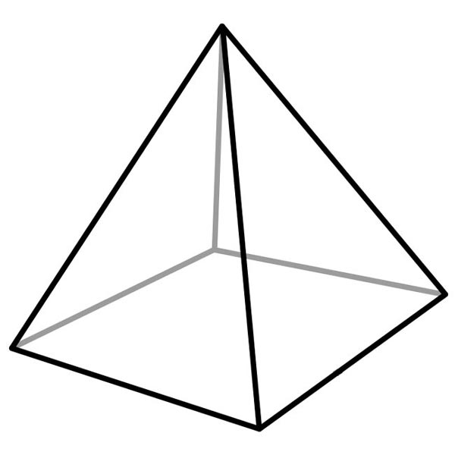
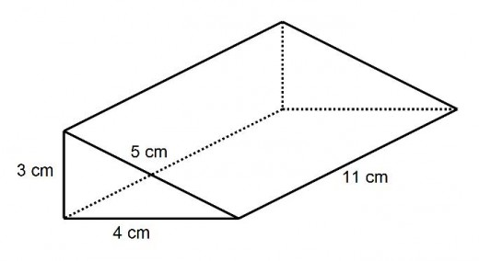
15m
14m
6cm
11cm
15m
8cm
Red
Amber
5m
2cm
7cm
6cm
1m
2cm
3m
2m
5m
12m
8mm
15m
15m
8mm
8mm
6cm
6cm

