Algebra – Creating Expressions

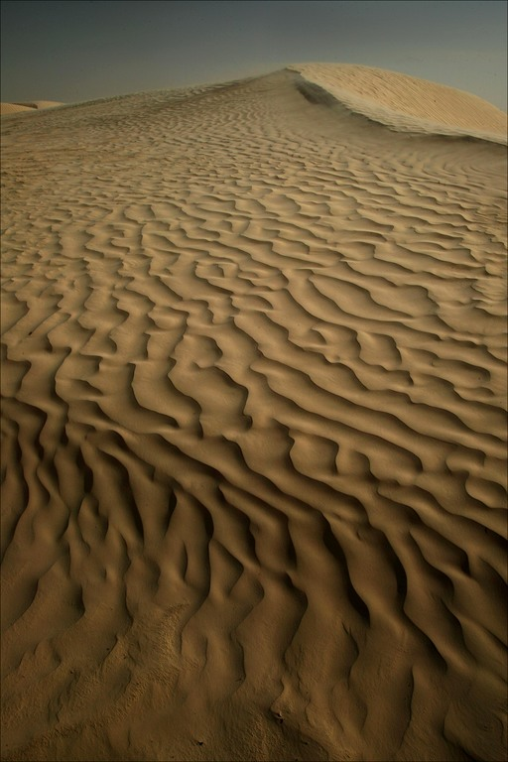
Copy and complete the following:

1) There are …………. grains of sand in this picture .

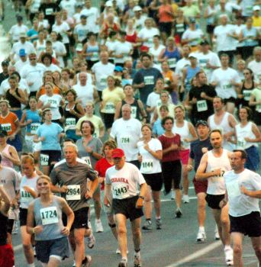
2) If I take 10 grains of sand. There will now be …………… grains of sand.

3) There are …………. people in this picture.

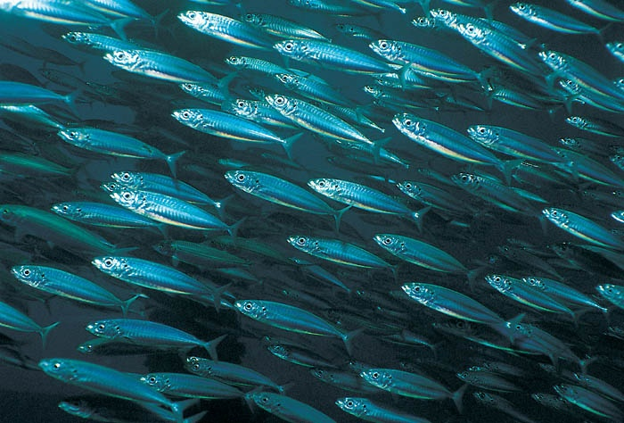
4) If 7 more people join the race there will ……………….. people in the race.

5) There are …………. fish in this picture.

6) If another 200 fish arrive. There will …………… fish

Write an expression for each sentence – read the example below

Example - I have £y and find £6. I now have y + 6 pounds

7) I have £w and lose £10. I now have …………….

8) Bob is k years old. In 5 more years he will be ……………. Years old.

9) Tom cycles 6km to school. He then cycles j km to meet Bill. Altogether he cycles ……………… km.

10) Molly scores 20 in a test. She has z marks taken away for copying. Molly now scores ……………… marks.

For each sentence a) choose a letter for the unknown value
b) use the letter to write an expression

11) I have some money in my wallet. I spend £8. I now have ………..

12) James is 45kg. He loses some weight. He now weighs ………..

13) Jack is 125cm tall. He grows a few more centimetres. Jack is now …………. cm tall

14) Arthur has a piece of wood. He cuts 50 cm off the wood. The new length of the wood is …………… cm.

