Drawing Nets of Cuboids

On square paper draw the nets of the following cuboids and then work out their volume and surface area.
Remember to use a ruler and look closely at the measurements.
Hints
Volume of a cuboid = L x W x H

Area of a rectangle = L x W
1.

3cm

3cm
3cm

2.
3cm
5cm
2cm

3.

2cm
1cm
6cm

4. 5. Extension
5cm
1cm
2cm
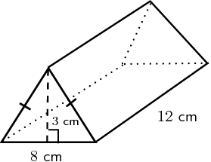
5cm

Volume of a prism = Area of the triangle multiplied by the length.

Answers
1. Volume = 54cm³
Surface area = 27cm²

2. Volume = 30cm³
Surface area = 62cm²

3. Volume = 12cm³
Surface area = 40cm²

4. Volume = 10cm³
Surface area = 34cm²

5. Volume = 144cm³
Surface area = 192cm²

