Name: Length-Area-Volume Test Date:
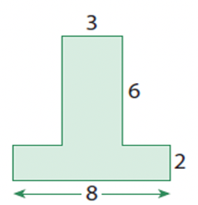
1. Find the perimeter and area of each of these shapes:
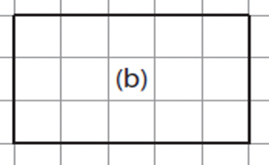
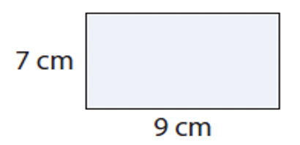
(a) (b) (c)

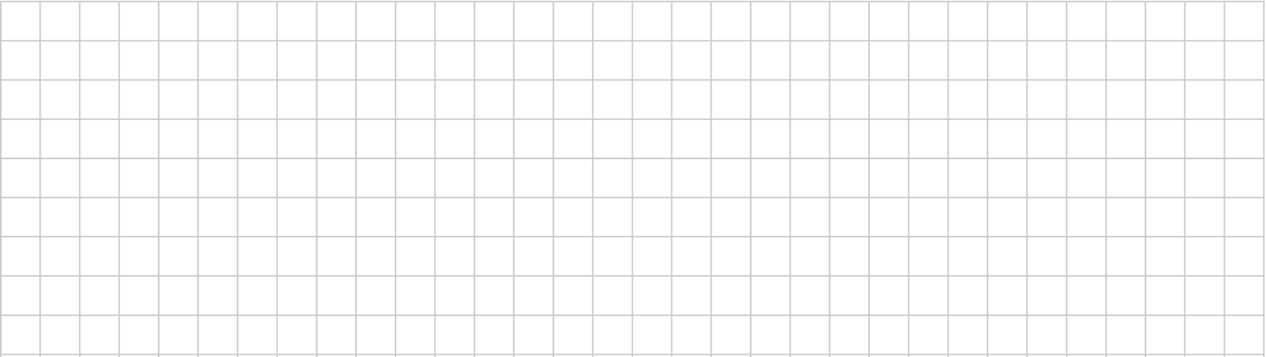

2. Find the area of these shapes:
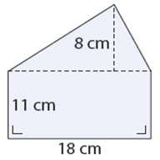
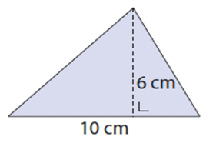
(a) (b) (c)
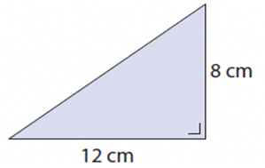



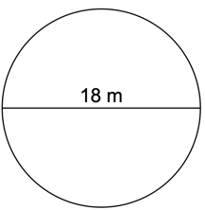
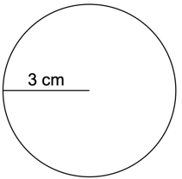
3. Find the circumference and area of these shapes. Round your answers to 2 decimal places.

(a) A circular garden with radius = 5cm (b) (c)

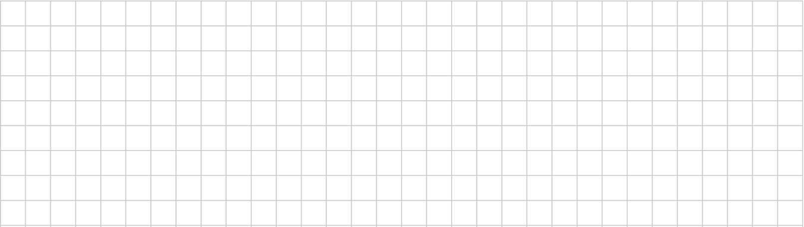

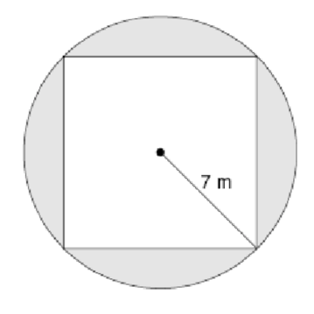
4. What is the area of the shaded region?


5. Find the volume of each of these shapes. Round your answer to 2 decimal places.
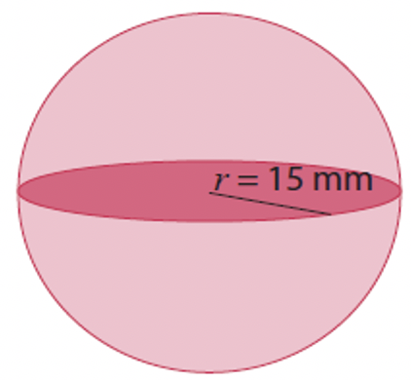
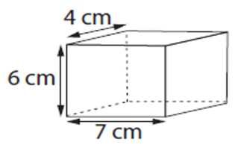
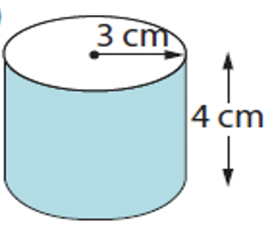
(a) (b) (c)

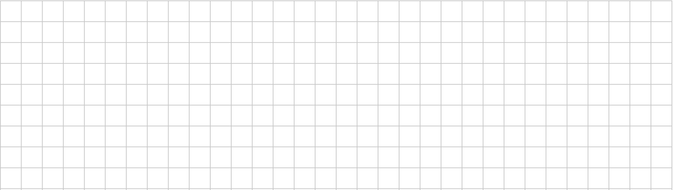

Perimeter of rectangle, irregular shape

Area of rectangle, irregular shape

