Title: How can I use a classroom response system to facilitate constructivist teaching and learning in my post-primary mathematics classroom?

Name: Cian Mac Liatháin
Supervisor: Kathy O'Sullivan

Table of Contents
List of Figures 3
List of Tables 4
1. Abstract 5
2. Introduction 5
3. Literature Review 7
3.1. Educational Technology Policy in Ireland 7
3.2. Educational Technology in the Mathematics Classroom 9
3.3. Formative Assessment and ICT 13
4. Methodology 16
5. Findings 23
5.1. Reflective Journal and Observation 23
5.2. Plickers Artifacts 25
5.3. Topic Surveys 28
5.3.1. Statistics Likert Scale 29
5.3.2. Algebra Likert Scale 30
5.3.3. Length, Area and Volume Likert Scale 31
5.3.4. Number Likert Scale 32
5.4. General Survey 33
5.4.1. Qualitative Questions 33
5.4.2. Qualitative Questions 34
5.5. Quiz Results 35
6. Discussion 36
7. Conclusion 38
8. Bibliography 39
9. Appendices 47
Appendix A: example of laminated Plickers card 47
Appendix B: Example of Consent form and Information sheet given to students and parents 48
Appendix C: Example of Pre/Post Overall Survey 50
Appendix D: Example of Pre/Post Topic Survey (Statistics) 51

List of Figures

Figure 5.2.1: Plickers Class Scoresheet.
Figure 5.2.2: Plickers Individual Student Report.
Figure 5.2.3: GIF of a cube
Figure 5.2.4: TeXify-Plickers
Figure 5.3.1: Stacked barchart of Statistics Likert Scale
Figure 5.3.2: Stacked barchart of Algebra Likert Scale
Figure 5.3.3: Stacked barchart of Length, Area, Volume Likert Scale
Figure 5.3.4: Stacked barchart of Number Likert Scale
Figure 5.4.1: Stacked barchart of Overall Likert Scale
Figure 5.5.1: Boxplots of Plickers Maths Quiz results
Figure 5.5.2: Scatter plot of change in likert score and end-of-topic quiz results

List of Tables

Table 4.1: Outline of data collection sources and their descriptions
Table 4.2: Timeline of action research project
Table 5.4.1: Qualitative question answers

Abstract
Technology has revolutionised many industries and educational technology has emerged as an important topic educational policy, but the everyday practices of post-primary mathematics teacher have changed very little over the past few decades. Constructivism is another emerging topic, and a classroom response system is an example of how educational technology can be implemented in line with constructivist ideals of personalised feedback and formative assessment. This action research project, carried out by a final year Bachelor of Mathematics & Education student, investigates how the classroom response system Plickers can be integrated into their practice can promote a constructivist learning environment, and how their identity as a teacher research develops in the process. Challenges of teacher action research are discussed from a student teacher's perspective. Findings show that post-primary mathematics students became more comfortable sharing opinions in class, and both the researcher and particpants felt that the classroom response system lead to more effective feedback for the students. A moderate correlation was found between student's engagement in classroom discussion and their maths test scores.
Keywords: educational technology, classroom response system, constructivism, formative assessment, post-primary mathematics education, action research

Introduction
Technology has undoubtedly had a widespread effect on our everyday lives over the past few decades. With such major innovations as the connectivity of the internet or the utility of smartphones, it is hard to think of many fields that have not adapted to the new opportunities that technology brings. There is an extensive, and growing, body of research on the effect that this digital age is having on all aspects of society (Dijk & Hacker, 2003; Servon, 2008; Organisation for Economic Co-operation and Development (OECD), 2019a). The education system is often described as a fundamental aspect of a functioning society, particularly as part of a group of interdependent systems where its role involves the transmission of shared societal values and the teaching of specialised skills that society values (Durkheim, 1956; Sadovnik, 2011). It should be no surprise, consequently, that the opportunities and changes in values brought about by technological innovations have grown to “significantly affect multiple facets of education” (OECD, 2019b, p.3). Nevertheless, the history of educational technology in the classroom has been described as resulting in disappointment and falling short of its potential to make significant long-lasting change in students’ learning (Rosenberg, 2001; Keengwe et al., 2008).

There is an especially strong history and synergistic relationship between technology and the subject of mathematics (Carreira et al., 2017). The simple abacus, for example, has evolved into the modern calculator that is undeniably useful at all levels of mathematical education. Conversely, the functioning of modern technology at its most basic level is firmly cemented in the binary mathematics of ones and zeros. Hansson (2019, p. 117) emphatically states that “modern technology would be unthinkable without mathematics. The relationship is reciprocal since mathematics also needs technology.”

This strong relationship does not necessarily mean that applying technology to mathematical teaching will result in increased student learning, however. The OECD (2015, p.15) explain that the complicated relationship between students, technology, and learning has meant that “the real contributions ICT can make to teaching and learning have yet to be fully realised and exploited”. Studies have shown that technological resources used in a way that is not effectively integrated into practice will not result in better learning and may in fact be a detriment to it (Tolmie, 2001; Mangen et al., 2015). Accordingly, contrasting views on the efficacy of technology use in education have resulted in differing cultures in schools. Perhaps the most prominent example of this, in Ireland and internationally, is the emergence of “tech-driven” schools that are strongly aligned with tech-driven pedagogies (Marcus-Quinn et al., 2019). In contrast, France has issued a blanket ban on mobile phone use in schools, as have individual schools throughout Ireland and elsewhere (Marcus-Quinn et al., 2019). There has been a call for educational policy to acknowledge the place of technology in the wider educational context, stressing that changes are also required to pedagogy and assessment for technology to have a significant, positive, impact (Keengwe et al., 2008; OECD, 2015).

This following review of relevant literature will investigate how educational technology policy in Ireland has grown over time, how educational technology is currently being used in mathematics classrooms, and which aspects of educational technology might be implemented in the mathematics classroom to meet the goals of current policy.

Literature Review

Educational Technology Policy in Ireland
In their analysis of educational technology policy in Ireland, McGarr & Johnston (2019) identify three distinct phases of policy over the last two decades. Phase 1 is marked by Schools IT2000: A Policy Framework for the New Millennium (Department of Education and Science (DES), 1997) and the follow-up policy, Blueprint for the Future of ICT in Irish Education (DES, 2000). Schools IT2000 is acknowledged as the first long-term funding of information and communications technology (ICT) in primary and post-primary schools throughout Ireland (McGarr & Johnston, 2019). The policy set out investment of £40 million into classroom resources and ICT infrastructure, teacher skills development and support, and policy and research (DES, 1997). This investment began the development of online resources (e.g. ScoilNet) to support teachers by providing an online database of ICT-related resources and supports (DES, 1997). In acknowledgement of Ireland lagging “significantly behind its European partners in the integration of ICTs” (DES, 1997, p.2), the policy emphasised that “ICTs need to be integrated into first and second-level curricula” (DES, 1997, p.14). In hindsight, the policy’s aim of ICT integration is seen largely as aspirational: while it identified the importance of ICT integration in order to develop “important skills necessary to our future economic wellbeing” (DES, 1997, p.1), it failed to outline how exactly it would be integrated (McGarr & Johnston, 2019). The follow-up policy Blueprint for the Future of ICT in Irish Education funded further investment into developing the ICT infrastructure of schools and failed again to detail a clear plan for pedagogical integration (DES, 2000). Phase 1 is summarised then as resulting in an increased effort towards improving the technological infrastructure of schools, but lacking guidelines for its application.

Phase 2 includes the key policies Investing Effectively in ICT in Schools 2008-2013 (DES, 2008) and Smart Schools = Smart Economy (DES, 2009). These policies involved further investment into the ICT infrastructure of schools, and policy focus began shifting towards the learning experience of students (McGarr & Johnston, 2019). Both policies recognised the growing prevalence of technology in students’ lives and outlined how ICT integration could allow for a more student-centred approach to teaching if schools embraced the “process of transforming themselves into purposeful e-learning environments” (DES, 2008, p.11). These policies have since been criticised for being written in such a way that their dominant economic discourse and neo-liberal ideology is often at odds with their educational goals, leading to “the coherence of the text dissolving under close reading” (Costello, 2012, p.80). Resultingly, most of the funding went towards the provision of “teaching computers and digital projectors” (DES, 2009, p.27), which were used to “merely digitize traditional teacher-centred approaches” rather than develop the student-centred pedagogies that were envisioned (McGarr & Johnston, 2019).

The current phase, Phase 3, is framed by the Digital Strategy for Schools 2015-2020 (DES, 2015). This strategy builds further on previous efforts of ICT integration, and has achieved important milestones in terms of its key themes: (i) teaching, learning and assessment using ICT (ii) teacher professional learning (iii) leadership, research, and policy and (iv) ICT infrastructure (DES, 2015). A Digital Strategy Action Plan has been published yearly in an effort to highlight the progress of carrying out the Digital Strategy’s key objectives (DES, 2019). In contrast to the policies of earlier phases, the funding outlined in in the Digital Strategy is provided to schools alongside clear guidance for its use in the form of the Digital Learning Framework (Professional Development Service for Teachers (PDST), 2017). Falling under theme (i) ‘teaching, learning and assessment using ICT’, the Digital Learning Framework is informed by academic research and “constructivist principles”, adapting the UNESCO ICT Competency Framework for Teachers to support successful ICT integration into Irish schools (PDST, 2017, p.1). The Digital Learning Framework provides subject-specific support for the integration of ICT into practice, and it is intended for it to inform any developments in subject curricula, including the recent Junior Cycle reform (PDST, 2017; DES, 2019). The objectives of theme (ii) ‘teacher professional learning’ have been carried out by making the use of ICT “a mandatory element” of initial teacher education, and providing in-depth Embedding ICT in Teaching, Learning and Assessment workshops for the continuous professional development of all teachers (DES, 2019, p.11). Similar professional development strategies have been implemented successfully in other countries for improving the pedagogical use of ICT (Ananiadou & Rizza, 2010). Actions related to theme (iii) ‘leadership, research and policy’ include strong engagement with industry and the promotion of innovative educational technology use through the School Excellence Fund (DES, 2017). In terms of theme (iv) ‘ICT infrastructure’, the Digital Strategy has successfully provided all post-primary schools throughout the country with high-speed broadband (DES, 2019). Furthermore, the policy involves a commitment of €210 million of multi-annual investment into school technology, €155 million of which has been issued to date (DES, 2020).

The goals of Phase 3 can be seen as more realistic than previous phases of educational technology policy due to the clear acknowledgement of the difficulty involved in integrating ICT into “traditional school practices” (DES, 2015, p.19) and the identification of “a constructivist pedagogical orientation” as being important for “effective use of digital technology” (DES, 2015, p.21). This promotion of a constructivist approach reflects similar developments in the Project Maths and Junior Cycle reforms, and it is hoped that this will result in the embedding of ICT as teachers align with a student-centred approach (DES, 2019). Thus, it has been shown how educational technology policy in Ireland has developed over time to a stage where it recognises the wider educational context that it finds itself in. McGarr & Johnston (2019, p.16) have described this evolution of policy as a sign of “pedagogical maturity”, explaining that the issue has changed from an isolated problem of technology integration to a more general issue of using educational technology to facilitate student-centred learning alongside constructivist developments of curricula. Policy has developed to acknowledge that any changes to teaching and learning brought about by educational technology will require “rethinking the role of teachers” (DES, 2015, p.11), and therefore the commitment of the social actors involved is critical for effective implementation of technology. It is important, then, to better understand the beliefs and practices of mathematics teachers in Ireland with regards to educational technology use.

Educational Technology in the Mathematics Classroom
Investigations into the use of technology by teachers often categorise the factors influencing its use into two groups: first-order external factors of resource availability, school culture and support, and subject culture and assessment; second-order internal factors of teacher’s knowledge and skills, and teacher’s attitudes and beliefs (Hew & Brush, 2006; Ertmer et al., 2012). Research on situations where the first-order factors have been satisfied has shown that the second-order internal factors of teacher knowledge and beliefs are the biggest determinants of how, and whether, technology is used in the classroom (Ertmer et al., 2012). Consequently, Tabach & Slutzky (2017) advise that for researchers to identify innovative ways that technology can improve the teaching and learning of mathematics, it is important to first understand the everyday knowledge, beliefs and practices of mathematics teachers.

Mishra & Koehler (2006) have identified three types of knowledge needed for a teacher to effectively embed ICT into their practice: technological, curriculum content, and pedagogical. The Technological Pedagogical Content Knowledge Framework (TPACK) recognises the complexity of ICT use in the classroom, outlining how these three types of knowledge and their interrelationships are needed for effective teaching using ICT (Mishra & Koehler, 2006; DES, 2015). Even in situations where teachers possess sufficient technological, pedagogical and content knowledge, their beliefs about learning and technology have been shown to have the strongest influence on the integration of technology in their classroom (Palak & Wallis, 2009; Anderson et al., 2011; Donnelly et al., 2011).

A constructivist framework of learning views the role of the teacher as that of a facilitator of students’ learning, emphasising the students’ autonomy and how they personally construct knowledge based on social interaction, active learning, and their previous experience (Anderson & Piazza, 1996; OECD, 2009a; Jones et al., 2010). This is often viewed in contrast with the more traditional “direct transmission” view of teaching which sees the teacher in the role of an instructor, transferring fixed knowledge to students through demonstration and providing information directly (OECD, 2014, p. 217).

Post-primary mathematics teaching in Ireland has recently undergone major reform as a result of Project Maths, an initiative that encourages “an investigative, constructivist approach to teaching and learning” (Cosgrove et al., 2012, p.2). Internationally, there is a similar trend toward constructivist beliefs, with most educational systems embracing constructivist ideals (OECD, 2012; Cerqua et al., 2017). An international survey of post-primary teachers has shown that, while Irish teachers endorse constructivist beliefs more strongly than direct transmission, they support constructivist beliefs relatively less-so and support traditional direct transmission beliefs relatively more-so than their international peers (Gilleece et al., 2009; OECD, 2009a). Putten et al. (2014) warn that the relationship between beliefs and practice is complex, recognising a significant disparity between some mathematics teachers’ beliefs and actions. In practice, Irish mathematics teachers are seen to teach more often with traditional structural practices than with student-centred approaches, though the extent to which traditional practices are favoured has lessened since the introduction of Project Maths (OECD, 2009a; Shiel & Kelleher, 2017). For reasons of lesson structure and classroom management, some evidence suggests that a combination of traditionally structured practices and constructivist approaches may result in the most student learning, but classrooms are still often dominated by the former (OECD, 2009b; Cerqua et al., 2017; Sorensen & Robertson, 2017).

Teachers tend to integrate technology in line with their pedagogical orientation (Ertmer et al., 2012). Various types of technology and their corresponding mathematical applications mean that there are many ways for teachers of all orientations to integrate technology into their classroom to strengthen students’ learning (National Council of Teachers of Mathematics (NCTM), 2015; Drijvers et al., 2016). The NCTM (2015) advise that mathematics-specific technologies support students in their exploring, understanding and identification of mathematical concepts. Such technologies include “computer algebra systems, dynamic geometry environments, interactive applets, handheld computation, data collection and analysis devices, and computer-based applications” (NCTM, 2015, p.1). Additionally, subject-neutral technologies such as web-based digital media and collaboration, communication, and presentation tools can “enhance student-student and student-teacher interactions to support and enrich sense making” (NCTM, 2015, p.2). Traditionalist and constructivist teachers alike can strategically design lessons around technological tools to improve the “learning of mathematical procedures and skills as well as the development of advanced mathematical proficiencies, such as problem solving, reasoning and justifying.” (NCTM, p.2). Importantly, however, teachers who align with traditionalist ideals use ICT less often than those with constructivist beliefs (Chai, 2010; Badizadegan, 2015). Furthermore, it has been shown that teachers aligned with traditionalist ideals utilise ICT less effectively than those utilising ICT in alignment with constructivist beliefs (Tondeur et al., 2008; Kim et al., 2013; Genlott & Grönlund, 2016).

Despite the increased efforts made by educational technology policy to address first-order and second-order barriers to ICT integration, these barriers remain strong in Ireland’s mathematics classrooms today. In their evaluation of the impact that Project Maths has had on mathematics teaching, Shiel & Kelleher (2017) highlight some important data provided by Mullis et al.’s (2015) Trends in International Mathematics and Science Study (TIMSS).
In terms of ICT infrastructure, Shiel & Kelleher (2017) advise that access to technology is low in Ireland relative to other OECD countries. TIMSS investigated the availability of computers for students in second year maths classes. In Ireland, 6.3% of students were in classes reported to have individual computing devices available to students, compared to an OECD-16 average of 12.5%. Only 2.7% of students were in classes with access to shared computing devices, compared to an OECD-16 average of 13.4%. Just 20.4% of students were in schools where their class could sometimes access computers elsewhere in the school for their mathematics lesson, compared to 29.7% OECD-16 average. Only 25% of Irish post-primary mathematics teachers involved in TIMSS had access to a computing device for their classes, whether that be “individual devices, sharing of devices or access to devices elsewhere in school” (Shiel & Kelleher, 2017, p.115). Drawing attention to the area of professional development, Shiel & Kelleher (2017, p.169) explain that while 65.2% of the Irish teachers involved in TIMSS had undergone professional development in the area of ICT use in mathematics teaching, compared to a 45.1% OECD-16 average, many of those teachers felt “a lack confidence in the use of ICTs for mathematics teaching and learning” and “unable to maximise its potential” even when ICT infrastructure is available.

Participant teachers reported using ICT for “classroom demonstrations, checking of homework, taking classroom- and home-administered tests, and as a tool for students to use in problem solving” (Shiel & Kelleher, 2017, p.137). The most common use was for classroom demonstrations, and GeoGebra was reported to be the most common resource used. The dynamic geometry and algebra software was praised for improving classroom demonstrations, student visualisation and problem solving but concern was also expressed for how “it appears that teachers are using GeoGebra (and other software) in class more often than students” (Shiel & Kelleher, 2017, p.137). Some participant teachers failed to see the value of ICT use, commenting that these technologies would not be available to students in their exams. Others acknowledged the potential of ICT integration and the constructivist teaching practices encouraged by the Project Maths Development Team, but these are often seen as impractical compared to quicker, traditional, methods: “you either get the course completely done or you do it in the spirit of Project Maths, in which case you run out of time” (Shiel & Kelleher, 2017, p.124). It is evident that the integration of ICT in Ireland’s mathematics classrooms is constrained not only by first-order barriers like limited available technological resources, but also second-order barriers like teacher beliefs. Shiel & Kelleher (2017, xx) advise that “there is significant scope for enhancing the use of ICTs for mathematics, and teachers need additional support in the area.”.

Tondeur et al. (2008, p.2550) advise that the relationship between teachers’ beliefs and actions is bi-directional, explaining that “beliefs lead to actions, which, in turn, lead to the creation of new, reconstructed or reaffirmed beliefs”. They suggest that certain types of ICT use can motivate teachers to develop a more constructivist practice, but the teacher “must see the utility of using a particular technology” for this to occur (Tondeur et al., 2008, p. 2551). As outlined above, teachers' use of ICT is influenced by other factors like technological infrastructure, pedagogical orientation, curriculum and assessment demands, and time constraints. For teachers to see the utility of a particular technology, it is important to consider the wider context of their practice, as it is possible that other pedagogical demands made of mathematics teachers limit their ability to prioritise ICT integration. The constructivist approach espoused by Project Maths and reflected again in Framework for Junior Cycle, for example, emphasises the importance of formative assessment for enabling “students to build on their learning to date” (DES, 2015, p.11). I feel it is important, then, as a student teacher beginning their lifelong professional development, to explore the possible utility of a technological approach to formative assessment, so as to increase the potentiality of implementation by myself or other teachers in future.

Formative Assessment and ICT
Formative assessment has been described as a method of assessment where evidence of student understanding "is elicited, interpreted, and used by teachers, learners or their peers, to make decisions about the next steps in instruction that are likely to be better, or better founded, than the decisions they would have taken in the absence of the evidence that was elicited” (Black and William, 2009, p.7). In their synthesis of over 800 meta-analyses related to achievement and assessment, Hattie (2009, p.22) concluded that “the biggest effects on student learning occur when teachers become learners of their own teaching and when students become their own teachers.” It can be said that formative assessment, or assessment for learning, happens “here and now” in the classroom and provides feedback not only to “students about the quality of their work and their levels of understanding” but also to teachers about the strengths and weaknesses of their teaching (Warner, 2011, p.336; Cizek, 2010). This concept of feedback is a core component of formative assessment, and it has been shown to have the potential to facilitate the constructivist principles of student autonomy and personally constructed knowledge when incorporated into social and active learning (O’Mahony, 2017). Effective feedback, clear learning intentions, self and peer assessment, and classroom dialogue have been identified as essential aspects of formative assessment in the mathematics classroom (Wiliam, 2011; DES, 2015)

Technology-enhanced assessment, where technology is used “to extend or add value to assessment and feedback processes” (JISC, 2010, p.57), has been identified as an area of increasing importance in education (Beatty & Gerace, 2009; Luckin et al., 2016). The EU-funded Formative Assessment in Science and Mathematics Education (FASMED) project is an example of collaborative, international, research undertaken with the aim of identifying how technology-enhanced formative assessment can be implemented to improve the understanding and achievement of students (CORDIS, 2017). Research from FASMED has shown that applying technology to formative assessment can result in improvements to: examining students’ learning progress, collecting student interactions over long periods of time and multiple classrooms, providing immediate personal feedback, scaffolding conceptual understanding, facilitating students' active role in classroom discussion and encouraging reflection and self-regulated learning (Cusi et al., 2019).

One promising example of technology-enhanced assessment is the classroom response system (CRS) (Beatty & Gerace, 2009; Russell, 2010; Cusi et al., 2019). CRSs are a form of networked technology that allow teachers to interact with students by offering different types of questions and polling the students’ answers. Beatty & Gerace (2009) have outlined a cycle that teachers can follow alongside their Technology-Enhanced Formative Assessment (TEFA) pedagogy to scaffold and foster constructivist learning:
- present thought-provoking question to the class
- give time for students to consider the question and their answer, either individually, in pairs, or in groups
- use CRS to gather, record and display students’ responses
- allow student-led whole-class discussion on their differing perspectives and assumptions
- summarise the discussion, providing feedback based on the different answers
- repeat cycle, analysing the recorded responses to inform further assessment
The effectiveness of a CRS is said to be dependent on “the quality of questions posed” and “the response options offered by teachers” (Russell, 2010, p.135). Research into CRSs to promote mathematical learning has suggested the use of four different types of polls to either a) “provoke thinking and exercise a cognitive skill”, b) “elicit a misconception and “stimulate discussion with questions having multiple reasonable answers”, c) improve students ability to reflect and develop strategies to face specific mathematical tasks and d) identify students’ feelings and opinions on different mathematical topics and approaches (Cusi et al., 2019, p.13).

Typically, classroom response systems require students to each have their own device, with the students’ devices (e.g. smartphone, tablet, clicker) networked to a display-connected device controlled by the teacher. This means that most forms of classroom response systems (e.g. Kahoot!, Quizalize, Quizizz, Socrative) are unsuitable for many post-primary mathematics classes due to the lack of ICT infrastructure (Tabach & Slutzky, 2017). Plickers, short for paper clickers, is unique as a CRS in that it doesn’t require the students to use special technological equipment or software (Kent, 2019). Instead, the entire CRS consists of a teacher’s smartphone, a projector and QR codes printed on card or paper. Each QR code has four orientations, and the students select their responses by rotating their QR code depending on their choice from a four-option pole. These codes are then held up by the students and scanned by the teacher’s phone camera. The data is displayed in real-time through the projector, available for classroom discussion, and also archived on the teacher’s Plickers account for further analysis. This form of CRS has been described as easily accessible, low cost, and has successfully been implemented to promote active learning and increase student engagement (McCargo, 2017; Chng & Gurvitch, 2018; Charalampos, 2019).

This review of relevant literature has helped me better understand the history of ICT use in Ireland’s mathematics classrooms. After assessing current educational technology policy, and prominent barriers to ICT integration, I concluded that research into applying ICT to assessment, with a constructivist approach, could provide utility for teachers teaching in the climate of Project Maths and the new Junior Cycle. By identifying ways that technology could enhance formative assessment, while remaining conscious of accessible ICT infrastructure, I am lead to a research question that I am excited to investigate further:

How can I use the classroom response system Plickers to facilitate constructivist teaching and learning in my post-primary mathematics classroom?

Methodology
This is a self-study, mixed-methods, action research project that was was carried out during the final-year teaching placement of my BA in Mathematics & Education. My interaction with educational theory throughout my degree had helped me identify values that were important to my developing teacher identity, such as promoting self-efficacy, utilising educational technology, facilitating an inclusive and constructivist learning environment, and engaging in both research-informed practice and practice-informed research. During the initial planning of this action research project, however, I realised that theory quickly became an afterthought on previous teaching placements and while my actions in the classroom failed to demonstrate the values I held. I was a student of the pre-Project Maths syllabus and very used to experiencing traditionalist methods of mathematics teaching like chalk-and-talk and rote learning, methods that I continue to rely in my own classroom despite them conflicting with my aspirations as a teacher. Beauchamp & Thomas (2011, p.7) have advised that student-teachers undergo "identity shifts" as they leave the insulated environment of initial teacher education, and my own experience mirrors Hiebert et al.'s (2003, p.201) warning that student-teachers "often abandon new practices and revert to the teaching methods their teachers used" in the face of challenging classrooms. My aim for this action research project was to identify a research question that would not only improve the learning of my students, but also help me to apply the educational theory that I value and develop my identity as a teacher researcher.
My literature review led me to identify an increasing demand for Irish post-primary mathematics teachers to develop practices that incorporate educational technology (DES, 2019) as well as constructivist learning principles (DES, 2015; O'Mahony, 2017). There was evidence to suggest that certain applications of educational technology could help promote a constructivist learning environment (Gilakanji, 2013), with classroom response systems being shown to be effective in improving student engagement, promoting classroom discussion, and encouraging active learning and reflection through targeted feedback (Beatty & Gerace, 2009; Cusi et al., 2019). In particular, Plickers was identified as being an easily accessible CRS that does not require the students' to have their own devices to vote, and I was motivated to investigate further how it could be to help me actualise my educational values. My aim was to incorporate Plickers into my practice and use it as as a tool to bring about constructivist learning conditions. Indicators of constructivist teachers include those who consider the prior knowledge and experience of their students, create environments where students feel safe to question and reflect upon their understandings and support collaboration for constructing knowledge (Driscoll, 2014). The design of the questions used with the classroom response system, and the subsequent classroom discussion, were informed by two important pedagogies in the area of technology enhanced assessment: Beatty & Gerace’s (2009) TEFA and Cusi et al.’s (2017; 2019) FaSMEd framework. For reasons of validity and reliability, such heavily evidenced constructivist-based frameworks are invaluable to this investigation.
This action research project was carried out in a coeducational urban school that serves ~300 post-primary students. Classified as a Delivering Equality of Opportunity in Schools (DEIS) school, they cater for the needs of students from diverse socio-economic and cultural backgrounds including those who have had previous difficulty in other schools. The school prides itself in providing an education to all types of students based on their individual strengths, emphasising an interdenominational, academic and vocational ethos. Post-Leaving Cert PLC courses and part-time adult evening courses are also provided at the school, offering alternative pathways to higher education.

The student participants available to me for this research project were the class groups that I was teaching during my placement: first-year ordinary level, third-year ordinary level, and fifth-year foundation level mathematics students. After observing each class group, I decided to undertake the research project with my fifth-year students as their initial class size of 10 offered more potential classroom discussion and interaction than the 4 and 5 students present in the first-year and third-year groups, respectively. These fifth-year students were observed to be disengaged and uncommunicative, and I felt that they would benefit most from the intended constructivist outcomes of the intervention. Throughout the course of the placement one student move to ordinary level maths, and another stopped attending school, and their data was removed from the analysis.

Eight students participated in the study, 3 females and 5 males. The students all shared low socio-economic backgrounds and were culturally diverse with 2 Spanish students who had English as an Additional Language, 2 Irish Traveller students, and 1 non-Traveller minority ethnic student. Although the fifth-year group was chosen as most suitable for the project, the choice was limited to those pre-made class groups available to me and should therefore be treated as convenience sampling (McMillan, 1996).
Methodological triangulation is important for improving the accuracy of action research (Sullivan et al., 2016), and I felt it would provide deeper insight into the effects of implementing Plickers into my practice. I considered three sources of data: myself the teacher-researcher, the students, and the artifacts of the students’ work. Data was collected, analysed and then used to inform improvements to the application of CRS’s next iteration. In my opinion, the value of this research is in building a knowledgebase of the challenges and insights that occur in an attempt to promote constructivist learning through this intervention of technology, and applying this knowledge to refining the intervention itself. This is in line with a pragmatic, design-based approach to research (Wang & Hannafin, 2005).
The choice of classroom response system and the design of this investigation was made with due regard to the ethical context of the research. Shamoo & Resnik’s (2009, p.18) description of “principles for ethical conduct in research” has helped me identify areas that I have considered ethically:
- Health & Safety: this investigation took place at a time where students were returning to schools after the initial lockdown of the COVID-19 pandemic, with high levels of COVID-19 still in the community it was important for the investigation to be in line with safety guidelines (DES, 2020). The QR codes that were in use by students were laminated (Appendix A) and disinfected before and after use. The Plickers CRS also released a new feature that would allow students to answer from home should schools be closed again.
- Informed Consent: as all participants were under 18, consent forms (Appendix B) with the signatures of their parents and the participants themselves were obtained and the aims of the investigation were explained clearly to the participants, emphasising their participation as being optional. Of the students' 5 forty-minute mathematics classes per week, the use of the CRS was limited to 15-20 minutes of two of those, in an effort to ensure that students felt free to revoke their participation should they wish.
- Honesty: due to my pragmatic design-based approach to the research, my objective was to improve successive iterations of research-informed CRS design. This meant that it was in my best interest to remain honest in my reporting, as I was more focused on the process itself rather than producing ‘perfect’ results.
- Confidentiality: all data will be gathered confidentially. When student responses are collected by the CRS, the QR codes will correspond to generic names like ‘Student 3’ and not contain any personal information.
- Social Responsibility: the choice of CRS, and the research approach, was specifically chosen to be conscious of an evolving digital divide seen between certain types of schools based on sociodemographic, funding and infrastructure (Marcus-Quinn, 2019). I did not want to research technological applications that are only available to those students and teachers who could afford it. Plickers was chosen because the service itself can be used for free, and only requires the teacher to have a smartphone and the ability to print paper QR codes rather than personal devices per student.
The data collection, analysis, and iteration of intervention is outlined below:
- Pre-intervention Survey: the students answered a survey with both quantitative (likert scale) and qualitative (open-ended) questions to try gauge their opinion on the relationships between mathematics, learning, and technology. (Appendix C)
- Beginning of Topic Survey: the CRS was used to collect students' answers for a Likert Survey asking how comfortable they felt sharing their opinions about different aspects of the current mathematics topic we were studying in class. (Appendix D)
- Intervention: the CRS was used to present multiple-choice-questions to students, gather responses, and display the data. The CRS was based on the TEFA and FaSMEd Frameworks with the intent of promoting the type of atmosphere outlined by Driscoll (2014) above. Data was used live in class and archived for analysis by teacher. (Appendix E)
- Observation: following the implementation of the classroom response system, I observed the resulting classroom discussion. This observation helped determine if the classroom response system is facilitating constructivist teaching and learning by gathering qualitative data that was later used to inform the next iteration of the CRS.
- Reflective Journal: the use of the CRS was also expected to inform future teaching, as effective formative assessment provides feedback to both students and teacher. I kept a qualitative Reflective Journal to gather data about the challenges of implementing the CRS and how the students' use of the CRS, and the resulting archive of student responses, were effecting my teaching.
- End of Topic Quiz: students answered an end-of topic quiz (e.g. Statistics Quiz). This quiz used questions similar to ones used in the weeks prior. Students' results were analysed and compared to previous data, did the classroom discussion and feedback given to students improve performance over time?
- End of Topic Survey: The CRS was used to collect students' answers for a Likert Survey asking how comfortable they felt sharing their opinions about different aspects of the current mathematics topic we were studying in class. To be compared with students' answers at the beginning of the topic.
- Data analysis and CRS iteration: the collected data was analysed and used justify and implement possible improvement to the CRS and the implementation CRS was iterated for the next mathematics topic.
- Post-intervention Survey: The students answered a survey with both quantitative (likert scale) and qualitative (open-ended) questions to try gauge their opinion on the relationships between mathematics, learning, and technology.

Table 4.1: Outline of data collection sources and their descriptions.
 | Data Collection Source 1 and Description | Data Collection Source 2 and Description | Data Collection Source 3 and Description | Data Collection Source 4 and Description | Data Collection Source 5 and Description
Method | Design-Based | Qualitative | Qualitative | Quantitative | Mixed Methods
Purpose | Assess students current understanding, facilitate effective feedback and promote active learning. Iterated throughout the research study based on the other data sources. | Observe the class’ behavior during and after the use of CRS. Is there evidence of reflection? Active learning? Peer discussion? Ideas why/why not? | Investigate the results from CRS questions that are saved on Plickers account. Can you derive insight to inform future classes? Why/why not? Would you change type of questions asked? What kind of data would best inform your formative assessment? | Quantify students end of topic quiz. To be compared with students’ earlier responses saved on CRS system. Improvement over time? | Assess student’s point of view about how they are learning in class, necessary to determine if constructivist learning is happening. Assessed before, during, and after the intervention.
Mode of Inquiry | Plickers classroom response system | Observation | Reflective Journal | Student quiz, artifact | Likert scales and open-ended questions
Perspective | Pragmatist | Pragmatist | Pragmatist | Pragmatist | Pragmatist

Table 4.2: Outline of action research project.
Date of Action | Action
Sept 7th – 11th Sept | School orientation, identification of research class participants and dissemination of permission slips. Begin reflective journal.
Sept 14st – 18th Sept | Collection of permission slips and dissemination of initial pre-intervention survey.
Sept 21st – 2nd Oct | First iteration of classroom response system for Statistics. Followed by an end-of-topic maths quiz and a topic-relevant survey.
Oct 5th – 9th Oct | Analysis of reflective journal, artifacts of student work, and student surveys.
Oct 12th – 30th Oct | Second iteration of classroom response system for Algebra. Followed by an end-of-topic maths quiz and a topic-relevant survey.
Nov 2nd - 6th Nov | Mid-term break. Analysis of reflective journal, artifacts of student work, and student surveys.
9th Nov – 20th Nov | Third iteration of classroom response system for Length, Area and Volume. Followed by an end-of-topic maths quiz and a survey.
23rd Nov – 27th Nov | Analysis of reflective journal, artifacts of student work, and student surveys.
30th Nov - 11th Dec | Fourth iteration of classroom response system for Number. Followed by an end-of-topic quiz and a final overall survey.
22nd December – January 2021 | Organise the data, reflect on findings, discuss the results and write the conclusion and recommendations.
January – March 2021 | Prepare presentation of action research project for Final Year Research Symposium.

Findings

Reflective Journal and Observation
A reflective journal was kept throughout the duration of this action research project and was analysed after each maths topic to inform successive iterations of the classroom response system. Brookfield (2017) suggests the examination of practice through different perspectives as a means of promoting critical reflection, and this reflective journal was organised using my own autobiographical lens, the lens of the student participants, the lens of my co-operating teacher and placement school, and the lens of educational literature.

Examining my practice through my own autobiographical lens helped me identify changes in how I perceived challenges met while implementing the action research project throughout my placement. Initially, both the project and my teaching practice in general were overshadowed by the uncertainty of the coronavirus pandemic and the changes it brought to the classroom. The reality of masks and social distancing was in stark contrast with the active and communal environment I was hoping to facilitate. Another unforeseen challenge was found in the design of the questions for the CRS. I had planned to have the questions prepared in advance, but the way this class group was taught was dynamic based on students' needs and attendance and it was difficult to know which aspects of each topic would be taught until a day or two beforehand. The effect that these challenges had on my outlook didn't become apparent until after finishing the topic of Statistics, when time was set aside to analyse the reflective journal and improve the next iteration of the CRS. Sullivan et al. (2016, p.40) suggest that teacher action researchers ask themselves "why do I do what I do?" as a way of linking critical thinking, reflection and taking action. As I asked myself that question during placement, I was able to identify that the challenges I faced implementing the project lead to a lessening of my enthusiasm and sense of self-efficacy. The uncertainty of the pandemic, for example, caused me to frame this research project as something merely 'extracurricular' and its implementation felt like an inconvenience. By revisiting my literature review and methodology, I was able to re-align myself with the aims of the project and improve my enthusiasm, motivation and positivity when interacting with the students using the CRS. In particular, reminding myself of the Pragmatist perspective helped me reframe the challenges and setbacks of the project as valuable learning opportunities and the benefits of using a CRS reaffirmed my commitment to the project. After getting used to the workflow of designing sets of CRS questions, implementing them in the classroom and analysing students' results after class, I found that I felt better prepared for lessons with this fifth-year class than with other classes where the CRS wasn't in use.

Observation of, and discussion with, the student participants helped improve the implementation of the CRS throughout the project. During the initial topic of Statistics, the students were observed to be disengaged and apathetic about the classroom response system. I failed, initially, to reflect critically about why this might be the case, but after renewing my enthusiasm for the project I opened a dialogue with the students and they provided valuable feedback for how I was facilitating classroom discussion. One student remarked 'sure you want us to talk, but then you say not to talk. Easiest just not to talk at all so', referring to how I would ask students to answer the CRS questions first and then engage in classroom discussion after. Reflecting on the student's remark, I realised that my limiting of student discussion was more reminiscent of the traditionalist teaching I was trying to improve upon than the constructivist environment I was aspiring towards. Another student's comment that 'these are just questions from the book anyway' helped me recognise that I was not making consistent use of the different types of questions shown in Appendix E, and was relying on adapting maths questions from the book without much thought into how the students would perceive them. Upon reflection, I felt that this was due again to the traditionalist way in which I myself was taught where students are judged on their individual merit and are expected to work individually for the most part. These students' comments helped me realise areas for improvement, and before the next iteration of the CRS I explained to the students that classroom discussion and sharing of opinions would be allowed before voting. I also reiterated the aims of my project to the students, explaining the benefits of each type of question and how archiving their votes can help me as a teacher. The subsequent iterations of the CRS helped facilitate the type of constructivist environment I was hoping for, with students and peers much more vocal and active in their own and eachother's learning.

During the third iteration of the CRS, I grew disheartened by technical issues with the projector and felt exhausted from the other demands of placement. Discussing this with my co-operating teacher, they commented on how they felt I was "a whizz with technology" and "very good at asking the right questions to get the students engaged". My co-operating teacher's comments helped boost my confidence and sense of self-efficacy, which led to me successfully solving the issue with the projector by changing the contrast. They also helped me to appreciate how the implementation of the different types of questions with the CRS resulted in a deeper understanding of the needs of each individual student and allowed me to improve my ability to reflect-in-action in the classroom, targetting questions and giving more effective feedback based on insights gained from analysing students' previous answers.

At times throughout the project I felt conflicted between my personal philosophy as a teacher and what I felt were the expectations of the education system in Ireland, and the lens of educational literature helped me make sense of my experience during my placement. The use of questions to facilitate classroom discussion about students’ emotions towards mathematics and their opinions about tackling different problems gave me valuable insight into each student's point of view and helped me tailor my instruction to them and build their understanding. This process, however, felt like a 'waste of time' in the context of preparing the students for their school and state examinations. Research has shown that many teachers have difficulty teaching the Project Maths syllabus in line with the constructivist aims of the curriculum while also having time to prepare students for state examinations (Ní Fhloinn et al., 2018; Johnson et al., 2019), and in many cases this results in a pressure to "teach to the exam" (ESRI, p.23). Burns (2015) advises that the emphasis on standardised testing can be particularly high in DEIS schools and discusses how implicit cultural assumptions like the validity of a meritocratic education system can have a negative effect on students' learning. Reflecting on this, and on Anyon's (1980) idea of The Hidden Curriculum of Work, I felt like I understood better the resistance I felt when moving from the 'typical' types of mathematics questions and lesson structure and was motivated to continue using the CRS to try and help students be active in their own learning.

Plickers Artifacts
Students engaged in classroom discussion and answered questions using the Plickers CRS for 20 minutes, two classes per week. The data gathered from this was then analysed by the teacher and used to inform the teaching of the subsequent classes. Figure 5.2.1 shows how the Scoresheet feature of the Plickers website was used to see the overall results of the class while Figure 5.2.2 shows the Student Report feature that was used to gain deeper insights into each student's understanding and opinions of the topic.

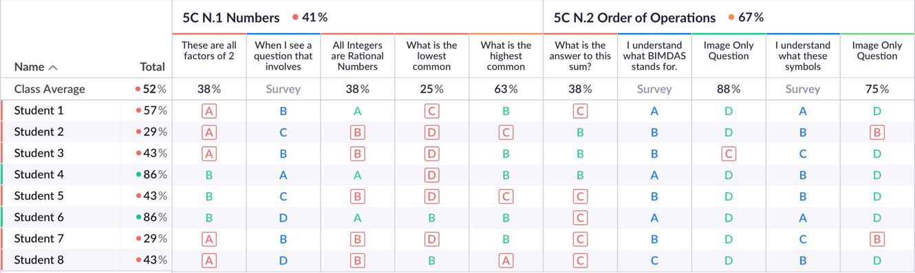
Figure 5.2.1: Class scoresheet on the Plickers website.

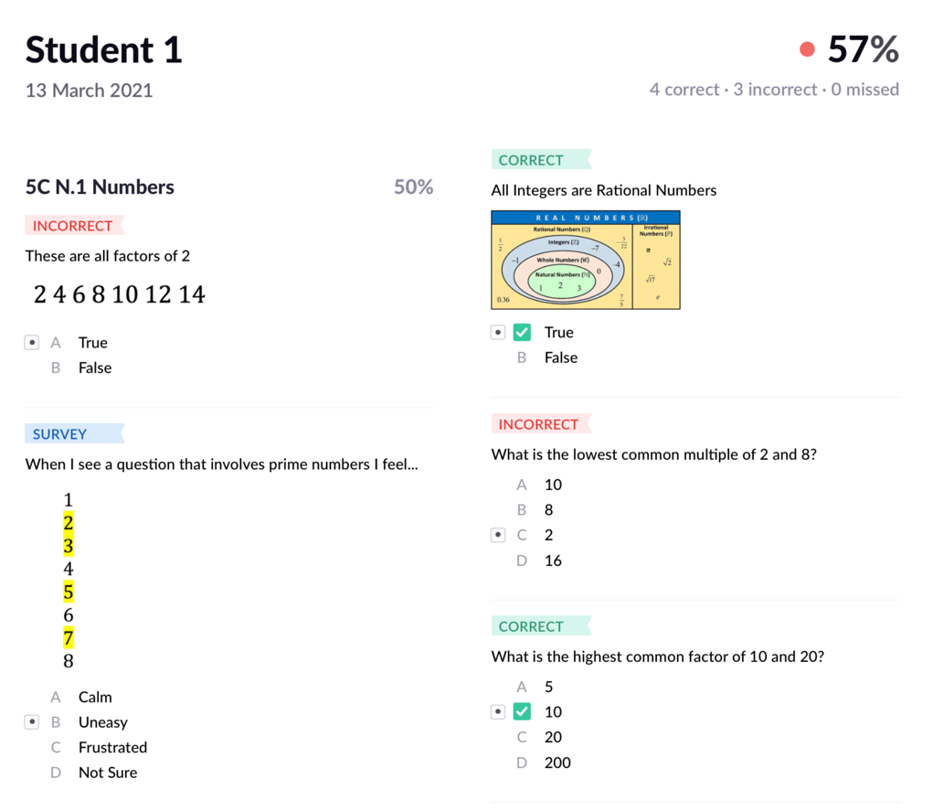
Figure 5.2.2: Individual student report on the Plickers website.

Another feature of the Plickers system that was used was its ability to display Graphics Interchange Format (GIF) images. Some questions were designed where a GIF could repeat on the projector, freeing the teacher to move around the classroom interacting with the students while they discussed the problem. An example of such a question is shown in Figure 5.2.3.
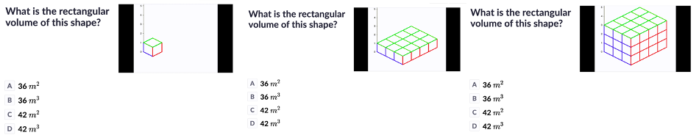
Figure 5.2.3: A GIF image was displayed beginning with a single 1 $m^{3}$cube, two more cubes then appeared below it, this line of three cubes was then duplicated 3 times, and finally this base of 12 cubes was duplicated 2 to form a cube with width of $3m$, length of $4m$, height of $3m$ and volume of 36 $m^{3}$. The repeating gif was used to facilitate classroom discussion about the relationship between width, length, height and volume.

An issue that was found with using Plickers for the teaching of mathematics was its lack of available symbols. The design of a Plickers question is limited to standard keyboard input, which can be an issue when teaching a range of mathematics topics as it is important to have consistent notation throughout students' learning. Teachers in the Plickers community resort to writing the question using alternative software (such as LaTeX) and adding a picture of this to the Plickers set. TeXify-Plickers is a free, unofficial, addon developed by the Plickers community that can be used with either Firefox or Chrome to format symbols correctly using LaTeX syntax nested between two square brackets. This was used throughout the project and helped avoid confusion caused by a lack of mathematical notation, as shown in Figure 5.2.4.

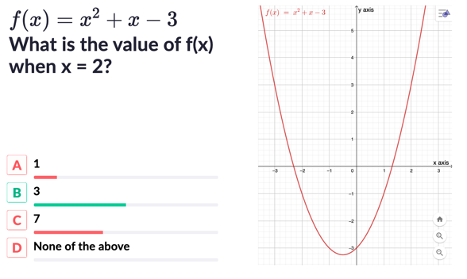
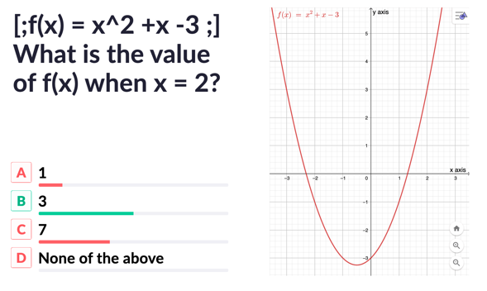

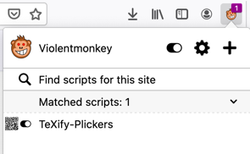
Figure 5.2.4: TeXify-Plickers was used to format the output of a typed Plickers question to LaTeX.

Topic Surveys
The data gathered from surveys given using the Plickers system at the beginning and end of each topic (Appendix D) was exported to a CSV file and analysed using RStudio. There is much debate in the literature about which statistical analysis methods are appropriate for Likert data (Jamieson, 2004; Norman, 2010; Harpe et al., 2015). For the purpose of this study, the median of student responses for each Likert item was measured and a paired Wilcoxon signed-rank test was performed comparing student's opinions at the beginning of each topic and after the CRS intervention. The Likert items were also summed and averaged to give total score for the Likert scale, and a paired t-test was performed comparing the mean before and after intervention.

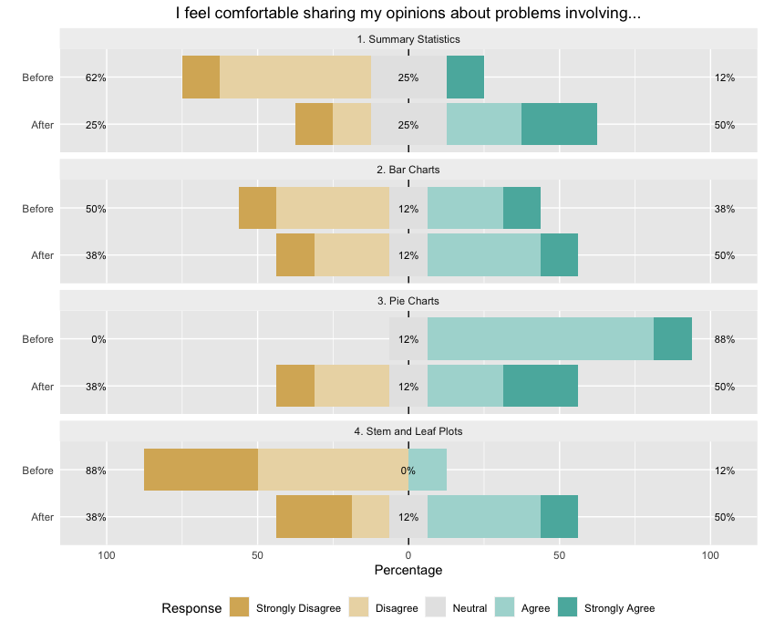
Statistics Likert Scale
Median

2

3.5

2.5

3.5

4

3.5

2

3.5

Figure 5.3.1: Stacked barchart showing the proportions of student responses to likert items indicating how comfortable they felt sharing opinions about different aspects of the Statistics topic.

A paired Wilcoxon signed-rank test returned a p-value of 0.1526 > 0.05, suggesting no evidence to reject the null hypothesis that there was a shift in distribution of answers. When each student's answers for the Likert items were summed to give a single score for the scale, the mean value for the class was 2.81 before and 3.19 after. A paired one-sided t-test returned a p-value of 0.8421 > 0.05, there was no evidence to reject the null hypothesis that the mean difference between Before and After scores was 0.

Algebra Likert Scale
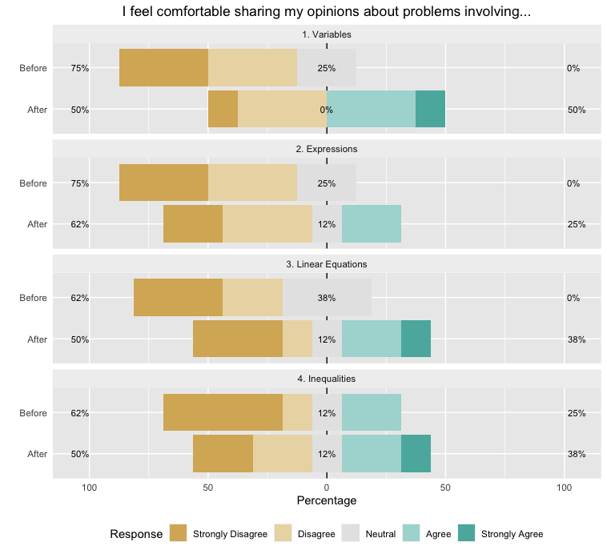
Median

2

3

2

2

2

2.5

1.5

2.5
Figure 5.3.2: Stacked barchart showing the proportions of student responses to likert items indicating how comfortable they felt sharing opinions about different aspects of the Algebra topic.

A paired Wilcoxon signed-rank test returned a p-value of 0.02 < 0.05, there is evidence to reject the null hypothesis and conclude there was statistically significant shift in the distribution of student answers. When each student's answers for the Likert items were summed to give a single score for the scale, the mean value for the class was 1.97 before and 2.69 after. A paired one-sided t-test returned a p-value of 0.09 > 0.05, there was no evidence to reject the null hypothesis that the mean difference between Before and After scores was 0.

Length, Area and Volume Likert Scale

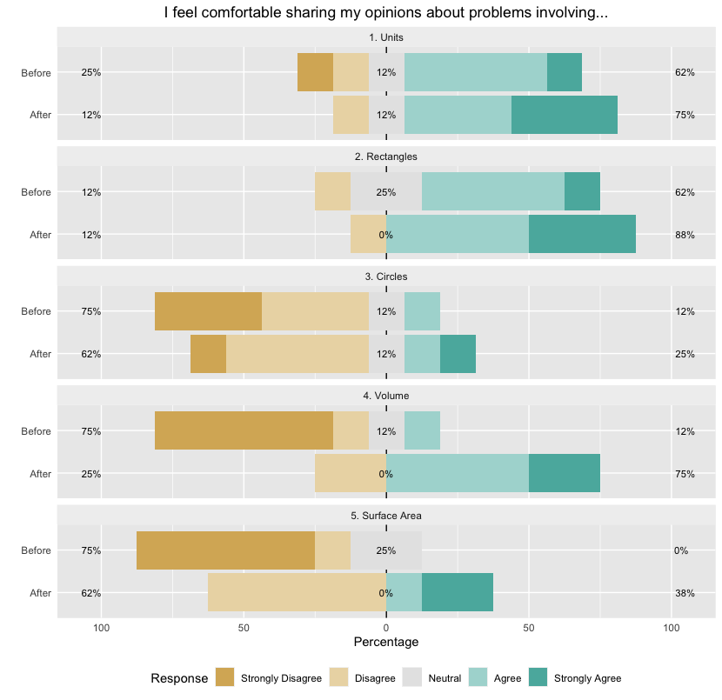
Median

4

4

4

4

2

2

1

4

1

2

Figure 5.3.3:: Stacked barchart showing the proportions of student responses to likert items indicating how comfortable they felt sharing opinions about different aspects of the Length, Area and Volume topic.

A paired Wilcoxon signed-rank test returned a p-value of 0.00001 < 0.05, there is evidence to reject the null hypothesis and conclude that there was statistically significant shift in the distribution of student answers. When each student's answers for the Likert items were summed to give a single score for the scale, the mean value for the class was 2.48 before and 3.5 after. A paired one-sided t-test returned a p-value of 0.001 < 0.05, there was evidence to reject the null hypothesis that the mean difference between Before and After scores was 0.

Number Likert Scale
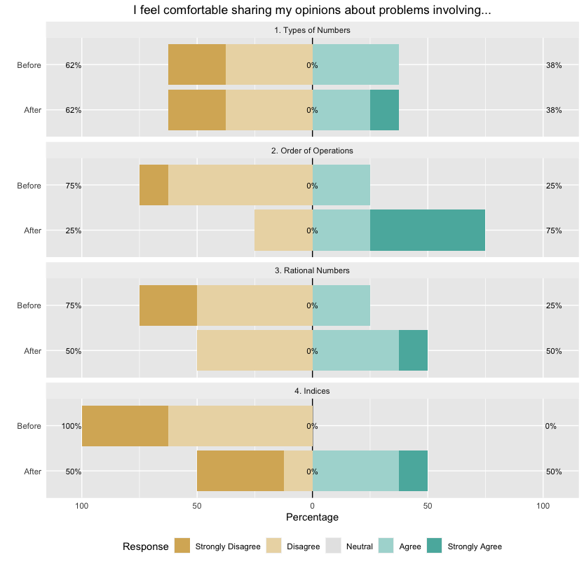
Median

2

2

2

4.5

2

3

2

3
Figure 5.3.4: Stacked barchart showing the proportions of student responses to likert items indicating how comfortable they felt sharing opinions about different aspects of the Number topic.

A paired Wilcoxon signed-rank test returned a p-value of 0.02 < 0.05, there was evidence to reject the null hypothesis and conclude that there was statistically significant shift in the distribution of student answers. When each student's answers for the Likert items were summed to give a single score for the scale, the mean value for the class was 2.19 before and 3.13 after. A paired one-sided t-test returned a p-value of 0.009 < 0.05, there was evidence to reject the null hypothesis that the mean difference between Before and After scores was 0.

General Survey

Qualitative Questions
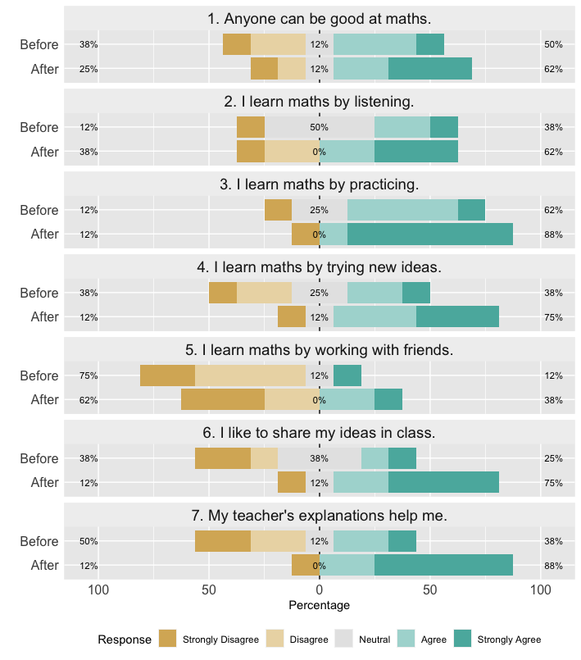
Median
3.5
4

3
4

4
5

3
4

2
2

3
4.5

2.5
5

Figure 5.4.1: Stacked barchart showing the proportions of student responses to likert items indicating how comfortable their opinions on aspects of the classroom related to a constructivist environment.

A Wilcoxon rank sum test returned a p-value of 0.02 < 0.05, providing evidence to reject the null hypothesis that there was no shift in distribution of students' answers.

Qualitative Questions
Students' answers to two open-ended questions are displayed in the tables below.
Table 5.4.1: Qualitative question answers
Does technology make maths better or worse?
Pre | Post
'Yes, it is always with us' | 'It makes it good'
'Calculators make the sums easier' | 'Much better, you don't have to waste time calculating'
'don't really have an opinion on it | 'The technology helps us share our ideas'
_________________ | 'Yeah because I can see what the class thinks'
_________________ | 'Helps me understand maths more'
_________________ | 'Yes because the teacher can help us more'
_________________ | 'I like to find new ways to help me do my maths, and share my ideas

What is your favourite thing to do in maths class?
Pre | Post
'Pie charts' | 'Fractions'
'Learn new things' | 'Algebra'
'Learn new things and new ways to help me do maths' | 'Learn'
'Listen to the teacher' | 'going home'
_________________ | 'Vote on a sum that's on the board'
_________________ | 'I like using plickers to vote'
_________________ | 'Using plickers'
_________________ | 'I like to find new ways to help me do my maths, and share my ideas

Quiz Results
Students were given an end-of-topic quiz composed of questions similar to those they had answered on the Plickers system previously.
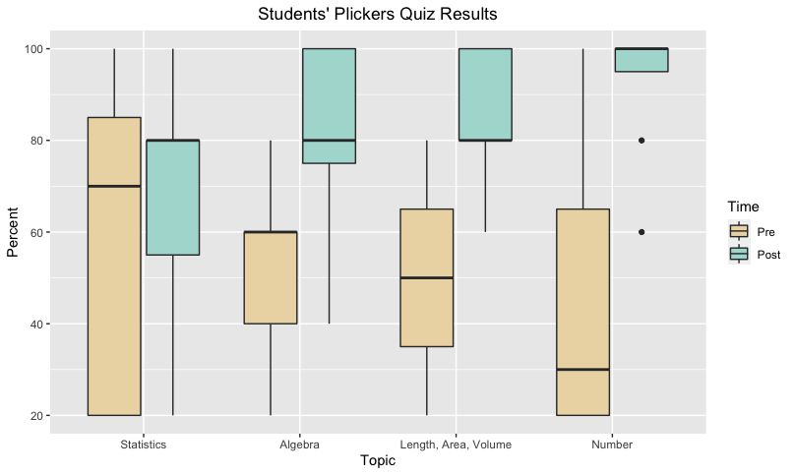
Figure 5.5.1: Boxplots of student scores from when they first answered certain questions, and when they answered these questions again after receiving feedback and engaging in classroom discussion. Median and range are visible on the plot for comparison.
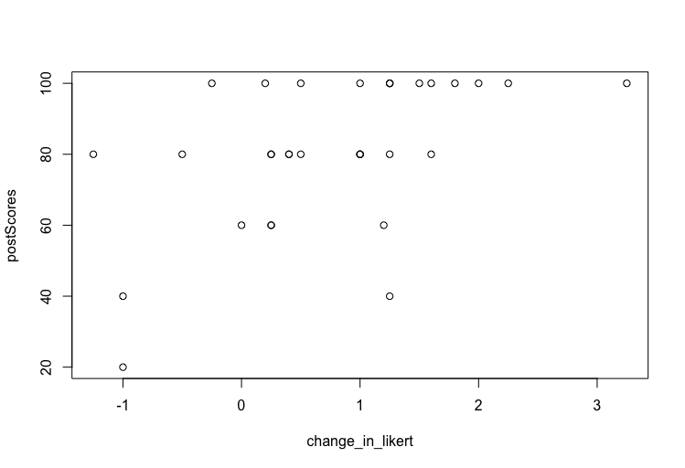
A moderate Spearman correlation coefficient of 0.53 was found between the post quiz scores and how much a student's overall likert survey score changed between pre and post surveys. This indicates a relationship between a student's comfort sharing opinions about a topic and their post quiz score, as seen in Figure 5.5.2.
Figure 5.5.2: Scatterplot of students end-of-topic quiz score plotted against the difference between their pre and post Likert survey score.

Discussion

Knowledge of how first and second order factors impair the implementation of technology in the classroom (Ertmer et al., 2012) did not prevent my enthusiasm and self-efficacy from being effected by challenges on placement. Importance of critical friend and the structure of the action research project, literature review (value of intervention) methodology (specified times for reflection, visible data collection) helped realign with my values and aims when faced with the challenges of pandemic and the day-to-day challenges of the classroom similar to advice found in research (Pine, 2010) ->something that may translate to other action research projects and be valuable to other student teachers
Dewey (1933) identified the three traits or characteristics most required of reflective practitioners as wholeheartedness, openmindedness and intellectual responsibility. Outline how each of these had an effect on my practice and implementing the project.
Driscoll's (2014) features of a constructivist environment are evident from the triangulation of data:
Felt a clear difference in student engagement and class atmosphere depending on types of questions used, and own personal alignment with the 3D FasMED model. This was identified through observation and discussion with the students.
Observed students clearly more active in their own and their peers' learning
Felt more connected to the students in this class, link to how education during COVID and wearing masks effects the ability to communicate (Spitzer, 2020) and the Plickers system offered a new communication channel
Signifiance of Wilcoxon tests, in comparison to the t-tests. Comment on the robustness of using a t-test even when assumptions of normality and homoscedasticity aren't met. Discuss how an improvement in student's comfort sharing their opinions about different topics is related to the research question.
Plickers data lead to better reflection in-action, more individualised questioning and better feedback -> this reflected in improvement in general likert survey responses

Novelty effect? Keeping the use of the CRS limited to ~20minutes twice a week seemed to keep students enthusiastic as long as types of questions were diverse and I remained enthusiastic. Regardless of a possible novelty effect, having students' work and opinions archived for study by the teacher remains very valuable for informing teaching.

To improve:
Better use of plickers system without being limited by pandemic e.g. supplying students with their report, combining it with group work and offering students to come to the board to explain their points of view (like in Cusi et al., 2019)
Small sample size and convenient sampling
Better designed likert surveys

Benefits of carrying out an action research project - not only possible to carry out but is now prefered due to the visible results after integrating the workflow into practice. Seeing research and action carried out in class together - a change in philosophy that I will endeavour to keep.

Conclusion

I began this action research project with the goal of developing my identity as a teacher research while also keeping up with the demands of teaching. My in-depth literature review helped me identify the value of topics like educational technology, constructivism and formative assessment for improving teaching and learning in the classroom and the integration of a classroom response system into my practice was identified as a practical way to convert these theories into action. My methodology's timeline gave clear structure to the project and I identified data sources like a reflective journal, likert surveys, and quiz results, that would help me quantify improvements to my practice from diffferent perspectives. The information gathered in my literature review and methodology proved crucial when I faced real challenges on teaching practice like a lack of self-efficacy, exhaustion and technological issues and allowed me to reaffirm my values and goals throughout the project. Deliberate critical reflection helped identify and overcome these issues, and the numerous data collection tools helped give insight and a clear sense of progress. Although the possible ways the classroom response system could be integrated into my practice was limited by the coronavirus pandemic, my confidence in using it and my familiarity with its features grew over the weeks of teaching and I felt it offered invaluable insight into each student's perspective and allowed me to not only target feedback more effectively but also to facilitate a constructivist environment. This appreciation for the classroom response system was reflected in students' surveys, and a moderate correlation between an improvement of students' comfort sharing their opinions and their quiz results has potential for further research. The entire process of the action research project has helped develop my identity as a teacher research and my sense of self-efficacy for engaging in a cycle practice-informed research and research-informed practice. The relevance of technology, constructivism and formative assessment to post-primary mathematics teaching is only going to grow in the future, and this project may help other student teachers or teacher researchers to integrate these concepts into their practice, in Ireland and internationally.

Bibliography
Aldon G., Cusi, A., Morselli, F., Panero, M. & Sabena, C. (2017) ‘Formative Assessment and Technology: Reflections Developed Through the Collaboration Between Teachers and Researchers’, Advances in Mathematics Education: Mathematics and Technology, 15, pp.551-578.
Ananiadou, K. & Rizza, C. (2010) ‘ICT in Initial Teacher Training: First Findings and Conclusions of an OECD Study’, EDULEARN10 International Conference on Education and New Learning Technologies. Barcelona, 5th-7th July. pp.5621-5632.
Anderson, D. S. & Piazza, J. A. (1996) ‘Changing Beliefs: Teaching and Learning Mathematics in Constructivist Preservice Classrooms’, Action in Teacher Education, 18(2), pp.51-62.
Anderson, S. E., Groulx, J. G. & Maninger, R. M. (2012) ‘Relationships among Preservice Teachers’ Technology-Related Abilities, Beliefs, and Intentions to Use Technology in Their Future Classrooms’, Journal of Educational Computing Research, 45(3), pp.321-338.
Anyon, J. (1980) 'Social Class and the Hidden Curriculum of Work', Journal of Education, 162(1), pp.67-92.
Badizadegan, P. (2015) Understanding and Evaluating Effective Technology Integration in the Classroom. Honors B.Sc. thesis. University of Utah. Available at: https://collections.lib.utah.edu/details?id=197132
Beatty, D. & Gerace, W. J. (2009) ‘Technology-Enhanced Formative Assessment: A Research-Based Pedagogy for Teaching Science with Classroom Response Technology’, Journal of Science Education and Technology, 18, pp.146-162.
Beauchamp, C. & Thomas, L. (2011) 'New teachers' identity shifts at the boundary of teacher education and initial practice', International Journal of Educational Research, 50(1), pp.6-13.
Black, P. & Wiliam, D. (2009) ‘Developing the theory of formative assessment’, Educational Assessment, Evaluation and Accountability, 21(1), pp.5–31.
Brookfield, S. (2017) Becoming a Critically Reflective Teacher. 2nd edn. California: Josey-Bass.
Burns, G. (2015) 'Challenges for Early Career Teachers in DEIS Schools', INTO/Educational Disadvantage Centre Joint Conference, Dublin, December. Available at: https://www.dcu.ie/sites/default/files/edc/pdf/garethburns_article.pdf
Carreira, S., Clarke-Wilson, A., Faggiano, E. & Montone, A. (2017) ‘From Acorns to Oak Trees: Charting Innovation Within Technology in Mathematics Education’, in Faggiano, E., Ferrara, F. & Montone, A. (eds.) Innovation and Technology Enhancing Mathematics Education: Perspectives in the Digital Era, pp.9-35. Switzerland: Springer International Publishing.
Cerqua, A., Gauthier, C. & Dembélé, M. (2017) ‘Pedagogical Orientations and Foundations in the Discourse Emanating from the OECD’s TALIS Initiative’, International Perspectives on Education and Society, pp.61-95.
Chai, C. S. (2010) ‘The relationship among Singaporean pre-service teacher’s ICT competencies, pedagogical beliefs, and their beliefs on the espoused use of ICT.’, The Asia-Pacific Education Research, 19(3), pp.387-400.
Charalampos, C. (2019) ‘Enabling Active Learning in Large Classes Through the Use of Plickers’, 5th International Conference on Higher Education Advances. Valencia, Spain, 26th June 2019. Glasgow: University of Glasgow.
Chng, L. & Gurvitch, R. (2018) ‘Using Plickers as an Assessment Tool in Health and Physical Education Settings’, Journal of Physical Education, 89(2), pp.19-25.
Cizek, G. J. (2010) ‘An Introduction to Formative Assessment: History, Characteristics, and Challenges’, in Andrade, H.L. & Cizek, G.J. (eds.) Handbook of Formative Assessment, pp.3-18. New York: Routledge.
Cosgrove, J., Perkins, R., Shiel, G., Fish, R. & McGuinness L. (2012) Teaching and Learning in Project Maths, Insights from Teachers who Participated in Pisa 2012: Summary Brochure. Dublin: Educational Research Centre. Available at: www.erc.ie/documents/p12tlpm_brochure.pdf
Costello, E. (2012) ‘Smart schools = smart economy: intelligence equation or text-speak policy. An examination of the influence of the concept of the knowledge economy on the framing of Irish government policy for ICT in schools’, Trinity Education Papers, 1(1), pp.72-93.
Cusi, A., Morselli, F. & Sabena, C. (2019) ‘The Use of Polls to Enhance Formative Assessment Processes in Mathematics Classroom Discussions’, Technology in Mathematics Teaching, 13, pp.7-30.
CORDIS (2017) Improving progress for lower achievers through Formative Assessment in Science and Mathematics Education. Available at: https://cordis.europa.eu/project/id/612337
Department of Education and Science (1997) Schools IT2000: A Policy Framework for the New Millennium. Dublin: DES. https://www.education.ie/en/Publications/Policy-Reports/Schools-IT2000.pdf
Department of Education and Science (2000) Blueprint for the Future of ICT in Irish Education 2001-2003. Dublin: DES. Available at: https://www.pdsttechnologyineducation.ie/en/PUBLICATIONS/Other-Publications-Reports/Blueprint-for-the-Future-of-ICT-in-Irish-Education.PDF
Department of Education and Science (2008) Investing Effectively in ICT in Schools 2008-2013. Dublin: DES. Available at: https://www.education.ie/en/Publications/Policy-Reports/Investing-Effectively-in-Information-and-Communication-Technology-in-Schools-2008-2013.pdf
Department of Education and Science (2009) Smart Schools = Smart Economy. Dublin: DES. Available at: https://www.education.ie/en/Publications/Policy-Reports/Investing-Effectively-in-Information-and-Communication-Technology-in-Schools-2008-2013.pdf
Department of Education and Skills (2015) Digital Strategy for Schools 2015-2020: Enhancing teaching, learning and assessment. Dublin: DES. Available at: https://www.education.ie/en/Publications/Policy-Reports/Digital-Strategy-for-Schools-2015-2020.pdf
Department of Education and Skills (2015) Framework for Junior Cycle. Dublin: DES. Available at: https://ncca.ie/media/3249/framework-for-junior-cycle-2015-en.pdf
Department of Education and Skills (2015) Formative Assessment in Mathematics. Dublin: DES. Available at: https://jct.ie/perch/resources/maths/formative-assessment-leaflet-pdf.pdf
Department of Education and Skills (2017) Minister Bruton launches School Excellence Fund – Digital [Press Release]. 15th December. Available at: https://www.education.ie/en/Press-Events/Press-Releases/2017-Press-Releases/PR17-12-15.html
Department of Education and Skills (2019) Digital Strategy for Schools 2015-2020: Action Plan 2019. Dublin: DES. Available at: https://www.education.ie/en/Publications/Policy-Reports/digital-strategy-action-plan-2019.pdf
Department of Education and Skills (2020) Circular 0031: Grant Scheme for ICT Infrastructure – 2019/2020 School Year. Dublin: DES. Available at: https://www.education.ie/en/Circulars-and-Forms/Active-Circulars/cl0031_2020.pdf
Department of Education and Skills (2020) COVID-19 Response Plan for the safe and sustainable operation of Post Primary Schools. Dublin: DES. Available at: https://assets.gov.ie/83312/6c36aaac-22fc-44fd-a4be-88cea4db82d6.pdf
Dijk, J. V. & Hacker, K. (2003) ‘The digital divide as a complex and dynamic phenomenon’, The information society, 19(4), pp.315-326.
Donnelly, D., McGarr, O. & O’Reilly, J. (2011) ‘A framework for teachers’ integration of ICT into their classroom practice’, Computers and Education, 57(2), pp.1469–1483.
Drijvers, P., Ball, L., Barzel, B., Heid, M. K., Cao, Y. & Maschietto, M. (2016) ‘Uses of Technology in Lower Secondary Mathematics Education: A Concise Topical Study’, ICME-13 Topical Surveys. pp.1-34.
Driscoll, M. (2014) Psychology of Learning for Instruction. 3rd edition. Essex: Pearson Education Limited
Durkheim, E. (1956) Education and sociology. New York: Free Press.
Ertmer, P. A., Ottenbreit-Leftwich, A. T., Sadik, O., Sendurur, E. & Sendurur, P. (2012) ‘Teacher beliefs and technology integration practices: A critical relationship’, Computers & Education, 59, pp.423-435.
Smyth, E., McCoy, S. & Banks, J. (2019) 'Student, Teacher and Parent Perspectives on Senior Cycle Education', ESRI Research Series, 94. Dublin: The Economic and Social Research Institute. Available at: https://www.esri.ie/system/files/publications/RS94_0.pdf
Gilleece, L., Shiel, G., Perkins, R. & Proctor, M. (2009) Teaching and learning International Survey (2008): National Report for Ireland. Dublin: Educational Research Centre. Available at: www.erc.ie/documents/talis_national_report_2009.pdf
Gilakanji, A. P., Leong, L. M. & Ismail, H. N. (2013) ‘Teachers’ Use of Technology and Constructivism’, International Journal of Modern Education and Computer Science, 4, pp.49-63.
Genlott, A. A. & Grönlund, A. (2016) ‘Closing the gaps – Improving literacy and mathematics by ict-enhanced collaboration’, Computers & Education, 99, pp.68-80.
Hansson, S. O. (2019) ‘Technology and Mathematics’, Philosophy & Technology, (33), pp.117-139.
Hattie, J. (2009) Visible learning: A synthesis of over 800 meta-analyses relating to achievement. New York: Routledge.
Hiebert, J., Morris, A. K. & Glass, B. (2003) 'Learning to Teach: An "Experiment" Model For Teaching And Teacher Preparation in Mathematics', Journal of Mathematics Teacher Education, 6(3), pp.201-222.
Jamieson, S. (2004) 'Likert scales: How to (ab) use them?', Medical education, 38(12), pp.1217-1218.
JISC (2010) Effective Assesment in a Digital Age: A guide to technology-enhanced assessment and feedback. Bristol: HEFCE. Available at: https://www.webarchive.org.uk/wayback/archive/20140614075437/http://www.jisc.ac.uk/whatwedo/programmes/elearning/assessment/digiassess.aspx
Johnson, P., Freemyer, J. V. & Fitzmaurice, O. (2019) 'The Perceptions of Irish Mathematics Teachers Towards a Curriculum Reform 5 Years After Its Implementation', Frontiers in education (Lausanne), 4 (12), pp.1-11.
Jones, K., Jones, J. L. & Vermette, P. J. (2010) ‘The Constructivist Mathematics Classroom’, Mathematics Teaching, 219, pp.33-35.
Keengwe, J., Onchwari, G. & Wachire, P. (2008) ‘Computer Technology Integration and Student Learning: Barriers and Promise’, Journal of Science Education and Technology, 17, pp.560-565.
Kent, D. B. ‘Plickers and the pedagogical practicality of fast formative assessment’, Teaching English with Technology, 19(3), pp.90-104.
Kim, C., Kim, M. K., Lee, C., Spector, J. M. & DeMeester, K. (2013) ‘Teacher beliefs and technology integration’, Teaching and Teacher Education, 29, pp.76-85.
Luckin, R., Clark, W., Avramides, K., Hunter, J. & Oliver, M. (2016) ‘Using teacher inquiry to support technology enhanced formative assessment: a review of the literature to inform a new method’, Interactive Learning Environments, 25(1), pp.85-97.
Hew, K. F. & Brush, T. (2006) ‘Integrating technology into K-12 teaching and learning: Current knowledge gaps and recommendations for future research’, Education Technology Research and Development, 55, pp.223-252.
Mangen, A., Anda, L.G., Oxborough, G.H. & Bronnick, K. (2015) ‘Handwriting versus Keyboard Writing: Effect on Word Recall’, Journal of Writing Research, 7(2), pp.227-247.
Marcus-Quinn A., Hourigan, T. & McCoy, S. (2019) ‘The Digital Learning Movement: How Should Irish Schools Respond?’, The Economic and Social Review, 50(4), pp.767-783.
McCargo, M. (2017) The Effects of Plickers as Response Cards on Academic Engagement Behavior in High School Students. MA Theses. University of Southern Mississippi.
McGarr, O. & Johnston, K. (2019) ‘Exploring the Evolution of Educational Technology Policy in Ireland: From Catching-Up to Pedagogical Maturity’, Educational Policy, pp.1-25.
McMillan, J. (1996) Educational Research: Fundamentals for the Consumer. 2nd edn. New York: Harper Collins.
Mishra, P. & Koehler, M. (2006) ‘Technological Pedagogical Content Knowledge: A Framework for Teacher Knowledge’, Teachers College Record, 108(6), pp.1017-1054.
Mullis, I. V. S., Martin, M. O., Foy, P. & Hooper & M. (2016) TIMSS 2015 international results in mathematics. Boston College: TIMSS & PIRLS International Study Centre.
National Council of Teachers of Mathematics (2015) Strategic Use of Technology in Teaching and Learning Mathematics. Available at: https://www.nctm.org/uploadedFiles/Standards_and_Positions/Position_Statements/Strategic%20Use%20of%20Technology%20July%202015.pdf
Ní Fhloinn, E., Nolan, B. C., Hoehne Candido, G. & Guerrero S. M. (2018) 'Pre-service versus in-service mathematics teachers' opinions of mathematics reform in post-primary schools in Ireland', Irish Educational Studies, 37(4), pp.431-452.
Norman, G. (2010) 'Likert scales, levels of measurement and the "laws" of statistics', Advances in Health Sciences Education, 15, pp.625-632.
OECD (2009a) Creating Effective Teaching and Learning Environments: First Results From TALIS. Paris: OECD Publishing. Available at: www.oecd.org/education/school/43023606.pdf
OECD (2009b) Evaluating and Rewarding the Quality of Teachers: International Practices. Paris: OECD Publishing. Paris: OECD Publishing. Available at: https://read.oecd-ilibrary.org/education/evaluating-and-rewarding-the-quality-of-teachers-international-practices_9789264034358-en
OECD (2012) Teaching Practices and Pedagogical Innovation. Paris: OECD Publishing. Available at: https://read.oecd-ilibrary.org/education/teaching-practices-and-pedagogical-innovations_9789264123540-en
OECD (2014) TALIS 2013 Results: An International Perspective on Teaching and Learning.
Paris: OECD Publishing. Available at: https://read.oecd-ilibrary.org/education/talis-2013-results_9789264196261-en
OECD (2015) Students, Computers and Learning: Making the Connection. Paris: OECD Publishing. Available at: http://www.oecd.org/edu/students-computers-and-learning-9789264239555-en.htm
OECD (2019a) How’s Life in the Digital Age? Opportunities and Risks of the Digital Transformation for People’s Well-being. Paris: OECD Publishing. Available at: https://www.oecd-ilibrary.org/docserver/9789264311800-en.pdf
OECD (2019b) Pisa 2021 ICT Framework. Paris: OECD Publishing. Available at: https://www.oecd.org/pisa/sitedocument/PISA-2021-ICT-framework.pdf
O’Mahony, Tom (2017) ‘The Impact of a Constructivist Approach to Assessment and Feedback on Student Satisfaction and Learning: A case-study’, All Ireland Journal of Teaching and Learning in Higher Education, 9, pp.2871-28719.
Palak, D. & Wallis, R. (2009) ‘Teacher’s beliefs and technology practices: A mixed-methods approach’, Journal of Research on Technology in Education, 41(4), pp.417-441.
Pine, G. (2010) Teacher Action Research: Building Knowledge Democracies. California: SAGE Publications.
Professional Development Service for Teachers (2017) Digital Learning Framework for Post-Primary Schools. Dublin: Department of Education and Skills. Available at: https://www.pdsttechnologyineducation.ie/en/Planning/Digital-Learning-Framework/Digital-Learning-Framework-Post-Primary.pdf
Putten, S., Stols, G. & Howie, S. (2014) ‘Do prospective mathematics teachers teach who they say they are?’, Journal of Mathematics Teacher Education, 17(4), pp.369-392.
Rosenberg, M. (2001) E-learning: strategies for delivering knowledge in the digital age. New York: McGraw Hill.
Russell, M.K. (2010) ‘Technology-Aided Formative Assessment of Learning: New Developments and Applications’, in Andrade, H.L. & Cizek, G.J. (eds.) Handbook of Formative Assessment, pp.125-138. New York: Routledge.
Servon, L.J. (2008) Bridging the digital divide: Technology, community and public policy. New Jersey: John Wiley & Sons.
Sadovnik, A. (2011) Sociology of Education: A Critical Reader. London: Routledge.
Shannon-Baker, P. (2015) ‘Making Paradigms Meaningful in Mixed Methods Research’, Journal of Mixed Methods Research, 10(4), pp.319-334.
Shamoo, A. & Resnik, D. (2009) Responsible Conduct of Research. 2nd edn. New York: Oxford University Press.
Sorensen, T. & Robertson, L. (2017) ‘The OECD program TALIS and Framing, Measuring and Selling Quality Teacher’ in Akiba, M. & LeTendre, G. K. (eds.) Routledge International Handbook of Teacher Quality and Policy, pp.117-131.
Shiel, G. & Kelleher, C. (2017) An Evaluation of the Impact of Project Maths on the Performance of Students in Junior Cycle Mathematics. Dublin: Educational Research Centre. Available at: https://ncca.ie/media/3629/pm_evaluation_strand1_2017.pdf
Sullivan, B., Glenn, M., Roche, M. & McDonagh, C. (2016) Introduction to Critical Reflection and Action for Teacher Researchers. New York: Routledge.
Spitzer, M. (2020) 'Masked education? The benefits and burdens of wearing face masks in schools during the current Corona pandemic', Trends in Neuroscience and Education, 20.
Tabach, M. & Slutzky, G. (2017) ‘Studying the Practice of High School Mathematics Teachers in a Single Computer Setting’, Mathematics Education in the Digital Era, 9, pp.215-233.
Tolmie, A. (2001) ‘Examining learning in relation to the contexts of use of ICT’, Journal of Computer Assisted Learning, 17, pp.235-241.
Tondeur, J., Hermans, R., Braak, J. & Valcke, M. (2008) ‘Exploring the link between teachers’ educational belief profiles and different types of computer use in the classroom’, Computers in Human Behaviour, 24(6), pp.2541-2553
Wang, F. & Hannafin, M. J. (2005) ‘Design-Based Research and Technology-Enhanced Learning Environments’, Educational Technology Research and Development, 53(4), pp.5-23.
Warner, Z. B. (2011) ‘Adoption of Computer-Based Formative Assessment in a High School Mathematics Classroom’, Journal of Cases on Information Technology, 13(4), pp.9-20.

Appendices

Appendix A: example of laminated Plickers card
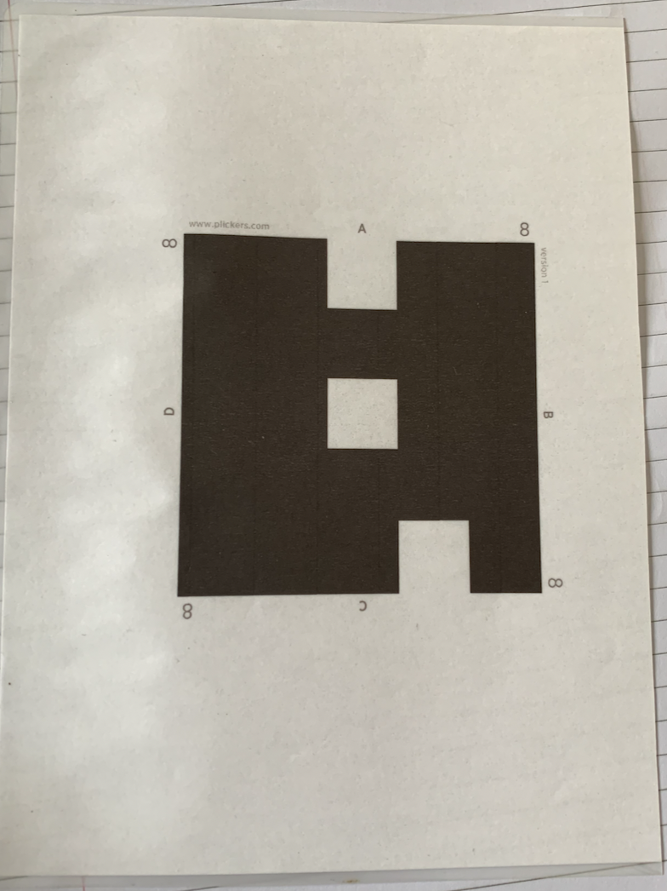

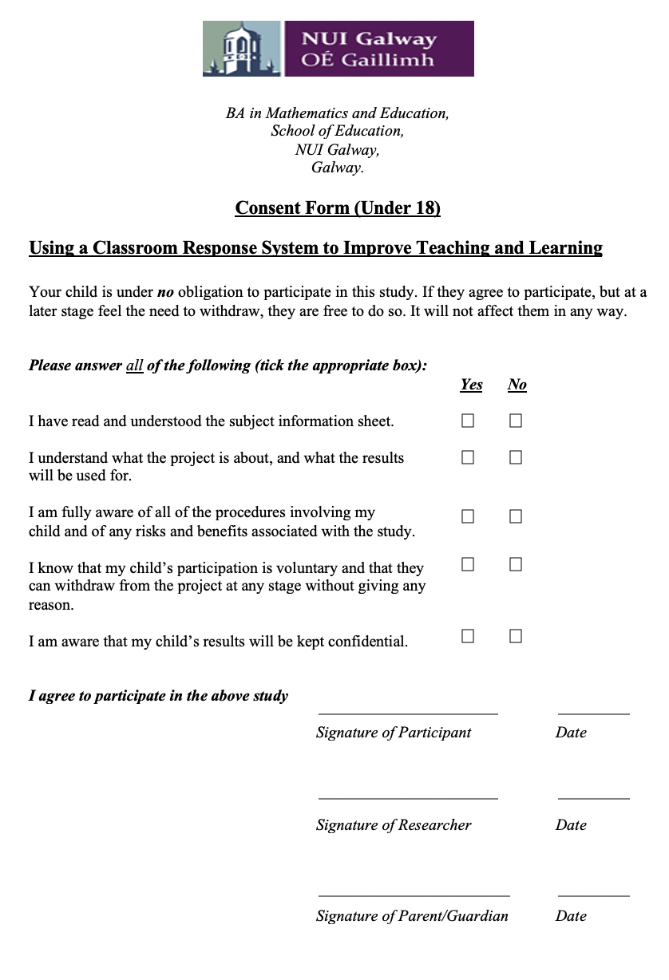
Appendix B: Example of Consent form and Information sheet given to students and parents
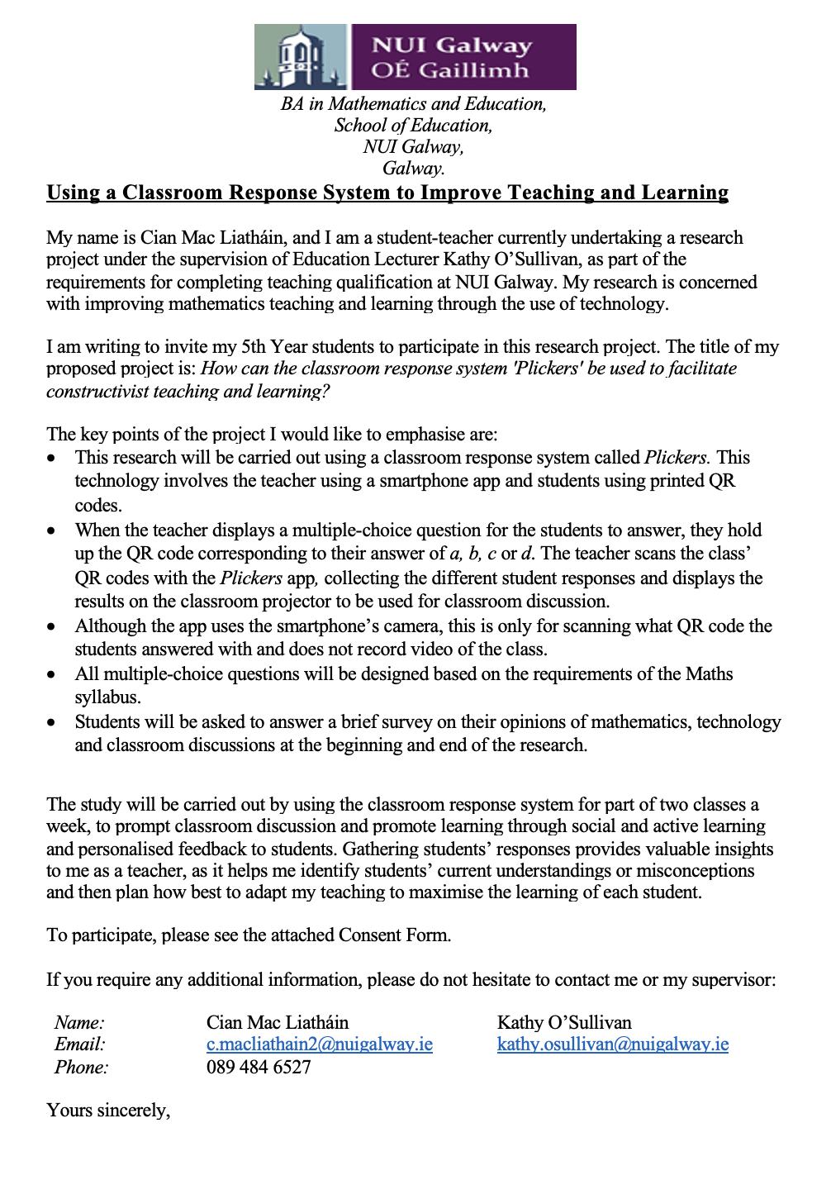

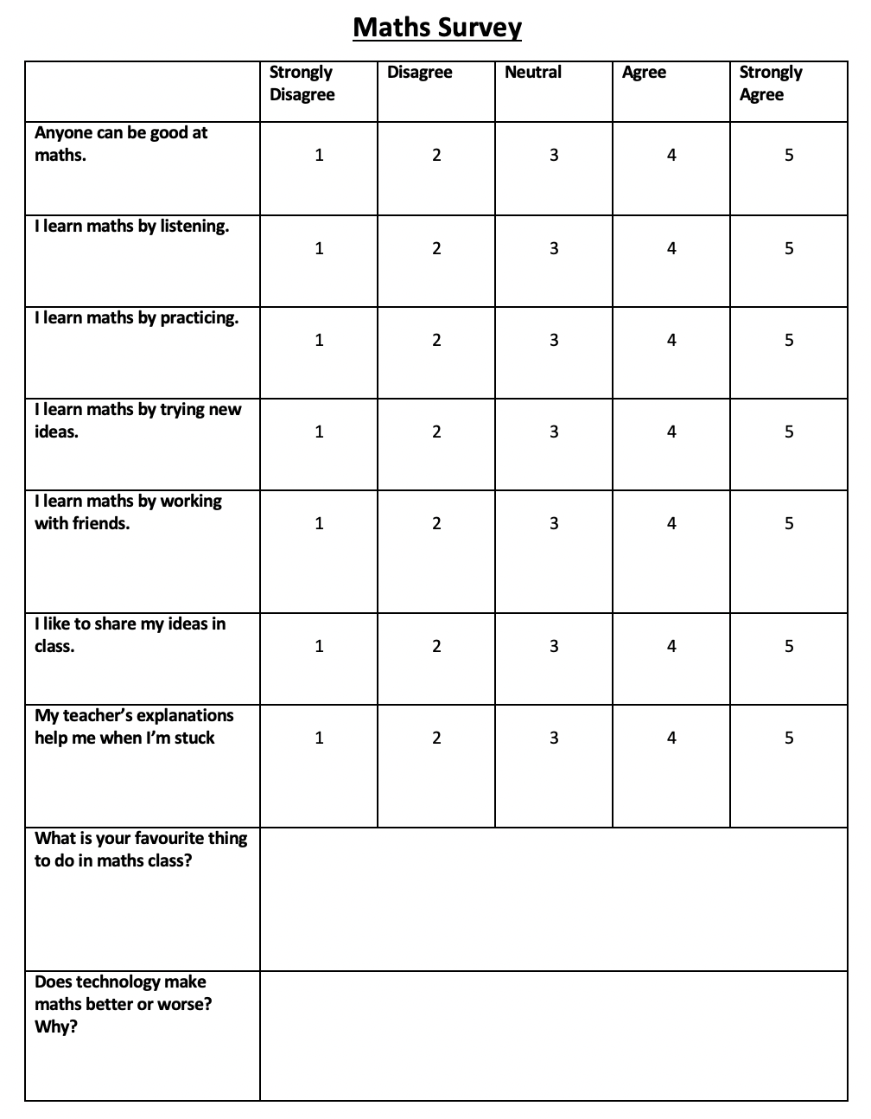
Appendix C: Example of Pre/Post Overall Survey

Appendix D: Example of Pre/Post Topic Survey (Statistics)
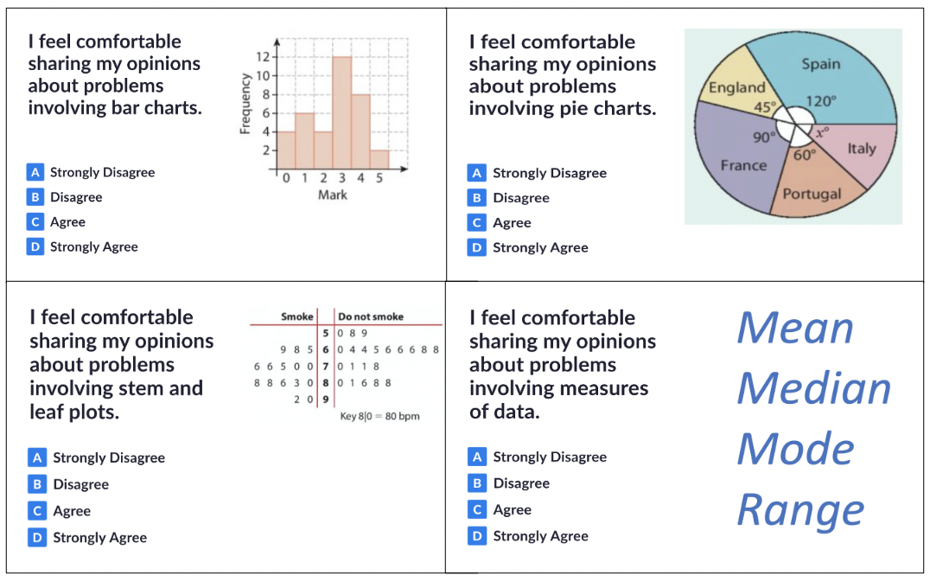
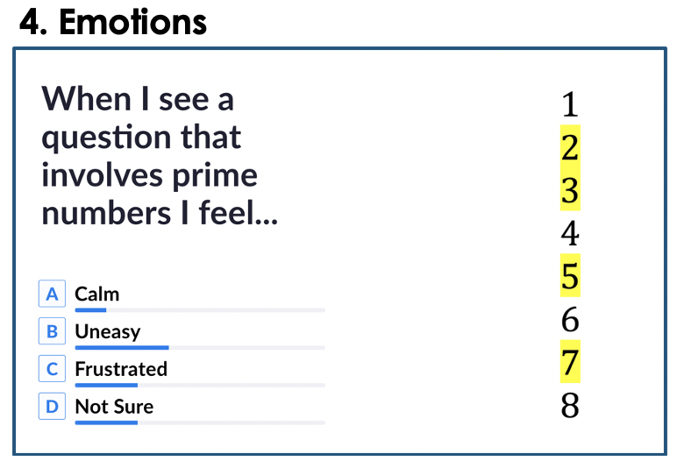
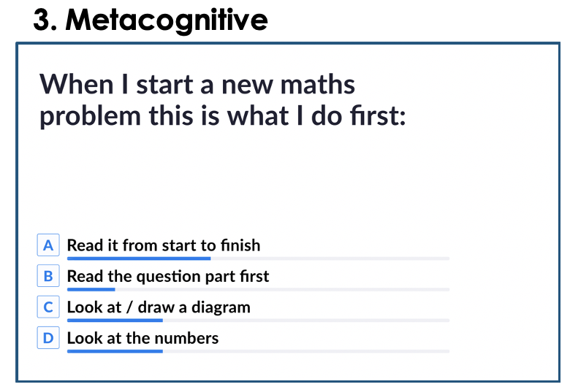
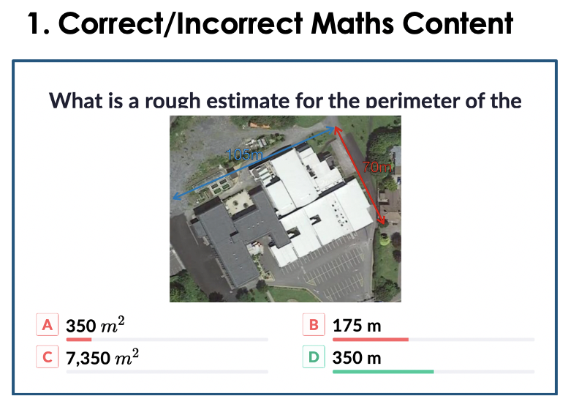
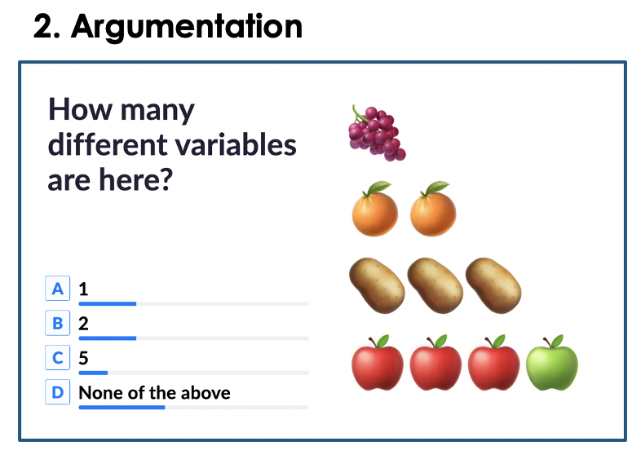
Appendix E: Examples of types of questions adapted from Cusi et al. (2019)

