Variable values
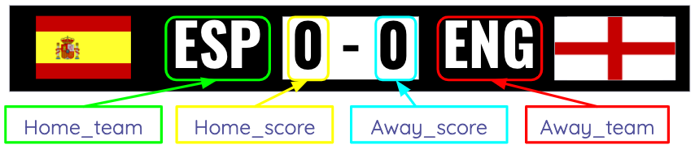

Using the format above, identify the values of each variable in the scores below.


Value
Home_team
Home_score
Away_team
Away_score


Value
Home_team
Home_score
Away_team
Away_score

Resources are updated regularly — the latest version is available at: ncce.io/tcc.

This resource is licensed under the Open Government Licence, version 3. For more information on this licence, see ncce.io/ogl.

