HOW CAN I IMPROVE SUMMATIVE ASSESSMENT IN MY FIRST YEAR MATH CLASS
Our education system relies heavily on summative assessment to represent student learning and to identify the students who are more academically inclined. Is this a fair system that accounts for every learner? Does it demonstrate student progress? Does it enhance student learning by providing an appropriate aim for the students to prepare for or does it create negative attitudes towards maths? These have been my primary concerns with regard to summative assessment, both as a student and teacher. It is evident to me that summative assessment is an essential element of education and it is therefore prudent for my teaching that these questions are examined and I develop my own opinion with regard to employing summative assessment in the classroom. Through my extensive research it became evident that the major fault with summative assessment did not lie with its fundamental ideas, but rather with how summative assessment was presented and employed in the classroom. I found that the students appreciated the importance of summative assessment in keeping them focused and motivated but many of the students resented completing summative assessments in the classroom that were not corrected or without adequate timing. Feedback and timing were significant improvements that the students would address regarding summative assessment.
Summative Assessment; Student Attitudes; Feedback
INTRODUCTION
Each and every one of us has experienced summative assessment at some stage in our life. In today’s world it is virtually impossible to get an education without being subjected to summative assessment. Summative assessment has been an element of my education as far back as junior infants in primary school. It is an essential aspect of our successes or failures throughout our education and is representative of our abilities when we are finished. As a result of its significance, I have been questioning the influence that summative assessment has had on our education since I began secondary school. It is characteristic of a secondary school student to question the teaching methodologies of the teacher, particularly with regard to class tests, but I felt more curious about the purpose of summative assessment than simply trying to avoid exams. Summative assessments, personally, did not provide a fair manner of judging student understanding and progress, and in my school at least, it did not benefit my learning significantly. I will always recall a poster hanging in the laboratory that had Einstein’s quote; ‘Everyone is a genius. But if you judge a fish by its ability to climb a tree, it will live its whole life believing that it is stupid.’ emblazoned on it. This quote has stuck in my mind since then and I cannot help but identify issues with summative assessment on the same pretence of judging a fish on its ability to fly. Assessment, whether it is formative or summative, must benefit student learning in some way and it is important that I identify and am aware of the benefits of an assessment method. I will investigate the advantages and disadvantages of summative assessment and will identify how I can improve summative assessment that I employ in my classroom. In conducting my investigation I felt it was important to consider the students’ opinions on summative assessment as it is the students’ attitude towards assessment that can dictate the success or failure. My primary data for this investigation is therefore focused on student opinion and the interpretation of their opinions.
LITERATURE REVIEW
Education is an abstract construction and as such there is no definitive formula for success, neither as a student nor as an educator. Every student within the education system today experiences education in a different manner; they learn differently, they study differently and their general attitude varies immensely. Many factors can be attributed to this, from demographic to society, and as such, students will respond differently to varying forms of assessment and teaching methods. As a consequence, much of the research that has been conducted in this area is abstract and their conclusions are based on opinions and experiments carried out on sample populations that were not characteristic of the whole population. Therefore, we can only provide a general theory regarding the most influential method of teaching and after this it is the responsibility of the educator to determine the most efficient and effective method for teaching their students. Biggs and Tang (2011) stated that the “best assessment method is the one that best realizes your objectives.” (P. 171)
“In the context of education, assessment is performed to gain an understanding of an individual learner’s strengths and weaknesses in order to make appropriate educational decisions.” (Salvia and Ysseldyke 1991) Assessment provides the basis from which educators develop their teaching style and if employed correctly will allow the educator to continuously alter their teaching methods to ensure that the students are receiving the optimum level of education and are being challenged, “assessment is not therefore an optional extra in learning but is rather a necessary, integral feature of every human effort to acquire mastery of a skill or body of knowledge.” (Williams 1992)
I found it interesting how difficult it was to find research that focused solely on summative assessment. It became evident quite early that formative assessment has become the most popular and recommended assessment method. Paul Black and Dylan Wiliam can be largely accredited with this. In 1998 Black and Wiliam published two important works, one an article in the journal “phi Delta kappan” and also an extensive review of empirical research studies focused on classroom management. Within their article “Assessment and classroom learning”, published in “Assessment in education”, Black and Wiliam define formative assessment as “all those activities undertaken by teachers, and or by their students, which provide information to be used as feedback to modify the teaching and learning activities in which they are engaged”. (1998, P. 10) Dunn and Melvonen, however, believe that the data employed by Black and Wiliam is insufficient to make the claims that they make. “The first study that they take issue with is the Fuchs and Fuchs piece, which, according to Dunn and Melvonen, suffers from uneven data quality. Of the effect sizes included in that meta-analysis almost 72% were only rated of ‘fair’ technical quality. In addition, the composite sample observed in the meta-analysis consisted of 83% learning disabled students.” (Hanover Research, 2014, P.8) This makes generalising their results for all students perilous and raises many concerns.
In agreement with Black and Wiliam, however, was Bloom, Hastings and Madaus(1971). They believed that formative assessment “intervenes during the formation of the student, not when the process is thought to be completed. It points to areas of needed remediation so that immediate subsequent instruction and study can be made more pertinent and beneficial.” We are taught from an early age the importance of being successful in the classroom. However, achievement is solely based on the results of summative assessments conducted periodically throughout the academic year. “Summative assessment takes place at the end of a module, course or academic year” (Petty, 2010, p.496). The purpose of summative assessment is to “differentiate between candidates on the basis of the breadth and depth of their learning.” (Petty, 2010, p.496) Summative assessment can be presented in many forms. Petty discusses these briefly; profiles, competences, continuous assessment, and examinations. However, while Petty highlights the benefits of these assessment methods, he also discusses in length the issues with regard to summative assessments and the requirements for an effective summative assessment. Petty has an acronym for outlining the requirements of an assessment method; ‘VACSAR’. ‘VACSAR’ stands for valid, authentic, current, sufficient, and reliable. (Petty, 2010, p.502) It is difficult to create an exam that is authentic and accurately reflects the demands of the real life applications of that subject within a classroom environment. Another issue associated with summative assessment is how sufficient the assessment is. When can we make judgement on a student’s ability accurately? At what stage are we assured that they are competent? Again, these decisions are primarily left to the judgement of those setting the exam and can vary from teacher to teacher. Therefore, summative assessments can lose their reliability. (Petty, 2010, p.502) These are common issues with summative assessment and are frequently presented as arguments against their use in education.
A study carried out in the University of Limerick by Faulkner, Hannigan and Gill into the mathematical competency of students entering third-level education in the University of Limerick revealed that there has been a “significant decline in the performance of students in the diagnostic test over time”. The study was completed over the years 1998 to 2008 and involved 5,949 students in total.
Unfortunately, much assessment is implemented with an idealistic view of students’ abilities and the uniformity of their learning. The Leaving Certificate system classifies students into three groups, based on their abilities demonstrated in school; foundation, pass and honours. The abilities within these three classifications vary greatly with the consequence of students with different abilities being assessed by “means of a 100% terminal written examination. ... This method of assessment has been said to encourage examination focused teaching to the detriment of learning essential mathematical knowledge and skills vital to students’ future success in education and life”. (F. Faulkner, A. Hannigan & O. Gill, 2010) While my extensive research into summative assessments was primarily negative, it did take me on a tangent, and identified the importance and popularity of formative assessment. This got me thinking, what if I combined certain aspects of both assessment methods to enhance their efficiency and effectiveness. Gardner (2012) debates whether there should be a distinction between the two forms of assessment or would there be more benefits to simply classifying it all under assessment but he ultimately concludes that “evidence gathered in a form that is already a summary, [as it is in summative assessment], generally lacks the detail needed to identify and inform next steps in learning.” (P.116) Shirley Clarke (2008) defines assessment for learning as “any practice which provides information to pupils about what to do to improve.” (P.9) This is in agreement with Gardner as summative assessment presents the results in the form of a level or grade. This is too general and does not identify where the student struggled or where they excelled. It simply informs us of their ability in that assessment. By considering both assessment methods, how can I improve summative assessment in my first year math class? I will also implement tasks after summative assessments that will encourage students to work on their weaker areas in an effort to improve student understanding and learning.
METHODOLOGY
This study was conducted in a DEIS mixed school that is located in a rural area and will be focused on first year students only. The school has approximately 360 students with a wide range of abilities throughout. The school accommodates students from four local villages which ensures that the majority of students are familiar with each other from outside of the school environment. This is the catalyst behind the inviting and comfortable atmosphere that is predominant throughout the school. Sport is an important aspect of the community, both within the school environment and outside. As a result, the school boasts a very successful sports programme with All-Irelands in both girls and boys categories. A greater emphasis has been placed on the music department in recent years and the number of students completing music as a leaving certificate exam has tripled in the past five years. As a former convent, there is a Sister present in the school during all school hours, with a room purposely left vacant for students that want to pray, meditate, or simply have time to themselves. There are excellent services provided to students with learning difficulties or those that are experiencing issues outside of school. This is evident in the school atmosphere. The teachers are particularly conscious of the need for staff and students to be respectful and helpful to each other. As a result, my co-operating teacher was extremely accommodating throughout placement. For the duration of my placement I was given a first year class (mixed ability), second year (honours) class, and a fifth year (ordinary) class to teach. I had the choice of conducting my research with either of the three year groups. However, I decided to conduct the research with the first year students. The first year students were new to secondary school and were getting accustomed with the new system of education. I felt that this would increase the reliability of my data as the students would be operating from their own personal preferences, and not of the preferences of other teachers that had been teaching them in previous years in the school. In order to accurately conduct my research I employed a combination of quantitative data and qualitative data research methods. These two approaches can be combined because they share the goal of understanding the world in which we live (Haase & Myers, 1988). “The ontological position of the quantitative paradigm is that there is only one truth, an objective reality that exists independent of human perception. ... In contrast, the qualitative paradigm is based on interpretivism and constructivism” (Plano Clark & Creswell, 2007). It is evident then from this that a combination of both practices provided the most developed and accurate results. Triangulation featured predominantly in this project as it gave a broad overview of the data. The triangulation method involved the use of multiple data sources for the same study. Observation, interviews and artefacts were the key components required to provide adequate data for my action research project. The use of observation and interviews was essential for qualitative data. These data collection tools allowed me to reflect on the results and determine why they are so. The students test results and questionnaire answers provided the basis of my quantitative data. Without quantitative data, my analysis will be based on interpretation and cannot be presented as fact.
Questionnaires
Questionnaires are a fundamental component of collecting data from a large sample group quickly and provided a reliable basis for conclusions. The fundamental reasoning for the questionnaires was to identify the students’ own opinions towards summative assessment and whether they find it beneficial or not. The questionnaires were given to the students on the 14th of September (beginning of placement) and the same questionnaire was given to the same students on the 21st of November. This allowed me to establish whether the first year students’ opinions changed throughout the course of my placement. All questionnaires were confidential as the students were instructed not to put their names on the questionnaire before submitting them. The questionnaire was approved by the ethics board in NUIG and a copy was given to the principal and co-operating teacher before they were given to the students, to ensure that it was in compliance with the school’s own ethics code. Only the students that returned signed permission forms were given the questionnaire to complete. The questionnaire focused primarily on establishing whether the students found it beneficial, were there changes they would make, was the time and quantity of assessment reasonable, and did they review summative assessment when it was returned to them.
Interviews
The interviews were conducted on a one-to-one basis and they allowed me to get a more in-depth understanding of the students’ opinions. The interviews were conducted in the same room that I taught the students in in an effort to ensure a more relaxed atmosphere. I conducted five interviews in total and these were completed throughout my placement, 14th of September, 5th of October, 22nd of October, 16th of November, and 22nd of November. The students were picked at random and were not selected due to maths ability or gender. The questions were similar to that of the questionnaire but were explored in more detail. One-to-one interviews are more reliable than focus groups as the students are less likely to be influenced by their peers and will give more honest answers.
Student Samples
Student samples are an important aspect of my data collection as they represented the students’ improvement/deterioration. To investigate the effectiveness of feedback on summative assessments I employed a system where the students completed an end of chapter assessment and their corrected tests were returned to them in the following lesson, along with feedback. The students were then given the subsequent lesson to correct their errors using the feedback provided and they were required to study their corrections as homework. The same test was then completed in the following lesson to determine if there had been any significant improvement in the students’ understanding of the topic. Their results were recorded for both assessments. This was employed three times throughout my placement. All students completed the same assessments after covering the same topics to ensure reliability (Sagor, 2000). I was not testing the students’ knowledge but the improvement in students’ knowledge and so there was no control group required in this action research project.

FINDINGS
The purpose of my findings was to identify the students’ attitudes towards assessment and investigate how assessment could be improved in the classroom.
Students’ Attitudes
The students were initially given a questionnaire to establish what their initial attitudes were towards summative assessment. The population for this questionnaire was twenty students. The questionnaire provided data that represented the students’ attitudes of assessment before they had been subjected to a significant quantity of assessment.
When initially asked whether they believed that homework improved their learning, 50% of the students agreed that it did. 35% strongly agreed with 10% uncertain. Only one person (5%) disagreed and felt that homework did not benefit their learning. Five students (25%) strongly agreed that they got too much homework to learn it all while one student (5%) felt that questioning in class benefitted their learning. Five students (40%) disagreed and said that questioning in class did not benefit their learning, in the first questionnaire.
The students were given the same questionnaire over two months later to establish whether their attitudes had changed throughout the research project. The population for this questionnaire was twenty also.
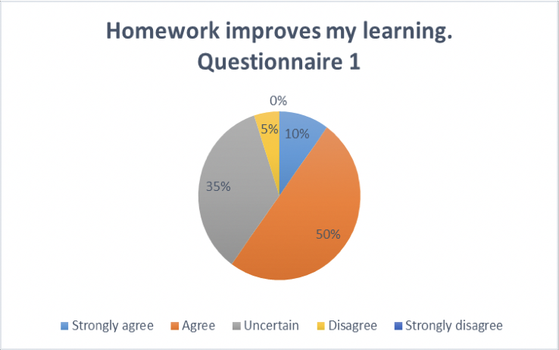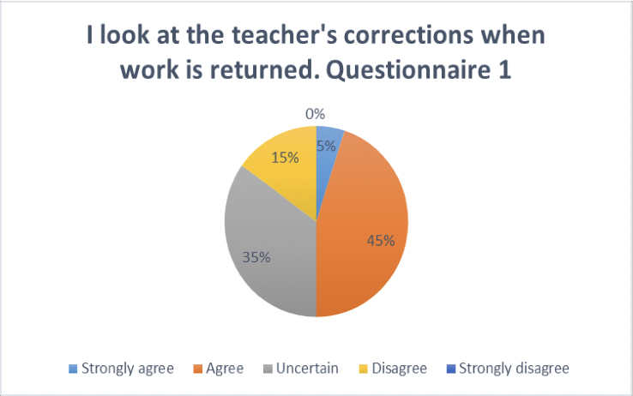
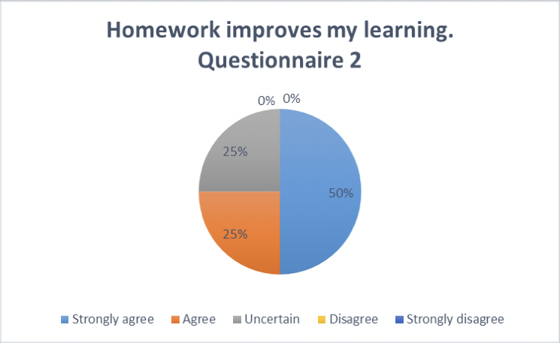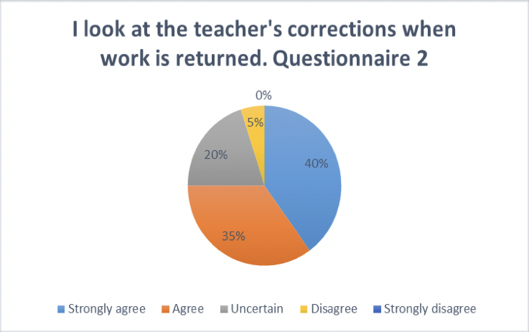
When presented with the same questions, ten students (50% of the sample population) strongly agreed that homework improved their learning, an increase of 40%. Five students (25%) of students agreed that it improved their learning while the remaining five students (25%) were uncertain.
Other questions such as ‘does having an upcoming test encourage [you] to learn the material more’ provided a 25% increase in the students that strongly agreed while there was a decrease in students that disagreed from 5% to none. The was also an increase in students who felt they did not require more time to complete assessments in class from 10% in the first questionnaire to 20% in the second questionnaire.
Students who felt that questioning in class was beneficial to their learning rose from 25% (inclusive of ‘agree’ and ‘strongly agree’) to 70% (inclusive of ‘agree’ and ‘strongly agree’). When asked does being questioned in front make you uncomfortable there was no increase in the students who agreed and strongly agreed (seventeen students- 85%) while there was an increase from two students (10%) to three students (15%) that disagreed.
Factors that contributed with engaging students with feedback
The five students that were interviewed will be referred to as ‘Student 1’, ‘Student 2’, ‘Student 3’, Student 4’, and ‘Student 5’ in chronological order. Of the five students interviewed, four expressed time as the most influential reason for not reviewing the feedback provided after a summative assessment. They claimed that with the workloads from other subjects and the demands of their own past times meant that they only completed activities that they felt would be inspected by the teacher, such as homework. ‘Student 4’ said that she reviewed any feedback that was given to her in an effort to improve her learning. ‘Student 4’ also made the necessary corrections to assessments to ensure that her work was complete for studying. All five students said that they found homework beneficial as an aid to learning. A transcript of a segment of the interview with ‘Student 2’ is provided.
Interviewer: XX Interviewee: ‘Student 2’ Date of interview: 5th of October Start time of interview: 1:15pm End time of interview: 1:30pm
Interviewer: Student 2: Interviewer: Student 2:
Interviewer:
Student 2: Interviewer: Student 2:
Interviewer: Student 2:
If you weren’t given homework would you revise a topic in the evening anyway?
No.
Why not?
I don’t need to. You [the teacher] don’t know if I did or not so I’m wasting my time.
Would it not make it easier to understand what’s going on in class and help you prepare for a test?
I guess, but sometimes I don’t have the time so I can’t. Do you think you get too much homework?
Sometimes. It depends on what day it is ‘cos some days are busier than others. Thursdays are my busiest day.
What would you change to make assessment better for you?
I think every subject should only be allowed to give a certain amount of homework in a night. I spend much more time doing English homework than any other subject.
‘Student 1’s’ answers reflected the results seen in questionnaire 1. At the time of the interview (14th of September), ‘Student 1’ had little experience of assessment at secondary school level and was drawing primarily from their experience in primary school.
Interviewer: XX Interviewee: ‘Student 1’ Date of interview: 14th of September Start time of interview: 1:15pm End time of interview: 1:30pm
Interviewer:
Student 1: Interviewer:
Student 1: Interviewer: Student 1:
In your opinion, do you get too much homework every evening from all the different subjects you study?
No, not really.
When teachers return homework/tests/groupwork corrected, do you look at the corrections and learn them or do you simply move on?
Depends on the subject. If I like the subject I’ll do the corrections. Sometimes I don’t really have the time ‘cos of football.
If you could change the way students are assessed in class what would it be and why?
I’d rather if the teachers went through the corrections with us. Sometimes I find it hard to see my mistakes but when they are explained to me it’s easier, especially in maths.

Methods I can employ to improve summative assessment and how it is presented in class.
Throughout my placement I employed varying methods for returning feedback to students and implemented tasks to encourage students to engage with the feedback to make it beneficial. The charts below represent the three summative assessments that were completed by the students. The charts on the left represent the first tests and on the right is the equivalent test sat the day after receiving their feedback.
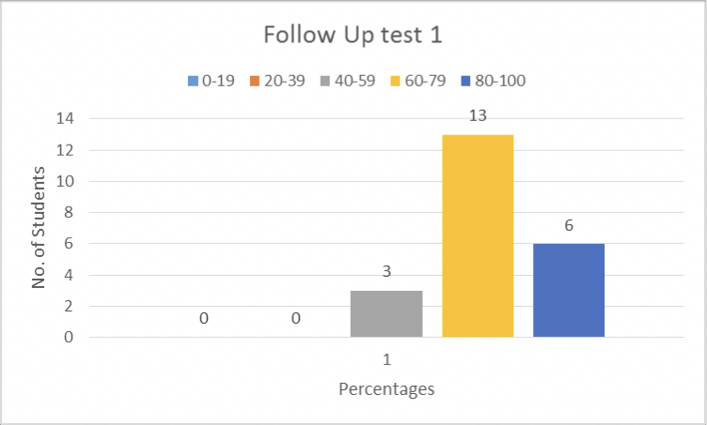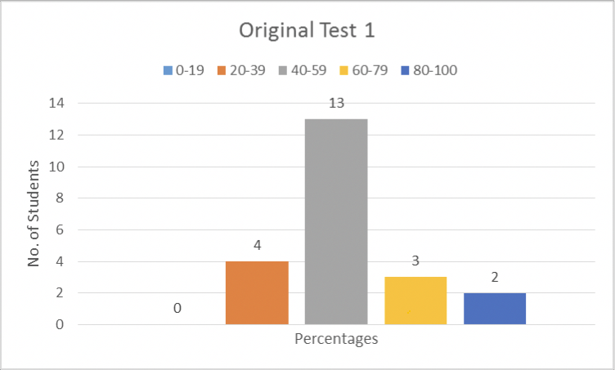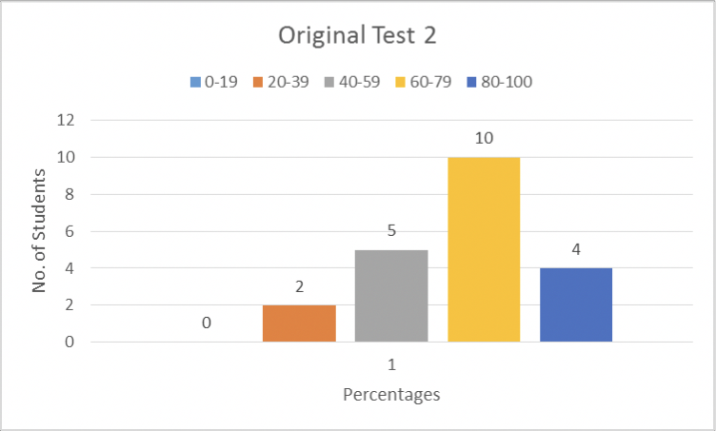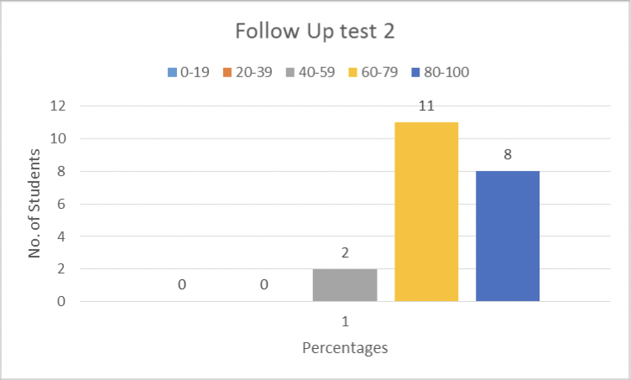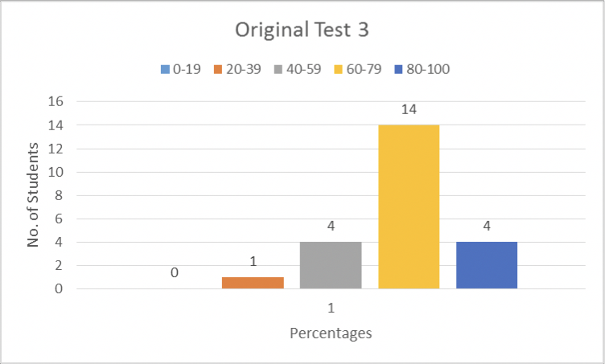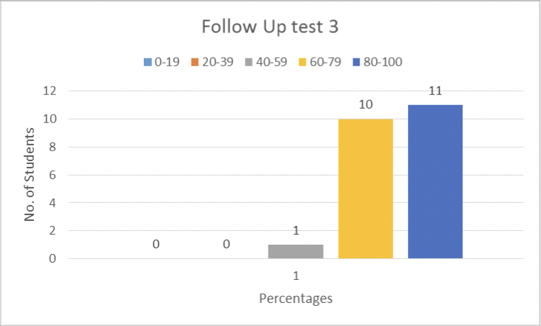

DISCUSSION
In this section I will elaborate on my key findings and draw conclusions from the results of my investigation of “how can I improve summative assessment in my first year math class?”
It was evident from the results of the questionnaire conducted on the 14th of September that many of the students (40%) did not view homework as a benefit to their learning. This poses the question why would students engage with their homework if they do not see the benefit of it. Engaging the students in assessment and educating them with regard to its function in their development is critical in encouraging meaningful learning through completing assessments, as opposed to completing assessments to avoid punishment. James H. McMillan writes “meaningful learning is intrinsically motivating because the content has relevance” (1997, p.12). In the interview with ‘Student 1’, he admitted to only completing corrections of the subjects that he likes. This outlines the significance of creating a positive attitude towards assessment and the subject in general. If students are succeeding in class they will be more likely to engage with the topic and will be motivated to augment their knowledge. In order for the students to enhance their knowledge they must be challenged accordingly. A “teacher needs to create an environment in which people can be stimulated to think and act in authentic tasks beyond their current level of competence” (S. Swaffield, 2008, p.30), a level that lies within Vygotsky’s zone of proximal development. To ensure that students are being challenged within their zone of proximal development, it is essential that they are given adequate time to complete their assessments.
As stated earlier, four of the five interviewed students expressed time as an issue with summative assessment, believing that they are not given adequate time to benefit from the assessment. If the students are not awarded an adequate amount of time to complete an assessment, whether it’s an in-class test or homework, then the assessment is not valid. J. McMillan defined validity as a “characteristic that refers to the appropriateness of the inferences, uses, and consequences that result from the test or other method of gathering information.” (1997, p.55) We cannot pass judgement on a student’s knowledge if they are not given sufficient time to express it. In today’s society, particularly in education, there is a great emphasis on a student being able to express their knowledge within a certain timeframe. As educators, we must be conscious of the students’ abilities and be realistic of our expectations. First year students find it difficult to cope with the demands of time. 80% of the students agreed (inclusive of ‘agree’ and ‘strongly agree’) that they would rather more time to complete tasks in class. Time management is therefore a significant element of a successful assessment and must be considered while constructing the assessment.
There was a significant increase in how students utilised feedback after completing a summative assessment. In each of the three follow up tests taken by the students, there was a significant increase in test scores. However, while this shows that the students’ knowledge of the topics on the test is increased, I cannot say that this was due entirely to the feedback provided. I must acknowledge that the students, knowing what was coming up on the test, were able to ‘study to the test’. Nevertheless, no student’s test score decreased in the follow-up test. I can say with confidence that although the results may not reflect precisely the increase in the students’ understanding of the topic, allowing them to reflect on their feedback and correct any mistakes that they made did increase their knowledge of the topics. In the first questionnaire conducted, ten students (50%) agreed (inclusive of ‘agree’ and ‘strongly agree’) that they look at the teacher’s corrections when assessment is returned. Only one student (5%) strongly agreed. In the second questionnaire conducted, the number of students that strongly agreed that they looked at the teacher’s corrections when assessment was returned had increased to eight students (40%), an increase of 35%. It is evident from this that the students realised the benefit of reflecting on the feedback given and utilising it to aid their learning. “Effective feedback enables the students to identify [their] strengths and weaknesses and shows [them] how to improve where weak or build upon what [they do] best” (Rowntree 1977). Through empowering the students to identify their own weaknesses and improve upon them, their attitudes towards assessment were changed and this made any assessment conducted more beneficial and efficient.
Allowing the students to complete their corrections in the lesson following the test ensured that the students completed the corrections thoroughly and with ample time. It also ensured that in the event that the students had questions regarding their feedback, I was available to answer them. This communication allowed me to establish where students were having difficulty following the feedback and adapt my feedback accordingly.
The population sample for this research paper was small, which prevents me being able to confidently generalise the research for the whole population. However, it does represent a microcosm of the population and taking the data into consideration will provide me with a better insight into the attitudes of students and the areas of assessment that they struggle most significantly with. I feel that the research would have been more substantial if it was carried out over a larger space of time and with a larger sample population. I believe that there would be a significant difference if the same research design was implemented to research different age groups. I do not think the research is sufficient to represent the attitudes of other years.
The areas of issue that I have highlighted in this paper are all areas that can be remedied in the classroom without much disruption to any teacher’s teaching methodologies. It simply requires the teachers to be more alert to the needs of the students and their capabilities. Allowing students time to reflect on their feedback is beneficial to the learning process and although it will take a full class away, it will aid in revision in the latter stages of the year. Providing the students with a strong foundation in the basics will ensure that there is not needless time wasted, when approaching end of term exams, spent revising the basics. Teachers must avoid setting homework simply for the sake of it. All assessment given to students must be relevant and enhance their learning in some way. If students feel that an assessment is irrelevant then they will not engage adequately and this will only succeed in creating a bad attitude towards the subject.
CONCLUSION
A common complaint that I hear from teachers is that they do not have enough time to complete the syllabus efficiently and revise before pivotal exams. However, I believe that teachers can make their lessons more efficient and constructive if they reflected on their assessment methods. By adopting a summative assessment that incorporates feedback and allows students adequate time to reflect on their mistakes, combined with ensuring that the assessment is relevant and the timing is sufficient, teachers will promote a positive learning atmosphere that induces the students to engage with the lessons and will increase productivity in the classroom. Students’ attitudes towards maths is a significant challenge that we face as teachers and is one that can be resolved with realistic consideration of our students’ needs. This is why I asked myself, and will continue to ask myself, how I can improve summative assessment in my classroom.
References
Biggs, J. and Tang, C. 2011. Teaching for quality learning at university. 1st ed. Maidenhead: McGraw-Hill/Society for Research into Higher Education/Open University Press.
Black, P. and Wiliam, D. 1998. Assessment and Classroom Learning. Assessment in Education: Principles, Policy & Practice, 5(1), p.10.
Bloom, B., Hastings, J. and Madaus, G. 1971. Handbook on formative and summative evaluation of student learning. 1st ed. New York: McGraw-Hill.
Clarke, S. 2008. Active learning through formative assessment. 1st ed. London: Hodder Education.
Creswell, J. and Plano Clark, V. 2007. Designing and conducting mixed methods research. 1st ed. Thousand Oaks, Calif.: SAGE Publications.
Faulkner, F., Hannigan, A. and Gill, O. 2010. Trends in the mathematical competency of university entrants in Ireland by leaving certificate mathematics grade. Teaching Mathematics and its Applications, 29(2).
Gardner, J. 2012. Assessment and learning. 1st ed. London: SAGE. Haase, J. and Myers, S. 1988. Reconciling Paradigm Assumptions of Qualitative and
Quantitative Research. Western Journal of Nursing Research, 10(2).
Hanover Research, 2014. The Impact of Formative Assessment and Learning Intentions on Student Achievement. Washington: Hanover Research. Available from: http://www.hanoverresearch.com/media/The-Impact-of-Formative-Assessment-and-Lear ning-Intentions-on-Student-Achievement.pdf [Accessed April 26, 2016].
McMillan, J. 1997. Classroom assessment. 1st ed. Boston: Allyn and Bacon.
Petty, G. 2014. Teaching today. 4th ed. Oxford: Oxford University Press.
Rowntree, D. 1977. Assessing students. 2nd ed. London: Harper & Row.
Sagor, R. 2000. Guiding school improvement with action research. 1st ed. Alexandria, Va.: Association for Supervision and Curriculum Development.
Salvia, J. and Ysseldyke, J. 1991. Assessment. 7th ed. Boston: Houghton Mifflin Co.
Swaffield, S. 2008. Unlocking assessment. 1st ed. London: Routledge.
Williams, K. 1992. Assessment: a discussion paper. 1st ed. Dublin: Association of Secondary Teachers, Ireland.

